DATA COMMUNICATION
Analysis of Data Communication in a Web Application Using Browser Developer Tools
Tool used: Google Chrome DevTools (Network, Application and Console panels)
1. Aim
To analyse how a browser and a web server exchange data by inspecting the HTTP requests and responses of a web application with the browser’s developer tools.
2. Theory
A web application follows the client–server model. The browser (client) resolves the site name to an IP address using DNS, opens a TCP connection (secured by TLS for HTTPS) and sends an HTTP request. The server replies with an HTTP response containing a status code, headers and a body such as HTML, CSS, JavaScript, images or JSON data. One page load normally triggers many such request–response pairs.
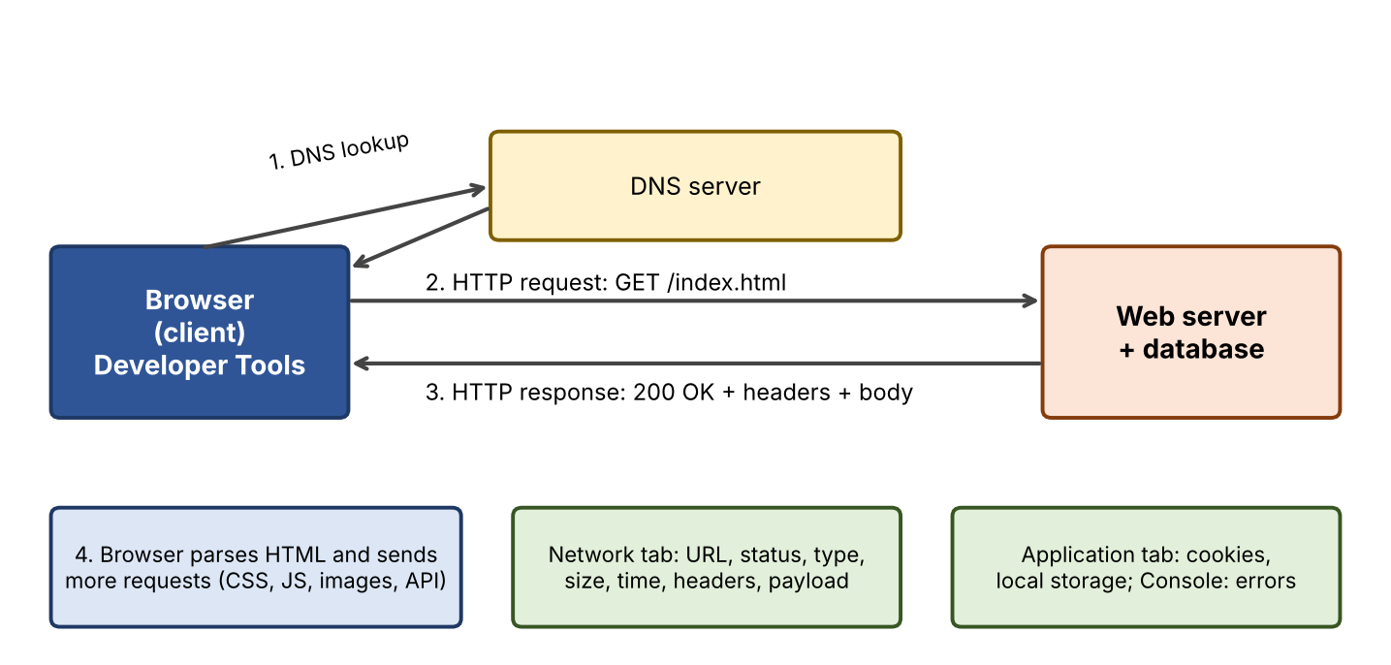
Figure 1: Data communication between browser and web server
HTTP element | Examples | Purpose
Request method | GET, POST, PUT, DELETE | GET fetches data; POST sends form data to the server.
Request headers | Host, User-Agent, Accept, Cookie | Describe the client and what it can accept; carry session cookies.
Status code | 200, 301, 304, 404, 500 | Success, redirect, cached copy used, not found, server error.
Response headers | Content-Type, Content-Length, Cache-Control, Set-Cookie | Describe the body, caching rules and new cookies.
Body / payload | HTML, CSS, JS, JSON, images | The actual data transferred.
3. Procedure
- Step 1: open Google Chrome and visit the web application to be analysed (for example a login page or a search page of any website).
- Step 2: press F12 (or Ctrl+Shift+I) to open DevTools and select the Network tab. Tick Preserve log and Disable cache, then reload the page with Ctrl+R.
- Step 3: read the request list: note the first (document) request, then the CSS, JS, image and API (Fetch/XHR) requests. Use the filter buttons to separate them.
- Step 4: click one request and study the Headers, Payload, Preview, Response and Timing sub-tabs.
- Step 5: submit a form (for example a search or login) and compare the POST/GET request payload with the response.
- Step 6: open the Application tab to view cookies and storage, and the Console tab to check errors. In the Security tab confirm the HTTPS certificate.
- Step 7: reload without Disable cache and note which requests now return 304 or load from cache.
4. Observations
Record the following for the first document request and two other requests. The values in the example column show what is typical; replace them with your own readings.
Item to record | Where to find it | Typical example
Request URL and method | Headers → General | https://example.com/ , GET
Status code | Headers → General | 200 OK (first load); 304 Not Modified (cached reload)
Remote address and protocol | Headers → General; Protocol column | Server IP on port 443; h2 or http/1.1
Content type and size | Response headers; Size column | text/html; charset=UTF-8, a few KB
Cookies sent / set | Request headers; Set-Cookie | Session cookie sent in later requests
Number of requests, data transferred | Status bar at the bottom of the Network tab | e.g. tens of requests, a few hundred KB to MB
Load time | Status bar: DOMContentLoaded and Load | e.g. under 2 seconds on a good connection
Timing breakdown | Timing sub-tab of a request | DNS lookup, initial connection, SSL, waiting (TTFB), content download
Example values are indicative only. Actual figures depend on the website, network and browser.
5. Analysis
- Layers involved: HTTP at the application layer, TCP/TLS at the transport layer, IP at the network layer; DevTools shows the application-layer view.
- Performance: the waterfall chart shows which resources load slowest; large images and scripts and long waiting time (TTFB) are the usual causes of slow pages.
- Caching: a 304 response or a “from disk cache” entry means the browser reused data instead of downloading it again, saving bandwidth.
- Security: over HTTPS the payload travels encrypted; a form sent over plain HTTP would expose the data in the Payload view and on the network.
6. Conclusion
Browser developer tools make the hidden data communication of a web application visible. By studying requests, status codes, headers, cookies and timings, one can understand how pages load, find performance problems and verify basic security such as HTTPS.

