CLOUD COMPUTING
Exploration of Cloud Service Models (IaaS, PaaS, SaaS) Using a Free-Tier Cloud Platform
Platform: a free-tier cloud account (AWS, Google Cloud or Microsoft Azure) plus a SaaS application
1. Aim
To explore the three cloud service models – Infrastructure as a Service, Platform as a Service and Software as a Service – by using a free-tier cloud platform and understanding who manages which layer in each model.
2. Theory
Cloud computing delivers computing resources over the Internet on a pay-as-you-go basis. The service models differ in how much the customer manages and how much the provider manages.
Model | What the provider gives | Examples | Typical user
IaaS | Virtual machines, storage and networks; the user installs the OS and software. | Amazon EC2, Google Compute Engine, Azure Virtual Machines | System administrators, DevOps engineers
PaaS | A ready platform (runtime, database, scaling) on which the user deploys code. | AWS Elastic Beanstalk, Google App Engine, Azure App Service, Zoho Creator | Application developers
SaaS | A complete application used through a browser; nothing to install or manage. | Gmail, Google Docs, Zoho CRM, Microsoft 365 | End users and businesses
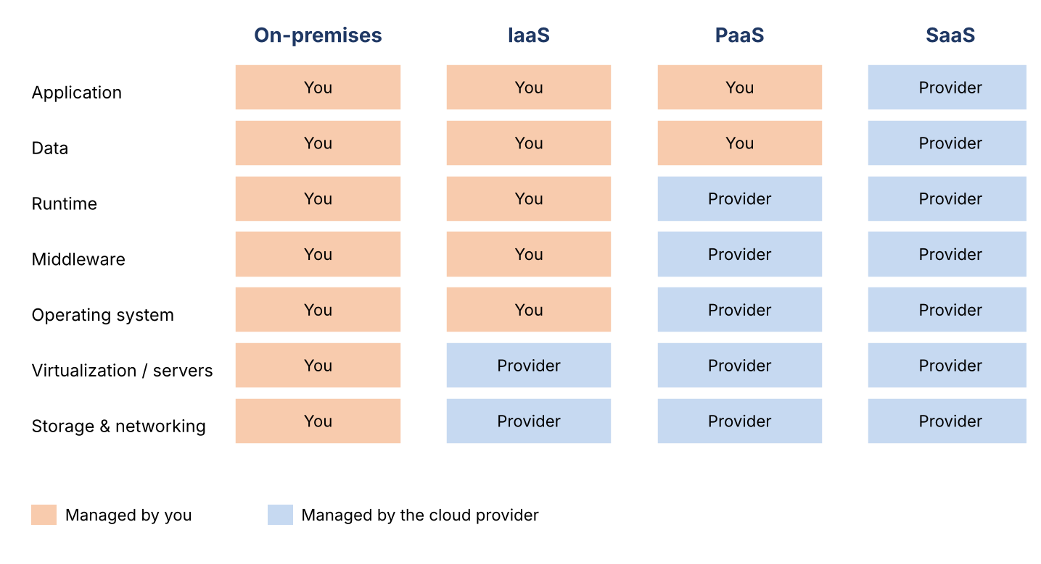
Figure 1: Division of responsibility in IaaS, PaaS and SaaS
3. Procedure
Free tiers and free credits change from time to time, so check the provider’s current free-tier page before starting and set a billing alert so that no charges are incurred.
- Step 1 – Account: create a free-tier account on the chosen platform and enable billing alerts. Record the region selected.
- Step 2 – IaaS: open the virtual machine service (for example EC2 or Compute Engine), launch the smallest free-tier instance with a Linux image, create a key pair and connect over SSH. Note the instance type, vCPU, memory, storage and public IP. Install a web server (for example nginx) and open the public IP in a browser. Stop or terminate the instance afterwards.
- Step 3 – PaaS: open the platform service (for example App Engine, Elastic Beanstalk or App Service), deploy a small “Hello World” web application, and note that the OS, runtime and scaling are handled for you.
- Step 4 – SaaS: sign in to a SaaS application such as Google Docs or Zoho and create a document or record. Observe that no installation, server or code is required.
- Step 5 – Compare: record the effort, time taken, level of control and cost in each case in the table below.
4. Observations and Comparison
Parameter | IaaS (virtual machine) | PaaS (app platform) | SaaS (web application)
Setup effort | High: choose image, keys, firewall, install software | Medium: write and upload code | Very low: sign in and use
Control | Full control of OS and software | Control of application and data only | Only application settings
Maintenance by user | Patching, security, backups | Application code only | None
Scalability | Manual or configured by the user | Automatic scaling provided | Handled by the provider
Time to start | Tens of minutes | Minutes | Seconds
Best for | Custom servers, legacy software, learning OS-level work | Fast development of web and mobile apps | Ready-made business functions
The setup-time entries are typical expectations; replace them with your own measured values.
5. Advantages and Limitations
Model | Advantages | Limitations
IaaS | Maximum flexibility; no hardware purchase; pay only for use. | Needs technical skill; user is responsible for security and updates.
PaaS | Faster development; no server administration; built-in scaling. | Less control; risk of vendor lock-in; platform restrictions.
SaaS | No installation; accessible anywhere; automatic updates. | Limited customisation; depends on Internet; data held by the provider.
6. Conclusion
The experiment shows that moving from IaaS to PaaS to SaaS reduces the customer’s management work and increases convenience, at the price of control. The right model depends on how much customisation, skill and time the user has; for example, a server administrator prefers IaaS while a business user prefers SaaS.

