NO-CODE / LOW-CODE
Case Study on the Business Impact of a No-Code Application Implementation
Case: Replacing a spreadsheet-based trade-license tracking process with a Zoho Creator application (Tlas)
1. Aim
To study how implementing a no-code application changes the cost, speed, accuracy and control of a business process, using a license-management scenario as the case.
2. Case Background
A municipal licensing office manages trade licenses and the inspectors who verify them. Inspector details, license categories, fees and validity periods are kept in separate spreadsheets and paper files. Staff re-type the same information, reports are assembled by hand at month end, and it is hard to see which inspector handles which category.
A no-code application named Tlas was built on Zoho Creator to replace this. It has a License inspector form (inspector id, name, contact details, specialization, city, state, number of categories and active/inactive status) and a license category form (category id, name, assigned inspector, trade type, license fee and validity period), with reports that list all inspectors and all categories. The impact below is an analysis of this kind of change; the before/after figures are assumptions made for illustration, not measured results of a deployed office.
3. Problems Before Implementation
- Duplicate data entry: the same inspector or category details were typed in several files.
- Errors and inconsistency: spelling and fee mismatches between files.
- Slow reporting: month-end reports needed manual collection and calculation.
- Poor visibility and access: data lived on individual computers and could not be searched or shared easily.
- Dependence on IT: any change needed a developer and a long waiting time.
4. Solution: The No-Code Implementation
Feature used | Business benefit
Forms with drop-downs and number fields | Standardised entry: specialization, city, state and status are chosen from lists, which removes spelling errors.
Central cloud database | One source of truth that every authorised user can open from a browser.
Reports (All License Inspectors, All License Categories) | Instant searchable lists with sorting and filtering, replacing manual compilation.
Charts and dashboard (extendable) | Visual view of inspectors by specialization and city for quick decisions.
Workflows and notifications (extendable) | Automatic emails and approval steps without manual follow-up.
Visual builder | The office’s own staff can add a field or report in minutes, without waiting for a developer.
5. Business Impact
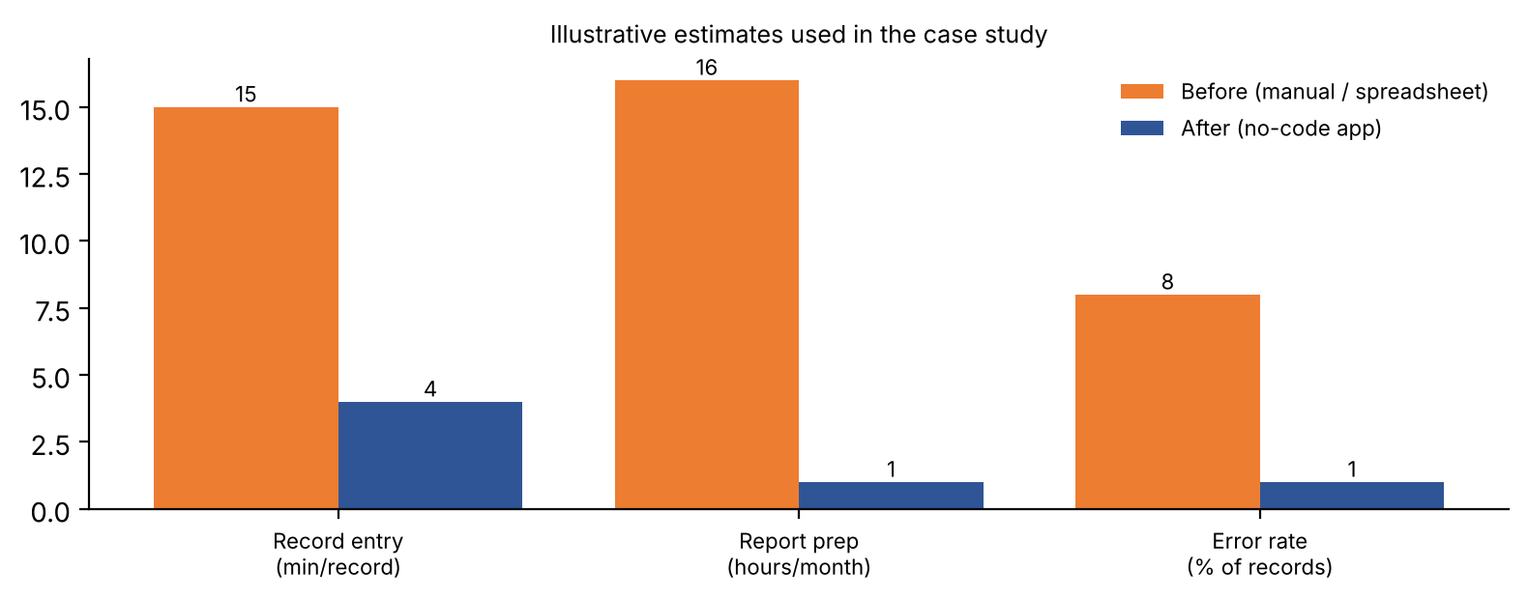
Figure 1: Assumed before/after comparison used for this case study
Measure | Before (assumed) | After (assumed) | Impact
Time to enter one record | 15 minutes across files | 4 minutes in one form | About 70% less effort
Monthly report preparation | 16 hours | 1 hour | About 94% time saved
Data error rate | 8% of records | 1% of records | Far fewer corrections and disputes
Time to change the process | Weeks (developer needed) | Hours (staff can edit) | Faster adaptation
Development cost | High: custom software | Low: subscription plus a short build | Lower upfront investment
All figures in this table and chart are illustrative assumptions chosen for the analysis. Replace them with measured values when the application is used in a real office.
Return on investment (method): ROI = (annual benefit − annual cost) ÷ annual cost. Annual benefit is the staff hours saved multiplied by the hourly cost plus the saved cost of error correction; annual cost is the platform subscription plus build and training effort.
6. Risks and Limitations
- Vendor lock-in: the application depends on the platform’s pricing and continuity; export options should be checked.
- Scalability and customisation limits: very complex logic may need low-code scripting or traditional development.
- Data security and governance: user roles, permissions and backups must be set up carefully.
- Shadow IT: uncontrolled apps built by many departments can create duplicate or inconsistent data.
7. Conclusion
A no-code implementation can cut data-entry effort, reporting time and errors, and it gives the business control over its own processes at a low cost. The benefits are greatest for form-and-report style applications such as Tlas; for very large or highly specialised systems, a low-code or custom approach may still be required.

