CS 101 SPRING 2015

COURSE PROJECT REPORT

ENIGMA MESSENGER

Team Deatails:
Group Number 113

Lele Ashwin Sanjay -14D070013
Surya Pratap Singh -140040033
Sahare Apoorv Yashwant -140070018
Bole Swapnil Sanjay -140070008

TABLE OF CONTENTS

1. Introduction
2. Software Requirements
3. Problem Statement
4. Implementation
4.1 Features
4.2 Project Screenshots
4.3 Test Cases
5. Problems Faced
6. Future Work
7. Conclusion
8. References

1.INTRODUCTION

This project is a encryption software for transmission of secret messages safely.
During transmission there is always a possibility of the message getting intercepted. Our aim was to provide a software that can take input from the user and after delivery shows original message safely to the receiver. Applications of this might be to common people, people working on some secret projects etc.

2.SOFTWARE REQUIREMENTS

- Simple codeblocks
- Microsoft visual basics studio
- .txt and .jpg file viewer
- VLC media player to play help video

3.PROBLEM STATEMENT:

- The user opens the graphic interface.
- Clicking on help button a video automatically starts in which a demo of working is provided for user's help.
- The interface then provides the buttons to encode or decode the message.
- Clicking on 'Enigmate' opens a window in which the plaintext that is to be converted to cipher is entered. This generates a .txt file(named message) and a .jpg file(named out) of the encoded message.
- Now this .jpg is sent to the receiver where the receiver again opens his
program and downloads the file to the same directory as the program.
- Clicking the 'De-enigmate' button on the dialogue box runs the decoder code and regenerates the original plaintext again in a .txt file in the same directory named output.

4.IMPLEMENTATION

4.1 Features:

- The entire graphic interface is prepared with Microsoft Visual Basics Studio.
- For user's benefit a help video is provided.
- The algorithm used for coding is ceaser cipher in 10 successive iteraions such that 10^10 possiblities are there for the decoder.
- A complex Base64 algorithm of bit alteration is also implemented.

4.2 Project Screenshots:
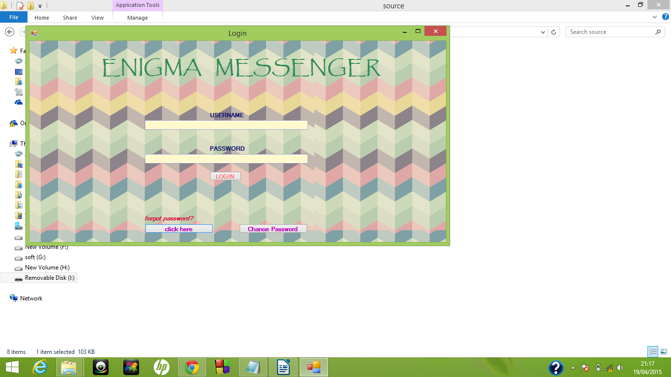
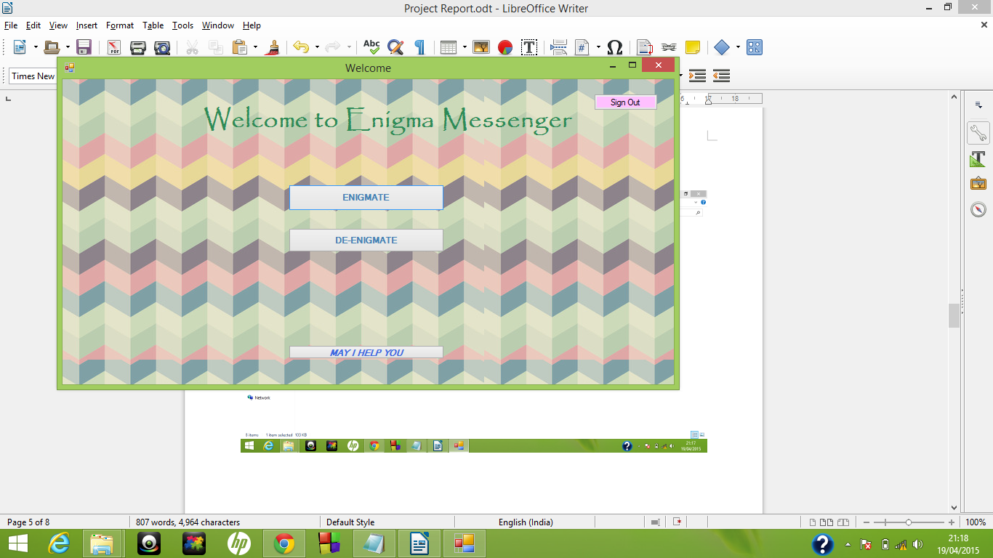
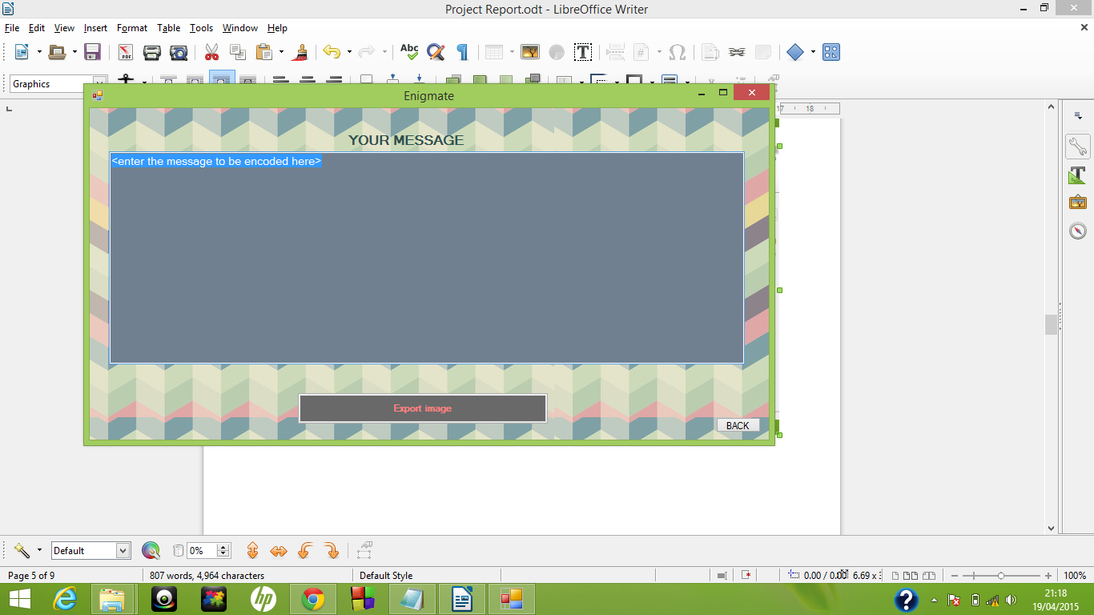

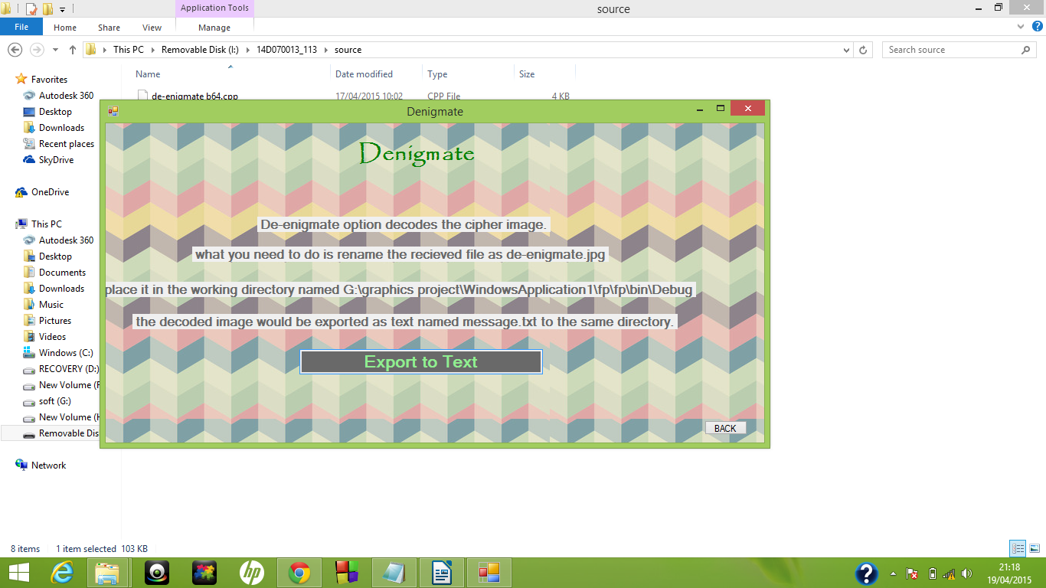

4.3 Test Cases:

Type in the following message : Hi This is our CS 101 project.
Enigmating this gives a text which is different every time as the selection of algorithm is governed by a random function.
De enigmating the .jpg file generated gives back the plaintext.

5.PROBLEMS FACED

- Integrating graphic interface with the code:
The code was written in simple codeblocks which uses c++ while the VB studio generates its code in a different syntax. This was overcome indirectly by conversion of user input into a .txt file and taking it as input for the c++ code.

- Implementing RSA algorithm
The RSA algorithm works on number taking mod of them with a number which is a product of two prime numbers. This causes the output always less than n while the ASCII values can go upto 255. This causes fault in decoder part.
While we tried to increase n beyond 255 the number whose mod we are
taking went very large(255^174) which we were unable to store.
Third problem faced with RSA was it gives incorrect values for a specific set of numbers(eg. 10^2=99)

Therefore we developed an easier algorithm which was able to encode and decode only specific characters.(eg. &,*,2,5 etc). We were unable to overcome this problem completely.

- Implementing Base 64 algorithm: Base 64 algorithm alters the bit configuration of the input. We faced difficulties in understanding it. Converting into pointers was quite painful job.

6.FUTURE DIRECTIONS

- Implementing actual steganography:

In this project we have written a code that converts a plaintext into a ciphertext which is the converted to .jpg format. No actual image is used. This project can be extended such that the code selects an image from a specific set of image and
adds the ciphered message in its .txt format at arbitary possition. The decoder should then recognize the ciphered characters and should decode them. For this purpose a sequence of characters can be used as starting point of string and endpoint of string.

- Implementing actual RSA algorithm:

Actual RSA algorithm requires product of two large prime numbers and powers of large number to be stored. This can be implemented using some technique such as actual division algorithm.

- Converting into a mobile application:

This project can be redesigned as a mobile phone application foe messaging daily messaging purpose adding the features mentioned above.

7.CONCLUSION

Through this project we have tried to develope an easy to use encryption software and we have tried to make it as user friendly as possible. Through the work done in this project we got introduced to fascinating world of encryption algorithms of which we implemented RSA(primitive version), ceaser cipher, Base 64.

8.REFERENCES

1. Wikipedia
2. https://engineering.purdue.edu/kak/compsec/NewLectures/Lecture2.pdf
3. https://www.youtube.com/watch?v=ADozzYA8sTs
4. http://en.wikipedia.org/wiki/Base64

