Final Project

Abstract

Controlling and monitoring the administration of drugs to prevent drug abuse.

# Problem Statement

In countries around the world, drug abuse is a growing menace due to many factors. Higher dosage of prescription pain-pills or anti-depressants by doctors can cause a patient to get addicted. In cases of addiction, patients go to multiple doctors (known as double-doctoring) to get a higher dosage of pills to sustain their addiction. Addicted people in many cases get pills with the same doctor’s prescription by going to multiple stores. This is how rampant drug abuse has become a major problem.

# Objective

# The project aims at addressing the problem of addiction to prescription pills. As doctors prescribe high-doses of pills, some patients are addicted to it even after they are cured of the original ailment. Our objective is to have a solution by introducing a governing body that is responsible for monitoring the medicines prescribed by a doctor. It also acts as a controlling body for medicine received by the patient. By the suggested design solution, we provide a way to track the amount of drugs taken by a person at the stores, the drugs administered by the doctors and the governing body also ranks doctors. Our solution also helps the doctors make the right choice while prescribing medication to patients by reviewing their prescription history.

Application Key Functionalities

1. Prescription creation by the doctor.
2. Patient work request to the governing body for medicines.
3. Work request from governing body to the doctor for approving the prescription.
4. After approval of prescription, a work request is sent to the store for medicine delivery approval.
5. On rejection of prescription, patient is notified.
6. After approval store updates the customer for medicine pickup/delivery.
7. The governing body ranks the doctors according to the prescribed medicines.

Eco-system architecture diagram

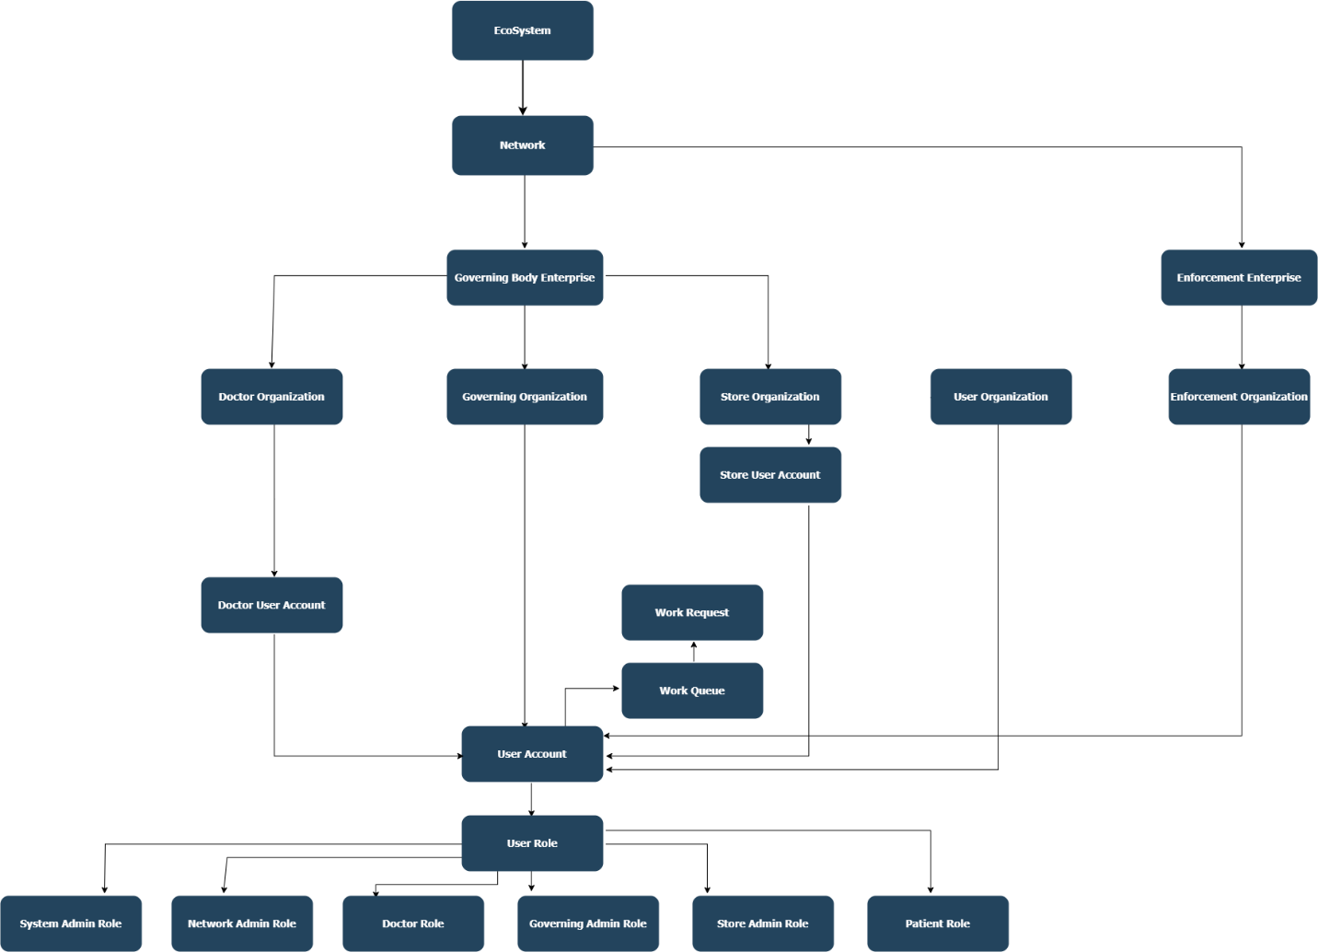

Proposed Entities

* Doctor – Id, Name, Specialization, Username, Licence
* Lab – Id, Name, Hospital Name, Username
* Patient – Id, Name, Vital signs, Address, Phone number, Username
* Governing Body – Id, Username
* Store – Id, Name, Location, Username
* User Account – Id, Password