NPTEl

Assignment 3

1. Which of the following displays a code which iterates from numbers 1 to 100, displays “fizz” if

the number is divisible by *a* but not *b*, displays “buzz” if the number is divisible by *b* but not *a* and displays “fizzbuzz” if the number is divisible by both *a* and *b. a* and *b* are inputs taken from the user.



1. 
2. 
3. Sdf
4. Sf
5. 
6. Which of the following correctly represents a sum function in Python
7. 
8. 
9. 
10. 
11. Which of the following statements correctly represents a jumbled form of a given word. For example, if the word=“lion”, one of the plausible outputs can be “oinl”.
12. "".join(random.sample(word,len(word)))
13. "a".join(random.sample(word,len(word)))
14. "".join(random.sample(word))
15. join(random.sample(word))
16. Given a variable word which is a string where no letter is repeated, what does the following code snippet do?
17. keeps printing the jumbled form of the word in an infinite loop
18. shows all the jumbled forms of the word where some forms might be repeated
19. shows some jumbled forms of the word where some forms might be repeated as well
20. shows all unique jumbled forms of the word including the original word as well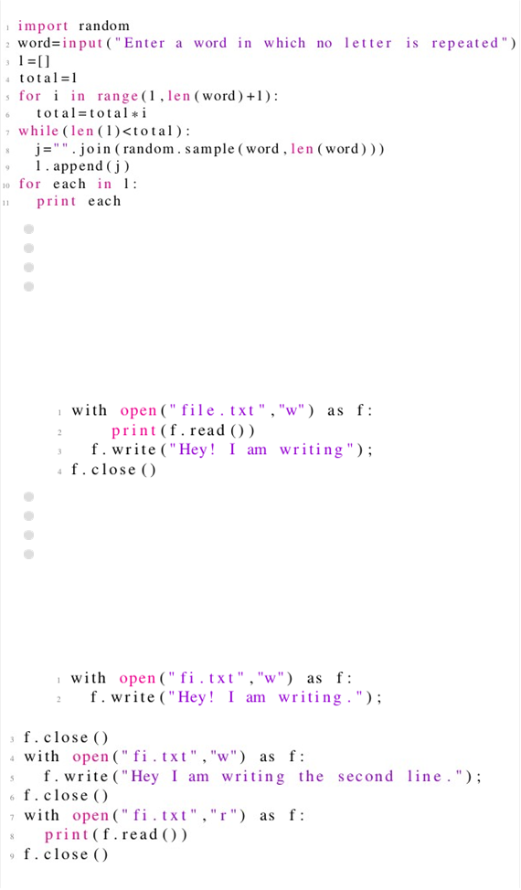
21. Given two numbers (integers) as input, print the smaller number.

**Input Format:**

The first line of input contains two numbers separated by a space

**Output Format:**

Print the smaller number

**Example:** Input: 2 3 Output: 2

Sample Test cases:

|  |  |  |
| --- | --- | --- |
| **Test Case Number** | **Input** | **Output** |
| 1 | 100 10 | 10 |
| 2 | 0 1 | 0 |
| 3 | 11 90 | 11 |
| 4 | 67 46 | 46 |
| 5 | 12 19 | 12 |
| 6 | 20 30 | 20 |

x,y = input().split(" ")

x = int(x)

y = int(y)

**if**(x<y):

**print**(x)

**else**:

**print**(y)

1. LOOPS You all have seen how to write loops in python. Now is the time to implement what you have learned.

Given an array **A** of **N** numbers (integers), you have to write a program which prints the sum of the elements of array **A** with the corresponding elements of the reverse of array **A**.

If array **A** has elements **[1,2,3]**, then reverse of the array **A** will be **[3,2,1]** and the resultant array should be **[4,4,4]**.

**Input Format:**

The first line of the input contains a number N representing the number of

elements in array A.

The second line of the input contains N numbers separated by a space. (after

the last elements, there is no space)

**Output Format:**

Print the resultant array elements separated by a space. (no space after the last element)

**Example:**

Input:

4

2 5 3 1

Output: - 3 8 8 3

**Explanation:**

Here array A is [2,5,3,1] and reverse of this array is [1,3,5,2] and hence the

resultant array is [3,8,8,3]

**Sample Test Cases**

|  |  |  |
| --- | --- | --- |
| **Test Case Number** | **Input** | **Output** |
| 1 | 6  9 9 1 9 3 2 | 11 12 10 10 12 11 |
| 2 | 5  4 3 2 1 3 7 | 4 4 4 7 |
| 3 | 8  1 1 11 1 1 1 1 1 2 2 12 2 | 2 12 2 2 |
| 4 | 1  1 | 2 |
| 5 | 4  1 2 3 4 5 5 | 5 5 |
| 6 | 6  1 3 5 7 9 11 | 12 12 12 12 12 12 |
| 7 | 3  9 2 3 | 12 4 12 |
| 8 | 4  6 2 3 4 | 10 5 5 10 |

N = int(input())

A = [int(i) **for** i in input().split(" ")]

B = []

**for** i in range(len(A)-1, -1,-1):

B.append(A[i])

C = []

**for** i in range(len(B)):

C.append(A[i]+B[i])

**for** i in range(len(C)):

**if**(i==len(C)-1):

**print**(C[i])

**else**:

**print**(C[i],end=" ")

1. Max Min

Given a list of numbers (integers),

find second maximum and second minimum in this list.

Input Format:

The first line contains numbers separated by a space.

Output Format:

Print second maximum and second minimum separated by a space

Example:

Input:

1 2 3 4 5

Output:

4 2

Sample Test Cases

|  |  |  |
| --- | --- | --- |
| **Test Case Number** | **Input** | **Output** |
| 1 | 10 11 100 200 300 34 | 200 11 |
| 2 | 10 10 | 10 10 |
| 3 | 1 1 1 1 | 1 1 |
| 4 | 1 2 3 4 5 6 7 8 | 7 2 |
| 5 | 2 3 4 5 | 4 3 |
| 6 | 1 3 5 7 | 5 3 |
| 7 | 1 2 88 99 100 | 99 2 |
| 8 | 100 44 200 10 | 100 44 |

a = [int(x) **for** x in input().split()]

a.sort() #this command sorts the list in ascending order

**print**(a[-2], a[1])

1. Dfg
2. Dfg
3. Dg
4. Dfg
5. dfg