Software Requirements Specification

For

Attendance management system

Prepared by Vishal Maurya

BITS Pilani

June 25, 2017

**Table of Contents**

**Table of Contents............................................................................................................................ii**

**Revision History .............................................................................................................................ii**

**1. Introduction.................................................................................................................................1**

1.1 Purpose….......................................................................................................................................... 1

1.2 Intended Audience…......................................................................................................................... 1

1.3 Project Scope…................................................................................................................................. 1

1.4 References…..................................................................................................................................... 1

**2. Overall Description.....................................................................................................................2**

2.1 Product Perspective........................................................................................................................... 2

2.2 Project Plan....................................................................................................................................... 3

2.3 Product Features............................................................................................................................... 3

2.4 User Classes and Characteristics...................................................................................................... 6

2.5 Operating Environment.................................................................................................................... 6

2.6 Data Model Design and.................................................................................................................... 6

**3. System Features..........................................................................................................................9**

**4. External Interface Requirements............................................................................................11**

4.1 User Interfaces................................................................................................................................ 11

4.2 Hardware Interfaces........................................................................................................................ 13

4.3 Software Interfaces......................................................................................................................... 13

**5. Other Nonfunctional Requirements.......................................................................................14**

5.1 Security Requirements................................................................................................................... 14

5.2 System Architecture....................................................................................................................... 16

**Appendix A: Use Case model......................................................................................................17**

**References …………………………............................................................................................19**

Revision History

|  |  |  |  |
| --- | --- | --- | --- |
| **Name** | **Date** | **Reason For Changes** | **Version** |
|  |  |  |  |
|  |  |  |  |

# Introduction

## Purpose

The main purpose of this specification is to help people who will work on this system to maintain the objectives and get started working in this project. This specification will direct people who will work on this project step by step through the process until they finish it successfully. This statement will describe specific details into every step of this project that workers will immediately locate the needs of this system to understand the purpose of doing any of the following steps into the system.

## Intended Audience

The audience of this system will be:

1. Students

2. Faculty members

3. Registration office.

This project will be managed by registration office, created and developed by the IT staff and other specialized people in the technology, such as programming, web design and others.

## Project Scope

The scope of the system is to have a high-tech environment in the Dominican university community. That means by using the automatic attendance system, the community will transfer to the technical environment that they already have the Canvas system to help them manage the courses they have in the whole semester. This system will add some features in the automatic attendance system to Canvas by using fingerprint device in every classroom at Dominican University.

That will help the community use the technology in effective ways:

1. Make the attendee process easier and effective.

2. Help faculty in the attendance process every time.

3. Mange and organize the attendance page through Canvas.

## References

<List any other documents or Web addresses to which this SRS refers. These may include user interface style guides, contracts, standards, system requirements specifications, use case documents, or a vision and scope document. Provide enough information so that the reader could access a copy of each reference, including title, author, version number, date, and source or location.>

# Overall Description

**2.1 Product Perspective**

At Dominican University, instructors manually take attendance in every class each day. They spend time to do that during class time. The Automatic Attendance System will help them do this process in an easy way. The main scope of this project is to make attendance process more organized in every class. This project will help instructors take the attendance automatically without spending some time during the class. It will provide the instructor who is/isn't present an early-warning of high levels of non-attendance through the Canvas page. There are also many benefits for students: they can manage their attendance, absences, and late walk-ins by checking the Canvas site. They will also know the current grade in their reports. It makes it easier to have a clear picture of every student’s attendance throughout the academic year.

The system is about to modify an existing system to develop the project. This system comes from Instructure. Instructure is a new company that has 200 employees. This company is an educational origination that works with technology to help the education community in an effective way. This company provides Canvas. The Canvas system is about a website page, which contains classes managed by instructors. It has management tools for courses. These tools play a significant role in the educational models these days, which are to organize the educational level using technology to achieve the educational goals easily. Instructors have the control panel for every class they have. The control panels allow them to create and develop the course’s page that all students can see. They may have a Home Page, Syllabus, Discussion, Grade, Assignments, People, Files, and more. All of these components are available and controlled by the faculty member to make any changes.

**Definitions:**

**Users:** This means students who will get the most befits of the system.

**Faculty:** Also, who has the top priority to get benefit for the system and they are the target actors of the system.

**The Registration Office:** This is for the system management, and it will be presented by the employees.

**2.2 Project Plan**

This project has six phases to be completed within the time line. They are initiating, project plan, components, process model, testing, and feedback. The expected time for the project will take around six months.

The project plan is in a PDF document.

**2.3 Product Features**

There are two kinds of process models for this system. There is the overview process model and the conditional process model. Starting with the first one. The first step of this process is to have a fingerprint capture device. That will do the following steps:

1- Students enter their fingerprints into the device.

2- Every fingerprint has a special code number for every recode. This code number takes the other step, which is matching.

3- The system checks on the fingerprint and sends to the server and the student database.

4- In this database file, the system checks this print for the identification. Also, the database sends it to the registration office data file to check if this code exists or not. If the code number for the fingerprint is in both databases, the code number will continue for other steps. And if the code is not there, it will give you a false result. Then, it will send you to the registration office for the identification and look for your record to modify it if there is any issue. Then, students will try again.

There is another step after the general identification.

5- Checkpoint, which will check if the student data is enrolled in the particular class or not. If yes, the process will continue, and if not, the system will send you to the registration office to check.

After that, the system now has access to the Canvas system. The system will access the student’s attendance page where it can take the attendance through the Canvas page automatically. The last step of this process is to send a notification message to students and faculty. Students can check on that and know their attendance grade. Faculty will have all students’ attendance reports, and they know who is attending and who is not.

There is also another process for this project that if a student missed a class, the system would make a decision. The aim of this process is to contain every student’s status and make sure the attendance for all students has already been taken. After ten minutes of the class time, the system will run automatically to check on the attendance page. If all students attended in that class, the system will send a report to them and stop.

However, if there are students who missed the class, the system would start some process. The system will check for who is missing the class and make a list of them. Every student of this list will receive a message that asks them for the reason of the missing the class. In this step, the system will wait for getting a response from each student separately. If the student answers with yes, and writes a note for it, the system will send this message to the faculty member. The faculty member has all the right to accept the excuse or not. If a student does not have a reason for the missed class, and checks on no, the system will count the missed class and send a report. Furthermore, if the student has an acceptable reason that he/she provides to faculty, the system will automatically report them, and the system will be done.

**Use case diagram:**

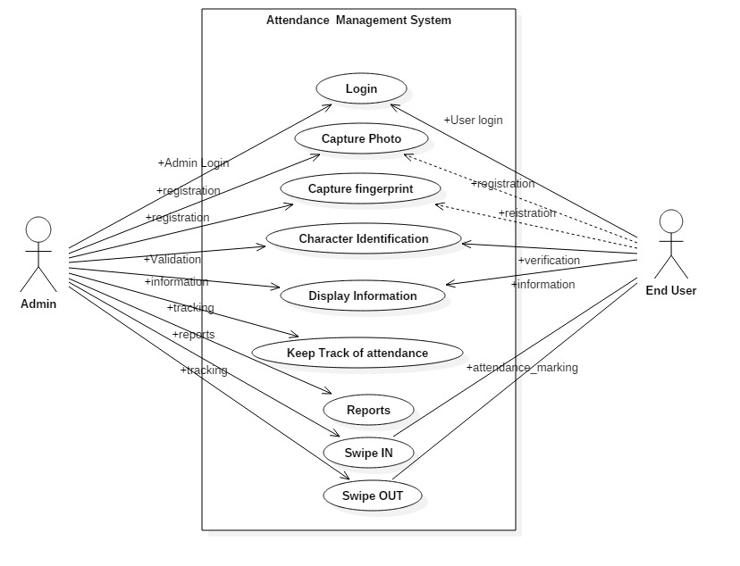

**Sequence diagram:**

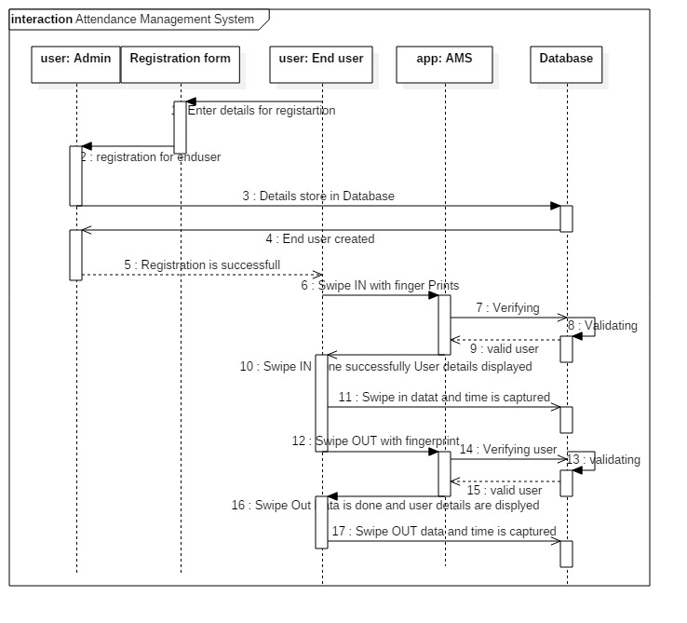

**2.4 User Classes and Characteristics**

There are three types of user classes in this community:

1) Students

2) Faculty

3) Registration Office

**2.5 Operating Environment**

This project will go through two steps:

The first step is to have the automatic attendance device in every classroom in the school. These devices will be connected to the computer and its system. Students have to put their fingerprints on file in the registration office on their first day to save their fingerprint data in the database.

The second step is to connect this system to the Canvas site. That is to connect the Canvas database to the system database to work as one system on the Canvas site. This step would complete the work, and the project will work in one system. That is because the attendance report will be updated all the time. Also, the Canvas site will control all the students’ attendance reports not in a separate system or database.

This system has some requirements to be accomplished. It needs hardware and software.

Hardware requirements:

1) Biometric Fingerprint Scanners

2) Cables for the device

The current system work is already in existence. However, we need some system requirements:

1) Create new databases and indexes for students and class list by using mysql

2) Make connation to the current database

3) Design interfaces for the users

4) Design an attendance page on Canvas

5) Programing using JavaScript, PHP, and HTML

**2.6 Data Model Design**

This system contains many processes to be completed. One of the processes is the database design. It needs to present data that is the data understandable not only for the human being but also for computers. This step would organize the needed data on every side of this project to make the database relationship. In this project, I will use the Entities Relationship Diagram (ERD) to help this project make the database relationship.

The system has four entities, each with its own attributes: People, Class list, Courses and Canvas. The People entity has the student fingerprint ID, first name, last name, Faculty fingerprint ID, first name, last name. Student and faculty ID are based on the code of the fingerprint in the system. The class list entity has class list ID, class ID class data and class time. The course entity has course ID, course name, credits, room number, and class time. Also, the course entity has an index for the date and time. Finally, the Canvas entity has the class list ID, class ID, student fingerprint ID, class date, and attendance information.

The relationship in this entity relationship diagram has many ways to define the following:

• Every student has zero to many classes (not all take classes this semester)

• Every faculty teaches zero to many classes (not all teach any class this semester, such as doing research)

• Every class has zero to many students

• Every class has only one faculty

The result of this relationship is connected with the others with the Canvas entity. The Canvas entity is the final result of this relationship. It has the student information, and the course information in one format. In the other words, it has the one to many relationships with each entity and its shows the result of the relationship.

• All entities related to the Canvas entity

• Classes have one to many relationships

The process starts with the class list entity. It must have at least one student in each class. Every faculty and student has a unique fingerprint ID. Also, every class has a unique ID too. Faculty can be signed for one mandatory class to many classes, and each class has only one faculty member, Students has zero to many optional classes. So, each class has many students with only one faculty. In the Canvas page, all results of the one to many relationships would end up on this page to give the outcome.

The whole process would be in this relationship as one part of the work, and it has everything we need to get the project started as planned. Entity relationship diagrams help this project to be more clear and understandable. This will continue working on the same steps that we use in this diagram. The overall benefit of this structure is to facilitate easy communication between humans and computers. Better communication will expedite the desired results.

**Class diagram:**

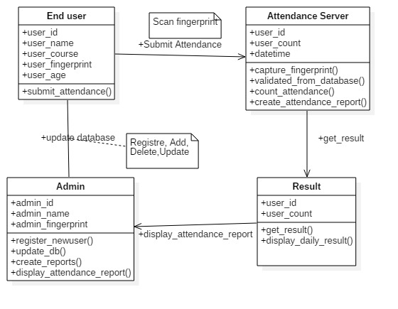

# System Features

**Functional Requirements**

## Adding a New student:

Function: Sign up a new student to the system.

Priority: Top (Required for first release)

Requirements: To add a new user to the system, all of them should have registered in the admission office before they can register in their classes. On the orientation day, all students must scan their thumbs in the input device for only one time to save the fingerprint data in the registration office to sign up.

## 3.2 Use the system to attend to classes

Function: Attend to classes

Priority: Top (Required for every class attended)

Requirements: When students have a class, they must scan their thumbs in the fingerprint input device. If the scan matches, students can enter the class, and they will be checked on the Canvas page. If the scan does not match, the student must check with the registration office to figure out the checking device.

## 3.3 Report students

Function: The user will look at their reports for the current status.

Priority: Top (Required for first release)

Requirements: When the students have enrolled in the class, they are now able to check on their current attendance situation through the Canvas page. In the system, they will be shown a page that gives them the whole attendance status in the semester.

## 3.4 Faculty receive a report

Function: Faculty receives a current report every class.

Priority: Top

Requirements: The system will send a message after ten minutes of the class time to the faculty. Faculty will have the all students’ attendance reports in the particular class. Faculty can modify some of the attendance grades if he/she needs.

## 3.5 Students missed classes

Function: Students receive a message for missing class and have to submit a form.

Priority: High (Required for second release)

Requirements: When a student misses a class, he/she will receive a message via email and Canvas page. Students must long in to the Canvas page and go to the attendance page to write the reason for missing the class. Students have to submit the form to wait for the response of the faculty’s decision.

**3.6 Students missed two classes and more**

Function: Students receive a warning message for missing class for the second time.

Priority: High (Required for second release)

Requirements: When students miss more than one class, students will receive a warning message for missing two classes or more. The warning message should be for the missed classes for the whole semester and their status in a danger level.

**3.7 Faculty check the report and the attendance control panel page**

Function: Users can provide feedback about search terms.

Priority: Medium (Second release if possible, mandatory for third release)

Requirements: Faculty has to check on the report and give the final submission. Faculty has full control of modifying any grades and looking at students who have excuses to modify their grades. Faculty receive messages from the system about students who missed classes. For students who submit the note for the missed class, faculty members could look at the note and give a decision on the student’s grades.

# External Interface Requirements

**4.1 User Interfaces**

**Login Display:**

This is the main login in the system which appears in the Biometric Fingerprint Scanners. This interface designed to be in the device view in every class. “Scan Your Thumb” is the login to the class and the system.

**Welcome View page:**

This view will be also in the device screen. This page means the device accepts the fingerprint data and identify the person. So, in the screen, it will show the student information (name, and his picture). Also, it has the data for the particular class at the time.

**Error message view:**

If the student data is not identified with the device, the student has to check with the registration office to fix that. This means, this student does not have a record in the system. Or, the student is in the wrong class or wrong class time.

**Add a New student:**

This page appears in the registration office when they add a new student. Students have to scan their fingerprint in the device. And then, their fingerprint record will be added by the employer to make sure the student has his record with his information; not anyone else’s. The employer submits the information to the system and the system will give a message that this student with his fingerprint information has added to the system.

**Student Report:**

This page will appear in a separate page in the system. It is a web page gives the students current report during the semester. It has the weekly report, the check in each class, and grade. It gives the student how many times he has been in the class and how many he missed. Also, it provides all grades that student makes during the semester.

**Faculty Attendance Report:**

This is a web page which has all student’s reports in the class. This page is controlled by a faculty member. Faculty can modify in this report. This page has the name, the time of the class and the class room number. It has weekly reports with the average of the student’s attendance in every class time. Also, it calculates the total grade for every student.

**Missed class form:**

If a student missed any class, the system automatically will send to him this form. Students should write their note and submit it to the system. The system will send it to the faculty member to have the final decision.

**4.2 Hardware Interfaces**

The hardware environment in this system will use the Biometric Fingerprint Scanners. These scanners will play a role in the system. This device must be available in every classroom in the school. Also, it must be in the registration office. The interfaces for the hardware part are the same in the registration office’s interface. This part of the interface has also other components, such as student’s information, faculty information, class’s information, and other related information. All of these data are stored in the database and end with the device screen and web pages.

**4.3 Software Interfaces**

The system will use:

1) Biometric Fingerprint Devices display software

2) Web pages for the forms HTML, PHP

3) Server

4) Programing using JavaScript

5) Database uses with mysql.

# Other Nonfunctional Requirements

## Security Requirements

**The Current System Security**

The current system, which is Canvas, has its policy on its site page. The current system builds upon a user name and password access. Students and faculty can access to his/her account through their page, and they can control it.

The system now has its own policy and security; however, the new feature we will add to the system will need some security requirements to the system. The new feature in the system will add some values to the current policy to maintain the security in the right way. It also provides proof of compliance.

The new policy in the system will deal with the security in many cases. The security will have more components on the system in a high control panel. The plan is to secure the outsider and insider community of misused the system (e.g. identification theft). Strong security is part of the policy’s purpose.

**User Access**

Inside the community, there are students, faculty, and registration office staff who are going to use the system. The main actor of the users in the entity is students. Students will use the entity everyday by scanning their fingerprints by the beginning of each class. Faculty will only use the system through Canvas, and they can access to student information. The faculty member will use the entity to control the attendance page. Faculty’s job is to add, edit, update and delete any record. Furthermore, registration office staff will check on every student’s identification for security purposes. They check on students for identification in person before they add, edit, update and delete any information from their fingerprint records in the system. The staff will ask students for ID for identification and print their thumb in the device if needed to make sure the person is identified.

**Threats to the system security**

This system may face many threats. Sometimes, it comes from a community insider. This could be someone who discloses the data form the database where it located, in the registration office. Another type of deception is false identification, such as a fake ID, when students present in the registration office. The system will reduce this kind of misuse because the fingerprint identification is more secure than others. Nobody can make up a fingerprint not related to them. However, staff in the registration office should check on the identification carefully before initiating any processes in the system. These records will be the official record for all students, since they begin school and until they graduate.

**Levels of security:**

1) **Hardware**: The fingerprint devices must be located in a secure location in every class. It should be behind the entrance that everyone can see the device inside and outside the class if the door is open.

2) **The operating system**: the security in this case will be in the same level of the Canvas security.

3) **The network**: it is part of the current system security.

4) **The data management system**:

1. Students can access to their classes to the system check by fingerprint.

2. Faculty access to Canvas would be the same as we have now, and they will control the attendance page/report.

3. The purpose of the registration office is to make sure every student has the right fingerprint record and right information in the system on a consistent basis.

**Level of access**

**Subject:**

**People level:**

1) Users (students).

2) Faculty (Control on Canvas).

3) Registration office (control the system).

**Computer level:**

1) Hardware (fingerprint reader)

2) Software (the system)

**Access request (operation)**

The operation will be presented in the security matrix that provides every task in the system and everybody in all task responses.

**Reference Monitor**

The authorization and the access control present in the security matrix below:

Faculty can create, read, update and delete the “Report student,” “Report faculty,” and only read “process student check.”

Registration office can create, read, update and delete the “add a new record,” “Process student’s check,” and they can only read the “Check-in.”

Student are able to create and read the “Check-in,” and they can only read the “Receive student check” and “report student”.

## System Architecture

A system architecture is the ideational model that defines the structure, behavior, technology and other views of any system. In the fingerprint system, we have the whole structure to build the system. In this architecture, we will describe the formal definition and the representation of the system. This description is a high level that can show the relationship between the components induces software, hardware and the communication between them.

The first level of this architecture is the hardware component. The hardware here is the fingerprint reader which will be connected to the system and other components. Then, it will check with security level. The security level here has database for the security purposes. Next, the architecture level will go to the process task, which has four components in the software. They are chick in for every class when student scan his/her fingerprint, check on fingerprint, this is kind of the security and to check into every class. Then check into the class, which is the class chick list to make sure the student in the right class. Finally, notify step, this step is to report everyone involves in the system to receive a notification.

The last two level of this architecture are the access data and the databases. There are three databases for this step which are for the classes, students, and fingerprint records. This architecture is the whole structure for the Automatic Attendance System. So, all process here will complete the communication between all the components.

**Appendix A: Use Case model**

Develop a system that can help the Dominican university community to take the attendance automatically that will be connected with Canvas page on a new attendance page

The target actors are:

1. Students

2. Faculty

3. Registration Office

All the data will be gathered by the Biometric Fingerprint Scanners and Readers that will help faculty, students and, registration to reach the end user by the Canvas page.

We will create the separate page on Canvas to take the attendance. Fortunately, we do not need to create the login page, as we already have the Canvas site to log into the system, starting with the students, faculty, and the registration office staff.

1. Students:

a. For the first time, students go to the registration for the fingerprint scanning.

b. In the beginning of each class, students must scan their thumbs in the Biometric Fingerprint Scanner.

c. Each student, receive the automatic attendance grad on his Canvas page.

d. Students will receive the notification on his/her Canvas page for the attendance.

e. Students can access to his page and look/print at his current attendance report and the final report.

f. Student would receive a warning message if they miss more than two classes.

2. Faculty:

a. To know who is in attendance automatically.

b. On the class time, faculty will receive a report for this particular time.

c. Faculty could know who is in attendance or missing that class.

d. On the Canvas page, they have every student’s report and grades.

e. They have the percentage of the attendance for the whole semester.

f. They can print the final attendance report for the class by the end of the semester.

3. Registration:

a. Registration office has all the students’ fingerprint records.

b. They check the identification for every student.

c. The fingerprint code will give access to the student account on Canvas (no username/password needed at this time).

d. They use these records for any student who will come by the office as the identifier.

e. They connect this information with the classes.

f. Students would have a hold if he/she does not have a fingerprint record in the registration office.

**References:**

<https://www.tutorialspoint.com/software_engineering/software_project_management.htm>

<http://www.ignousolvedassignments.com>

<http://feedburner.google.com/fb/a/mailverify?uri=ignousolvedassignments_com>

<https://www.slideshare.net/rhspcte/software-engineering-ebook-roger-s-pressman>

[www.cse.msu.edu/~cse870/IEEEXplore-SRS-template.pdf](http://www.cse.msu.edu/~cse870/IEEEXplore-SRS-template.pdf)