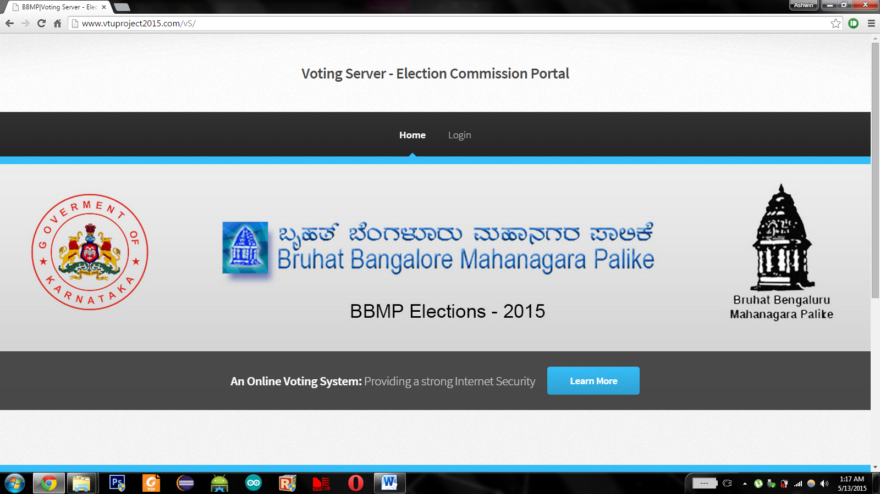

Figure A.2 Splash Screen of Election Commission

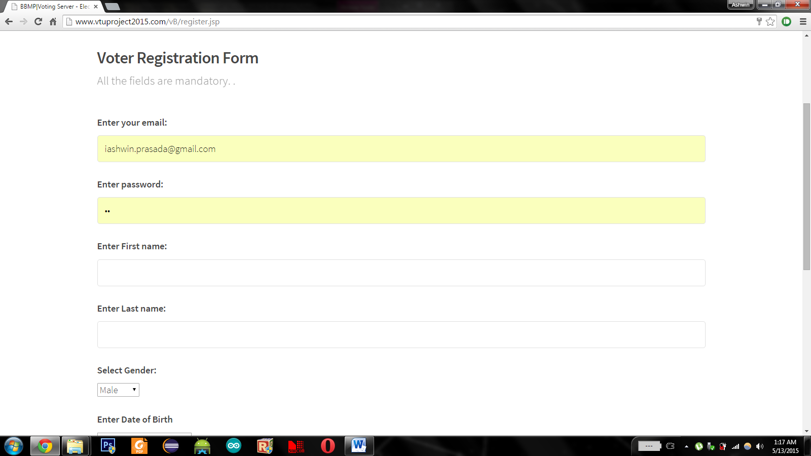

Figure A.3 Voter Enrollment Form

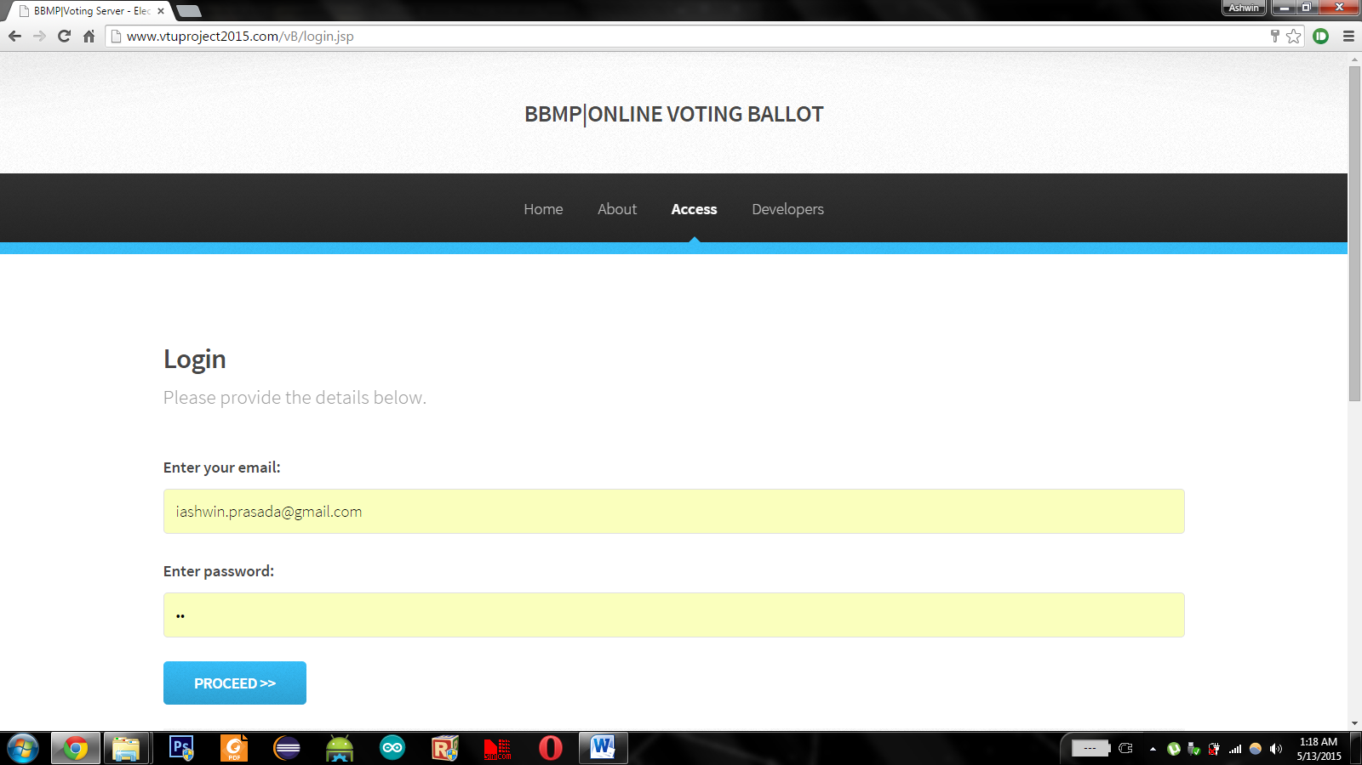

Figure A.4 Login Window

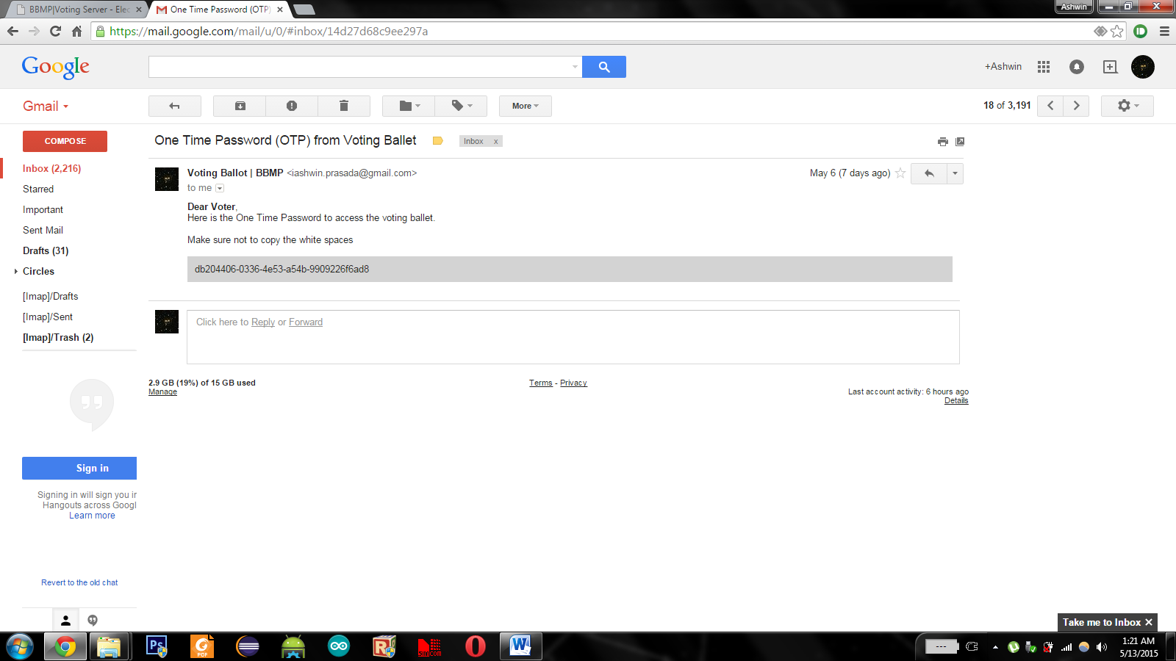

Figure A.5 Login OTP sent to mail

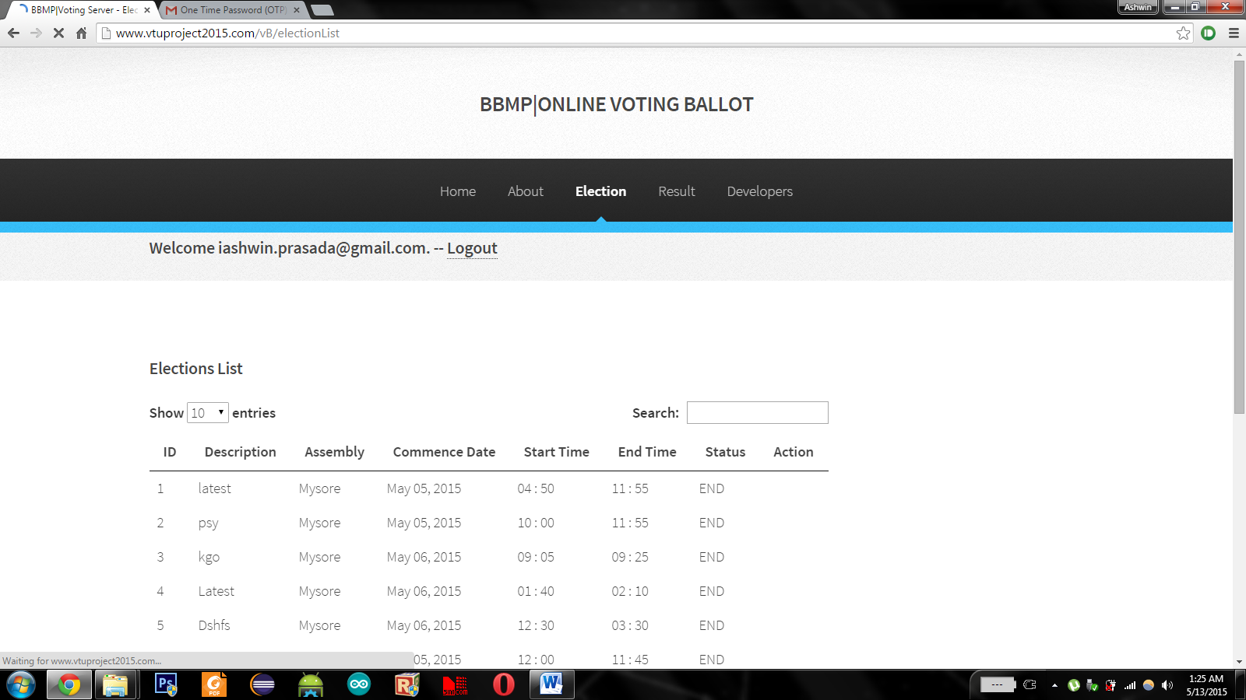

Figure A.6 Election List

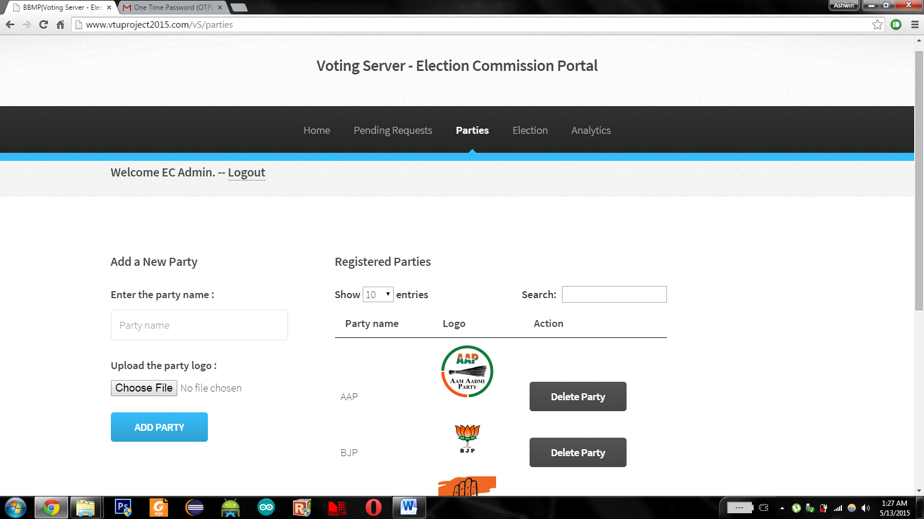

Figure A.7 Adding a new Party