**Java - Project Proposal**

**Pizza Store Management**



**Group member names: Ashwin Rajan,**

**Tanveer Ghatourha,**

**Jenish Patel**

Basically what the project does is it takes the order from the customer and saves it in the database. Whenever the order is taken the inventory is updated automatically. It has the information for the every food and drink that is available in the store. It has a Login page similar to the view down below admin has to login before entering the program otherwise it will not work.

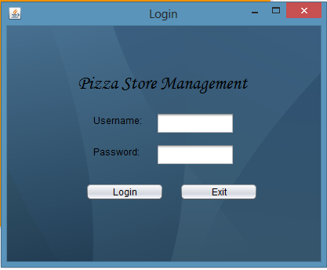

There is only admin view, who can take order and cancel order at any time. Admin view will have order view similar to the view down below. 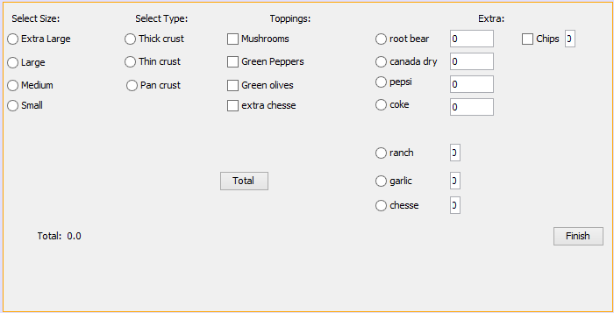

Key features of Pizza store management:

* Takes order and saves it in the database for future references
* Updates the inventory in the database and display the inventory file
* Generate a receipt and display it

The program is only intended for the person who works for the Pizza store such as cashier. This will be made in JSP and servlet. This program is useful for taking pizza orders and checks the previous order and updating inventory. It also keeps track of the customer information.