Weed Population Detection in Live Grass using Modified Backpropagation Algorithm

Aswin Ramachandran
School of Electrical and Computer Engineering, Oklahoma State University
{asramac@okstate.edu}

Abstract:
A modified form of backpropagation algorithm (MBP) for fast learning time is reviewed in this paper. The proposed algorithm modifies the standard backpropagation (SBP) algorithm with an extra term for linear errors. The new algorithm is compared with the standard backpropagation algorithm for a function approximation problem. In order to test the response of the neural network a non-linear function approximation problem, the detection of weed population from live grass is chosen. The neural network with MBP is trained with 3 different training data sets and the network response of each trained network is studied. It is shown that MBP has a fast learning time and its dependence of learning rate is explored.

Introduction:

The scope of the neural networks is very wide ranging from biological to business applications. Many tools and software libraries for neural networks are available and have fueled the growth of neural network development. The time taken for the neural network to learn and its response time is always a critical factor in any application. Tedious gradient calculations are simplified by back propagation algorithm using chain rule. Many researchers [1], [4], [5] in neural networks have worked to increase the rate of error convergence.

In general, fast learning neural networks are essential because networks may be re-trained periodically depending upon the change in pattern of the input vectors. The re-training of a neural network must consume less time as the network is operationally down during the training period. In addition, many low-cost embedded systems applications, can handle only simple computations and hence it is important the computations to be kept simple.

Stone [6], 1994, notes that complexity in neural networks involving computationally intensive training, non-closed form implementations and lack of traditional understanding in regression approaches have limited the applications of neural networks in agricultural machinery. He further notes that, although, non-linear effects can be modeled with additional hidden layers, it also reduces the likelihood of convergence.

Drummond et al. [7] concludes that weather variations were potentially the major cause of un-explained variability in the modeling. In addition, they also concluded that some further un-explained variability may have been due to non-weather related factors not included in the models.

The authors of this review paper; Abid et al. [1] have proposed a new training algorithm that partition the error term into non-linear and linear errors. However, it is not clear if this method would be advantageous for highly non-linear function behavior.

1.1 WEED DETECTION IN SPRAYER SYSTEMS:

A neural network to recognize color patterns in an agricultural weed sprayer is discussed application by Stone [6], (1994). The neural network model came out to be an potential solution to model much interference in detecting the type of plant, dead plant matter, many soil colors, and variation in the color of the target plant.

In embedded application look-up table based models are popular. However, as the input vector dimensions increase it is not possible to store every combination in the look-up table. An alternative to a look-up table is to encode the necessary response into an equation. However, complexity of the equation also increases increasing the response time. In this review, it will be verified whether solution from Abid et al. is useful to classify weeds into populations of 10%, 50% and 70%. The reason for such a classification is that it allows the weed sprayers to automatically adjust the valve to control the amount of weedicides that are sprayed.

II. Paper Review

The learning time of a network can be reduced by both reducing the number of iterations with equations that have faster convergence as well as by simplifying equations such that takes less time for each iteration. The major contribution of the paper by Abid et al [1] is a proposed modification of the standard backpropagation algorithm to reduce the learning time during the network training period. The paper considers both non-linear and linear error terms to reduce the learning time and uses the generalized Least Mean Square (LMS) equation. In the following section, the paper’s approach and notation is compared with the standard backpropagation that is discussed in the book of Neural Network Design [2].

2.1 Derivation and comparison of modified backpropagation [1] with the standard backpropagation algorithm.
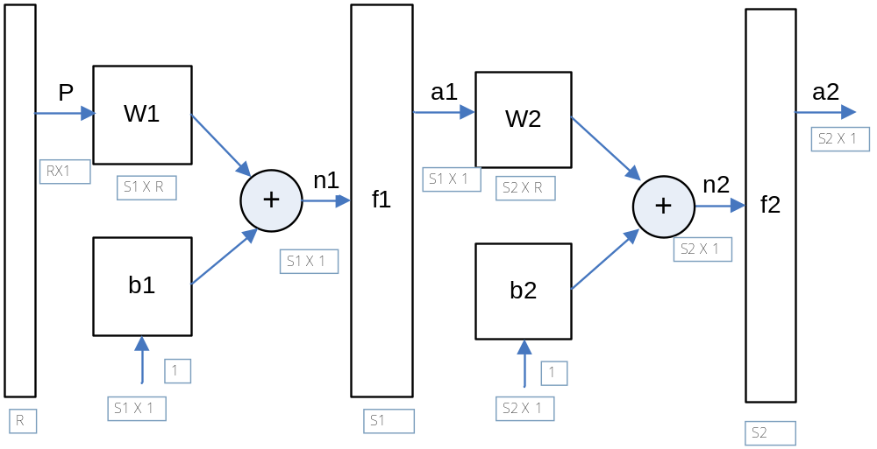

Figure 2.1. Multi-Layer Network (Output Layer M = 2)

Generalized Least Mean Square (LMS) Algorithm is given by:
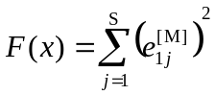 (1)
where,
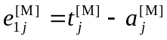 and
M is output layer, S number of neurons in the layer

1. Error Signal for the Output Layer, M:

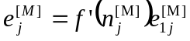

This can be expressed in the matrix form described in the neural network design book [2] as,

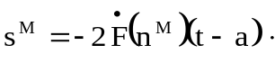 (2)

2. Error signals for layers from s = M -1 to 1:

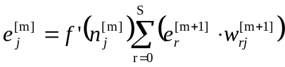
Again, in matrix form it is simply given as,

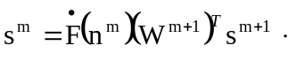 (3)

3. Update the Weights and Biases for layers m = 1 to M:

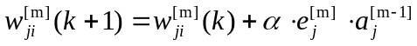

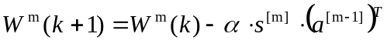 (4)

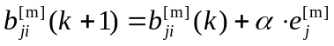

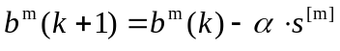 (5)

The ‘α’ used in the paper [1] is of negative value and hence gradient is added in the weight update equations.

In this section the standard backpropagation is described according the notations used in the book [2]. Rewriting the equations in the matrix form provides a more clear description of relationship between the variables. In section II, the modified form of standard backpropagation that is proposed by the Abid et al. is described.

2.2. Modified Standard Backpropagation Algorithm Proposed by Abid et al [1]:

For the purpose of understanding the authors’ work, the equations are written in vector expansion form. However, expressing the equation in matrix form makes is easier to extend for multi-layer networks.
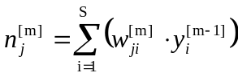 (6)
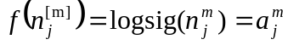 (7)

at the j^{th} neuron.

The non-linear and linear errors described by the authors are,

Non-Linear Error | 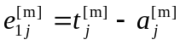
Linear Error | 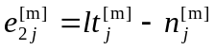

Where,
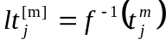, i.e. the inverse of the output neuron function.

The authors introduce a new error Optimization Error Criterion Ep,

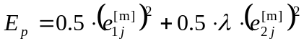 (8)

The linear error term 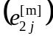 is also weighted by a new parameter ‘λ’. The choice of ‘λ’ is critical for faster convergence of the error.

The gradient of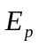,
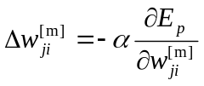 (9)
hence, the new Weight Update Rule is,

(10)

The extra term ‘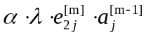’ represents the weighted linear error term.

The above equations are now written in the convenient matrix form to extend it for multi-layer networks.
1. The weight update for the final output layer M is expressed in equation (16) [1] by the authors as,

(11)

This can be expressed in sensitivities as described previously in equation (2).

The non-linear sensitivity is given by s^{M} and the new linear sensitivity is given by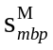 as,

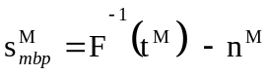 (12)

2. The weight update for layers from M-1 to 1 is expressed by Abid et al [1] in equation (15).

(13)
Where,
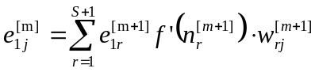
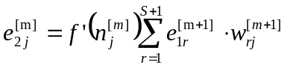

Equation (13) can be expressed in the matrix form as below,

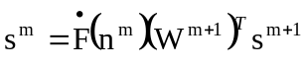 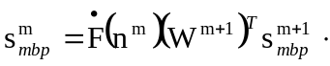 (14)

The weight update rule,

(15)

As λ tends to 0, equation (15) reduces to standard backpropagation. The authors find the choice of λ important for practical applications and suggest testing the network for a wide range of values. In the section IV, the performance of standard backpropagation and the modified backpropagation are compared and studied.

III. Program Description

In order to test and compare the performance of the 2 backpropagation algorithms, a computer program is written to describe the modified backpropagation algorithm [1] in MATLAB. The standard backpropagation algorithm can be tested by simply making λ, weight term on the linear error, to be equal to 0.

3.1 Experimental Setup:
The weed reflectance data collected using a 4-band sensor is shown in Figure 3.1. The sensor samples 3 square feet of area at 10 Hz for red reflectance and Near-Infra Red light reflectance. The recorded reflectance data of red (660nm), NIR1 (780nm), NIR2 (870nm) and NIR3 (970nm) are then stored in ASCII format.

Figure 3.1. OSU 4-Band Reflectance Sensor
As reflectance of light can vary with light condition that is incident on the grass, air humidity, moisture and color of the grass, the data is recorded for 3 different conditions.
- Bright and Dry
- Bright and Wet
- Overcast and Dry
The following flowchart in Figure 3.2, describes the computer program for the 2 algorithms,
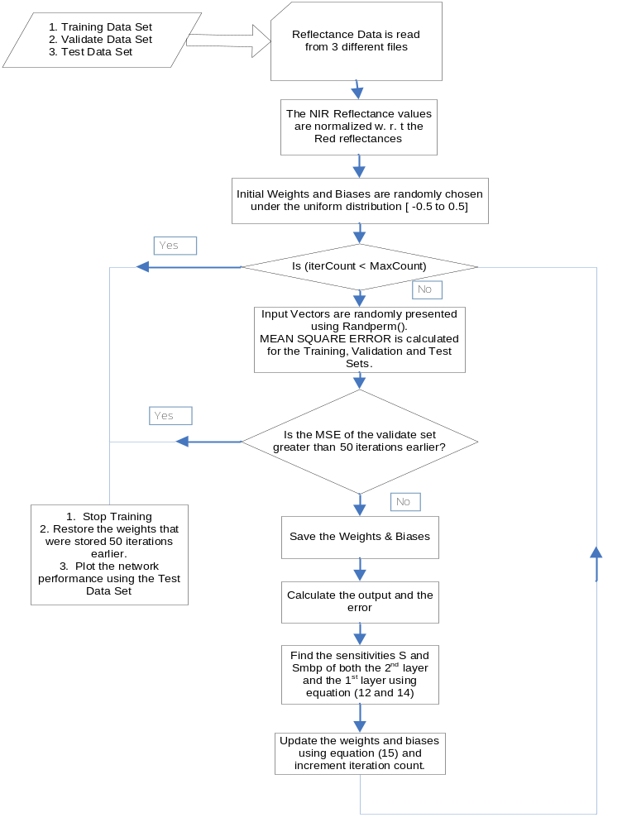
Figure 3.2. Flow Chart of the Modified Backpropagation and Standard Backpropagation with Early-Stopping. The lambda in equation (15) is set to zero to evaluate Standard Backpropagation (SBP).
In section IV, the performance of the network under these conditions is discussed. The input data gathered under each of these conditions is categorized into 3 levels of weed populations {10%, 50% and 70%}. There is a factor of human error involved in obtained the data. However, the data is collected carefully on wide open areas and also with distinct levels of weed population. To obtain the best trained neural network that can operate at all weather conditions to detect the percentage of weed populations, the network is trained with 3 different training sets.

Training Sets:
- Bright and dry.
- Mixture of all reflectance data (Bright & Dry, Bright & Wet and Overcast & Dry).
- Bright and dry (with large train data set).

IV RESULTS

In this section, the performance of the proposed modified backpropagation algorithm [1] is compared with the standard backpropagation algorithm. The details of this comparison are given below. Before discussing the performance of the network to detect the population of weeds, it is interesting to study the behavior of the 2 algorithms with a simple function to approximate.

4.1. Function Approximation:
Function to Approximate: (1+ sin(p*pi/8)),
Training points: p = -2:0.2:2; % 21 Training Points
Testing points: p = -2:0.01:2; % 401 Testing Points

The training set is randomized using randperm( ) and so the network is presented with a random order of input, p. In the following convergence characteristics, the blue line indicates the modified backpropagation algorithm (MBP) and the red line indicates the standard backpropagation algorithm (SBP).
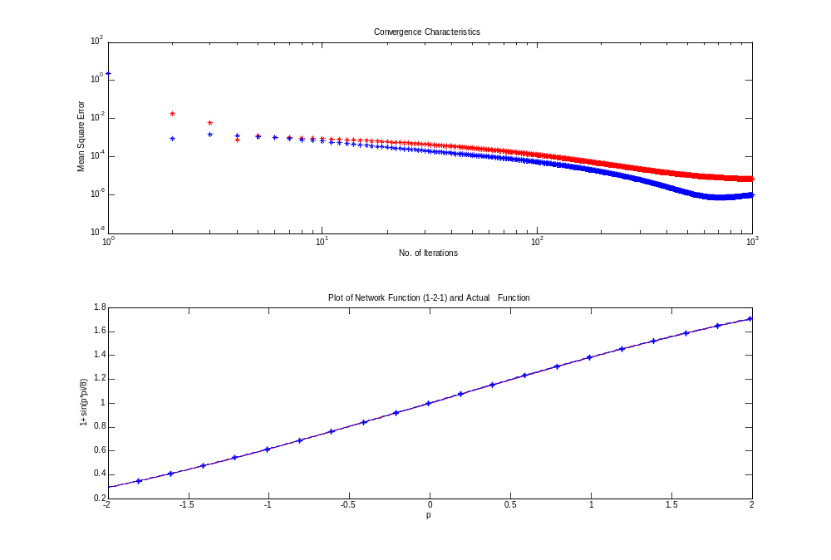
Figure 4.1 Convergence Characteristics of the 2 algorithms for (α = 0.5). It shows the MBP algorithm with (λ = 0.5) converging faster than the SBP.

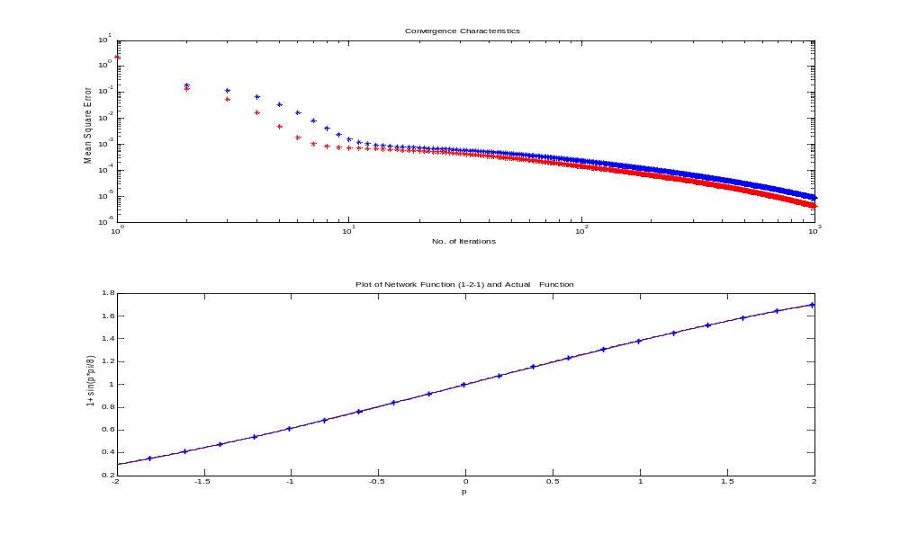
Figure 4.2 Convergence Characteristics of the 2 algorithms for (α = 0.1). It shows the SBP algorithm converging faster than the MBP with (λ = 0.5).
As indicated by the authors in the paper [1], the error convergence is faster than the standard backpropagation. In Figure 4.2, the learning rate is reduced to illustrate its sensitiveness.

In Figure 4.2, the rate of convergence of the MBP is shown to be sensitive to the learning rate, α. As λ -> 0, the MBP algorithm reduces to SBP algorithm. Let us increase the frequency of the sine wave to observe the behavior of the error convergence between the 2 algorithms.

In order to thoroughly study the behavior of the 2 algorithms, early-stopping is not implemented while approximating the sine function. However, it is implemented while training the network for detecting the weed population.

4.2. Function Approximation with Increased Frequency:
Function to Approximate: (1+ sin(p*pi/2)),
Training points: p = -2:0.2:2; Testing points: p = -2:0.01:2;
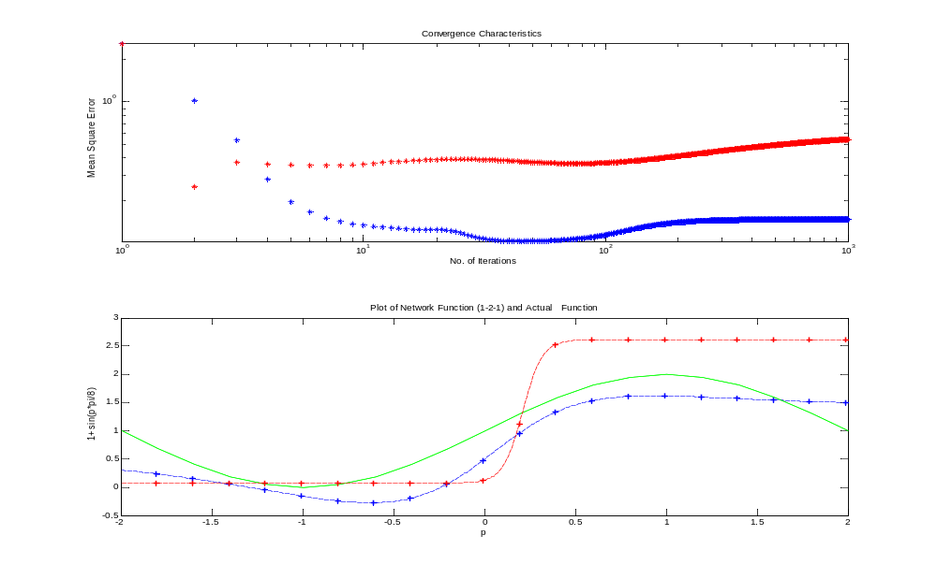
Figure 4.3 Convergence Characteristics of the 2 algorithms for (α = 0.5). At a high learning rate and without early stopping, the MBP is seen to perform better than the SBP. The green, red and blue lines represent the actual function, SBP and MBP prediction respectively.

Early-Stopping is disabled in the performance index plot of Figure 4.3, to study the true behavior of the 2 algorithms. Although, the MBP increased in mean square error, the overall performance of the MBP to approximate the function with increased frequency is much better than the SBP algorithm.

Next, the sensitiveness of the learning rate in the 2 algorithms is studied. The learning rate α, is decreased resulting in the SBP having a better performance than the MBP algorithm as shown is Figure 4.4.
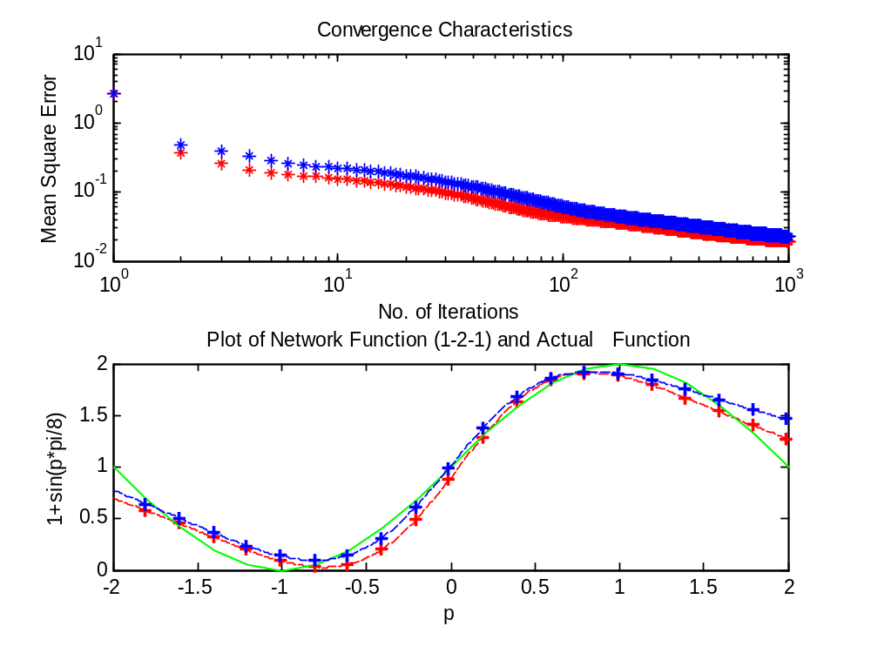
Figure 4.4 Convergence Characteristics of the 2 algorithms for (α = 0.1). The 2 algorithms have a similar behavior when the learning rate is reduced.

4.3 Neural Network Layers:

The basic architecture of the neural network is a (3-N-1) network. This structure is chosen for its simplicity, its robustness to solve problems with fair amount of complexity and to keep the computation time low. The first layer of the network consists of 3 neurons followed by a hidden layer, N. The final output layer has 1 neuron that estimates the fraction of weed population. The number of neurons in the hidden layers is chosen after testing the network performance with different number of neurons. The data recorded under bright and dry conditions is used to determine the optimal number of neurons necessary in the hidden layer. Figure 4.5 shows the network under test.

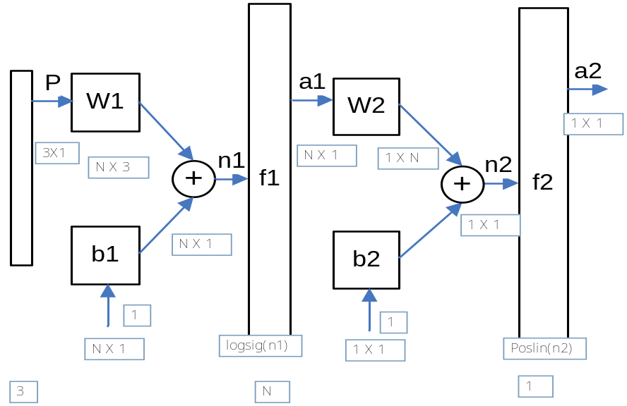

Figure 4.5 (3-N-1) Neural Network under test

To find the optimal number of neurons in the hidden layer, a sequence of numbers based on Fibonacci series is used to vary the number of neurons in the hidden layer. Hence, the following sequence of network structures is tested to determine the number of hidden layer neurons that has the best performance index.
(3-2-1), (3-3-1), (3-5-1), (3-8-1), (3-13-1), (3-21-1), (3-34-1)

4.4 Early-Stopping:

In the following figure 4.2, the early-stopping method is implemented such that no updates to weighs are made if the current error is greater than the previous error.
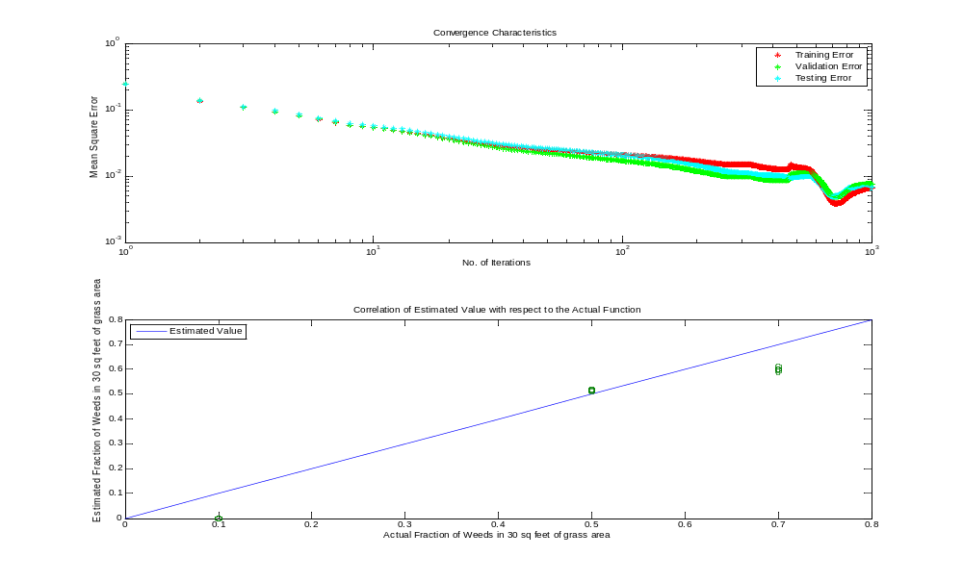
Figure 4.6 3-2-1 Neural Network Layer Performance for weed estimates.

In Figure 4.6, the amount of data for validation is chosen based on [3]. Hence, out of 100 total data points, 70% are chosen for the training set, and 15 % each for the validation and testing point. The effect of early-stopping is shown in Figure 4.7.

As observed in Figure 4.6, the error rises after 700 iterations but still continues to 1000 iterations. This is because, for every other iteration the early-stopping counter gets reset. This is solved by checking whether to stop the training at iteration of modulo 50. That is, the errors and weights are saved for every 50 iterations, after a training period of 200.
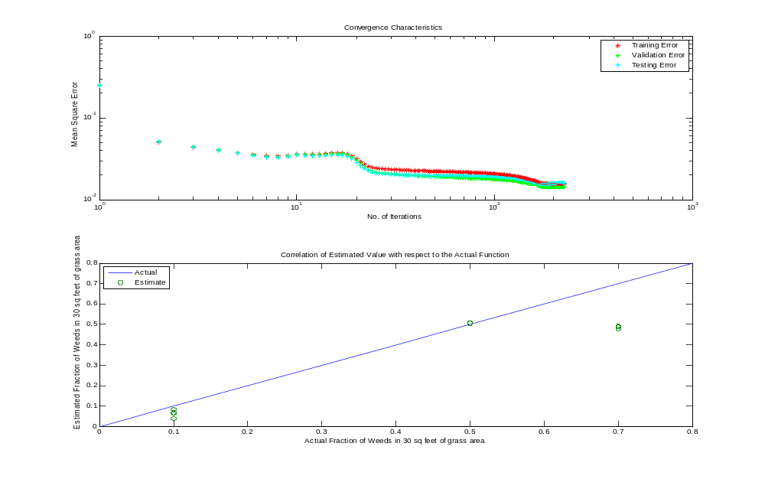
Figure 4.7. 3-2-1 Neural Network Layer Performance for Weed estimates with Early-Stopping after 25 iterations of increase in Mean Square Error.

The errors are compared between the error at 50 iterations earlier and the error at current iteration. Thus, small variations in errors are damped. The resulting network response is shown in Figure 4.7.

Table I. Performance of the Neural Network by varying the number of neurons in the hidden layer that follows a Fibonacci sequence for SBP.

 | SBP: Alpha = 0.1
Network Under Test | Final MSE | Elapsed Time (s)
3-2-1 | 0.0125 | 315.61
3-3-1 | 0.0171 | 283.59
3-5-1 | 0.017 | 315.33
3-8-1 | 0.011 | 474.93
3-13-1 | 0.0108 | 286.57
3-21-1 | 0.0078 | 281.11
3-34-1 | 0.0082 | 282.83
Average | 0.0127 | 326.19

Table II. Performance of the Neural Network by varying the number of neurons in the hidden layer that follows a Fibonacci sequence for MBP [1]
Network Under Test | Final MSE | Elapsed Time (s)
3-2-1 | 0.0127 | 285.5
3-3-1 | 0.0125 | 306.37
3-5-1 | 0.0192 | 360.72
3-8-1 | 0.0118 | 285.68
3-13-1 | 0.0246 | 303.27
3-21-1 | 0.0157 | 301.149
3-34-1 | 0.0106 | 280.53
Average | 0.0161 | 307.1148

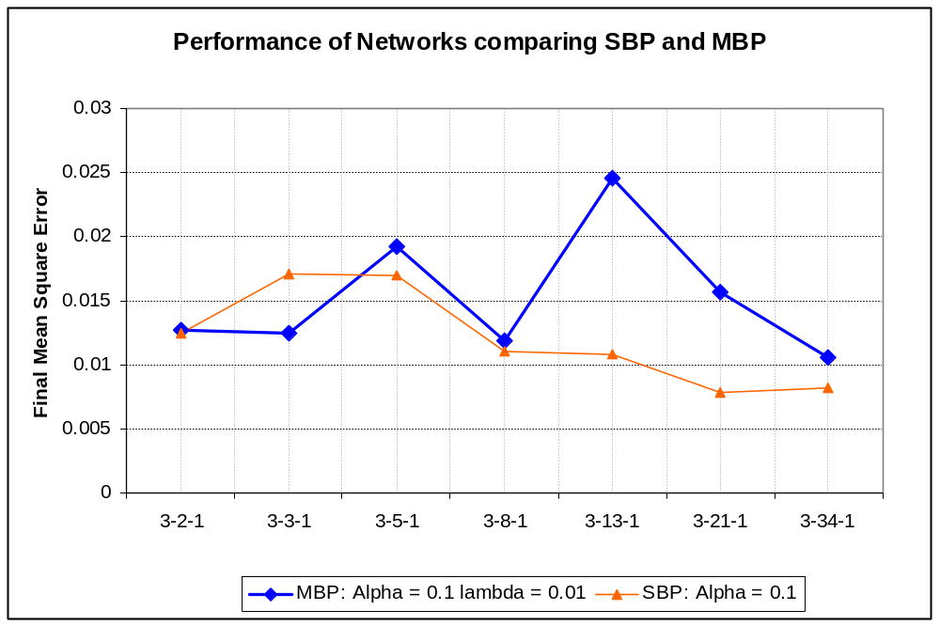
Figure 4.8. Performance of the Neural Networks for the 2 Algorithms trained with same initial weights and biases.

From the Figure 4.8, it is seen that the network (3-8-1) is the optimum choice as it has just enough neurons to fit the training data. Although, (3-34-1) network has smaller mean square error, it is not a convenient choice for embedded system applications due to its increased complexity and network response delays.

Now, the network (3-8-1) is trained with data from 3 different categories.
- Bright and dry.
- Mixture of all reflectance data (Bright & Dry, Bright & Wet and Overcast & Dry).
- Bright and dry (with large train data set).

  - Bright and Dry Conditions:
Training Data Points = 72 alpha = 0.1
Validation Data Points = 14 lambda = 0.01
Test Data Points = 14 (3-8-1) Network
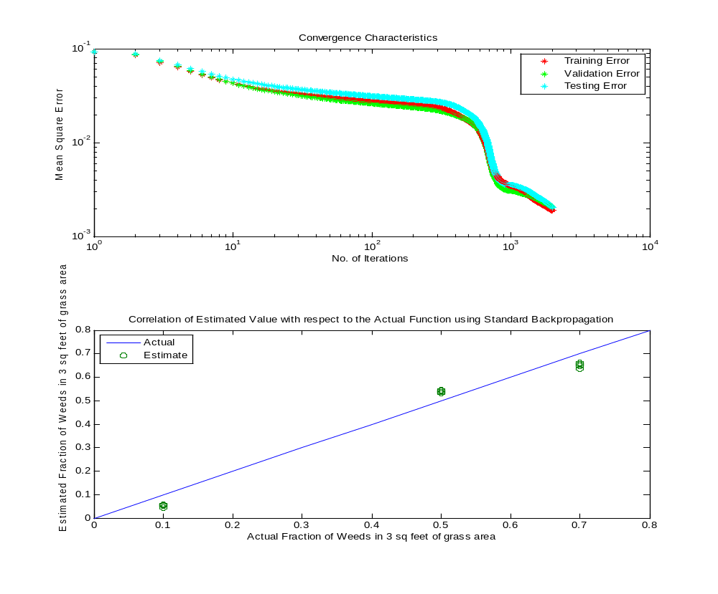
Figure 4.9a. Performance Index and Network Response under Bright and Dry Condition. Stopped after 2000 iterations.
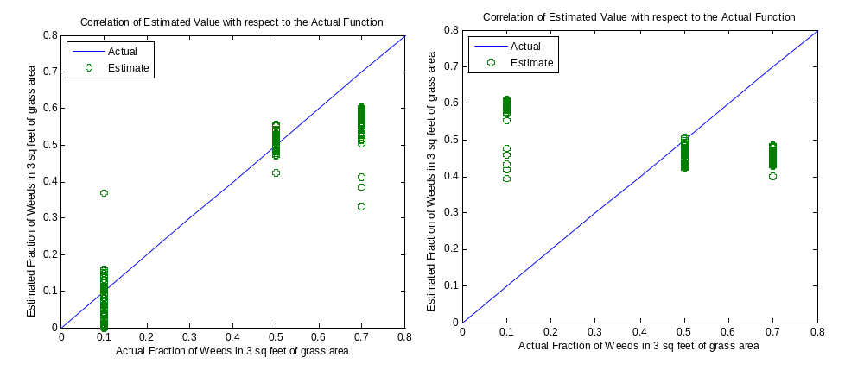
4.9 b. Cloudy and Dry 4.9 c. Bright and Wet
Figure 4.9 Neural Network Response with Bright and Dry data (3-8-1). Figure 4.9a, shows the performance index of the network as well as the network response. Figure 4.9b and 4.9c show the network response for Cloudy & Dry and Bright & Wet conditions.
Although, the mean square error is decreasing in Figure 4.9a, the training is stopped after 2000 iterations as it takes about 30 minutes to complete it. However, the network response shows better estimation of weed population. Figure 4.9b also has better clustering near 0.1 and 0.5. But, although the cluster on the region around 0.7 is higher than 0.5, it is still not close to better estimate. The network fails to estimate the weed population under wet conditions and is seen in Figure 4.9c.

  - Mixture of all Reflectance Data (Bright & Dry, Bright & Wet and Cloudy & Dry):
Training Data Points = 72 alpha = 0.05
Validation Data Points = 14 lambda = 0.01
Test Data Points = 14 (3-8-1) Network
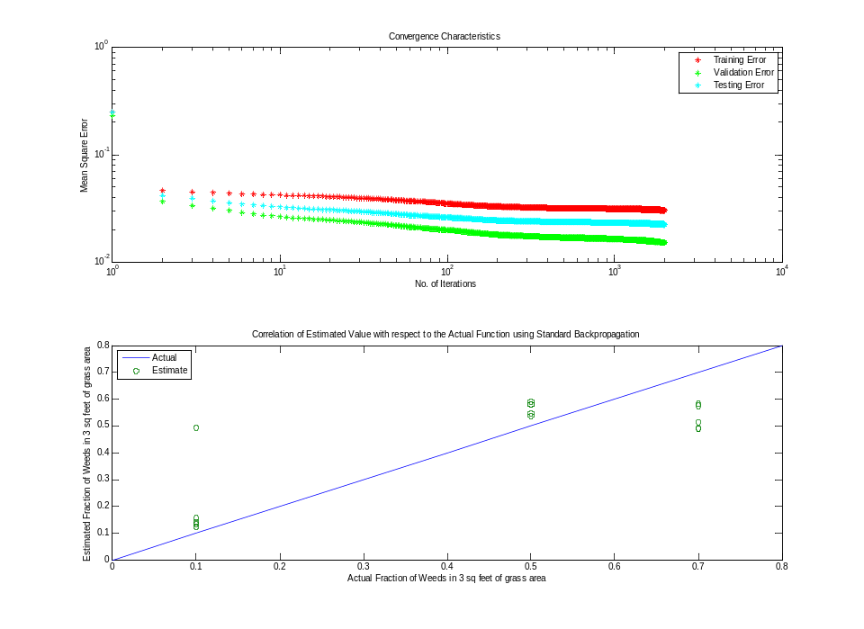
4.10 a. Performance Index and Network Response for the combined test data set

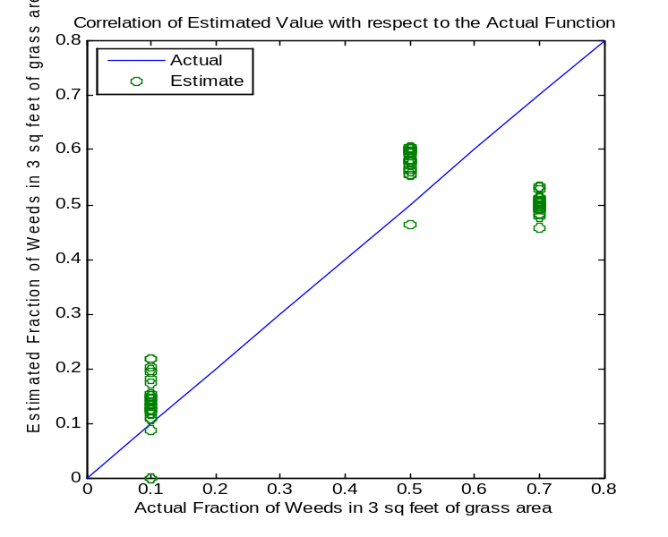
4.10 b. Bright and Dry

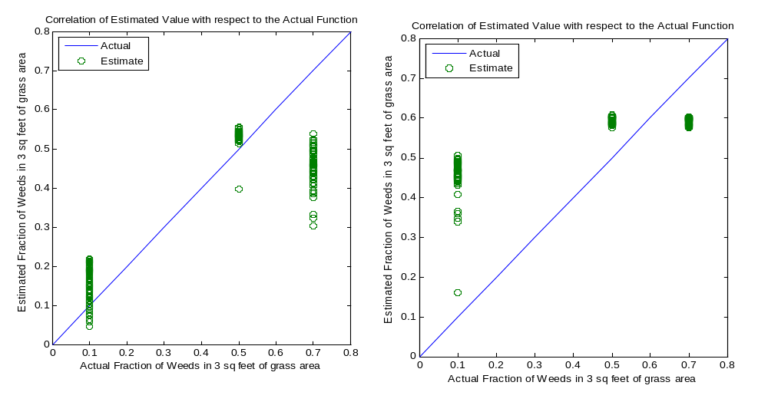
c. Cloudy and Dry d. Bright and Wet

Figure 4.10 Neural Network Response with mixture of {bright & dry, bright & wet and cloudy & dry} data. Figure 4.10a, shows the performance index of the network as well as the network response. Figure 4.10b, 4.10c and 4.10d show the network response for Bright & Dry, Cloudy & Dry and Bright & Wet conditions.

This training set is an interesting classification of data from all the 3 conditions taken into account. Although, the network did not train as well as under bright and dry conditions, the under the wet conditions the cluster on 0.1 in Figure 4.10d moved than in Figure 4.9c.

  - Bright and Dry (with large train data set):

Training Data Points = 691 alpha = 0.05
Validation Data Points = 146 lambda = 0.01
Test Data Points = 146 (3-8-1) Network
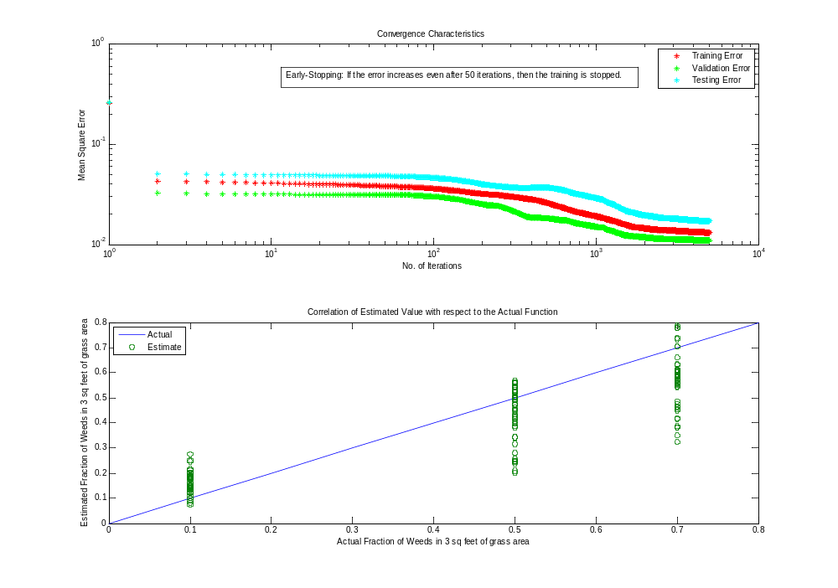

Figure 4.11. a Trained Neural Network Response with large train data set under Bright and Dry conditions.

Figure 4.11a, shows the performance index of the network as well as the network response under Bright and Dry conditions. Figure 4.11b and 4.11c show the network response for Cloudy & Dry and Bright & Wet conditions. This training set is included to make sure the neural network has been trained to see most of the combination of input vector sequences. Hence, as seen in the network response of Figure 4.11, it has resulted in better classification of weed populations.

However, as seen in Figure 4.11b and Figure 4.11c, it suffers a problem of over-fitting a particular sequence of data. Hence, it completely mis-fits the data shown in Figure 4.11c, under the bright and wet conditions.

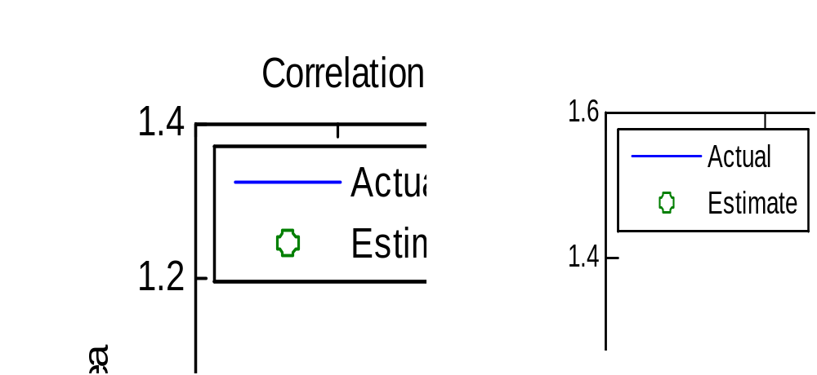
Figure 4.11 b. Cloudy and Dry Figure 4.11 c. Bright and Wet

V Conclusion

The modified backpropagation algorithm proposed by Abid et al. [1] is thoroughly investigated in this review. The effect of non-linear and linear errors is analyzed in Table I and II, for several networks with varying hidden layer neurons based on Fibonacci sequence. Given the same initial weights and biases, as seen in Figure 4.8, the final mean square error in SBP reduced more consistently than the MBP. However, the MBP has faster learning times as claimed by the authors [1] and the average final mean square error in from Table II for MBP is 26 % more than SBP.

To test the network performance the (1+sin(p*pi/2)) and (1+sin(p*pi/8)) functions are used and depending on the learning rate, SBP and MBP algorithms well approximated the functions. In order to test neural network on a real-time application, the problem of estimating the weed population in a 3 square feet of live grass is considered. The data collected from 4 bands of reflectance is used to estimate the amount of weed content.

The training data set is also collected carefully under 3 different light and atmospheric conditions. The neural network is trained to estimate 3 levels of weed population, 10%, 50% and 70%. From the Figures 4.9 to 4.11, it can be summarized that the network clearly distinguishes between 10% and 50% weed populations. On the other hand, it has problems in correctly estimating the weed population at 50% and 70% for bright & dry and cloudy & dry conditions. For the case of the bright & wet condition, all the networks failed to classify the different levels of weed population. Although, normalizing the data was considered and tested, it was not able to classify the weed population. This is due to the interference of infra-red signals with water particles [11]. However, weedicides are used only under dry conditions to avoid chemicals seeping into ground water table.

The proposed MBP by Abid et al. can be extended to Radial Basis Network to cluster the weeds based on their types and also classify them with different level of population. Such a system would be useful to apply both the correct type and amount of weedicide to minimize crop and soil damages.

Acknowledgements:
I would like to thank Dr. Marvin Stone, Emeritus Professor, School of Bio-Systems and Agricultural Engineering for his support and readiness in allowing me to use the sensor. The discussions between the instructor and the students in the Spring 208 class of Neural Networks also turned out to be useful in the experimental setup of the project.

References:

- S. Abid, F. Fnaiech and M. Najim, “A Fast Feedforward Training Algorithm Using a Modified Form of the Standard Backpropagation Algorithm”, IEEE Transactions on Neural Networks, Vol. 12, No.2, March 2001.
- M. Hagan, H. Demuth and M. Beale, “Neural Network Design”, Colorado University Bookstore, ISBN 0-9717321-0-8.
- Amari et al, "Asymptotic Statiscal Theory of Overtraining and Cross-Validation”,IEEE Transactions on Neural Networks”, Vol. 8, No. 5, 1997.
- Zhihong Man, Hong Ren Wu, Liu Sophie, Xingho Yu,”A new adaptive backpropagation algorithm based on Lyapunov stability theory for neural networks”, IEEE Transactions on Neural Networks, vol. 17, No. 6, pp. 1580-1591, 2006.
- G. D. Magoulas, M. N. Vrahatis, G. S. Androulakis, “Improving the Convergence of the Backpropagation Algorithm Using Learning Rate Adaptation Methods”, Neural Computation. 1999; 11:1769-1796.
- Stone, M. L.,”High Speed Networking in Construction and Agricultural Equipment”, SAE Paper 941662, Symposium on Future Transportation Electronics: Multiplexing and In-Vehicle Networking, SAE, 1994.
- Drummond, S. T., K. A. Suddeth, and S. J. Birrell.”Analysis and Correlation Methods for Spatial Data”, ASAE Paper 95-1335, 1995.
- Stone, M. L.,”Embedded Neural Networks in Real Time Controls”, SAE Paper 941067, 45th Annual Earthmoving Industry Conference, SAE, Warrendale PA, 1994.
- C.-C. Yang, S.O. Prasher, J.-A. Landry, H.S. Ramaswamy And A. Ditommaso, “Application of artificial neural networks in image recognition and classification of crop and weeds”, CANADIAN AGRICULTURAL ENGINEERING Vol. 42, No. 3 July/August/September 2000
- Guang-Bin Huang and Haroon A. Babri, “Upper Bounds on the Number of Hidden Neurons in Feedforward Networks with Arbitrary Bounded Nonlinear Activation Functions”, IEEE Transactions On Neural Networks, Vol. 9, No. 1, January 1998.
- S. H. Gordon, “Signal Enhancement and Elimination of Water-Vapor Interference in Fourier-Transformed Infrared Photoacoustic Spectroscopy of Powdered Plant Materials”, Society for Applied Spectroscopy, Volume 41, Number 2, 1987

Appendix A
Program Code:
%*******ECEN 5733 Final Project****************************
%*******Neural Network Weed Detection using MBP[1]*********
%***05/02/2008*************by*Aswin Ramachandran***********
%**********************************************************
clear
clc
clf
%****Load the Input File******
load ./nnm_train.txt
redData = nnm_train(:,2);
nir1Data = [nnm_train(:,3) ./ redData]';
nir2Data = [nnm_train(:,4) ./ redData]';
nir3Data = [nnm_train(:,5) ./ redData]';
pg = [ nir1Data; nir2Data; nir3Data];
targetData = nnm_train(:,7) ;
%*******Validate Data*******
load ./nnm_validate.txt
redData_v = nnm_validate(:,2);
nir1Data_v = [nnm_validate(:,3) ./ redData_v]';
nir2Data_v = [nnm_validate(:,4) ./ redData_v]';
nir3Data_v = [nnm_validate(:,5) ./ redData_v]';
targetData_v = nnm_validate(:,7) ;
pValidate = [nir1Data_v; nir2Data_v; nir3Data_v];
%*******Test Data*******
load ./nnm_test.txt
redData_t = nnm_test(:,2);
nir1Data_t = [nnm_test(:,3) ./ redData_t]';
nir2Data_t = [nnm_test(:,4) ./ redData_t]';
nir3Data_t = [nnm_test(:,5) ./ redData_t]';
targetData_t = nnm_test(:,7) ;
pTest = [nir1Data_t; nir2Data_t; nir3Data_t];
%---Learning Rate---
fprintf( 'Learning Rate');
alpha = 0.1 %0.1
lambda = 0.01
earlyStopCount = 0;
prev_eSq_v =10;
%---Input,pt----

pa = 1 : length(targetData_t);
%---Plot the Original Function----
actLine = 0:0.1:0.8;
subplot(2,1,2), plot (actLine, actLine); legend('Actual');%scatter(targetData_t, targetData_t,'^b');
hold on

%-----Randomized First Layer Weights & Bias-------
fprintf( 'Initial Weights and Biases');
%****3-8-1******
W1 = [ -0.5+rand -0.5+rand -0.5+rand -0.5+rand -0.5+rand -0.5+rand -0.5+rand -0.5+rand;
-0.5+rand -0.5+rand -0.5+rand -0.5+rand -0.5+rand -0.5+rand -0.5+rand - 0.5+rand;...
-0.5+rand -0.5+rand -0.5+rand -0.5+rand -0.5+rand -0.5+rand -0.5+rand -0.5+rand]'; %Uniform distribution [-0.5 0.5]

b1 = [ -0.5+rand -0.5+rand -0.5+rand -0.5+rand -0.5+rand -0.5+rand -0.5+rand -0.5+rand]';

W2 = [ -0.5+rand -0.5+rand -0.5+rand -0.5+rand -0.5+rand -0.5+rand -0.5+rand -0.5+rand];
%-----Randomized Second Layer Bias------
b2 = [-0.5+rand];

if (lambda == 0) % Save the Weights and Bias on SBP
W1_initial = W1;
b1_initial = b1;
W2_initial = W2;
b2_initial = b2;
else % Reuse the Weights and Bias on MBP
W1 = W1_initial;
b1 = b1_initial;
W2 = W2_initial;
b2 = b2_initial;
end

%-----RandPermutation of Input Training Set-------
j = randperm(length(targetData));
j_v = randperm(length(targetData_v));
j_t = randperm(length(targetData_t));

%--Set Max. Iterations---

maxIter = 2000;

tic %--Time Stamp---

for train = 1 : maxIter +1
eSq = 0; eSq_v = 0; eSq_t = 0;

% **** Mean Square Error ****
%if ( train <= maxIter )
for p = 1 : length(targetData)
n1 = W1*pg(:,p)+ b1 ;
a1 = logsig(n1);
a2 = poslin( W2 * a1 + b2 );
e = targetData(p) - a2 ;
eSq = eSq + (e^2);
end
eSq = eSq/length(targetData);

%*******Validate Error**********
for p = 1 : length(targetData_v)
n1 = W1*pValidate(:,p)+ b1 ;
a1 = logsig(n1);
a2 = poslin( W2 * a1 + b2 );
e = targetData_v(p) - a2 ;
eSq_v = eSq_v + (e^2);
end
eSq_v = eSq_v/length(targetData_v);

%********Use Validate Error for Early Stopping********
if ( train > 200 )
earlyStopCount = earlyStopCount + 1;
% fprintf('EarlyStop = %d', earlyStopCount);
if (earlyStopCount == 50)
if ( (prev_eSq_v - eSq_v) < 0 )
W2 = W2_25;
b2 = b2_25;
W1 = W1_25;
b1 = b1_25;
break;
end
prev_eSq_v = eSq_v; %Store previous validation error
earlyStopCount = 0; % Reset Early Stopping
%----Save the weights and biases depending
%-------- on the earlystopCount -------
disp('Saving'); eSq
W2_25 = W2;
b2_25 = b2;
W1_25 = W1;
b1_25 = b1;
end

else
% ----Initialize the Weights----
if ( train == 200 )
W2_25 = W2;
b2_25 = b2;
W1_25 = W1;
b1_25 = b1;
end
prev_eSq_v = eSq_v; % Store previous validation error
end

%*******Test Error**********
for p = 1 : length(targetData_t)
n1 = W1*pTest(:,p)+ b1 ;
a1 = logsig(n1);
a2 = poslin( W2 * a1 + b2 );
e = targetData_t(p) - a2 ;
eSq_t = eSq_t + (e^2);
end

eSq_t = eSq_t/length(targetData_t);

if (train == 1 || mod (train, 100) == 0 )
fprintf( 'Weights and Biases at Iter = %d\n',train);
fprintf('W1');
(W1)
fprintf('b1')
b1
fprintf('W2')
W2
fprintf('b2')
b2
fprintf( 'Mean Error Square at Iter = %d',train);
eSq
eSq_v
eSq_t
end

subplot(2,1,1),
xlabel('No. of Iterations');
ylabel('Mean Square Error');
title('Convergence Characteristics ');
loglog(train, eSq, '*r'); hold on
loglog(train, eSq_v, '*g'); hold on
loglog(train, eSq_t, '*c'); hold on
legend('Training Error', 'Validation Error', 'Testing Error');
%************Train Data**********************
% Update only when the error is decreasing

for p = 1 : length(targetData)
%----Output of the 1st Layer-----------
n1 = W1*pg(:,j(p))+ b1 ;
a1 = logsig(n1) ;
%-----Output of the 2nd Layer----------
n2 = W2 * a1 + b2;
a2 = (poslin( n2 ));
%a2 = (logsig( n2 ));
%-----Error-----
t = targetData(j(p));
e = t - a2;
%******CALCULATE THE SENSITIVITIES************
%-----Derivative of logsig function----
%f1 = dlogsig(n1,a1)
% f1 = [(1-a1(1))*a1(1) 0; 0 (1-a1(2))*a1(2)] ;
f1 = diag((1-a1).*a1);
%-----Derivative of purelin function---
f2 = 1;
%f2 = diag((1-a2).*a2);
%------Last Layer (2nd) Sensitivity----
S2 = -2 * f2 * e;
S2mbp = ((t)-n2);

%------First Layer Sensitivity---------
S1 = f1 *(W2' * S2);
S1mbp = f1 * (W2' * S2mbp);
%******UPDATE THE WEIGHTS**********************
%-----Second Layer Weights & Bias------

W2 = W2 - (alpha * S2*(a1)') - (alpha * lambda * S2mbp *(a1)');
b2 = b2 - alpha * S2 - (alpha * lambda * S2mbp);
%-----First Layer Weights & Bias-------
W1 = W1 - alpha * S1*(pg(:,j(p)))' - (alpha * lambda * S1mbp *(pg(:,j(p)))');
b1 = b1 - alpha * S1 - (alpha * lambda * S1mbp );
end

% End of 21 Input Training Sets

% ********** Function Apporx. *****************
if (train == 1 || mod (train, 100) == 0 || train == maxIter )
disp('Trained');
subplot(2,1,2),
xlabel('Actual Fraction of Weeds in 3 sq feet of grass area');
ylabel('Estimated Fraction of Weeds in 3 sq feet of grass area');
title('Correlation of Estimated Value with respect to the Actual Function using Standard Backpropagation');
legend('Estimated');
for p = 1 : length(targetData_t)
n1 = W1*pTest(:,p)+ b1 ; % Test Data
a1 = logsig(n1) ;
a2(p) = (poslin( W2 * a1 + b2 ));
end %end for
%scatter(targetData_t, a2); hold on;
end
end
toc %-------End of Time Stamp------------

%-------End of Iterations------------
%***Plot of Final Function******
subplot(2,1,2),
for p = 1 : length(targetData_t)
n1 = W1*pTest(:,p)+ b1 ; % Test Data
a1 = logsig(n1) ;
a2(p) = (poslin( W2 * a1 + b2 ));
end %end for
scatter(targetData_t,a2);
legend('Actual ','Estimate','Location','NorthWest');

hold on;
% End of Training Iterations
fprintf( 'No. of Iterations = %d\n',train);
fprintf( 'Final Mean Squared Error at Iter = %d',train);
eSq

%******************* End of Weed Detection Program ***************

