G33 Toxic Gas Alerting System

Hardware

1. Listing of the embedded prototyping platform used and the list of sensors

Platform – RaspBerry Pi 1 B with Grove shield

Sensors – Winsen ME2-O2 electrochemical oxygen sensor

Buzzer – Grove Buzzer

Battery Bank – E Element 7200 mAh

Internet Router – Cisco DPC 3925 4 port internet router

1. Brief write up of the steps to connect the components
2. Connect the O2 sensor to the A0 Port and the buzzer to D8 port of the grove shield board.
3. Connect the Grove shield board to the Raspberry Pi
4. Connect the Internet Router to the Ethernet Port of Raspberry Pi
5. Connect the Power bank to the micro USB port of Raspberry Pi
6. Include an image of the hardware components/schematics.

**Grove Shield Board**

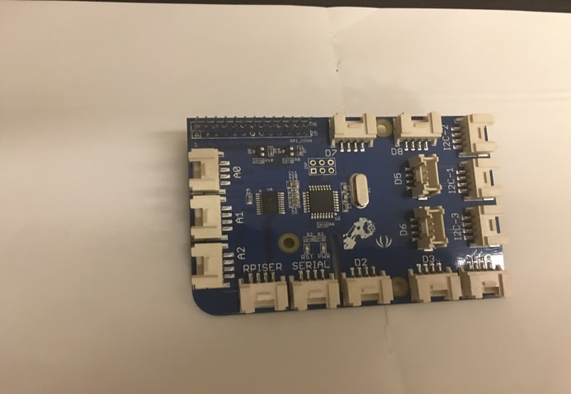

**Raspberry Pi 1B**

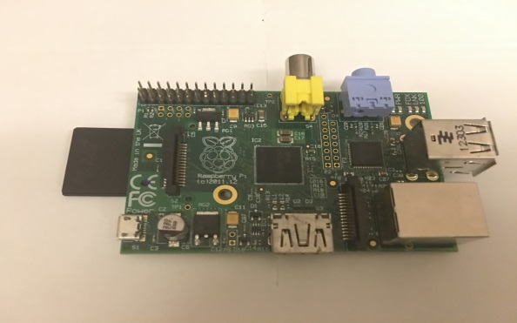

**O2 Sensor**

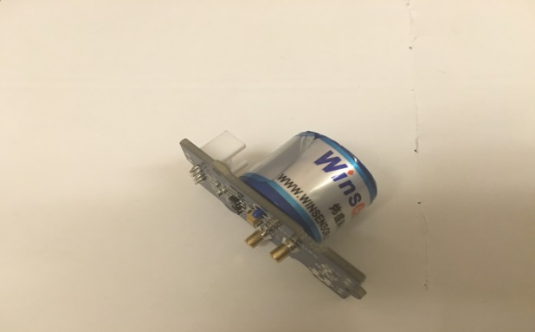

**Buzzer**

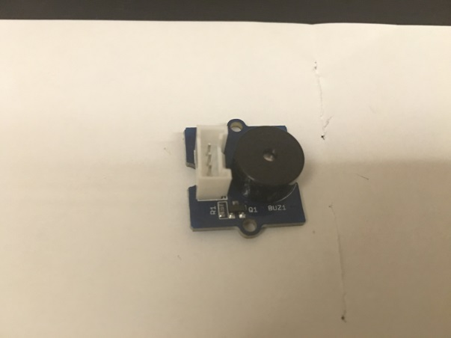

**Internet router**

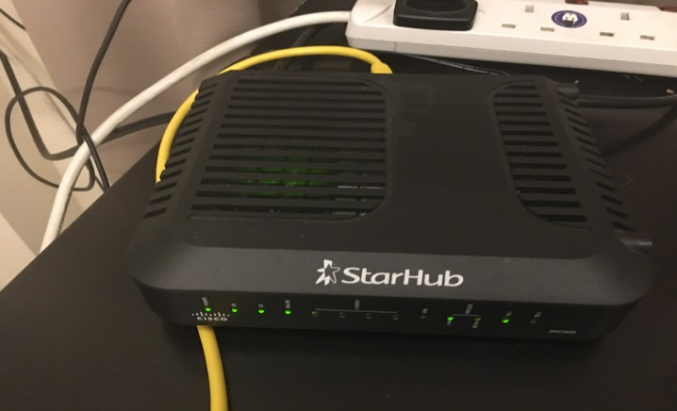

**Battery Bank**

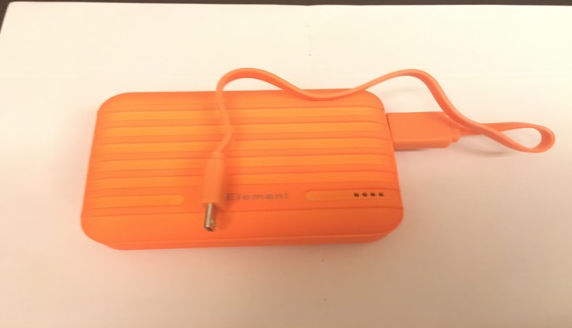

**Integrated System Setup**

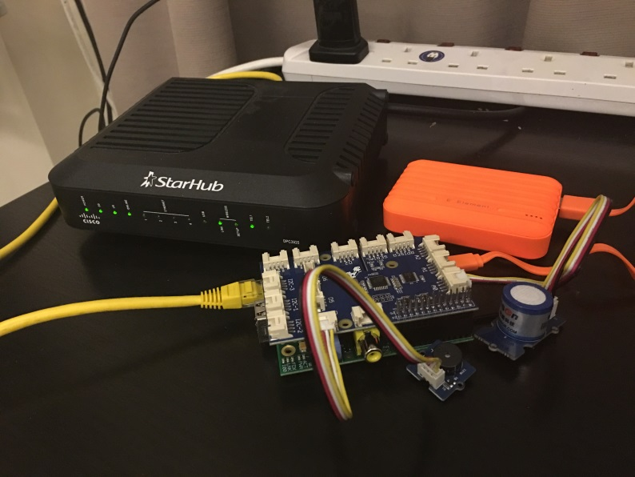

Internet Router

Battery Bank

O2 Sensor (Port A0)

Buzzer (Port D8)

Raspberry Pi 1 B

Grove Shield

**Schematic**

O2 Sensor

Port A0

Grove Shield

Port D8

Buzzer

Internet Router

Raspberry pi 1 B

Battery Bank