SOM: Analysis of model building blocks usefulness

2023-02-27

Table of Contents

# Edits

# Introduction

Now let us read data in!

# Clearing all  
rm(list=ls())  
  
# Packages:  
library(tidyverse)  
library(readr)  
library(dplyr)  
library(tibble)  
library(forcats)  
library(ggplot2)  
library(rstatix)  
library(stringr)  
library(knitr)  
# library(kableExtra)  
library(stargazer)  
  
#### Reading data in:  
# source("SOM_loading.R")  
load("SOM.RData")

# Step 1 VS. Step 2

Firstly, data filtering:

df = tc %>% filter((Step == "No Identity, Constant Boundary" | Step == "No Identity, Normal Boundary"),   
 Boundary_STD == 0, Conformity_STD == 0, HK_distribution == "FALSE")  
df %>% count(Step)

## # A tibble: 2 × 2  
## Step n  
## <fct> <int>  
## 1 No Identity, Constant Boundary 5040  
## 2 No Identity, Normal Boundary 5040

Comparison:

Computing sim-by-sim difference:

# We split data into pairs according all relevant varibles, except STEP:  
dp = df %>% #group_by(RS, N, Boundary, Conformity) %>%   
 pivot_longer(cols = diversity:ESBG) %>%   
 pivot_wider(id_cols = c(HK_distribution:Conformity_STD, name), names_from = Step, values_from = value) %>%   
 rename("S1" = 14, "S2" = 15) %>%   
 mutate(  
 Difference = S2 - S1,  
 highDifference = abs(Difference) > 0.1) %>%   
 # Then we compute difference:  
 # summarise(across(diversity:ESBG, ~sd(.x) / sqrt(2), .names = "{.col}_sd")) %>% ungroup() %>%   
 # And now, also pivoting data for the future graph:  
 # select(ends_with("_sd")) %>%   
 mutate(across(N:name, ~factor(.x)))  
  
# We split data into groups according all relevant varibles, except STEP:  
# dg = df %>% group_by(N, Boundary, Conformity) %>%   
# # Then we compute difference:  
# summarise(across(diversity:ESBG, ~sd(.x), .names = "{.col}_sd")) %>% ungroup() %>%   
# # And now, also pivoting data for the future graph:  
# # select(ends_with("_sd")) %>%   
# pivot_longer(cols = ends_with("_sd")) %>%   
# mutate(across(N:name, ~factor(.x)))  
dg = dp %>% group_by(N, Boundary, Conformity, name) %>%   
 summarise(Difference_sd = sd(Difference)) %>%   
 mutate(highDifference = Difference_sd > 0.1)

## `summarise()` has grouped output by 'N', 'Boundary', 'Conformity'. You can  
## override using the `.groups` argument.

dp %>%   
 ggplot() +  
 aes(x = Difference, fill = name) +  
 facet_wrap(~name) +  
 geom_histogram(alpha = 0.6) +  
 geom_vline(xintercept = c( 0.1, -0.1)) +  
 labs(title = "Absolute pair differences (S2 - S1)") +   
 theme_light()

## `stat_bin()` using `bins = 30`. Pick better value with `binwidth`.

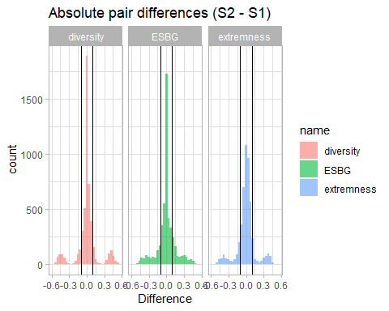

dg %>%   
 ggplot() +  
 aes(x = Difference_sd, fill = name) +  
 facet_wrap(~name) +  
 geom_histogram(alpha = 0.6) +  
 geom_vline(xintercept = c( 0.1)) +  
 labs(title = "SD of differences (S2 - S1) in groups") +  
 theme_light()

## `stat_bin()` using `bins = 30`. Pick better value with `binwidth`.

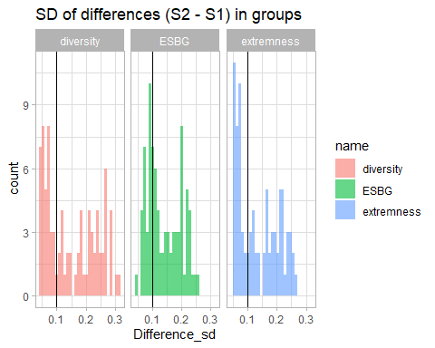

mp = lm(Difference ~ name+Conformity+Boundary+N, data = dp)  
mpa = lm(abs(Difference) ~ name+Conformity+Boundary+N, data = dp)  
mg = lm(Difference_sd ~ name+Conformity+Boundary+N, data = dg)  
stargazer(mp, mpa, mg, type = "text")

##   
## ===================================================================================================  
## Dependent variable:   
## -------------------------------------------------------------------------------  
## Difference abs(Difference) Difference_sd   
## (1) (2) (3)   
## ---------------------------------------------------------------------------------------------------  
## nameESBG -0.004 -0.0002 -0.009***   
## (0.003) (0.002) (0.003)   
##   
## nameextremness 0.001 0.001 -0.013***   
## (0.003) (0.002) (0.003)   
##   
## Conformity0.8 0.0005 -0.007*** -0.010***   
## (0.003) (0.002) (0.003)   
##   
## Boundary0.11 -0.0004 0.004 0.005   
## (0.008) (0.006) (0.008)   
##   
## Boundary0.12 -0.001 0.006 0.009   
## (0.008) (0.006) (0.008)   
##   
## Boundary0.13 0.002 0.011* 0.014*   
## (0.008) (0.006) (0.008)   
##   
## Boundary0.14 -0.002 0.014** 0.020**   
## (0.008) (0.006) (0.008)   
##   
## Boundary0.15 0.001 0.019*** 0.027***   
## (0.008) (0.006) (0.008)   
##   
## Boundary0.16 0.002 0.023*** 0.033***   
## (0.008) (0.006) (0.008)   
##   
## Boundary0.17 0.001 0.026*** 0.036***   
## (0.008) (0.006) (0.008)   
##   
## Boundary0.18 0.009 0.037*** 0.057***   
## (0.008) (0.006) (0.008)   
##   
## Boundary0.19 0.016* 0.055*** 0.084***   
## (0.008) (0.006) (0.008)   
##   
## Boundary0.2 0.013 0.073*** 0.116***   
## (0.008) (0.006) (0.008)   
##   
## Boundary0.21 0.012 0.093*** 0.140***   
## (0.008) (0.006) (0.008)   
##   
## Boundary0.22 0.015* 0.110*** 0.161***   
## (0.008) (0.006) (0.008)   
##   
## Boundary0.23 0.023*** 0.133*** 0.183***   
## (0.008) (0.006) (0.008)   
##   
## Boundary0.24 0.005 0.146*** 0.200***   
## (0.008) (0.006) (0.008)   
##   
## Boundary0.25 -0.005 0.126*** 0.188***   
## (0.008) (0.006) (0.008)   
##   
## Boundary0.26 -0.004 0.106*** 0.178***   
## (0.008) (0.006) (0.008)   
##   
## Boundary0.27 -0.002 0.076*** 0.154***   
## (0.008) (0.006) (0.008)   
##   
## Boundary0.28 -0.021** 0.040*** 0.114***   
## (0.008) (0.006) (0.008)   
##   
## Boundary0.29 -0.034*** 0.016*** 0.081***   
## (0.008) (0.006) (0.008)   
##   
## Boundary0.3 -0.015* -0.006 0.044***   
## (0.008) (0.006) (0.008)   
##   
## N101 -0.015*** -0.005** -0.004   
## (0.003) (0.002) (0.003)   
##   
## Constant 0.010 0.049*** 0.069***   
## (0.006) (0.005) (0.006)   
##   
## ---------------------------------------------------------------------------------------------------  
## Observations 15,120 15,120 252   
## R2 0.009 0.141 0.929   
## Adjusted R2 0.007 0.140 0.922   
## Residual Std. Error 0.159 (df = 15095) 0.118 (df = 15095) 0.020 (df = 227)   
## F Statistic 5.485*** (df = 24; 15095) 103.604*** (df = 24; 15095) 124.636*** (df = 24; 227)  
## ===================================================================================================  
## Note: *p<0.1; **p<0.05; ***p<0.01

## Tables with extremes

dp %>% group_by(name) %>% summarise(fractionOfHighDifferences = mean(highDifference)) %>%   
 kable(caption = "Table with fraction of extreme absolute differences in pairs comparison")

Table with fraction of extreme absolute differences in pairs comparison

| name | fractionOfHighDifferences |
| --- | --- |
| diversity | 0.2333333 |
| ESBG | 0.3162698 |
| extremness | 0.2549603 |

dg %>% group_by(name) %>% summarise(fractionOfHighDifferences = mean(highDifference)) %>%   
 kable(caption = "Table with fraction of extreme SD of within-groups comparison")

Table with fraction of extreme SD of within-groups comparison

| name | fractionOfHighDifferences |
| --- | --- |
| diversity | 0.5952381 |
| ESBG | 0.6785714 |
| extremness | 0.5833333 |

# Step 2 VS. Step 3

Firstly, data filtering:

df = tc %>% filter((Step == "Constant SPIRO, Normal Boundary" | Step == "No Identity, Normal Boundary"), SPIRO_Mean == 0.25)  
df %>% count(Step)

## # A tibble: 2 × 2  
## Step n  
## <fct> <int>  
## 1 No Identity, Normal Boundary 80640  
## 2 Constant SPIRO, Normal Boundary 80640

Comparison:

Computing sim-by-sim difference:

# We split data into pairs according all relevant varibles, except STEP:  
# dp = df %>% group_by(RS, HK_distribution, N, Boundary, Boundary_STD, Conformity, Conformity_STD) %>%   
# # Then we compute difference:  
# summarise(across(diversity:ESBG, ~sd(.x) / sqrt(2), .names = "{.col}_sd")) %>% ungroup() %>%   
# # And now, also pivoting data for the future graph:  
# # select(ends_with("_sd")) %>%   
# pivot_longer(cols = ends_with("_sd")) %>%   
# mutate(across(N:name, ~factor(.x)))  
dp = df %>%   
 pivot_longer(cols = diversity:ESBG, values_drop_na = T) %>%   
 pivot_wider(id_cols = c(RS, HK_distribution, N, Boundary, Boundary_STD, Conformity, Conformity_STD, name),   
 names_from = Step, values_from = value) %>%   
 rename("S1" = 9, "S2" = 10) %>%   
 mutate(  
 Difference = S2 - S1,  
 highDifference = abs(Difference) > 0.1,  
 asymetryDifference = Difference < -0.25) %>%   
 mutate(across(N:name, ~factor(.x)))  
  
# We split data into groups according all relevant varibles, except STEP:  
# dg = df %>% group_by(HK_distribution, N, Boundary, Boundary_STD, Conformity, Conformity_STD) %>%   
# # Then we compute difference:  
# summarise(across(diversity:ESBG, ~sd(.x), .names = "{.col}_sd")) %>% ungroup() %>%   
# # And now, also pivoting data for the future graph:  
# # select(ends_with("_sd")) %>%   
# pivot_longer(cols = ends_with("_sd")) %>%   
# mutate(across(N:name, ~factor(.x)))  
dg = dp %>% group_by(HK_distribution, N, Boundary, Boundary_STD, Conformity, Conformity_STD, name) %>%   
 summarise(Difference_sd = sd(Difference)) %>%   
 mutate(highDifference = Difference_sd > 0.1)

## `summarise()` has grouped output by 'HK_distribution', 'N', 'Boundary',  
## 'Boundary_STD', 'Conformity', 'Conformity_STD'. You can override using the  
## `.groups` argument.

dp %>%   
 ggplot() +  
 aes(x = Difference, fill = name) +  
 facet_wrap(~name) +  
 geom_histogram(alpha = 0.6) +  
 geom_vline(xintercept = c( 0.1, -0.1)) +  
 labs(title = "Absolute pair differences (S3 - S2)") +   
 theme_light()

## `stat_bin()` using `bins = 30`. Pick better value with `binwidth`.

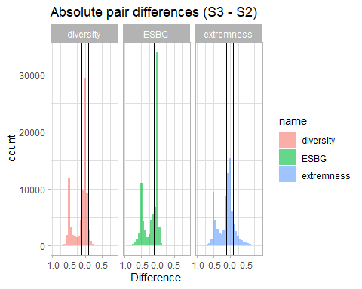

dg %>%   
 ggplot() +  
 aes(x = Difference_sd, fill = name) +  
 facet_wrap(~name) +  
 geom_histogram(alpha = 0.6) +  
 geom_vline(xintercept = c( 0.1)) +  
 labs(title = "SD of differences (S3 - S2) in groups") +  
 theme_light()

## `stat_bin()` using `bins = 30`. Pick better value with `binwidth`.

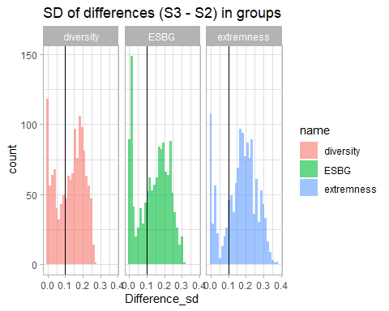

mp = lm(Difference ~ name+Conformity+Conformity_STD+Boundary+Boundary_STD+N+HK_distribution, data = dp)  
mpa = lm(abs(Difference) ~ name+Conformity+Conformity_STD+Boundary+Boundary_STD+N+HK_distribution, data = dp)  
mg = lm(Difference_sd ~ name+Conformity+Conformity_STD+Boundary+Boundary_STD+N+HK_distribution, data = dg)  
stargazer(mp, mpa, mg, type = "text")

##   
## ============================================================================================================  
## Dependent variable:   
## ----------------------------------------------------------------------------------------  
## Difference abs(Difference) Difference_sd   
## (1) (2) (3)   
## ------------------------------------------------------------------------------------------------------------  
## nameESBG -0.036*** 0.016*** 0.010***   
## (0.001) (0.001) (0.003)   
##   
## nameextremness 0.020*** 0.037*** 0.042***   
## (0.001) (0.001) (0.003)   
##   
## Conformity0.8 -0.028*** 0.042*** 0.018***   
## (0.001) (0.001) (0.002)   
##   
## Conformity_STD0.1 0.012*** -0.012*** 0.006***   
## (0.001) (0.001) (0.002)   
##   
## Boundary0.11 -0.004 0.007*** 0.009   
## (0.003) (0.002) (0.007)   
##   
## Boundary0.12 -0.020*** 0.022*** 0.013*   
## (0.003) (0.002) (0.007)   
##   
## Boundary0.13 -0.028*** 0.023*** 0.012*   
## (0.003) (0.002) (0.007)   
##   
## Boundary0.14 -0.031*** 0.027*** 0.013*   
## (0.003) (0.002) (0.007)   
##   
## Boundary0.15 -0.029*** 0.027*** 0.015**   
## (0.003) (0.002) (0.007)   
##   
## Boundary0.16 -0.038*** 0.033*** 0.017**   
## (0.003) (0.002) (0.007)   
##   
## Boundary0.17 -0.033*** 0.029*** 0.019***   
## (0.003) (0.002) (0.007)   
##   
## Boundary0.18 -0.035*** 0.030*** 0.020***   
## (0.003) (0.002) (0.007)   
##   
## Boundary0.19 -0.043*** 0.034*** 0.021***   
## (0.003) (0.002) (0.007)   
##   
## Boundary0.2 -0.055*** 0.049*** 0.020***   
## (0.003) (0.002) (0.007)   
##   
## Boundary0.21 -0.072*** 0.065*** 0.015**   
## (0.003) (0.002) (0.007)   
##   
## Boundary0.22 -0.084*** 0.075*** 0.011   
## (0.003) (0.002) (0.007)   
##   
## Boundary0.23 -0.102*** 0.089*** 0.005   
## (0.003) (0.002) (0.007)   
##   
## Boundary0.24 -0.112*** 0.098*** 0.007   
## (0.003) (0.002) (0.007)   
##   
## Boundary0.25 -0.117*** 0.104*** -0.001   
## (0.003) (0.002) (0.007)   
##   
## Boundary0.26 -0.113*** 0.099*** -0.001   
## (0.003) (0.002) (0.007)   
##   
## Boundary0.27 -0.103*** 0.086*** -0.003   
## (0.003) (0.002) (0.007)   
##   
## Boundary0.28 -0.091*** 0.072*** -0.006   
## (0.003) (0.002) (0.007)   
##   
## Boundary0.29 -0.073*** 0.053*** -0.009   
## (0.003) (0.002) (0.007)   
##   
## Boundary0.3 -0.060*** 0.036*** -0.018***   
## (0.003) (0.002) (0.007)   
##   
## Boundary_STD0.05 -0.039*** 0.047*** 0.108***   
## (0.001) (0.001) (0.003)   
##   
## Boundary_STD0.1 0.128*** -0.062*** 0.133***   
## (0.001) (0.001) (0.003)   
##   
## Boundary_STD0.15 0.209*** -0.109*** 0.087***   
## (0.001) (0.001) (0.003)   
##   
## N101 -0.008*** 0.007*** -0.003   
## (0.001) (0.001) (0.002)   
##   
## HK_distribution -0.055*** 0.049*** -0.026***   
## (0.001) (0.001) (0.002)   
##   
## Constant -0.103*** 0.098*** 0.042***   
## (0.002) (0.002) (0.006)   
##   
## ------------------------------------------------------------------------------------------------------------  
## Observations 241,920 241,920 4,032   
## R2 0.244 0.152 0.421   
## Adjusted R2 0.244 0.152 0.417   
## Residual Std. Error 0.198 (df = 241890) 0.180 (df = 241890) 0.066 (df = 4002)   
## F Statistic 2,696.208*** (df = 29; 241890) 1,497.269*** (df = 29; 241890) 100.310*** (df = 29; 4002)  
## ============================================================================================================  
## Note: *p<0.1; **p<0.05; ***p<0.01

## Tables with extremes

dp %>% group_by(name) %>% summarise(fractionOfHighDifferences = mean(asymetryDifference)) %>%   
 kable(caption = "Table with fraction of extreme negative (asymetric) absolute differences in pairs comparison")

Table with fraction of extreme negative (asymetric) absolute differences in pairs comparison

| name | fractionOfHighDifferences |
| --- | --- |
| diversity | 0.2651290 |
| ESBG | 0.3010541 |
| extremness | 0.2675099 |

dp %>% group_by(name) %>% summarise(fractionOfHighDifferences = mean(highDifference)) %>%   
 kable(caption = "Table with fraction of extreme absolute differences in pairs comparison")

Table with fraction of extreme absolute differences in pairs comparison

| name | fractionOfHighDifferences |
| --- | --- |
| diversity | 0.3848586 |
| ESBG | 0.4413442 |
| extremness | 0.5521577 |

dg %>% group_by(name) %>% summarise(fractionOfHighDifferences = mean(highDifference)) %>%   
 kable(caption = "Table with fraction of extreme SD of within-groups comparison")

Table with fraction of extreme SD of within-groups comparison

| name | fractionOfHighDifferences |
| --- | --- |
| diversity | 0.6450893 |
| ESBG | 0.6688988 |
| extremness | 0.7879464 |

# Step 4 VS. Step 3

Firstly, data filtering:

df = tc %>% filter((Step == "Constant SPIRO, Normal Boundary" | Step == "Normal SPIRO, Normal Boundary"), SPIRO_STD == 0)  
df %>% count(Step)

## # A tibble: 2 × 2  
## Step n  
## <fct> <int>  
## 1 Constant SPIRO, Normal Boundary 483840  
## 2 Normal SPIRO, Normal Boundary 483840

Comparison:

Computing sim-by-sim difference:

# We split data into pairs according all relevant varibles, except STEP:  
# dp = df %>% group_by(RS, HK_distribution, N, Boundary, Boundary_STD, Conformity, Conformity_STD, SPIRO_Mean) %>%   
# # Then we compute difference:  
# summarise(across(diversity:ESBG, ~sd(.x) / sqrt(2), .names = "{.col}_sd")) %>% ungroup() %>%   
# # And now, also pivoting data for the future graph:  
# # select(ends_with("_sd")) %>%   
# pivot_longer(cols = ends_with("_sd")) %>%   
# mutate(across(N:name, ~factor(.x)))  
#   
# # We split data into groups according all relevant varibles, except STEP:  
# dg = df %>% group_by(HK_distribution, N, Boundary, Boundary_STD, Conformity, Conformity_STD, SPIRO_Mean) %>%   
# # Then we compute difference:  
# summarise(across(diversity:ESBG, ~sd(.x), .names = "{.col}_sd")) %>% ungroup() %>%   
# # And now, also pivoting data for the future graph:  
# # select(ends_with("_sd")) %>%   
# pivot_longer(cols = ends_with("_sd")) %>%   
# mutate(across(N:name, ~factor(.x)))  
dp = df %>%   
 pivot_longer(cols = diversity:ESBG, values_drop_na = T) %>%   
 pivot_wider(id_cols = c(RS, HK_distribution, N, Boundary, Boundary_STD, Conformity, Conformity_STD, SPIRO_Mean, name),   
 names_from = Step, values_from = value) %>%   
 rename("S1" = 10, "S2" = 11) %>%   
 mutate(  
 Difference = S2 - S1,  
 highDifference = abs(Difference) > 0.1) %>%   
 mutate(across(N:name, ~factor(.x)))  
  
# We split data into groups according all relevant varibles, except STEP:  
dg = dp %>% group_by(HK_distribution, N, Boundary, Boundary_STD, Conformity, Conformity_STD, SPIRO_Mean, name) %>%   
 summarise(Difference_sd = sd(Difference)) %>%   
 mutate(highDifference = Difference_sd > 0.1) %>% ungroup()

## `summarise()` has grouped output by 'HK_distribution', 'N', 'Boundary',  
## 'Boundary_STD', 'Conformity', 'Conformity_STD', 'SPIRO_Mean'. You can override  
## using the `.groups` argument.

dp %>%   
 ggplot() +  
 aes(x = Difference, fill = name) +  
 facet_wrap(~name) +  
 geom_histogram(alpha = 0.6) +  
 geom_vline(xintercept = c( 0.1, -0.1)) +  
 labs(title = "Absolute pair differences (S4 - S3)") +   
 theme_light()

## `stat_bin()` using `bins = 30`. Pick better value with `binwidth`.

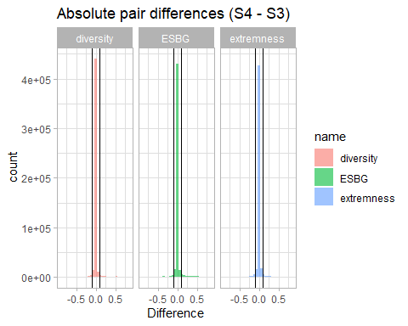

dg %>%   
 ggplot() +  
 aes(x = Difference_sd, fill = name) +  
 facet_wrap(~name) +  
 geom_histogram(alpha = 0.6) +  
 geom_vline(xintercept = c( 0.1)) +  
 labs(title = "SD of differences (S4 - S3) in groups") +  
 theme_light()

## `stat_bin()` using `bins = 30`. Pick better value with `binwidth`.

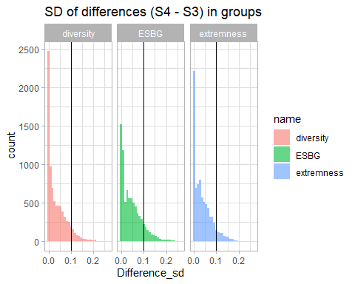

mp = lm(Difference ~ name+SPIRO_Mean+Conformity+Conformity_STD+Boundary+Boundary_STD+N+HK_distribution, data = dp)  
mpa = lm(abs(Difference) ~ name+SPIRO_Mean+Conformity+Conformity_STD+Boundary+Boundary_STD+N+HK_distribution, data = dp)  
mg = lm(Difference_sd ~ name+SPIRO_Mean+Conformity+Conformity_STD+Boundary+Boundary_STD+N+HK_distribution, data = dg)  
stargazer(mp, mpa, mg, type = "text" )

##   
## =============================================================================================================  
## Dependent variable:   
## -----------------------------------------------------------------------------------------  
## Difference abs(Difference) Difference_sd   
## (1) (2) (3)   
## -------------------------------------------------------------------------------------------------------------  
## nameESBG 0.003*** 0.004*** 0.009***   
## (0.0001) (0.0001) (0.0005)   
##   
## nameextremness 0.0004*** 0.002*** 0.001***   
## (0.0001) (0.0001) (0.0005)   
##   
## SPIRO_Mean0.37 0.011*** 0.015*** 0.043***   
## (0.0002) (0.0002) (0.001)   
##   
## SPIRO_Mean0.49 0.013*** 0.017*** 0.044***   
## (0.0002) (0.0002) (0.001)   
##   
## SPIRO_Mean0.61 -0.004*** 0.009*** 0.024***   
## (0.0002) (0.0002) (0.001)   
##   
## SPIRO_Mean0.73 0.001*** 0.019*** 0.034***   
## (0.0002) (0.0002) (0.001)   
##   
## SPIRO_Mean0.85 -0.001*** 0.011*** 0.016***   
## (0.0002) (0.0002) (0.001)   
##   
## Conformity0.8 -0.001*** 0.002*** 0.005***   
## (0.0001) (0.0001) (0.0004)   
##   
## Conformity_STD0.1 -0.0002** -0.0003*** 0.0001   
## (0.0001) (0.0001) (0.0004)   
##   
## Boundary0.11 -0.0002 0.0001 0.001   
## (0.0003) (0.0003) (0.001)   
##   
## Boundary0.12 0.001** -0.0005 -0.00001   
## (0.0003) (0.0003) (0.001)   
##   
## Boundary0.13 -0.0001 -0.001** -0.00000   
## (0.0003) (0.0003) (0.001)   
##   
## Boundary0.14 0.001** 0.0001 0.002   
## (0.0003) (0.0003) (0.001)   
##   
## Boundary0.15 0.0004 -0.0005 0.001   
## (0.0003) (0.0003) (0.001)   
##   
## Boundary0.16 0.0005 -0.001* 0.001   
## (0.0003) (0.0003) (0.001)   
##   
## Boundary0.17 0.001*** -0.001** 0.001   
## (0.0003) (0.0003) (0.001)   
##   
## Boundary0.18 0.001* -0.001*** 0.001   
## (0.0003) (0.0003) (0.001)   
##   
## Boundary0.19 0.001*** -0.001*** 0.001   
## (0.0003) (0.0003) (0.001)   
##   
## Boundary0.2 0.001*** -0.001*** 0.001   
## (0.0003) (0.0003) (0.001)   
##   
## Boundary0.21 0.002*** -0.001* 0.003**   
## (0.0003) (0.0003) (0.001)   
##   
## Boundary0.22 0.001*** -0.001*** 0.002*   
## (0.0003) (0.0003) (0.001)   
##   
## Boundary0.23 0.001*** -0.001*** 0.002   
## (0.0003) (0.0003) (0.001)   
##   
## Boundary0.24 0.002*** -0.0004 0.005***   
## (0.0003) (0.0003) (0.001)   
##   
## Boundary0.25 0.003*** 0.001*** 0.006***   
## (0.0003) (0.0003) (0.001)   
##   
## Boundary0.26 0.004*** 0.002*** 0.009***   
## (0.0003) (0.0003) (0.001)   
##   
## Boundary0.27 0.004*** 0.002*** 0.011***   
## (0.0003) (0.0003) (0.001)   
##   
## Boundary0.28 0.004*** 0.002*** 0.010***   
## (0.0003) (0.0003) (0.001)   
##   
## Boundary0.29 0.005*** 0.002*** 0.012***   
## (0.0003) (0.0003) (0.001)   
##   
## Boundary0.3 0.006*** 0.003*** 0.013***   
## (0.0003) (0.0003) (0.001)   
##   
## Boundary_STD0.05 0.0004*** 0.004*** 0.014***   
## (0.0001) (0.0001) (0.001)   
##   
## Boundary_STD0.1 0.005*** 0.020*** 0.054***   
## (0.0001) (0.0001) (0.001)   
##   
## Boundary_STD0.15 0.006*** 0.022*** 0.057***   
## (0.0001) (0.0001) (0.001)   
##   
## N101 -0.0004*** 0.004*** 0.009***   
## (0.0001) (0.0001) (0.0004)   
##   
## HK_distribution -0.0005*** 0.003*** 0.004***   
## (0.0001) (0.0001) (0.0004)   
##   
## Constant -0.005*** -0.014*** -0.034***   
## (0.0003) (0.0003) (0.001)   
##   
## -------------------------------------------------------------------------------------------------------------  
## Observations 1,451,520 1,451,520 24,192   
## R2 0.015 0.044 0.510   
## Adjusted R2 0.015 0.044 0.509   
## Residual Std. Error 0.059 (df = 1451485) 0.056 (df = 1451485) 0.030 (df = 24157)   
## F Statistic 637.678*** (df = 34; 1451485) 1,947.352*** (df = 34; 1451485) 738.023*** (df = 34; 24157)  
## =============================================================================================================  
## Note: *p<0.1; **p<0.05; ***p<0.01

## Tables with extremes

dp %>% group_by(name) %>% summarise(fractionOfHighDifferences = mean(highDifference)) %>%   
 kable(caption = "Table with fraction of extreme absolute differences in pairs comparison")

Table with fraction of extreme absolute differences in pairs comparison

| name | fractionOfHighDifferences |
| --- | --- |
| diversity | 0.0345672 |
| ESBG | 0.0451306 |
| extremness | 0.0403191 |

dg %>% group_by(name) %>% summarise(fractionOfHighDifferences = mean(highDifference)) %>%   
 kable(caption = "Table with fraction of extreme SD of within-groups comparison")

Table with fraction of extreme SD of within-groups comparison

| name | fractionOfHighDifferences |
| --- | --- |
| diversity | 0.0879216 |
| ESBG | 0.1256200 |
| extremness | 0.0825893 |