##### Relativity of Opinion: How the accessibility of attitudes shapes the dynamics of opinion polarization

František Kalvas, Michael Slater, Ashwin Ramaswamy, Ashley Sanders-Jackson   
University of West Bohemia, Univerzitní 8, Pilsen, Czech Republic (kalvas@kss.zcu.cz)  
Ohio State University, 1800 Cannon Dr, Columbus, OH, USA  
Independent researcher, India  
 Michigan State University, 426 Auditorium Rd., East Lansing, MI, USA

In the paper we present our preliminary investigations on effect of accessibility of attitudes on dynamics of opinion polarization. Besides other effects the accessibility of attitude provides a weight for respective opinion dimension and that shapes the opinion space where the polarization process happens. This also means that agents with different accessibilities of their attitudes will see the shared opinion space differently. The opinion weight for the attitude with highest accessibility is 1, for other opinions are weights given by the equation:

|  |  |
| --- | --- |
|  | (1) |

While many opinion dynamics models study ‘what does happen at the pitch’ we studied here how accessibility does ‘shape the pitch’ and how it does affect respective processes studied in the field of opinion dynamics. The studied effect we call ‘accessibility shaping effect’.

In present paper we show the ‘accessibility shaping effect’ on well-studied Hegselmann-Krause (HK) model of opinion dynamics. We used the version generalized for more than one opinion dimension. Obviously, in canonical one dimensional version there is no effect of opinion weights stemming from accessibility, the interesting effect might star at two and more dimensions. In more than one dimension might agents apply different weights on the opinion space, therefor see the shared space differently which might produce interesting ‘accessibility shaping effect’. How the different accessibilities of attitudes and therefore the shaping of opinion space might influence the HK model is illustrated in Fig. 1:

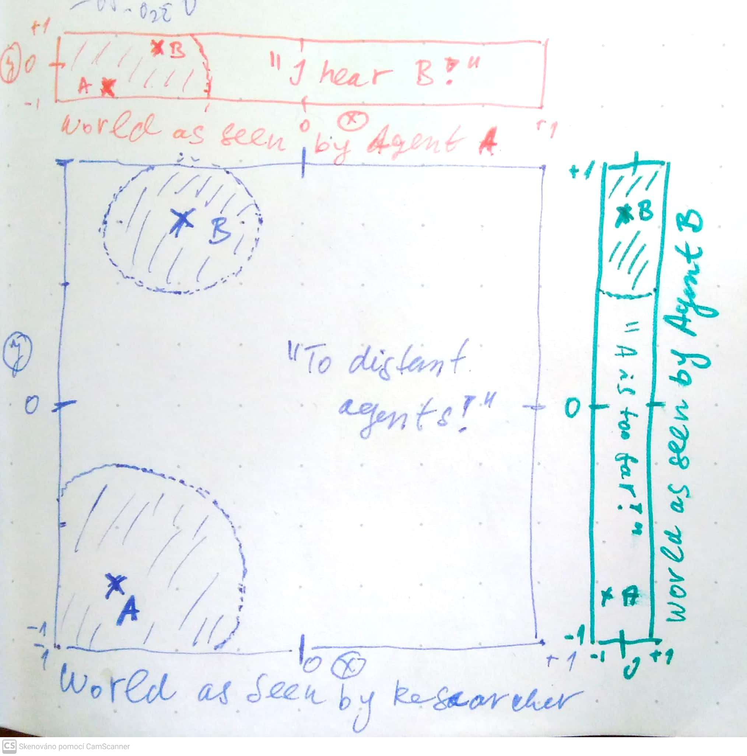

Fig. 1: Shaded areas are HK bounded confidence intervals in 2D space. Blue color illustrate the shape of the opinion space for the objective observer, red and green colors illustrates the vision of the respective agents.

Our paper finally discuss the effect of random development of accessibilities and effects of strategic manipulation of accessibilities by competing external sources. Our paper concludes that if we care of opinion dynamics in 2+D opinion space we should care of ‘accessibility shaping effect’, since it is the effect shaping the space where all the studied dynamics happen.