**RU Parking**

**ANDROID-BASED APPLICATION FOR SUGGESTING PARKING SPACES**

<http://code.google.com/p/ruparking/>

**OBJECT-ORIENTED ANALYSIS REPORT**

**Project Members:**

**Cyrus Gerami**

**Ashwin Revo**

**Shweta Sagari**

**Samson Sequeira**

**Vrajesh Vyas**

Contents

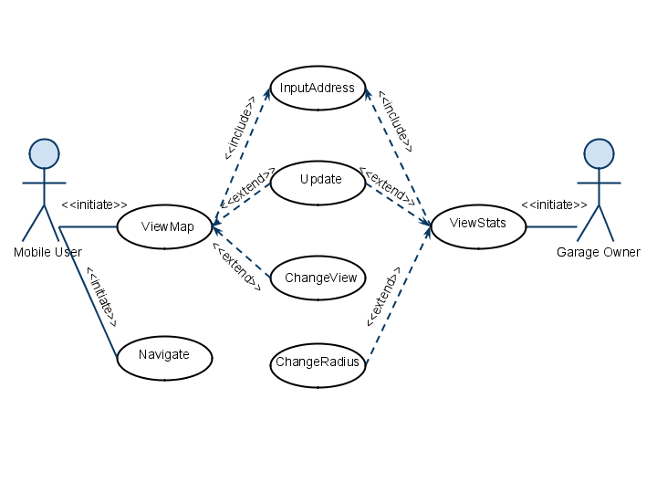

From the above use case diagram we will implement the use cases in the following order of priority:

1. ViewMap
2. ViewStats
3. Navigate
4. ChangeView
5. ChangeRadius
6. Update

**Textual analysis of Requirements document**

The Use cases in the requirements analysis document were subjected to a textual analysis to identify the following objects: