RainCastSG
Exploring Singapore Rainfall Patterns and Predicting 30-Minute Threshold Exceedance with Apache Spark
DSA5208 | Scalable Distributed Computing for Data Science
National University of Singapore | October 2026

Group members
Name | Student ID
Nithillen Jayaseelan | [Insert student ID]
Amitej Singh | [Insert student ID]
Ashwin Sasikumar | [Insert student ID]

Abstract
This project analyses five-minute rainfall observations from monitoring stations across Singapore for 2017–2024 and develops an Apache Spark MLlib classifier estimating the probability that the next 30 minutes of accumulated rainfall exceed a user-specified threshold. Data were ingested from the data.gov.sg annual datasets, cleaned and stored in Parquet, then analysed for annual, seasonal, diurnal, intensity and spatial variation. A logistic regression pipeline was trained using historical rainfall, temporal and station features and evaluated chronologically on 2023 and 2024 data. The held-out 2024 test produced pooled ROC-AUC 0.9063 and PR-AUC 0.4076. Threshold-specific calibration using 2023 validation data reduced Brier score against an historical-frequency baseline at all five evaluated thresholds. The approach is computationally practical but limited by missing observations, sampling, station coverage and the calibration range.

1. Introduction and objectives
Rainfall in Singapore varies across seasons, hours and locations. High-frequency monitoring-station observations allow these variations to be investigated and provide inputs to short-horizon probabilistic forecasts. Task 1 explores rainfall patterns within and across 2017–2024. Task 2 estimates P(R(t,t+30 min] > x | station, time, available history), where x is a rainfall threshold in millimetres.

2. Data and computing environment
The data source is the National Environment Agency Historical Rainfall across Singapore collection on data.gov.sg (collection 2279), comprising eight annual datasets for 2017–2024. Each raw observation includes an ISO 8601 timestamp, station metadata and five-minute rainfall reading. The collection warns of missing records and that the data have not undergone the quality-control procedures applied to official climate records.
Year | Cleaned observations | Stations
2017 | 5,256,106 | 62
2018 | 4,594,246 | 56
2019 | 5,026,862 | 54
2020 | 6,334,473 | 80
2021 | 7,044,646 | 76
2022 | 7,133,230 | 72
2023 | 6,742,890 | 74
2024 | 6,406,260 | 70

The analysis ran on Google Colab (Linux, Python 3.13.16, Apache Spark/PySpark 4.0.4), with 2 available CPUs and 12.67 GB RAM. Spark operated in local[2] mode with 16 shuffle partitions during final processing. The session timezone was set to Asia/Singapore; intermediate Parquet files, figures, evaluation outputs and models were stored on Google Drive. This is a single-machine Spark configuration, not a multi-node cluster.

3. Data preprocessing and quality considerations
Raw CSVs were streamed one year at a time and read as Spark DataFrames. Relevant fields were cast to timestamps, doubles and strings. Records with missing timestamps or station IDs, invalid/non-numeric or negative rainfall, or unexpected rainfall units were filtered. Zero rainfall was retained as a valid observation. The 2017 audit found 5,256,106 valid rows, 62 stations and no duplicate station–timestamp groups after filtering. Subsequent years used a latest-reading-update deduplication rule before writing Snappy-compressed Parquet. The complete counts of rejected raw records and conflicting duplicate readings were not retained in the current result exports; this is a reproducibility limitation.
For prediction, observation times were mapped to five-minute buckets. Duplicate bucket values in the combined feature pipeline were averaged; any disagreements should be audited before operational use. Station-ordered Spark windows calculated past 5-, 15-, 30- and 60-minute rainfall and the sum over the following six five-minute intervals. Exact 55-minute past and 30-minute future timestamp-span checks were used to reject incomplete windows. This relies on unique five-minute buckets and does not treat missing readings as zero. The resulting eight-year feature dataset contains 47,048,915 station-time rows.

4. Task 1 — Exploratory rainfall analysis

4.1 Annual variation
Observed annual rainfall was first aggregated within each station and then averaged across stations. Differences in station counts and observation coverage mean that these figures describe the available observations rather than fully quality-controlled national annual rainfall totals.
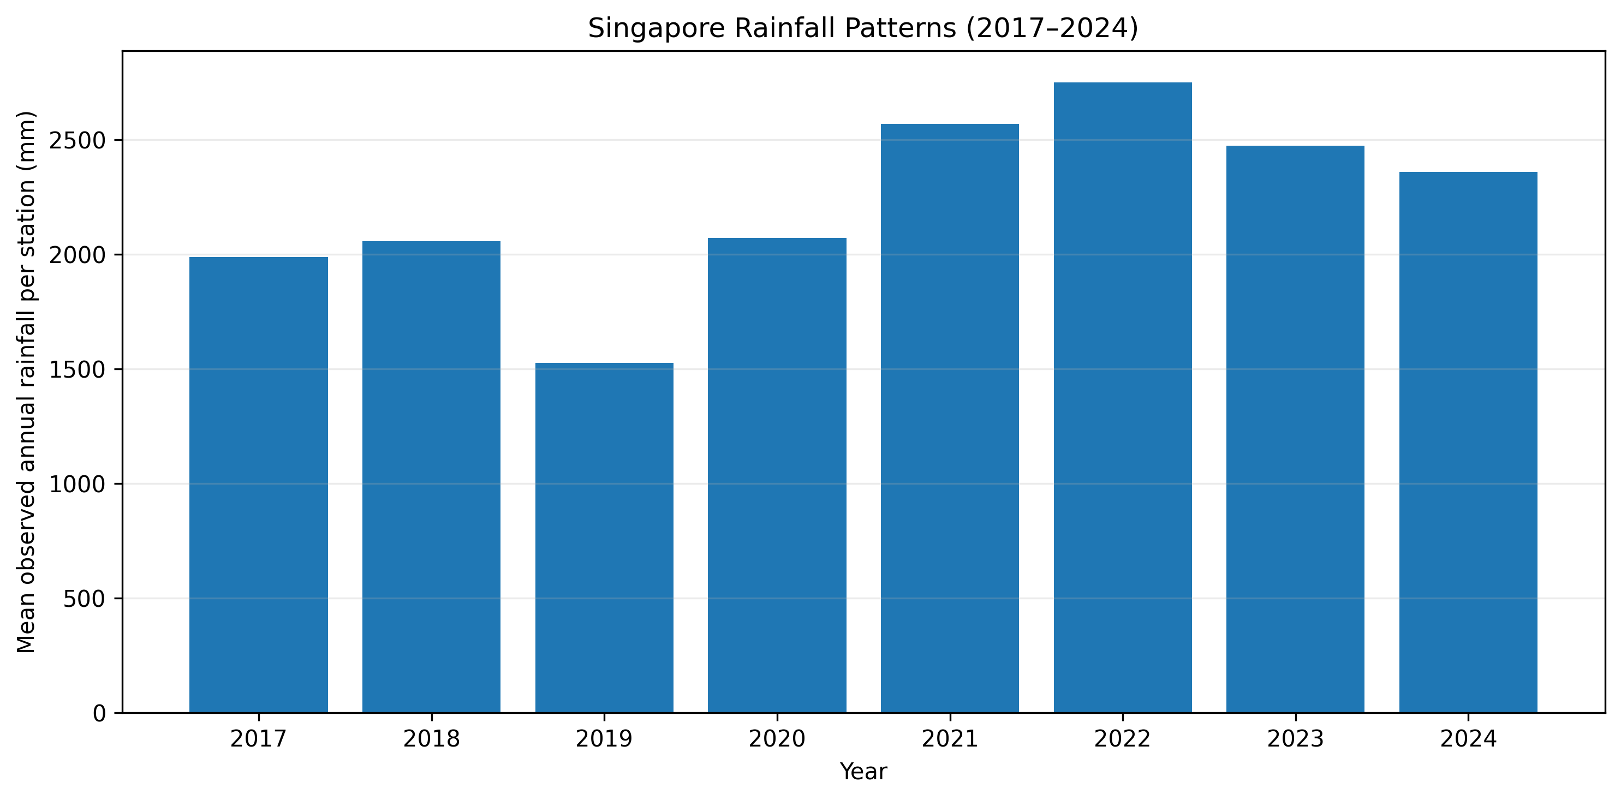
Figure 1. Mean observed annual rainfall per station, 2017–2024.

4.2 Monthly seasonality and interannual changes
Monthly rainfall was summarized as rainfall per observed five-minute interval multiplied by 288 to express an estimated daily rate. November was generally wet, with January and December often elevated, while February was commonly drier. Some April and October periods were also wet. Patterns varied substantially between years; coverage-normalization does not remove all bias if missing intervals are non-random.
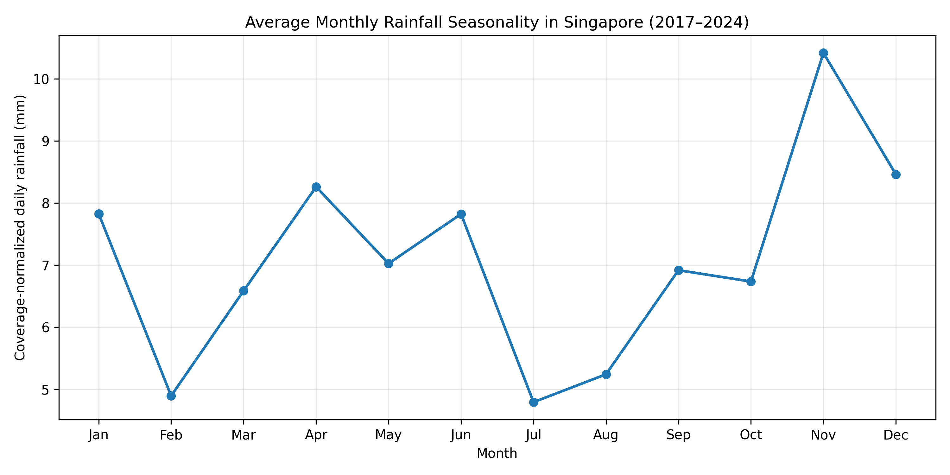
Figure 2. Mean monthly seasonality across the eight years.
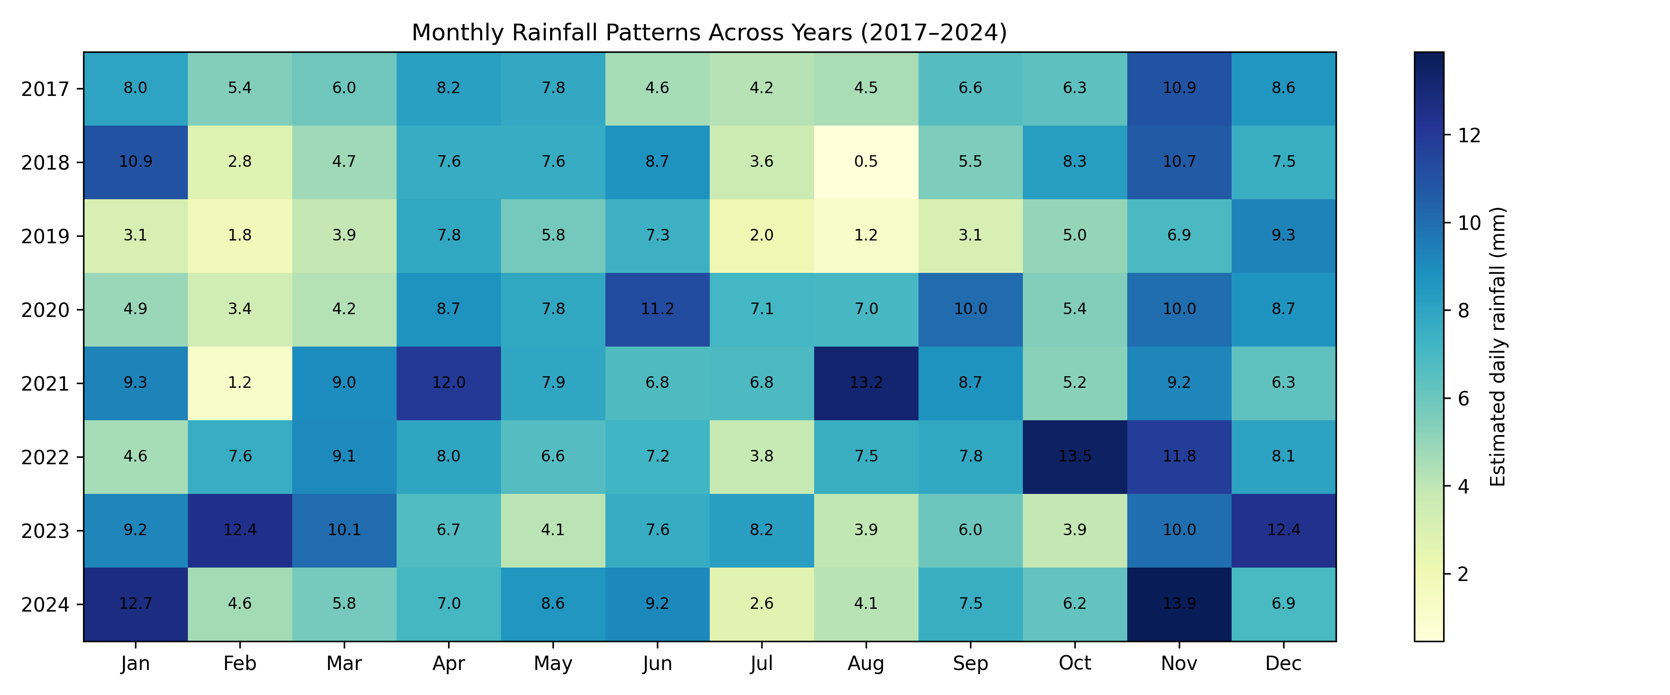
Figure 3. Year-by-month coverage-normalized estimated daily rainfall.

4.3 Diurnal rainfall occurrence
Wet-interval frequency (reading > 0 mm) rises through the morning and peaks around 15:00–16:00 Singapore time, before falling toward late evening. The afternoon maximum is consistent with convective rainfall patterns, but the observed association does not establish meteorological causality.
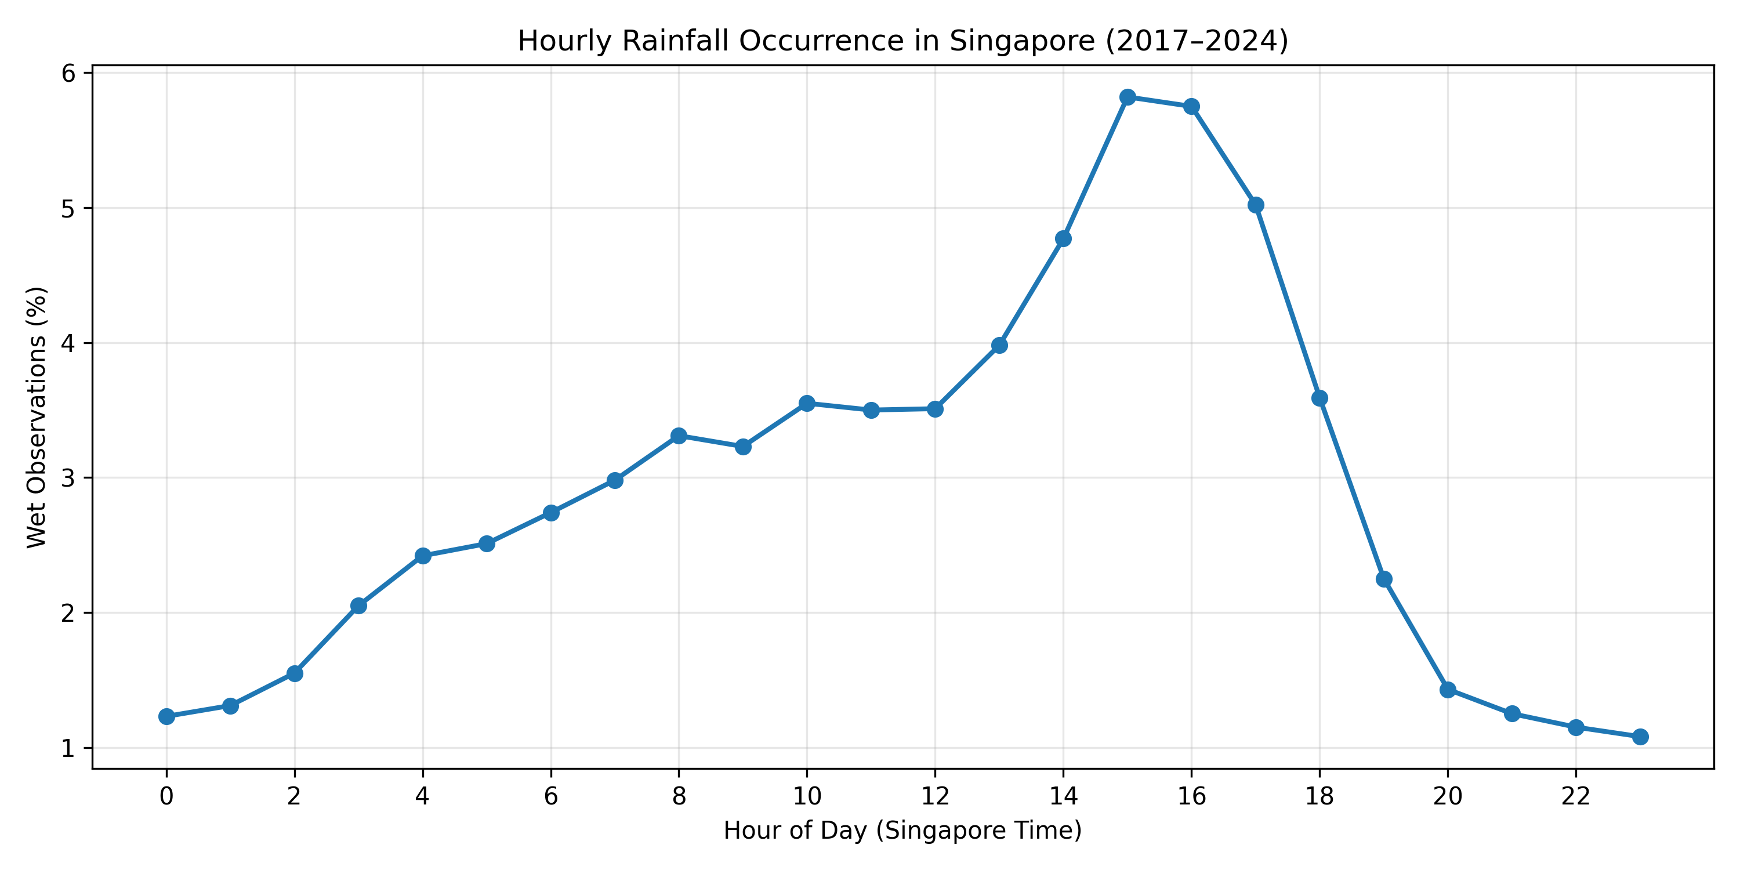
Figure 4. Percentage of observed five-minute intervals with non-zero rainfall, by hour.

4.4 Intensity and spatial variation
Among wet five-minute observations, low rainfall amounts dominate and the intensity distribution is strongly right-skewed. Higher-intensity five-minute events are much rarer, foreshadowing the imbalance in high-threshold prediction labels. Station-level mean rainfall was normalized by observation count and mapped geographically; differences should be interpreted cautiously because stations have unequal periods of operation and missingness.
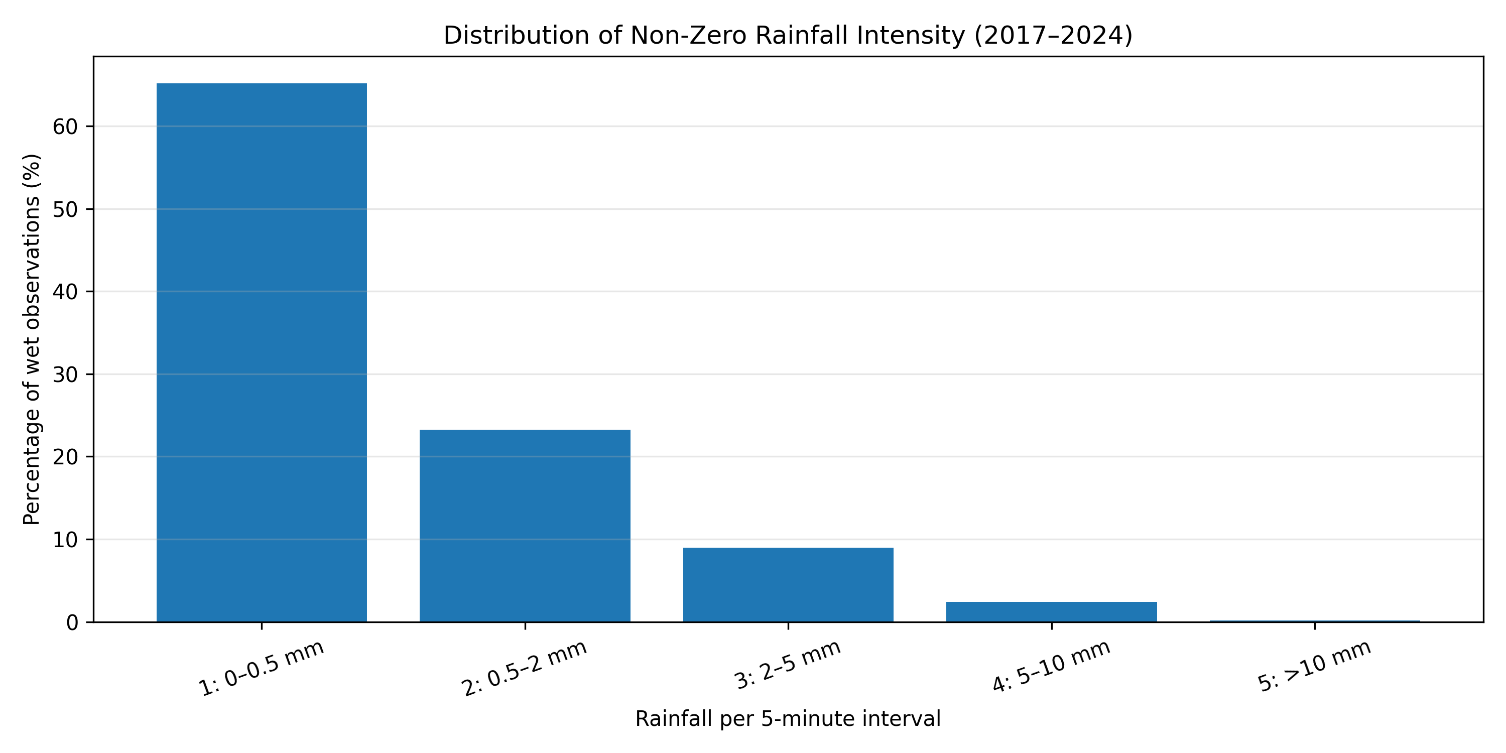
Figure 5. Distribution of non-zero five-minute rainfall amounts.
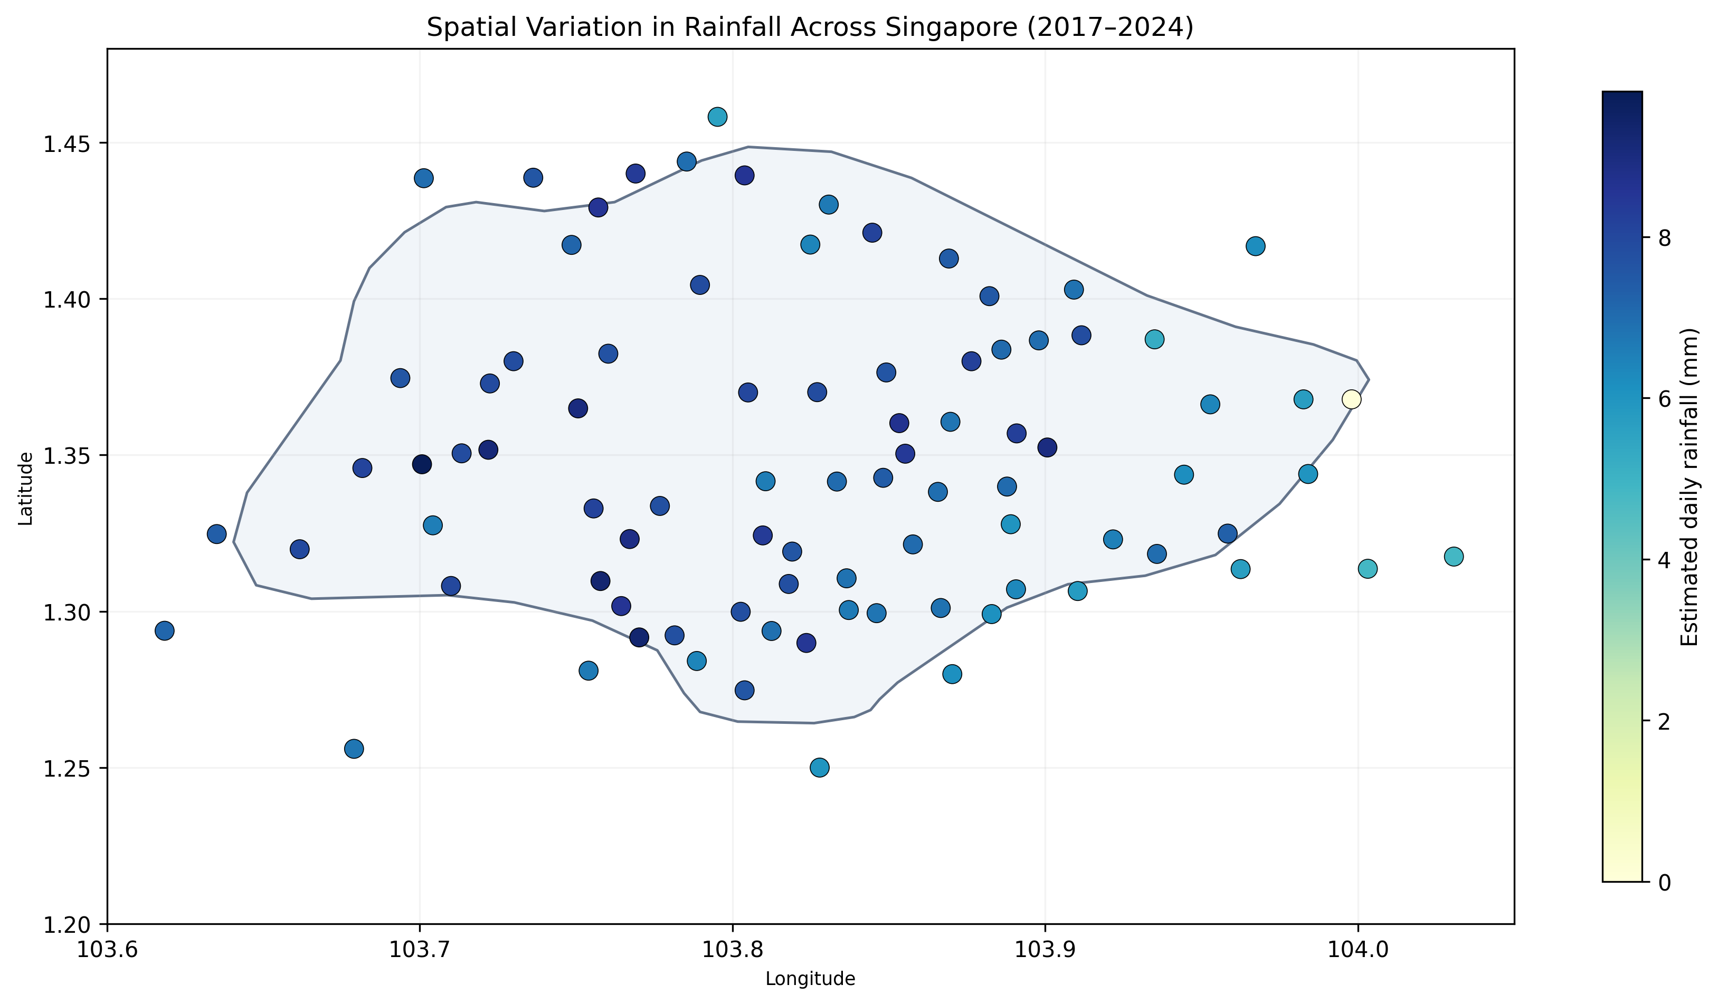
Figure 6. Monitoring-station spatial rainfall estimates with Singapore geographic context.

5. Task 2 — Probabilistic rainfall prediction

5.1 Target and features
At a prediction timestamp t, the binary label equals 1 when accumulated rainfall over the next six five-minute readings strictly exceeds threshold x, and 0 otherwise. The model includes station identity (StringIndexer and OneHotEncoder), sine/cosine encodings of hour and month, rainfall over the latest 5, 15, 30 and 60 minutes, and threshold in millimetres. The future rainfall total is used to construct labels only, not as a model feature. The prediction interface looks up historical feature rows for the requested station and timestamp; it is not a live forecast without recent observations.

5.2 Training design
Data were split chronologically: 2017–2022 for training, 2023 for validation/calibration, and 2024 for final testing. Boundary observations near split transitions were excluded from training and validation where future labels could cross the split. To fit the available Colab runtime, 5% of training observations and 10% of each validation/test period were sampled reproducibly (seed 42). Each sampled station-time row was expanded to thresholds 0, 1, 2, 5 and 10 mm. Logistic regression was trained using Spark MLlib (30 iterations, regularization parameter 0.05). Evaluation therefore reflects sampled observations and a pooled five-threshold test set, not the entire 2024 population.

5.3 Discrimination performance
Metric | 2023 validation | 2024 test
ROC-AUC | 0.9101 | 0.9063
PR-AUC | 0.4155 | 0.4076

The similar validation and test scores suggest stable ranking performance across these two periods. ROC-AUC and PR-AUC above are pooled across the five threshold-specific examples, and should not be interpreted as individual-threshold performance. The preliminary 2022 prototype showed ROC-AUC 0.9035 and PR-AUC 0.4507 on its later-2022 holdout.
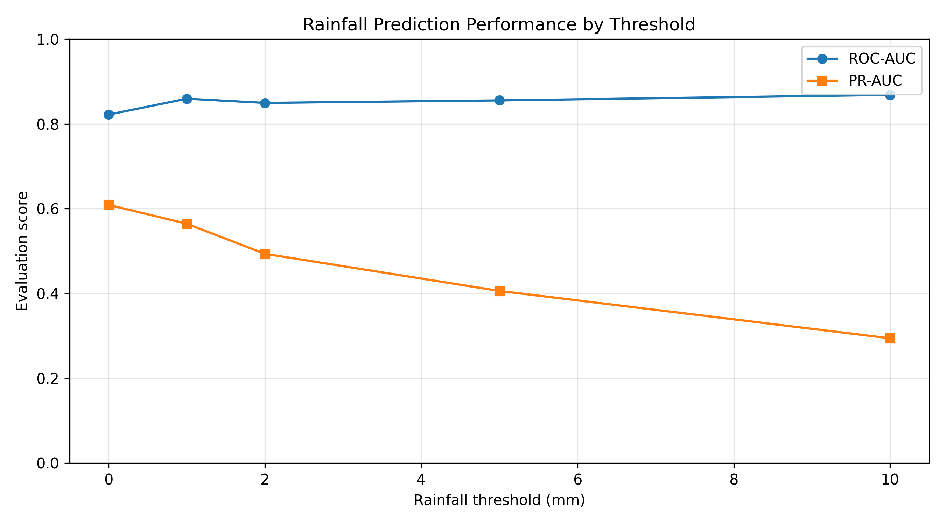
Figure 7. Threshold-specific ROC-AUC and PR-AUC from the 2022 prototype test.

5.4 Probability calibration and baseline
Because a probability forecast should be evaluated for numerical accuracy as well as ranking, five threshold-specific logistic calibrators were fitted on 2023 validation predictions using the log-odds of the base-model probability. Their Brier scores were compared on 2024 with the uncalibrated model and with a constant historical-frequency baseline estimated from training data. Lower Brier scores indicate better squared probability accuracy.
Threshold (mm) | Actual rate (%) | Raw Brier | Calibrated Brier | Baseline Brier
0.0 | 6.362 | 0.05468 | 0.04119 | 0.05958
1.0 | 2.567 | 0.02024 | 0.01843 | 0.02502
2.0 | 1.708 | 0.01319 | 0.01292 | 0.01679
5.0 | 0.834 | 0.00696 | 0.00685 | 0.00827
10.0 | 0.374 | 0.00414 | 0.00332 | 0.00373

Calibration improved Brier score for each evaluated threshold. Relative to the historical-frequency baseline, calibrated Brier score fell by approximately 30.9%, 26.3%, 23.1%, 17.2% and 11.0% for thresholds 0, 1, 2, 5 and 10 mm respectively. These gains are measured on the sampled 2024 test set. Independently calibrated thresholds were checked for monotonic ordering: zero violations occurred among 633,357 sampled station-time observations at the five tested thresholds.
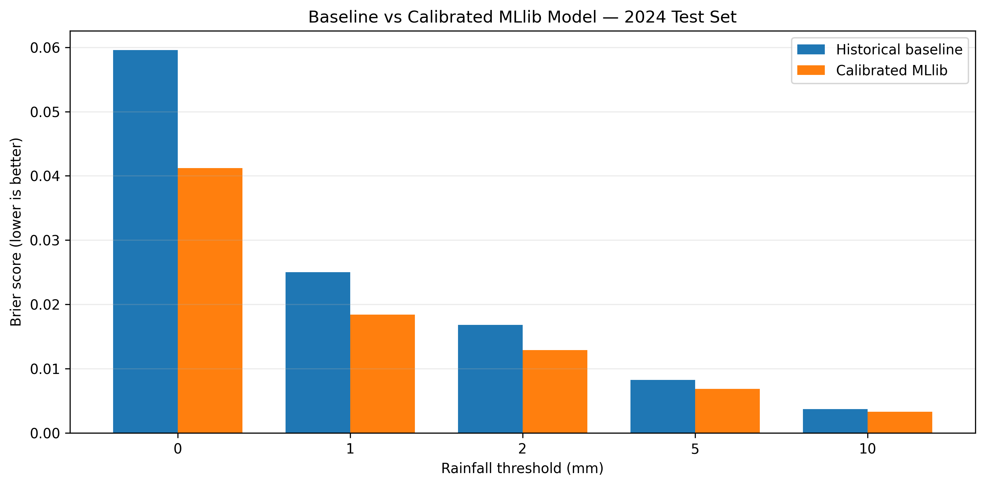
Figure 8. Historical-frequency baseline versus calibrated MLlib Brier score.

5.5 Example prediction and operational interface
For station S06 at 2024-11-07 16:45 SGT, the saved model and 5 mm calibrator returned an exceedance probability of 0.02494 (2.494%). For a 3.5 mm threshold at the same station/time, piecewise linear interpolation between calibrated 2 mm and 5 mm predictions returned 0.062363 (6.2363%). This interpolation is an approximation and was not independently calibrated at intermediate thresholds. The implemented calibrated interface supports thresholds from 0 to 10 mm; values outside that range are rejected.

6. Limitations and potential improvements
Key limitations include: (i) incomplete station coverage and lack of official climate-record quality control; (ii) station activation and missingness changing across years; (iii) training and evaluation based on random samples of station-time observations; (iv) possible temporal dependence among nearby sampled intervals; (v) calibration validated at only five thresholds; (vi) limited assurance of calibration for arbitrary interpolated thresholds; and (vii) the need for recently available measurements at prediction time. The logistic regression model also cannot fully capture nonlinear space-time interactions. Future work could audit missing-data mechanisms, use coverage-balanced station subsets, evaluate by event and season, compare tree-based Spark MLlib models, and incorporate nearby-station signals or live rainfall feeds.

7. AI-use declaration
Generative AI assistance (ChatGPT) was used during project planning, PySpark code development and debugging, interpretation of exploratory plots and model diagnostics, and preparation of the written report. The project also involved human execution of the code in Google Colab, inspection of generated outputs and decisions on model design. AI-generated suggestions and wording should be reviewed by all group members before submission. [Edit this declaration to accurately reflect any additional use of Gemini or other tools and the contributions of each member.]

8. Conclusion
The project demonstrates a reproducible Spark-based workflow for exploring large-scale Singapore rainfall observations and building a short-horizon threshold-exceedance classifier. The data exhibit seasonal, diurnal, spatial and strongly right-skewed rainfall patterns. A sampled historical logistic regression model achieved 2024 pooled ROC-AUC 0.9063 and PR-AUC 0.4076; threshold-specific calibration improved Brier scores and outperformed a training-frequency baseline across all five evaluated thresholds. Further data-quality auditing and probability validation would be necessary before operational deployment.

References
National Environment Agency. Historical Rainfall across Singapore (2017–2024). data.gov.sg collection 2279. https://data.gov.sg/collections/2279/view
Apache Software Foundation. Apache Spark MLlib documentation. https://spark.apache.org/docs/latest/ml-guide.html
OpenStreetMap contributors / geographic boundary source: see attribution associated with the station map asset; verify the exact boundary dataset and license before publication.

