INDEX
Exp.  No. | Date | Name of the Experiment | Page no. | Marks | Signature
1. |  | 8051 ALP to apply various addressing modes for arithmetic and logical functions
a. | 10.07.2026 | Addition & Subtraction of two 8 bit numbers | 1
b. | 10.07.2026 | Multiplication & Division of two 8 bit numbers | 3
c. | 10.07.2026 | Logical AND & OR of two 8 bit numbers | 5
d. | 10.07.2026 | Logical NOT & XOR of two 8 bit numbers | 7
2. |  | 8051 ALP for data transfer between memory blocks
a. | 17.07.2026 | Transfer the block of data between two Memory locations | 9
b. | 17.07.2026 | Exchange the block of data between locations | 10
3. |  | 8051 ALP to find the Largest / Smallest in a given array
a. | 24.07.2026 | ALP Program for finding largest number of given N numbers | 11
b. | 24.07.2026 | ALP Program for finding smallest number of given N numbers | 12
4. |  | 8051 C programming for delay timer
a. | 31.07.2026 | 8051 programming for timer mode 1 and enable/disable a port pin with a delay | 13
b. | 31.07.2026 | 8051 programming with timer-based interrupt to toggle an output pin at a fixed time interval | 14
c. | 31.07.2026 | Universal Asynchronous Receiver Transmitter (UART) programming using 8051 | 15
5. |  | 8051 C programming for port handling operations
a. | 07.08.2026 | To display ASCII number in a port | 16
b. | 07.08.2026 | I/O port programming with delay | 17
c. | 07.08.2026 | I/O port programming to toggle between two or more ports | 18
6. |  | 8051 C programming for interfacing actuators and sensors
a. | 14.08.2026 | Blinking the LED with some delay | 19
b. | 14.08.2026 | 8051 programming to interface with LED with switch control | 20
7. |  | 8051 C programming for interfacing output unit
a. | 21.08.2026 | Display the input text in LCD | 23
b. | 21.08.2026 | LCD with switch control | 25
8. | 28.08.2026 | ARM7 programming to interface LED and LCD | 29
9. | 11.09.2026 | ARM7 programming for buzzer interface | 34
10. | 25.09.2026 | ARM7 programming for Timer controlling operation | 36
Content Beyond the Syllabus
CBS | 27.06.2026 | Virtual Lab  Programming for Delay Generation and Effect of CPU Clock | 38
 | 03.07.2026 | Virtual Lab  Programming for I/O Interfacing (LED and Switch Interfacing)  Programming with On-Chip Timers/Counters | 41, 44
 |  |  | Average

EXP NO.1a | ADDITION AND SUBTRACTION OF TWO 8 BIT NUMBERS
DATE: 10.07.26 | ADDITION AND SUBTRACTION OF TWO 8 BIT NUMBERS

AIM:
To develop and simulate 8051 Assembly language programs for the addition and subtraction of two 8 bit numbers using Keil µVision IDE.
DESCRIPTION:
Keil µVision is a software development environment used for programming and simulating 8051 microcontrollers. It provides tools for writing Assembly language programs, assembling source code, debugging errors, and observing register as well as memory contents through simulation.
In this experiment, the ADD and SUBB instructions of the 8051 were used to add and subtract two 8 bit hexadecimal numbers, with and without carry or borrow. The simulator was used to verify the results by monitoring the accumulator, registers and the carry flag.
ARITHMETIC OPERATIONS
(i) Addition without Carry
Objective: To add two hexadecimal numbers without generating a carry.
Input | Calculation | Result
18H = 24  25H = 37 | 24 + 37 = 61 | 3DH = 61  Carry = 0
Program | Output
CLR C  MOV A,#18H  ADD A,#25H  MOV R0,A | 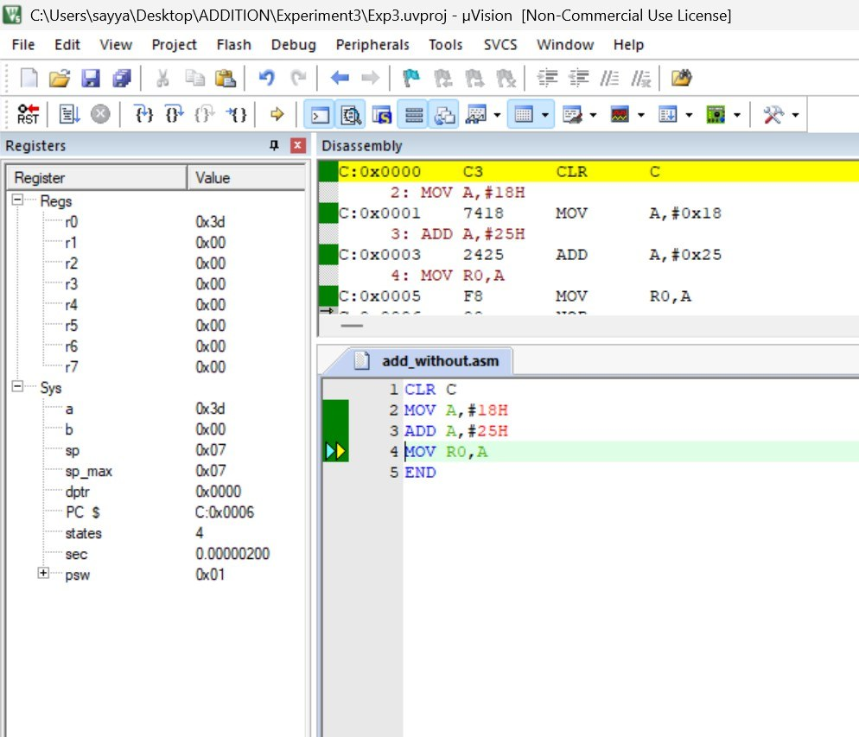

(ii) Addition with Carry
Objective: To perform addition of two hexadecimal numbers that produces a carry.
Input | Calculation | Result
B2H = 178  5AH = 90 | 178 + 90 = 268 | R1 = 0CH  Carry = 1
Program | Output
CLR C  MOV A,#0B2H  ADD A,#5AH  MOV R1,A | 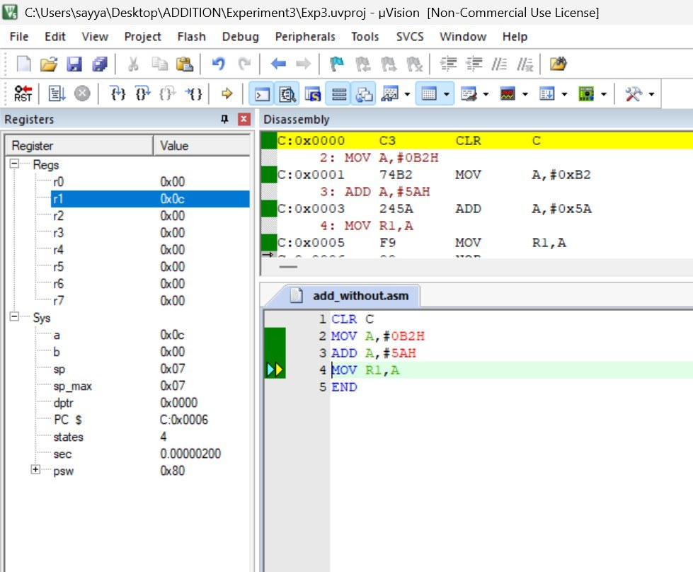

(iii) Subtraction without Borrow
Objective: To subtract one hexadecimal number from another without borrow.
Input | Calculation | Result
58H = 88  1EH = 30 | 88 − 30 = 58 | 3AH = 58  Borrow(Carry)=0
Program | Output
CLR C  MOV A,#58H  SUBB A,#1EH  MOV R2,A | 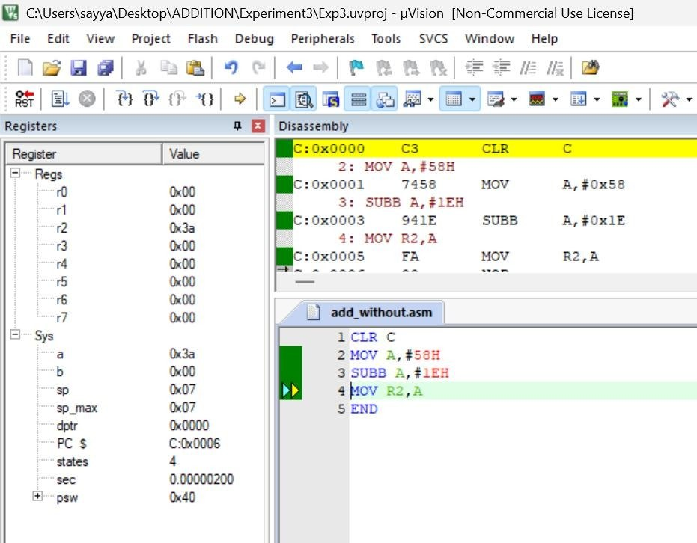

(iv) Subtraction with Borrow
Objective: To subtract a greater hexadecimal value from a smaller one.
Input | Calculation | Result
2AH = 42  45H = 69 | 42 − 69 = −27 | E5H  Borrow(Carry)=1
Program | Output
CLR C  MOV A,#2AH  SUBB A,#45H  MOV R3,A | 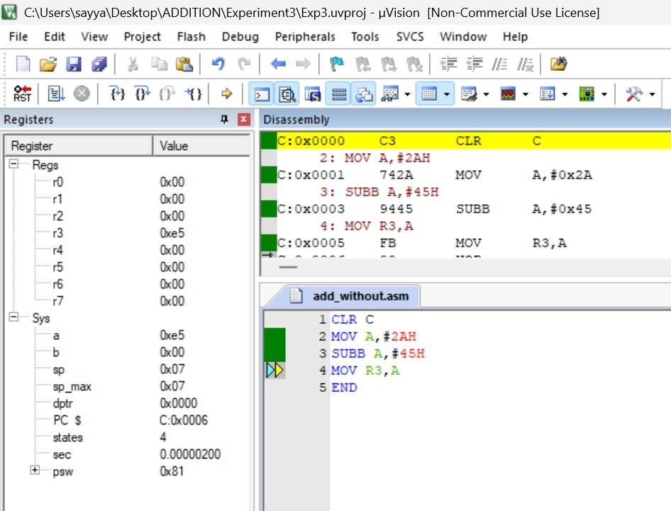

RESULT:
Thus, the addition and subtraction of two 8 bit numbers were successfully implemented and verified using 8051 Assembly Language in Keil µVision IDE.

EXP NO.1b | MULTIPLICATION AND DIVISION OF TWO 8 BIT NUMBERS
DATE: 10.07.26 | MULTIPLICATION AND DIVISION OF TWO 8 BIT NUMBERS

AIM:
To develop and simulate 8051 Assembly language programs for the multiplication and division of two 8 bit numbers using Keil µVision IDE.
DESCRIPTION:
Keil µVision is a software development environment used for programming and simulating 8051 microcontrollers. It provides tools for writing Assembly language programs, assembling source code, debugging errors, and observing register as well as memory contents through simulation.
In this experiment, the MUL AB and DIV AB instructions of the 8051 were used to multiply and divide two 8 bit hexadecimal numbers. The product is obtained as a 16-bit result in registers B and A, while division gives the quotient in the accumulator and the remainder in register B. The simulator was used to verify the results.
ARITHMETIC OPERATIONS
(i) Multiplication without Overflow
Objective: To multiply two hexadecimal numbers without overflow.
Input | Calculation | Result
08H = 8  06H = 6 | 8 × 6 = 48 | A = 30H  B = 00H
Program | Output
MOV A,#08H  MOV B,#06H  MUL AB  MOV R4,A | 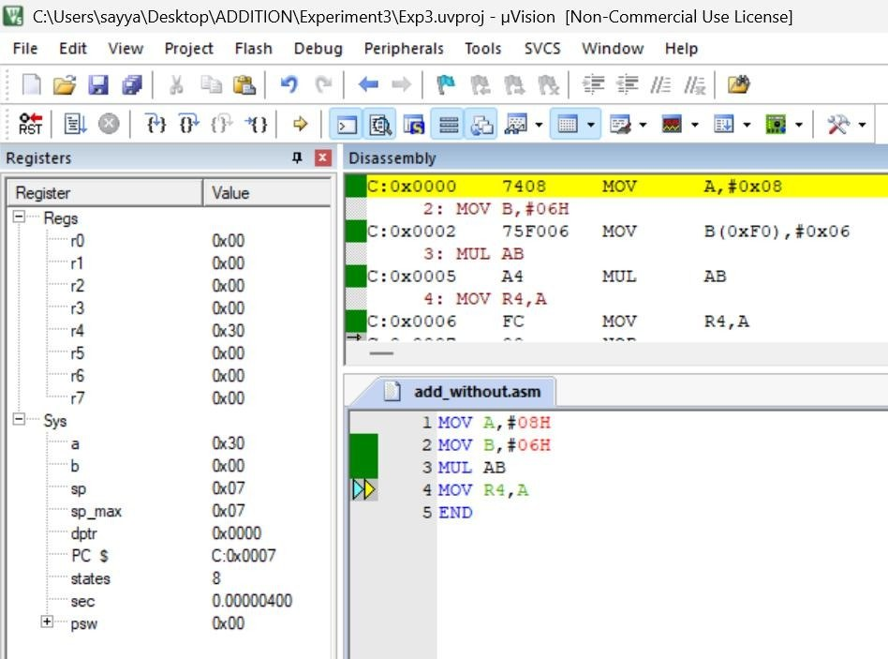

(ii) Multiplication with Overflow
Objective: To multiply two hexadecimal numbers producing a 16-bit result.
Input | Calculation | Result
28H = 40  14H = 20 | 40 × 20 = 800 | A = 20H  B = 03H
Program | Output
MOV A,#28H  MOV B,#14H  MUL AB  MOV R5,A  MOV R6,B | 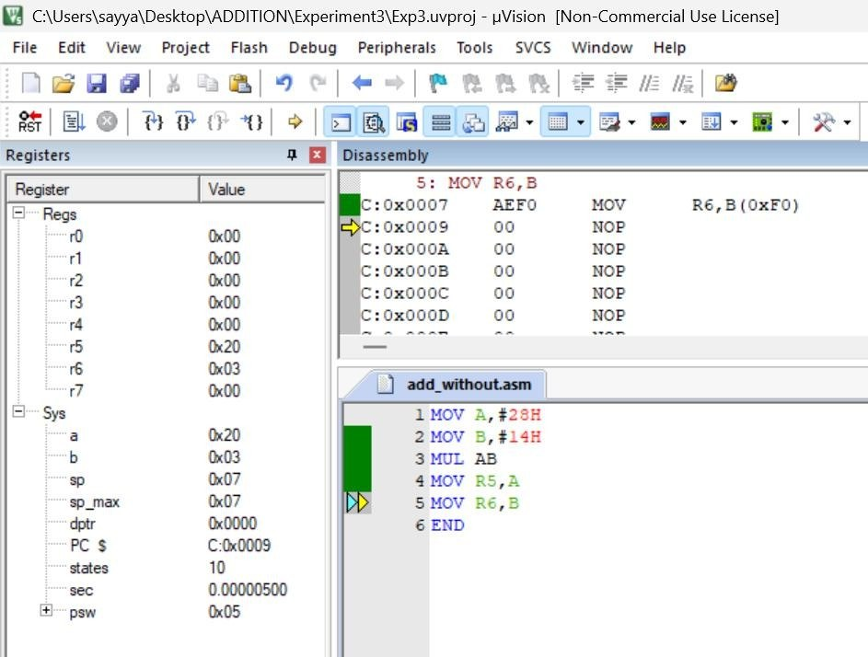

(iii) Division without Remainder
Objective: To divide two hexadecimal numbers exactly without remainder.
Input | Calculation | Result
40H = 64  08H = 8 | 64 ÷ 8 = 8 | Quotient = 08H  Remainder = 00H
Program | Output
MOV A,#40H  MOV B,#08H  DIV AB  MOV R7,A | 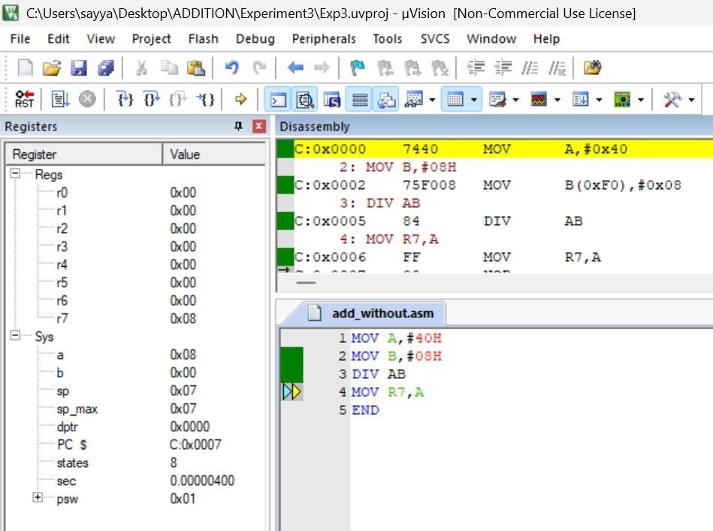

(iv) Division with Remainder
Objective: To divide two hexadecimal numbers producing quotient and remainder.
Input | Calculation | Result
3BH = 59  08H = 8 | 59 ÷ 8 = 7  Remainder = 3 | Quotient = 07H  Remainder = 03H
Program | Output
MOV A,#3BH  MOV B,#08H  DIV AB  MOV R0,A  MOV R1,B | 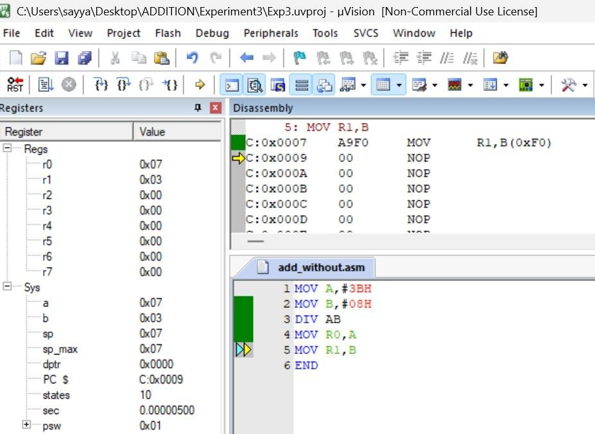

RESULT:
Thus, the multiplication and division of two 8 bit numbers were successfully implemented and verified using 8051 Assembly Language in Keil µVision IDE.

EXP NO.1c | LOGICAL AND & OR OF TWO 8 BIT NUMBERS
DATE: 10.07.26 | LOGICAL AND & OR OF TWO 8 BIT NUMBERS

AIM:
To develop and simulate 8051 Assembly language programs for the logical AND and OR operations on two 8 bit numbers using Keil µVision IDE.
DESCRIPTION:
Keil µVision is a software development environment used for programming and simulating 8051 microcontrollers. It provides tools for writing Assembly language programs, assembling source code, debugging errors, and observing register as well as memory contents through simulation.
In this experiment, the ANL and ORL instructions of the 8051 were used to perform the bitwise AND and OR operations on two 8 bit hexadecimal numbers. The simulator was used to verify the results by monitoring the accumulator and registers.
LOGICAL OPERATIONS
(i) Logical AND
Objective: To perform a bitwise AND operation.
Input | Calculation | Result
5AH = 90  3CH = 60 | 01011010  00111100  ──────────  00011000 | 18H = 24
Program | Output
MOV A,#5AH  ANL A,#3CH  MOV R2,A | 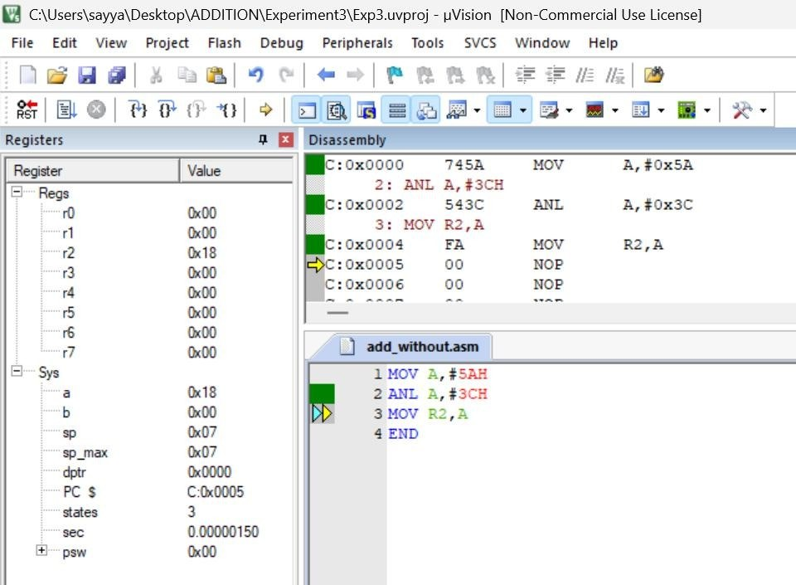

(ii) Logical OR
Objective: To perform a bitwise OR operation.
Input | Calculation | Result
44H = 68  13H = 19 | 01000100  00010011  ──────────  01010111 | 57H = 87
Program | Output
MOV A,#44H  ORL A,#13H  MOV R3,A | 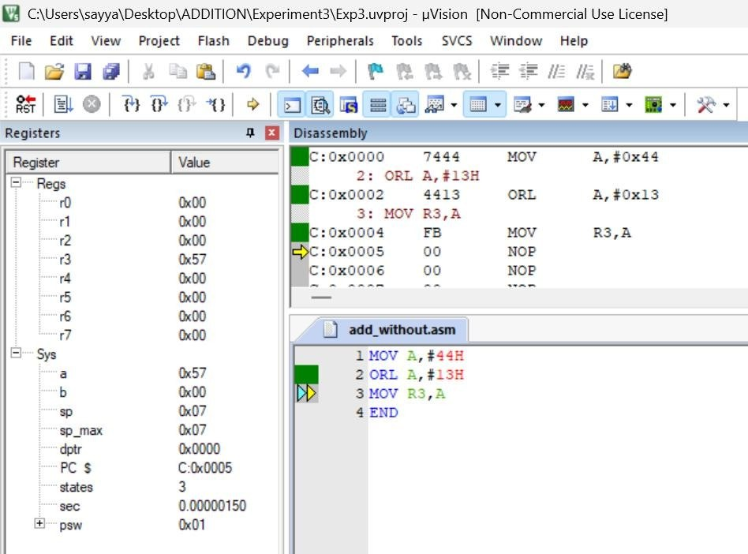

RESULT:
Thus, the logical AND and OR operations on two 8 bit numbers were successfully implemented and verified using 8051 Assembly Language in Keil µVision IDE.

EXP NO.1d | LOGICAL NOT & XOR OF TWO 8 BIT NUMBERS
DATE: 10.07.26 | LOGICAL NOT & XOR OF TWO 8 BIT NUMBERS

AIM:
To develop and simulate 8051 Assembly language programs for the logical NOT and XOR operations on 8 bit numbers using Keil µVision IDE.
DESCRIPTION:
Keil µVision is a software development environment used for programming and simulating 8051 microcontrollers. It provides tools for writing Assembly language programs, assembling source code, debugging errors, and observing register as well as memory contents through simulation.
In this experiment, the CPL instruction of the 8051 was used to find the complement (NOT) of an 8 bit number, and the XRL instruction was used to perform the bitwise XOR operation on two 8 bit hexadecimal numbers. The simulator was used to verify the results by monitoring the accumulator and registers.
LOGICAL OPERATIONS
(i) Logical NOT (Complement)
Objective: To complement every bit of the accumulator.
Input | Calculation | Result
55H = 85 | 01010101  ↓ 10101010 | AAH = 170
Program | Output
MOV A,#55H  CPL A  MOV R5,A | 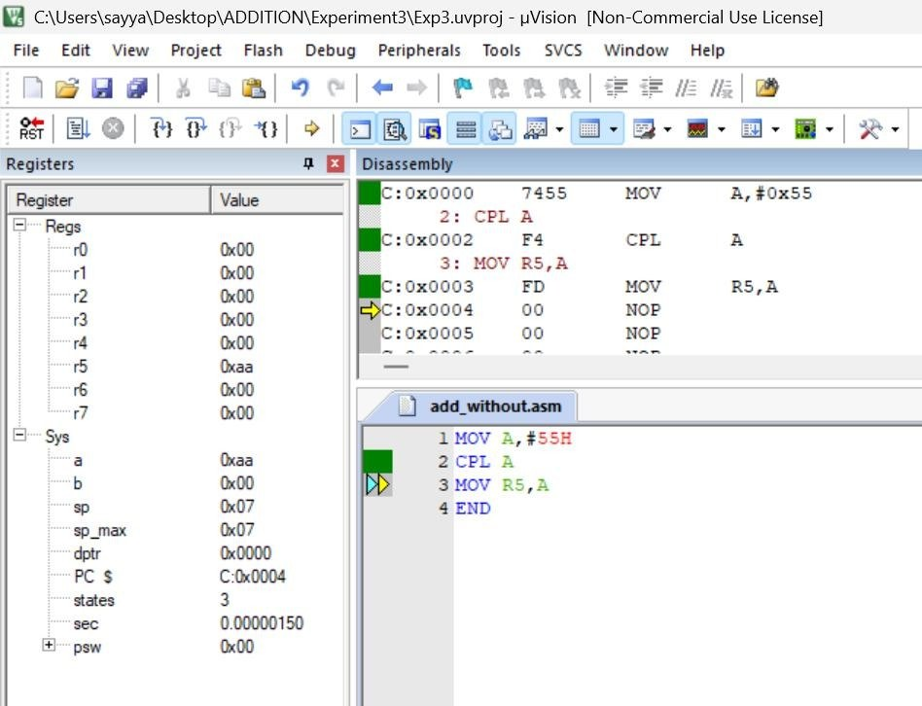

(ii) Logical XOR
Objective: To perform a bitwise Exclusive-OR operation.
Input | Calculation | Result
5AH = 90  33H = 51 | 01011010  00110011  ──────────  01101001 | 69H = 105
Program | Output
MOV A,#5AH  XRL A,#33H  MOV R4,A | 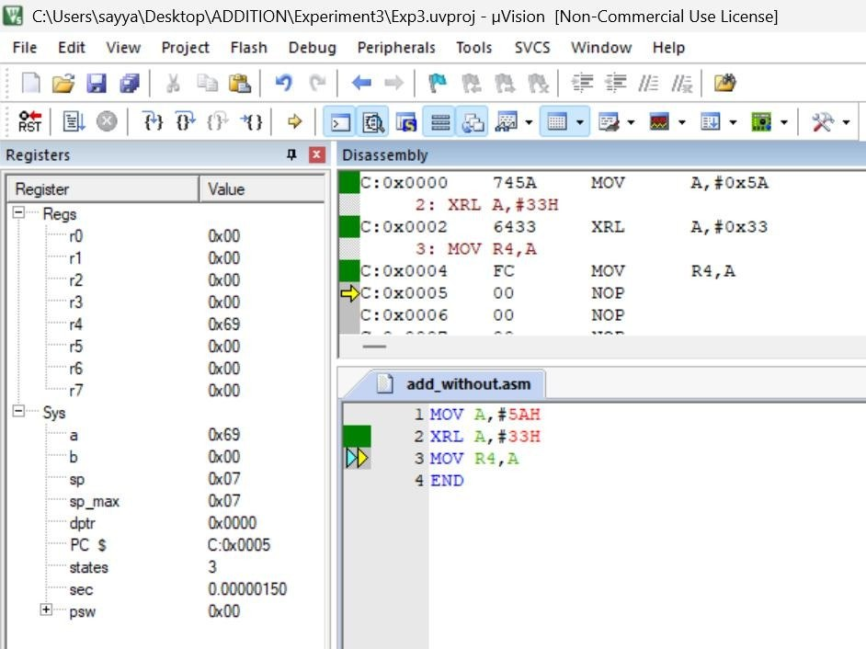

RESULT:
Thus, the logical NOT and XOR operations on 8 bit numbers were successfully implemented and verified using 8051 Assembly Language in Keil µVision IDE.

EXP NO.2 | 8051 ALP FOR DATA TRANSFER BETWEEN MEMORY BLOCKS
DATE: 17.07.26 | 8051 ALP FOR DATA TRANSFER BETWEEN MEMORY BLOCKS

A) Transfer the Block of Data between two Memory Locations
AIM:
To write an Assembly Language Program (ALP) to transfer a block of data from one internal memory location to another.
ALGORITHM:
1. Initialize the source memory address.
2. Initialize the destination memory address.
3. Load the counter with the number of bytes to be transferred.
4. Read one byte from the source location.
5. Store the byte in the destination location.
6. Increment both source and destination pointers.
7. Decrement the counter.
8. Repeat until the counter becomes zero.
9. Stop the program.
PROGRAM:
ORG 00H
MOV R0,#60H
MOV R1,#70H
MOV R2,#04H
L1: MOV A,@R0
MOV @R1,A
INC R0
INC R1
DJNZ R2,L1
END
OUTPUT:
Memory window before execution
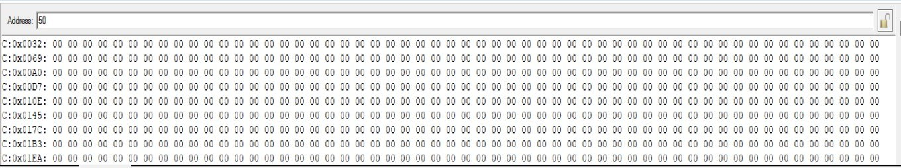
Memory window after execution
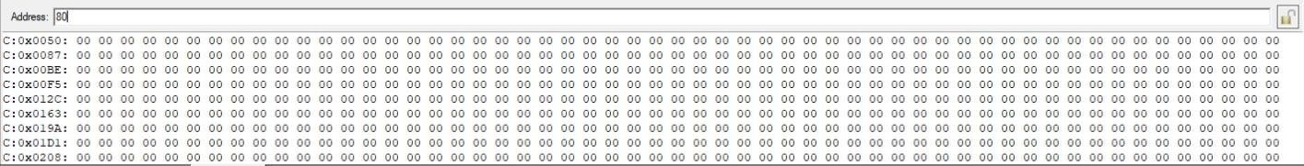
RESULT:
Thus, the block of data was successfully transferred from one internal memory location to another and verified successfully.
B) Exchange (Swap) the Block of Data Between Two Memory Locations
AIM:
To write an Assembly Language Program (ALP) to exchange (swap) the contents of a block of data between two internal memory locations.
ALGORITHM:
1. Initialize the starting address of Block 1.
2. Initialize the starting address of Block 2.
3. Load the counter with the number of bytes.
4. Read one byte from Block 1 into the Accumulator.
5. Store it temporarily in Register B.
6. Read one byte from Block 2 into the Accumulator.
7. Move the contents of Register B to Block 2.
8. Move the Accumulator contents to Block 1.
9. Increment both memory pointers.
10. Decrement the counter.
11. Repeat until all bytes are exchanged.
12. Stop the program.
PROGRAM:
ORG 00H
MOV R0,#50H
MOV R1,#80H
MOV R2,#04H
L1: MOV A,@R0
MOV B,A
MOV A,@R1
MOV @R0,A
MOV A,B
MOV @R1,A
INC R0
INC R1
DJNZ R2,L1
END
OUTPUT:
Memory window before execution
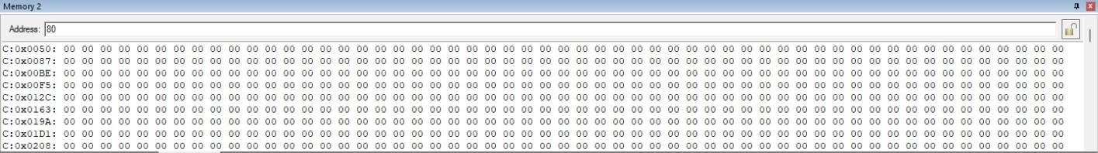
Memory window after execution
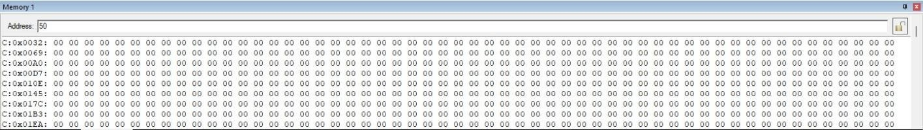

RESULT:
Thus, the contents of the two memory blocks were successfully exchanged and verified successfully.

EXP NO.3 | 8051 ALP TO FIND THE LARGEST / SMALLEST IN A GIVEN ARRAY
DATE: 24.07.26 | 8051 ALP TO FIND THE LARGEST / SMALLEST IN A GIVEN ARRAY

(a) Largest Number in an Array
AIM:
To write and execute an 8051 Assembly Language program to find the largest and smallest numbers in an array and store the results in the specified memory location.
ALGORITHM:
1. Start the program.
2. Load the number of array elements into register R2.
3. Initialize R0 with the starting address of the array.
4. Move the first array element into accumulator A.
5. Initialize R1 with the address of the next element.
6. Compare the current largest value in A with the next array element.
7. If the next element is larger, move it into A.
8. Increment the array pointer.
9. Repeat the comparison until all elements are checked.
10. Store the largest value from A into memory location 70H.
11. Stop.
PROGRAM:
Program | Output
ORG 00H  MOV R2,50H  DEC R2  MOV R0,#60H  MOV A,@R0  MOV R1,#61H  L1: MOV 00H,@R1  CJNE A,00H,L2  L2: JNC L3  MOV A,@R1  L3: INC R1  DJNZ R2,L1  MOV 70H,A  END | 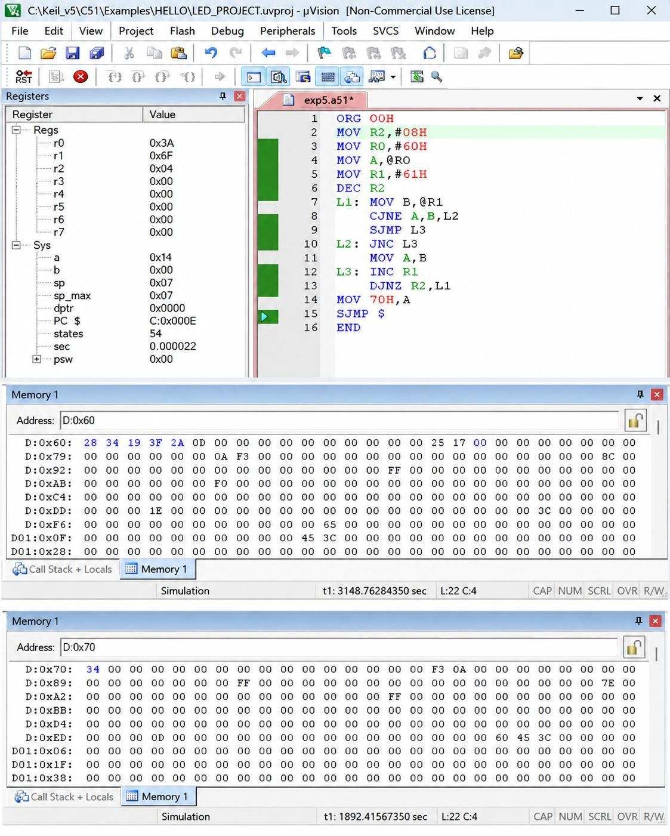
(b) Smallest Number in an Array
AIM:
To write and execute an 8051 Assembly Language program to find the smallest number in an array stored in the specified memory location.
ALGORITHM:
1. Start the program.
2. Load the number of array elements into register R2.
3. Initialize R0 with the starting address of the array.
4. Move the first array element into accumulator A.
5. Initialize R1 with the address of the next element.
6. Compare the current smallest value in A with the next array element.
7. If the next element is smaller, move it into A.
8. Increment the array pointer.
9. Repeat the comparison until all elements are checked.
10. Store the smallest value from A into memory location 70H.
11. Stop.
PROGRAM:
Program | Output
ORG 00H  MOV R2,50H  DEC R2  MOV R0,#60H  MOV A,@R0  MOV R1,#61H  L1: MOV 00H,@R1  CJNE A,00H,L2  L2: JNC L3  MOV A,@R1  L3: INC R1  DJNZ R2,L1  MOV 70H,A  END | 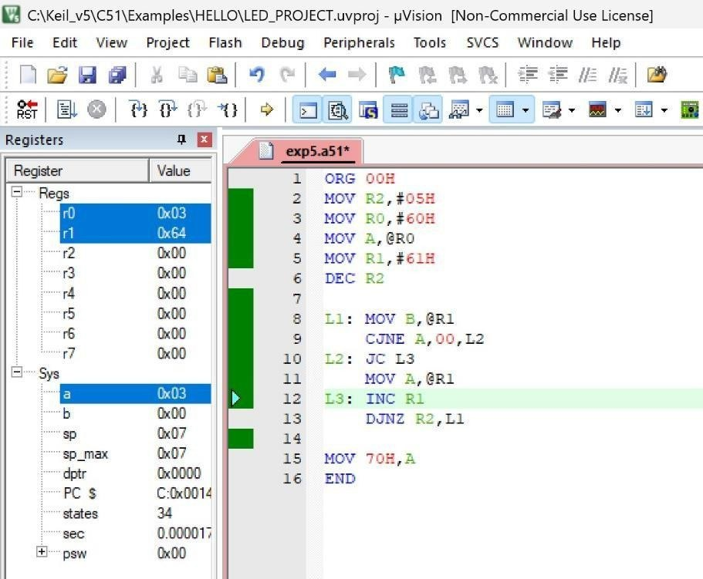  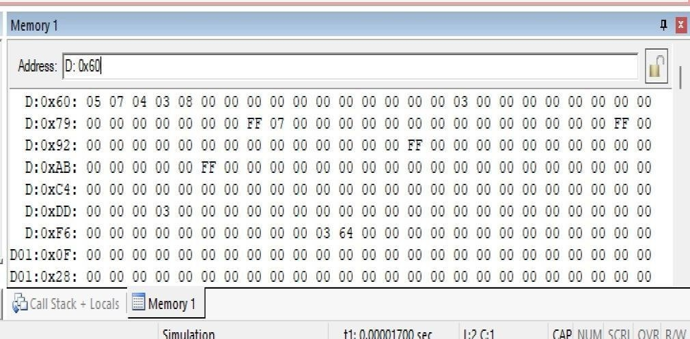  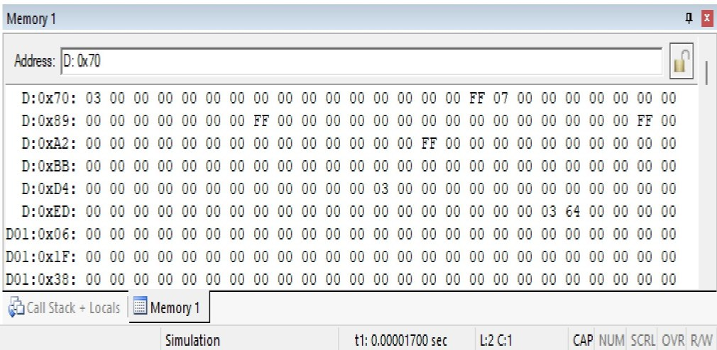

RESULT:
Thus, the 8051 Assembly Language programs for finding the largest and smallest numbers in an array were executed successfully.

EXP NO.4 | 8051 C PROGRAMMING FOR DELAY TIMER
DATE: 31.07.26 | 8051 C PROGRAMMING FOR DELAY TIMER

(a) 8051 Timer Mode 1 with Delay
AIM:
To write and execute an 8051 C program using Timer 0 in Mode 1 to generate a delay and enable/disable a port pin.
ALGORITHM:
1. Start the program.
2. Define the port pin P1.0 as the test pin.
3. Configure Timer 0 in Mode 1 (16-bit timer mode).
4. Load the initial values into TH0 and TL0.
5. Start Timer 0.
6. Wait until the Timer 0 overflow flag TF0 is set.
7. Stop the timer and clear TF0.
8. Toggle the P1.0 pin.
9. Repeat the process continuously.
PROGRAM:
Program | Output
#include <reg51.h>  sbit test = P1^0;  void timer_delay()  {  TH0 = 0xFC;  TL0 = 0x74;  TR0 = 1;  while(TF0 == 0);  TR0 = 0;  TF0 = 0;  }  void main()  {  TMOD = 0x01;  while(1)  {  test = ~test;  timer_delay();  }  } | 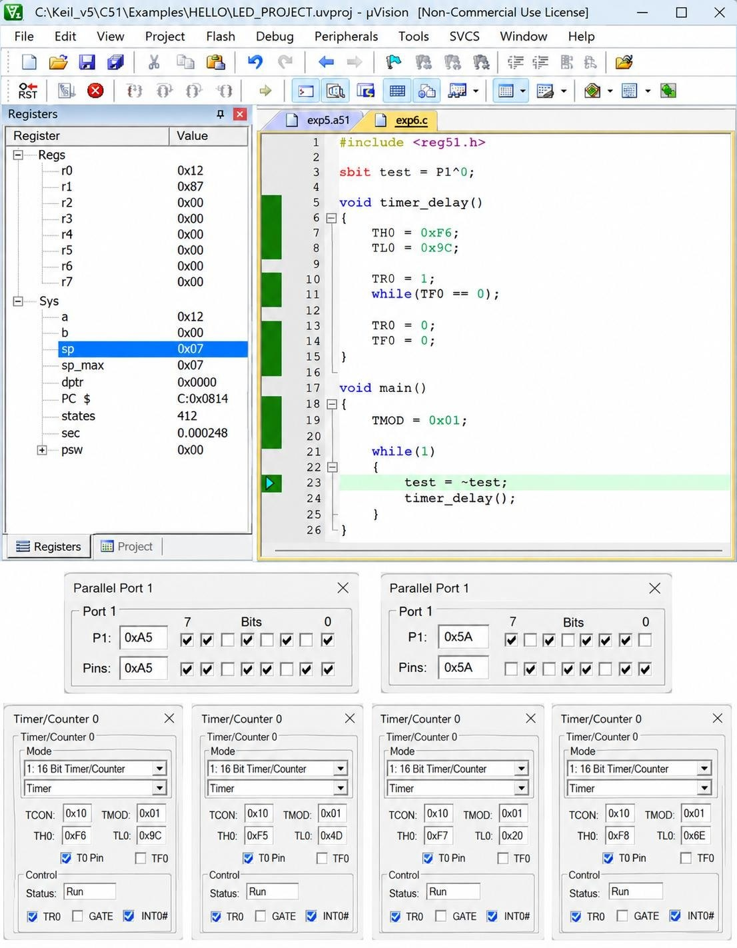
(b) Timer-Based Interrupt to Toggle Output Pin
AIM:
To write and execute an 8051 C program using a timer-based interrupt to toggle an output pin at a fixed time interval.
ALGORITHM:
1. Start the program.
2. Define P1.0 as the output/test pin.
3. Configure Timer 0 in Mode 1.
4. Load TH0 and TL0 with the required initial values.
5. Enable the global interrupt.
6. Enable Timer 0 interrupt.
7. Start Timer 0.
8. When Timer 0 overflows, execute the interrupt service routine.
9. Toggle P1.0.
10. Reload TH0 and TL0.
11. Repeat the process continuously.
PROGRAM:
Program | Output
#include <reg51.h>  sbit test = P1^0;  void Timer_init(void)  {  TMOD = 0x01;  TH0 = 0x4C;  TL0 = 0x00;  TR0 = 1;  }  void Timer0_ISR(void) interrupt 1  {  test = ~test;  TH0 = 0x4C;  TL0 = 0x00;  }  int main(void)  {  EA = 1;  ET0 = 1;  Timer_init();  while(1);  } | 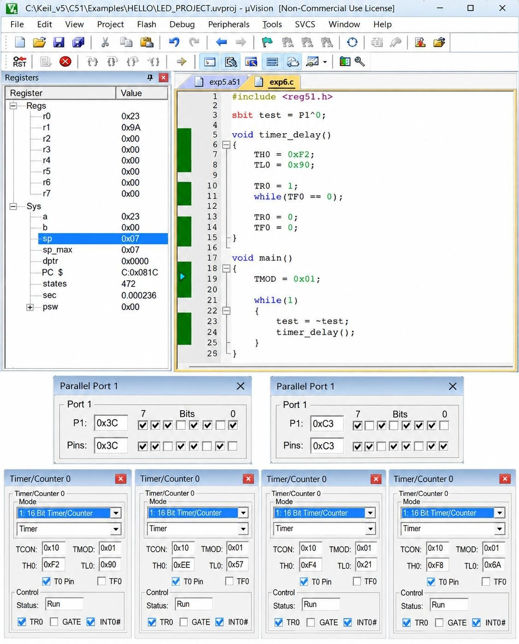
(c) UART Programming Using 8051
AIM:
To write and execute an 8051 C program for Universal Asynchronous Receiver Transmitter (UART) to transmit a character serially.
ALGORITHM:
1. Start the program.
2. Configure Timer 1 in Mode 2 for baud-rate generation.
3. Load the required value into TH1.
4. Configure the serial control register SCON.
5. Start Timer 1.
6. Load the character to be transmitted into SBUF.
7. Wait until the transmission interrupt flag TI is set.
8. Clear the TI flag.
9. Repeat the transmission continuously.
PROGRAM:
Program | Output
#include <reg51.h>  void main(void)  {  TMOD = 0x20;  TH1 = 0xFA;  SCON = 0x50;  TR1 = 1;  while(1)  {  SBUF = 'B';  while(TI == 0);  TI = 0;  }  } | 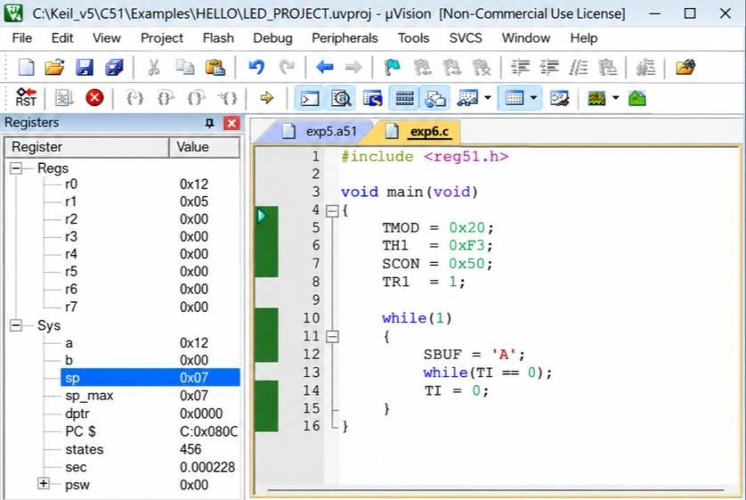  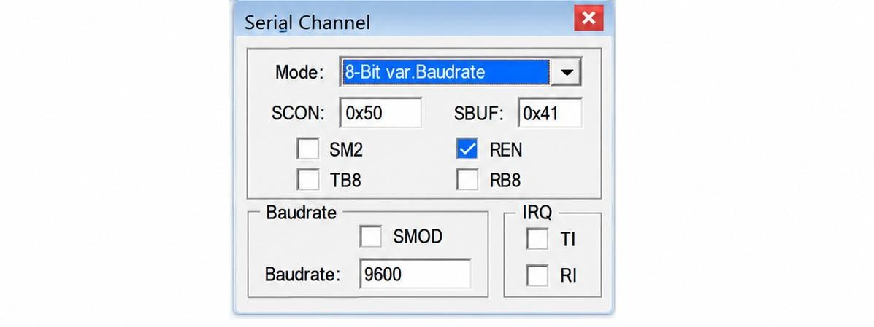

RESULT:
Thus, the 8051 C programs were successfully implemented for timer delay and port toggling, timer-based interrupt, and UART serial data transmission.

EXP NO.5 | 8051 C PROGRAMMING FOR PORT HANDLING OPERATIONS
DATE: 07.08.26 | 8051 C PROGRAMMING FOR PORT HANDLING OPERATIONS

(a) To Display ASCII Number in a Port
AIM:
To write and execute 8051 C programs that display an ASCII number through a port, perform I/O port programming with a delay, and toggle between two or more I/O ports.
ALGORITHM:
1. Begin the program.
2. Include the header file REG51.H.
3. Declare the variables x and y.
4. Load the hexadecimal number 29H into the variable mb.
5. Separate the lower nibble using mb & 0x0F.
6. Add 30H to change the lower nibble into its ASCII value.
7. Send the result to Port 1.
8. Separate the upper nibble using mb & 0xF0.
9. Shift the upper nibble four bits to the right.
10. Add 30H to get its ASCII value.
11. Send the result to Port 1.
12. Repeat the steps continuously.
PROGRAM:
Program | Output
#include<reg51.h>  void main(void){  while(1){  unsigned char x,y;  unsigned char mb = 0x29 ;  x = mb &0x0F;  P1 = x|0x30;  y = mb & 0xF0;  y = y >>4;  P1 = y|0x30;}} | 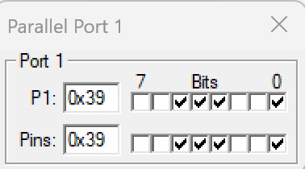  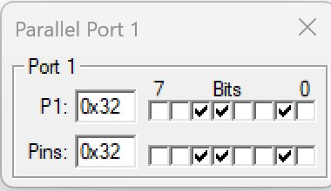
(b) I/O Port Programming with Delay
ALGORITHM:
1. Begin the program.
2. Include the header file REG51.H.
3. Define P1.7 as the bit mybit.
4. Write a delay function.
5. Clear mybit to 0.
6. Call the delay function.
7. Make mybit equal to 1.
8. Call the delay function once more.
9. Repeat this process in an endless loop.
10. Watch Port 1 bit 7 toggle in the simulator.
PROGRAM:
Program | Output
#include <reg51.h>  sbit mybit = P1^7;  void delay(unsigned int a);  void main(void)  {  while(1)  {  mybit = 0;  delay(20);  mybit = 1;  delay(20);  }  }  void delay(unsigned int a)  {  unsigned int i, j;  for(i = 0; i < a; i++)  for(j = 0; j < 50; j++);  } | 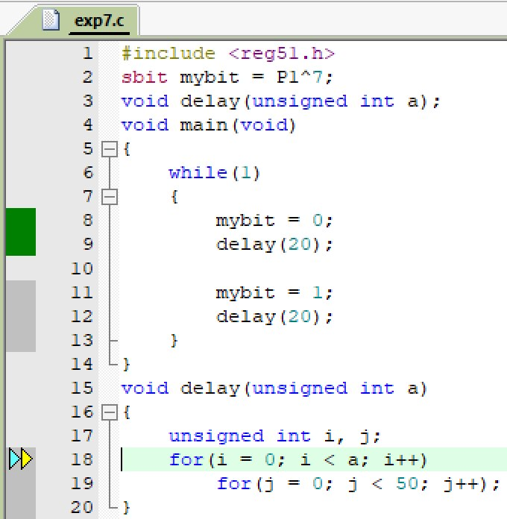  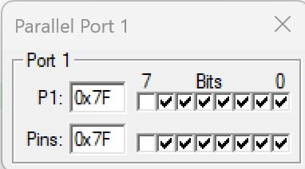  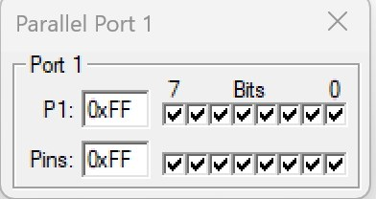
(c) 8051 I/O Port Programming to Toggle Between Two or More Ports
ALGORITHM:
1. Begin the program.
2. Include the header file REG51.H.
3. Initialize Port 0, Port 1, Port 2 and Port 3 with 33H.
4. Invert the contents of Port 0.
5. Invert the contents of Port 1.
6. Invert the contents of Port 2.
7. Invert the contents of Port 3.
8. Add a short delay.
9. Repeat this process in an endless loop.
10. Observe that the ports alternate between 33H and CCH.
PROGRAM:
Program | Output
#include <reg51.h>  void MsDelay(unsigned int);  void main()  {  P0 = P1 = P2 = P3 = 0x33;  while(1)  {  P0 = ~P0;  P1 = ~P1;  P2 = ~P2;  P3 = ~P3;  MsDelay(1);  }  }  void MsDelay(unsigned int itime)  {  unsigned int i, j;  for(i = 0; i < itime; i++)  for(j = 0; j < 3; j++);  } | 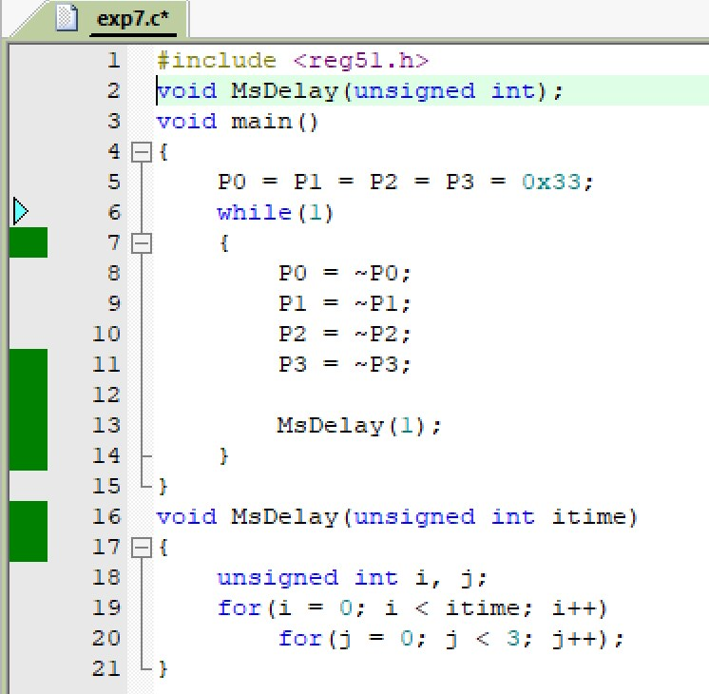  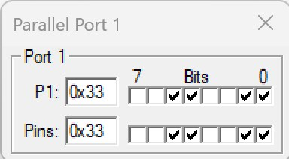  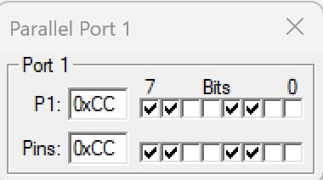

RESULT:
Thus, the 8051 C programs for displaying an ASCII number, I/O port programming with delay and toggling of multiple I/O ports were executed successfully and the expected port outputs were obtained.

EXP NO.6 | 8051 C PROGRAMMING FOR INTERFACING ACTUATORS AND SENSORS
DATE: 14.08.26 | 8051 C PROGRAMMING FOR INTERFACING ACTUATORS AND SENSORS

A. 8051 Programming to Blink the LED with Delay
AIM:
To interface LEDs with the 8051 microcontroller and blink them with a time delay.

PROCEDURE:
1. Create a new project.
2. Select the microcontroller Atmel → AT89C52.
3. Enter the source code.
4. Save the program.
5. Add the HEX file to the output.
6. Compile the program using Project → Build Target / F7.
7. The HEX file will be generated in the project folder.
PROGRAM:
#include <REGX52.H>
#define LED1 P1_5
#define LED2 P1_4
#define LED3 P1_3
void delay(unsigned int count);
void main()
{
while(1)
{
LED1 = 0;
LED2 = 1;
LED3 = 0;
delay(50);
LED1 = 1;
LED2 = 0;
LED3 = 0;
delay(50);
}
}
void delay(unsigned int count)
{
int x, y;
for(x = 0; x < count; x++)
for(y = 0; y < 1275; y++);
}

OUTPUT:
BEFORE EXECUTION:
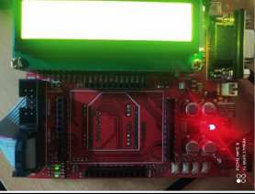
AFTER EXECUTION:
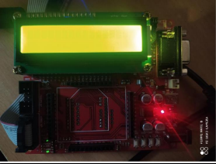

B. LED with Switch Control
AIM:
To operate the LEDs through switches connected to the 8051 microcontroller and produce a beep whenever a switch is pressed.

ALGORITHM:
1. Start the program.
2. Include the required header file and define the ports for LEDs, switches and beep.
3. Run an infinite while loop for continuous switch monitoring.
4. Check whether a particular switch is pressed.
5. When a switch is pressed, produce a beep for a short delay and switch ON the corresponding LED.
6.

PROGRAM:
#include <REGX52.H>
#define EN P1_0
#define RS P1_2
#define SW1 P2_0
#define SW2 P2_1
#define SW3 P2_2
#define beep P1_6
#define LED0 P1_5
#define LED1 P1_4
#define LED2 P1_3
void delay(unsigned int count);
void main()
{
while(1)
{
if(SW1 == 0)
{
while(!SW1);
beep = 0;
delay(25);
beep = 1;
LED0 = 0;
LED1 = 1;
LED2 = 1;
}
if(SW2 == 0)
{
while(!SW2);
beep = 0;
delay(25);
beep = 1;
LED0 = 1;
LED1 = 0;
LED2 = 1;
}
if(SW3 == 0)
{
while(!SW3);
beep = 0;
delay(25);
beep = 1;
LED2 = 0;
LED1 = 1;
LED0 = 1;

}
}
}
void delay(unsigned int count)
{
int x, y;
for(x = 0; x < count; x++)
for(y = 0; y < 1275; y++);
}

OUTPUT:
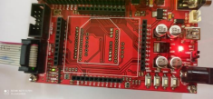

LED1
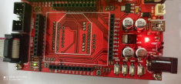

LED2
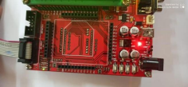

LED3

RESULT
Thus, the 8051 C program for LED interfacing was executed and verified successfully.

EXP NO.7 | 8051 C PROGRAMMING FOR INTERFACING OUTPUT UNIT
DATE: 21.08.26 | 8051 C PROGRAMMING FOR INTERFACING OUTPUT UNIT

A. 8051 C programming to interface with LCD and display the given input

AIM:
To interface an LCD with the 8051 microcontroller, display the given text, and show different messages on the LCD according to the switch pressed.

ALGORITHM:
1. Start the program.
2. Include the required header file and define the LCD data port, EN, RS and RW pins.
3. Initialize the LCD using the required commands.
4. Send the required text to the LCD.
5. Run the program continuously.
6. Stop the program.

HEXCODE COMMANDS:
30 1 Line, 5x7 matrix
38 2 lines and 5×7 matrix
01 Clear display screen
06 Increment cursor (shift cursor to right)
0C Display on, cursor off
80 Force cursor to beginning (1st line)
C0 Force cursor to beginning (2nd line)

PROGRAM:
#include <REGX52.H>
#define LCD_PORT P0
#define EN P1_0
#define RS P1_2
#define RW P1_1
void lcd_initial(void);
void lcd_command(char);
void lcd_data(char);
void lcd_display(unsigned char, const char *);
void delay(unsigned int);
void main()
{
lcd_initial();
lcd_display(0x80, "AJAY.I");
lcd_display(0xC0, "3rd Year");
while(1);
}
void lcd_initial(void)
{
lcd_command(0x30);
lcd_command(0x30);
lcd_command(0x30);
lcd_command(0x38);
lcd_command(0x01);
lcd_command(0x06);
lcd_command(0x0C);
lcd_command(0x80);
}
void lcd_command(char value)
{
RW = 0;
RS = 0;
EN = 1;
LCD_PORT = value;
delay(1);
EN = 0;
}
void lcd_data(char value)
{
RW = 0;
RS = 1;
EN = 1;
LCD_PORT = value;
delay(1);
EN = 0;
}
void lcd_display(unsigned char locn, const char *dat)
{
lcd_command(locn);
while(*dat != '\0')
{
lcd_data(*dat);
dat++;
}
}
void delay(unsigned int count)
{
int x, y;
for(x = 0; x < count; x++)
for(y = 0; y < 1275; y++);
}

OUTPUT:
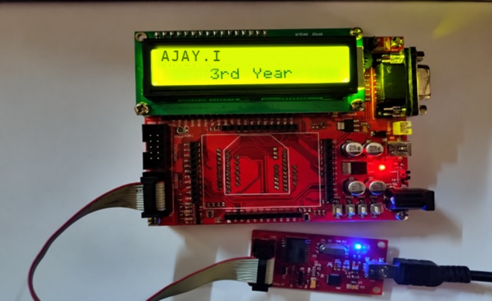

B. LCD WITH SWITCH CONTROL
AIM:
To interface an LCD with the 8051 microcontroller and show a different message for each switch that is pressed.

ALGORITHM:
1. Start the program.
2. Include the required header file and define LCD, switch, EN, RS, RW and buzzer pins.
3. Initialize the LCD.
4. Display “Press Any Switch” initially.
5. Continuously check the switches.
6. If SW1 is pressed, display “Pressed Switch 1”.
7. If SW2 is pressed, display “Pressed Switch 2”.
8. If SW3 is pressed, display “Pressed Switch 3”.
9. Stop the program.

PROGRAM:
#include <REGX52.H>
#define LCD_PORT P0
#define EN P1_0
#define RS P1_2
#define RW P1_1
#define SW1 P2_0
#define SW2 P2_1
#define SW3 P2_2
#define beep P1_6
void Lcd_Initial(void);
void lcd_command(char);
void lcd_data(char);
void lcd_display(unsigned char, const char *);

void delay(unsigned int);
void main()
{
P2 = 0x07;
Lcd_Initial();
lcd_display(0x80, "Press Any Switch");
delay(100);
while(1)
{
if(SW1 == 0)
{
while(!SW1);
beep = 0;
delay(25);
beep = 1;
lcd_display(0x80, "Pressed Switch 1");
}
if(SW2 == 0)
{
while(!SW2);
beep = 0;
delay(25);
beep = 1;
lcd_display(0x80, "Pressed Switch 2");
}
if(SW3 == 0)
{
while(!SW3);
beep = 0;
delay(25);
beep = 1;
lcd_display(0x80, "Pressed Switch 3");
}
}
}
void Lcd_Initial(void)
{
lcd_command(0x30);
lcd_command(0x30);
lcd_command(0x30);
lcd_command(0x38);
lcd_command(0x01);
lcd_command(0x06);
lcd_command(0x0C);
}
void lcd_command(char value)
{
RW = 0;
RS = 0;
EN = 1;
LCD_PORT = value;
delay(1);
EN = 0;
}
void lcd_data(char value)
{
RW = 0;
RS = 1;
EN = 1;
LCD_PORT = value;
delay(1);
EN = 0;
}
void lcd_display(unsigned char locn, const char *dat)
{
lcd_command(locn);
while(*dat != '\0')
{
lcd_data(*dat);
dat++;
}
}
void delay(unsigned int count)
{
int x, y;
for(x = 0; x < count; x++)
for(y = 0; y < 1275; y++);
}
OUTPUT:
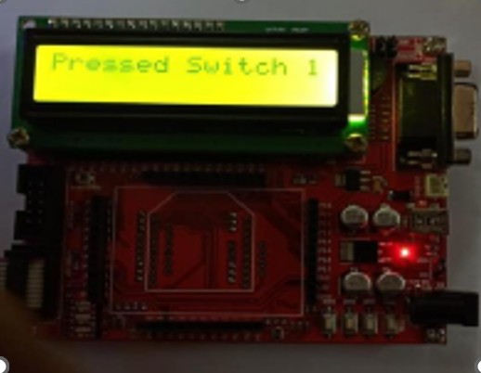

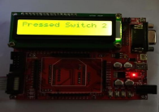

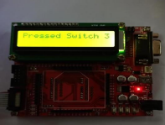

RESULT:
Thus, the 8051 C programs for LCD interfacing and for LCD with switch control were executed and verified successfully.

EXP NO.8 | ARM7 PROGRAMMING TO INTERFACE LED AND LCD
DATE: 28.08.26 | ARM7 PROGRAMMING TO INTERFACE LED AND LCD

A. Interfacing ARM7 with LED using LPC2148.

AIM:
To demonstrate the interfacing of an LED and an LCD with the ARM7 LPC2148 processor, to control the LED and to display the given text on the LCD.

PROCEDURE:
1. Create a new project.
2. Select ARM → ARM7.
3. Enter the source code.
4. Save the program.
5. Add the source code to the target.
6. Compile and build the target.
7. Generate the HEX file.
8. Add the HEX file to the LPC2000 Flash Utility.
9. Transfer the HEX file to the ARM processor.
10. End the program.

PROGRAM:
#include <lpc21xx.h>

void delay(unsigned long val);

int main()
{
IO1DIR = 0x00FF0000;

while(1)
{
IO1SET = 0x00FF0000;
delay(1000000);

IO1CLR = 0x00FF0000;
delay(1000000);
}
}

void delay(unsigned long val)
{
while(val > 0)
val--;
}

PHILIPS LPC2000 FLASH UTILITY
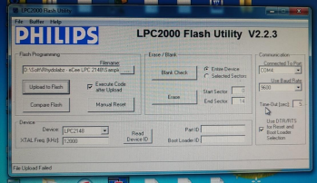

OUTPUT:
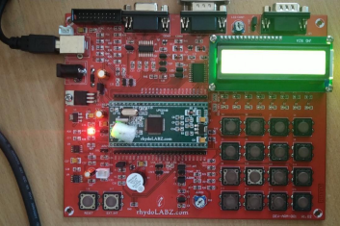

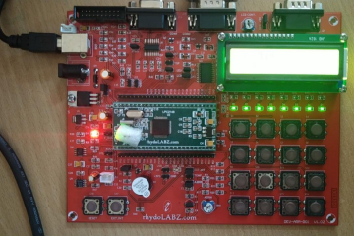

B. ARM7 Programming for LCD Interface
AIM:
To interface an LCD with the ARM7 LPC2148 processor and display the given text on it.

PROCEDURE:
1. Create a new project.
2. Select ARM → ARM7.
3. Enter the source code.
4. Save the program.
5. Add the source code to the target.
6. Compile and build the target.
7. Generate the HEX file.
8. Add the HEX file to the LPC2000 Flash Utility.
9. Transfer the HEX file to the ARM processor.
10. End the program.

PROGRAM:
#include <LPC21xx.h>
#include "lcd4bit.h"
void Delay(unsigned long b)
{
while(--b != 0);
}
void write_command(int cmd)
{
IO1CLR |= 0x00f00000;
IO1CLR |= 0x00040000;
IO1CLR |= 0x00020000;
IO1SET |= 0x00f00000 & cmd;
IO1SET |= 0x00080000;
Delay(30000);
IO1CLR |= 0x00080000;
}
void write_data(int dat)
{
IO1CLR |= 0x00f00000;
IO1CLR |= 0x00040000;
IO1SET |= 0x00020000;
IO1SET |= 0x00f00000 & dat;
IO1SET |= 0x00080000;
Delay(30000);
IO1CLR |= 0x00080000;
}
void lcd_data(char dat)
{
write_data(dat << 16);
write_data(dat << 20);
}
void lcd_command(char cmd)
{
write_command(cmd << 16);
write_command(cmd << 20);
}
void printlcd(char *CPtr)
{
while(*CPtr != '\0')
{
lcd_data(*CPtr);
CPtr++;
Delay(20000);
}
}
void init_lcd(void)
{
IO1DIR |= 0x00FE0000;
Delay(200000);
write_command(0x30 << 16);
Delay(100000);
write_command(0x30 << 16);
Delay(100000);
write_command(0x30 << 16);
Delay(100000);
write_command(0x20 << 16);
lcd_command(0x01);
lcd_command(0x06);
lcd_command(0x0c);
lcd_command(0x80);
}

int main(void)
{
init_lcd();
printlcd("eCee LPC2148 DLB");
lcd_command(0xC0);
printlcd(" rhydolabz.com ");
while(1);
}

PHILIPS LPC2000 FLASH UTILITY:

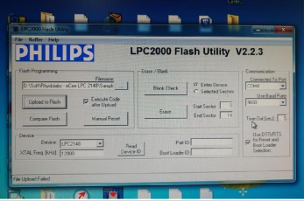

OUTPUT:

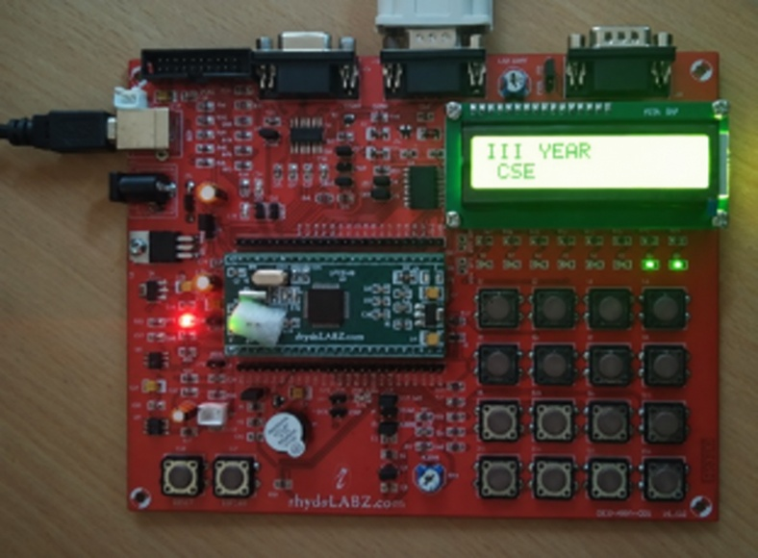

RESULT:
Thus, the ARM7 programs for LED and LCD interfacing were executed and verified successfully.

EXP NO.9 | ARM7 PROGRAMMING FOR BUZZER INTERFACE
DATE: 11.09.26 | ARM7 PROGRAMMING FOR BUZZER INTERFACE

AIM:
To demonstrate how a buzzer is interfaced with the ARM7 processor.

PROCEDURE:
1. Create a new project.
2. Select ARM → ARM7.
3. Enter the source code.
4. Save the program.
5. Add the source code to the target.
6. Compile and build the target.
7. Generate the HEX file.
8. Add the HEX file to the LPC2000 Flash Utility.
9. Transfer the HEX file to the ARM processor.
10. End the program.

PROGRAM:
#include <lpc21xx.h>
void ext_interrupt(void) irq
{
EXTINT = 0X02;
IO0PIN = (IO0PIN ^ 0X00010080) & 0X00010080;
VICVectAddr = 0x00000000;
}
void init_ext(void)
{
PINSEL0 |= 0X20000000;
EXTMODE = 0X02;
EXTPOLAR = 0X02;
VICVectAddr0 = (unsigned int)ext_interrupt;
VICVectCntl0 = 0x0000002F;
VICIntEnable = 0x00008000;
}
int main(void)
{
IO0DIR = 0X00010080;
init_ext();
while(1);
}

PHILIPS LPC2000 FLASH UTILITY

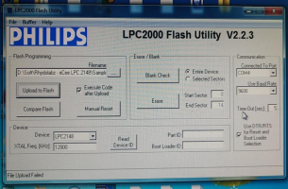

OUTPUT:
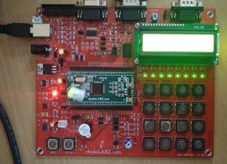

RESULT:
Thus, the ARM7 program for buzzer interfacing was executed and verified successfully.

EXP NO.10 | ARM7 PROGRAMMING FOR TIMER CONTROLLING OPERATION
DATE: 25.09.26 | ARM7 PROGRAMMING FOR TIMER CONTROLLING OPERATION

AIM:
To demonstrate LED blinking with the help of a Timer of the ARM7 processor.

PROCEDURE:
1. Create a new project.
2. Select ARM → ARM7.
3. Enter the source code.
4. Save the program.
5. Add the source code to the target.
6. Compile and build the target.
7. Generate the HEX file.
8. Add the HEX file to the LPC2000 Flash Utility.
9. Transfer the HEX file to the ARM processor.
10. End the program.

PROGRAM:
#include <lpc21xx.h>
void timer0_delay_ms(unsigned int ms)
{
T0TCR = 0x02;
T0PR = 14999;
T0TCR = 0x01;
while (T0TC < ms);
T0TCR = 0x00;
}
int main(void)
{
IO0DIR = 0x00000080;
while (1)
{
IO0SET = 0x00000080;
timer0_delay_ms(500);
IO0CLR = 0x00000080;
timer0_delay_ms(500);
}
}

PHILIPS LPC2000 FLASH UTILITY:

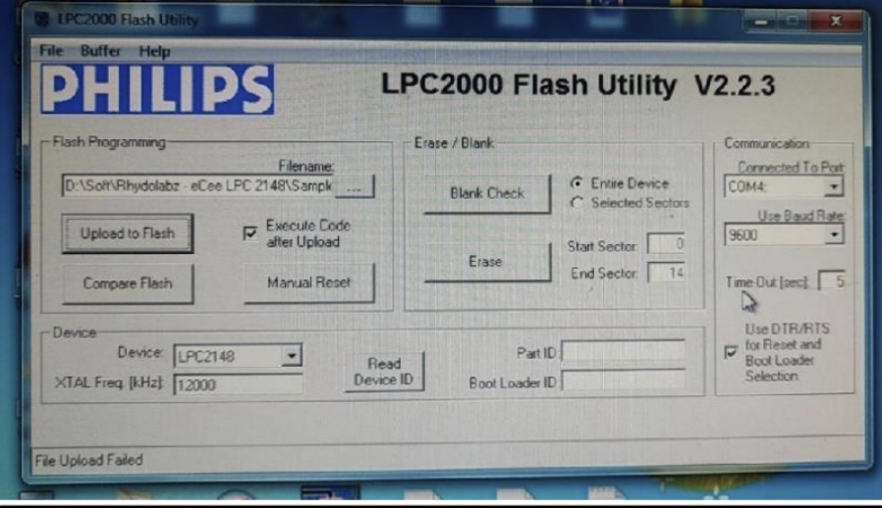

OUTPUT:
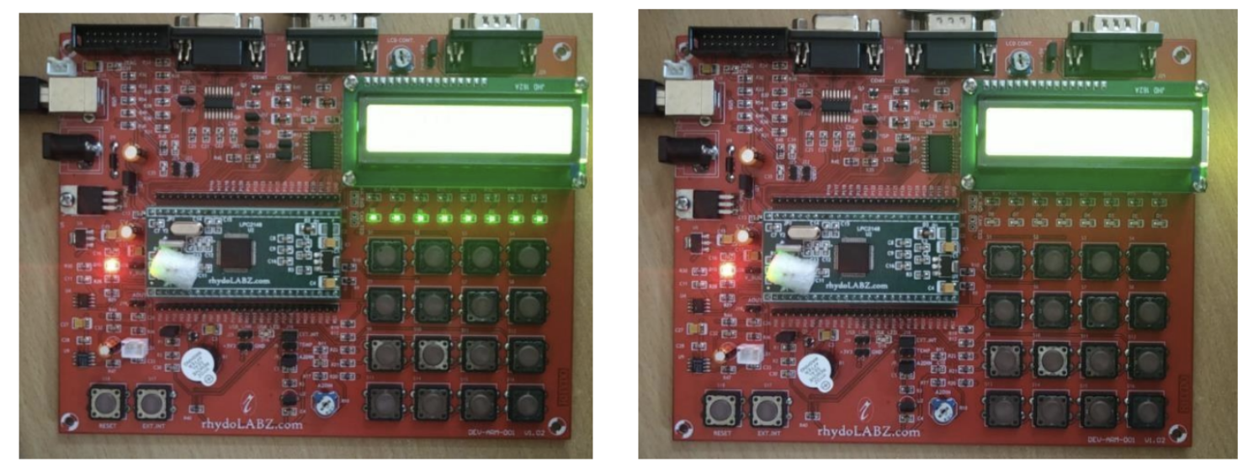

RESULT:
Thus, the ARM7 program for LED blinking using the Timer was executed and verified successfully.

EXP NO.CBS-1 | VIRTUAL LABS PROGRAMMING FOR DELAY GENERATION AND EFFECT OF CPU CLOCK
DATE: 27.06.26

AIM
To study the effect of CPU clock on Microcontroller operations.
OBJECTIVE
To investigate the impact of varying the clock speed of a PIC18F4550 series microcontroller on the execution speed of instructions and to understand how CPU clock frequency affects the overall performance of the microcontroller.
PROCEDURE
1. Open the Virtual Labs simulator.
2. Select the required CPU Clock Frequency.
3. Enter the Total Delay between 1 ms and 1000 ms.
4. Enter the ON Delay and OFF Delay such that:
5. Click SUBMIT.
6. Select the required output pin.
7. Select the LED Configuration.
8. Click GENERATE CODE.
9. Click COMPILE CODE.
10. Click EXECUTE CODE.
11. The MIMIC window opens.
12. Connect the selected pin to the LED anode.
13. Connect the LED cathode to the resistor.
14. Click Check Connection.
15. If the connection is incorrect, click Reset Connection and reconnect.
16. Click Run.
17. Observe the LED blinking and square wave output.
18. Repeat the experiment with different clock frequencies.
SIMULATIONS:
SCENARIO – 1
INPUT PARAMETERS:
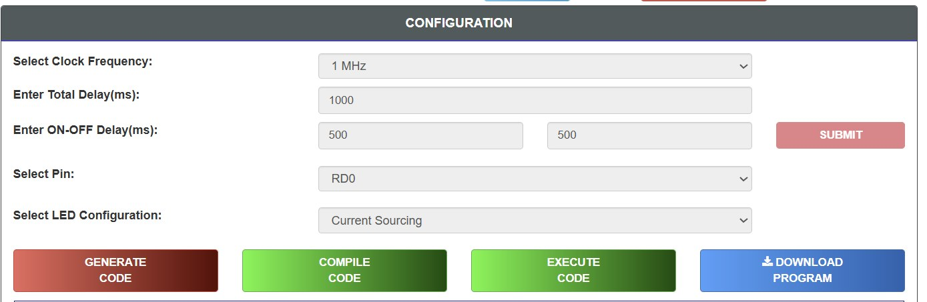
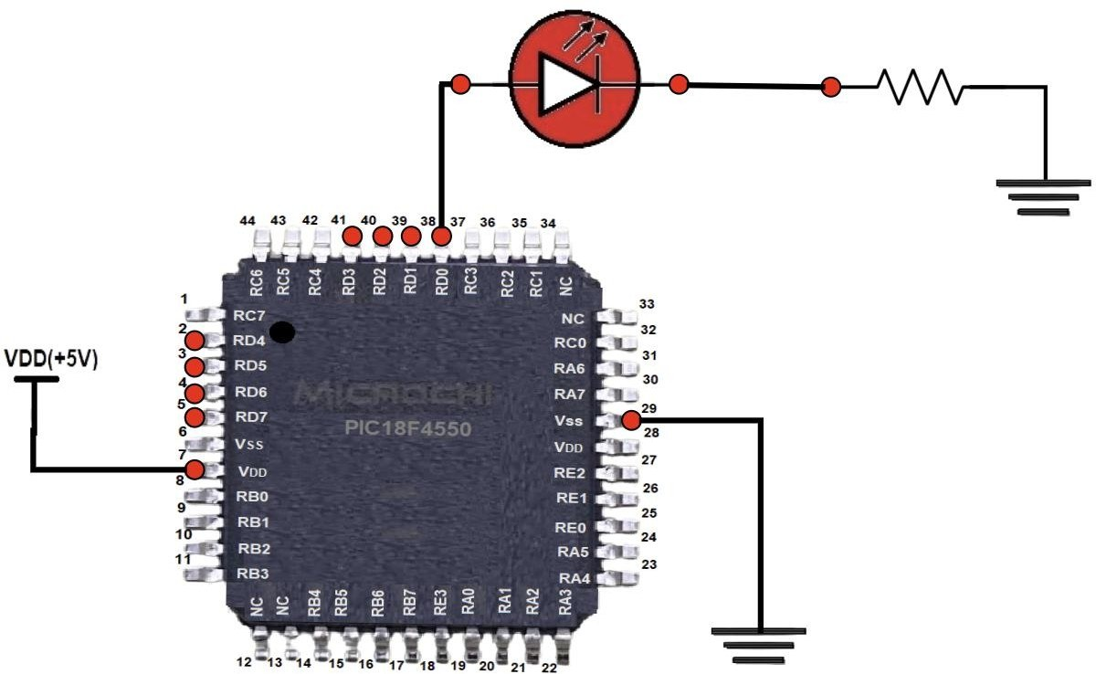 | 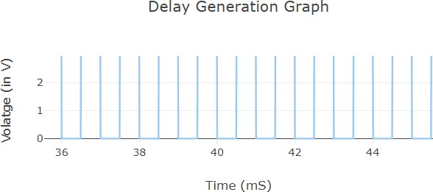

SCENARIO – 2
INPUT PARAMETERS:
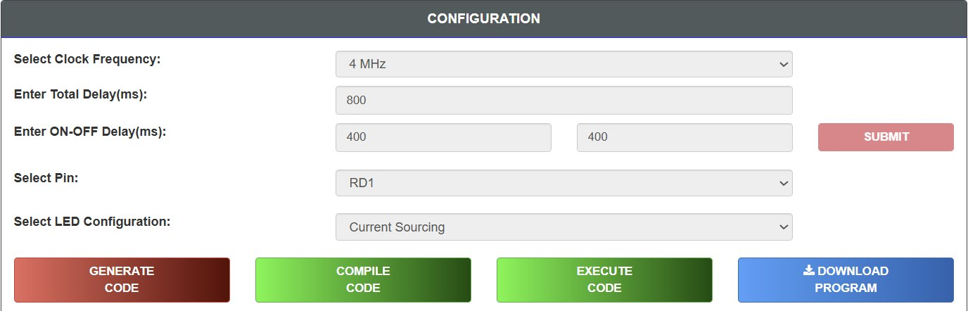
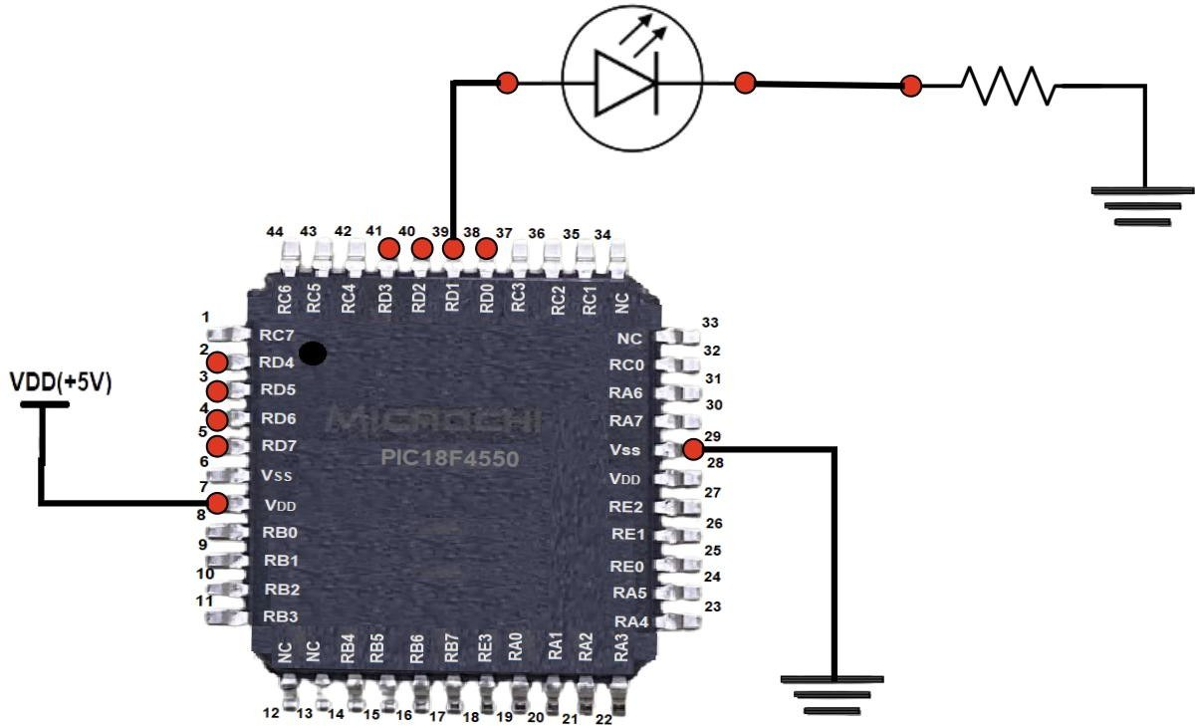 | 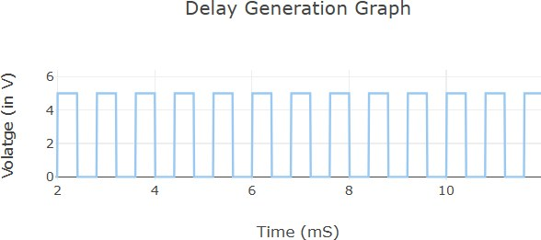

SCENARIO – 3
INPUT PARAMETERS:
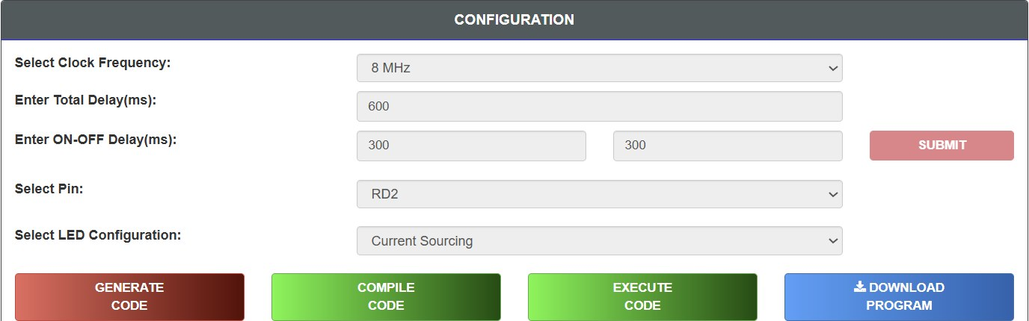
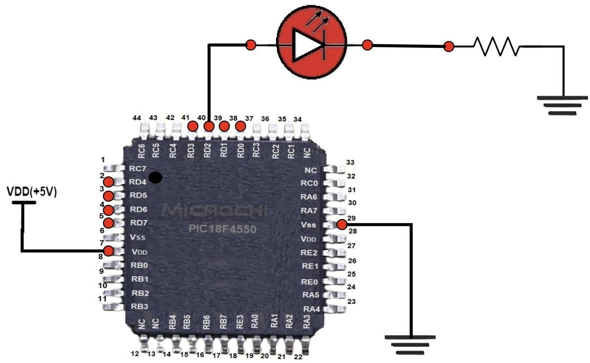 | 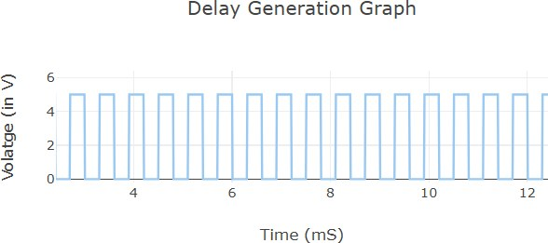

SCENARIO – 4
INPUT PARAMETERS:
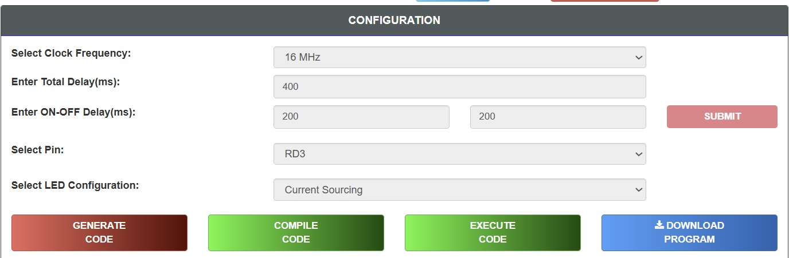
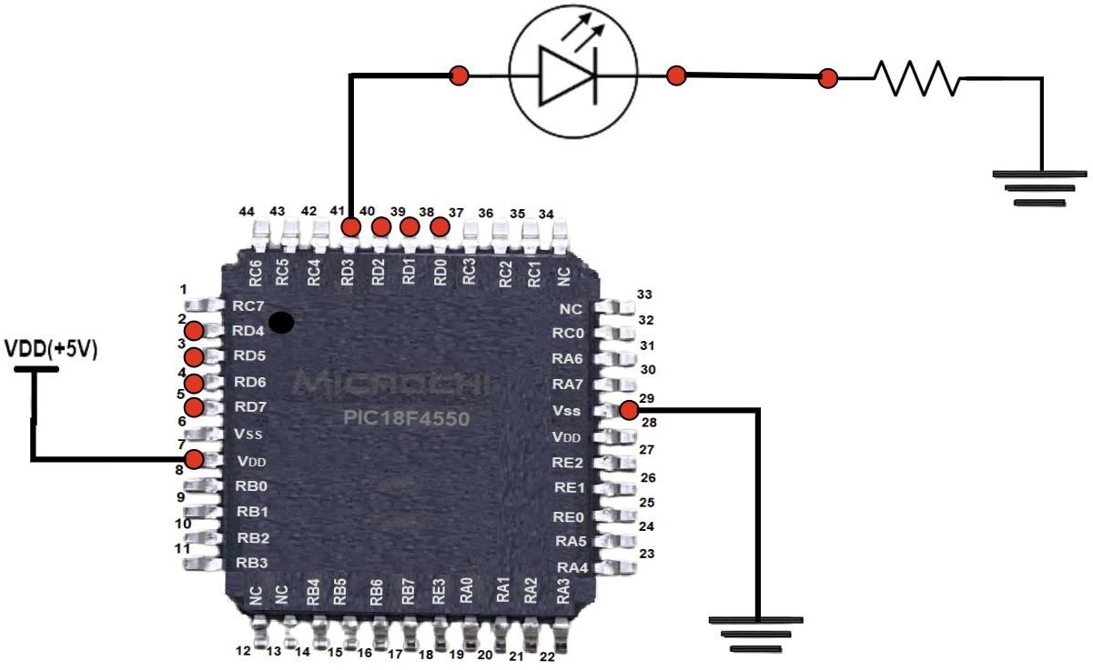 | 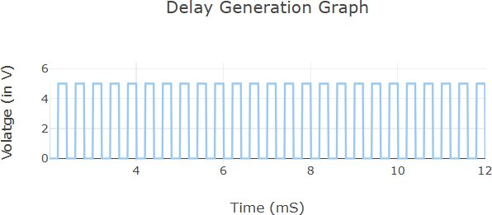

SCENARIO – 5
INPUT PARAMETERS:
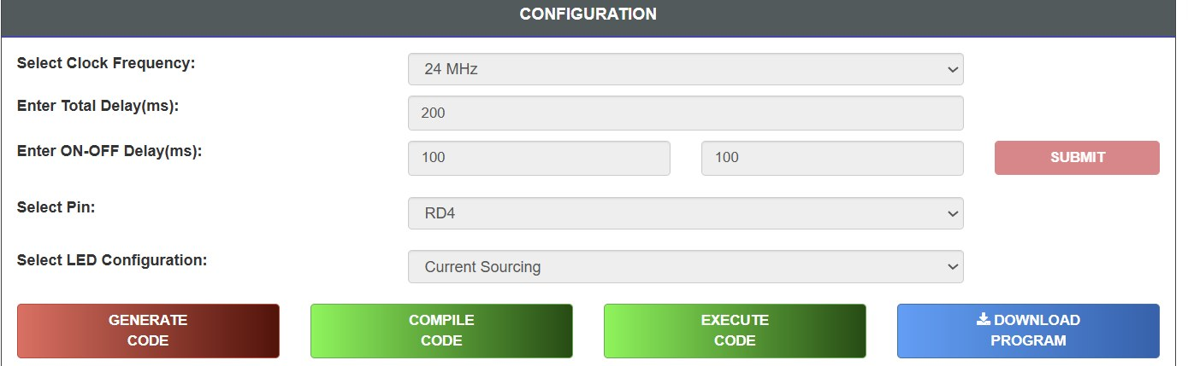
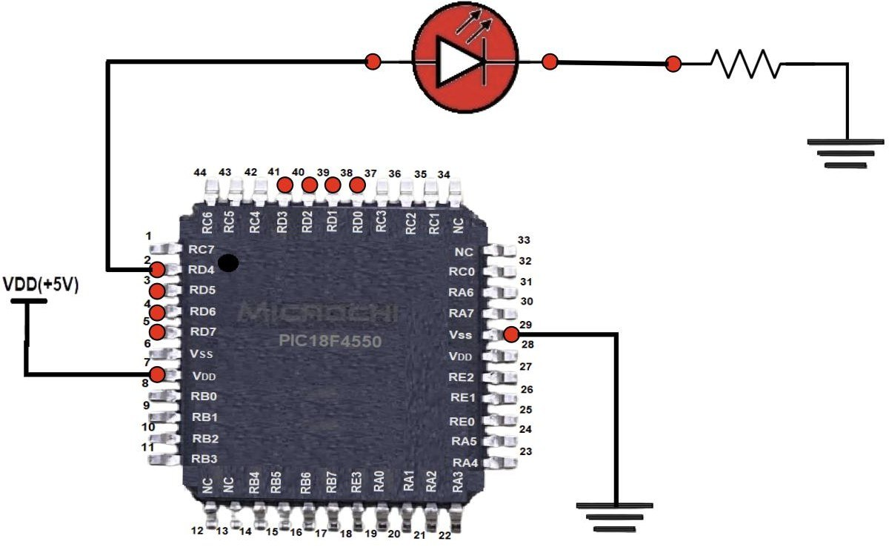 | 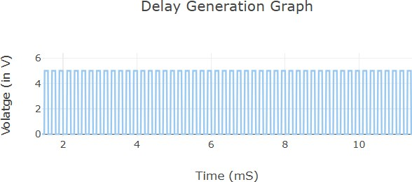

RESULT:
Thus, the effect of CPU clock frequency on the operation of the PIC18F4550 microcontroller was studied successfully. It was observed that increasing the clock frequency decreases instruction execution time, resulting in faster LED blinking and quicker program execution.

EXP NO.CBS-2 | VIRTUAL LABS PROGRAMMING FOR I/O INTERFACING (LED AND SWITCH INTERFACING)
DATE: 03.07.26

AIM
To write a program for LED blinking through a push button using the PIC18F4550 series microcontroller.
OBJECTIVE
To demonstrate the use of the PIC18F4550 microcontroller's GPIO (General Purpose Input Output) pins for interfacing an input device (push button switch) and an output device (LED). The experiment aims to understand how the microcontroller reads the state of a push button and controls the LED accordingly.
PROCEDURE
1. Open the Virtual Labs simulator.
2. Select the Input Pin for the Switch.
3. Select the Output Pin for the LED.
4. Select the Switch Configuration.
5. Select the LED Configuration.
6. Click GENERATE CODE.
7. Click COMPILE CODE.
8. Click EXECUTE CODE.
9. The MIMIC window opens.
10. Connect the selected Output Pin to the LED Anode.
11. Connect the LED Cathode to the resistor.
12. Connect the selected Input Pin to the Switch.
13. Click Check Connection.
14. If the connection is incorrect, click Reset Connection and reconnect.
15. Press and hold the Switch.
16. Observe the LED and square wave output.
17. Repeat the experiment with different pin configurations.
SIMULATIONS:
SCENARIO – 1
INPUT PARAMETERS:
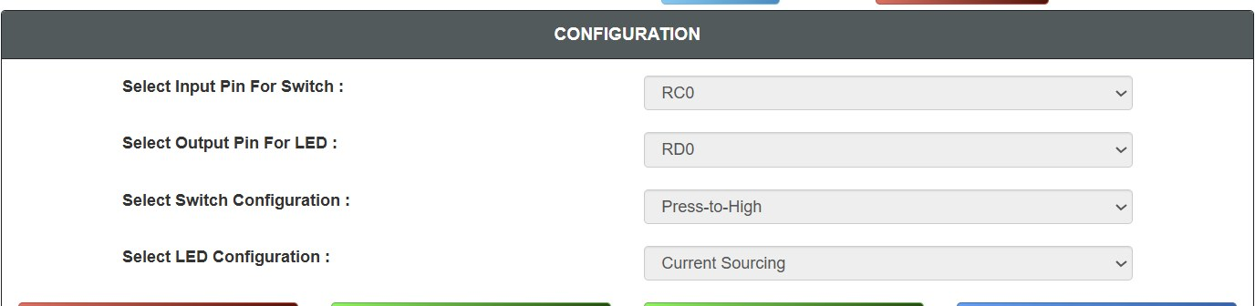
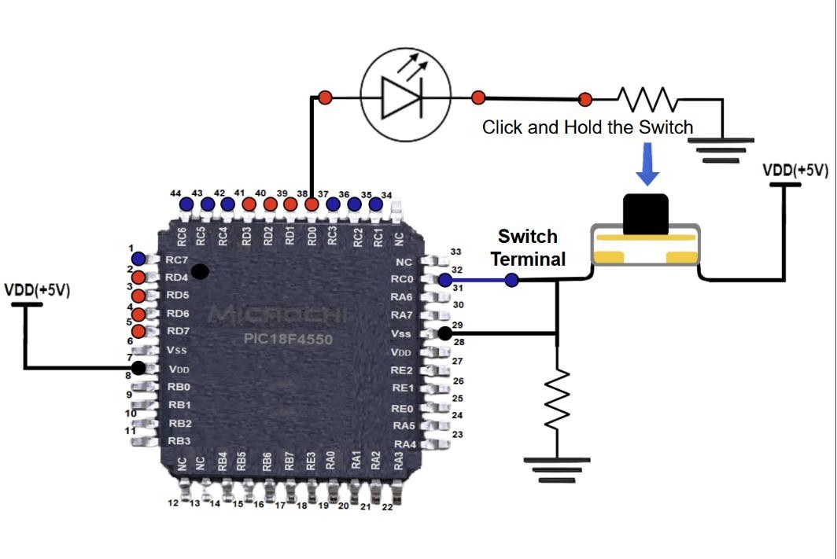 | 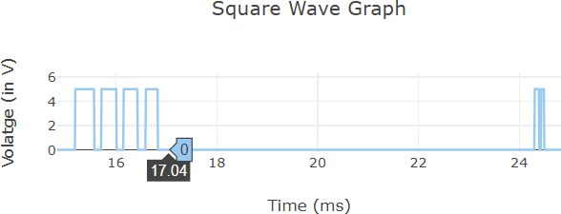

SCENARIO – 2
INPUT PARAMETERS:
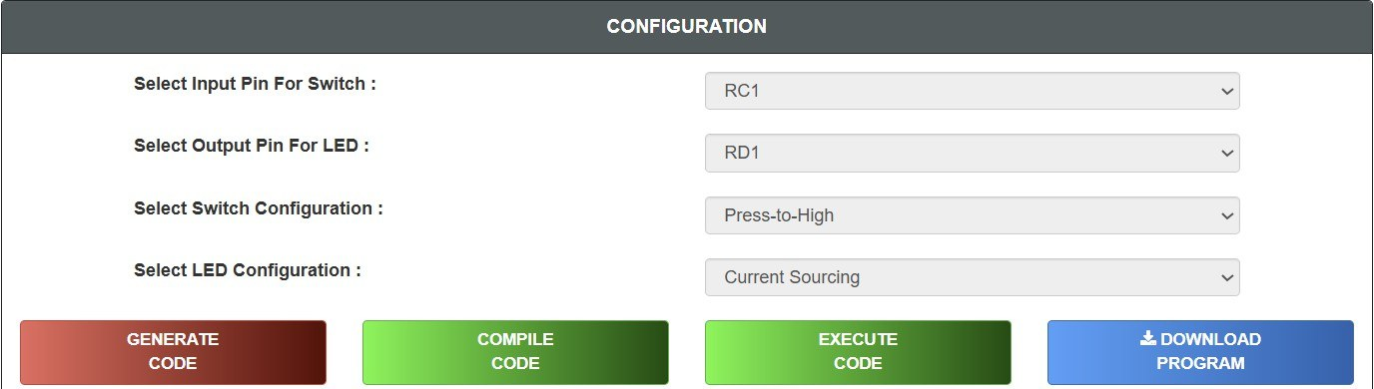
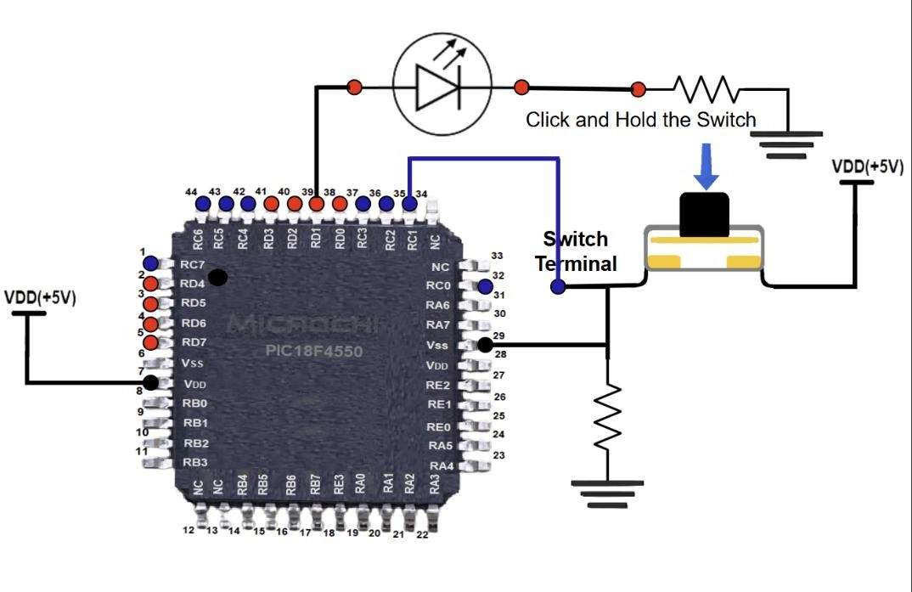 | 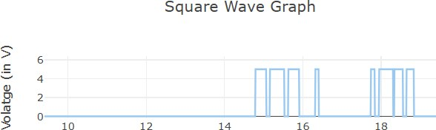

SCENARIO – 3
INPUT PARAMETERS:
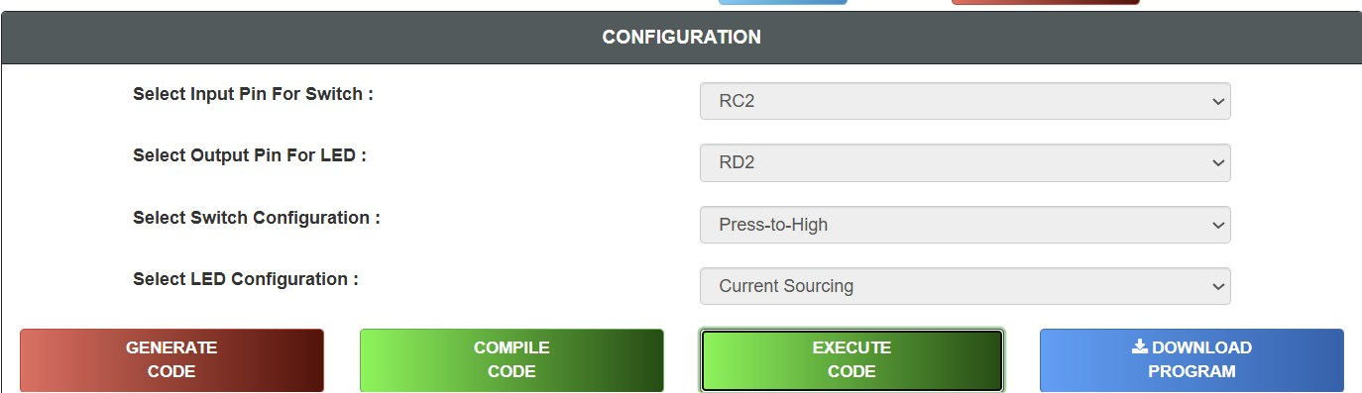
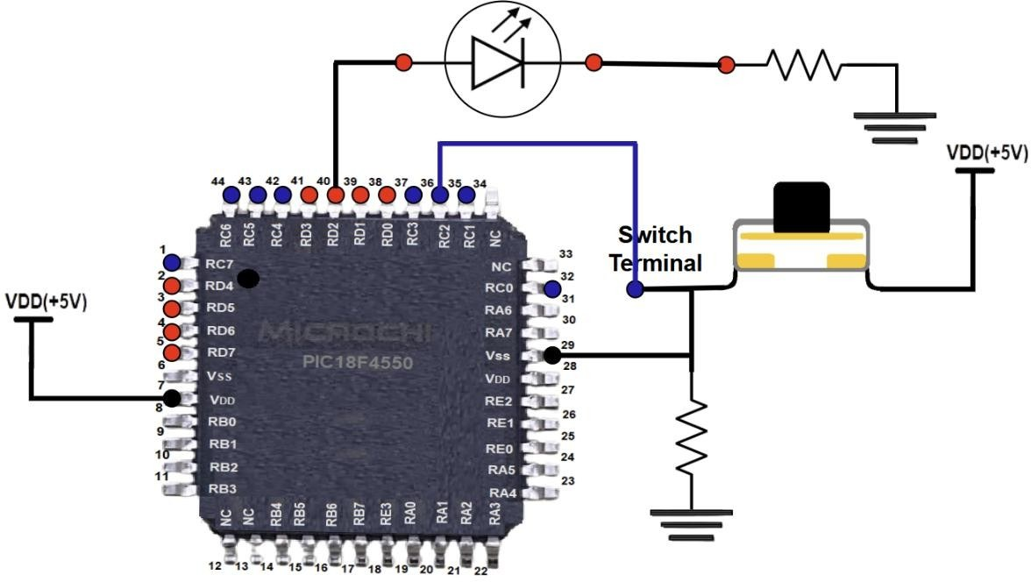 | 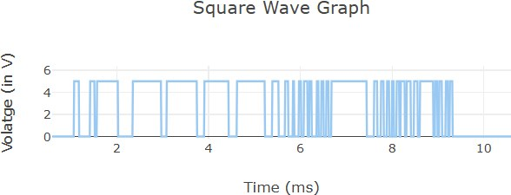

SCENARIO – 4
INPUT PARAMETERS:
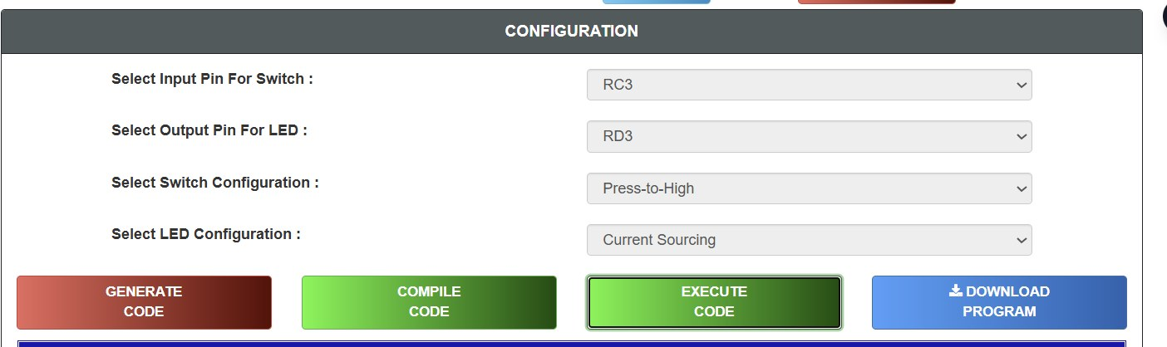
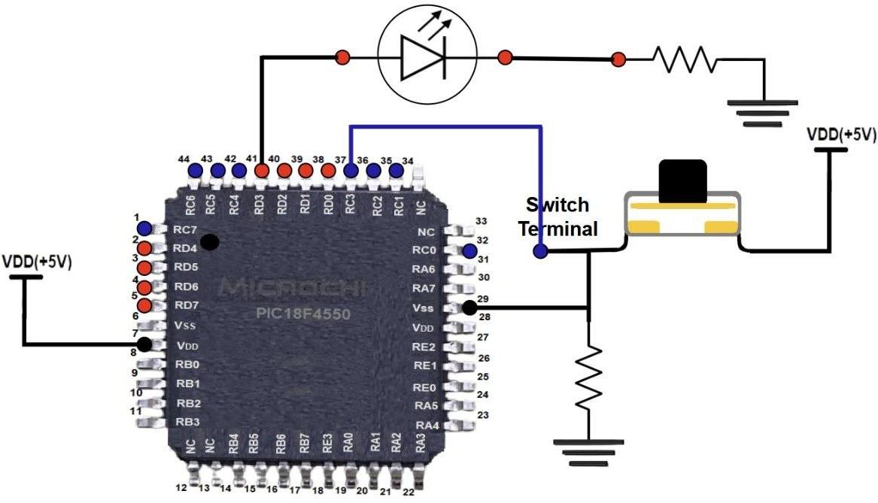 | 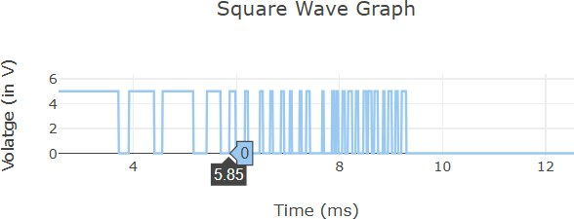

SCENARIO – 5
INPUT PARAMETERS:
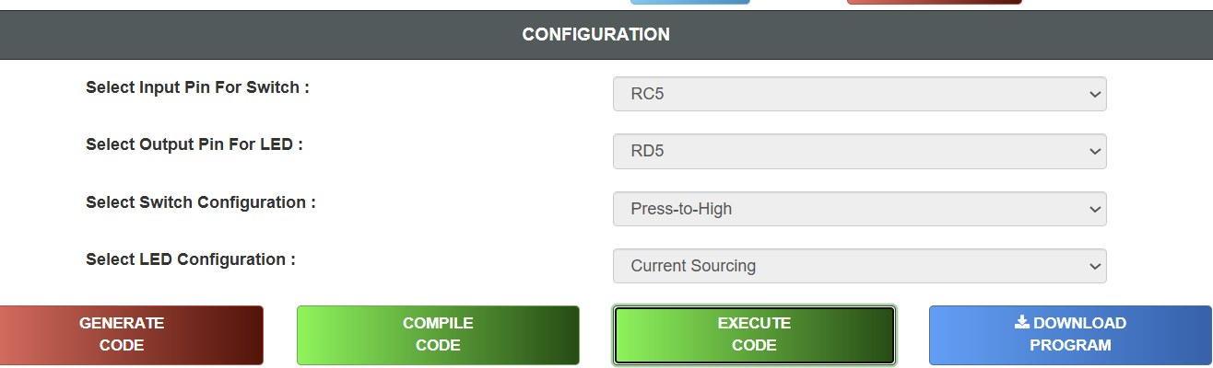
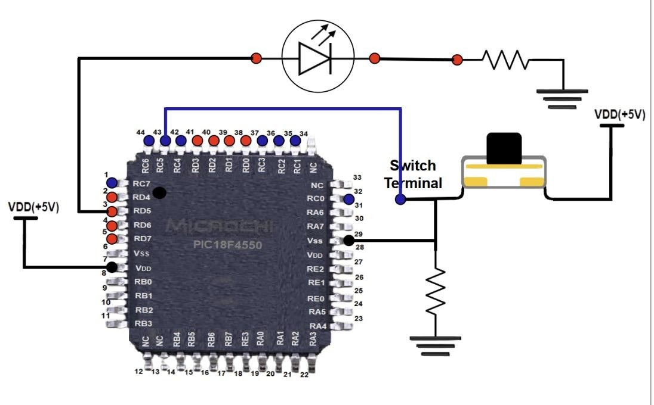 | 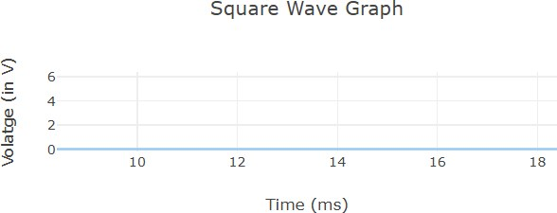 | 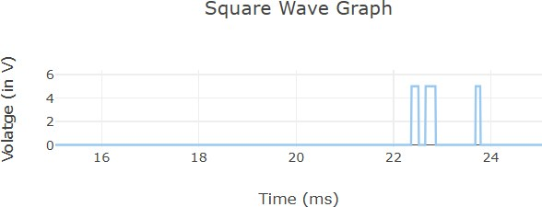 | 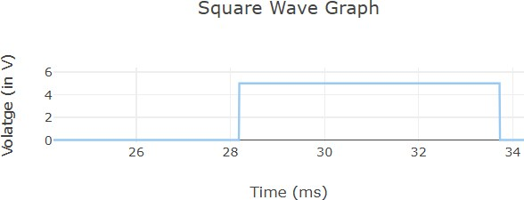

RESULT:
Thus, the interfacing of a push button switch and an LED using the PIC18F4550 microcontroller was successfully studied. The GPIO pins correctly detected the switch input and controlled the LED output.

EXP NO.CBS-3 | VIRTUAL LABS PROGRAMMING WITH ON-CHIP TIMERS/COUNTERS
DATE: 03.07.26 | VIRTUAL LABS PROGRAMMING WITH ON-CHIP TIMERS/COUNTERS

AIM
To study programming with on-chip Timers/Counters using the PIC18F4550 microcontroller.
OBJECTIVE
• To understand the basic concepts of Timer and Counter.
• To study Timer0 of the PIC18F4550 microcontroller.
• To understand the interrupt structure of the PIC18F4550.
• To generate accurate delays using Timer0 and interrupts.
PROCEDURE
1. Select the Operating Frequency.
2. Select the Timer.
3. Select the Prescaler.
4. Select Enable Interrupt.
5. Enter ON Delay (in ms).
6. Enter OFF Delay (in ms).
7. Click GENERATE CODE.
8. Click COMPILE CODE.
9. Click EXECUTE CODE.
10. The MIMIC window opens.
11. Connect the output pin to the LED anode.
12. Connect the LED cathode to the resistor.
13. Click CHECK CONNECTION.
14. If the connection is incorrect, click RESET CONNECTION and reconnect.
15. Click RUN.
16. Observe the LED blinking and square wave output.
17. Click REFRESH to repeat the experimentSIMULATIONS
SIMULATIONS:
SCENARIO – 1
INPUT PARAMETERS:
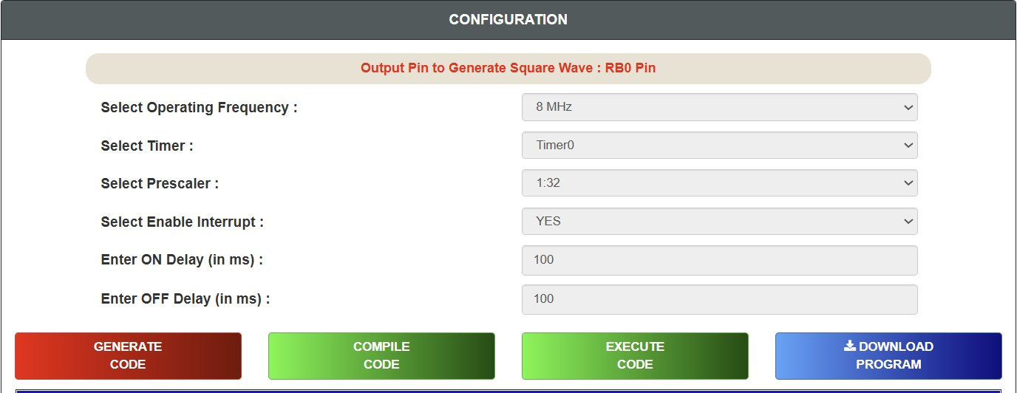
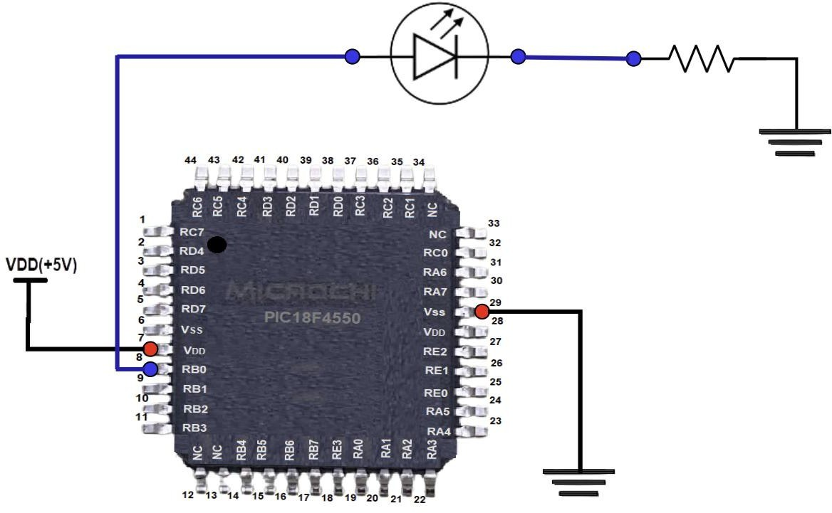 | 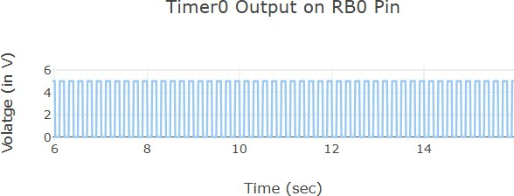

SCENARIO – 2
INPUT PARAMETERS:
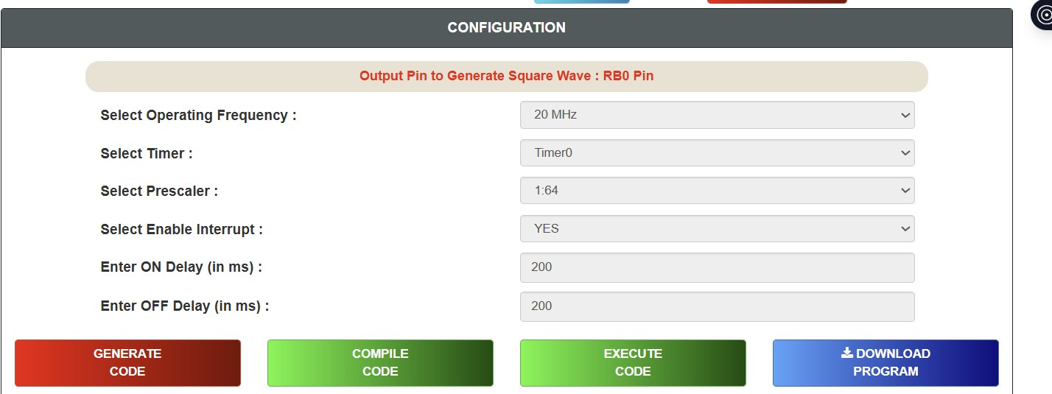
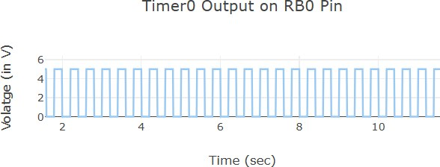

SCENARIO – 3
INPUT PARAMETERS:
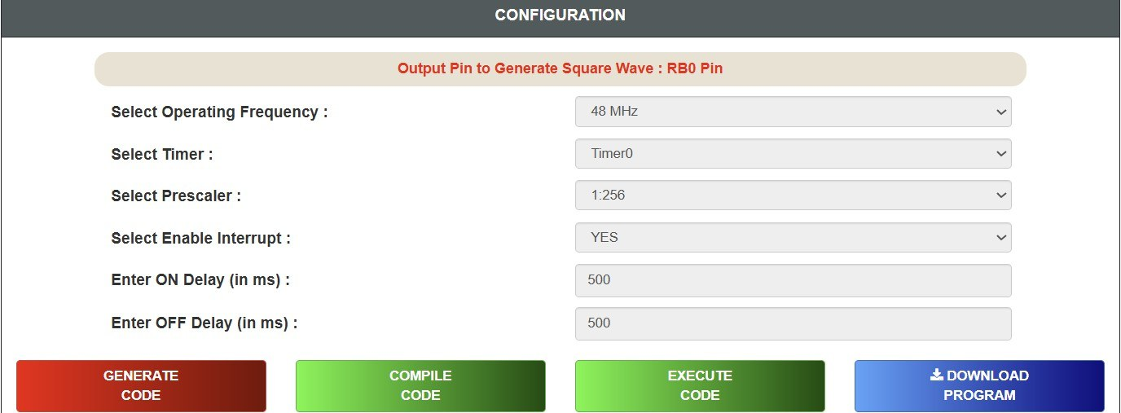
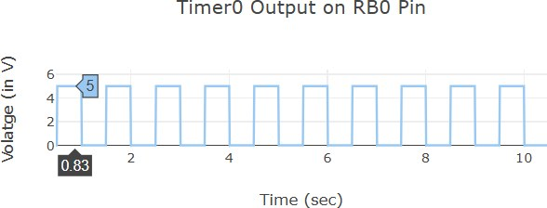

SCENARIO – 4
INPUT PARAMETERS:
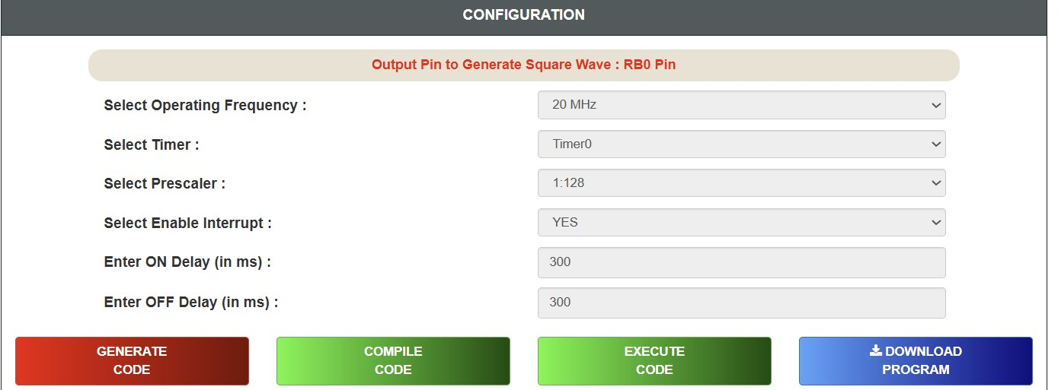
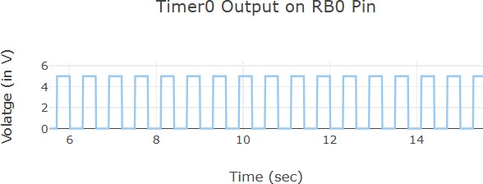

SCENARIO – 5
INPUT PARAMETERS:
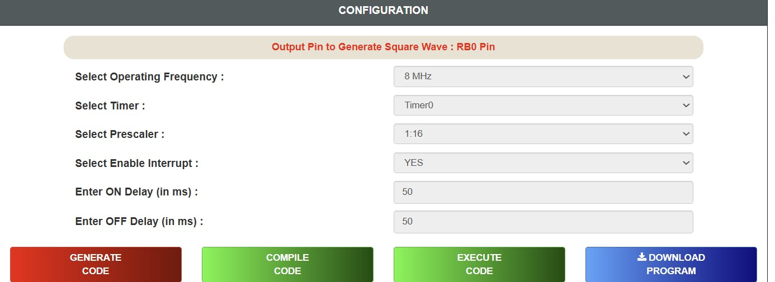
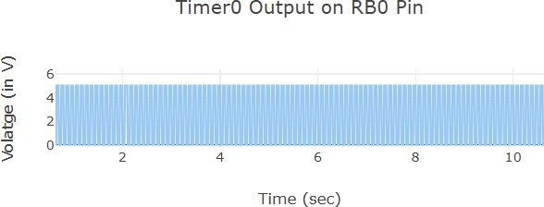

RESULT:
Thus, programming with on-chip Timers/Counters using the PIC18F4550 microcontroller was studied successfully.

