EX.NO.1 | STUDY OF HTML TAGS
DATE: 29.06.26 | STUDY OF HTML TAGS

AIM:
To study about different HTML tags and their usage in webpage creation.
DESCRIPTION:
HTML (HyperText Markup Language) is the standard markup language used to create web pages. It defines the structure of a webpage using different tags. Browsers interpret these tags and display the webpage accordingly.
HTML consists of:
- Elements (tags)
- Attributes
- Content
HTML tags are predefined keywords enclosed within angle brackets (< >) that tell the browser how to display or organize the content on a web page.
Most HTML tags have:
- Opening tag
- Content
- Closing tag
HTML SYNTAX:
<!DOCTYPE html>
<html>
<head>
<title>My First Web Page</title>
</head>
<body>
<h1>Welcome to HTML</h1>
<h2>Let's Learn HTML Tags</h2>
<p>This is Ajay's first HTML page.</p>
</body>
</html>
Output:
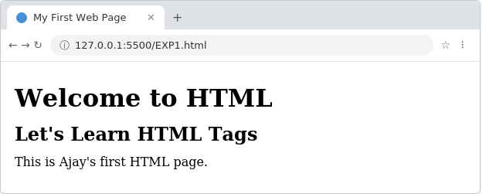
TAGS in HTML:
1. Heading Tag (<h1> to <h6>) : Displays headings with different font sizes.
Syntax:
<h1>Heading 1</h1>
<h2>Heading 2</h2>
<h3>Heading 3</h3>
<h4>Heading 4</h4>
<h5>Heading 5</h5>
<h6>Heading 6</h6>
Output:
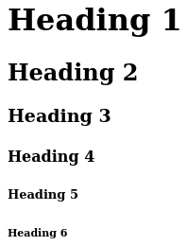
2. Paragraph Tag (<p>) : Displays text as a paragraph.
Syntax:
<p>
HTML (HyperText Markup Language) is the standard language used to
create web pages. It provides the basic structure of a webpage and
works together with CSS and JavaScript to build attractive and
interactive websites.
</p>
Output:
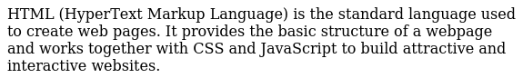
3. Line Break Tag (<br>) : Inserts a line break.
Syntax:
HTML<br>
CSS<br>
JavaScript
Output:
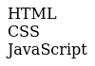
4. Horizontal Rule Tag (<hr>) : Inserts a horizontal line.
Syntax:
<p>First Section</p>
<hr>
<p>Second Section</p>
Output:
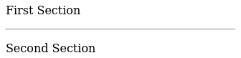
5. Bold Tag (<b>) : Displays bold text.
Syntax:
<b>Bold Text</b>
Output:
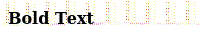
6. Italic Tag (<i>) : Displays italic text.
Syntax:
<i>Italic Text</i>
Output:
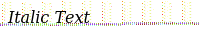
7. Underline Tag (<u>) : Underlines text.
Syntax:
<u>Underlined Text</u>
Output:
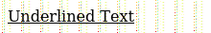
8. Superscript Tag (<sup>) : Displays superscript text.
Syntax:
x<sup>2</sup>
Output:
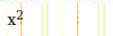
9. Subscript Tag (<sub>) : Displays subscript text.
Syntax:
H<sub>2</sub>O
Output:
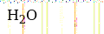
10. Anchor Tag (<a>) : Creates hyperlinks.
Syntax:
<a href="https://www.google.com">Visit Google</a>
Output:


11. Image Tag (<img>) : Displays an image.
Syntax:
<img src="flower.jpg" width="200" height="150" alt="wolf">
Output:

12. Ordered List (<ol>) : Displays a numbered list.
Syntax:
<ol>
<li>HTML</li>
<li>CSS</li>
<li>JavaScript</li>
</ol>
Output:
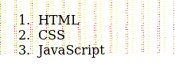
13. Unordered List (<ul>) : Displays a bulleted list.
Syntax:
<ul>
<li>Apple</li>
<li>Mango</li>
<li>Orange</li>
</ul>
Output:
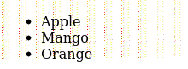
14. Table Tag (<table>) : Creates tables.
Syntax:
<table border="1">
<tr>
<th>Name</th>
<th>Age</th>
</tr>
<tr>
<td>Rahul</td>
<td>20</td>
</tr>
</table>
Output:
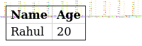
15. Form Tag (<form>) : Creates user input forms.
Syntax:
<form>
Name:
<input type="text"><br><br>
<input type="submit" value="Submit">
</form>
Output:
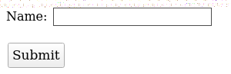
16. Input Tag (<input>) : Creates an input field.
Syntax:
<input type="text" placeholder="Enter Name">
Output:

17. Button Tag (<button>) : Creates a clickable button.
Syntax:
<button>Click Me</button>
Output:
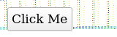
18. Division Tag (<div>) : Groups HTML elements into sections.
Syntax:
<div>
<h2>Student Details</h2>
<p>Name: Ajay</p>
</div>
Output:
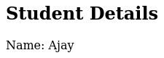
19. Span Tag (<span>) : Groups inline text for styling.
Syntax:
<p>
My favourite colour is
<span style="color:red;">Red</span>
</p>

Output:
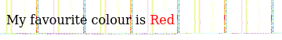
20. Marquee Tag (<marquee>) : Displays scrolling text.
Syntax:
<marquee>
Welcome to HTML Laboratory
</marquee>
Output:
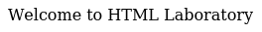

RESULT:
Thus, the basic structure of an HTML document and the usage of various HTML tags such as headings, paragraphs, formatting tags, links, images, lists, tables, forms, and other commonly used HTML elements were studied and executed successfully.

