EX.NO.2 | SIMPLE BLOG WEBPAGE CREATION USING HTML
DATE: | SIMPLE BLOG WEBPAGE CREATION USING HTML

AIM:

To design and develop a Personal Digital Profile webpage using HTML and CSS that displays personal information, educational qualifications, technical skills, daily routine, favourite website, favourite quote and contact details..

ALGORITHM:
- Create an HTML document.
- Add CSS inside the <style> tag.
- Create sections for About Me, Skills, Education, Routine, Favourite Website and Contact.
- Insert profile image.
- Apply CSS for colours and layout.
- Save the file as index.html and execute it in a browser.

HTML Code:

<!DOCTYPE html>

<html>

<head>

<title>My Digital Profile</title>

<style>

body{

font-family:Arial;

background:#f3f3f3;

margin:20px;

}

.container{

width:850px;

margin:auto;

background:white;

padding:20px;

border-radius:10px;

}

h1{

text-align:center;

color:navy;

}

img{

width:180px;

height:200px;

border-radius:10px;

border:2px solid gray;

}

table{

width:100%;

}

.section{

color:crimson;

}

ul,ol{

font-size:18px;

}

.routine td,.routine th{

border:1px solid black;

padding:8px;

text-align:center;

}

.routine{

border-collapse:collapse;

margin-top:10px;

}

.footer{

text-align:center;

margin-top:20px;

font-size:14px;

}

</style>

</head>

<body>

<div class="container">

<h1>WELCOME TO MY DIGITAL PROFILE</h1>

<table>

<tr>

<td width="30%">

<img src="ajay.jpg" alt="Ajay">

</td>

<td>

<h2 class="section">ABOUT ME</h2>

<p>

Hello! I am <b>Ajay</b>, a Third Year Computer Science and Engineering student at

<b>Sri Ramakrishna Engineering College, Coimbatore.</b>

I enjoy learning Full Stack Development, Artificial Intelligence,

Machine Learning and Data Science.

</p>

</td>

</tr>

</table>

<hr>

<table>

<tr>

<td>

<h2 class="section">MY SKILLS</h2>

<ul>

<li>HTML</li>

<li>CSS</li>

<li>JavaScript</li>

<li>Python</li>

<li>C Programming</li>

</ul>

</td>

<td>

<h2 class="section">EDUCATION</h2>

<ol>

<li>SSLC</li>

<li>HSC</li>

<li>B.E Computer Science and Engineering</li>

</ol>

</td>

</tr>

</table>

<hr>

<h2 class="section">MY DAILY ROUTINE</h2>

<table class="routine">

<tr>

<th>Time</th>

<th>Activity</th>

</tr>

<tr>

<td>8.00 AM</td>

<td>College</td>

</tr>

<tr>

<td>5.00 PM</td>

<td>Coding Practice</td>

</tr>

<tr>

<td>8.00 PM</td>

<td>Study</td>

</tr>

</table>

<hr>

<h2 class="section">FAVOURITE WEBSITE</h2>

<a href="https://openai.com">OpenAI</a>

<h2 class="section">FAVOURITE QUOTE</h2>

<p><i>"Learning never exhausts the mind."</i></p>

<p><b>— Leonardo da Vinci</b></p>

<hr>

<h2 class="section">CONTACT ME</h2>

<p><b>Name :</b> Ajay</p>

<p><b>College :</b> Sri Ramakrishna Engineering College</p>

<p><b>Department :</b> Computer Science and Engineering</p>

<p><b>City :</b> Coimbatore, Tamil Nadu</p>

<div class="footer">

© 2026 My Digital Profile

</div>

</div>

</body>

</html>

OUTPUT:
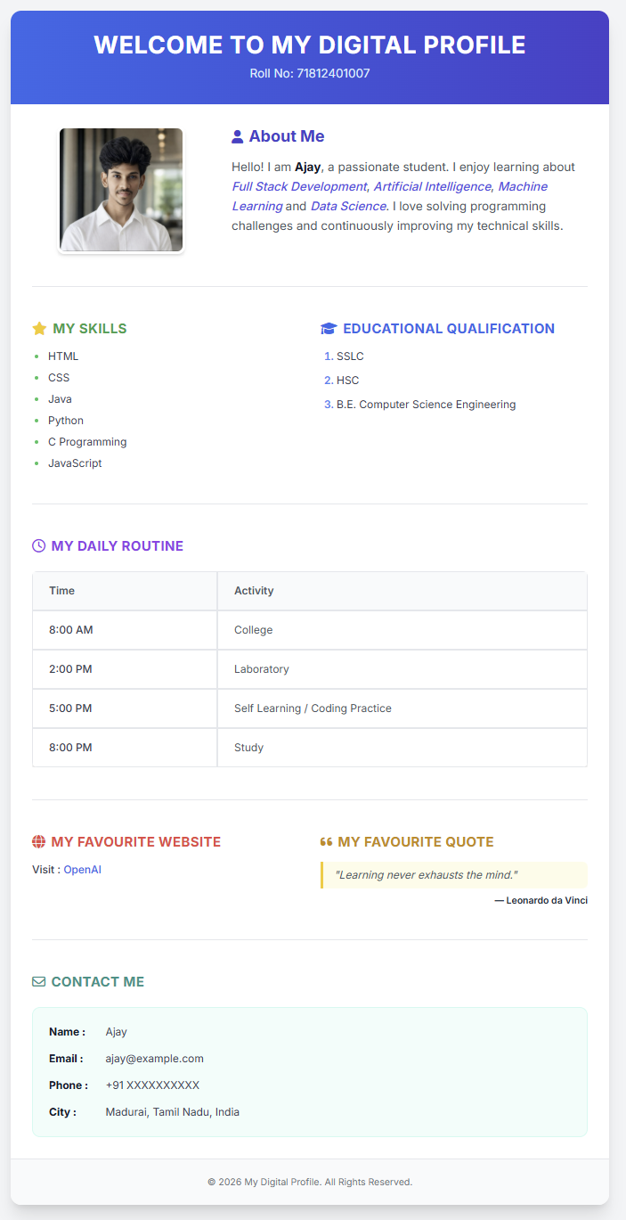

RESULT:

Thus, a Personal Digital Profile Web Page was successfully created using HTML and CSS and executed successfully in the web browser.

