EX.NO.3 | HOTSPOT CREATION
DATE: 13.07.26 | HOTSPOT CREATION

AIM:

To design a webpage that displays an image of the India map with clickable hotspots using HTML Image Maps. Clicking on different regions should navigate to their respective Wikipedia pages.

ALGORITHM:

Create an HTML file.

Create a CSS file for styling.

Add the India map image using the <img> tag.

Associate the image with an image map using the usemap attribute.

Create a <map> element.

Define hotspot areas using the <area> tag.

Specify the coordinates of each hotspot.

Provide Wikipedia links for each state.

Apply CSS styling.

Save the files.

Execute the HTML file in a web browser.

Verify that clicking each hotspot opens the correct webpage.

HTML Code:

<!DOCTYPE html>

<html>

<head>

<title>Ajay's India Map Hotspots</title>

<link rel="stylesheet" href="style.css">

</head>

<body>

<h1>INDIA MAP HOTSPOTS</h1>

<h2>Ajay's Statewise Wikipedia Finder</h2>

<p>

Click on any highlighted state to know more about it.

</p>

<img src="maps.png"

usemap="#india"

class="map">

<map name="india">

<!-- Jammu & Kashmir -->

<area

shape="circle"

coords="378,106,22"

href="https://en.wikipedia.org/wiki/Jammu_and_Kashmir"

target="_blank"

alt="Jammu and Kashmir">

<!-- Delhi -->

<area

shape="circle"

coords="429,323,15"

href="https://en.wikipedia.org/wiki/Delhi"

target="_blank"

alt="Delhi">

<!-- Odisha -->

<area

shape="circle"

coords="520,470,18"

href="https://en.wikipedia.org/wiki/Odisha"

target="_blank"

alt="Odisha">

<!-- Chennai -->

<area

shape="circle"

coords="512,620,18"

href="https://en.wikipedia.org/wiki/Chennai"

target="_blank"

alt="Chennai">

</map>

</body>

</html>

CSS CODE:

body{

margin:0;

padding:20px;

background:#f5f5f5;

font-family:Arial, Helvetica, sans-serif;

text-align:center;

}

h1{

color:darkblue;

margin-bottom:5px;

}

h2{

color:crimson;

margin-top:5px;

}

p{

font-size:20px;

color:#333;

}

.map{

width:850px;

max-width:100%;

border:3px solid black;

border-radius:8px;

margin-top:20px;

box-shadow:0 0 12px gray;

}

footer{

margin-top:25px;

color:#666;

font-size:16px;

}

OUTPUT:
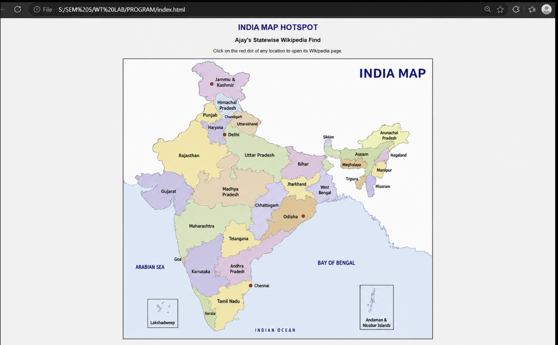

WIKIPEDIA PAGES IT OPENS TO:

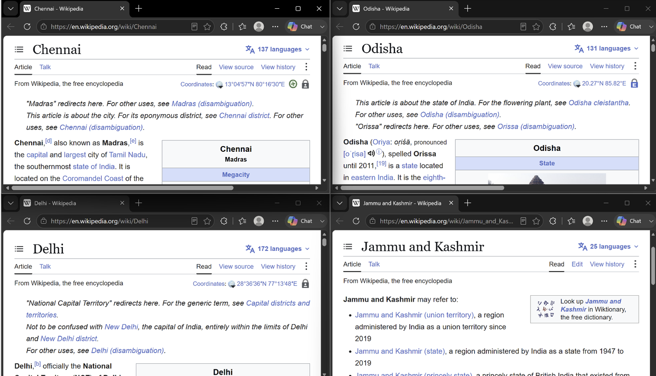

RESULT:

Thus, a webpage containing an India Map with clickable hotspots was successfully created using HTML Image Maps (<map> and <area>) and CSS. Each hotspot correctly navigates to its corresponding Wikipedia page when clicked.

