EX.NO.4 | REGISTRATION FORM FOR AN APPLICATION
DATE: 20.07.26 | REGISTRATION FORM FOR AN APPLICATION

AIM
To design and develop a PAN Card Registration Form using HTML and CSS that collects applicant personal details, address details, contact details, identity details, and PAN application information

ALGORITHM
- Create an HTML file with the basic structure using <html>, <head>, and <body> tags.
- Add the page title and link the external CSS file using the <link> tag.
- Design the webpage using an Indian Government (Income Tax Department) theme with appropriate colors and layout.
- Create a <form> element to hold all PAN registration fields.
- Add text fields for applicant name, father's name, mother's name, address, city, state, district, and PIN code using <input type="text">.
- Add a date field for date of birth using <input type="date">.
- Add radio buttons for gender and citizenship using <input type="radio">.
- Add a drop-down list for state and identity proof using <select> and <option> tags.
- Add fields for Aadhaar Number, Mobile Number, and Email ID using appropriate HTML input types.
- Add a declaration checkbox confirming that the information provided is correct.
- Add Submit and Reset buttons using <input type="submit"> and <input type="reset">.
- Apply CSS styles to provide an official Income Tax Department appearance using Indian Government colors, borders, spacing, typography, and responsive layout.
- Save both HTML and CSS files in the same folder and execute the HTML file in a web browser.
- Verify that the PAN Card Registration Form is displayed correctly and accepts user input successfully.

CODE
HTML:
<!DOCTYPE html>
<html>
<head>
<title>PAN Card Registration</title>
<link rel="stylesheet" href="style.css">
</head>

<body>

<div class="container">

<h2>Government of India</h2>
<h3>Income Tax Department</h3>
<h1>PAN Card Registration Form</h1>

<form>

<label>Full Name</label>
<input type="text" placeholder="Enter Name" required>

<label>Father's Name</label>
<input type="text" placeholder="Father's Name" required>

<label>Date of Birth</label>
<input type="date" required>

<label>Gender</label>

<input type="radio" name="gender"> Male
<input type="radio" name="gender"> Female
<input type="radio" name="gender"> Other

<br><br>

<label>Aadhaar Number</label>
<input type="text" placeholder="12 Digit Aadhaar Number">

<label>Mobile Number</label>
<input type="tel" placeholder="10 Digit Mobile Number">

<label>Email</label>
<input type="email" placeholder="Email Address">

<label>Address</label>
<textarea placeholder="Enter Address"></textarea>

<label>State</label>

<select>
<option>Tamil Nadu</option>
<option>Kerala</option>
<option>Karnataka</option>
<option>Andhra Pradesh</option>
<option>Telangana</option>
</select>

<br><br>

<input type="checkbox">
I declare that the information given above is correct.

<br><br>

<input type="submit" value="Register">

<input type="reset" value="Reset">

</form>

</div>

</body>
</html>

CSS:
body{

font-family:Arial,sans-serif;

background:#eef4f9;

}

.container{

width:450px;

margin:40px auto;

background:white;

padding:25px;

border-radius:10px;

box-shadow:0 0 10px gray;

}

h1{

color:#0b5394;

text-align:center;

}

h2,h3{

text-align:center;

margin:5px;

}

label{

display:block;

margin-top:12px;

font-weight:bold;

}

input[type=text],
input[type=email],
input[type=tel],
input[type=date],
textarea,
select{

width:100%;

padding:8px;

margin-top:5px;

border:1px solid gray;

border-radius:5px;

}

input[type=reset]{

background:red;

color:white;

padding:10px 18px;

border:none;

border-radius:5px;

cursor:pointer;

}

input[type=submit]:hover{

background:#073763;

}

input[type=reset]:hover{

background:darkred;

}

OUTPUT

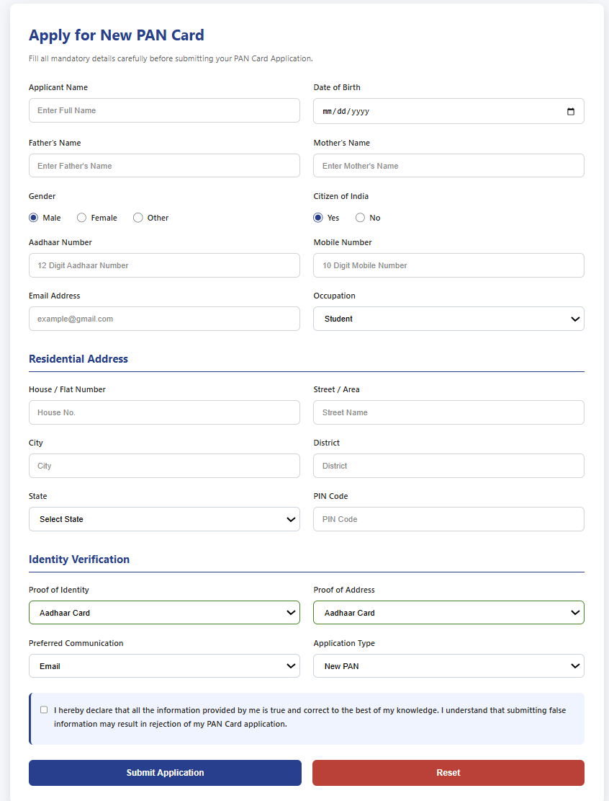

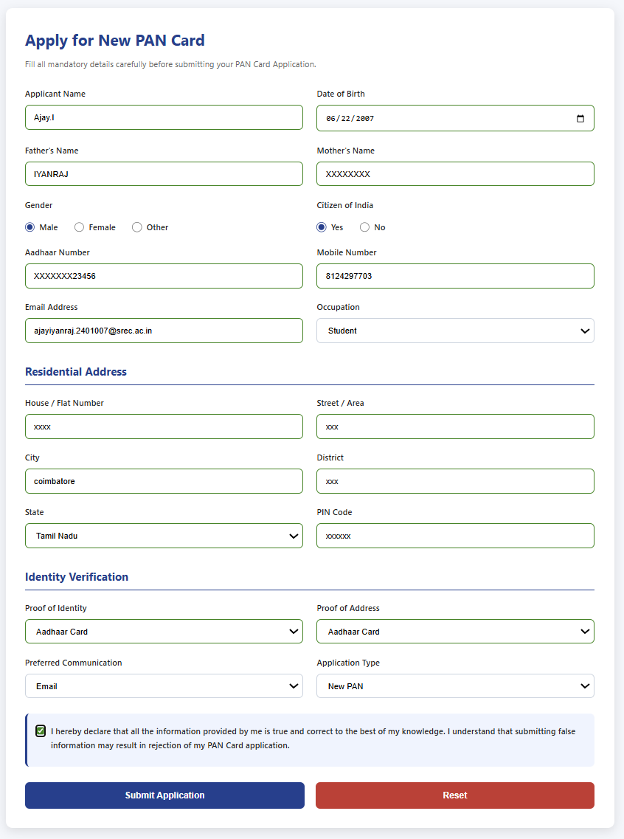

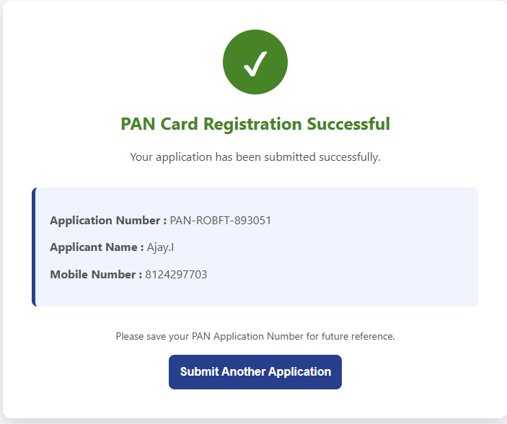

RESULT
Thus, a PAN Card Registration Form based on the Government of India Income Tax Department theme was successfully designed and developed using HTML and CSS. The webpage successfully accepts applicant details, validates user inputs, and displays a confirmation page upon successful registration.

