DEPARTMENT OF COMPUTER SCIENCE AND ENGINEERING

ACTIVE LEARNING METHODOLOGY REPORT

STUDENT REGISTRATION FORM FOR AN ONLINE COURSE PORTAL

AISHWARYA U (71812401006)
AJAY IYANRAJ (71812401007)
AKASHVARMAN R (71812401008)
AKHILESH RAJ P (71812401009)

THIRD YEAR B.E. CSE – V SEM
Academic Year 2026-2027

20CS212 &WEB TECHNOLOGIES

COURSE COORDINATOR
Mr.N.Manoj,AP/CSE
DEPARTMENT OF COMPUTER SCIENCE AND ENGINEERING

20CS212 &WEB TECHNOLOGIES

Assessment

INDEX

S.  No. | Name & Roll No. | Tool Explanation(2) | Implementation (5) | Presentaation (3) | Total  (10)
1. | AISHWARYA U  71812401006
2. | AJAY IYANRAJ  71812401007
3. | AKASHVARMAN R  71812401008
4. | AKHILESH RAJ P  71812401009

SIGNATURE OF COURSE COORDINATOR
Mr.N.Manoj,AP/CSE

CONTENTS

S. No. | TITLE | PAGE  NUMBER
 | Scenario / Problem Statement | 4
 | ICT Tool Used | 5
 | Activity Procedure | 5
 | Student Activity / Implementation | 6
 | Expected Output | 13

1. SCENARIO / PROBLEM STATEMENT
1.1 Scenario
LearnHub is an online course portal that offers technology courses such as Full Stack Web Development, Data Science with Python, Artificial Intelligence, Cyber Security and Cloud Computing to students across the country. Every learner must first create an account before enrolling in a course. At present the portal collects data through plain text boxes, so students often enter wrong email addresses, invalid phone numbers, impossible birth dates and weak passwords. This produces bad records, failed confirmation mails and many support requests.
1.2 Problem Statement
An online course portal needs a Student Registration Form. Select suitable HTML5 input types for email, phone number, date of birth, password and the other fields, so that the browser itself helps the student to enter correct data (proper keyboards on mobile devices, date picker, masked password, built-in validation) and the portal receives clean and complete data.
1.3 Requirements
• Correct input types: each field must use the HTML5 input type that best matches its data (email, tel, date, password, url, number, range, time, month, file, radio, checkbox, select and textarea).
• Validation: use HTML5 attributes (required, pattern, min, max, minlength, maxlength) together with a small JavaScript layer for friendly messages.
• Security: the password must be hidden, at least 8 characters long, and contain upper-case, lower-case and numeric characters; a confirm-password field must match it.
• Usability: labels, placeholders, hints, a password-strength meter, grouped sections and a responsive layout for phones and desktops.
• Feedback: invalid fields are highlighted in red with a message, valid fields in green, and a success message is shown after a correct submission.
1.4 Expected outcome
• A responsive registration page in which every field uses the most suitable HTML5 input type.
• Wrong emails, phone numbers, birth dates and weak passwords are rejected before submission.
• Clear red / green feedback and a success message improve the experience of the student.
• Clean data reaches the portal, which reduces failed confirmation mails and support requests.
1.5 Scope
• Design and code the client-side registration form only (HTML5, CSS3 and JavaScript).
• Test the form for empty, wrong and correct inputs on desktop and mobile screen sizes.
• Server-side storage of the registered data is outside the scope of this activity.
2. ICT TOOL USED
The following Information and Communication Technology tools were used to design, code, test and document the Student Registration Form.
S. No. | Tool / Technology | Purpose in this activity
1 | HTML5 | Structure of the form; semantic elements (form, fieldset, legend, label) and modern input types such as email, tel, date, password, url, number, range, time and month.
2 | CSS3 | Styling, grid layout, colours for valid / invalid states, and media queries for a responsive mobile view.
3 | JavaScript (ES6) | Constraint Validation API, custom error messages, password-match check, strength meter and success message.
4 | Visual Studio Code | Code editor used to write and format the source code (registration.html).
5 | Google Chrome / Chromium | Web browser used to run the page and to inspect the behaviour of each input type.
6 | Playwright (headless Chromium) | Used to open the page automatically, fill the fields and capture the output screenshots shown in this report.
7 | Microsoft Word | Preparation of this Active Learning Methodology report.

3. ACTIVITY PROCEDURE
3.1 Steps followed
Step 1: Analyse: Read the problem statement and list all the data that a student must give while registering.
Step 2: Select input types: Choose the most suitable HTML5 input type for every data item (see Table 3.3).
Step 3: Create the page: Create registration.html with the HTML5 boilerplate and the viewport meta tag for mobile devices.
Step 4: Design the form: Build a form with three fieldsets - Personal Details, Account Security and Course Preferences - and add a label for every control.
Step 5: Add validation attributes: Add required, minlength, maxlength, min, max and pattern attributes so that the browser validates the data.
Step 6: Apply CSS: Style the page with CSS (two-column grid, red / green states, responsive media query).
Step 7: Add JavaScript: Write JavaScript to show messages, compare the two passwords, show the password strength and display a success message.
Step 8: Test and record output: Open the page in the browser, test empty submission, wrong values and correct values, and capture the screenshots.
3.2 Design decisions
• Labels and grouping: every control has a label linked with the for attribute, and fieldset / legend group the related fields.
• Hints: short hint text under the date, phone and password fields tells the expected format before the mistake is made.
• Novalidate: the browser rules are kept, but custom messages are displayed by JavaScript for a consistent look.
3.3 Selection of HTML5 input types
Data | Input type | Key attributes | Reason for selection
Full name | type="text" | required, minlength, pattern | Free text; pattern allows only letters, space and dot.
Email | type="email" | required | Browser checks the name@domain format; mobile shows the @ keyboard.
Phone number | type="tel" | pattern="[6-9][0-9]{9}", maxlength | Numeric keypad on phones; pattern enforces a 10-digit mobile number.
Date of birth | type="date" | required, min, max (today) | Built-in date picker; max blocks future dates.
Password | type="password" | minlength=8, pattern | Characters are masked; pattern demands upper, lower and digit.
Confirm password | type="password" | required | Must match the password (checked in JavaScript).
Gender | type="radio" | required, same name | Only one option can be chosen.
Course | input + datalist | list, required | Type-ahead suggestions of available courses.
Qualification | <select> | required | Fixed list of choices.
Start month | type="month" | - | Month and year picker.
Class time | type="time" | value="18:00" | Time picker.
Experience | type="number" | min=0, max=40, step=1 | Numeric spinner with limits.
Study hours | type="range" | min=1, max=40 | Slider for an approximate value.
Profile link | type="url" | - | Browser checks for a valid URL.
Photo | type="file" | accept="image/png, image/jpeg" | Restricts the upload to image files.
Address | <textarea> | rows, maxlength | Multi-line text.
Terms / Updates | type="checkbox" | required (terms) | Yes / no choice; terms must be accepted.

4. STUDENT ACTIVITY / IMPLEMENTATION
The complete source code of the Student Registration Form is given below. The HTML part defines the form and the input types, the CSS part gives the design, and the JavaScript part performs validation and displays the feedback. The file is saved as registration.html and can be opened in any modern web browser.
Program: registration.html
<!DOCTYPE html>
<html lang="en">
<head>
<meta charset="UTF-8">
<meta name="viewport" content="width=device-width, initial-scale=1.0">
<title>Student Registration - LearnHub Online Course Portal</title>
<style>
* { box-sizing: border-box; }
body { margin: 0; font-family: "Segoe UI", Arial, sans-serif; background: #eef2f7; color: #1f2937; }
header { background: #0b5d3b; color: #fff; padding: 18px 24px; text-align: center; }
header h1 { margin: 0; font-size: 26px; }
header p { margin: 4px 0 0; font-size: 14px; opacity: .9; }
main { max-width: 860px; margin: 24px auto; padding: 0 12px; }
form { background: #fff; border-radius: 10px; padding: 24px; box-shadow: 0 2px 10px rgba(0,0,0,.12); }
fieldset { border: 1px solid #cbd5e1; border-radius: 8px; margin: 0 0 20px; padding: 14px 16px 6px; }
legend { font-weight: 600; color: #0b5d3b; padding: 0 8px; }
.grid { display: grid; grid-template-columns: 1fr 1fr; gap: 0 18px; }
.field { margin-bottom: 14px; }
.full { grid-column: 1 / -1; }
label { display: block; font-size: 14px; font-weight: 600; margin-bottom: 5px; }
label span.req { color: #dc2626; }
input, select, textarea { width: 100%; padding: 9px 10px; font-size: 14px; border: 1px solid #94a3b8;
border-radius: 6px; font-family: inherit; }
input[type=radio], input[type=checkbox] { width: auto; margin-right: 6px; }
input[type=range] { padding: 0; }
input:focus, select:focus, textarea:focus { outline: 2px solid #34a56f; border-color: #34a56f; }
.inline label { display: inline-block; font-weight: 400; margin-right: 18px; }
.hint { font-size: 12px; color: #64748b; margin-top: 3px; }
.error { font-size: 12px; color: #dc2626; min-height: 15px; margin-top: 3px; }
.invalid { border-color: #dc2626; background: #fef2f2; }
.valid { border-color: #16a34a; }
.meter { height: 6px; background: #e2e8f0; border-radius: 3px; margin-top: 6px; overflow: hidden; }
.meter div { height: 100%; width: 0; transition: width .3s; }
.buttons { text-align: center; }
button { padding: 11px 30px; font-size: 15px; border: 0; border-radius: 6px; cursor: pointer; margin: 0 6px; }
button[type=submit] { background: #0b5d3b; color: #fff; }
button[type=reset] { background: #e2e8f0; color: #1f2937; }
#success { display: none; background: #dcfce7; border: 1px solid #16a34a; color: #14532d;
padding: 14px; border-radius: 8px; margin-bottom: 18px; }
@media (max-width: 640px) { .grid { grid-template-columns: 1fr; } header h1 { font-size: 21px; } }
</style>
</head>
<body>
<header>
<h1>LearnHub Online Course Portal</h1>
<p>Student Registration Form</p>
</header>
<main>
<form id="regForm" novalidate>
<div id="success"></div>

<fieldset>
<legend>Personal Details</legend>
<div class="grid">
<div class="field">
<label for="fullname">Full Name <span class="req">*</span></label>
<input type="text" id="fullname" name="fullname" placeholder="e.g. Aishwarya U"
required minlength="3" maxlength="50" pattern="[A-Za-z .]+" autocomplete="name">
<div class="error"></div>
</div>
<div class="field">
<label for="dob">Date of Birth <span class="req">*</span></label>
<input type="date" id="dob" name="dob" required min="1990-01-01">
<div class="hint">You must be at least 16 years old.</div>
<div class="error"></div>
</div>
<div class="field">
<label for="email">Email Address <span class="req">*</span></label>
<input type="email" id="email" name="email" placeholder="name@example.com" required autocomplete="email">
<div class="error"></div>
</div>
<div class="field">
<label for="phone">Phone Number <span class="req">*</span></label>
<input type="tel" id="phone" name="phone" placeholder="9876543210" required
pattern="[6-9][0-9]{9}" maxlength="10" inputmode="numeric" autocomplete="tel">
<div class="hint">10-digit Indian mobile number.</div>
<div class="error"></div>
</div>
<div class="field full inline">
<label>Gender <span class="req">*</span></label>
<input type="radio" id="male" name="gender" value="Male" required><label for="male">Male</label>
<input type="radio" id="female" name="gender" value="Female"><label for="female">Female</label>
<input type="radio" id="other" name="gender" value="Other"><label for="other">Other</label>
<div class="error"></div>
</div>
</div>
</fieldset>

<fieldset>
<legend>Account Security</legend>
<div class="grid">
<div class="field">
<label for="password">Password <span class="req">*</span></label>
<input type="password" id="password" name="password" required minlength="8"
pattern="(?=.*[a-z])(?=.*[A-Z])(?=.*[0-9]).{8,}" autocomplete="new-password">
<div class="meter"><div id="bar"></div></div>
<div class="hint">Min 8 characters with upper-case, lower-case and a digit.</div>
<div class="error"></div>
</div>
<div class="field">
<label for="confirm">Confirm Password <span class="req">*</span></label>
<input type="password" id="confirm" name="confirm" required autocomplete="new-password">
<div class="error"></div>
</div>
</div>
</fieldset>

<fieldset>
<legend>Course Preferences</legend>
<div class="grid">
<div class="field">
<label for="course">Course <span class="req">*</span></label>
<input list="courses" id="course" name="course" placeholder="Type or select a course" required>
<datalist id="courses">
<option value="Full Stack Web Development">
<option value="Data Science with Python">
<option value="Artificial Intelligence">
<option value="Cyber Security">
<option value="Cloud Computing">
</datalist>
<div class="error"></div>
</div>
<div class="field">
<label for="qualification">Highest Qualification <span class="req">*</span></label>
<select id="qualification" name="qualification" required>
<option value="">-- Select --</option>
<option>Higher Secondary</option>
<option>Diploma</option>
<option>Undergraduate</option>
<option>Postgraduate</option>
</select>
<div class="error"></div>
</div>
<div class="field">
<label for="startdate">Preferred Start Month</label>
<input type="month" id="startdate" name="startdate">
</div>
<div class="field">
<label for="classtime">Preferred Class Time</label>
<input type="time" id="classtime" name="classtime" value="18:00">
</div>
<div class="field">
<label for="experience">Years of Experience</label>
<input type="number" id="experience" name="experience" min="0" max="40" step="1" value="0">
</div>
<div class="field">
<label for="hours">Weekly Study Hours: <output id="hoursOut">10</output> hrs</label>
<input type="range" id="hours" name="hours" min="1" max="40" value="10">
</div>
<div class="field">
<label for="profile">Profile Link (LinkedIn / GitHub)</label>
<input type="url" id="profile" name="profile" placeholder="https://www.linkedin.com/in/yourname">
<div class="error"></div>
</div>
<div class="field">
<label for="photo">Profile Photo</label>
<input type="file" id="photo" name="photo" accept="image/png, image/jpeg">
</div>
<div class="field full">
<label for="address">Address</label>
<textarea id="address" name="address" rows="3" maxlength="200" placeholder="Door no, street, city, PIN"></textarea>
</div>
</div>
</fieldset>

<div class="field inline">
<input type="checkbox" id="news" name="news" checked><label for="news">Send me course updates by email</label><br>
<input type="checkbox" id="terms" name="terms" required><label for="terms">I agree to the Terms &amp; Conditions <span class="req">*</span></label>
<div class="error"></div>
</div>

<div class="buttons">
<button type="submit">Register Now</button>
<button type="reset">Reset</button>
</div>
</form>
</main>

<script>
const form = document.getElementById('regForm');
const pwd = document.getElementById('password');
const cpwd = document.getElementById('confirm');
const dob = document.getElementById('dob');

dob.max = new Date().toISOString().split('T')[0];

const messages = {
fullname: 'Enter a valid name (letters, spaces and dots only, min 3 characters).',
dob: 'Select a valid date of birth.',
email: 'Enter a valid email address, e.g. name@example.com.',
phone: 'Enter a valid 10-digit mobile number starting with 6-9.',
gender: 'Please select your gender.',
password: 'Password must be 8+ characters with upper-case, lower-case and a digit.',
course: 'Please choose a course.',
qualification: 'Please select your qualification.',
profile: 'Enter a valid URL starting with http:// or https://.',
terms: 'You must accept the Terms & Conditions.'
};

function showError(el, msg) {
const box = el.closest('.field').querySelector('.error');
if (box) box.textContent = msg;
if (el.type !== 'radio' && el.type !== 'checkbox') {
el.classList.toggle('invalid', !!msg);
el.classList.toggle('valid', !msg && el.value !== '');
}
}

function validateField(el) {
let msg = '';
if (el.id === 'dob' && el.value) {
const age = (Date.now() - new Date(el.value)) / (365.25 * 24 * 3600 * 1000);
if (age < 16) { el.setCustomValidity('age'); msg = 'You must be at least 16 years old.'; }
else el.setCustomValidity('');
}
if (el.id === 'confirm') {
el.setCustomValidity(el.value !== pwd.value ? 'mismatch' : '');
if (el.value !== pwd.value) msg = 'Passwords do not match.';
}
if (!msg && !el.checkValidity()) {
msg = el.validity.valueMissing && el.id === 'confirm' ? 'Please confirm your password.'
: messages[el.name] || 'This field is required.';
}
showError(el, msg);
return !msg;
}

pwd.addEventListener('input', () => {
let score = 0;
if (pwd.value.length >= 8) score++;
if (/[a-z]/.test(pwd.value) && /[A-Z]/.test(pwd.value)) score++;
if (/[0-9]/.test(pwd.value)) score++;
if (/[^A-Za-z0-9]/.test(pwd.value)) score++;
const bar = document.getElementById('bar');
bar.style.width = score * 25 + '%';
bar.style.background = ['#dc2626', '#dc2626', '#f59e0b', '#84cc16', '#16a34a'][score];
if (cpwd.value) validateField(cpwd);
});

document.getElementById('hours').addEventListener('input', e =>
document.getElementById('hoursOut').textContent = e.target.value);

form.querySelectorAll('input, select, textarea').forEach(el =>
el.addEventListener('blur', () => { if (el.required || el.value) validateField(el); }));

form.addEventListener('submit', e => {
e.preventDefault();
let ok = true;
form.querySelectorAll('input[required], select[required], input[type=url], input[type=email]')
.forEach(el => { if (!validateField(el)) ok = false; });
const success = document.getElementById('success');
if (ok) {
success.style.display = 'block';
success.innerHTML = '<strong>Registration successful!</strong> Welcome, ' +
form.fullname.value + '. A confirmation has been sent to ' + form.email.value + '.';
window.scrollTo({ top: 0, behavior: 'smooth' });
} else {
success.style.display = 'none';
}
});

form.addEventListener('reset', () => {
document.getElementById('success').style.display = 'none';
form.querySelectorAll('.error').forEach(x => x.textContent = '');
form.querySelectorAll('.invalid, .valid').forEach(x => x.classList.remove('invalid', 'valid'));
document.getElementById('bar').style.width = '0';
});
</script>
</body>
</html>

Explanation of the code
• Form and fieldsets: the form uses novalidate so that our JavaScript can show custom messages, while the HTML5 constraint attributes still define the rules.
• Email and phone: type="email" validates the address format; type="tel" with pattern="[6-9][0-9]{9}" accepts only 10-digit mobile numbers.
• Date of birth: type="date" gives a calendar picker; JavaScript sets max to today and rejects students younger than 16 years.
• Password: type="password" hides the text; the lookahead pattern (?=.*[a-z])(?=.*[A-Z])(?=.*[0-9]).{8,} enforces the strength rules and the meter shows the score.
• Validation flow: validateField() uses checkValidity() and setCustomValidity() to decide whether a field is valid and then shows the message and the red / green border.
Explanation of the CSS and JavaScript
• CSS grid: the .grid class creates two equal columns; the media query (max-width: 640px) changes it to one column so the form fits phone screens.
• Visual feedback: the .invalid class gives a red border and pink background, and the .valid class gives a green border, so the student sees the result of every field immediately.
• Password meter: the input event on the password field scores length, mixed case, digits and symbols and changes the width and colour of the bar.
• Submit handler: preventDefault() stops the page reload, every required field is validated, and the success banner is shown only when all fields are valid.
Advantages of using suitable HTML5 input types
• Mobile devices open the correct keyboard automatically (email keyboard for email, numeric keypad for phone).
• Date, month and time pickers avoid typing mistakes and wrong formats.
• Built-in validation reduces the JavaScript code and the load on the server.
• Passwords are masked, and pattern rules enforce a strong password.
• Clean and correct data is stored, so confirmation mails and phone contacts do not fail.
HTML5 validation attributes used in the form
Attribute | Purpose | Used on
required | Field cannot be left empty | Name, date of birth, email, phone, password, course, terms
minlength / maxlength | Limits the number of characters | Name, password, phone, address
pattern | Regular expression the value must match | Name, phone, password
min / max | Lowest and highest allowed value or date | Date of birth, experience, study hours
step | Step size of a number input | Years of experience
accept | Allowed file types | Profile photo (PNG, JPEG)
list (datalist) | Type-ahead suggestions | Course
placeholder / autocomplete | Sample text and browser auto-fill hints | Name, email, phone, passwords

Sample test data used for the outputs
Field | Valid data entered (Output 4 and 5) | Invalid data entered (Output 3)
Full name | Aishwarya U | Ajay Iyanraj (valid)
Date of birth | 14-08-2005 | 10-05-2012 (under 16)
Email | aishwarya.u@example.com | ajay.iyanraj@
Phone | 9876543210 | 12345
Password | Learn@2026 | abc123
Confirm password | Learn@2026 | abc124 (mismatch)
Course | Full Stack Web Development | (not selected)
Qualification | Undergraduate | (not selected)
Profile link | https://www.linkedin.com/in/aishwarya-u | linkedin.com/in/ajay
Terms and Conditions | Accepted | Not accepted

Behaviour of the main input types in the browser
Input type | On a desktop browser | On a mobile browser
type="email" | Rejects values without @ and a domain | Shows a keyboard with @ and .com keys
type="tel" | Accepts text; pattern checks 10 digits | Shows the numeric dial pad
type="date" | Calendar drop-down picker | Native date wheel / calendar
type="password" | Characters shown as dots | Characters masked; no auto-capitalisation
type="number" | Up / down spinner within min and max | Numeric keyboard
type="url" | Rejects values without a scheme | Keyboard with / and .com keys
type="range" | Draggable slider | Touch slider

Learning outcomes
• Identified the HTML5 input type that best fits each kind of data in a registration form.
• Applied constraint-validation attributes (required, pattern, min, max, minlength, maxlength).
• Used JavaScript and CSS to give instant visual feedback and a responsive design.
Conclusion
Choosing the right HTML5 input type is the first and simplest level of validation. With type="email", type="tel", type="date" and type="password", the browser itself gives the student the correct keyboard, picker or masking and checks the format before the data reaches the server. Combined with attributes such as required, pattern, min and max, and a little JavaScript for friendly messages, the LearnHub registration form collects accurate data with less effort for both the student and the portal.
The next section shows the form running in the browser in its different states, starting with the blank form and ending with the mobile view and the test results.
Browser compatibility of the form
Browser | Version tested | Result
Google Chrome / Chromium | Latest | All input types and validation work
Microsoft Edge | Latest | All input types and validation work
Mozilla Firefox | Latest | All input types work; date picker style differs
Safari (iOS / macOS) | Latest | All input types work; native pickers on iPhone

Future enhancements
• Send the form data to a server (PHP / Node.js) and store it in a database.
• Send an email or SMS verification code to confirm the email address and phone number.
• Add a CAPTCHA to stop automatic registrations by bots.
• Show a live check whether the email address is already registered.
• Support more languages so that students from every region can register easily.
5. EXPECTED OUTPUT
The screenshots below were captured from the running registration.html page in a Chromium browser. They show the form in its different states.
Output 1: Blank Student Registration Form
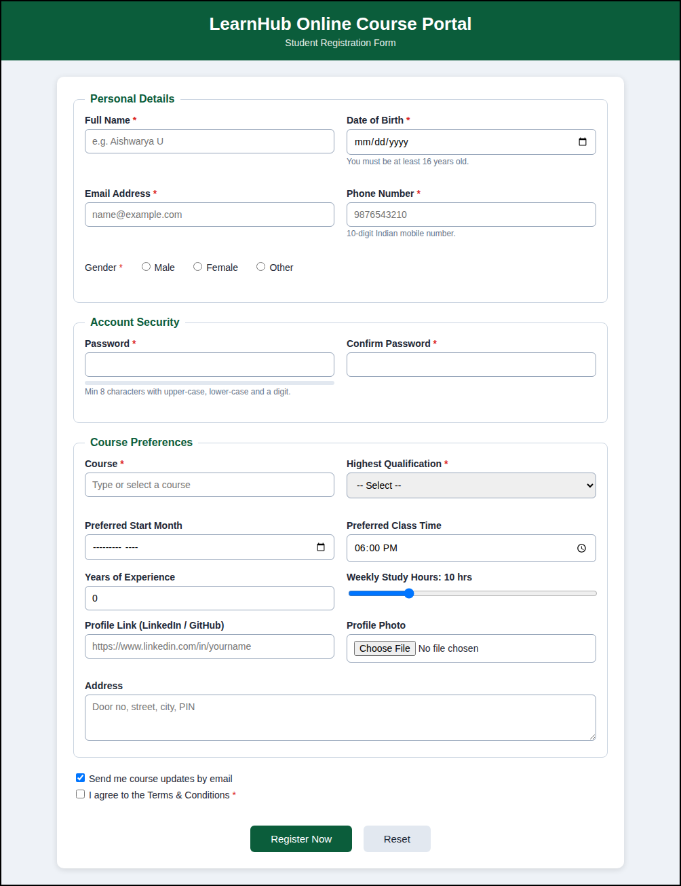
Fig. 1 - Initial form with all HTML5 input controls (text, date, email, tel, radio, password, list, select, month, time, number, range, url, file, textarea and checkbox).
Output 2: Validation messages on empty submission
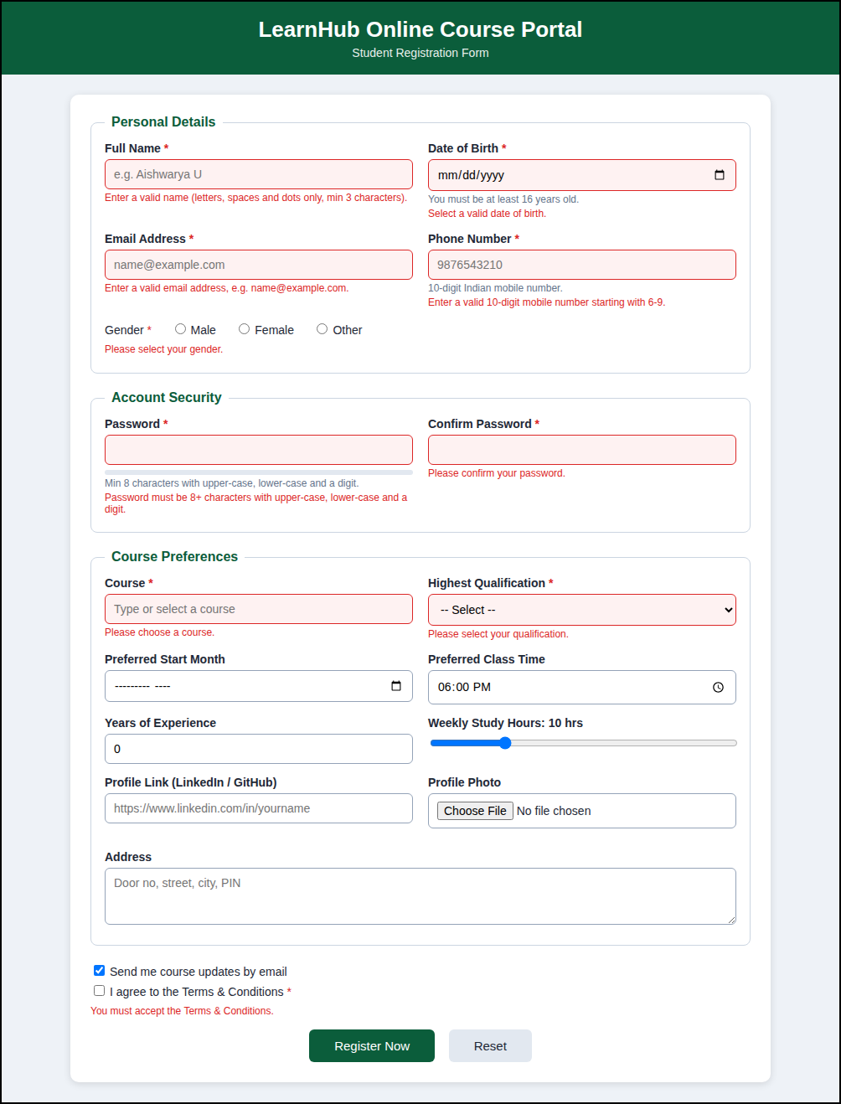
Fig. 2 - Clicking Register Now with no data highlights every required field in red and shows a message below it.
Output 3: Invalid email, phone, date of birth, password and URL
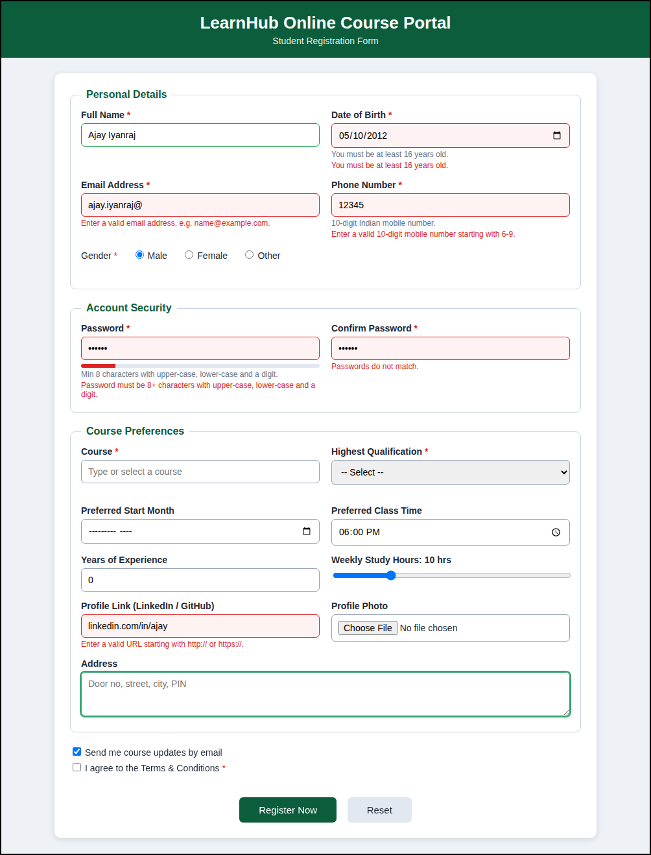
Fig. 3 - Wrong email format, 5-digit phone, age below 16, weak password, mismatch of passwords and an invalid URL are rejected.
Output 4: Correctly filled form
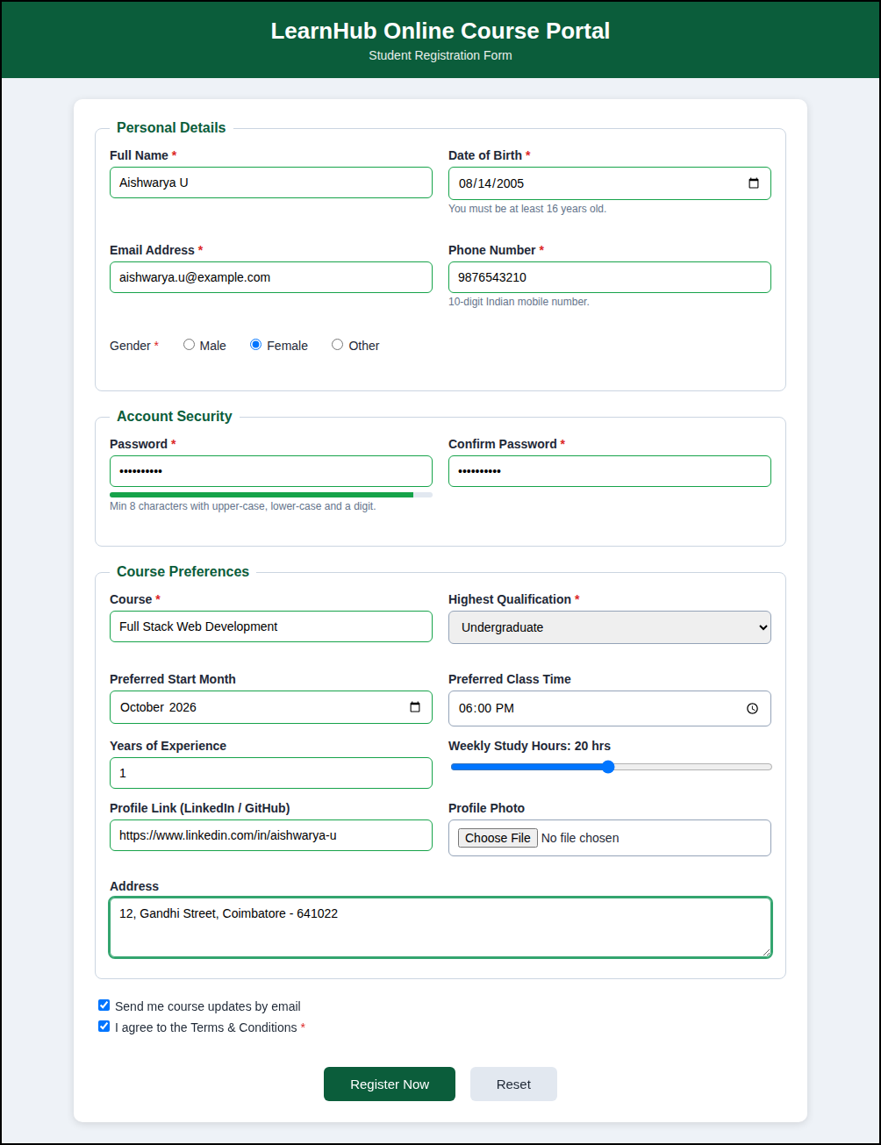
Fig. 4 - All fields contain valid data; borders turn green and the password-strength meter is full.
Output 5: Successful registration
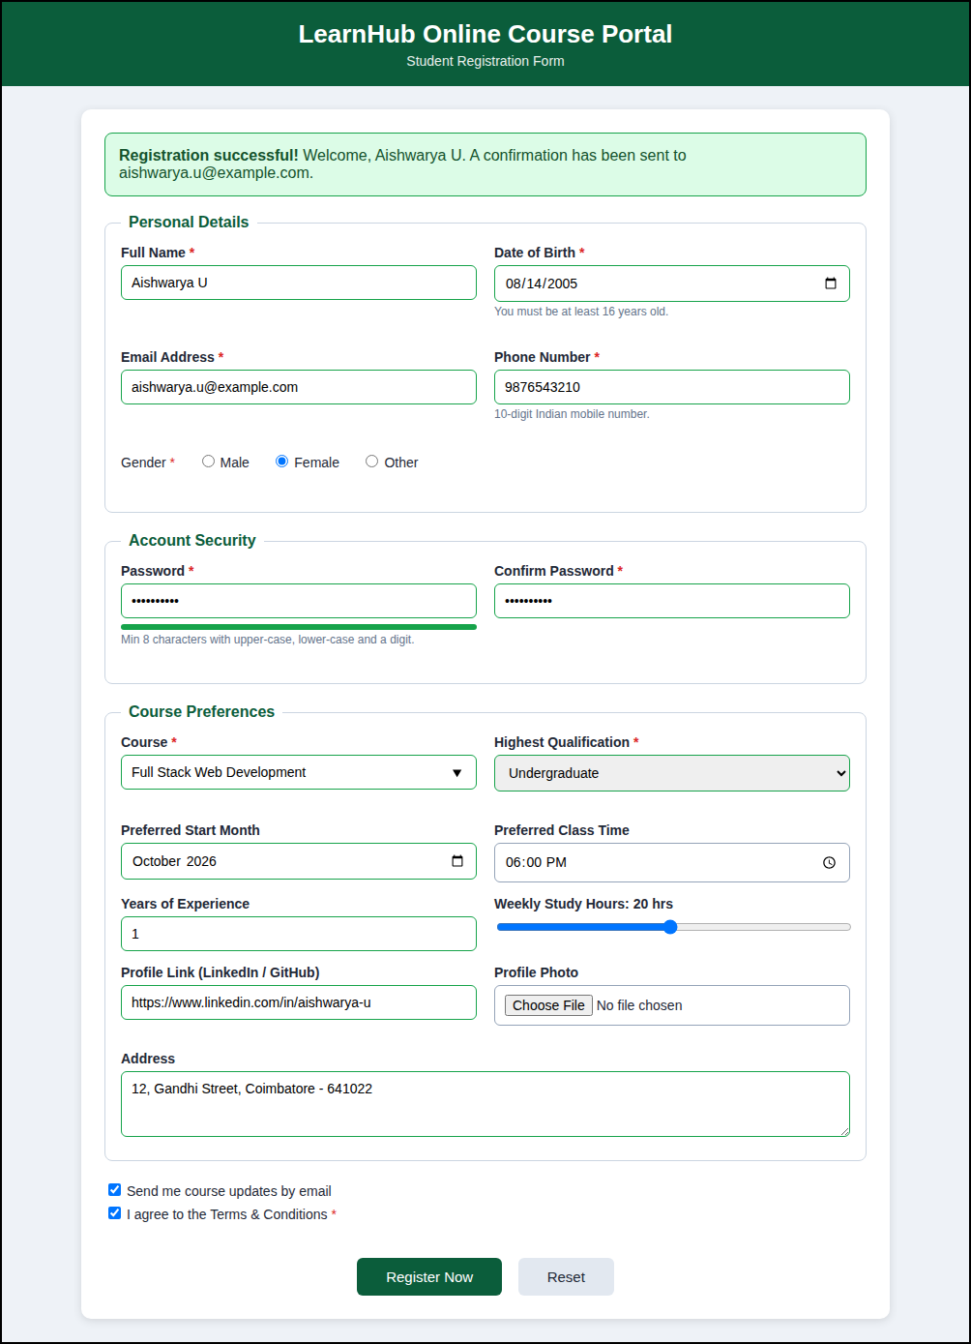
Fig. 5 - After a valid submission a green confirmation message with the student name and email is displayed.
Output 6: Responsive view on a mobile screen (390 px width)
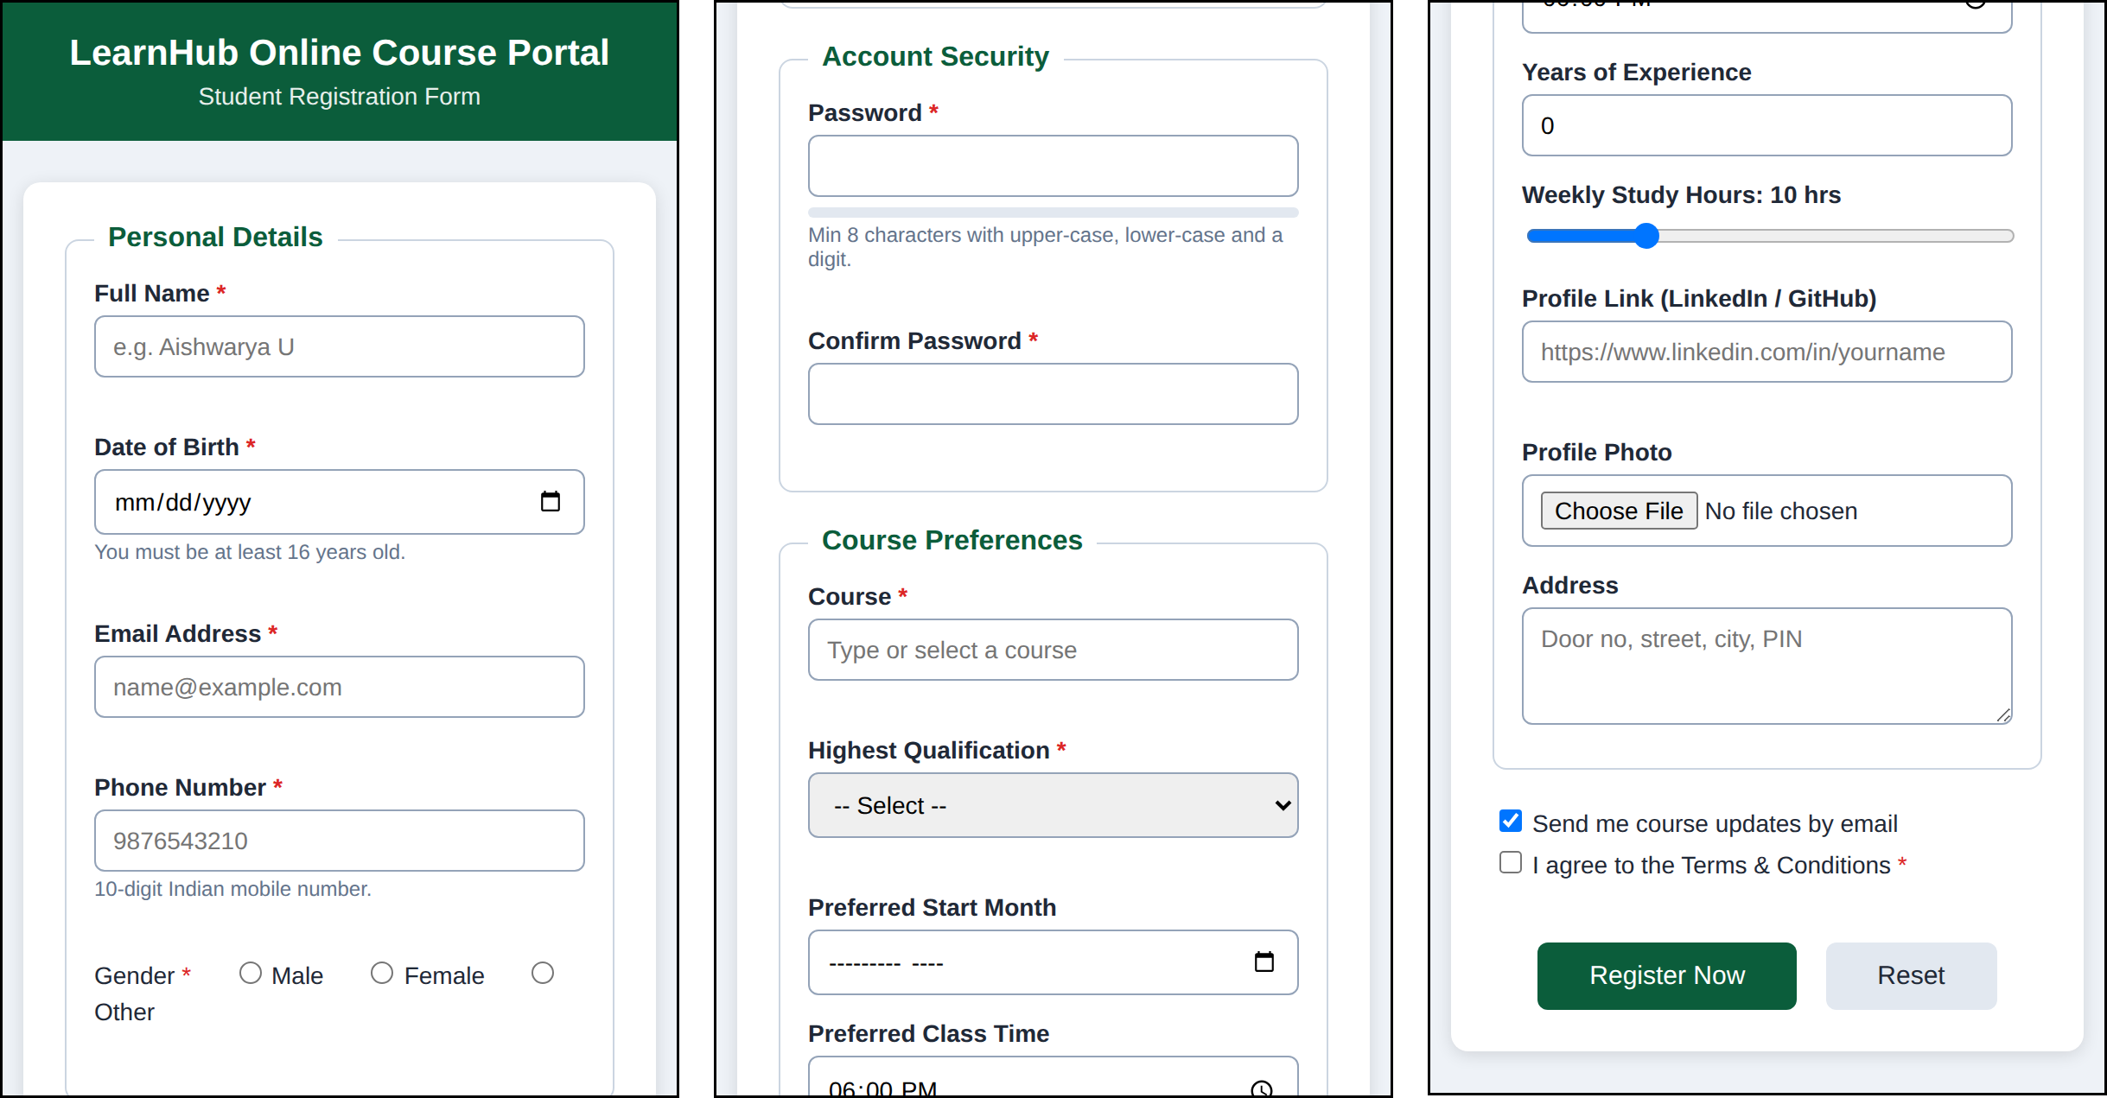
Fig. 6 - On a phone the two-column layout collapses into a single column (shown in three parts, top to bottom, left to right).
Test cases
S. No. | Test input | Expected behaviour | Result
1 | Submit the form with all fields empty | Every required field turns red with a message | Pass
2 | Email = ajay.iyanraj@ | Message: valid email address required | Pass
3 | Phone = 12345 | Message: 10-digit mobile number starting with 6-9 | Pass
4 | Date of birth = 10-05-2012 | Message: must be at least 16 years old | Pass
5 | Password = abc123 | Weak strength bar; pattern message shown | Pass
6 | Confirm password different from password | Message: passwords do not match | Pass
7 | Profile link = linkedin.com/in/ajay | Message: URL must start with http:// or https:// | Pass
8 | All fields valid and terms accepted | Green borders and success message | Pass

Result
The Student Registration Form for the online course portal was designed with suitable HTML5 input types - email for the email address, tel for the phone number, date for the date of birth and password for the password - together with number, range, time, month, url, file, radio, checkbox, select and textarea for the remaining data. The built-in validation attributes and the JavaScript feedback prevented invalid data and produced a clean, user-friendly and mobile-responsive registration page.

