WEB TECHNOLOGIES
EXAM STUDY MATERIAL
10-Mark Programs • 2-Mark Short Answers • Compact two-column revision sheet
PART A — 10-MARK QUESTIONS
1 | DOM Event Handling Using JavaScript | 1
2 | Node.js CRUD Operation Using MongoDB | 2
3 | Form Validation Using AngularJS | 4
4 | ReactJS Application | 5
 | The 4 Programs You Should Memorize | 8
 | How to Prepare | 9

PART B — 2-MARK QUESTIONS
1 | Installation of NPM — Steps | 9
2 | Role of REST API | 9
3 | Traditional Website vs Single Page Application | 10
4 | AngularJS Directives | 10
5 | Hello World Using ReactJS | 10
6 | Two-Way Data Binding in AngularJS | 11
7 | Filters in AngularJS | 11
8 | Modules and Controllers in AngularJS | 11
9 | File Operations in Node.js | 12
 | Last-Minute Memory Sheet | 12

PART A — 10-MARK QUESTIONS

YOUR 4 MASTER 10-MARK QUESTIONS

No. | Topic | Master program
1 | DOM Event Handling | Interactive Product/Student page
2 | Node.js CRUD + MongoDB | Online Bookstore
3 | AngularJS Form Validation | Retail Product Form
4 | ReactJS Application | Recipe Management

These four cover almost everything your staff has identified.
1. DOM EVENT HANDLING USING JAVASCRIPT

What you need to know
For a 10-mark answer, remember these concepts:
• DOM = Document Object Model
• HTML elements become DOM objects
• JavaScript can access and modify them
• Events = user/browser actions
• Event handling = responding to events
• getElementById()
• addEventListener()
• .value
• .innerHTML
• .style
The master pattern is:
HTML element
↓
getElementById()
↓
addEventListener()
↓
User performs event
↓
JavaScript function executes
↓
DOM is modified

★ MASTER DOM PROGRAM
This one demonstrates:
• button click
• input
• DOM access
• changing text
• changing CSS
• calculation
• multiple event handlers
</> HTML
<!DOCTYPE html>
<html>
<head>
<title>DOM Event Handling</title>

<style>
body {
font-family: Arial;
padding: 30px;
}

.box {
width: 400px;
padding: 20px;
border: 2px solid black;
}

button {
padding: 10px;
margin: 5px;
}
</style>
</head>

<body>

<div class="box">

<h2 id="title">Product Calculator</h2>

<label>Product Name:</label>
<input type="text" id="name">

<br><br>

<label>Price:</label>
<input type="number" id="price">

<br><br>

<label>Quantity:</label>
<input type="number" id="quantity">

<br><br>

<button id="calculate">Calculate</button>
<button id="change">Change Style</button>

<h3 id="result"></h3>

</div>

<script>

document.getElementById("calculate").addEventListener("click", function() {

let name = document.getElementById("name").value;

let price = document.getElementById("price").value;

let quantity = document.getElementById("quantity").value;

let total = price * quantity;

document.getElementById("result").innerHTML =
"Product: " + name + "<br>Total Price: ₹" + total;

});

document.getElementById("change").addEventListener("click", function() {

document.getElementById("title").style.color = "blue";

document.getElementById("result").style.fontSize = "20px";

});

</script>

</body>
</html>

▶ Output
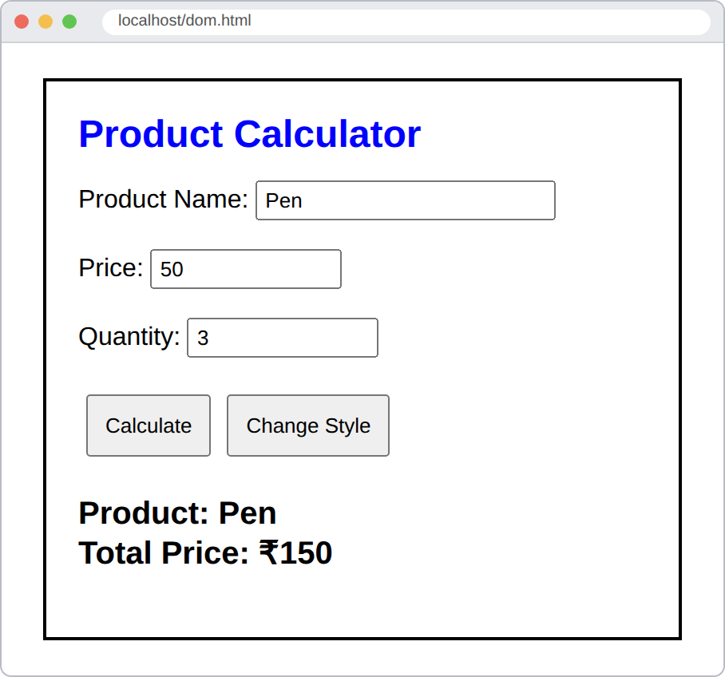
How to adapt this to ANY question
Suppose the question says:
Develop a student result application using JavaScript DOM event handling.

Don't panic.
Change:
Product Name → Student Name
Price → Mark
Quantity → Subject
Total → Average/Total Mark

The event-handling structure remains exactly the same.
If they ask:
Create a ticket booking system.

Change:
Product → Movie
Price → Ticket Price
Quantity → Number of Tickets
Total → Ticket Cost

Same structure.
What to write for theory
DOM
The Document Object Model (DOM) represents an HTML document as a tree of objects. JavaScript can access and manipulate these objects to dynamically change HTML content, attributes and CSS styles.

Event
An event is an action that occurs in a web page, such as a mouse click, keyboard input or form submission.

Event handling
Event handling is the process of detecting an event and executing a function in response to that event.

addEventListener()
</> JavaScript
element.addEventListener("click", function() {
// action
});

It attaches an event handler to an HTML element.
2. NODE.JS CRUD OPERATION USING MONGODB

This is probably your highest-priority question.
Your previous paper literally had:
Node.js application + MongoDB + CRUD + online bookstore.

So learn this one very well.
First understand CRUD
CRUD means:
C → Create
R → Read
U → Update
D → Delete

For a bookstore:
CREATE → Add book
READ → Display books
UPDATE → Change book
DELETE → Remove book

Basic architecture
Understand this:
Browser
↓
Node.js Application
↓
MongoDB
↓
Database
↓
books collection

Required package
For the MongoDB Node.js driver:
</> Bash
npm install mongodb

Your previous paper specifically asks this type of command.
★ MASTER NODE + MONGODB CRUD PROGRAM
</> JavaScript
const { MongoClient } = require("mongodb");

const url = "mongodb://127.0.0.1:27017";

const client = new MongoClient(url);

async function main() {

try {

// CONNECT
await client.connect();

console.log("MongoDB Connected");

const db = client.db("bookstore");

const books = db.collection("books");

// =========================
// CREATE
// =========================

await books.insertOne({
title: "JavaScript Basics",
author: "John",
genre: "Programming",
stock: 10
});

console.log("Book inserted");

// =========================
// READ
// =========================

const allBooks = await books.find().toArray();

console.log("Books:");

console.log(allBooks);

// =========================
// UPDATE
// =========================

await books.updateOne(
{ title: "JavaScript Basics" },
{ $set: { stock: 15 } }
);

console.log("Book updated");

// =========================
// DELETE
// =========================

await books.deleteOne({
title: "JavaScript Basics"
});

console.log("Book deleted");

} catch (error) {

console.log(error);

} finally {

await client.close();

console.log("MongoDB connection closed");
}
}

main();

▶ Output
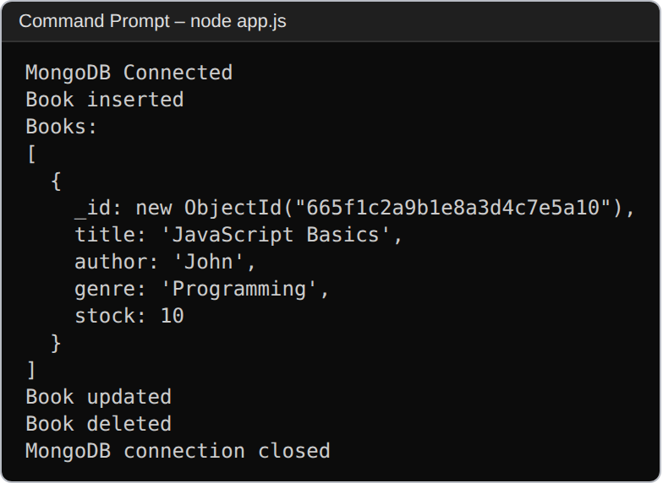
Understand this code instead of memorizing blindly
Connection
</> JavaScript
const { MongoClient } = require("mongodb");

const url = "mongodb://127.0.0.1:27017";

const client = new MongoClient(url);

await client.connect();

This connects Node.js to MongoDB.
Database
</> JavaScript
const db = client.db("bookstore");

Creates/accesses:
bookstore

database.
Collection
</> JavaScript
const books = db.collection("books");

The collection is:
books

CREATE
</> JavaScript
await books.insertOne({
title: "JavaScript Basics",
author: "John",
genre: "Programming",
stock: 10
});

Adds a document.
READ
</> JavaScript
const allBooks = await books.find().toArray();

console.log(allBooks);

Retrieves documents.
UPDATE
</> JavaScript
await books.updateOne(
{ title: "JavaScript Basics" },
{ $set: { stock: 15 } }
);

Finds the book and changes:
stock: 10

to:
stock: 15

DELETE
</> JavaScript
await books.deleteOne({
title: "JavaScript Basics"
});

Deletes the matching document.
How to adapt this to different questions
Previous paper:
Online bookstore

You use:
books
title
author
genre
stock

If question becomes:
Employee management system

Change to:
employees
name
department
salary

If question becomes:
Product management

Change to:
products
name
price
category
stock

If question becomes:
Student management

Change to:
students
name
department
mark

The CRUD structure doesn't change.
What to write in the 10-mark answer
Use this structure:
1. Definition
CRUD represents Create, Read, Update and Delete operations used to manage data in a database.

2. Connection architecture
Node.js → MongoDB → Database → Collection

3. Installation
</> Bash
npm install mongodb

4. Connection code
5. Create
6. Read
7. Update
8. Delete
9. Output
That is a strong 10-mark answer.
3. FORM VALIDATION USING ANGULARJS

This is another staff-highlighted 10-mark question.
The examiner can easily turn it into:
Develop an AngularJS application for validating a registration form.

or:
Develop an AngularJS application for validating employee/student/customer details.

The actual application doesn't matter much.
The important part is:
AngularJS
↓
Form
↓
ng-model
↓
Validation
↓
$valid / $invalid
↓
Error messages

AngularJS validation concepts you absolutely need
ng-app
Starts AngularJS.
ng-controller
Connects the controller.
ng-model
Connects input to data.
required
Makes field mandatory.
ng-minlength
Minimum characters.
ng-maxlength
Maximum characters.
$valid
Form/input is valid.
$invalid
Form/input is invalid.
$touched
User has interacted with the field.
★ MASTER ANGULARJS FORM VALIDATION PROGRAM
</> HTML
<!DOCTYPE html>
<html>

<head>

<title>AngularJS Form Validation</title>

<script src="https://ajax.googleapis.com/ajax/libs/angularjs/1.8.2/angular.min.js">
</script>

<style>

body {
font-family: Arial;
padding: 30px;
}

.box {
width: 400px;
padding: 20px;
border: 2px solid black;
}

input {
width: 90%;
padding: 8px;
margin: 5px;
}

.error {
color: red;
}

button {
padding: 10px 20px;
}

</style>

</head>

<body ng-app="myApp">

<div ng-controller="formController">

<div class="box">

<h2>Registration Form</h2>

<form name="myForm" ng-submit="submitForm()" novalidate>

<!-- NAME -->

<label>Name:</label>

<input
type="text"
name="name"
ng-model="user.name"
required
ng-minlength="3">

<p class="error"
ng-show="myForm.name.$touched && myForm.name.$invalid">

Name must contain at least 3 characters.

</p>

<!-- EMAIL -->

<label>Email:</label>

<input
type="email"
name="email"
ng-model="user.email"
required>

<p class="error"
ng-show="myForm.email.$touched && myForm.email.$invalid">

Enter a valid email address.

</p>

<!-- AGE -->

<label>Age:</label>

<input
type="number"
name="age"
ng-model="user.age"
required
min="18"
max="60">

<p class="error"
ng-show="myForm.age.$touched && myForm.age.$invalid">

Age must be between 18 and 60.

</p>

<!-- PASSWORD -->

<label>Password:</label>

<input
type="password"
name="password"
ng-model="user.password"
required
ng-minlength="6">

<p class="error"
ng-show="myForm.password.$touched &&
myForm.password.$invalid">

Password must contain at least 6 characters.

</p>

<br>

<button type="submit"
ng-disabled="myForm.$invalid">

Submit

</button>

</form>

<h3>{{message}}</h3>

</div>

</div>

<script>

var app = angular.module("myApp", []);

app.controller("formController", function($scope) {

$scope.user = {};

$scope.message = "";

$scope.submitForm = function() {

if ($scope.myForm.$valid) {

$scope.message =
"Form submitted successfully!";

}

};

});

</script>

</body>

</html>

▶ Output
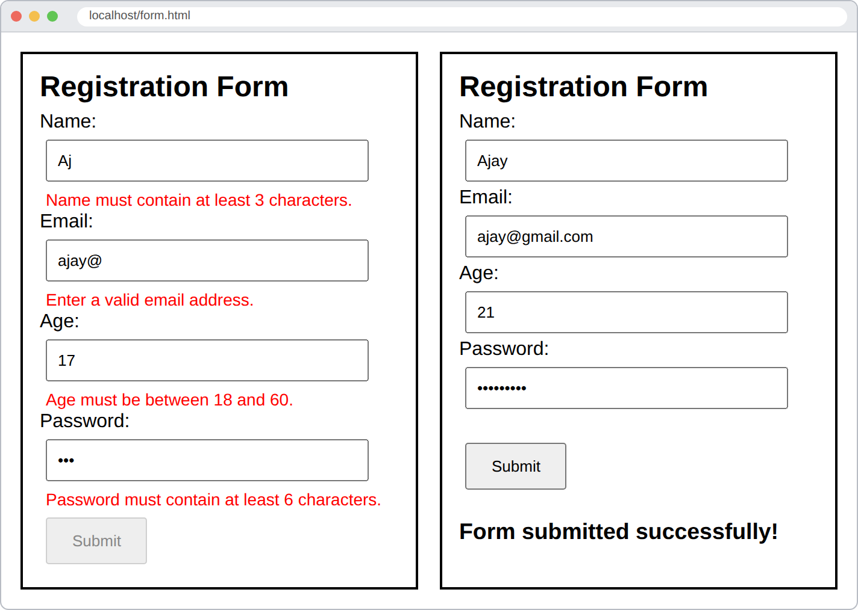
Understand the important pieces
AngularJS starts here
</> HTML
<body ng-app="myApp">

Controller
</> HTML
<div ng-controller="formController">

Form
</> HTML
<form name="myForm">

AngularJS gives the form an object:
myForm

Input binding
</> HTML
<input
ng-model="user.name"
required>

ng-model connects the input with:
user.name

Validation
This:
</> HTML
required

means:
The field cannot be empty.

This:
</> HTML
ng-minlength="3"

means:
Minimum 3 characters.

This:
</> HTML
type="email"

makes AngularJS validate the input as an email.
$invalid
</> JavaScript
myForm.name.$invalid

means the name field is currently invalid.
$valid
</> JavaScript
myForm.$valid

means the entire form is valid.
$touched
</> JavaScript
myForm.name.$touched

means the user has interacted with the field.
So:
</> HTML
ng-show="myForm.name.$touched && myForm.name.$invalid"

means:
Show the error only after the user has interacted with the field and the value is invalid.

How to adapt this to any question
Suppose question:
Develop an AngularJS application to validate a student registration form.

Change:
Name
Email
Age
Password

to whatever fields the question asks.
For:
Employee registration

Use:
Employee Name
Email
Salary
Department

For:
Product form

Use:
Product Name
Price
Quantity
Category

The validation mechanism remains the same.
4. REACTJS APPLICATION

This is the other huge question.
Your staff specifically said:
ReactJS application
JSX, props, state, event handling, CSS styling

And your previous paper asked for a recipe management application with:
• View recipes
• Add recipes
• Edit recipes
• Delete recipes
• Filter recipes
So we're going to create one master React application containing all of these concepts.
React concepts you need
JSX
JavaScript XML.
Allows you to write HTML-like syntax inside JavaScript.
</> JavaScript (JSX)
<h1>Hello</h1>

Component
A reusable part of the UI.
</> JavaScript (JSX)
function App() {
return <h1>Hello</h1>;
}

Props
Data passed from parent component to child component.
Parent
↓ props
Child

Props are generally read-only.
State
Data maintained by a component.
</> JavaScript (JSX)
const [recipes, setRecipes] = useState([]);

When state changes, React re-renders the component.
Event handling
</> JavaScript (JSX)
<button onClick={handleClick}>

React uses events such as:
onClick
onChange
onSubmit

CSS styling
Can use a CSS file:
</> JavaScript (JSX)
import "./App.css";

★ MASTER REACT APPLICATION
For exam purposes, this is the kind of application I recommend learning.
It contains:
• JSX
• Component
• Props
• State
• Events
• Form
• Add
• Delete
• Search/filter
• CSS
</> JavaScript (JSX)
import React, { useState } from "react";
import "./App.css";

function Recipe({ recipe, onDelete }) {

return (

<div className="card">

<h3>{recipe.title}</h3>

<p>{recipe.description}</p>

<p>
Cooking Time: {recipe.time} minutes
</p>

<button
onClick={() => onDelete(recipe.id)}>
Delete
</button>

</div>

);
}

function App() {

const [recipes, setRecipes] = useState([
{
id: 1,
title: "Pizza",
description: "Cheese pizza",
time: 30
},

{
id: 2,
title: "Pasta",
description: "Creamy pasta",
time: 20
}
]);

const [title, setTitle] = useState("");

const [description, setDescription] = useState("");

const [time, setTime] = useState("");

const [search, setSearch] = useState("");

function addRecipe(event) {

event.preventDefault();

if (title === "" || description === "" || time === "") {
return;
}

const newRecipe = {

id: Date.now(),

title: title,

description: description,

time: time

};

setRecipes([...recipes, newRecipe]);

setTitle("");

setDescription("");

setTime("");

}

function deleteRecipe(id) {

setRecipes(
recipes.filter(recipe => recipe.id !== id)
);

}

const filteredRecipes = recipes.filter(recipe =>
recipe.title
.toLowerCase()
.includes(search.toLowerCase())
);

return (

<div className="container">

<h1>Recipe Management</h1>

{/* SEARCH */}

<input
type="text"
placeholder="Search recipe"
value={search}
onChange={(e) => setSearch(e.target.value)}
/>

{/* ADD FORM */}

<form onSubmit={addRecipe}>

<input
type="text"
placeholder="Recipe title"
value={title}
onChange={(e) => setTitle(e.target.value)}
/>

<input
type="text"
placeholder="Description"
value={description}
onChange={(e) =>
setDescription(e.target.value)
}
/>

<input
type="number"
placeholder="Cooking time"
value={time}
onChange={(e) =>
setTime(e.target.value)
}
/>

<button type="submit">
Add Recipe
</button>

</form>

{/* RECIPE LIST */}

<div>

{filteredRecipes.map(recipe => (

<Recipe
key={recipe.id}
recipe={recipe}
onDelete={deleteRecipe}
/>

))}

</div>

</div>

);
}

export default App;

CSS for the React application
Create:
App.css

</> CSS
body {
font-family: Arial;
background: #f2f2f2;
}

.container {
width: 700px;
margin: 30px auto;
padding: 20px;
background: white;
}

input {
padding: 10px;
margin: 5px;
}

button {
padding: 10px 15px;
margin: 5px;
cursor: pointer;
}

.card {
border: 1px solid #ccc;
padding: 15px;
margin-top: 15px;
}

▶ Output
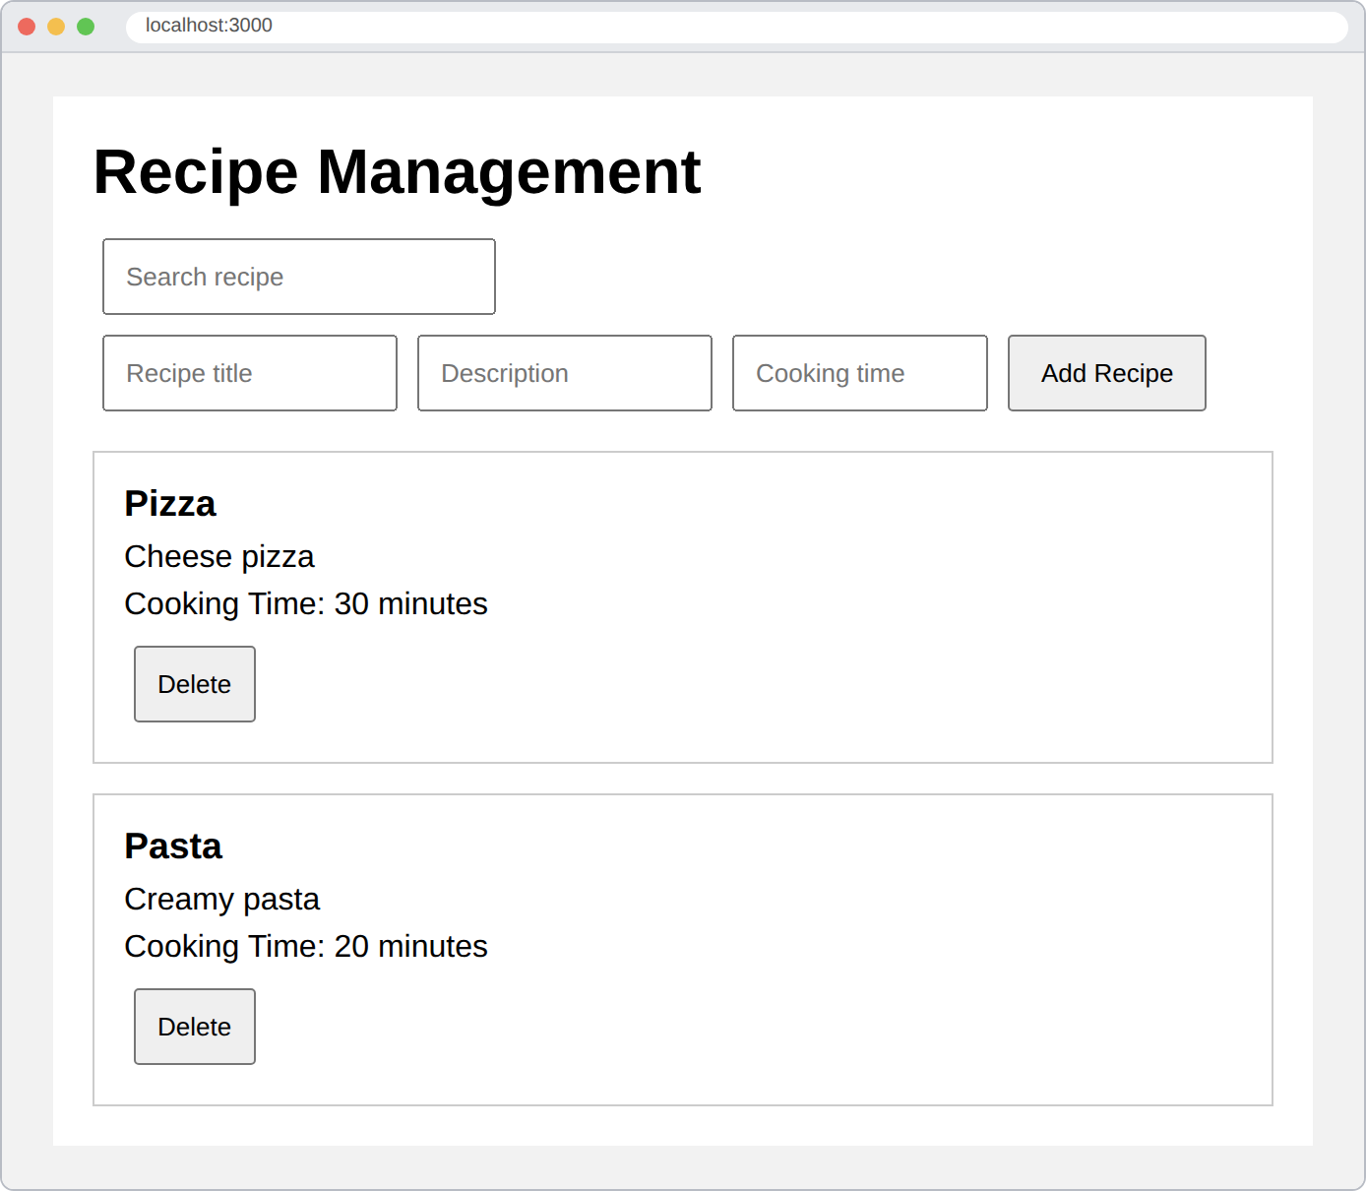
Now understand how this single React program covers your syllabus
This is important.
Don't just memorize the code.
Know where each exam keyword appears.
JSX
This entire:
</> JavaScript (JSX)
return (
<div className="container">
<h1>Recipe Management</h1>
</div>
);

is JSX.
Props ★★★★★
Look at:
</> JavaScript (JSX)
function Recipe({ recipe, onDelete }) {

The parent sends:
</> JavaScript (JSX)
<Recipe
recipe={recipe}
onDelete={deleteRecipe}
/>

These are props.
The flow is:
App
↓
Recipe component
↓
props
↓
recipe
onDelete

State ★★★★★
This:
</> JavaScript (JSX)
const [recipes, setRecipes] = useState([]);

is state.
Other states:
</> JavaScript (JSX)
const [title, setTitle] = useState("");

const [description, setDescription] = useState("");

const [time, setTime] = useState("");

const [search, setSearch] = useState("");

When state changes, React updates the UI.
Event handling ★★★★★
Here:
</> JavaScript (JSX)
onClick={() => onDelete(recipe.id)}

handles a click.
Here:
</> JavaScript (JSX)
onChange={(e) => setTitle(e.target.value)}

handles input changes.
Here:
</> JavaScript (JSX)
onSubmit={addRecipe}

handles form submission.
So you've covered React event handling.
CSS styling
We import:
</> JavaScript (JSX)
import "./App.css";

and use:
</> JavaScript (JSX)
className="container"

</> JavaScript (JSX)
className="card"

The CSS file styles them.
Forms
This:
</> JavaScript (JSX)
<form onSubmit={addRecipe}>

creates the form.
And:
</> JavaScript (JSX)
event.preventDefault();

prevents the browser from reloading the page when the form is submitted.
Add operation
</> JavaScript (JSX)
setRecipes([...recipes, newRecipe]);

adds the new recipe to the existing state.
Delete operation
</> JavaScript (JSX)
setRecipes(
recipes.filter(recipe => recipe.id !== id)
);

removes the selected recipe.
Search/filter
</> JavaScript (JSX)
const filteredRecipes = recipes.filter(recipe =>
recipe.title
.toLowerCase()
.includes(search.toLowerCase())
);

This filters recipes according to the search text.
★ If the question changes
Suppose the exam asks:
Build a ReactJS application for managing employees.

Don't try to create a new program from scratch.
Take the recipe program and change:
Recipe
↓
Employee

title
↓
name

description
↓
department

time
↓
salary

The React concepts remain exactly the same.
VERY IMPORTANT: React setup
If the question asks for the steps to create a React application, your syllabus/old paper may expect the traditional setup:
</> Bash
npx create-react-app myapp
cd myapp
npm start

Then:
src/
├── App.js
├── App.css
└── index.js

Depending on what your staff teaches, they may expect create-react-app because your previous paper specifically asks about the React toolchain.
THE 4 PROGRAMS YOU SHOULD ACTUALLY MEMORIZE

Don't memorize every line separately.
Memorize these four structures.
PROGRAM 1 — DOM
HTML
↓
getElementById()
↓
addEventListener()
↓
click/input event
↓
function
↓
innerHTML / style / value

Master:
</> JavaScript
element.addEventListener("click", function() {
element.innerHTML = "...";
});

PROGRAM 2 — NODE + MONGODB
Memorize this structure:
require mongodb
↓
MongoClient
↓
connect()
↓
db()
↓
collection()
↓
insertOne()
find()
updateOne()
deleteOne()
↓
close()

The four lines you absolutely cannot forget:
</> JavaScript
insertOne()
find()
updateOne()
deleteOne()

That's CRUD.
PROGRAM 3 — ANGULARJS
Memorize this structure:
ng-app
↓
module
↓
controller
↓
$scope
↓
ng-model
↓
form validation
↓
$valid / $invalid

Important validation attributes:
required
ng-minlength
ng-maxlength
type="email"
min
max

PROGRAM 4 — REACT
Memorize:
Component
↓
JSX
↓
State
↓
Props
↓
Events
↓
Forms
↓
CSS

The core patterns:
State
</> JavaScript (JSX)
const [data, setData] = useState([]);

Props
</> JavaScript (JSX)
<Child data={data} />

Event
</> JavaScript (JSX)
<button onClick={handleClick}>

Input
</> JavaScript (JSX)
<input
value={name}
onChange={(e) => setName(e.target.value)}
/>

CSS
</> JavaScript (JSX)
import "./App.css";

How I would prepare if I were writing your exam

You have four 10-mark topics.
I'd allocate your study time like this:
● 1. Node.js + MongoDB CRUD
Highest priority
Be able to write the entire program.
● 2. ReactJS Application
Be able to write the entire application and explain JSX, props, state, events and CSS.
● 3. AngularJS Form Validation
Be able to write the complete form and explain ng-model , $valid , $invalid , etc.
● 4. DOM Event Handling
Be able to write the complete HTML + JavaScript program.
One more important thing
You don't need four completely different programs for four possible scenarios.
For example, if the paper says:
"Develop a movie ticket booking application using AngularJS."

Your Angular master program already gives you:
ng-app
ng-controller
ng-model
form
validation
$scope

You simply change the fields and calculations.
If it says:
"Develop a retail product price application."

Same thing.
If React says:
"Build a recipe management application."

Use the recipe master.
If it says:
"Build an employee management application."

Use the same React architecture and change the data.
The examiner is changing the story, not the underlying programming concepts.
So your goal is not to memorize 10 applications.
Master these 4 architectures.

And when we continue, I can take these four master programs one at a time and explain every line that is actually worth understanding for the exam, rather than teaching the entire framework.
PART B — 2-MARK QUESTIONS

Perfect. Since these are strictly your 2-mark topics, we should prepare them differently from the 10-mark programs.
For each one, I'll give you:
1. What the concept means
2. What to write for 2 marks
3. Important syntax/example
4. What keywords you must remember
You don't need huge explanations for these. The goal is: see the question → immediately know what to write.
1. Installation of NPM — Steps ★★★★★

First: What is NPM?
NPM = Node Package Manager.
It is the package manager used with Node.js to install, manage and share JavaScript packages/modules.
Installation steps
First install Node.js from the official Node.js website. NPM is normally installed along with Node.js.
Verify installation:
</> Bash
node -v

Check NPM:
</> Bash
npm -v

Create a project:
</> Bash
mkdir myapp
cd myapp

Initialize the project:
</> Bash
npm init -y

Install a package:
</> Bash
npm install mongodb

★ 2-mark answer
NPM (Node Package Manager) is used to install and manage packages required by Node.js applications. After installing Node.js, NPM can be verified using `npm -v`. A project can be initialized using `npm init -y`, and packages can be installed using `npm install package-name`.

▶ Output
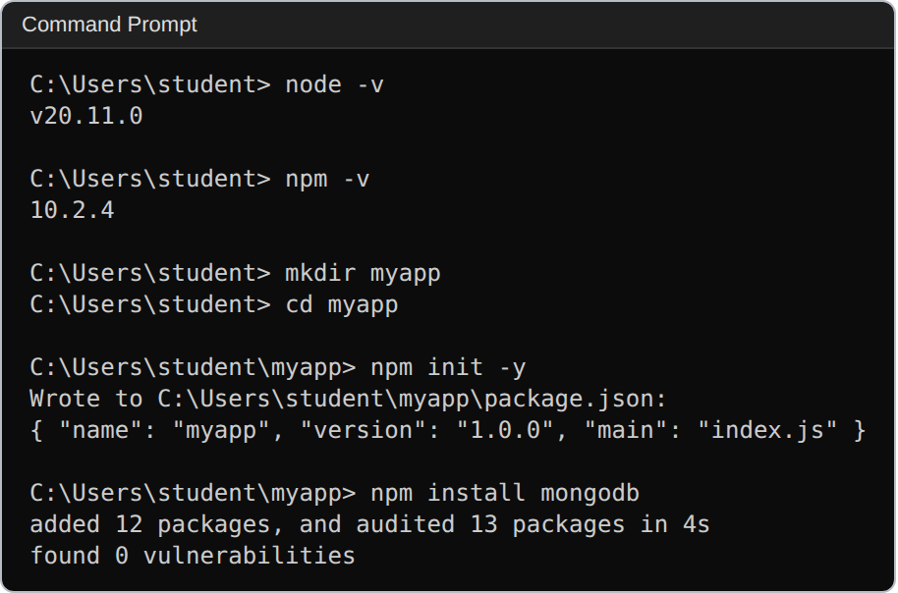
Remember:
node -v
npm -v
npm init -y
npm install package-name

2. Role of REST API ★★★★★

What is REST?
REST = Representational State Transfer.
A REST API allows different applications to communicate over HTTP.
For example:
React Application
↓
REST API
↓
Node.js Server
↓
MongoDB

Common HTTP methods:
Method | Purpose
GET | Retrieve data
POST | Create data
PUT | Update data
DELETE | Delete data

Example
GET /students

gets students.
POST /students

creates a student.
★ 2-mark answer
A REST API enables communication between client and server using HTTP. It allows resources to be created, retrieved, updated and deleted using methods such as POST, GET, PUT and DELETE. REST APIs are commonly used to connect web applications with server-side applications and databases.

Remember:
GET → Read
POST → Create
PUT → Update
DELETE → Delete

This is directly connected to your Node.js + MongoDB CRUD 10-mark question.
3. Traditional Website vs Single Page Application ★★★★★

This is very easy if you remember the fundamental difference.
Traditional Website
When moving between pages, the browser generally requests and loads another HTML page.
Page 1
↓
Reload
↓
Page 2
↓
Reload
↓
Page 3

SPA
SPA = Single Page Application
The application loads a main page and JavaScript dynamically updates the content without requiring a complete page reload for every action.
One main page
↓
JavaScript
↓
Content changes dynamically

Comparison
Traditional Website | SPA
Multiple page loads | Mainly one page
Full-page reloads | Dynamic updates
Navigation can involve server requests for new pages | JavaScript updates the view
Simpler traditional architecture | Rich interactive UI

★ 2-mark answer
A traditional website loads separate HTML pages and may perform a full-page reload during navigation. A Single Page Application (SPA) loads one main page and dynamically updates its content using JavaScript without completely reloading the page.

Examples of technologies associated with SPA
AngularJS
React
Vue

4. AngularJS Directives ★★★★★

This is very important because your previous paper directly tested directives.
What is a directive?
An AngularJS directive is a special instruction added to HTML that extends HTML's functionality.
They usually begin with:
ng-

Important directives
</> HTML
ng-app
ng-controller
ng-model
ng-init
ng-repeat
ng-click
ng-show
ng-hide
ng-bind

What they do
Directive | Purpose
ng-app | Defines AngularJS application
ng-controller | Specifies controller
ng-model | Provides data binding
ng-init | Initializes data
ng-repeat | Repeats HTML elements
ng-click | Handles click
ng-show | Shows element
ng-hide | Hides element
ng-bind | Binds/displays data

Example
</> HTML
<div ng-app="myApp" ng-controller="myCtrl">

<input ng-model="name">

<p>{{name}}</p>

</div>

★ 2-mark answer
AngularJS directives are special instructions added to HTML that extend its functionality and provide AngularJS features. Examples include `ng-app`, `ng-controller`, `ng-model`, `ng-repeat` and `ng-click`.

If they ask:
Which directive binds HTML controls to data?

Answer:
ng-model

Which directive initializes AngularJS?

ng-app

5. Hello World Using ReactJS ★★★★

This is a very likely short question because your previous paper literally had it.
Basic React program
</> JavaScript (JSX)
import React from "react";
import ReactDOM from "react-dom/client";

function App() {
return <h1>Hello World</h1>;
}

const root = ReactDOM.createRoot(
document.getElementById("root")
);

root.render(<App />);

HTML:
</> HTML
<div id="root"></div>

Output
Hello World

Understand the code
This:
</> JavaScript (JSX)
function App() {
return <h1>Hello World</h1>;
}

is a React component.
This:
</> JavaScript (JSX)
<h1>Hello World</h1>

is JSX.
This:
</> JavaScript
ReactDOM.createRoot(...)

creates the React root.
This:
</> JavaScript
root.render(<App />);

renders the component into the DOM.
★ 2-mark answer
ReactJS can display Hello World by creating a functional component that returns JSX and rendering it into the root DOM element using `ReactDOM.createRoot()` and `root.render()`.

▶ Output
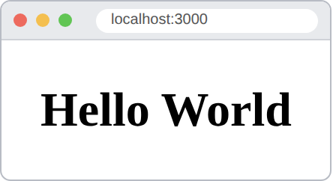
Remember:
Component → JSX → createRoot() → render()

6. Two-Way Data Binding in AngularJS ★★★★★

This is one of your most important 2-mark questions.
Two-way binding means:
Model
↕
ng-model
↕
View

Data flows in both directions.
Example
</> HTML
<input ng-model="name">

<p>Hello {{name}}</p>

If the model changes:
</> JavaScript
$scope.name = "Ajay";

the view updates.
If the user types something into the input:
Input → Model

the model also updates.
★ 2-mark answer
Two-way data binding in AngularJS synchronizes the model and the view. Changes in the model are automatically reflected in the view, and changes made by the user in the view update the model. The `ng-model` directive is used for two-way binding.

▶ Output
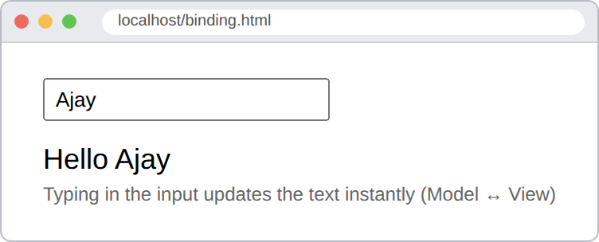
Most important keyword:
ng-model

Easy memory:
Model ↔ View

7. Filters in AngularJS ★★★★★

A filter is used to format or transform data before displaying it.
For example:
</> HTML
{{name | uppercase}}

If:
name = "ajay"

output:
AJAY

Important built-in filters
Filter | Purpose
uppercase | Converts to uppercase
lowercase | Converts to lowercase
currency | Formats currency
number | Formats numbers
date | Formats dates
orderBy | Sorts data
filter | Filters data
limitTo | Limits displayed data

Examples
</> HTML
{{name | uppercase}}

</> HTML
{{price | currency}}

</> HTML
{{name | lowercase}}

</> HTML
{{students | orderBy:'name'}}

★ 2-mark answer
Filters in AngularJS are used to format or transform data before displaying it in the view. Common built-in filters include `uppercase`, `lowercase`, `currency`, `number`, `date`, `orderBy`, `filter` and `limitTo`.

▶ Output
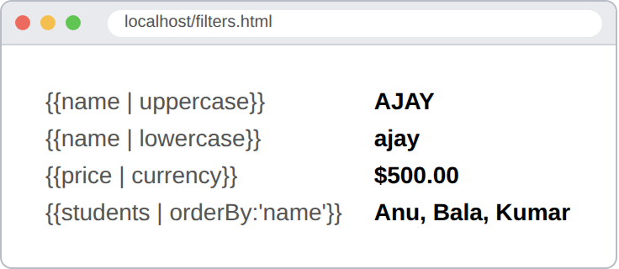
Remember:
uppercase
lowercase
currency
number
date
orderBy
filter
limitTo

8. Modules and Controllers in AngularJS ★★★★★

This looks complicated but it's actually simple.
Module
A module is a container for an AngularJS application and its components.
Example:
</> JavaScript
var app = angular.module("myApp", []);

Controller
A controller contains the application logic and data.
</> JavaScript
app.controller("myCtrl", function($scope) {

$scope.name = "Ajay";

});

HTML:
</> HTML
<div ng-app="myApp" ng-controller="myCtrl">

{{name}}

</div>

Output:
Ajay

Relationship
Remember:
Module
↓
Controller
↓
$scope
↓
View

★ 2-mark answer
A module is a container that organizes an AngularJS application and its components. A controller contains the application's logic and data and communicates with the view using `$scope`.

▶ Output
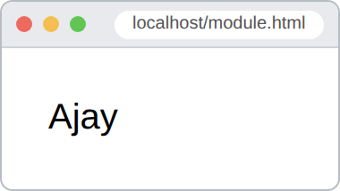
Important syntax
</> JavaScript
var app = angular.module("myApp", []);

app.controller("myCtrl", function($scope) {
$scope.name = "Ajay";
});

9. File Operations in Node.js ★★★★★

Node.js provides the File System (`fs`) module for working with files.
First import it:
</> JavaScript
const fs = require("fs");

Create/Write a file
</> JavaScript
fs.writeFile("data.txt", "Hello World", function(err) {

if (err) throw err;

console.log("File created");

});

Read a file
</> JavaScript
fs.readFile("data.txt", "utf8", function(err, data) {

if (err) throw err;

console.log(data);

});

Append data
</> JavaScript
fs.appendFile("data.txt", "Welcome", function(err) {

if (err) throw err;

console.log("Data added");

});

Delete a file
</> JavaScript
fs.unlink("data.txt", function(err) {

if (err) throw err;

console.log("File deleted");

});

★ The four operations you MUST remember
writeFile()
↓
Create / Write

readFile()
↓
Read

appendFile()
↓
Add data

unlink()
↓
Delete

★ 2-mark answer
Node.js provides the built-in `fs` (File System) module for performing file operations. Common methods are `fs.writeFile()` for writing, `fs.readFile()` for reading, `fs.appendFile()` for adding data and `fs.unlink()` for deleting a file.

▶ Output
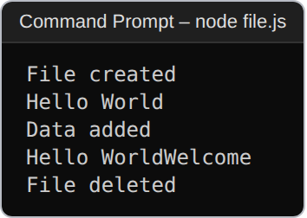
Important syntax:
</> JavaScript
const fs = require("fs");

YOUR 9 QUESTIONS — LAST-MINUTE MEMORY SHEET

If you're revising just before entering the exam, remember this:
1. NPM
npm = Node Package Manager

node -v
npm -v
npm init -y
npm install package

2. REST API
GET → Read
POST → Create
PUT → Update
DELETE → Delete

3. Traditional vs SPA
Traditional → multiple pages + reload
SPA → one main page + dynamic update

4. AngularJS Directives
ng-app
ng-controller
ng-model
ng-init
ng-repeat
ng-click
ng-show
ng-hide
ng-bind

5. React Hello World
Component
↓
JSX
↓
createRoot()
↓
render()

6. Two-way binding
Model ↔ View
↑
ng-model

7. AngularJS Filters
uppercase
lowercase
currency
number
date
orderBy
filter
limitTo

8. AngularJS Module + Controller
Module
↓
Controller
↓
$scope
↓
View

</> JavaScript
angular.module("myApp", []);

app.controller("myCtrl", function($scope) {
$scope.name = "Ajay";
});

9. Node.js File Operations
fs.writeFile()
fs.readFile()
fs.appendFile()
fs.unlink()

What I'd memorize word-for-word
There are five particularly likely 2-mark answers from your previous paper/staff list:
1. Role of REST API
2. AngularJS directives
3. Two-way data binding
4. Filters in AngularJS
5. Modules and controllers
And the five syntax-heavy ones:
npm commands
React Hello World
ng-model
AngularJS directives
Node.js fs operations

If you understand the 9 blocks above, you have essentially covered the exact short-question list your staff gave you.

