


[Educational Service : SNR Sons Charitable Trust]

Vattamalaipalayam, N.G.G.O. Colony Post, www.srec.ac.in

Coimbatore – 641022. +917530089996
----------------------------------------------------------------------------------------------------------------------------------------------------
DEPARTMENT OF ARTIFICIAL INTELLIGENCE AND DATA SCIENCE

Class: III B.Tech - AI&DS Semester : V

Certified that this is the bonafide record of work done by
AJAY I in the
20AD2E41 – AGENTIC AI COGNITION of this institution for V semester during the academic year 2026-2027.

Faculty In-Charge  Mrs. C. Kavitha  AP(OG) / AI&DS |  | Head Of The Department  Dr. V. Karpagam  Professor & Head /AI&DS
71812401007
Reg.No.:

Submitted for the Autonomous Practical Examination held on

Internal Examiner Subject Expert

DEPARTMENT OF
ARTIFICIAL INTELLIGENCE AND DATA SCIENCE

VISION
To achieve excellence in the domain of Artificial Intelligence and Data Science and produce globally competent professionals providing multidisciplinary, sustainable solutions for societal challenges and industrial needs.

MISSION
- To deliver quality education to develop ethical and sustainable intelligent solutions for interdisciplinary domains.
- To promote research, innovation, and entrepreneurship through collaboration with industry and academia.
- To foster leadership and lifelong learning for professional and societal advancement.

PROGRAMME EDUCATIONAL OBJECTIVES (PEOs)
- PEO 1: Demonstrate professional and research competence using combined knowledge in Mathematics, Computing, Artificial Intelligence and Data Science
- PEO 2: Apply knowledge and skills in Artificial Intelligence and Data Science to develop innovative, sustainable and ethically responsible solutions to complex, multidisciplinary problems
- PEO 3: Engage in constructive research, professional growth and lifelong learning by effectively applying emerging technological expertise

PROGRAMME OUTCOMES (POs)

- Engineering knowledge: Apply knowledge of mathematics, natural science, computing, engineering fundamentals and an engineering specialization as specified in WK1 to WK4 respectively to develop to the solution of complex engineering problems.
- Problem analysis: Identify, formulate, review research literature and analyse complex engineering problems reaching substantiated conclusions with consideration for sustainable development (WK1 to WK4).
- Design/development of solutions: Design creative solutions for complex engineering problems and design/ develop systems/ components/processes to meet identified needs with consideration for the public health and safety, whole-life cost, net zero carbon, culture, society and environment as required (WK5).
- Conduct Investigations of Complex Problems: Conduct investigations of complex engineering problems using research-based knowledge including design of experiments, modelling, analysis & interpretation of data to provide valid conclusions (WK8).
- Engineering Tool Usage: Create, select and apply appropriate techniques, resources and modern engineering & IT tools, including prediction and modelling recognizing their limitations to solve complex engineering problems (WK2 and WK6).
- The Engineer and The World: Analyze and evaluate societal and environmental aspects while solving complex engineering problems for its impact on sustainability with reference to economy, health, safety, legal framework, culture and environment (WK1, WK5 and WK7).
- Ethics: Apply ethical principles and commit to professional ethics, human values, diversity and inclusion; adhere to national & international laws (WK9).
- Individual and Collaborative Team work: Function effectively as an individual, and as a member or leader in diverse/multi-disciplinary teams.
- Communication: Communicate effectively and inclusively within the engineering community and society at large, such as being able to comprehend and write effective language, and learning differences.
- Project Management and Finance: Apply knowledge and understanding of engineering management principles and economic decision-making and apply these to one’s own work, as a member , leader in a team and to manage projects and in multidisciplinary environments.
- Life-Long Learning: Recognize the need for, and have the preparation and ability for i) independent and life-long learning ii) adaptability to new and emerging technologies and
iii) critical thinking in the broadest context of technological change (WK8).

PROGRAMME SPECIFIC OUTCOMES (PSOs)
PSO1: Analyze, design and develop sustainable intelligent solutions to address complex challenges posed by industry and society.
PSO2: Demonstrate data analysis skills to achieve effective insights and decision making to solve real-life problems.
PSO3: Apply mathematical and statistical techniques to model real-world problems using appropriate AI algorithms.
INDEX

EX. NO | DATE | NAME OF THE EXPERIMENT | PAGE NO
01. | 01/08/2026 | Implement reasoning techniques using Chain of Thought (CoT) | 05
02. | 08/08/2026 | Implement reasoning techniques using Program of Thought (PoT) | 07
03. | 22/08/2026 | Develop a self-correcting AI agent using the Reflexion framework | 09
04. | 12/09/2026 | Implement planning strategies using ReAct and Tree of Thoughts (ToT) | 11
05. | 19/09/2026 | Develop a Language Agent Tree Search (LATS)-based reasoning agent | 13
06. | 02/10/2026 | Design and implement Retrieval-Augmented Generation (RAG) for AI agents | 15
07. | 03/10/2026 | Design and implement GraphRAG for AI agents | 18
08. | 14/10/2026 | Develop a persistent memory-enabled AI agent using MemGPT concepts | 21
09. | 15/10/2026 | Implement episodic memory and experience replay for autonomous agents | 25
10. | 16/10/2026 | Evaluate autonomous AI agents using AgentBench and SWE-bench benchmarks | 28
CONTENT BEYOND SYLLABUS
 | 17/10/2026 | Design and develop an autonomous Agentic AI system integrating reasoning, planning, and memory for a real-world application | 31

Ex No: 1 | Implementation of reasoning techniques using Chain of Thought (CoT).
Date: 01/08/2026

AIM:
To implement Chain of Thought reasoning for decision making based on weather conditions.
ALGORITHM:
- Identify the problem to be solved using Chain of Thought (CoT) reasoning.
- Provide the input or problem statement to the system.
- Break the problem into smaller, manageable steps.
- Analyze each step logically to reach a solution.
- Combine the results to determine the final answer.
- Display the final answer and verify its correctness.

PROGRAM:

def weather_forecast():
print("=== Weather Decision System ===")

temperature = float(input("Enter temperature (°C): "))
rain = input("Is it raining? (yes/no): ").lower()
forecast = input("Rain expected? (yes/no): ").lower()
cloudy = input("Is it cloudy? (yes/no): ").lower()

print("\n--- Reasoning Steps ---")

if rain == "yes":
print("1. It is currently raining.")
print("2. Carry an umbrella.")
decision = "Carry an umbrella"

elif forecast == "yes":
print("1. Rain is expected.")
print("2. Prepare for possible rainfall.")
decision = "Carry an umbrella"

elif cloudy == "yes":
print("1. The sky is cloudy.")
print("2. Rain is not forecast, but conditions may change.")
decision = "Check the forecast before leaving"

else:
print("1. It is not raining.")
print("2. Rain is not expected and the sky is clear.")
decision = "Umbrella may not be necessary"

if temperature >= 35:
print("3. The temperature is high. Stay hydrated.")
elif temperature <= 15:
print("3. The temperature is low. Wear warm clothes.")
else:
print("3. The temperature is moderate.")

print("\nFinal Decision:", decision)

weather_forecast()

OUTPUT:
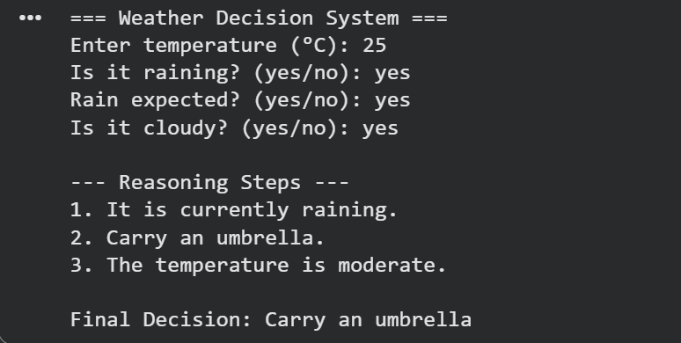
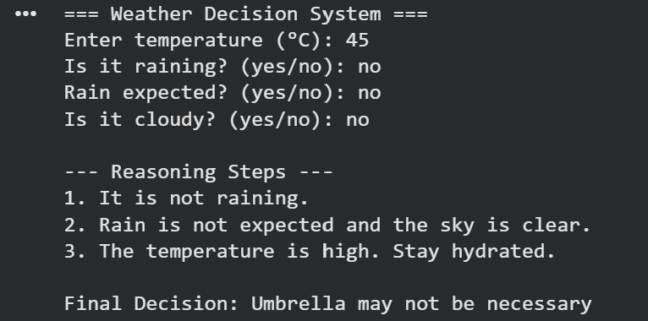

RESULT:
Thus, the experiment to implement Chain of Thought (CoT) for decision making based on weather conditions was completed successfully.

Ex No: 2 | Implementation of reasoning techniques using Program of Thought (PoT).
Date: 08/08/2026

AIM:
To implement Program of Thought (PoT) reasoning using Python to calculate the total bill amount for items purchased.

ALGORITHM:
- Initialize the program and obtain the number of items.
- Accept the price and quantity of each item dynamically.
- Calculate each item's cost using multiplication.
- Add all item costs to obtain the subtotal.
- Calculate the discount and subtract it from the subtotal.
- Display the subtotal, discount, and final bill amount.

PROGRAM:
def calculate_bill():
n = int(input("Enter number of items: "))
total = 0
for i in range(1, n + 1):
price = float(input(f"Enter price of item {i}: "))
quantity = int(input(f"Enter quantity of item {i}: "))
item_total = price * quantity
print(f"Item {i} total = {item_total:.2f}")
total += item_total
discount = float(input("Enter discount percentage: "))
discount_amount = total * discount / 100
final_amount = total - discount_amount
print("\n--- Bill Summary ---")
print(f"Subtotal: Rs. {total:.2f}")
print(f"Discount: Rs. {discount_amount:.2f}")
print(f"Final Bill: Rs. {final_amount:.2f}")
calculate_bill()

OUTPUT:
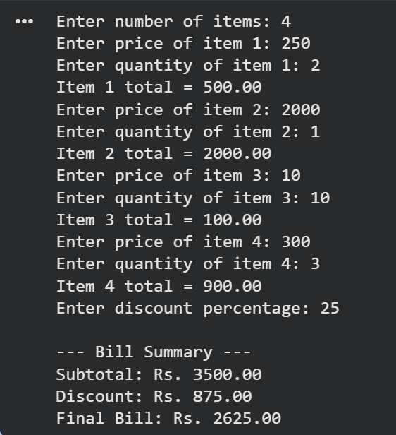

RESULT:
Thus, the experiment to implement Program of Thought (PoT) reasoning using Python to calculate the total bill amount for items purchased was completed successfully.

Ex No: 3 | DevelopING a self-correcting AI agent using the Reflexion framework.
Date: 22/08/2026
AIM:
To develop a self-correcting AI agent that detects errors in a student's quiz answers, reflects on mistakes, and provides corrected answers.
ALGORITHM:
- Initialize the AI agent with a set of questions and correct answers.
- Accept the user's answers dynamically.
- Evaluate each answer against the expected result.
- Identify incorrect answers and generate feedback through reflection.
- Provide the correct answer and allow the user to retry.
- Display the final score after completing the evaluation.

PROGRAM:
def reflexion_agent():
questions = {
"What is an AI agent?":
("A system that observes and acts to achieve goals", ["A system that only stores files",
"A system that observes and acts to achieve goals",
"A system used only for calculations"]),
"What is the purpose of an LLM in an AI agent?":
("To understand inputs and generate responses", ["To understand inputs and generate responses",
"To replace all computer hardware", "To store electricity"]),
"What is the main purpose of the Reflexion framework?":
("To improve performance using feedback and reflection",
["To delete previous results",
"To improve performance using feedback and reflection",
"To avoid evaluating outputs"]),
}
score = 0
for question, (correct_answer, options) in questions.items():
print("\nQuestion:", question)
for i, option in enumerate(options, 1):
print(f"{i}. {option}")
answer = input("Enter your answer (1-3): ").strip()
if answer in ("1", "2", "3") and options[int(answer) - 1] == correct_answer:
print("Evaluation: Correct!")
score += 1
else:
print("Evaluation: Incorrect!")
print("Reflection: Review the concept and try again.")
print("Correction: The correct answer is", correct_answer)
retry = input("Try again (1-3): ").strip()
if retry in ("1", "2", "3") and options[int(retry) - 1] == correct_answer:
print("Self-correction successful!")
score += 1
else:
print("Learning point:", correct_answer)
print("\nFinal Score:", score, "/", len(questions))
print("Agent completed the evaluation.")
reflexion_agent()

OUTPUT:
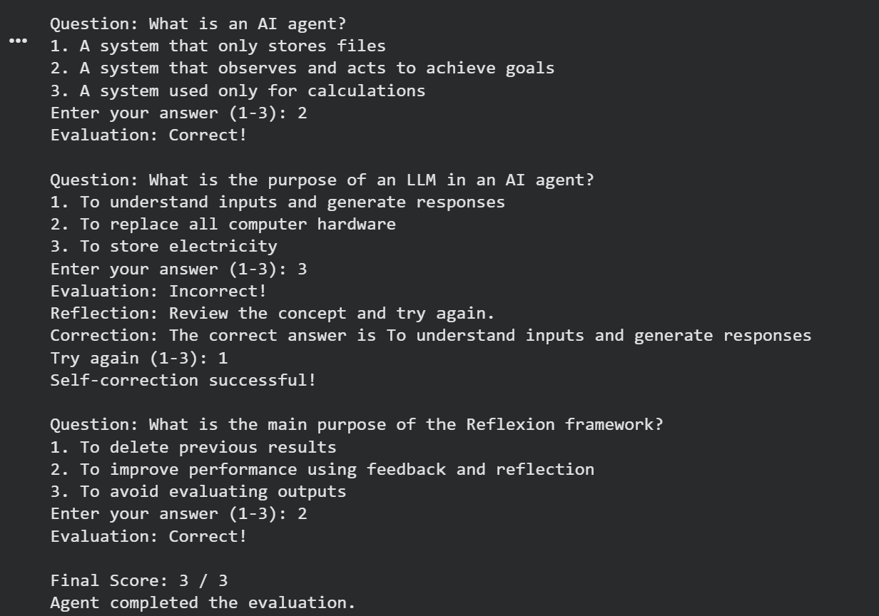

RESULT:
Thus, the experiment to develop a self-correcting AI agent was successfully completed.

Ex No: 4 | Implement planning strategies using ReAct and Tree of Thoughts (ToT).
Date: 12/09/2026
AIM:
To implement ReAct and Tree of Thoughts (ToT) planning strategies using Python for an event-planning agent that selects a suitable venue based on budget and guest capacity.
ALGORITHM:
- Initialize the event-planning agent with venue details, costs, and capacities.
- Accept the budget and expected number of guests dynamically.
- Apply the ReAct strategy by reasoning about requirements, evaluating venues, and observing the results.
- Apply the Tree of Thoughts strategy by exploring and comparing suitable venue options.
- Select the most cost-effective venue that satisfies both constraints.
- Display the selected plan or suggest adjustments if no venue is suitable.

PROGRAM:
def event_planning_agent():
print("=== Event Planning Agent ===")
budget = int(input("Enter your budget (Rs.): "))
guests = int(input("Enter number of guests: "))
venues = {
"Community Hall": {"cost": 3000, "capacity": 100},
"Banquet Hall": {"cost": 8000, "capacity": 300},
"Conference Room": {"cost": 2000, "capacity": 50}
}
# ReAct: Reason, Act, Observe
print("\n--- ReAct Planning ---")
print("Reason: Identify venues within budget and capacity.")
print("Act: Evaluate available venues.")
suitable = []
for name, details in venues.items():
if details["cost"] <= budget and details["capacity"] >= guests:
suitable.append((name, details["cost"]))
print(f"Observation: {name} is suitable.")
else:
print(f"Observation: {name} does not meet the requirements.")
# Tree of Thoughts: Compare possible choices
print("\n--- Tree of Thoughts (ToT) ---")
if suitable:
for name, cost in suitable:
print(f"Thought: Consider {name}, costing Rs. {cost}.")

best = min(suitable, key=lambda x: x[1])
print("\nBest Plan:", best[0])
print("Venue Cost: Rs.", best[1])
else:
print("No venue meets both requirements.")
print("Thought: Increase the budget or reduce guest capacity.")
print("\nPlanning completed.")
event_planning_agent()

OUTPUT:
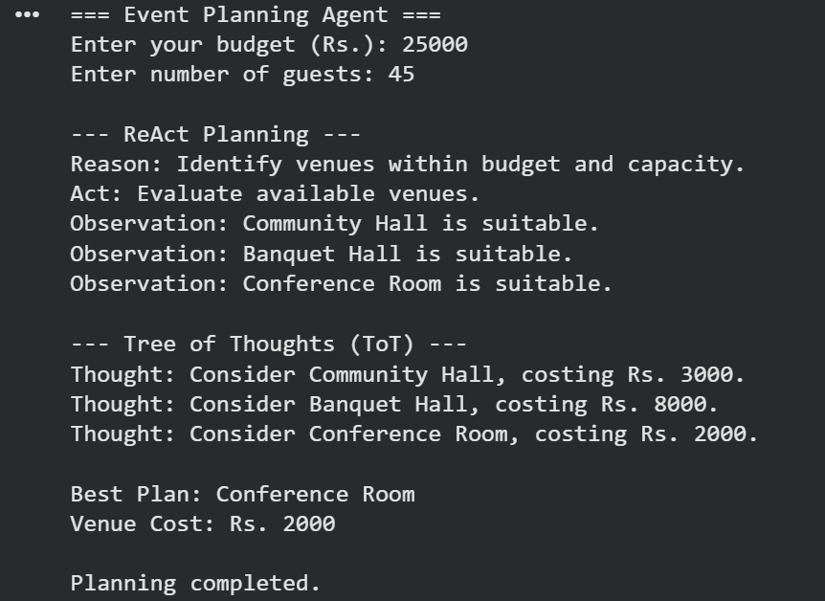

RESULT:
To implement ReAct and Tree of Thoughts (ToT) planning strategies using Python for an event-planning agent was completed successfully.

Ex No: 5 | DevelopING a Language Agent Tree Search (LATS)-based reasoning agent.
Date: 19/09/2026
AIM:
To develop a LATS-based reasoning agent that explores different solutions and selects the best study schedule based on available time and subject priorities.
ALGORITHM:
- Initialize the reasoning agent and obtain the available study time.
- Accept subject names, priorities, and required study hours dynamically.
- Generate possible study plans as candidate branches in a search tree.
- Evaluate each candidate based on priority and time requirements.
- Select the candidate with the highest evaluation score.
- Display the best plan and terminate the program.

PROGRAM:
def lats_agent():
print("=== Study Schedule Planning Agent ===")
hours = float(input("Enter available study hours: "))
subjects = int(input("Enter number of subjects: "))
tasks = []
for i in range(subjects):
name = input(f"Enter subject {i + 1}: ")
priority = int(input(f"Enter priority of {name} (1-5): "))
duration = float(input(f"Enter study hours needed for {name}: "))
tasks.append({
"name": name,
"priority": priority,
"duration": duration
})
# Generate candidate plans (search tree)
print("\n--- Exploring Candidate Plans ---")
plans = []
for task in tasks:
if task["duration"] <= hours:
score = task["priority"] * 10 - task["duration"]
plans.append((task["name"], task["duration"], score))
print(f"Thought: Study {task['name']}")
print(f"Evaluation score: {score}")
# Select the best candidate
if plans:
best = max(plans, key=lambda p: p[2])
print("\n--- Best Plan ---")
print("Subject:", best[0])
print("Study Hours:", best[1])
print("Score:", best[2])
else:
print("No subject fits the available study time.")
print("\nLATS reasoning completed.")
lats_agent()

OUTPUT:
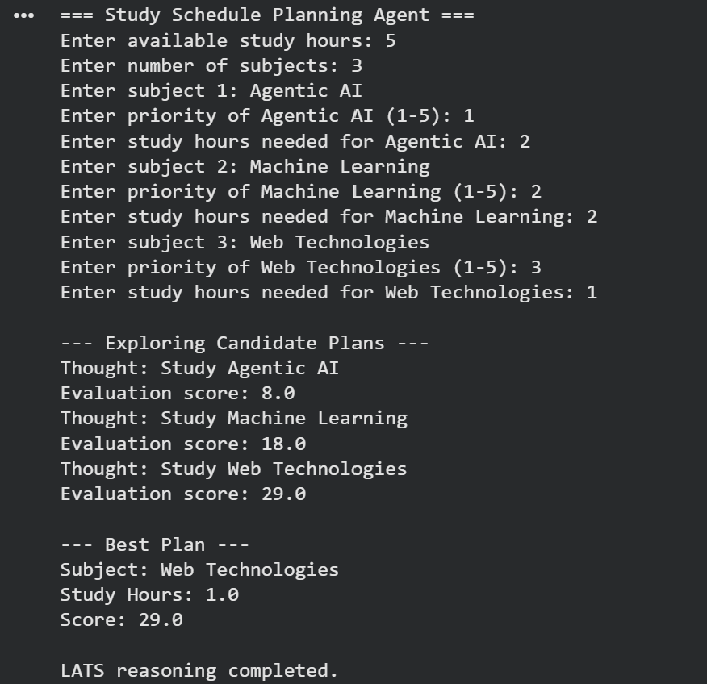

RESULT:
Thus, the experiment to develop a LATS-based reasoning agent was completed successfully.

Ex No: 6 | Design and implement Retrieval-Augmented Generation (RAG) for AI agents.
Date: 02/10/2026
AIM:
To implement a RAG-based AI agent that retrieves relevant information from a collection of technical support FAQs and generates answers based on the retrieved information.
ALGORITHM:
- Create a knowledge base containing technical support information.
- Accept a user query dynamically.
- Retrieve relevant information by matching query keywords with stored knowledge.
- Generate an answer using the retrieved information.
- Display the generated response or a fallback message when no relevant information is found.
PROGRAM:
import pandas as pd
import re
def rag_agent():
try:
# Load the external knowledge base
df = pd.read_csv("college_faq.csv")
print("=== College FAQ RAG Agent ===")
print("Knowledge base loaded:", len(df), "records")
while True:
query = input(
"\nEnter your question (or 'exit' to stop): "
).strip().lower()
if query == "exit":
print("RAG Agent stopped.")
break
if not query:
print("Please enter a question.")
continue
# Retrieval: compare query with stored questions
query_words = set(re.findall(r"\w+", query))
best_row = None
best_score = 0
for _, row in df.iterrows():
question = str(row["question"]).lower()
question_words = set(re.findall(r"\w+", question))
score = len(query_words & question_words)
if score > best_score:
best_score = score
best_row = row
# Generation: form a response from retrieved context
print("\n--- RAG Response ---")
if best_row is not None and best_score >= 1:
print("Category:", best_row["category"])
print("Retrieved Question:", best_row["question"])
print("Generated Answer:", best_row["answer"])
else:
print(
"No relevant information found in the knowledge base."
)
except FileNotFoundError:
print("Error: college_faq.csv not found.")
print("Place the CSV file in the same folder as this program.")
except KeyError:
print("Error: CSV must contain category, question, and answer columns.")
rag_agent()

OUTPUT:
college_faq.csv
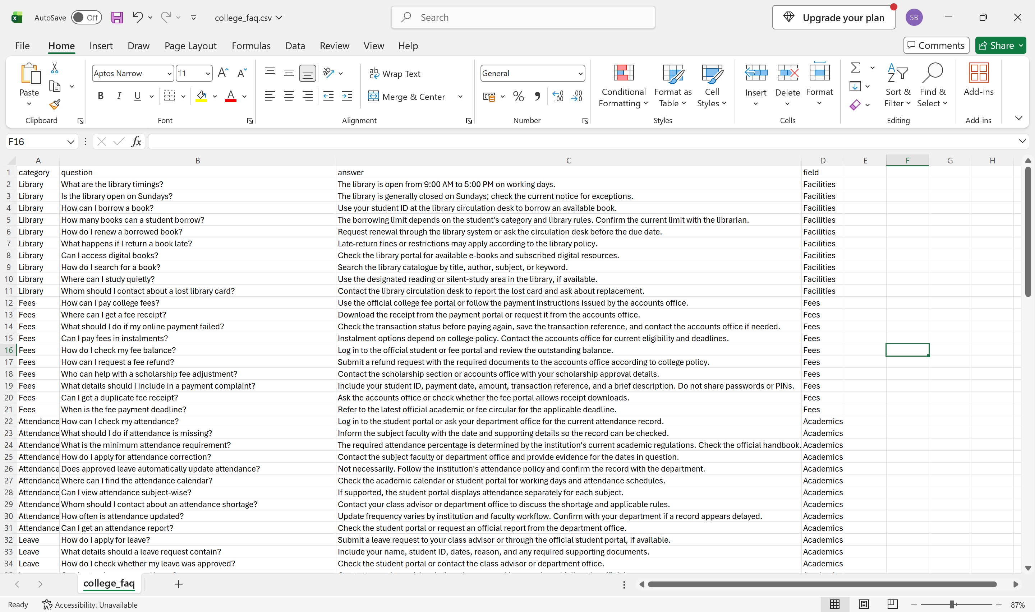

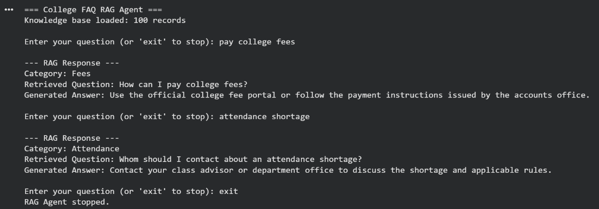
RESULT: A basic RAG-based AI agent was implemented successfully to retrieve relevant information from a knowledge base and generate context-based answers.

Ex No: 7 | Design and implement GraphRAG for AI agents.
Date: 03/10/2026 | Design and implement GraphRAG for AI agents.
AIM:
To design and implement a GraphRAG-based AI agent that answers student queries by using relationships between subjects, faculty, departments, and laboratories.
ALGORITHM:
- Install NetworkX and create a knowledge graph.
- Represent entities as nodes and relationships as edges.
- Accept a query dynamically from the user.
- Search the graph for matching topics.
- Retrieve connected entities and their relationships.
- Display the retrieved knowledge and stop when the user enters exit.

Install necessary libraries:
pip install pandas network

PROGRAM:
import pandas as pd
import networkx as nx
def graphrag_agent():
try:
# Load the 500-row knowledge graph dataset
df = pd.read_csv("graphrag_knowledge_graph_500.csv")
# Create a directed knowledge graph
graph = nx.DiGraph()
for _, row in df.iterrows():
subject = str(row["subject"]).strip()
relation = str(row["relation"]).strip()
obj = str(row["object"]).strip()
graph.add_edge(subject, obj, relation=relation)
print("=== GraphRAG AI Agent ===")
print("Knowledge graph loaded successfully!")
print("Total records:", len(df))
print("Entities:", graph.number_of_nodes())
print("Relationships:", graph.number_of_edges())
while True:
query = input(
"\nAsk a question (or type 'exit'): "
).strip()
if query.lower() == "exit":
print("GraphRAG agent stopped.")
break
if not query:
print("Please enter a question.")
continue
# Retrieve matching entities
matches = [
node for node in graph.nodes()
if query.lower() in node.lower()
]
if not matches:
print("No matching entity found in the knowledge graph.")
continue
print("\n--- Retrieved Knowledge ---")
for entity in matches:
print("\nEntity:", entity)
found = False
# Outgoing relationships
for neighbor in graph.successors(entity):
relation = graph[entity][neighbor]["relation"]
print(f"{entity} --{relation}--> {neighbor}")
found = True
# Incoming relationships
for neighbor in graph.predecessors(entity):
relation = graph[neighbor][entity]["relation"]
print(f"{neighbor} --{relation}--> {entity}")
found = True
if not found:
print("No connected relationships found.")
print("\nAnswer retrieved from the knowledge graph.")
except FileNotFoundError:
print("Error: CSV file not found.")
print("Place the dataset in the same folder as this program.")
except KeyError:
print("Error: CSV must contain subject, relation, and object columns.")
graphrag_agent()

OUTPUT
graphrag_knowledge_graph_500.csv:
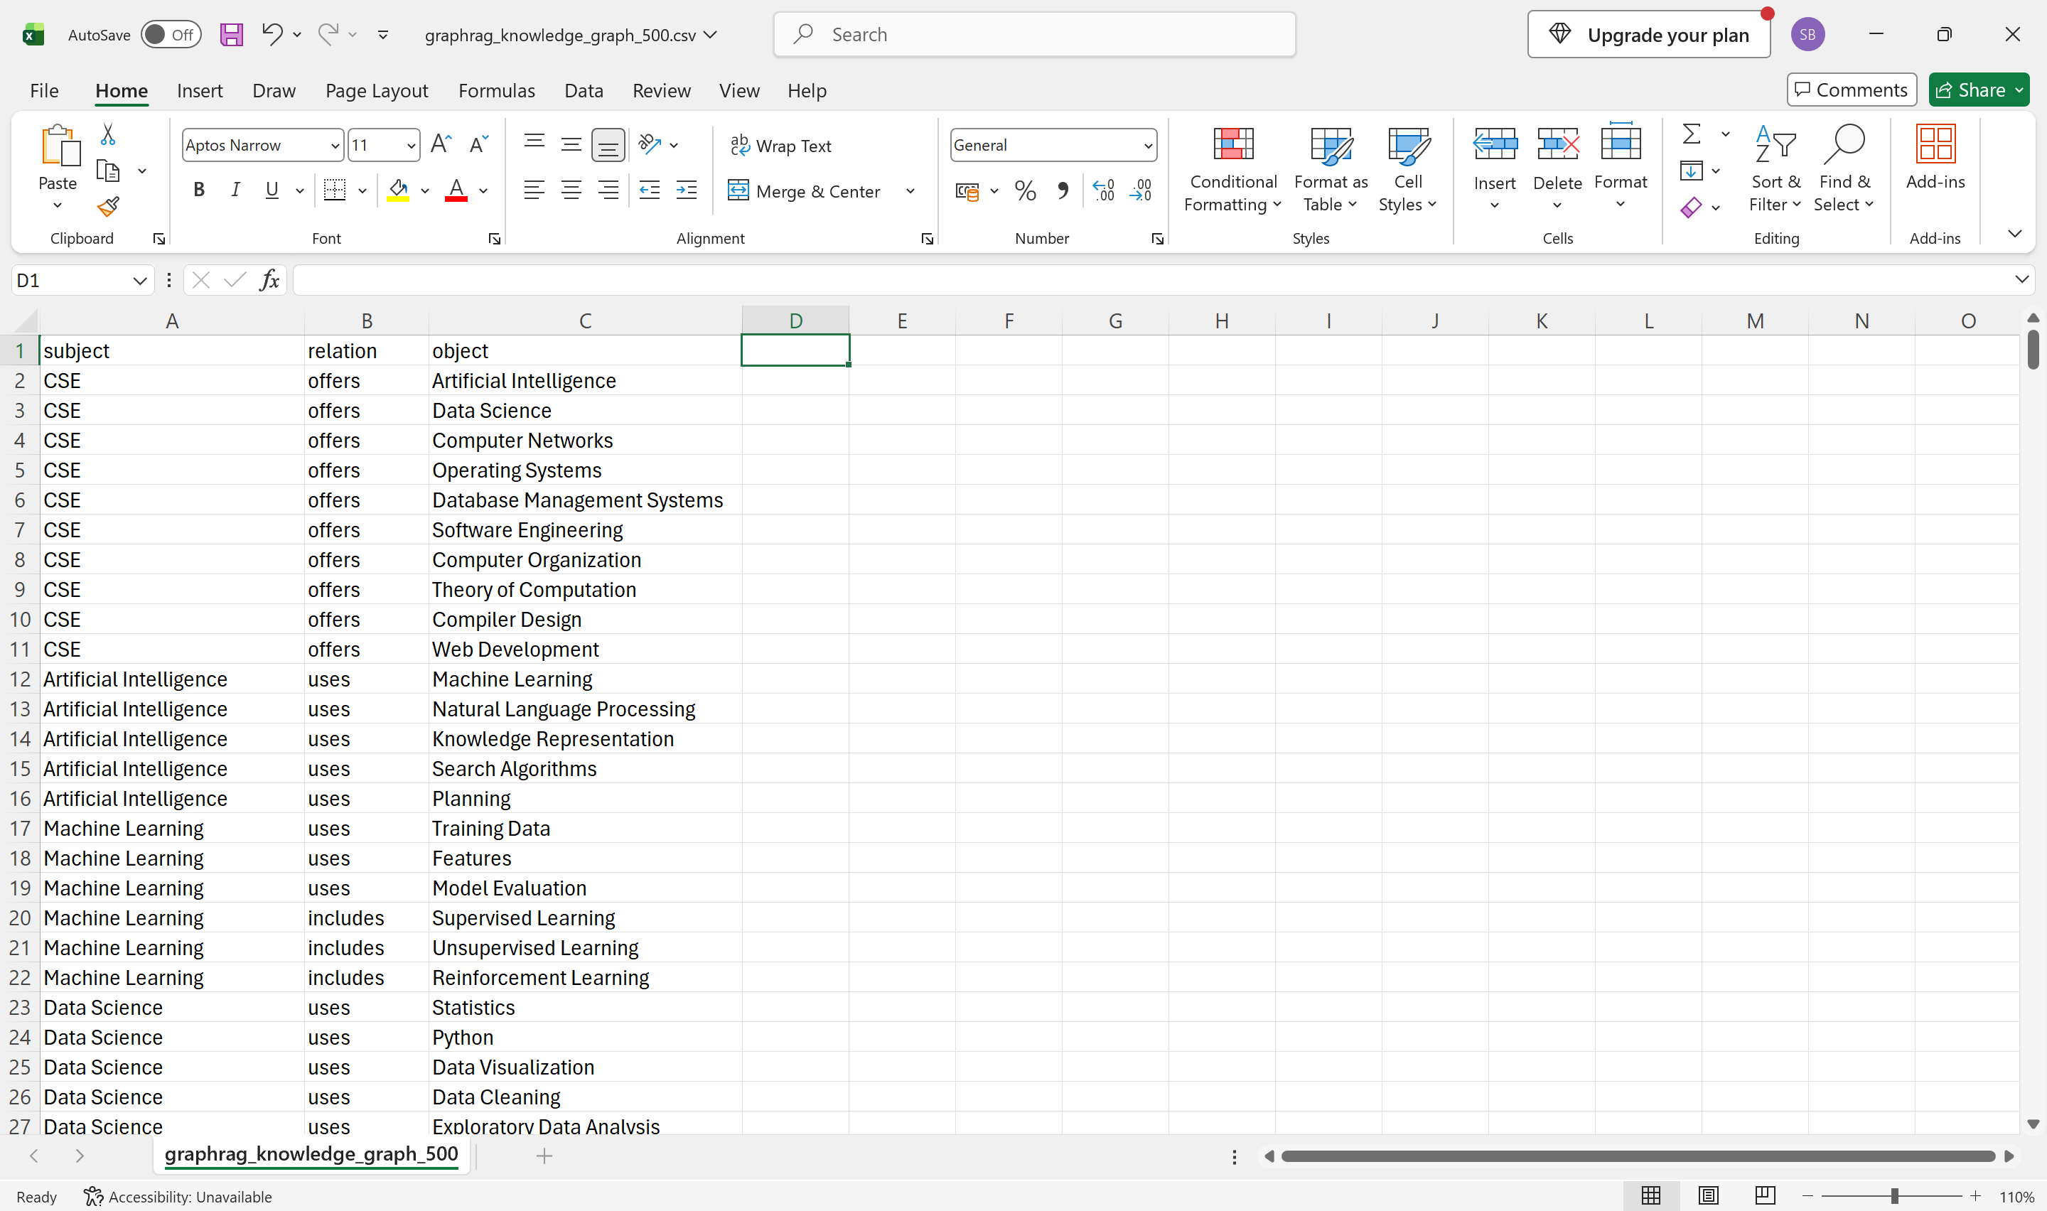
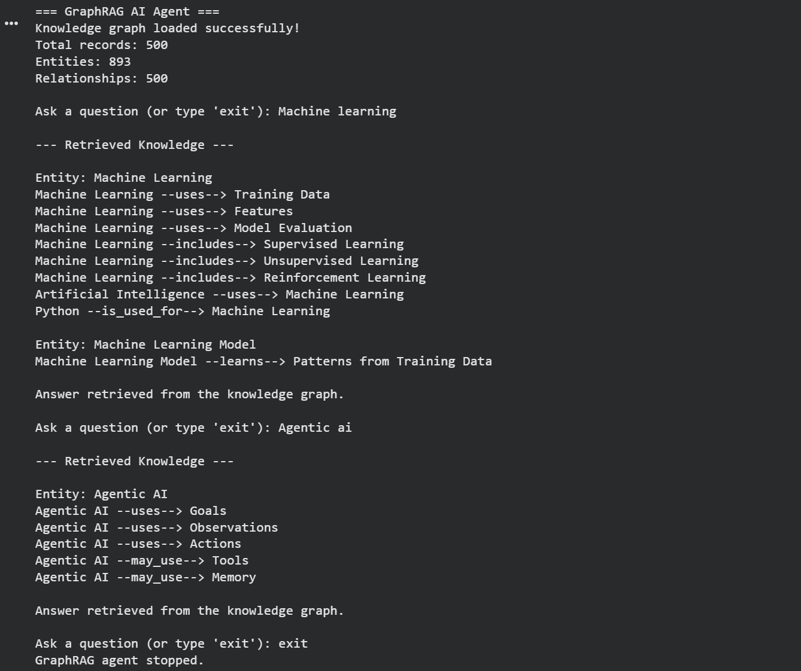

RESULT:
A basic GraphRAG-inspired AI agent was implemented using a knowledge graph to retrieve related entities and relationships for student queries.

Ex No: 8 | Develop a persistent memory-enabled AI agent using MemGPT concepts.
Date: 14/10/2026
AIM:
To develop a persistent memory-enabled AI agent using MemGPT concepts that keeps important facts in core memory, stores conversation history in archival memory using SQLite, and recalls the stored information after the program is restarted.
Note: This is a simplified, rule-based educational simulation of MemGPT concepts. It is not the official MemGPT implementation and does not use a large language model.
ALGORITHM:
- Create a SQLite database with a core memory table for important facts and an archival memory table for conversation history.
- Start the agent, load the stored core memory and display the number of saved entries.
- Accept the user's message and identify whether it stores a fact, asks for a fact or searches the history.
- Save a new fact in core memory, or update the existing value when the user changes it.
- Answer questions by retrieving the fact from core memory or by searching archival memory.
- Archive every message, keep only the latest four messages in the working context and stop when the user types exit.
- Restart the agent and verify that the earlier information is retrieved from the database.

PROGRAM:
import sqlite3
import re

class MemGPTAgent:
def __init__(self, db_file="memgpt_memory.db", window=4):
self.db = sqlite3.connect(db_file)
self.window = window
self.context = []
self.db.execute("CREATE TABLE IF NOT EXISTS core_memory "
"(key TEXT PRIMARY KEY, value TEXT)")
self.db.execute("CREATE TABLE IF NOT EXISTS archival_memory "
"(id INTEGER PRIMARY KEY AUTOINCREMENT, "
"role TEXT, content TEXT)")
self.db.commit()

def get_core(self, key):
row = self.db.execute("SELECT value FROM core_memory WHERE key = ?",
(key,)).fetchone()
return row[0] if row else None

def update_core(self, key, value):
self.db.execute("INSERT OR REPLACE INTO core_memory VALUES (?, ?)",
(key, value))
self.db.commit()

def archive(self, role, text):
self.db.execute("INSERT INTO archival_memory (role, content) "
"VALUES (?, ?)", (role, text))
self.db.commit()

def search_archive(self, word):
rows = self.db.execute("SELECT content FROM archival_memory "
"WHERE role = 'user' AND content LIKE ?",
("%" + word + "%",)).fetchall()
return [r[0] for r in rows]

def count(self, table):
sql = "SELECT COUNT(*) FROM " + table
return self.db.execute(sql).fetchone()[0]

def remember(self, role, text):
self.context.append((role, text))
if len(self.context) > self.window:
self.context.pop(0)
self.archive(role, text)

def respond(self, message):
text = message.strip()
topics = "(name|favourite subject|goal)"
store = re.search("my " + topics + r" is ([\w\s]+)", text, re.I)
ask = re.search("what is my " + topics, text, re.I)
history = re.search(r"what did i say about (\w+)", text, re.I)
if store:
key, value = store.group(1).lower(), store.group(2).strip()
old = self.get_core(key)
self.update_core(key, value)
if old and old != value:
return (f"Core memory updated: {key} changed "
f"from {old} to {value}.")
return f"Core memory saved: {key} = {value}."
if ask:
key = ask.group(1).lower()
value = self.get_core(key)
if value:
return f"Your {key} is {value}."
return f"I do not have your {key} in core memory."
if history:
found = self.search_archive(history.group(1))
if found:
return "Archival memory says: \"" + found[0] + "\""
return "I found nothing in archival memory."
return "Message saved to archival memory."

agent = MemGPTAgent()
print("=== MemGPT-Style Memory Agent ===")
print("Core memory entries:", agent.count("core_memory"))
print("Archived messages:", agent.count("archival_memory"))
while True:
message = input("\nYou: ").strip()
if message.lower() == "exit":
print("Session ended. Memory saved to disk.")
break
reply = agent.respond(message)
agent.remember("user", message)
agent.remember("agent", reply)
print("Agent:", reply)

OUTPUT:
Session 1:
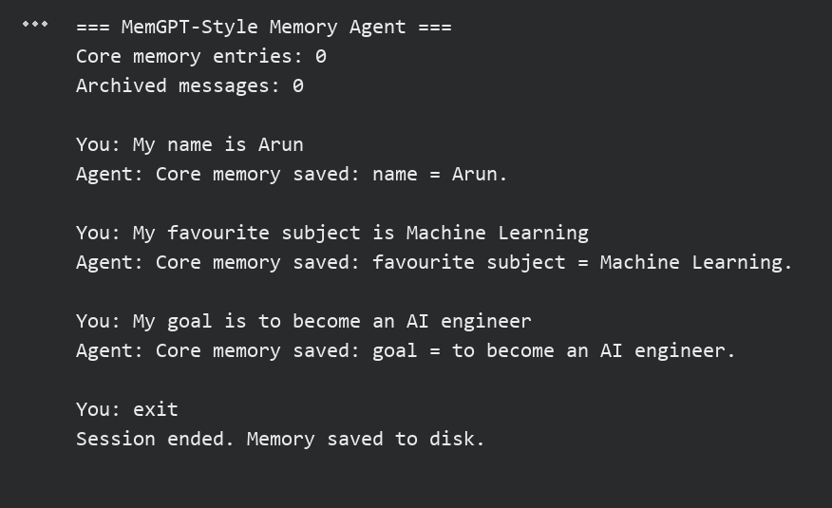
Session 2 (after restarting the program):
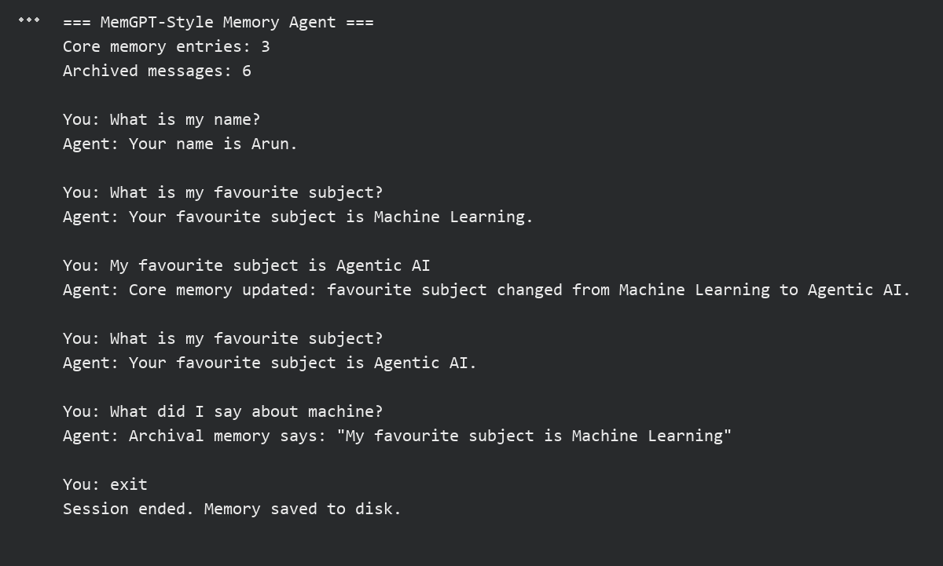

RESULT:
Thus, the experiment to develop a persistent memory-enabled AI agent using MemGPT concepts was completed successfully, and the facts stored in the first session were retrieved correctly after restarting the program.

Ex No: 9 | Implement episodic memory and experience replay for autonomous agents.
Date: 15/10/2026
AIM:
To implement episodic memory and experience replay for an autonomous route-selection agent that records the state, action, reward and outcome of every episode and uses past experience to make a better decision.
ALGORITHM:
- Create a SQLite table to store episodes with state, action, reward and outcome.
- Define an environment that returns a reward and an outcome for every state and action pair.
- Run the agent for several episodes and record each experience in episodic memory.
- Retrieve the stored episodes and replay them several times in random order to update the learned value of each state and action pair.
- Compare the average reward and the learned value of each action for every state.
- Select the action with the highest learned value for a new trip and display the decision.

PROGRAM:
import sqlite3
import random

random.seed(42)
db = sqlite3.connect(":memory:")
db.execute("CREATE TABLE episodes (id INTEGER PRIMARY KEY "
"AUTOINCREMENT, state TEXT, action TEXT, "
"reward INTEGER, outcome TEXT)")

states = ["Rush Hour", "Normal"]
actions = ["Highway", "City Road", "Bypass"]
base_reward = {
("Rush Hour", "Highway"): -4, ("Rush Hour", "City Road"): 1,
("Rush Hour", "Bypass"): 3, ("Normal", "Highway"): 5,
("Normal", "City Road"): 2, ("Normal", "Bypass"): 1,
}

def environment(state, action):
reward = base_reward[(state, action)] + random.randint(-1, 1)
if reward >= 3:
outcome = "Arrived early"
elif reward >= 0:
outcome = "Arrived on time"
else:
outcome = "Delayed"
return reward, outcome

print("=== Episodic Memory: Recording Experiences ===")
for i in range(12):
state, action = states[i % 2], actions[(i // 2) % 3]
reward, outcome = environment(state, action)
db.execute("INSERT INTO episodes (state, action, reward, outcome) "
"VALUES (?, ?, ?, ?)", (state, action, reward, outcome))
print(f"Episode {i + 1:2d} | {state:9s} | {action:9s} | "
f"Reward {reward:2d} | {outcome}")

print("\n=== Experience Replay ===")
values = {}
for epoch in range(1, 4):
episodes = db.execute("SELECT state, action, reward "
"FROM episodes").fetchall()
random.shuffle(episodes)
for state, action, reward in episodes:
old = values.get((state, action), 0.0)
values[(state, action)] = old + 0.5 * (reward - old)
print(f"Replay pass {epoch}: {len(episodes)} episodes replayed")

print("\n=== Comparing Outcomes ===")
for state in states:
rows = db.execute("SELECT action, AVG(reward) FROM episodes "
"WHERE state = ? GROUP BY action "
"ORDER BY AVG(reward) DESC", (state,)).fetchall()
for action, avg in rows:
print(f"{state:9s} | {action:9s} | Average reward {avg:5.1f} | "
f"Learned value {values[(state, action)]:5.2f}")

print("\n=== Decision Using Past Experience ===")
for state in states:
best = max(actions, key=lambda a: values[(state, a)])
print(f"New trip in '{state}' -> choose {best}")

OUTPUT:
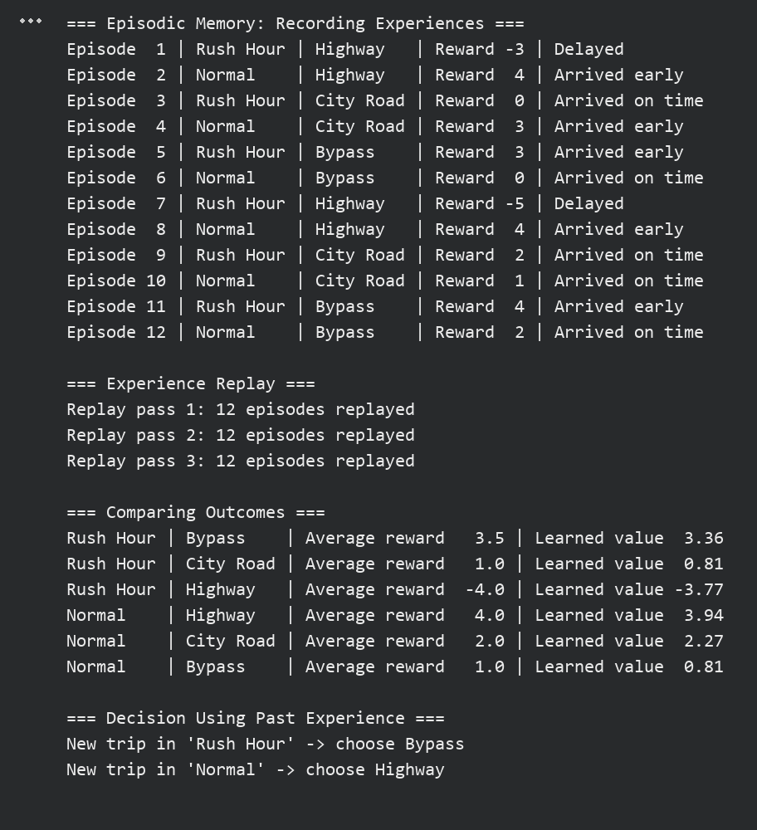

RESULT:
Thus, the experiment to implement episodic memory and experience replay for an autonomous agent was completed successfully, and the agent used its stored experiences to select the best action for each state.

Ex No: 10 | Evaluate autonomous AI agents using AgentBench and SWE-bench benchmarks.
Date: 16/10/2026
AIM:
To evaluate an autonomous AI agent using benchmark-style tasks inspired by AgentBench and SWE-bench and to calculate its completion rate, success rate and execution time.
AgentBench tests agents on decision-making and tool-use tasks, and SWE-bench tests whether an agent can fix a software issue so that the unit tests pass. This program is only a benchmark-inspired demonstration of these evaluation principles; it does not run the official AgentBench or SWE-bench suites.
ALGORITHM:
- Define sample tasks of two types: AgentBench-style tool-use tasks and SWE-bench-style bug-fixing tasks with unit tests.
- Create a simple rule-based agent that can answer the tasks and propose code patches.
- Run the agent on every task and measure the execution time of each task.
- For AgentBench-style tasks, compare the agent's answer with the expected answer.
- For SWE-bench-style tasks, apply the proposed patch and run the unit tests; the task is resolved only if all tests pass.
- Calculate the completion rate, success rate and average time and display the evaluation summary.

PROGRAM:
import re
import time

def run_tests(code, tests):
namespace = {}
exec(code, namespace)
return all(namespace[func](*args) == expected
for func, args, expected in tests)

class SimpleAgent:
def solve_task(self, instruction):
text = instruction.lower()
numbers = [int(n) for n in re.findall(r"\d+", text)]
if "percent" in text:
return numbers[0] * numbers[1] / 100
if "vowels" in text:
word = re.findall(r"'(\w+)'", text)[0]
return sum(1 for c in word if c in "aeiou")
if "reverse" in text:
return re.findall(r"'(\w+)'", text)[0][::-1]
if "sort" in text:
return sorted(numbers)
return None

def fix_bug(self, issue, code):
if "subtracts" in issue:
return code.replace("a - b", "a + b")
if "odd" in issue:
return code.replace("== 1", "== 0")
if "excludes" in issue:
return code.replace("range(n)", "range(n + 1)")
return None

AB = "AgentBench-style"
SW = "SWE-bench-style"
tasks = [
("AB-1", AB, "Find 15 percent of 2400", 360),
("AB-2", AB, "Count the vowels in 'benchmark'", 2),
("AB-3", AB, "Reverse the word 'agent'", "tnega"),
("AB-4", AB, "Sort 5, 2, 9 in descending order", [9, 5, 2]),
("AB-5", AB, "Translate 'hello' to French", "bonjour"),
("SW-1", SW, "add() subtracts instead of adding",
"def add(a, b):\n return a - b",
[("add", (2, 3), 5), ("add", (0, 0), 0)]),
("SW-2", SW, "is_even() returns True for odd numbers",
"def is_even(n):\n return n % 2 == 1",
[("is_even", (4,), True), ("is_even", (7,), False)]),
("SW-3", SW, "sum_to_n() excludes n from the total",
"def sum_to_n(n):\n return sum(range(n))",
[("sum_to_n", (4,), 10), ("sum_to_n", (1,), 1)]),
("SW-4", SW, "max_of() fails for negative numbers",
"def max_of(xs):\n best = 0\n for x in xs:\n"
" best = x if x > best else best\n return best",
[("max_of", ([3, 8, 1],), 8), ("max_of", ([-5, -2, -9],), -2)]),
]

agent = SimpleAgent()
results = []
print("=== Benchmark-Inspired Agent Evaluation ===")
for task in tasks:
task_id, kind, text = task[0], task[1], task[2]
start = time.perf_counter()
if kind == AB:
answer = agent.solve_task(text)
completed = answer is not None
success = completed and answer == task[3]
else:
patched = agent.fix_bug(text, task[3])
completed = patched is not None
success = completed and run_tests(patched, task[4])
elapsed = (time.perf_counter() - start) * 1000
results.append((kind, completed, success, elapsed))
status = "PASS" if success else "FAIL"
print(f"{task_id} | {kind:16s} | completed={str(completed):5s} | "
f"{status} | {elapsed:.3f} ms")

total = len(results)
rates = [100 * sum(r[i] for r in results) / total for i in (1, 2)]
print("\n=== Evaluation Summary ===")
print("Total tasks :", total)
print("Completion rate : %.1f%%" % rates[0])
print("Success rate : %.1f%%" % rates[1])
average = sum(r[3] for r in results) / total
print("Average time : %.3f ms" % average)
for kind in (AB, SW):
group = [r for r in results if r[0] == kind]
won = sum(r[2] for r in group)
print("%-17s: %d/%d solved" % (kind, won, len(group)))

OUTPUT:
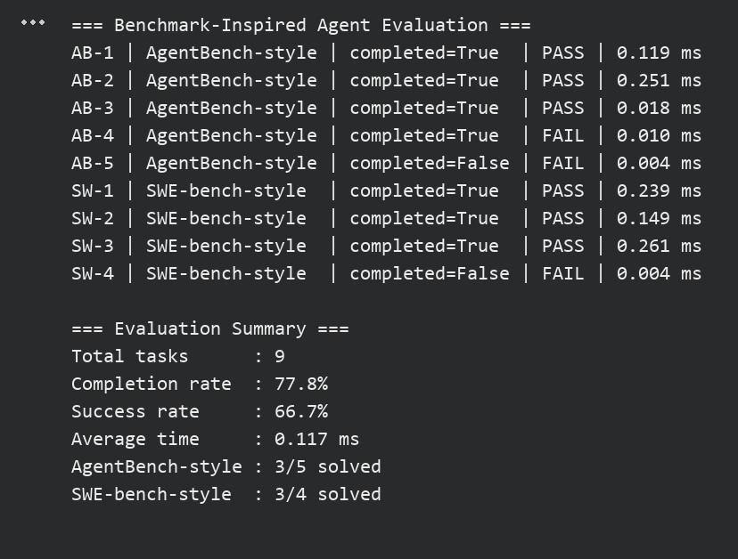

RESULT:
Thus, the experiment to evaluate an autonomous AI agent using AgentBench-style and SWE-bench-style tasks was completed successfully, and the agent achieved a success rate of 66.7% on the sample tasks (execution times vary slightly between runs).

Ex No: CBS | Design and develop an autonomous Agentic AI system integrating reasoning, planning, and memory for a real-world application.
Date: 17/10/2026
AIM:
To design and develop an autonomous Agentic AI study-planning assistant that integrates reasoning, planning and persistent memory to generate a study schedule, select its first action and improve its plans using past experience.
ALGORITHM:
- Create SQLite tables to store user preferences and past study experiences.
- Load the stored preferences, such as the start time and the maximum study block, from memory.
- Accept the available study hours, the subjects, their priorities and the days left for each exam.
- Reason about each subject by calculating a weight from its priority, exam urgency and past performance.
- Plan the study hours in proportion to the weights and arrange them into time blocks with short breaks.
- Select the first action by choosing the subject with the highest weight.
- Collect feedback on each session, store it as experience and update the preferences.
- Run the agent again and show that the new plan uses the stored experience.

PROGRAM:
import sqlite3

db = sqlite3.connect("study_agent.db")
db.execute("CREATE TABLE IF NOT EXISTS preferences "
"(key TEXT PRIMARY KEY, value TEXT)")
db.execute("CREATE TABLE IF NOT EXISTS experiences "
"(id INTEGER PRIMARY KEY AUTOINCREMENT, "
"subject TEXT, hours REAL, rating INTEGER)")

def get_pref(key, default):
row = db.execute("SELECT value FROM preferences WHERE key = ?",
(key,)).fetchone()
return float(row[0]) if row else default

def set_pref(key, value):
db.execute("INSERT OR REPLACE INTO preferences VALUES (?, ?)",
(key, str(value)))
db.commit()

def past_rating(subject):
sql = "SELECT AVG(rating) FROM experiences WHERE subject = ?"
return db.execute(sql, (subject,)).fetchone()[0]

def reason(subjects):
print("\n--- Reasoning ---")
for s in subjects:
s["weight"] = s["priority"] * 2
notes = [f"priority {s['priority']}"]
if s["days"] <= 7:
s["weight"] += 4
notes.append("exam within a week")
rating = past_rating(s["name"])
if rating is not None and rating < 3:
s["weight"] += 3
notes.append(f"weak in past sessions (avg {rating:.1f}/5)")
reasons = ", ".join(notes)
print(f"{s['name']}: {reasons} -> weight {s['weight']}")

def plan(subjects, hours, max_block, start):
total = sum(s["weight"] for s in subjects)
for s in subjects:
s["hours"] = round(hours * s["weight"] / total * 2) / 2
top = max(subjects, key=lambda s: s["weight"])
top["hours"] += hours - sum(s["hours"] for s in subjects)
schedule, clock = [], int(start * 60)
for s in sorted(subjects, key=lambda s: -s["weight"]):
left = s["hours"]
while left > 0:
block = min(left, max_block)
end = clock + int(block * 60)
slot = (f"{clock // 60:02d}:{clock % 60:02d}-"
f"{end // 60:02d}:{end % 60:02d}")
schedule.append(f"{slot} {s['name']} ({block} h)")
clock, left = end + 10, left - block
return schedule

print("=== Study Planning Agent ===")
start = get_pref("start_hour", 9)
max_block = get_pref("max_block", 2.0)
print(f"Memory consulted: start time {int(start)}:00, "
f"maximum block {max_block} h")
hours = float(input("Enter available study hours: "))
subjects = []
for i in range(int(input("Enter number of subjects: "))):
name = input(f"Subject {i + 1} name: ")
priority = int(input(f"Priority of {name} (1-5): "))
days = int(input(f"Days left for {name} exam: "))
subjects.append({"name": name, "priority": priority, "days": days})

reason(subjects)
schedule = plan(subjects, hours, max_block, start)
print("\n--- Study Plan ---")
print("\n".join(schedule))
print("\nDecision: start with", schedule[0].split(" ")[1])

print("\n--- Learning from Experience ---")
for s in subjects:
rating = int(input(f"Rate your {s['name']} session (1-5): "))
db.execute("INSERT INTO experiences (subject, hours, rating) "
"VALUES (?, ?, ?)", (s["name"], s["hours"], rating))
comfortable = input("Was the block length comfortable? (yes/no): ")
if comfortable.lower() == "no":
set_pref("max_block", max(1.0, max_block - 0.5))
print("Preference updated: maximum block reduced.")
db.commit()
print("Experiences stored. The agent will use them next time.")

OUTPUT:
Run 1 (no stored experience):
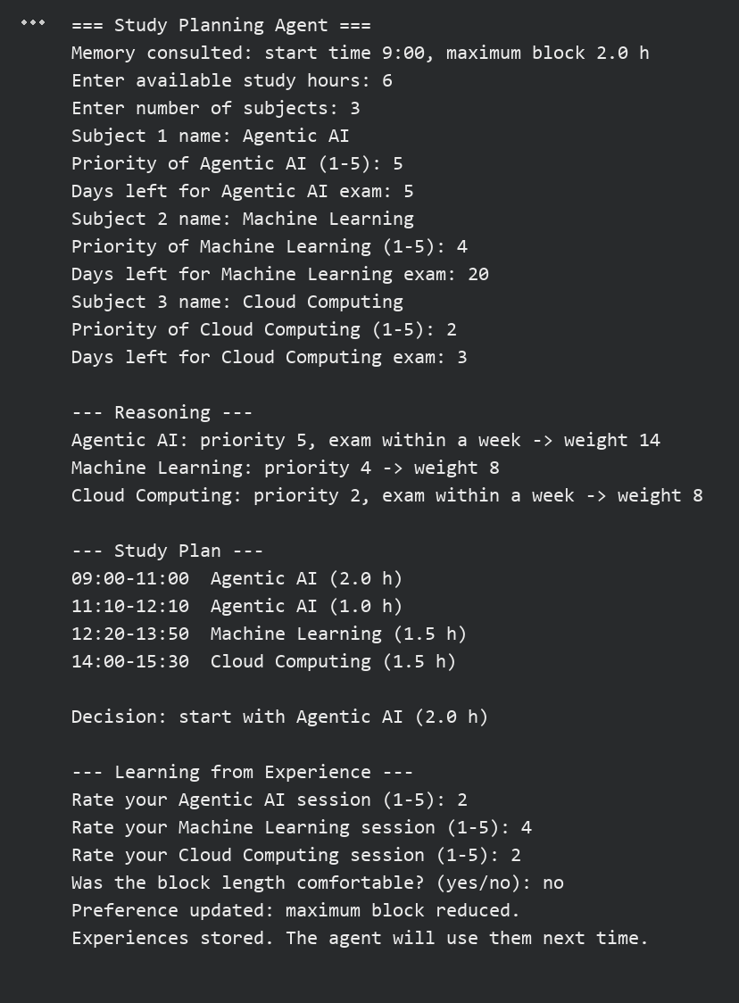
Run 2 (after storing feedback):
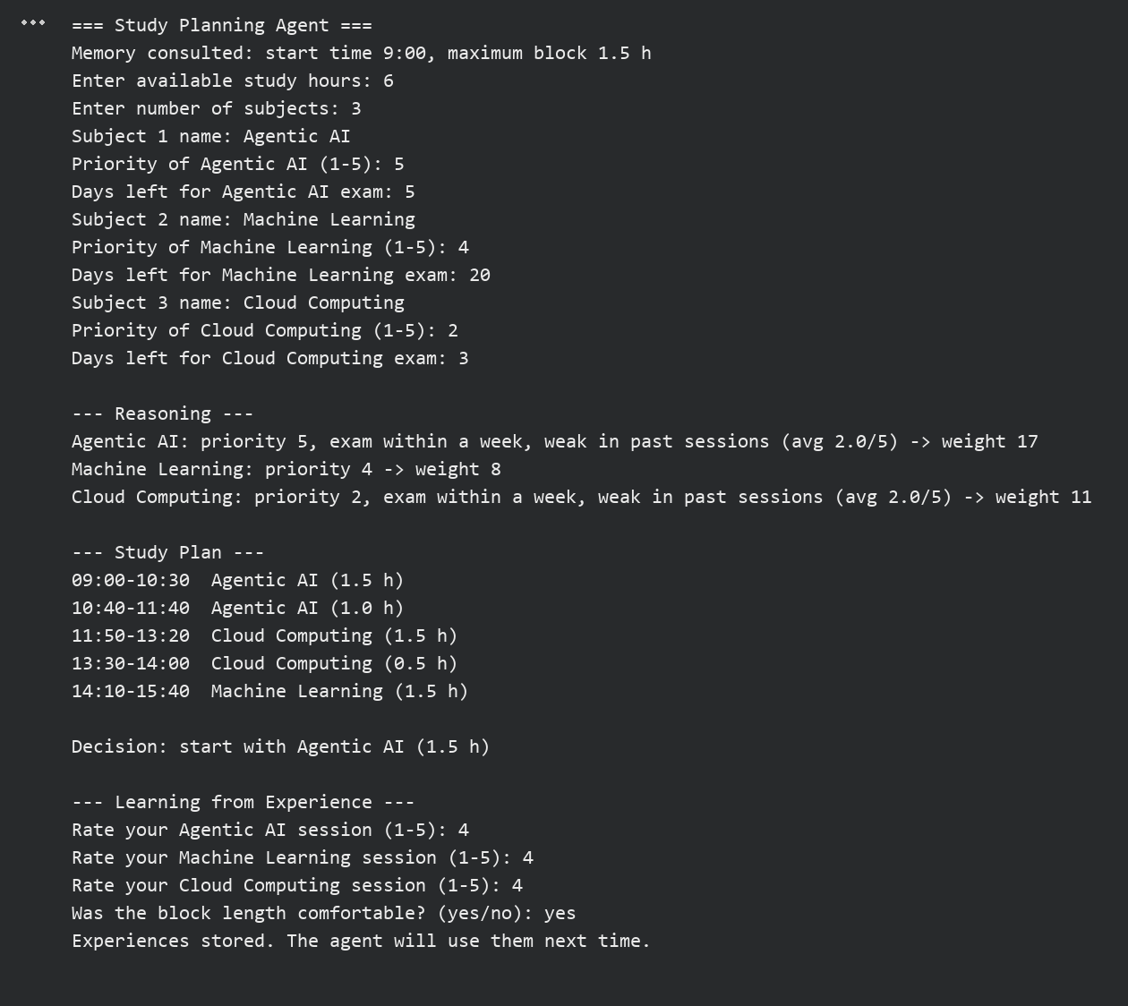

RESULT:
Thus, the autonomous Agentic AI study-planning assistant integrating reasoning, planning and memory was designed, developed and executed successfully, and it improved its plan using the stored experience.

