UNIVERSAL HUMAN VALUES (UHV)
EXAM STUDY MATERIAL
10-Mark Topics • 2-Mark Topics • Visual flow diagrams for quick learning
PART A — 10-MARK QUESTIONS
1 | Globalisation | #
2 | Computer Ethics | #
3 | Safety and Risk | #
4 | Engineering as Experimentation | #

PART B — 2-MARK QUESTIONS
1 | Definitiveness of Ethical Human Conduct | #
2 | Competence in Professional Ethics | #
3 | Role and Responsibilities of Engineers | #
4 | Professional Societies and their Codes of Ethics | #
5 | Constraints in Engineering | #

PART A — 10-MARK QUESTIONS

1) GLOBALISATION — 10 MARKS

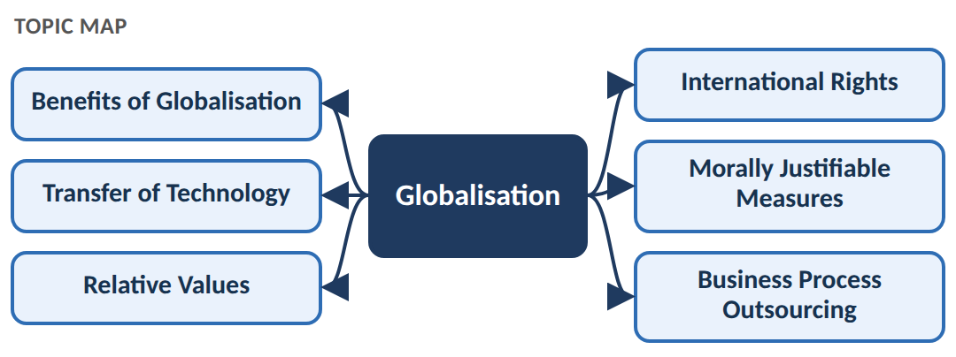
Meaning of Globalisation
Globalisation is the process by which countries, businesses, people and technologies become increasingly connected with each other across the world.
Simple flow
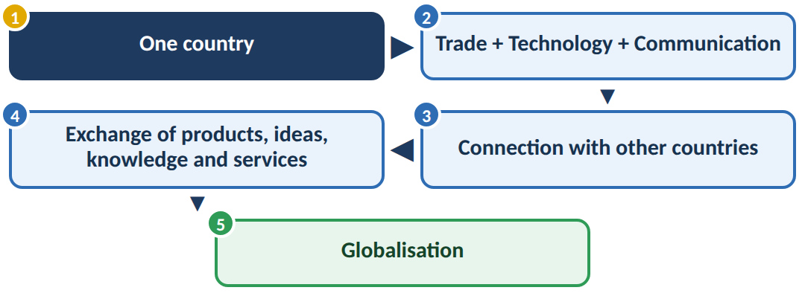
1. Benefits of Globalisation
Globalisation provides several advantages:
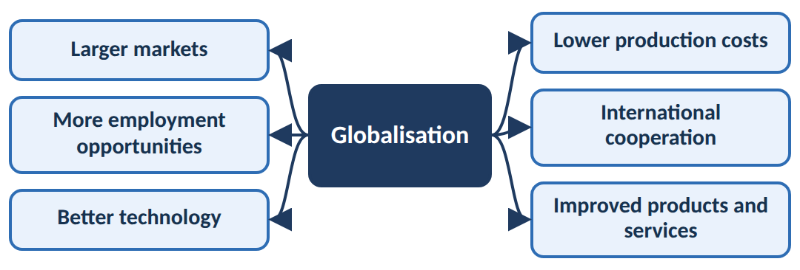
Important benefits
• Larger market: Companies can sell products to customers in many countries.
• Employment: International companies create jobs in different countries.
• Technology development: Countries can obtain and use advanced technologies.
• Better quality: Global competition encourages companies to improve quality.
• Lower cost: Production can be carried out where resources and labour are economical.
• Knowledge sharing: Countries can exchange scientific and technical knowledge.
2. Transfer of Technology
Transfer of technology means moving technical knowledge, machines, methods or expertise from one country or organisation to another.
Flow
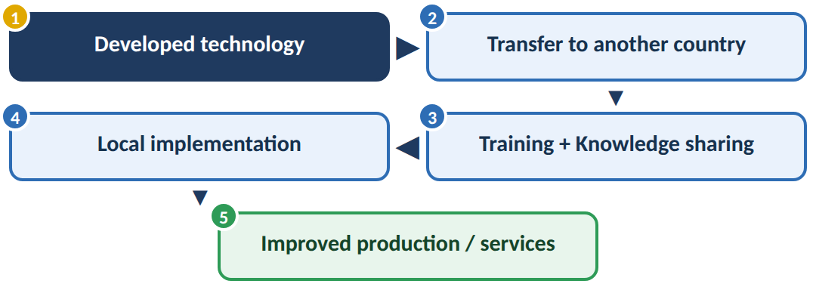
Example
A company from Germany transfers advanced manufacturing technology to an Indian company.
The Indian company receives:
Technology + Equipment + Training + Technical knowledge
This helps the company produce better products.
Problems
Technology transfer should be done carefully because:
• Old or unsuitable technology may be transferred.
• The receiving country may become dependent on another country.
• Environmental damage may occur.
• Intellectual property rights must be respected.
3. Relative Values
Relative values means that values, customs and moral expectations may differ between different societies and cultures.
Flow
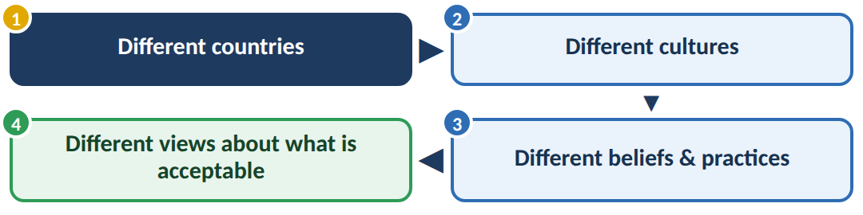
For example, a business practice considered acceptable in one country may be considered inappropriate in another.
Therefore, engineers and companies working internationally must respect cultural differences while maintaining basic ethical principles.
4. International Rights
International rights are basic rights that should be respected for people across countries.
Important rights include:
• Right to life and safety
• Right to equality
• Right to freedom
• Right to fair treatment
• Right to privacy
• Right to dignity
• Workers' rights
Simple idea
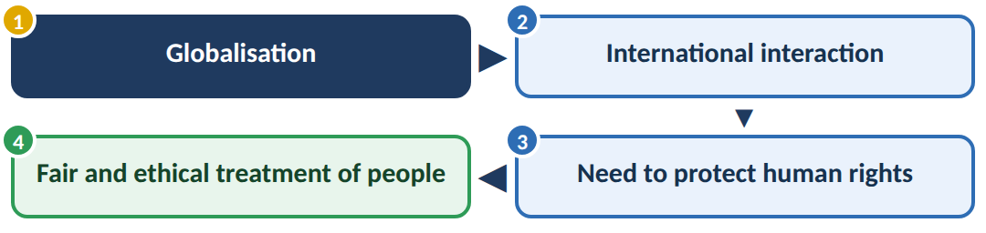
Engineers and organisations should ensure that their activities do not violate these rights.
5. Promoting Morally Justifiable Measures
Globalisation can create ethical problems such as exploitation of workers, environmental pollution and unfair business practices.
Therefore, organisations should take morally justifiable measures, meaning actions that are ethically acceptable and beneficial to people and society.
Ethical approach
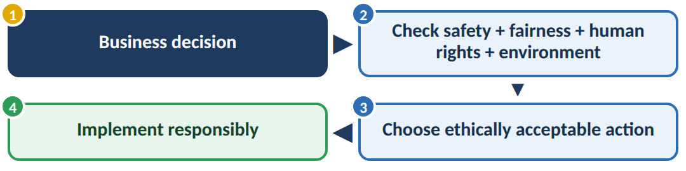
For example, a company should not reduce production costs by using unsafe working conditions.
6. Business Process Outsourcing (BPO)
BPO means giving certain business activities to an external company, often located in another country.
Flow
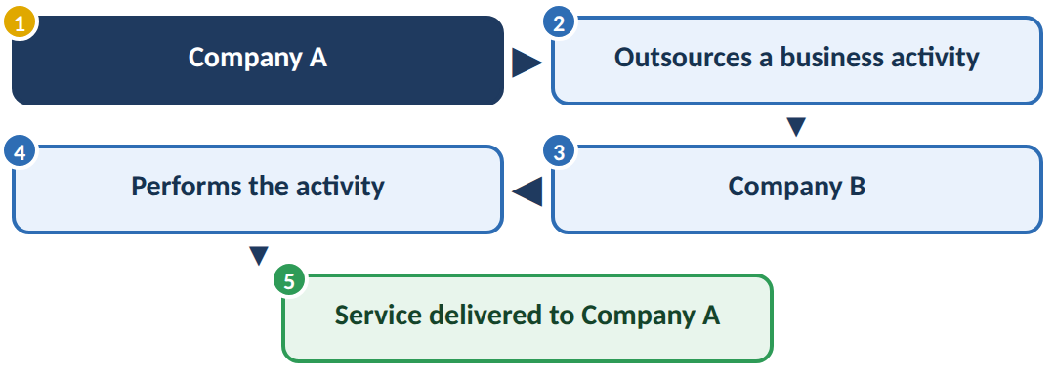
Examples:
• Customer support
• Data entry
• Accounting
• Technical support
• Call centres
Advantages
• Reduces operating costs
• Provides specialised skills
• Saves time
• Allows companies to focus on core activities
Ethical concerns
• Employee job security
• Data privacy
• Fair wages
• Working conditions
• Protection of confidential information
2) COMPUTER ETHICS — 10 MARKS

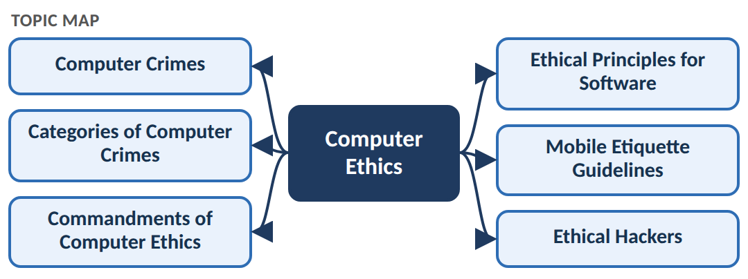
Meaning of Computer Ethics
Computer ethics refers to the moral principles and rules that guide the responsible use of computers, software, networks and digital information.
Flow
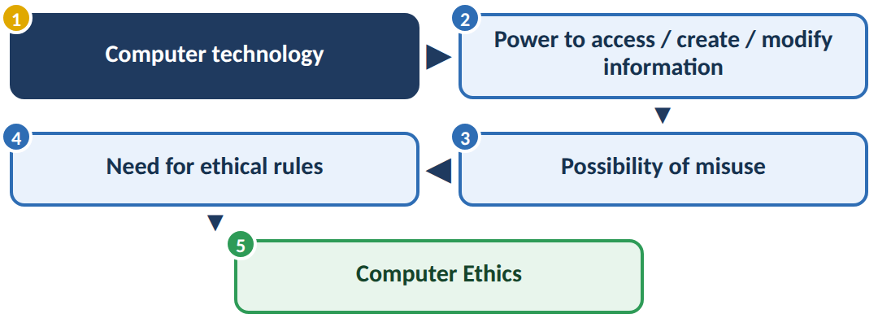
1. Computer Crimes
A computer crime is an illegal activity in which a computer, network or digital information is used as a target or as a tool.
Examples:
• Hacking
• Identity theft
• Online fraud
• Data theft
• Malware attacks
• Password theft
• Cyberstalking
Basic flow
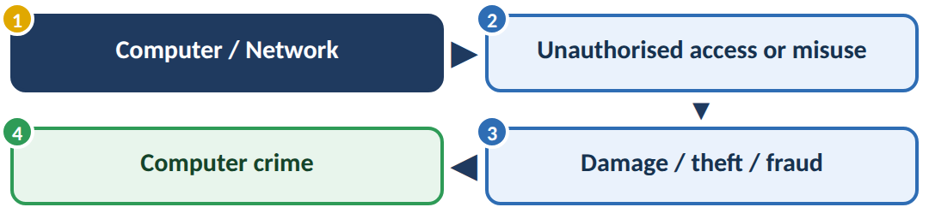
2. Categories of Computer Crimes
Computer crimes can broadly be classified according to what is attacked.
A. Crimes against individuals
Target a particular person.
Examples:
• Identity theft
• Cyberstalking
• Online harassment
• Phishing
B. Crimes against property
Target digital or physical property.
Examples:
• Data theft
• Software piracy
• Intellectual property theft
• Malware causing damage
C. Crimes against organisations
Target companies or institutions.
Examples:
• Database attacks
• Ransomware
• Data breaches
• Denial-of-service attacks
D. Crimes against society/government
Target large groups or public systems.
Examples:
• Cyberterrorism
• Attacks on government systems
• Spreading harmful information
Easy classification
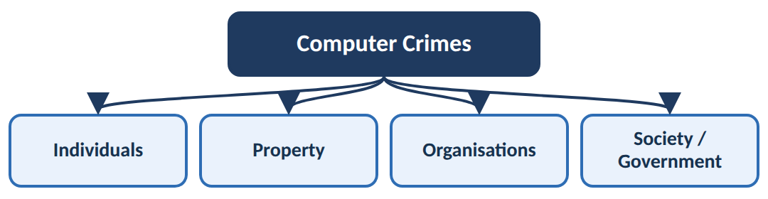
3. Commandments of Computer Ethics
The Ten Commandments of Computer Ethics provide basic rules for responsible computer use.
1. Do not use a computer to harm others.
2. Do not interfere with another person's computer work.
3. Do not access another person's files without permission.
4. Do not use a computer to steal.
5. Do not use a computer to spread false information.
6. Do not copy or use software without permission.
7. Do not use another person's computer resources without authorisation.
8. Do not take another person's intellectual work.
9. Think about the social consequences of the programs you create.
10. Use computers with consideration and respect for others.
Core idea
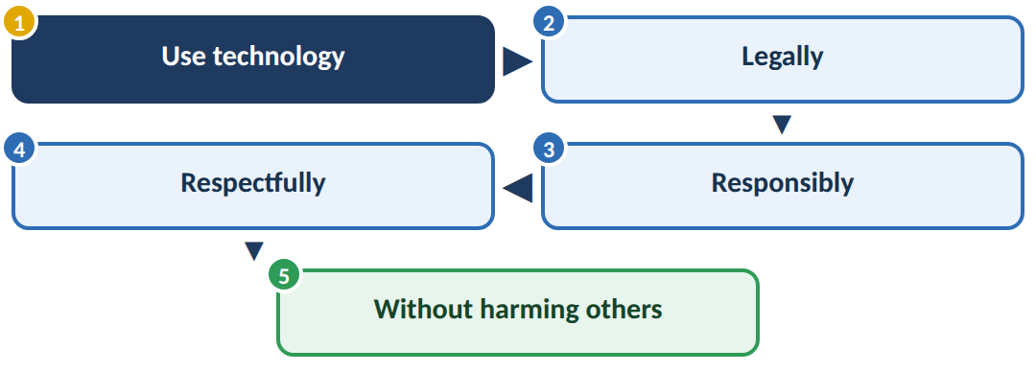
4. Ethical Principles for Software
Software engineers should develop and use software responsibly.
Important principles:
1. Public interest
Software should not unnecessarily harm users or society.
2. Quality
Software should be reliable, safe and properly tested.
3. Privacy
Users' personal information must be protected.
4. Confidentiality
Confidential information should not be disclosed without permission.
5. Intellectual property
Copyrights, patents and licenses must be respected.
6. Honesty
Developers should not intentionally provide false information about software.
Flow
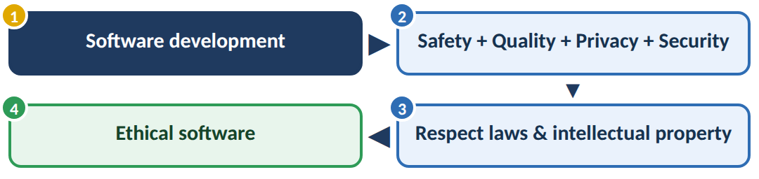
5. Mobile Etiquette Guidelines
Mobile etiquette means using mobile phones in a socially responsible and respectful manner.
Important guidelines:
• Keep the phone silent in classrooms, meetings and hospitals.
• Do not disturb others with loud conversations.
• Do not use phones while driving.
• Respect other people's privacy.
• Do not record or photograph people without permission.
• Avoid unnecessary calls in public places.
• Do not use phones during important discussions.
• Use mobile devices responsibly.
Simple idea
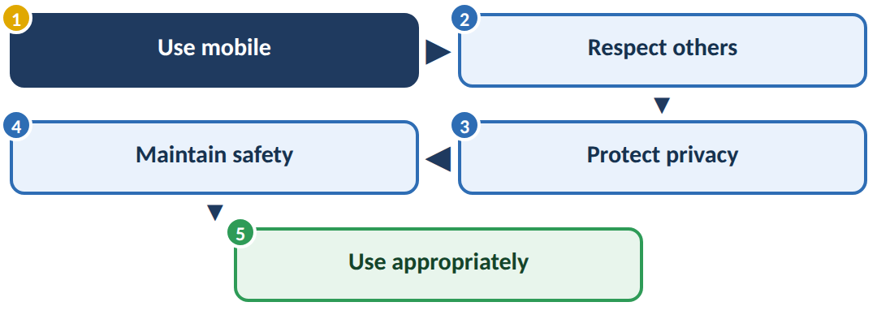
6. Ethical Hackers
An ethical hacker is a security professional who legally tests computer systems to find vulnerabilities before malicious hackers can exploit them.
Flow
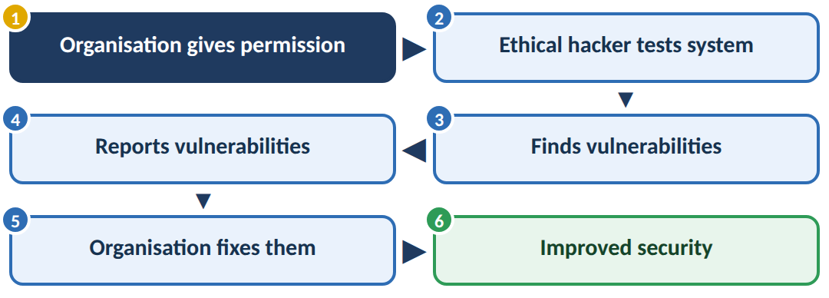
Ethical hacker vs malicious hacker
Ethical Hacker | Malicious Hacker
Has permission | No permission
Finds vulnerabilities | Exploits vulnerabilities
Protects systems | Damages/steals
Reports problems | Hides activities
Legal | Illegal

3) SAFETY AND RISK — 10 MARKS

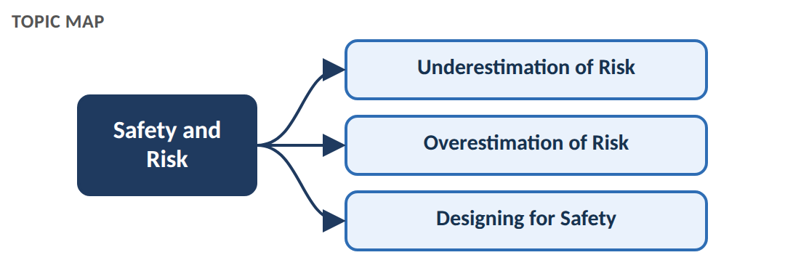
Meaning of Safety
Safety means protecting people, property and the environment from harm or unacceptable danger.
Meaning of Risk
Risk is the possibility that a hazard may cause harm, together with the seriousness of that harm.
Basic relationship
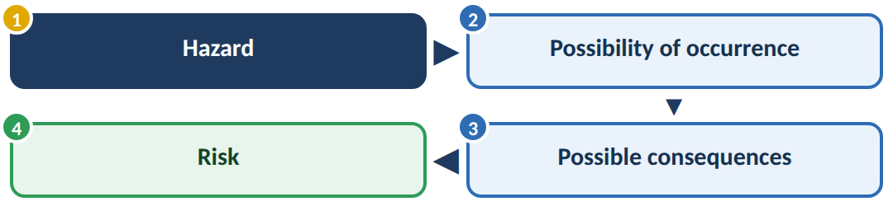
For example:
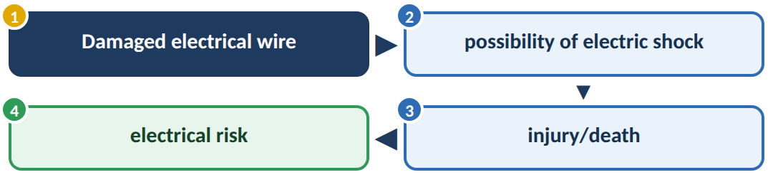
1. Underestimation of Risk
Underestimation of risk means judging a danger as less serious or less likely than it actually is.
Flow
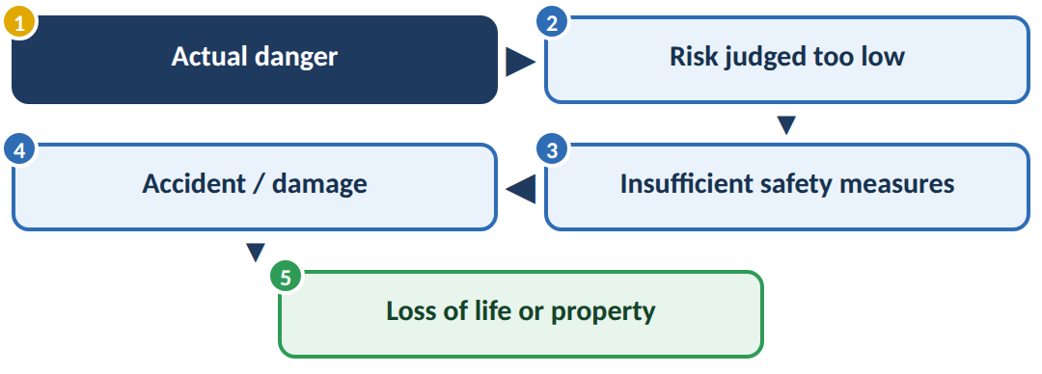
Example
An engineer thinks a machine has only a very small chance of failure and does not install adequate protection.
If the machine fails, workers may be injured.
2. Overestimation of Risk
Overestimation of risk means judging a danger as greater than it actually is.
Flow
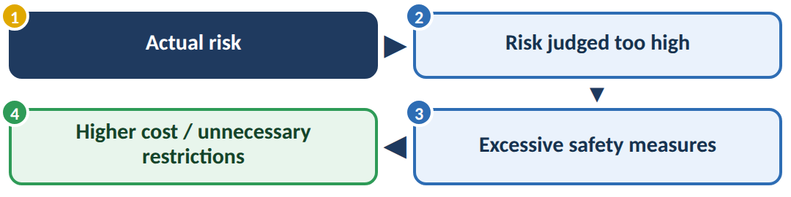
Example
If an engineer assumes that a very unlikely failure will definitely occur, they may spend excessive money on unnecessary protection.
Underestimation vs Overestimation
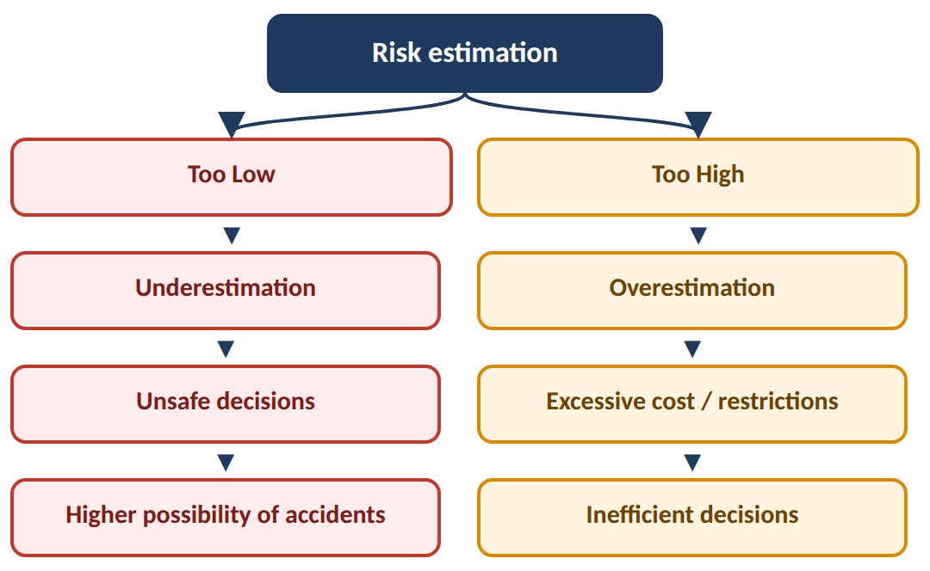
Therefore, engineers should aim for realistic and scientifically supported risk assessment.
3. Designing for Safety
Designing for safety means considering safety from the beginning of the engineering design process instead of trying to add safety after the product is completed.
Flow
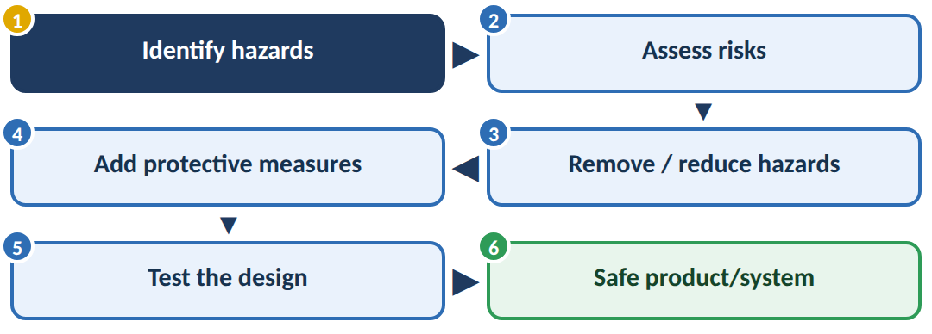
Important methods
1. Eliminate the hazard
Best option: remove the dangerous condition completely.
2. Reduce the risk
If elimination is impossible, reduce the probability or severity of harm.
3. Protective devices
Use guards, alarms, emergency stops, insulation, etc.
4. Warning systems
Provide warnings where hazards cannot be completely removed.
5. Testing and maintenance
Regular testing ensures that safety features continue to work.
Important principle
Safety should be built into the design, not added as an afterthought.

4) ENGINEERING AS EXPERIMENTATION — 10 MARKS

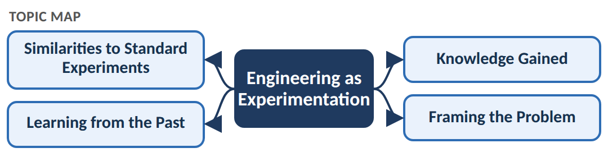
Engineering is similar to experimentation because engineers often design, test, observe results and improve their solutions.
An engineering product may not behave exactly as predicted because real-world conditions are complex.
Main flow
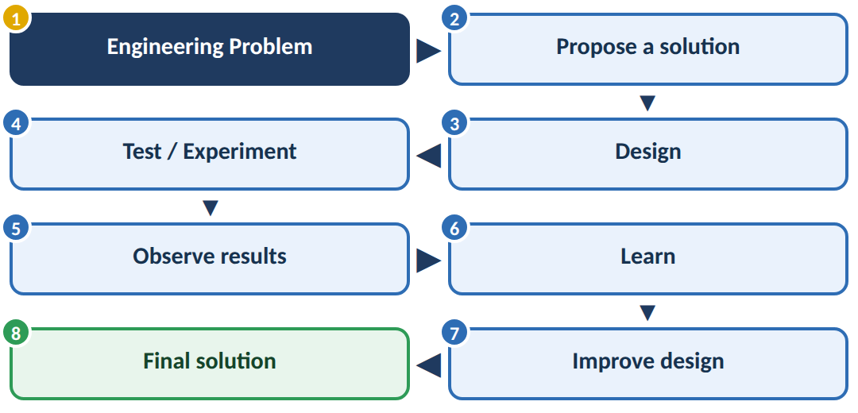
1. Similarities to Standard Experiments
Engineering activities have many similarities with scientific experiments.
Scientific experiment
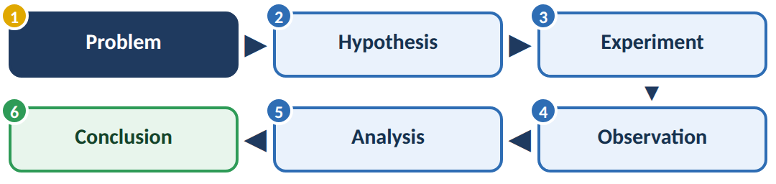
Engineering
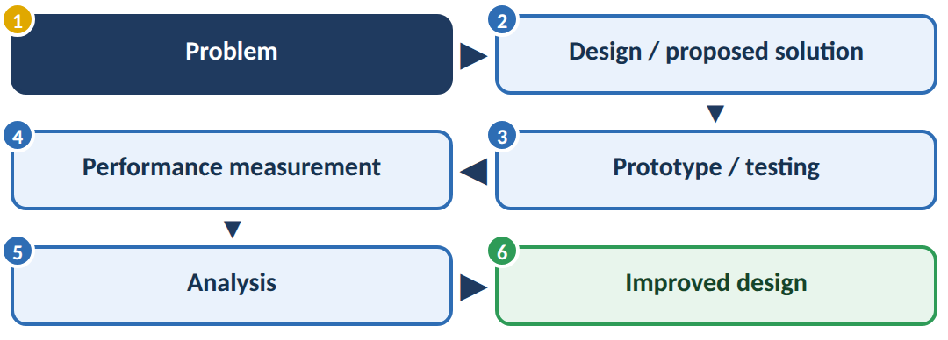
Both involve:
• Planning
• Testing
• Observation
• Data collection
• Analysis
• Learning from results
2. Learning from the Past
Engineers should study previous failures and successes before designing a new system.
Flow
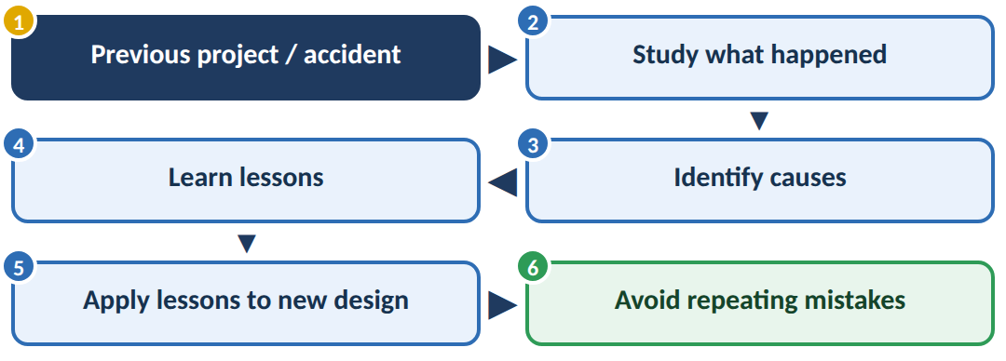
Example
If an earlier bridge failed because of inadequate load calculations, engineers designing a new bridge should study that failure and improve the design calculations.
Past failure → Knowledge → Better future design
3. Knowledge Gained
Engineering experiments generate useful knowledge about the behaviour and performance of a system.
For example, testing a machine may reveal:
• Maximum load
• Temperature limits
• Failure points
• Efficiency
• Material behaviour
• Safety limits
Flow
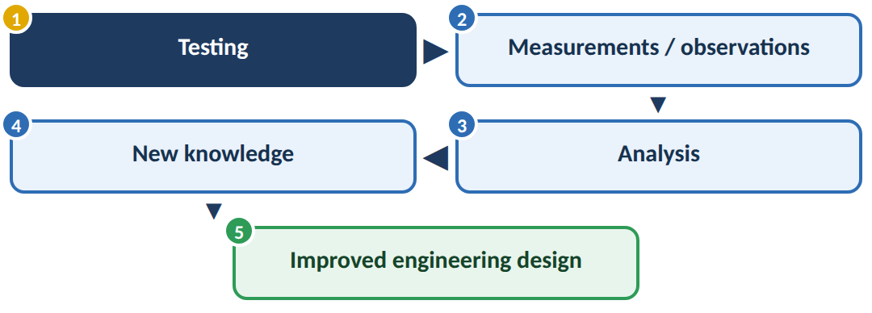
The knowledge gained should be properly documented and used in future engineering decisions.
4. Framing the Problem
Framing the problem means clearly defining what the actual engineering problem is before trying to solve it.
A poorly defined problem can lead to a wrong solution.
Flow
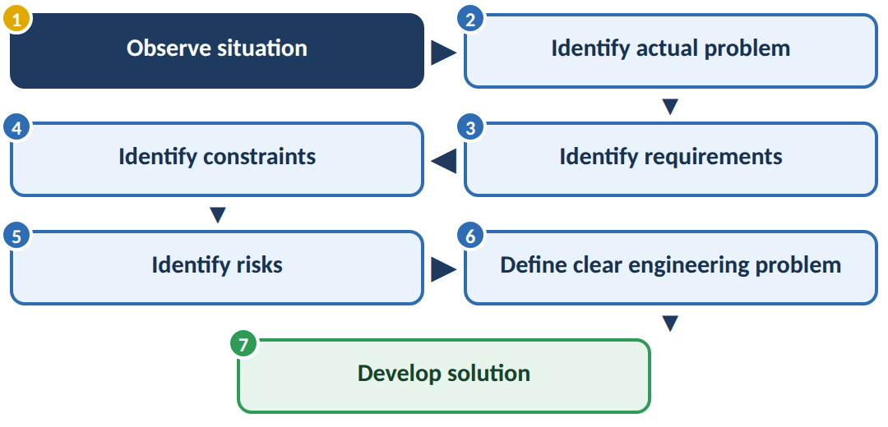
Example
Instead of saying:
✗ "The vehicle is unsafe."
A better engineering problem statement is:
✔ "The vehicle's braking distance is too long at high speeds and must be reduced while maintaining cost and passenger comfort."
Now the engineer knows exactly what needs to be improved and what constraints must be considered.
Complete Engineering Experimentation Concept
You can remember the entire topic through this single flow:
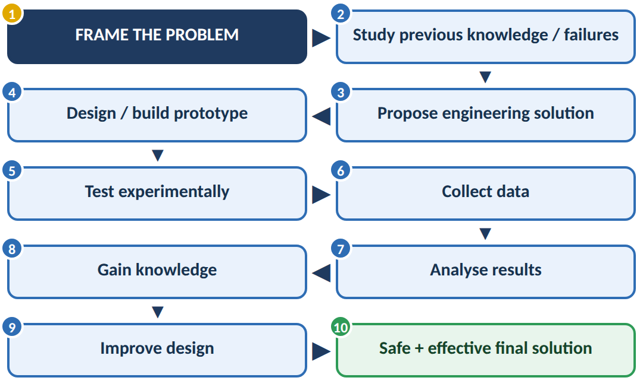
PART B — 2-MARK QUESTIONS

1) DEFINITIVENESS OF ETHICAL HUMAN CONDUCT — 5 MARKS

Ethical human conduct means behaving in a way that is morally right, responsible and beneficial to oneself and others.
Definitiveness means that ethical behaviour should be clear, consistent and based on correct understanding, rather than changing according to convenience or personal benefit.
Basic concept
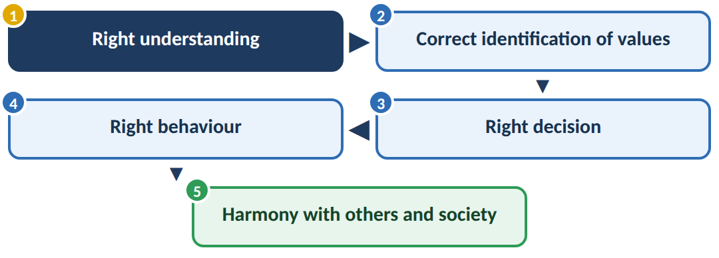
Main points
• Ethical conduct should be based on right understanding and universal human values.
• A person should distinguish between right and wrong before taking decisions.
• Ethical behaviour should be consistent, even when there is pressure or temptation.
• It should promote mutual happiness, trust and respect.
• A person should consider the effect of their actions on others and society.
• Ethical conduct should not depend only on fear of punishment or personal gain.
Example
An engineer discovers a safety defect in a product.
Personal benefit: Hide the defect → earn profit
Ethical conduct: Report the defect → protect users
Therefore, ethical human conduct means choosing the right action based on values and responsibility, even when it is difficult.
2) COMPETENCE IN PROFESSIONAL ETHICS — 5 MARKS

Professional ethical competence is the ability of a professional to combine technical knowledge with ethical understanding and make responsible decisions.
An engineer should not only know how to build something, but also understand whether it is safe, fair and beneficial.
Flow
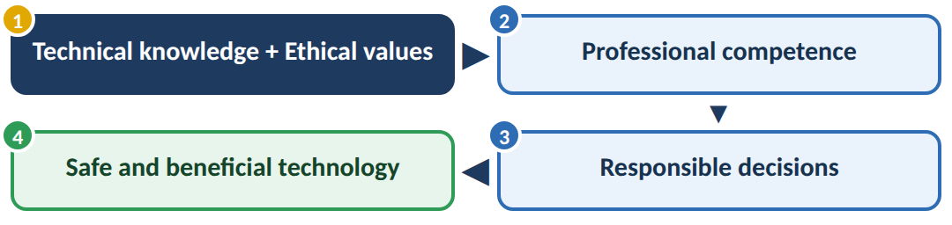
Main requirements
An ethically competent engineer should:
• Have sufficient technical knowledge and skills.
• Understand professional codes of ethics.
• Give importance to public safety and welfare.
• Be honest about technical limitations and risks.
• Protect confidential information.
• Respect intellectual property.
• Avoid discrimination and conflicts of interest.
• Take responsibility for professional decisions.
• Continuously improve knowledge and skills.
Example
An engineer is asked to approve a product even though testing shows a serious safety problem.
A technically competent but unethical engineer may approve it.
A professionally ethically competent engineer will:
Identify risk → refuse unsafe approval → report the problem → protect users.
Thus, professional competence requires both technical excellence and ethical responsibility.
3) ROLE AND RESPONSIBILITIES OF ENGINEERS — 5 MARKS

Engineers use scientific and technical knowledge to design and develop products, systems and technologies that affect society.
Therefore, their responsibility is not only towards their employer but also towards public safety, society and the environment.
Flow
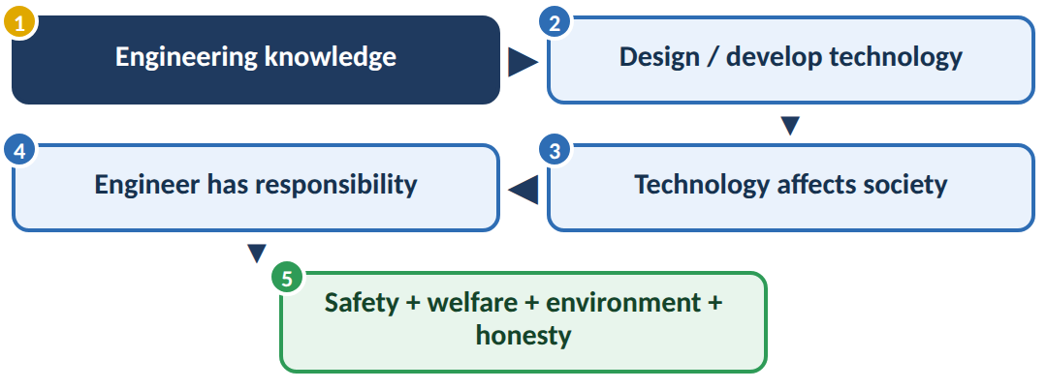
Major responsibilities
1. Protect public safety
Engineers must ensure that their designs do not unnecessarily endanger people.
2. Maintain professional competence
They should continuously update their technical knowledge and skills.
3. Be honest
Engineers should provide accurate information and should not hide important risks or defects.
4. Protect the environment
Engineering activities should minimise pollution, waste and environmental damage.
5. Follow laws and ethical standards
Engineers must comply with applicable laws, regulations and professional codes.
6. Maintain confidentiality
Confidential information obtained through professional work should be protected.
7. Report unsafe practices
Engineers should raise concerns when they identify serious safety or ethical problems.
8. Consider society
Engineers should consider the social consequences of their technologies.
Example
If an engineer discovers that a bridge design has a serious structural weakness, the engineer must report it and ensure corrective action, even if it causes delay or financial loss.
4) PROFESSIONAL SOCIETIES AND THEIR CODES OF ETHICS — 5 MARKS

Professional Societies
A professional society is an organisation formed by people belonging to a particular profession to promote professional knowledge, standards and responsible practice.
Examples include engineering professional organisations that establish standards and ethical guidelines for engineers.
Flow
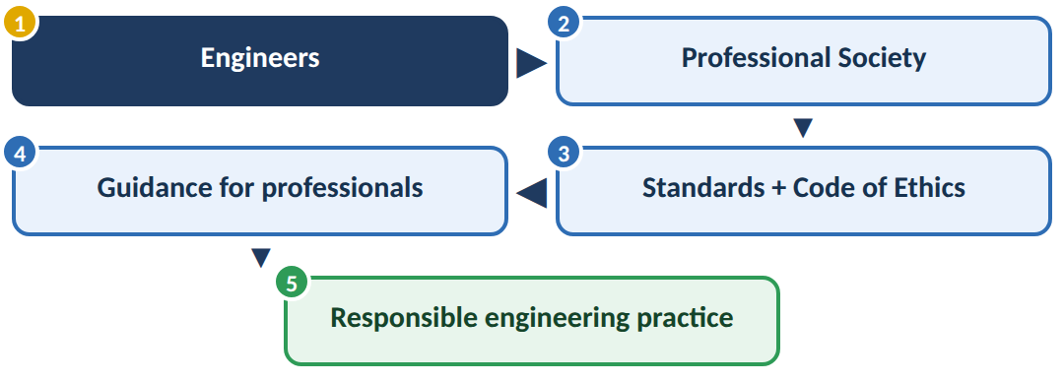
Functions of Professional Societies
• Promote professional knowledge and education.
• Organise conferences, seminars and technical activities.
• Develop professional standards.
• Encourage ethical behaviour.
• Provide professional development opportunities.
• Protect the reputation and integrity of the profession.
• Help professionals understand their responsibilities.
Codes of Ethics
A code of ethics is a set of principles and rules that guides professionals in making ethical decisions.
Important principles include:
• Protect public safety and welfare.
• Be honest and trustworthy.
• Maintain professional competence.
• Avoid conflicts of interest.
• Respect confidentiality.
• Respect intellectual property.
• Follow laws and professional standards.
• Act responsibly towards society and the environment.
Example
If an engineer's company asks them to hide a dangerous defect:
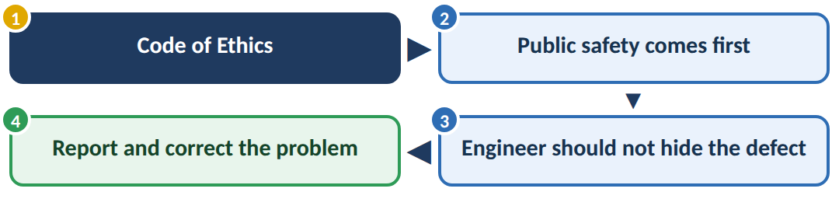
Thus, professional societies and their codes of ethics help engineers maintain professional standards and make responsible decisions.
5) CONSTRAINTS IN ENGINEERING — 5 MARKS

Engineering constraints are the limitations or conditions that engineers must consider while designing and developing a product or system.
An engineer cannot design something based only on what is technically possible. The design must also satisfy practical limitations.
Flow
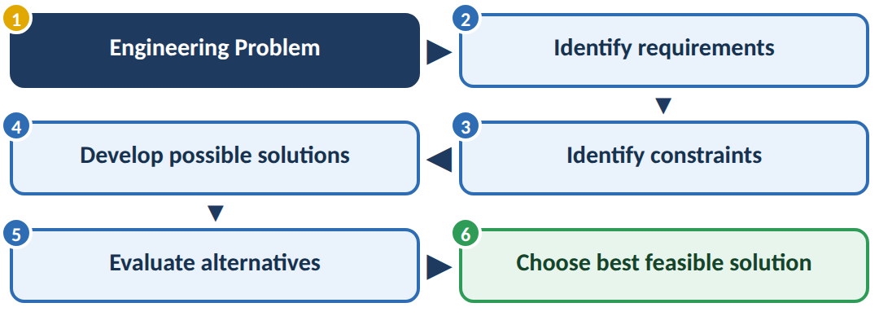
Major Engineering Constraints
1. Cost
The solution must usually remain within the available budget.
2. Time
The project must be completed within the required deadline.
3. Materials
The availability, strength and properties of materials limit the design.
4. Technology
Available tools, machines and technical knowledge can restrict what can be developed.
5. Safety
The design must not create unacceptable risks to users or workers.
6. Environmental constraints
The design should minimise pollution, waste and environmental damage.
7. Legal constraints
Engineers must follow laws, regulations and standards.
8. Social and ethical constraints
The solution should respect human rights, social values and ethical principles.
Example
Suppose an engineer has to design an electric vehicle.
The design must satisfy:
Low cost + adequate battery range + safety + available materials + environmental requirements + legal standards
The engineer therefore cannot simply choose the most powerful battery. The solution must satisfy multiple constraints simultaneously.
Important concept
Best engineering solution ≠ Most powerful solution
It is the solution that provides the best balance between performance, cost, safety, time, environmental impact and other requirements.

