EX.NO.8a | JAVASCRIPT DOM (HOVER AND CLICKS ON A TABLE)
DATE: 07.09.26 | JAVASCRIPT DOM (HOVER AND CLICKS ON A TABLE)

AIM:
To build a student list in HTML and use JavaScript mouse events (mouseover, mouseout, click and dblclick) to highlight, select and clear table rows dynamically.
ALGORITHM:
1. Design an HTML table that lists student names, departments and years.
2. Attach a mouseover handler that gives the row under the pointer a yellow background.
3. Attach a mouseout handler that removes the yellow background unless the row is selected.
4. Attach a click handler that marks the row as selected with an orange background.
5. Attach a dblclick handler that clears the selection of that row.
6. Open the page in the browser and observe that the rows react without reloading the page.
CODE:
<!DOCTYPE html>
<html>
<head>
<title>Student List Events</title>
<style>
table { border-collapse: collapse; width: 560px; font-family: Arial; }
th, td { border: 1px solid #333; padding: 9px 12px; text-align: left; }
th { background: #cfe3f1; }
.hover { background: #fff3a8; }
.picked { background: #ffb36b; font-weight: bold; }
</style>
</head>
<body>
<h2>Student List - Mouse Events</h2>
<table id="stuTable">
<tr><th>Name</th><th>Department</th><th>Year</th></tr>
<tr><td>Akhilesh Raj P</td><td>CSE</td><td>III</td></tr>
<tr><td>Naveen R</td><td>IT</td><td>III</td></tr>
<tr><td>Divya S</td><td>ECE</td><td>II</td></tr>
<tr><td>Karthik M</td><td>MECH</td><td>IV</td></tr>
</table>
<script>
var rows = document.querySelectorAll("#stuTable tr");
for (var i = 1; i < rows.length; i++) {
rows[i].addEventListener("mouseover", function () { this.classList.add("hover"); });
rows[i].addEventListener("mouseout", function () { this.classList.remove("hover"); });
rows[i].addEventListener("click", function () { this.classList.add("picked"); });
rows[i].addEventListener("dblclick", function () { this.classList.remove("picked"); });
}
</script>
</body>
</html>
OUTPUT:
Before any event
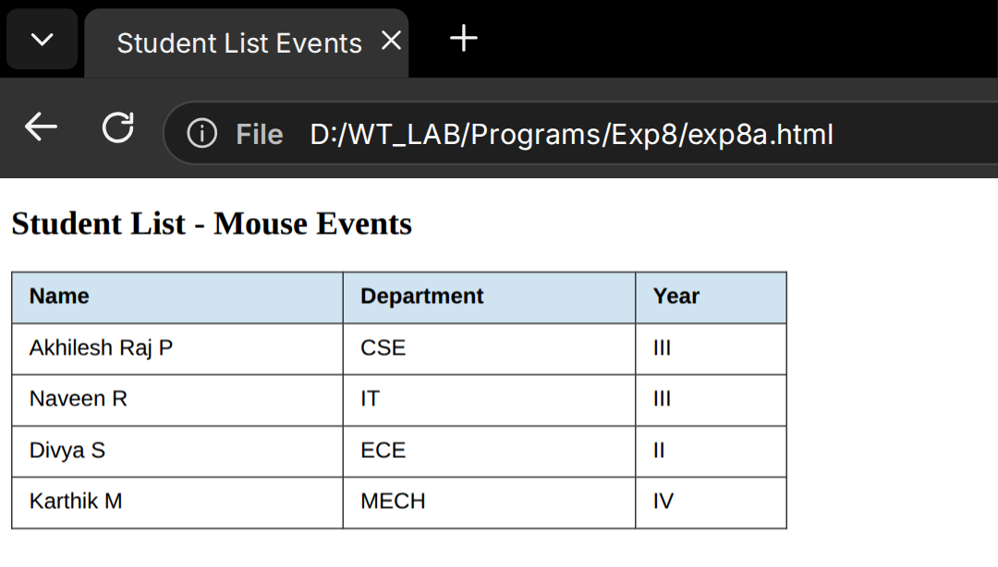
After hover, click and double-click
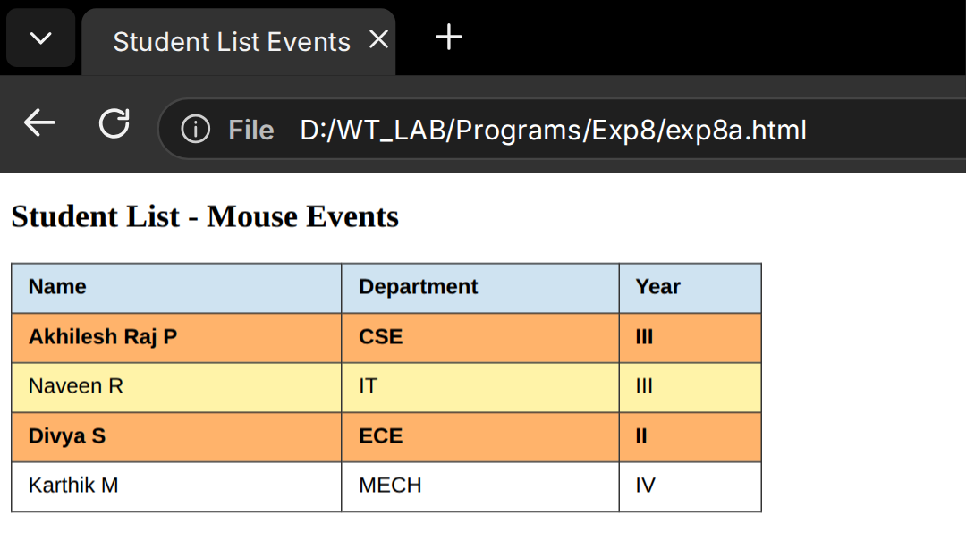
RESULT:
Thus, the JavaScript mouse events mouseover, mouseout, click and dblclick were applied to the table rows successfully.

EX.NO.8b | JAVASCRIPT DOM (REAL-TIME DIGITAL CLOCK)
DATE: 07.09.26 | JAVASCRIPT DOM (REAL-TIME DIGITAL CLOCK)

AIM:
To create a digital clock web page that shows the current date and the live time in 12-hour format using JavaScript timers.
ALGORITHM:
1. Create a page with two elements, one for the date and one for the time.
2. Write a function that reads the current Date object and formats hours, minutes and seconds.
3. Convert the hours to the 12-hour format and add the AM or PM label.
4. Pad single-digit values with a leading zero.
5. Call the function once and then repeat it every second with setInterval().
6. Run the page and confirm that the time changes every second.
CODE:
<!DOCTYPE html>
<html>
<head>
<title>Live Digital Clock</title>
<style>
body { font-family: Arial; text-align: center; margin-top: 70px; }
#date { font-size: 20px; color: #444; }
#time { font-size: 56px; font-weight: bold; color: #0b3d91; letter-spacing: 3px; }
</style>
</head>
<body>
<h2>Live Digital Clock</h2>
<div id="date"></div>
<div id="time"></div>
<script>
function two(n) { return n < 10 ? "0" + n : n; }
function tick() {
var d = new Date();
var h = d.getHours();
var ap = h >= 12 ? "PM" : "AM";
h = h % 12 || 12;
document.getElementById("time").innerHTML =
two(h) + ":" + two(d.getMinutes()) + ":" + two(d.getSeconds()) + " " + ap;
document.getElementById("date").innerHTML = d.toDateString();
}
tick();
setInterval(tick, 1000);
</script>
</body>
</html>
OUTPUT:
Live digital clock
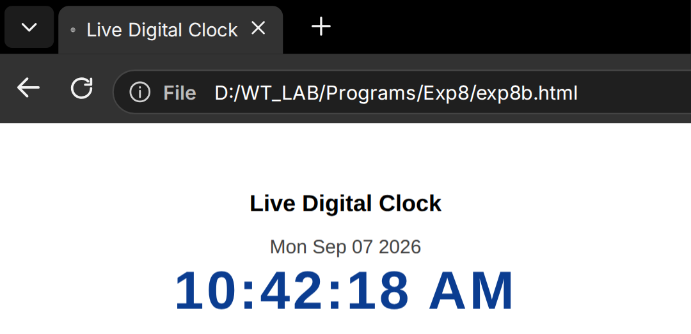
RESULT:
Thus, a real-time digital clock was created using JavaScript and it updates every second.

EX.NO.8c | JAVASCRIPT DOM (KEYBOARD INTERACTION)
DATE: 07.09.26 | JAVASCRIPT DOM (KEYBOARD INTERACTION)

AIM:
To handle keyboard events in JavaScript so that pressing specific keys changes the border style of a table.
ALGORITHM:
1. Create a page with a short instruction and a small marks table.
2. Register a keydown listener on the document object.
3. If the key G is pressed, give the table a thick green border.
4. If the key R is pressed, remove the border from the table.
5. Display the last pressed key below the table.
6. Press the keys in the browser and check the result.
CODE:
<!DOCTYPE html>
<html>
<head>
<title>Keyboard Events</title>
<style>
body { font-family: Arial; margin: 30px; }
table { border-collapse: collapse; width: 420px; }
th, td { border: 1px solid #555; padding: 9px; }
</style>
</head>
<body>
<h2>Keyboard Interaction</h2>
<p>Press G for a green border</p>
<p>Press R to remove the border</p>
<table id="mark">
<tr><th>Subject</th><th>Marks</th></tr>
<tr><td>Web Technologies</td><td>92</td></tr>
<tr><td>Microcontrollers</td><td>88</td></tr>
</table>
<p id="msg"></p>
<script>
var t = document.getElementById("mark");
document.addEventListener("keydown", function (e) {
var k = e.key.toUpperCase();
if (k === "G") t.style.border = "4px solid green";
if (k === "R") t.style.border = "";
document.getElementById("msg").innerHTML = "Last key pressed: " + k;
});
</script>
</body>
</html>
OUTPUT:
Before pressing a key
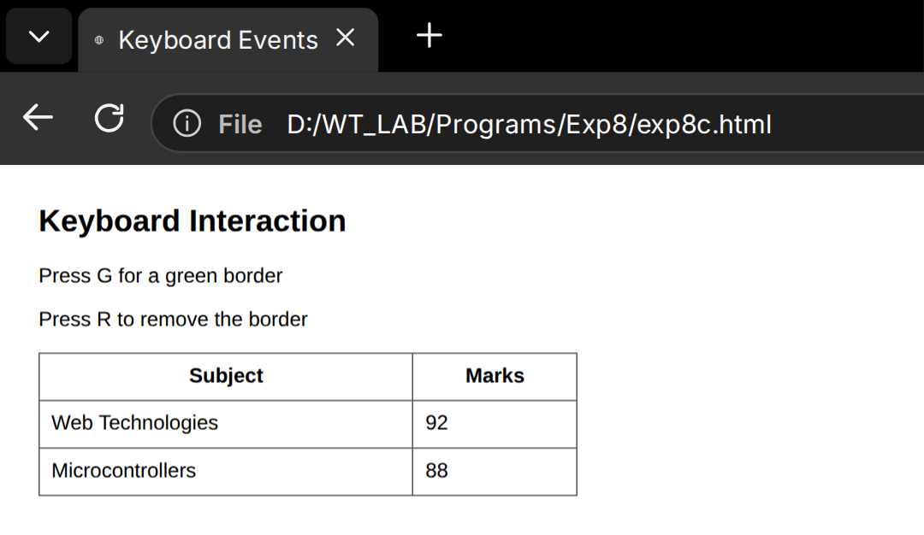
After pressing the G key
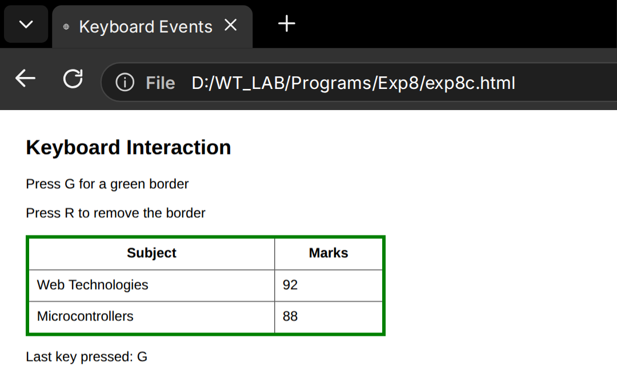
RESULT:
Thus, keyboard events were handled with JavaScript to change the style of the table dynamically.

EX.NO.8d | JAVASCRIPT DOM (SIMPLE FORM WITH DISPLAY)
DATE: 07.09.26 | JAVASCRIPT DOM (SIMPLE FORM WITH DISPLAY)

AIM:
To read a value typed into an HTML form and display a personalised greeting on the same page using JavaScript DOM methods.
ALGORITHM:
1. Create a form with a text box and a Greet button.
2. Write a function that reads the value of the text box with getElementById().
3. Check whether the box is empty and show a warning if it is.
4. Otherwise build a greeting message from the entered name.
5. Write the message into a paragraph using innerHTML.
6. Enter a name in the browser and verify the displayed greeting.
CODE:
<!DOCTYPE html>
<html>
<head>
<title>Greeting Form</title>
<style>
body { font-family: Arial; margin: 40px; }
input, button { font-size: 16px; padding: 8px 12px; }
#out { margin-top: 20px; font-size: 20px; color: #0a6b2d; font-weight: bold; }
</style>
</head>
<body>
<h2>Greeting Form</h2>
<input type="text" id="nm" placeholder="Enter your name">
<button onclick="greet()">Greet</button>
<p id="out"></p>
<script>
function greet() {
var n = document.getElementById("nm").value.trim();
var o = document.getElementById("out");
if (n === "") {
o.style.color = "red";
o.innerHTML = "Please enter your name.";
}
else {
o.style.color = "#0a6b2d";
o.innerHTML = "Hello, " + n + "! Welcome to the Web Technologies Lab.";
}
}
</script>
</body>
</html>
OUTPUT:
Empty form
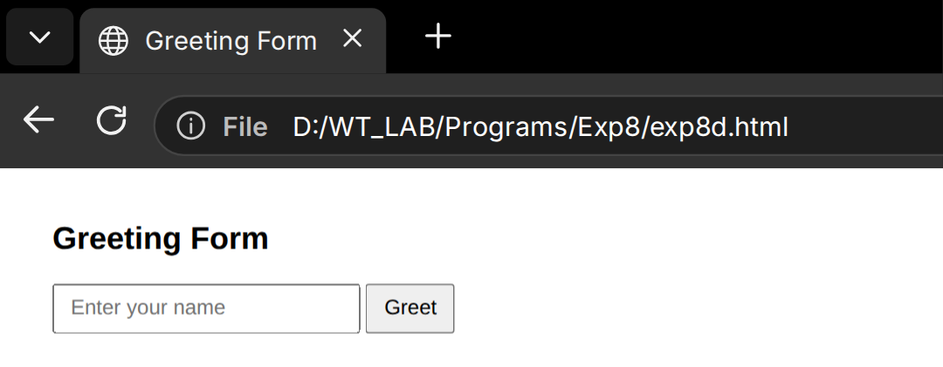
Greeting displayed after clicking Greet
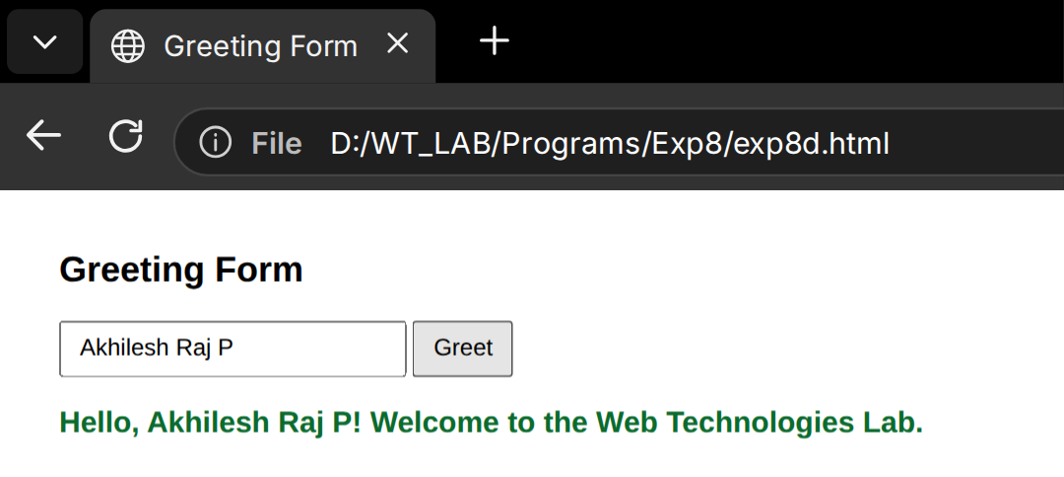
RESULT:
Thus, a simple form was created and the entered name was displayed as a greeting using JavaScript.

EX.NO.8e | JAVASCRIPT DOM (MINI LOGIN SYSTEM)
DATE: 07.09.26 | JAVASCRIPT DOM (MINI LOGIN SYSTEM)

AIM:
To design a mini login page that validates a username and password with JavaScript and shows a success or failure message.
ALGORITHM:
1. Design a login form with a username box, a password box and a Login button.
2. Store the valid username and password in JavaScript variables.
3. Read the values typed by the user when the button is clicked.
4. Compare the typed values with the stored credentials.
5. Show a welcome message for correct values and an error message otherwise.
6. Test the page with correct and wrong credentials.
CODE:
<!DOCTYPE html>
<html>
<head>
<title>Mini Login</title>
<style>
body { font-family: Arial; margin: 40px; }
.box { width: 300px; padding: 22px; border: 1px solid #aaa;
border-radius: 8px; }
input { width: 100%; padding: 9px; margin: 8px 0 14px;
font-size: 15px; box-sizing: border-box; }
button { padding: 9px 22px; font-size: 15px; }
#res { margin-top: 16px; font-weight: bold; }
</style>
</head>
<body>
<div class="box">
<h2>Mini Login</h2>
<label>Username</label>
<input type="text" id="u">
<label>Password</label>
<input type="password" id="p">
<button onclick="check()">Login</button>
<div id="res"></div>
</div>
<script>
function check() {
var ok = (document.getElementById("u").value === "akhilesh" &&
document.getElementById("p").value === "wt@1009");
var r = document.getElementById("res");
r.style.color = ok ? "green" : "crimson";
r.innerHTML = ok ? "Welcome, Akhilesh!" : "Invalid username or password";
}
</script>
</body>
</html>
OUTPUT:
Wrong password
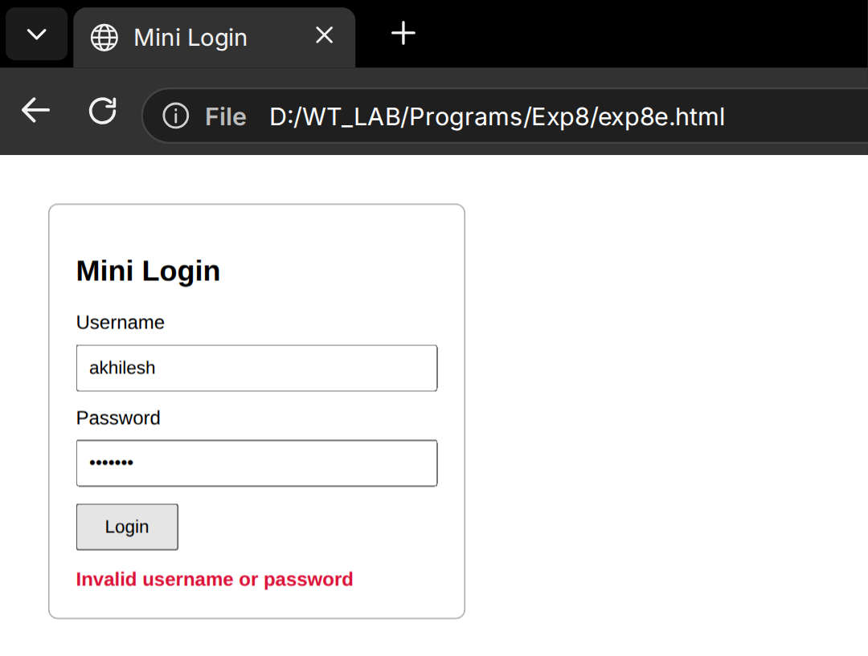
Correct credentials
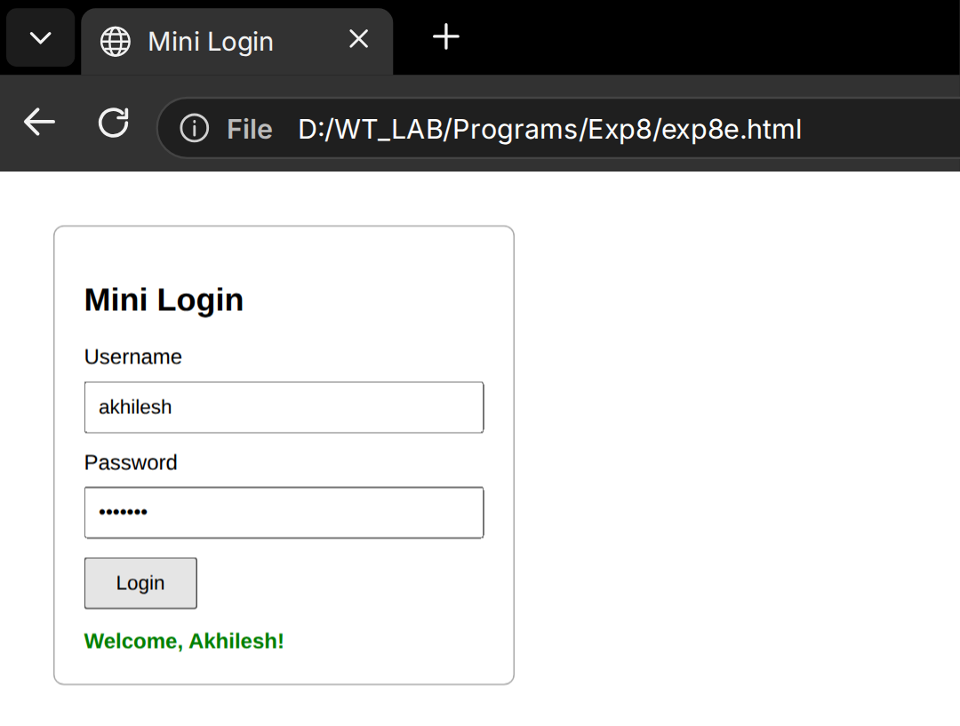
RESULT:
Thus, a mini login system was implemented and the credentials were validated using JavaScript.

EX.NO.8f | JAVASCRIPT DOM (DARK/LIGHT MODE)
DATE: 07.09.26 | JAVASCRIPT DOM (DARK/LIGHT MODE)

AIM:
To create a web page with a theme switch button that toggles between a light mode and a dark mode using JavaScript and CSS classes.
ALGORITHM:
1. Define CSS rules for the default light theme and a dark theme class.
2. Add a button that triggers the theme change.
3. Write a function that toggles the dark class on the body element.
4. Change the button text according to the current theme.
5. Save the choice so the page remembers it.
6. Click the button in the browser and check both themes.
CODE:
<!DOCTYPE html>
<html>
<head>
<title>Theme Switcher</title>
<style>
body { font-family: Arial; background: #ffffff; color: #1b1b1b;
padding: 40px; transition: .3s; }
body.dark { background: #1c1f26; color: #f1f1f1; }
button { padding: 10px 20px; font-size: 16px; cursor: pointer; border-radius: 6px; }
</style>
</head>
<body>
<h2>Light / Dark Mode Switcher</h2>
<p>Use the button to switch the colour theme of this page.</p>
<button id="tb" onclick="swap()">Switch to Dark Mode</button>
<script>
function swap() {
var dark = document.body.classList.toggle("dark");
document.getElementById("tb").innerHTML =
dark ? "Switch to Light Mode" : "Switch to Dark Mode";
localStorage.setItem("theme", dark ? "dark" : "light");
}
</script>
</body>
</html>
OUTPUT:
Light mode
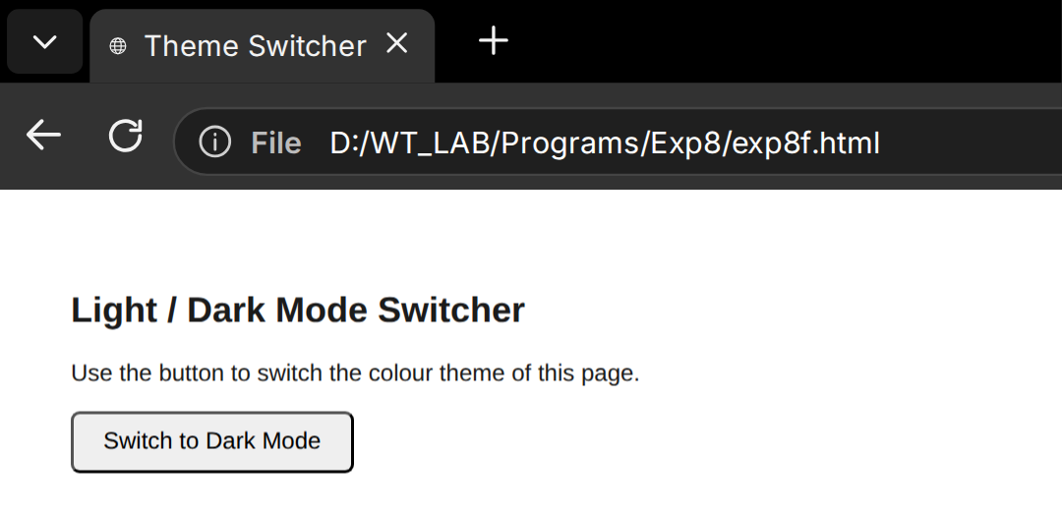
Dark mode
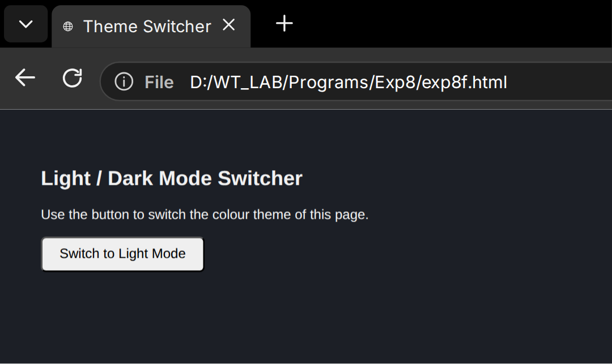
RESULT:
Thus, a dark and light mode switcher was developed using JavaScript DOM manipulation.

EX.NO.9 | ANGULAR JS FORM VALIDATION
DATE: 21.09.26 | ANGULAR JS FORM VALIDATION

AIM:
To build a course enrolment form in AngularJS and validate the name, email, age and mobile number fields using the built-in form validation directives.
ALGORITHM:
1. Include the AngularJS library and create a module and controller named enrolApp and enrolCtrl.
2. Create a form with the name enrolForm and set novalidate on it.
3. Add required and ng-minlength validation to the name field.
4. Use type="email" for the email field and min and max limits for the age field.
5. Use ng-pattern to accept exactly ten digits for the mobile number.
6. Show error messages with ng-show using $dirty and $error.
7. Disable the Enrol button until the whole form is valid ($invalid).
8. Display the entered details after a successful submit.
CODE:
<!DOCTYPE html>
<html ng-app="enrolApp">
<head>
<title>Course Enrolment</title>
<script src="https://ajax.googleapis.com/ajax/libs/angularjs/1.8.2/angular.min.js"></script>
<style>
body { font-family: Arial; margin: 30px; }
.err { color: crimson; font-size: 13px; }
input.ng-invalid.ng-dirty { border: 2px solid crimson; }
input.ng-valid.ng-dirty { border: 2px solid green; }
</style>
</head>
<body ng-controller="enrolCtrl">
<h2>Course Enrolment Form</h2>
<form name="enrolForm" novalidate ng-submit="save()">
<p>Name:<br>
<input type="text" name="nm" ng-model="s.name" required ng-minlength="3">
<span class="err" ng-show="enrolForm.nm.$dirty && enrolForm.nm.$invalid">Name must have at least 3 letters</span></p>
<p>Email:<br>
<input type="email" name="em" ng-model="s.email" required>
<span class="err" ng-show="enrolForm.em.$dirty && enrolForm.em.$invalid">Enter a valid email</span></p>
<p>Age:<br>
<input type="number" name="ag" ng-model="s.age" min="17" max="30" required>
<span class="err" ng-show="enrolForm.ag.$dirty && enrolForm.ag.$invalid">Age must be between 17 and 30</span></p>
<p>Mobile:<br>
<input type="text" name="mb" ng-model="s.mobile" ng-pattern="/^[0-9]{10}$/" required>
<span class="err" ng-show="enrolForm.mb.$dirty && enrolForm.mb.$invalid">Mobile must have 10 digits</span></p>
<button type="submit" ng-disabled="enrolForm.$invalid">Enrol</button>
</form>
<p ng-show="done"><b>Enrolled:</b> {{s.name}}, {{s.email}}, {{s.age}}, {{s.mobile}}</p>
<script>
angular.module("enrolApp", []).controller("enrolCtrl", function ($scope) {
$scope.s = {};
$scope.done = false;
$scope.save = function () { $scope.done = true; };
});
</script>
</body>
</html>
OUTPUT:
Validation errors for invalid input
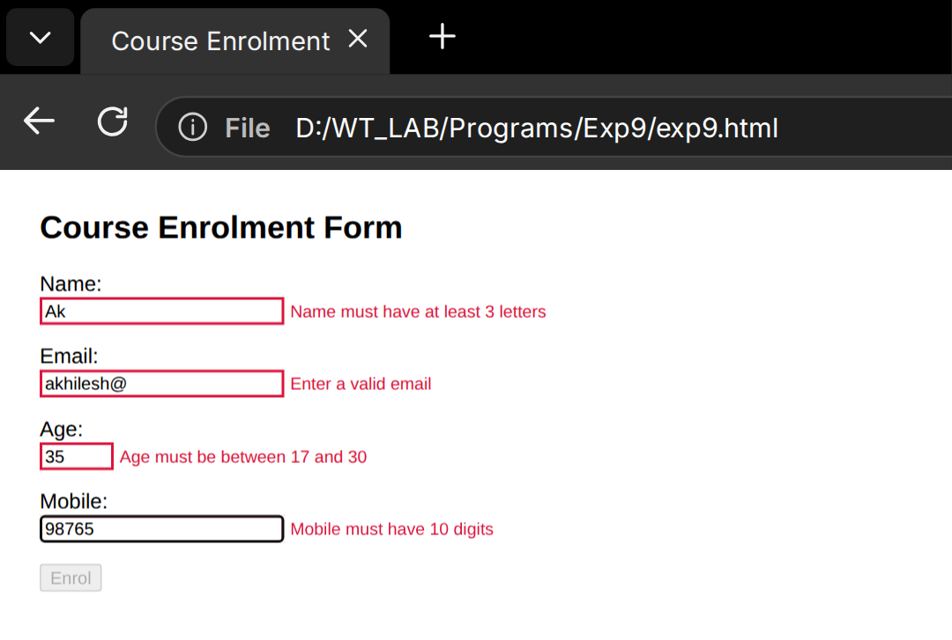
Valid form submitted
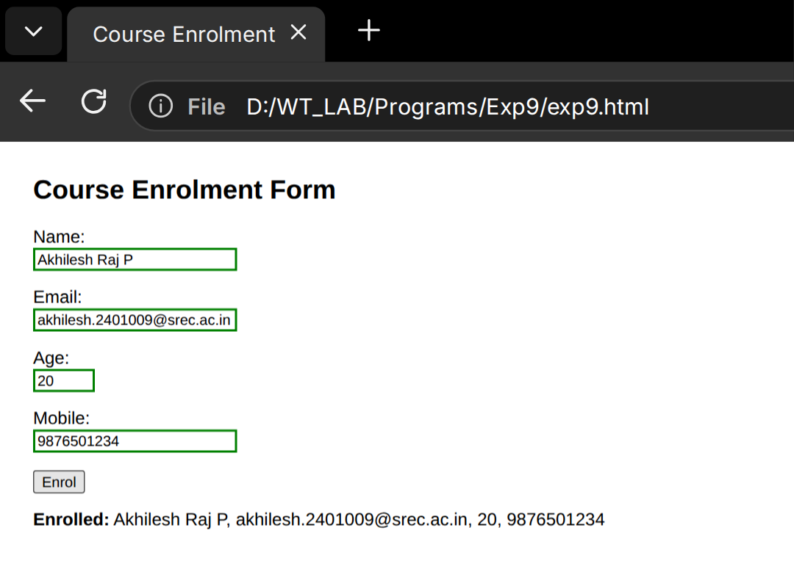
RESULT:
Thus, an AngularJS enrolment form with field validation was created and tested successfully.

EX.NO.10 | REACT JS: COMPONENTS, PROPS, STATE AND EVENTS
DATE: 28.09.26 | REACT JS: COMPONENTS, PROPS, STATE AND EVENTS

AIM:
To create a React application with reusable components, pass data through props, and use state and click events to update the page.
ALGORITHM:
1. Create a React project with Vite and open the src folder.
2. Create a ProfileCard component that receives name, role and skills as props.
3. Create a Counter component that stores the number of likes in state using useState.
4. Handle the click event of a button to increase the like count.
5. Use a second state value to toggle the availability status of the student.
6. Render both components inside the App component.
7. Run npm run dev and open the page in the browser.
CODE:
App.jsx:
import { useState } from "react";
import "./App.css";

function ProfileCard({ name, role, skills }) {
const [available, setAvailable] = useState(true);
return (
<div className="card">
<h2>{name}</h2>
<p className="role">{role}</p>
<ul>
{skills.map((s, i) => <li key={i}>{s}</li>)}
</ul>
<p className={available ? "on" : "off"}>
Status: {available ? "Available" : "Busy"}
</p>
<button onClick={() => setAvailable(!available)}>Change Status</button>
</div>
);
}

function Counter() {
const [likes, setLikes] = useState(0);
return (
<div className="card small">
<p>Profile likes: <b>{likes}</b></p>
<button onClick={() => setLikes(likes + 1)}>Like</button>
</div>
);
}

export default function App() {
return (
<div className="page">
<h1>Student Profile Board</h1>
<ProfileCard name="Akhilesh Raj P" role="B.E. CSE - Third Year"
skills={["HTML & CSS", "JavaScript", "React JS", "Node.js"]} />
<Counter />
</div>
);
}
OUTPUT:
Initial page
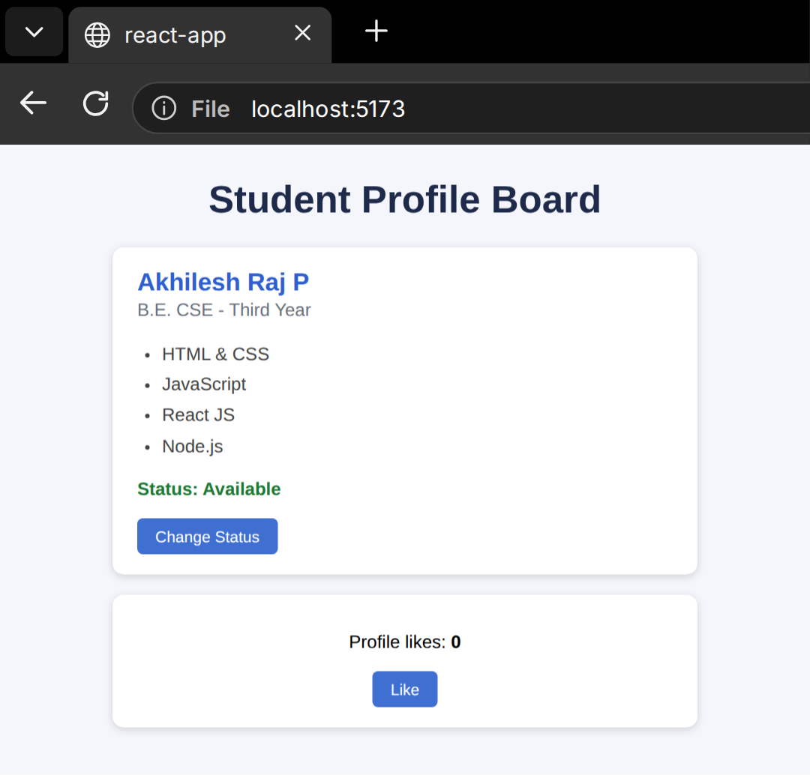
After Change Status and three likes
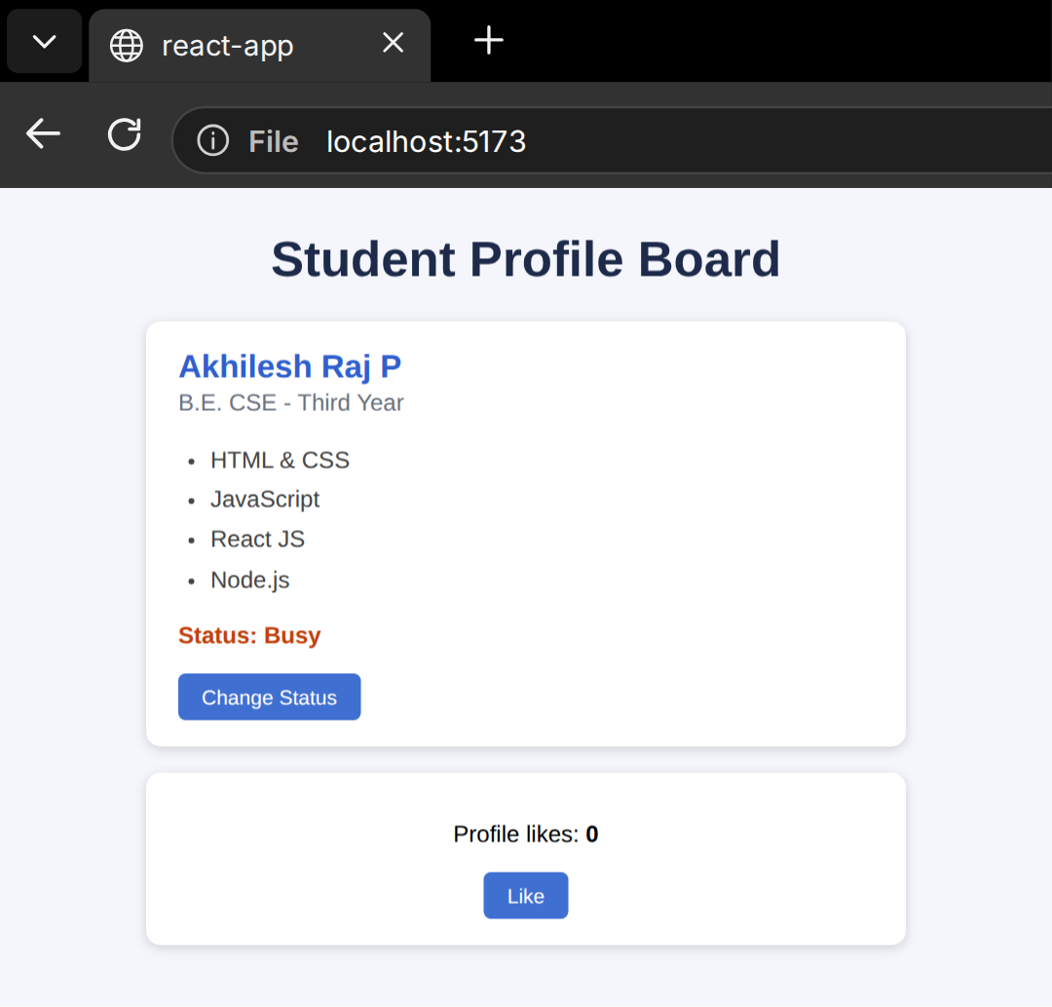
RESULT:
Thus, a React application using components, props, state and events was developed successfully.

EX.NO.11 | REACT JS: COMPONENT STATE AND INPUT HANDLING
DATE: 28.09.26 | REACT JS: COMPONENT STATE AND INPUT HANDLING

AIM:
To build a feedback form in React that keeps every input in component state, shows a live preview and displays the submitted feedback.
ALGORITHM:
1. Create a React component named FeedbackForm.
2. Declare one state object holding name, email, course and rating.
3. Write a single handleChange function that updates the state from any input.
4. Connect each input to the state as a controlled component with value and onChange.
5. Show a live preview of the entered data below the form.
6. Validate the fields on submit and store the submitted data in a second state variable.
7. Display a confirmation card after a successful submit.
CODE:
FeedbackForm.jsx:
import { useState } from "react";

export default function FeedbackForm() {
const [form, setForm] = useState({ name: "", email: "", course: "", rating: "5" });
const [sent, setSent] = useState(null);

const handleChange = (e) =>
setForm({ ...form, [e.target.name]: e.target.value });

const handleSubmit = (e) => {
e.preventDefault();
if (!form.name || !form.email || !form.course) {
alert("Please fill all the fields");
return;
}
setSent(form);
};

return (
<div className="wrap">
<h2>Course Feedback</h2>
<form onSubmit={handleSubmit}>
<label>Name</label>
<input name="name" value={form.name} onChange={handleChange} />
<label>Email</label>
<input name="email" value={form.email} onChange={handleChange} />
<label>Course</label>
<select name="course" value={form.course} onChange={handleChange}>
<option value="">Select</option>
<option>Web Technologies</option>
<option>Software Development Process</option>
<option>Microcontrollers</option>
</select>
<label>Rating (1-5)</label>
<input type="number" name="rating" min="1" max="5"
value={form.rating} onChange={handleChange} />
<button type="submit">Submit</button>
</form>
<p className="live">Live preview: {form.name} | {form.course} | {form.rating}/5</p>
{sent && <div className="done">Thank you, {sent.name}! Feedback saved for {sent.course}.</div>}
</div>
);
}
OUTPUT:
Live preview while typing
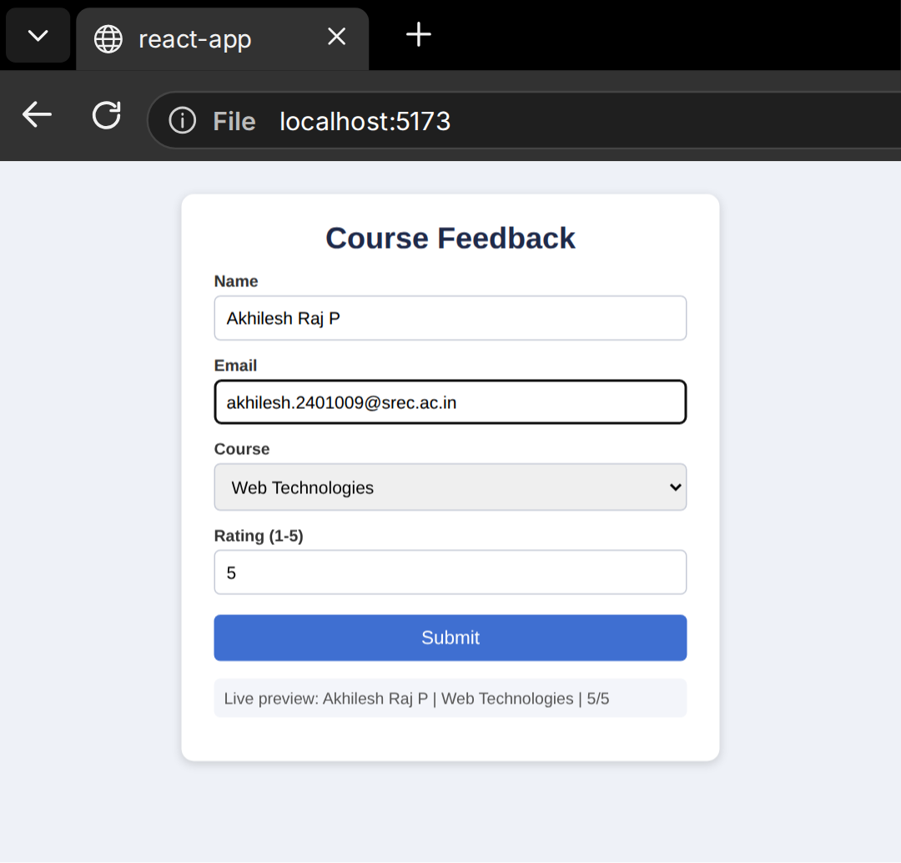
Feedback submitted
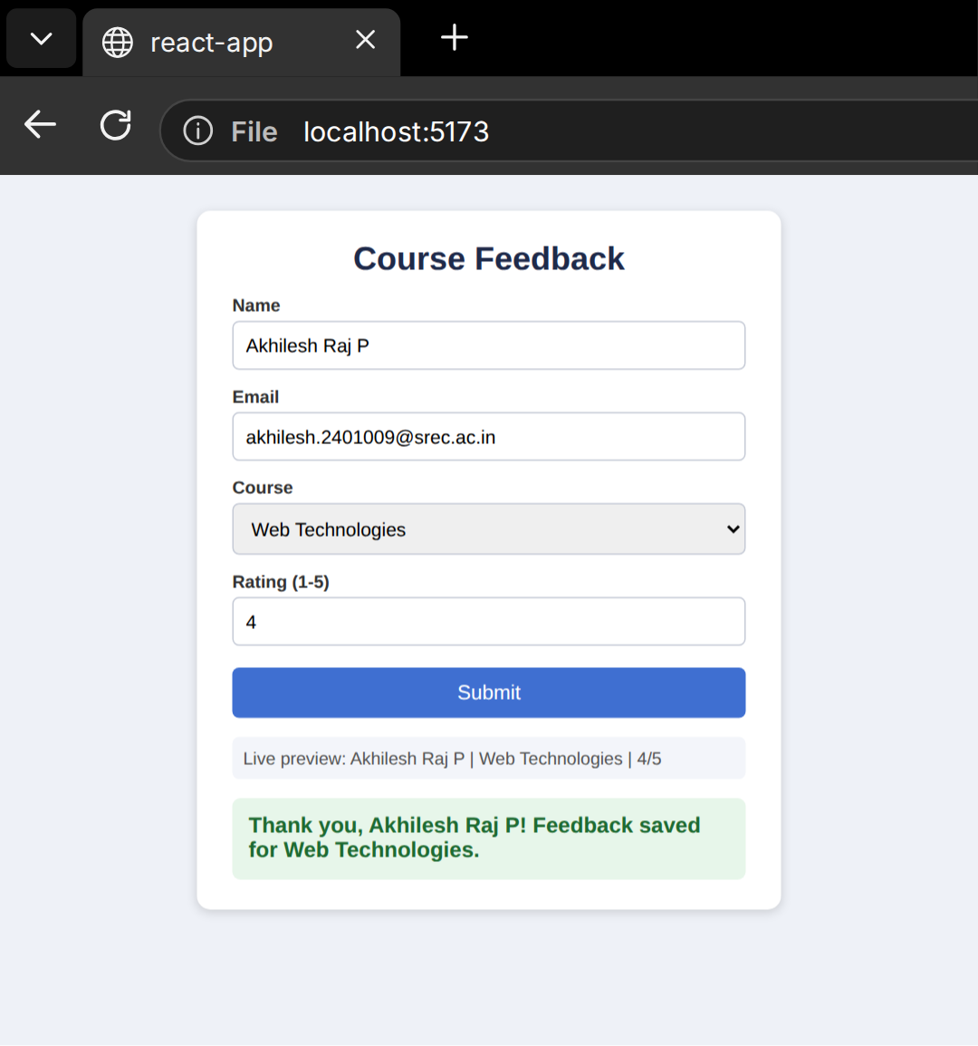
RESULT:
Thus, a React feedback form with controlled inputs and live state updates was created successfully.

EX.NO.12 | NODE.JS AND MONGODB
DATE: 28.09.26 | NODE.JS AND MONGODB

AIM:
To develop a Node.js and Express server connected to MongoDB that performs create, read, update and delete (CRUD) operations on library member records.
ALGORITHM:
1. Create a project folder and run npm init -y.
2. Install the packages express and mongodb with npm install.
3. Start the MongoDB server and open MongoDB Compass at mongodb://127.0.0.1:27017.
4. Create the database library and the collection members.
5. Write server.js that connects to MongoDB and enables JSON parsing in Express.
6. Create the routes POST /members, GET /members, PUT /members/:id and DELETE /members/:id.
7. Run node server.js and test every route from the browser page and Compass.
CODE:
server.js:
const express = require("express");
const { MongoClient } = require("mongodb");

const app = express();
app.use(express.json());
app.use(express.static("public"));

const client = new MongoClient("mongodb://127.0.0.1:27017");
let members;

async function start() {
await client.connect();
members = client.db("library").collection("members");
console.log("MongoDB connected - library.members");

// CREATE
app.post("/members", async (req, res) => {
await members.insertOne(req.body);
res.send("Member added successfully");
});

// READ
app.get("/members", async (req, res) => {
res.json(await members.find().toArray());
});

// UPDATE
app.put("/members/:id", async (req, res) => {
await members.updateOne({ memberId: req.params.id }, { $set: req.body });
res.send("Member updated successfully");
});

// DELETE
app.delete("/members/:id", async (req, res) => {
await members.deleteOne({ memberId: req.params.id });
res.send("Member deleted successfully");
});

app.listen(4000, () => console.log("Server running at http://localhost:4000"));
}
start();
Sample document:
{
"memberId": "LIB1009",
"name": "Akhilesh Raj P",
"department": "Computer Science and Engineering",
"email": "akhilesh.2401009@srec.ac.in",
"booksIssued": 2
}
OUTPUT:
Server start
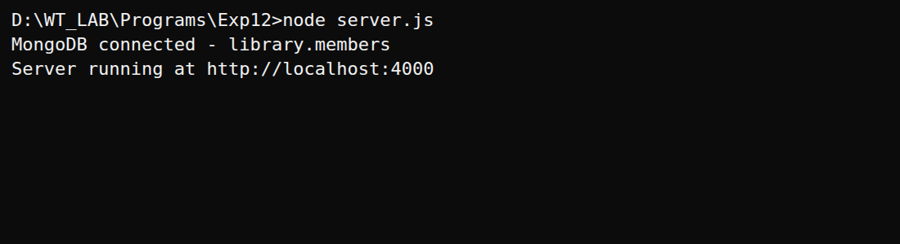
ADD - insert document in MongoDB Compass
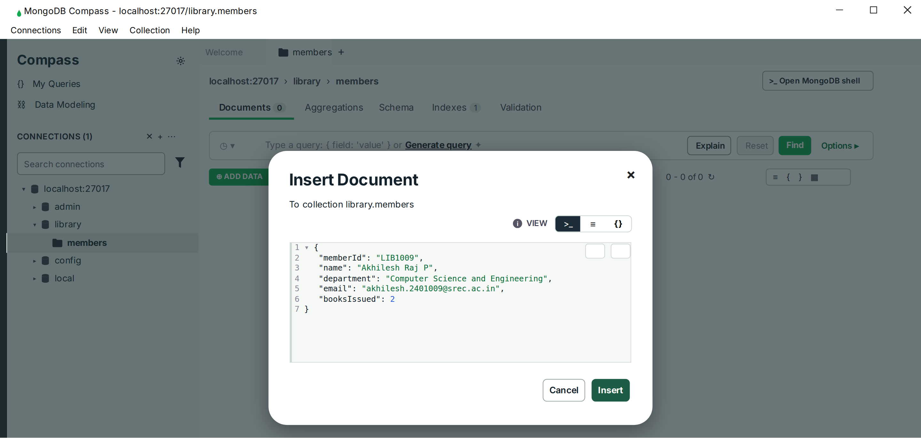
VIEW
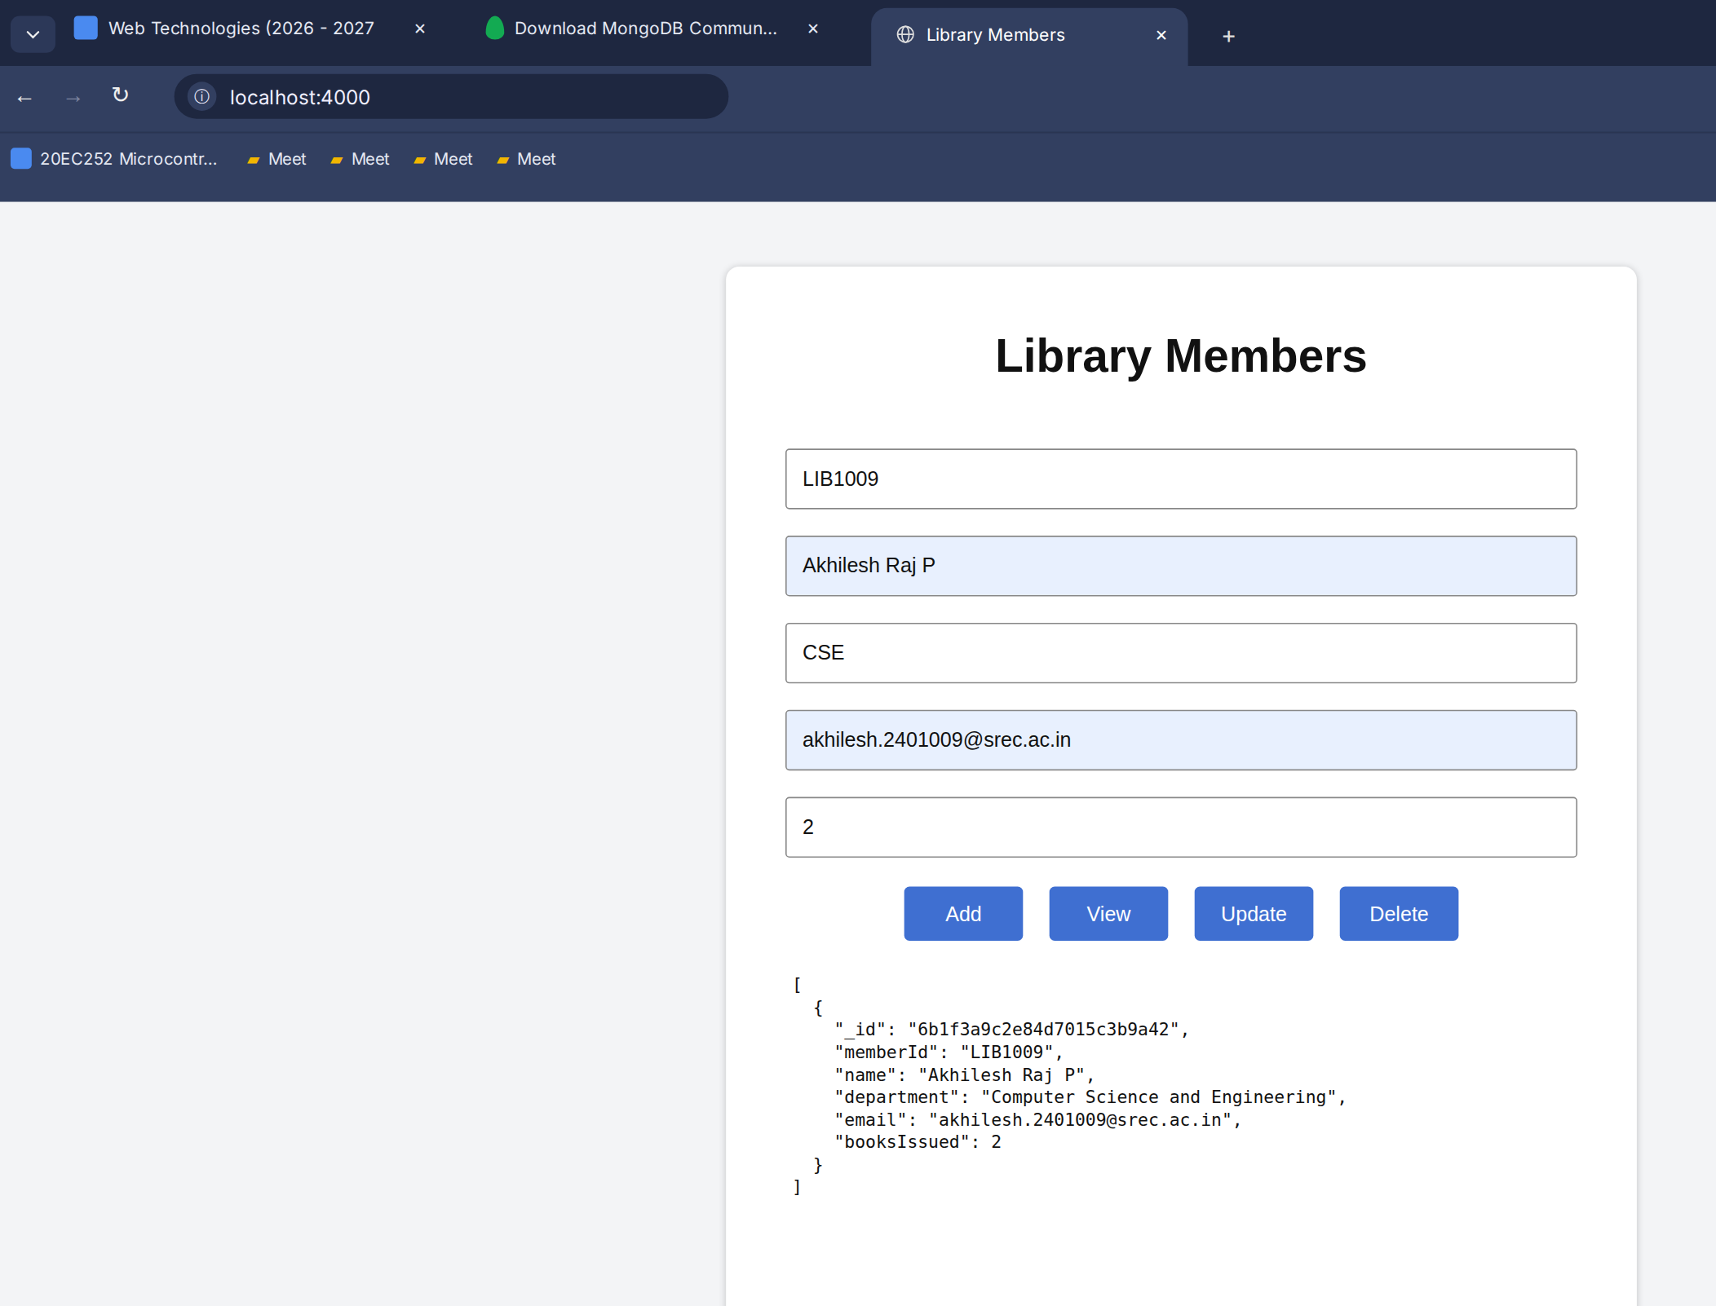
UPDATE
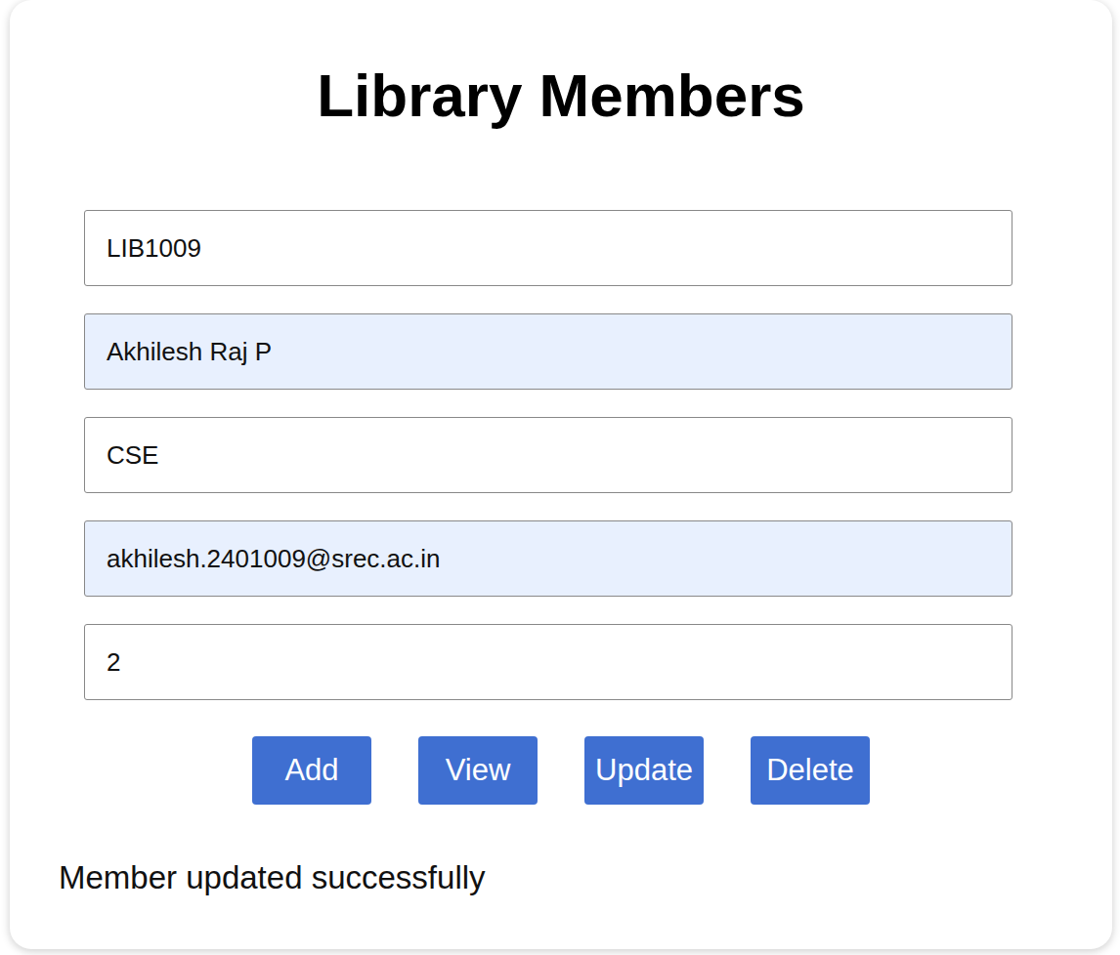
DELETE - document flagged for deletion in Compass
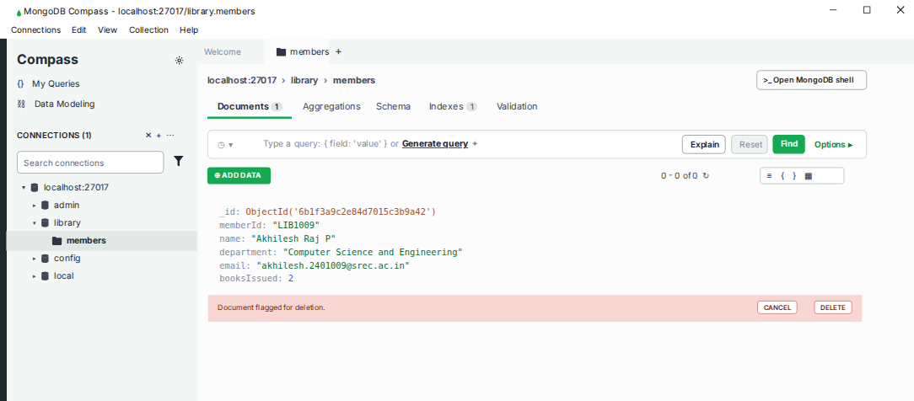
RESULT:
Thus, a Node.js and MongoDB library member management system was developed and the CRUD operations were verified successfully.

