DEPARTMENT OF COMPUTER SCIENCE AND ENGINEERING

CAPSTONE PROJECT REPORT

STUDENT COURSE REGISTRATION SYSTEM

AISHWARYA U (71812401006)
AJAY IYANRAJ (71812401007)
AKASHVARMAN R (71812401008)
AKHILESH RAJ P (71812401009)

THIRD YEAR B.E. CSE – V SEM
Academic Year 2026-2027

20CS279 &WEB TECHNOLOGIES LABORATORY

COURSE COORDINATOR
Mr.N.Manoj,AP/CSE
DEPARTMENT OF COMPUTER SCIENCE AND ENGINEERING

20CS279 &WEB TECHNOLOGIES LABORATORY

STUDENT COURSE REGISTRATION SYSTEM

Assessment

INDEX

S.  No. | Name & Roll No. | Introduction (2) | Logic Building (2) | Implementation Steps (4) | Report (2) | Total  (10)
1. | AISHWARYA U  71812401006
2. | AJAY IYANRAJ  71812401007
3. | AKASHVARMAN R  71812401008
4. | AKHILESH RAJ P  71812401009

SIGNATURE OF COURSE COORDINATOR
Mr.N.Manoj,AP/CSE

CONTENTS

S. No. | TITLE | PAGE  NUMBER
 | STUDENT COURSE REGISTRATION SYSTEM | 4
 | INTRODUCTION | 4
 | LOGIC BUILDING | 5
 | IMPLEMENTATION STEPS | 7
 | CODE AND OUTPUT SCREENSHOTS | 9
 | CONCLUSION | 16

STUDENT COURSE REGISTRATION SYSTEM
Abstract
The Student Course Registration System is a web application that allows the students of a college to log in with their roll number, browse the list of courses offered in the semester, register for the courses they want, drop a course, and view the registered courses in a weekly timetable. The system checks every registration against the available seats, the maximum credit limit and the time-slot clash rules, and it shows clear messages when a rule fails. The project is developed with HTML5 for the structure, CSS3 for the design and JavaScript for the logic, and the registrations are stored in the browser localStorage, so the complete application runs on the client side without any server.
Team members
S. No. | Name | Roll Number
1 | AISHWARYA U | 71812401006
2 | AJAY IYANRAJ | 71812401007
3 | AKASHVARMAN R | 71812401008
4 | AKHILESH RAJ P | 71812401009

Objectives
• To replace the manual, paper based course registration with a simple and fast web application.
• To allow only valid students to log in and to register for courses.
• To prevent over-booking of seats, crossing of the credit limit and clash of class timings.
• To show the registered courses, the total credits and the weekly timetable instantly.
• To keep the design responsive so that it works on desktop and mobile screens.
Technologies used
Technology / Tool | Purpose
HTML5 | Page structure: login form, tabs, tables and containers
CSS3 | Layout, colours, badges, progress bar, timetable grid and responsive design
JavaScript (ES6) | Login validation, course filtering, registration rules, timetable and localStorage
Browser localStorage | Stores the registrations of all students without a database
Visual Studio Code | Writing and formatting the source code
Google Chrome / Playwright | Running the application and capturing the output screenshots

1. INTRODUCTION
1.1 Background
At the beginning of every semester a student has to choose the courses to study, such as the core subjects, the electives and the laboratory courses. In many colleges this is still done with paper forms or spreadsheets. The staff have to check the seats, the credits and the time-table of every student by hand, which takes a lot of time and often leads to mistakes such as two courses at the same hour or more students than seats.
1.2 Problem Statement
Design and develop a Student Course Registration System in which a student can log in, view the courses with their credits, faculty, time slots and available seats, register or drop courses, and see the total credits and the timetable. The system must automatically reject a registration when the course is full, when the credit limit of 24 is crossed, or when the time slot clashes with an already registered course.
1.3 Scope of the project
• Student side functions: login, search / filter courses, register, drop, view credits and timetable.
• Twelve sample courses of five departments with limited seats and fixed weekly time slots.
• Four sample student accounts (the members of this team) protected by a password.
• A client side implementation only; a real deployment would store the data on a server database.
1.4 Modules of the system
Module | Description
Login | Checks the roll number format, the existence of the student and the password.
Available Courses | Lists all courses with seats left; supports search by code, title, faculty and department filter.
Registration engine | Applies the rules for seats, credits and time clash before saving a registration.
My Registrations | Shows the registered courses, total credits with a progress bar, and a Drop button.
Timetable | Builds a Monday to Friday, five period grid from the slots of the registered courses.
Storage | Saves the registrations of every student in localStorage so they remain after a page refresh.

1.5 Key features
• Live seat count: the seats left of every course are updated immediately and shown in green, yellow or red badges.
• Credit control: a progress bar shows the credits used out of the maximum of 24.
• Clash detection: a course whose slot is already taken is rejected with the name of the clashing course.
• Responsive design: the layout adapts to phone screens with a scrollable table.
1.6 Advantages
• Saves the time of both students and the staff.
• Avoids human errors in seat allotment and in time-table clashes.
• Works in any browser without installation, and the data is available offline.
2. LOGIC BUILDING
2.1 Overall logic
Step 1: Login: The student enters the roll number and the password; the login logic validates both.
Step 2: Show portal: After a successful login the application hides the login view and shows the main view with the student name.
Step 3: List courses: The array of courses is displayed as table rows; the search text and department filter reduce the rows.
Step 4: Validate: When Register is clicked the three rules (seats, credits, clash) are checked one after another.
Step 5: Save: If all rules pass the course code is added to the list of the student and saved in localStorage.
Step 6: Refresh: The seat badges, credit chip, progress bar, My Registrations table and the timetable are redrawn.
2.2 Data used by the program
Each course is stored as a JavaScript object. The registrations of all the students are stored in one object in localStorage, where the key is the roll number and the value is the list of registered course codes.
// one course object
{ code: '20CS212', title: 'Web Technologies', dept: 'CSE', credits: 3,
faculty: 'Mr. N. Manoj', slots: ['Mon-1', 'Wed-2'], seats: 60, taken: 41 }

// registrations saved in localStorage under the key "scrs"
{ '71812401006': ['20CS212', '20CS202'], '71812401007': ['20CS205'] }

// seats left = total seats - seats already taken - registrations of all students
seatsLeft = course.seats - course.taken - countOfStudentsRegistered(course.code)

2.3 Business rules
Rule | Condition checked | Message shown
Valid roll number | 11 digits and present in the student list | Roll number must contain exactly 11 digits / not found
Valid password | At least 8 characters and equal to the stored password | Incorrect password. Please try again.
Seat availability | seats left > 0 | 20CS206 is full. No seats left.
Credit limit | registered credits + course credits <= 24 | Credit limit of 24 exceeded.
Time clash | no common slot with any registered course | Time clash with 20CS212 at Mon-1.
Duplicate | a registered course shows a disabled button | Registered (button disabled)

2.4 Algorithm for registering a course
registerCourse(code):
course <- find course with this code
if seatsLeft(course) <= 0 -> show "course is full"; stop
if totalCredits() + course.credits > 24 -> show "credit limit exceeded"; stop
if any registered course shares a slot -> show "time clash"; stop
add code to registrations of the current student
save registrations in localStorage
show "Registered" message
redraw catalogue, my registrations and timetable

2.5 Flowchart
Flowchart of login and course registration
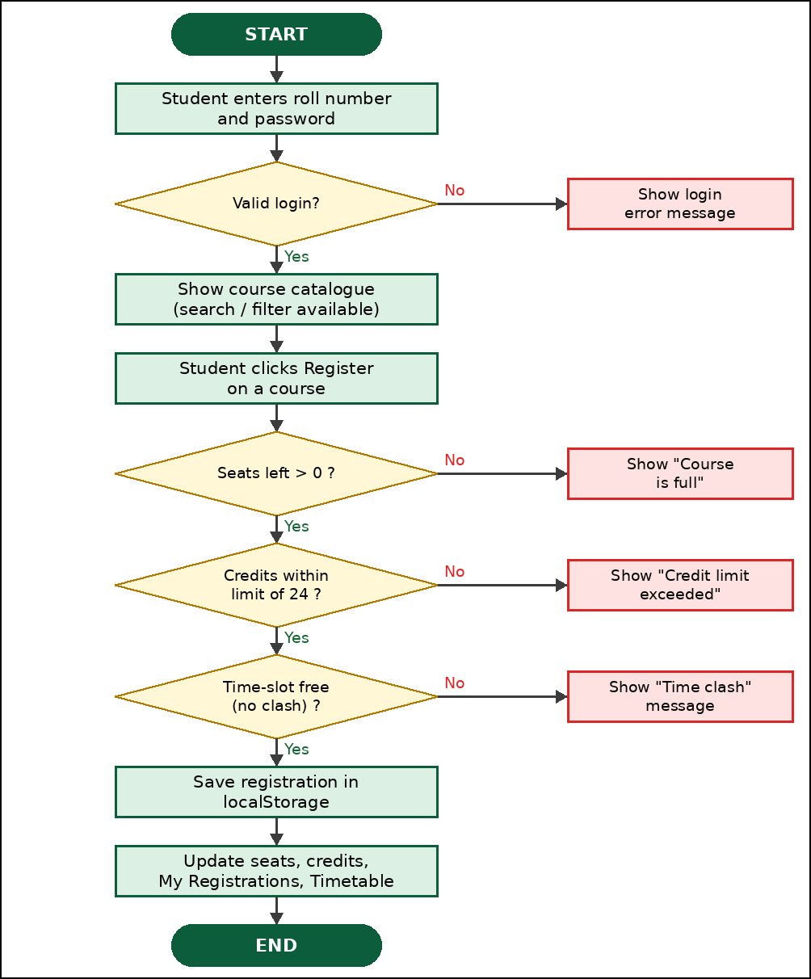
Fig. 1 - Logic of login and course registration.
2.6 Logic of credits and timetable
The total credits are the sum of the credits of the registered courses; the width of the progress bar is total / 24 x 100 percent. For the timetable every slot is written as Day-Period (for example Wed-2). A map is created from slot to course code and the grid of five days and five periods is drawn by looking up each cell in this map, so a clash is impossible because a slot can hold only one course.
3. IMPLEMENTATION STEPS
3.1 Steps followed
Step 1: Create the project folder with three files: index.html, style.css and script.js.
Step 2: Design the HTML: a login section, and a main section with a top bar, three tabs and three panels.
Step 3: Style with CSS: green theme, cards, badges, progress bar, timetable grid and a media query for phones.
Step 4: Store the data: define the student list, the constants and the array of twelve courses in script.js.
Step 5: Write the login logic: validate the roll number and the password and switch the views.
Step 6: Display the catalogue: build the table rows with template strings; add the search box and the department filter.
Step 7: Write the registration engine: functions seatsLeft, totalCredits, findClash, registerCourse and dropCourse.
Step 8: Build My Registrations and Timetable: render the list, the credit bar and the weekly grid.
Step 9: Save to localStorage after every register or drop so the data survives a refresh.
Step 10: Test the application with wrong login, search, filter, registration, clash, full course and drop cases and capture the screenshots.
3.2 Project files
File | Lines | Purpose
index.html | 84 | Structure of the login page, the tabs, the tables and the toast message box
style.css | 66 | Appearance of every component and the responsive rules
script.js | 171 | Data, login, filtering, registration rules, timetable and storage

3.3 Main functions of script.js
Function | Purpose
seatsLeft(course) | Returns the seats still free after counting the registrations of all students
totalCredits() | Adds the credits of the courses registered by the current student
findClash(course) | Returns the registered course that shares a time slot with the given course
registerCourse(code) | Applies seat, credit and clash rules and saves the registration
dropCourse(code) | Removes a registered course and refreshes the screen
renderCatalogue() | Draws the course table after applying the search text and department filter
renderMine() | Draws the registered courses and the credit progress bar
renderTimetable() | Draws the Monday to Friday timetable grid
toast(msg, type) | Shows a green success or red error message for a short time

3.4 Test cases
S. No. | Test case | Expected result | Result
1 | Login with a wrong password | Error message "Incorrect password" | Pass
2 | Login with a valid roll number and password | Portal opens with the student name | Pass
3 | Filter by department AI&DS | Only the two AI&DS courses are listed | Pass
4 | Register 20CS212 | Success message and credits become 3 / 24 | Pass
5 | Register 20CS204 after 20CS212 | Error: time clash at Mon-1 | Pass
6 | Open a full course (20CS206) | Button shows Full and is disabled | Pass
7 | Open the Timetable tab | Registered slots are highlighted | Pass

4. CODE AND OUTPUT SCREENSHOTS
4.1 index.html
<!DOCTYPE html>
<html lang="en">
<head>
<meta charset="UTF-8">
<meta name="viewport" content="width=device-width, initial-scale=1.0">
<title>Student Course Registration System</title>
<link rel="stylesheet" href="style.css">
</head>
<body>

<!-- ============ LOGIN VIEW ============ -->
<section id="loginView" class="login-wrap">
<form id="loginForm" class="card login-card" novalidate>
<h1>Student Course Registration</h1>
<p class="sub">Sri Ramakrishna Engineering College</p>
<label for="roll">Roll Number</label>
<input type="text" id="roll" placeholder="e.g. 71812401006" maxlength="11" inputmode="numeric" required>
<label for="pwd">Password</label>
<input type="password" id="pwd" placeholder="Enter password" required>
<div id="loginError" class="error"></div>
<button type="submit" class="btn primary block">Login</button>
<p class="hint">Demo password for all students: <b>Srec@2026</b></p>
</form>
</section>

<!-- ============ MAIN APPLICATION ============ -->
<section id="appView" class="hidden">
<header class="topbar">
<div>
<h2>Course Registration Portal</h2>
<span id="welcome"></span>
</div>
<div class="right">
<span class="chip" id="creditChip"></span>
<button id="logoutBtn" class="btn light">Logout</button>
</div>
</header>

<nav class="tabs">
<button class="tab active" data-tab="catalogue">Available Courses</button>
<button class="tab" data-tab="mine">My Registrations</button>
<button class="tab" data-tab="timetable">Timetable</button>
</nav>

<main>
<div id="catalogue" class="panel">
<div class="filters">
<input type="search" id="search" placeholder="Search by code, title or faculty">
<select id="deptFilter">
<option value="All">All Departments</option>
</select>
</div>
<table>
<thead>
<tr><th>Code</th><th>Course Title</th><th>Dept</th><th>Credits</th>
<th>Faculty</th><th>Slots</th><th>Seats Left</th><th>Action</th></tr>
</thead>
<tbody id="courseBody"></tbody>
</table>
</div>

<div id="mine" class="panel hidden">
<div class="progress-box">
<span id="creditText"></span>
<div class="bar"><div id="creditBar"></div></div>
</div>
<table>
<thead>
<tr><th>Code</th><th>Course Title</th><th>Credits</th><th>Faculty</th><th>Slots</th><th>Action</th></tr>
</thead>
<tbody id="myBody"></tbody>
</table>
</div>

<div id="timetable" class="panel hidden">
<table class="grid" id="ttTable"></table>
</div>
</main>
</section>

<div id="toast" class="toast hidden"></div>
<script src="script.js"></script>
</body>
</html>

4.2 style.css
* { box-sizing: border-box; }
body { margin: 0; font-family: "Segoe UI", Arial, sans-serif; background: #eef2f7; color: #1f2937; }
.hidden { display: none !important; }

/* login */
.login-wrap { min-height: 100vh; display: flex; align-items: center; justify-content: center;
background: linear-gradient(135deg, #0b5d3b, #1f8a5b); padding: 16px; }
.card { background: #fff; border-radius: 12px; box-shadow: 0 6px 24px rgba(0,0,0,.25); }
.login-card { width: 100%; max-width: 380px; padding: 28px; }
.login-card h1 { margin: 0; font-size: 22px; color: #0b5d3b; text-align: center; }
.sub { text-align: center; color: #64748b; margin: 4px 0 20px; font-size: 14px; }
label { display: block; font-weight: 600; font-size: 14px; margin: 12px 0 5px; }
input, select { width: 100%; padding: 10px; font-size: 14px; border: 1px solid #94a3b8; border-radius: 6px; }
input:focus, select:focus { outline: 2px solid #34a56f; }
.error { color: #dc2626; font-size: 13px; min-height: 18px; margin-top: 6px; }
.hint { font-size: 12px; color: #64748b; text-align: center; margin-bottom: 0; }

/* buttons */
.btn { padding: 8px 16px; border: 0; border-radius: 6px; cursor: pointer; font-size: 14px; }
.btn.primary { background: #0b5d3b; color: #fff; }
.btn.light { background: #fff; color: #0b5d3b; }
.btn.danger { background: #dc2626; color: #fff; }
.btn.block { width: 100%; margin-top: 8px; padding: 11px; }
.btn:disabled { background: #cbd5e1; color: #64748b; cursor: not-allowed; }

/* top bar and tabs */
.topbar { display: flex; justify-content: space-between; align-items: center; flex-wrap: wrap;
gap: 8px; background: #0b5d3b; color: #fff; padding: 14px 24px; }
.topbar h2 { margin: 0; font-size: 20px; }
.topbar span#welcome { font-size: 13px; opacity: .9; }
.right { display: flex; align-items: center; gap: 12px; }
.chip { background: rgba(255,255,255,.2); padding: 6px 12px; border-radius: 20px; font-size: 13px; }
.tabs { display: flex; gap: 4px; padding: 12px 24px 0; background: #fff; border-bottom: 2px solid #0b5d3b; }
.tab { border: 0; background: #e2e8f0; padding: 10px 18px; border-radius: 8px 8px 0 0; cursor: pointer; font-size: 14px; }
.tab.active { background: #0b5d3b; color: #fff; }
main { max-width: 1100px; margin: 20px auto; padding: 0 16px; }

/* tables */
.filters { display: flex; gap: 12px; margin-bottom: 14px; }
.filters input { flex: 2; } .filters select { flex: 1; }
table { width: 100%; border-collapse: collapse; background: #fff; border-radius: 8px; overflow: hidden;
box-shadow: 0 1px 6px rgba(0,0,0,.12); font-size: 14px; }
th { background: #0b5d3b; color: #fff; text-align: left; padding: 10px; }
td { padding: 10px; border-bottom: 1px solid #e2e8f0; }
tr:hover td { background: #f0fdf4; }
.badge { padding: 3px 9px; border-radius: 12px; font-size: 12px; font-weight: 600; }
.badge.ok { background: #dcfce7; color: #166534; } .badge.low { background: #fef3c7; color: #92400e; }
.badge.full { background: #fee2e2; color: #991b1b; }

/* credit progress and timetable */
.progress-box { background: #fff; padding: 14px; border-radius: 8px; margin-bottom: 14px; box-shadow: 0 1px 6px rgba(0,0,0,.12); }
.bar { height: 12px; background: #e2e8f0; border-radius: 6px; margin-top: 8px; overflow: hidden; }
.bar div { height: 100%; width: 0; background: #16a34a; transition: width .4s; }
.grid th, .grid td { text-align: center; border: 1px solid #cbd5e1; height: 56px; }
.grid td.filled { background: #dcfce7; font-weight: 600; font-size: 13px; }

/* toast */
.toast { position: fixed; bottom: 24px; right: 24px; padding: 12px 20px; border-radius: 8px; color: #fff;
box-shadow: 0 4px 14px rgba(0,0,0,.3); font-size: 14px; max-width: 360px; }
.toast.success { background: #16a34a; } .toast.error { background: #dc2626; }

@media (max-width: 700px) {
.filters { flex-direction: column; }
table { display: block; overflow-x: auto; white-space: nowrap; }
.topbar { padding: 12px 14px; }
}

4.3 script.js
// ---------- DATA ----------
const PASSWORD = 'Srec@2026';
const STUDENTS = {
'71812401006': 'Aishwarya U',
'71812401007': 'Ajay Iyanraj',
'71812401008': 'Akashvarman R',
'71812401009': 'Akhilesh Raj P'
};
const MAX_CREDITS = 24;
const DAYS = ['Mon', 'Tue', 'Wed', 'Thu', 'Fri'];
const PERIODS = ['9:00 - 10:00', '10:00 - 11:00', '11:15 - 12:15', '1:15 - 2:15', '2:15 - 3:15'];

// seats = total seats, taken = seats already occupied by other students
const COURSES = [
{ code: '20CS212', title: 'Web Technologies', dept: 'CSE', credits: 3, faculty: 'Mr. N. Manoj', slots: ['Mon-1', 'Wed-2'], seats: 60, taken: 41 },
{ code: '20CS201', title: 'Data Structures', dept: 'CSE', credits: 4, faculty: 'Dr. S. Priya', slots: ['Tue-1', 'Thu-1'], seats: 60, taken: 52 },
{ code: '20CS202', title: 'Database Management', dept: 'CSE', credits: 3, faculty: 'Ms. R. Kavitha', slots: ['Mon-3', 'Fri-2'], seats: 60, taken: 38 },
{ code: '20CS203', title: 'Operating Systems', dept: 'CSE', credits: 3, faculty: 'Dr. M. Suresh', slots: ['Tue-2', 'Fri-1'], seats: 60, taken: 59 },
{ code: '20CS204', title: 'Computer Networks', dept: 'CSE', credits: 3, faculty: 'Mr. K. Arun', slots: ['Mon-1', 'Thu-3'], seats: 60, taken: 30 },
{ code: '20CS205', title: 'Software Engineering', dept: 'CSE', credits: 3, faculty: 'Ms. L. Divya', slots: ['Wed-3', 'Fri-4'], seats: 60, taken: 45 },
{ code: '20CS206', title: 'Artificial Intelligence', dept: 'AI&DS', credits: 4, faculty: 'Dr. V. Rajesh', slots: ['Tue-4', 'Thu-2'], seats: 40, taken: 40 },
{ code: '20CS207', title: 'Cyber Security', dept: 'AI&DS', credits: 3, faculty: 'Mr. T. Harish', slots: ['Wed-4', 'Fri-3'], seats: 40, taken: 22 },
{ code: '20CS208', title: 'Cloud Computing', dept: 'IT', credits: 3, faculty: 'Ms. P. Anitha', slots: ['Thu-4', 'Tue-3'], seats: 50, taken: 35 },
{ code: '20MA201', title: 'Discrete Mathematics', dept: 'MATHS', credits: 4, faculty: 'Dr. G. Latha', slots: ['Mon-2', 'Wed-1'], seats: 70, taken: 48 },
{ code: '20HS201', title: 'Professional Ethics', dept: 'HSS', credits: 2, faculty: 'Mr. B. Karthik', slots: ['Fri-5'], seats: 80, taken: 50 },
{ code: '20CS279', title: 'Web Technologies Lab', dept: 'CSE', credits: 2, faculty: 'Mr. N. Manoj', slots: ['Thu-5'], seats: 60, taken: 44 }
];

// ---------- STORAGE (registrations of all students) ----------
let currentUser = null;
const store = {
load() { try { return JSON.parse(localStorage.getItem('scrs')) || {}; } catch (e) { return {}; } },
save(data) { localStorage.setItem('scrs', JSON.stringify(data)); }
};
const $ = id => document.getElementById(id);

function myCodes() { return store.load()[currentUser] || []; }
function courseByCode(code) { return COURSES.find(c => c.code === code); }
function seatsLeft(course) {
const all = store.load();
const mine = Object.values(all).filter(list => list.includes(course.code)).length;
return course.seats - course.taken - mine;
}
function totalCredits() { return myCodes().reduce((sum, c) => sum + courseByCode(c).credits, 0); }

// ---------- TOAST ----------
let toastTimer;
function toast(msg, type) {
const t = $('toast');
t.textContent = msg; t.className = 'toast ' + type;
clearTimeout(toastTimer);
toastTimer = setTimeout(() => t.classList.add('hidden'), 3500);
}

// ---------- LOGIN / LOGOUT ----------
$('loginForm').addEventListener('submit', e => {
e.preventDefault();
const roll = $('roll').value.trim(), pwd = $('pwd').value;
let msg = '';
if (!/^\d{11}$/.test(roll)) msg = 'Roll number must contain exactly 11 digits.';
else if (!STUDENTS[roll]) msg = 'Roll number not found.';
else if (pwd.length < 8) msg = 'Password must be at least 8 characters.';
else if (pwd !== PASSWORD) msg = 'Incorrect password. Please try again.';
$('loginError').textContent = msg;
if (msg) return;
currentUser = roll;
$('loginView').classList.add('hidden');
$('appView').classList.remove('hidden');
$('welcome').textContent = 'Welcome, ' + STUDENTS[roll] + ' (' + roll + ')';
refreshAll();
});

$('logoutBtn').addEventListener('click', () => {
currentUser = null;
$('appView').classList.add('hidden');
$('loginView').classList.remove('hidden');
$('loginForm').reset();
});

// ---------- TABS ----------
document.querySelectorAll('.tab').forEach(btn => btn.addEventListener('click', () => {
document.querySelectorAll('.tab').forEach(b => b.classList.toggle('active', b === btn));
document.querySelectorAll('.panel').forEach(p => p.classList.toggle('hidden', p.id !== btn.dataset.tab));
}));

// ---------- CATALOGUE ----------
[...new Set(COURSES.map(c => c.dept))].forEach(d => {
const o = document.createElement('option'); o.value = o.textContent = d; $('deptFilter').appendChild(o);
});

function renderCatalogue() {
const q = $('search').value.toLowerCase(), dept = $('deptFilter').value;
const rows = COURSES.filter(c =>
(dept === 'All' || c.dept === dept) &&
(c.code + c.title + c.faculty).toLowerCase().includes(q));
$('courseBody').innerHTML = rows.map(c => {
const left = seatsLeft(c), done = myCodes().includes(c.code);
const cls = left <= 0 ? 'full' : left <= 10 ? 'low' : 'ok';
const btn = done ? '<button class="btn" disabled>Registered</button>'
: left <= 0 ? '<button class="btn" disabled>Full</button>'
: '<button class="btn primary" onclick="registerCourse(\'' + c.code + '\')">Register</button>';
return '<tr><td>' + c.code + '</td><td>' + c.title + '</td><td>' + c.dept + '</td><td>' + c.credits +
'</td><td>' + c.faculty + '</td><td>' + c.slots.join(', ') + '</td><td><span class="badge ' + cls + '">' +
Math.max(left, 0) + '</span></td><td>' + btn + '</td></tr>';
}).join('') || '<tr><td colspan="8">No courses match your search.</td></tr>';
}
$('search').addEventListener('input', renderCatalogue);
$('deptFilter').addEventListener('change', renderCatalogue);

// ---------- REGISTER / DROP ----------
function findClash(course) {
for (const code of myCodes()) {
const other = courseByCode(code);
const shared = other.slots.find(s => course.slots.includes(s));
if (shared) return { other, slot: shared };
}
return null;
}

function registerCourse(code) {
const course = courseByCode(code), all = store.load();
const clash = findClash(course);
if (seatsLeft(course) <= 0) return toast(course.code + ' is full. No seats left.', 'error');
if (totalCredits() + course.credits > MAX_CREDITS)
return toast('Credit limit of ' + MAX_CREDITS + ' exceeded.', 'error');
if (clash) return toast('Time clash with ' + clash.other.code + ' at ' + clash.slot + '.', 'error');
all[currentUser] = [...myCodes(), code];
store.save(all);
toast('Registered for ' + course.code + ' - ' + course.title, 'success');
refreshAll();
}

function dropCourse(code) {
const all = store.load();
all[currentUser] = myCodes().filter(c => c !== code);
store.save(all);
toast('Dropped ' + code, 'success');
refreshAll();
}

// ---------- MY REGISTRATIONS ----------
function renderMine() {
const list = myCodes().map(courseByCode), total = totalCredits();
$('creditText').textContent = 'Credits registered: ' + total + ' / ' + MAX_CREDITS +
' | Courses: ' + list.length;
$('creditBar').style.width = (total / MAX_CREDITS * 100) + '%';
$('myBody').innerHTML = list.map(c =>
'<tr><td>' + c.code + '</td><td>' + c.title + '</td><td>' + c.credits + '</td><td>' + c.faculty +
'</td><td>' + c.slots.join(', ') + '</td><td><button class="btn danger" onclick="dropCourse(\'' +
c.code + '\')">Drop</button></td></tr>').join('') ||
'<tr><td colspan="6">You have not registered for any course yet.</td></tr>';
}

// ---------- TIMETABLE ----------
function renderTimetable() {
const slotMap = {};
myCodes().map(courseByCode).forEach(c => c.slots.forEach(s => slotMap[s] = c.code));
let html = '<tr><th>Period</th>' + DAYS.map(d => '<th>' + d + '</th>').join('') + '</tr>';
PERIODS.forEach((time, p) => {
html += '<tr><th>' + time + '</th>' + DAYS.map(d => {
const code = slotMap[d + '-' + (p + 1)];
return code ? '<td class="filled">' + code + '</td>' : '<td></td>';
}).join('') + '</tr>';
});
$('ttTable').innerHTML = html;
}

function refreshAll() {
$('creditChip').textContent = 'Credits: ' + totalCredits() + ' / ' + MAX_CREDITS;
renderCatalogue(); renderMine(); renderTimetable();
}

4.4 Output screenshots
The screenshots below were captured from the running application in a Chromium browser.
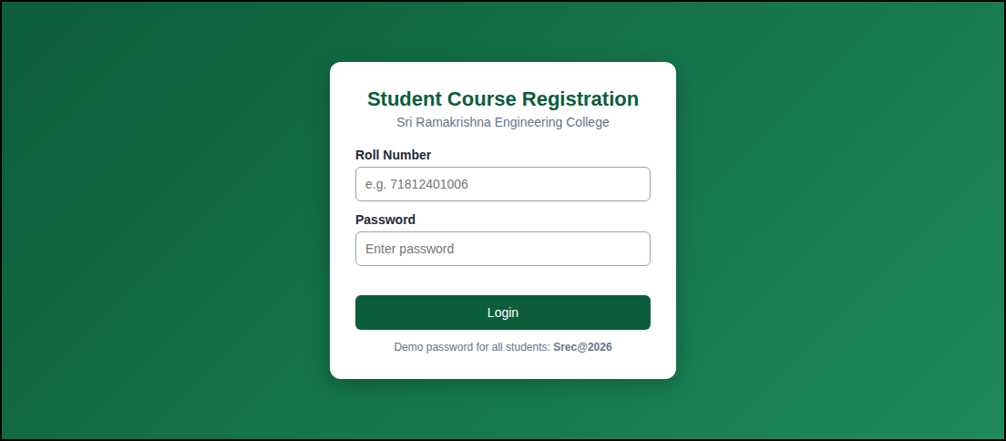
Fig. 2 - Login page asking for the roll number and password.
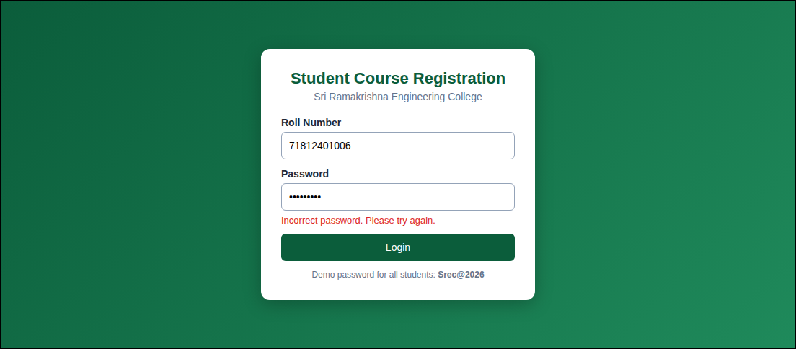
Fig. 3 - Error message shown for an incorrect password.
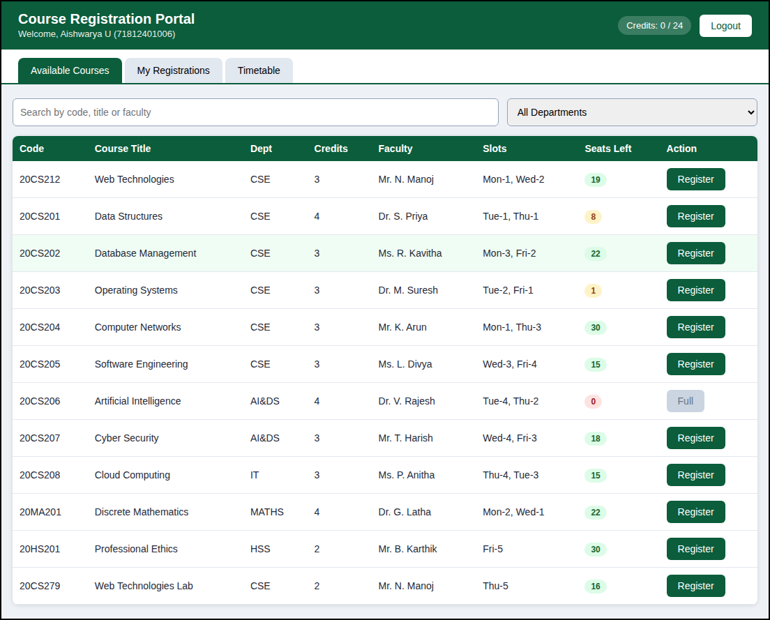
Fig. 4 - Course catalogue with credits, faculty, slots and seat badges (20CS206 is full).
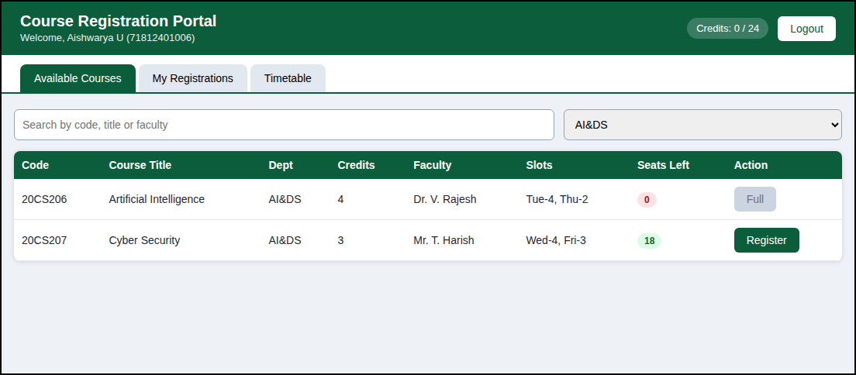
Fig. 5 - Filtering by the AI&DS department shows only two courses.
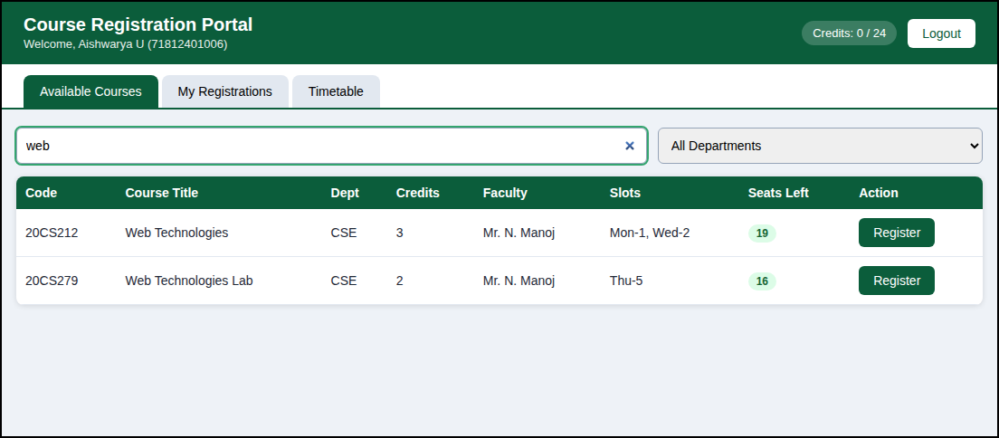
Fig. 6 - Searching "web" lists Web Technologies and Web Technologies Lab.
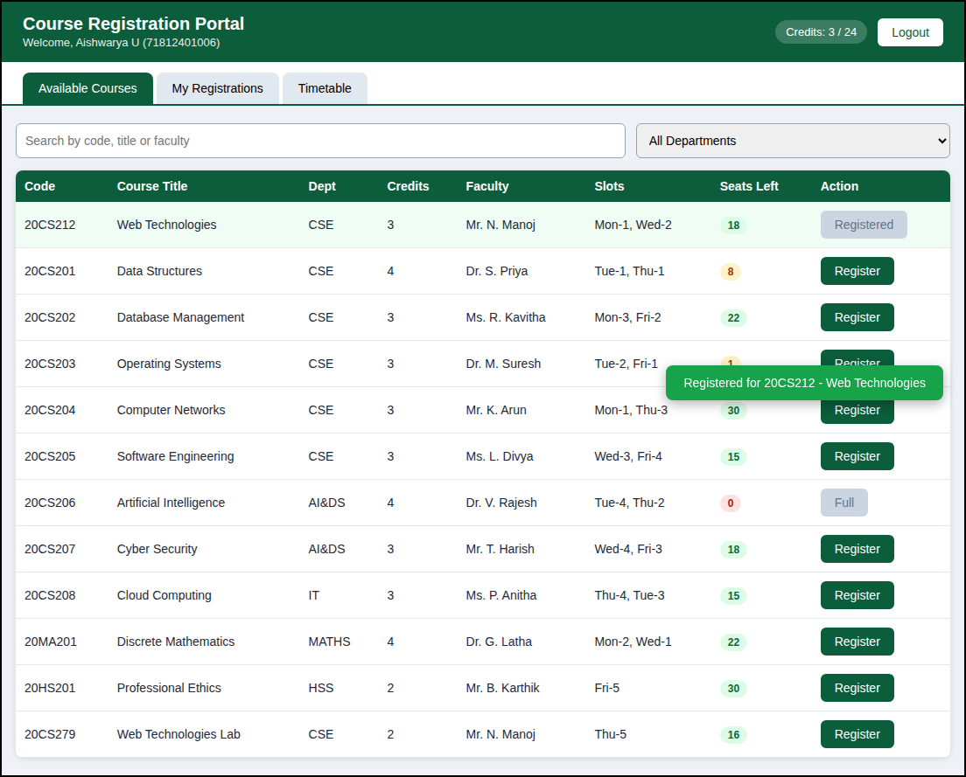
Fig. 7 - Registering 20CS212 shows a green message and the button changes to Registered.
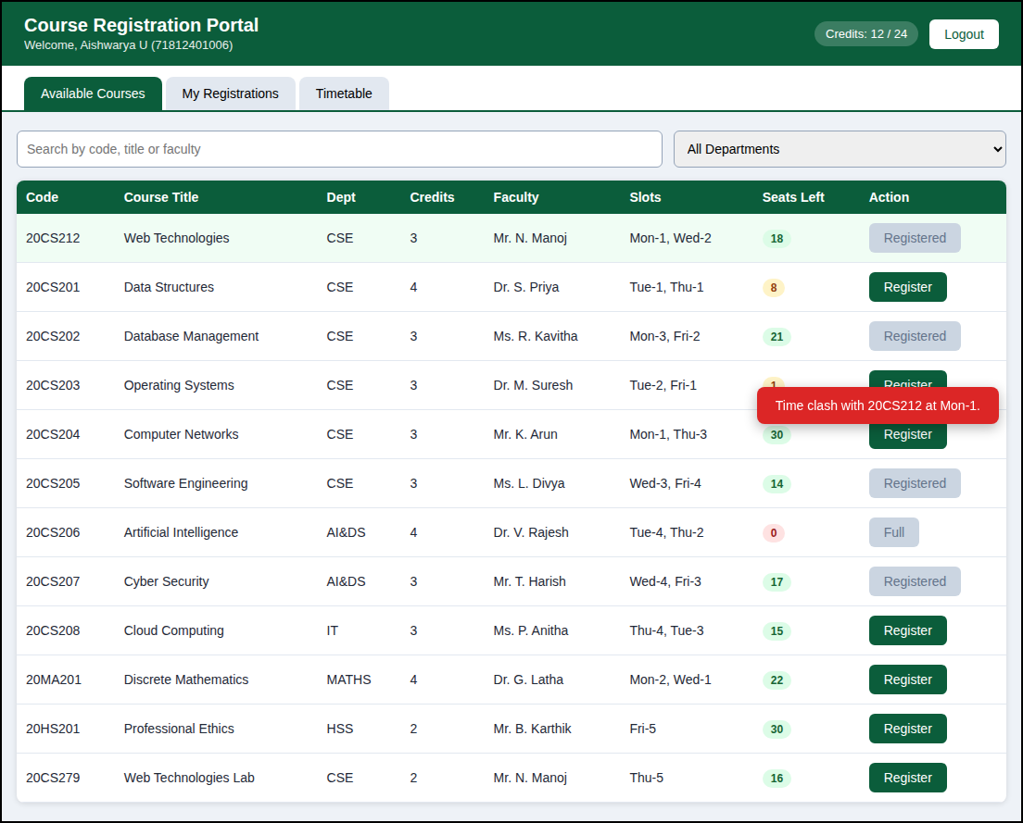
Fig. 8 - Registering 20CS204 is rejected because it clashes with 20CS212 at Mon-1.
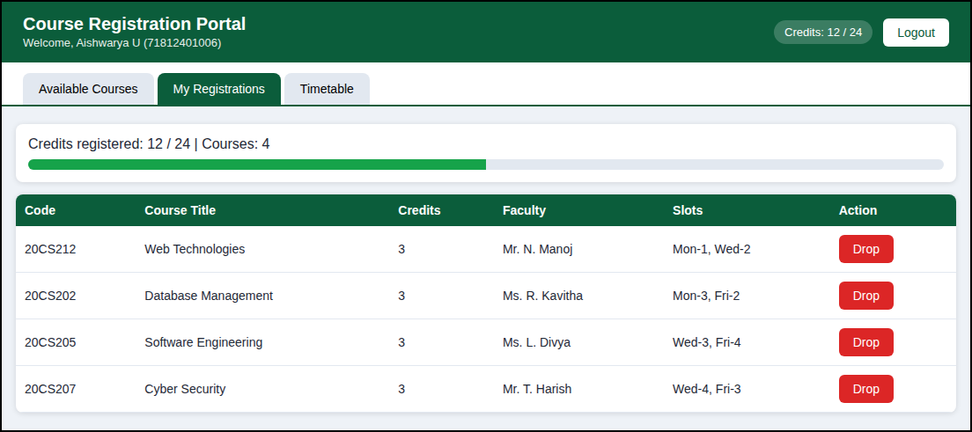
Fig. 9 - Four registered courses, 12 of 24 credits and a Drop button for each course.
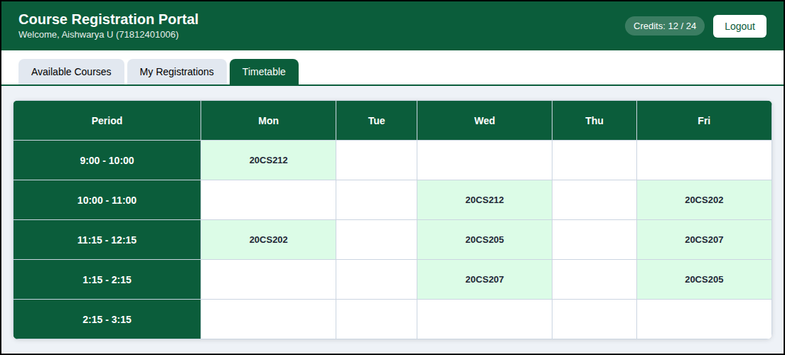
Fig. 10 - Weekly timetable with the slots of the registered courses highlighted.
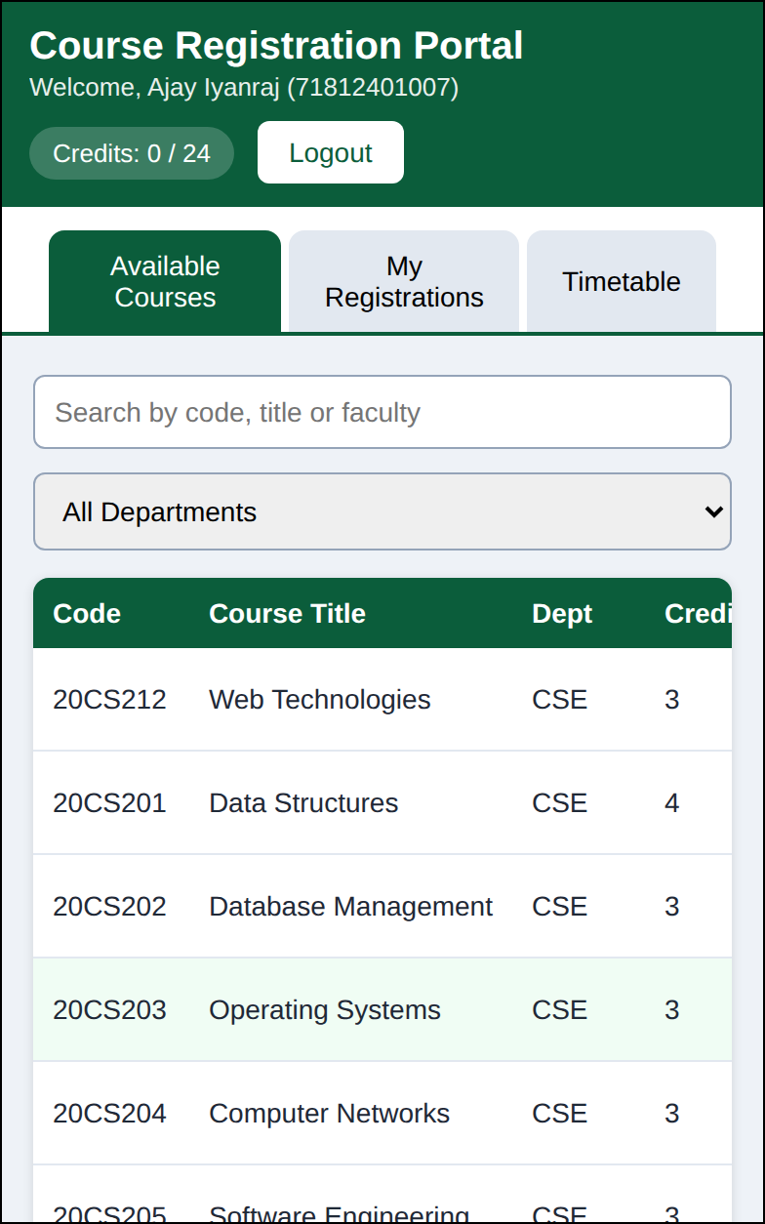
Fig. 11 - The portal on a 390 px wide phone screen.
5. CONCLUSION
The Student Course Registration System was designed and implemented with HTML5, CSS3 and JavaScript. It allows a student to log in, search and filter the courses, register and drop courses and view the credits and the timetable. The rules for seat availability, credit limit and time clash are applied automatically, which removes the manual work and the mistakes of the paper based process. The test cases and the screenshots show that the application works correctly on desktop and mobile screens.
Learning outcomes
• Built a multi-view single page application using only HTML, CSS and JavaScript.
• Applied array methods (filter, find, reduce, map) to search and process the course data.
• Used localStorage to keep data in the browser and events to make the page interactive.
Future enhancements
• Connect the application to a server and a database (Node.js / MySQL) for real data storage.
• Add an administrator login to create courses, change seats and approve registrations.
• Send the registration confirmation by email and allow the timetable to be downloaded as a PDF.
• Add prerequisites, elective groups and a waiting list for full courses.
References
S. No. | Reference
1 | MDN Web Docs - HTML, CSS and JavaScript reference (developer.mozilla.org)
2 | MDN Web Docs - Window.localStorage and Web Storage API
3 | W3Schools - JavaScript array methods and CSS grid tutorials

