DEPARTMENT OF COMPUTER SCIENCE AND ENGINEERING

ALM

TEMPERATURE MONITORING SYSTEM USING LPC2148

AJAY IYANRAJ (71812401007)
AKASHVARMAN R (71812401008)
AKHILESH RAJ P (71812401009)
AKSHAY KRISHNA S M (71812401010)
AKSHAYA KEERTHI S (71812401011)

THIRD YEAR B.E. CSE – V SEM
Academic Year 2026-2027

20EC252 & MICROCONTROLLER AND PROGRAMMING

COURSE COORDINATOR
Mrs.M.Amuthasurabi,AP/CSE
DEPARTMENT OF COMPUTER SCIENCE AND ENGINEERING

20EC252 & MICROCONTROLLER AND PROGRAMMING LABORATORY
TEMPERATURE MONITORING SYSTEM USING LPC2148

Assessment

INDEX

S.  No. | Name & Roll No. | Introduction (2) | Logic Building (2) | Implementation Steps (4) | Report (2) | Total  (10)
1. | AJAY IYANRAJ  71812401007
2. | AKASHVARMAN R  71812401008
3. | AKHILESH RAJ P  71812401009
4. | AKSHAY KRISHNA S M  71812401010
5. | AKSHAYA KEERTHI S  71812401011

SIGNATURE OF COURSE COORDINATOR Mrs.M.Amuthasurabi,AP/CSE

CONTENTS

S. No. | TITLE | PAGE  NUMBER
 | TEMPERATURE MONITORING SYSTEM USING LPC2148 | 4
 | INTRODUCTION | 5
 | WORKFLOW DESCRIPTION | 7
 | IMPLEMENTATION STEPS | 9
 | CODE IMPLEMENTATION | 11
 | OUTPUT | 14
 | DIAGRAMMATIC REPRESENTATION | 18
 | CONCLUSION | 20

TEMPERATURE MONITORING SYSTEM USING LPC2148
Abstract
Temperature is one of the most commonly monitored physical quantities in industries, laboratories, server rooms, greenhouses and homes. This project designs a digital temperature monitoring system around the LPC2148 ARM7TDMI-S microcontroller. An LM35 precision temperature sensor produces an analog voltage of 10 mV for every degree Celsius. This voltage is applied to the on-chip 10-bit Analog to Digital Converter (ADC0, channel AD0.1 on pin P0.28) of the LPC2148, which converts it into a digital number between 0 and 1023. The program converts the number into degrees Celsius, shows it on a 16 x 2 LCD, sends it to a PC through UART0, and switches a fan, a buzzer and an alarm LED when the temperature crosses the limit of 40 °C. The report explains in detail how the ADC of the LPC2148 is configured and used to read the sensor value.
Working in brief
The LM35 output voltage is connected to the analog input AD0.1 (P0.28). The ADC of the LPC2148 converts it into a number from 0 to 1023 in about 3 µs. The program averages eight conversions, calculates the temperature, shows it on the LCD and the serial terminal, and drives the fan, the buzzer and the alarm LED when the temperature reaches 40 °C. The fan is switched off again at 38 °C so that it does not switch on and off continuously.
Key formulas
Quantity | Formula
Input voltage | Vin = ADC x 3.3 / 1023
Temperature | T (°C) = Vin / 0.010 = ADC x 330 / 1023
ADC result | AD0DR1 bits 15:6 = (Vin / VREF) x 1023

Objectives
• To study the architecture and the on-chip ADC of the LPC2148 microcontroller.
• To interface the LM35 analog temperature sensor with the ADC channel AD0.1 (P0.28).
• To convert the digital ADC result into the temperature in degrees Celsius and display it on an LCD and a serial terminal.
• To switch a fan, a buzzer and an alarm LED automatically when the temperature exceeds the set limit.
Hardware and software used
Component / Tool | Specification | Purpose
LPC2148 development board | ARM7TDMI-S, 512 KB flash, 12 MHz crystal | Main controller with on-chip ADC
LM35 sensor | 10 mV / °C, 4 V to 30 V supply | Converts temperature into voltage
16 x 2 LCD (JHD162A) | HD44780 controller, 4-bit mode | Shows temperature and status
Relay + DC fan, buzzer, LED | 5 V relay, 5 V buzzer, 330 Ω resistor | Cooling and alarm outputs
Keil uVision, Flash Magic | ARM compiler and ISP programmer | Writing, building and loading the code
Serial terminal / HTML simulator | 9600 baud, 8N1 | Viewing the output

1. INTRODUCTION
1.1 Background
Many systems must run within a safe temperature range. A server room that becomes too hot damages the equipment, a cold storage that becomes warm spoils the food, and an overheated motor may burn. A temperature monitoring system measures the temperature continuously, shows it to the user and takes an action, such as switching on a fan, when the temperature is high. A microcontroller based system is small, cheap and accurate, and it can also send the readings to a computer.
1.2 Problem statement
Design a temperature monitoring system using LPC2148. Explain how the ADC (Analog to Digital Converter) of LPC2148 can be used to read the temperature sensor value.
1.3 LPC2148 microcontroller
The LPC2148 is a 16/32-bit ARM7TDMI-S based microcontroller from NXP (Philips) with real-time emulation and embedded trace support. It is widely used in embedded system laboratories because it contains many peripherals on a single chip.
Feature | Details
CPU | 16/32-bit ARM7TDMI-S, up to 60 MHz using the on-chip PLL
Memory | 512 KB on-chip flash, 32 KB static RAM + 8 KB USB RAM
ADC | Two 10-bit ADCs: ADC0 with 6 channels and ADC1 with 8 channels
DAC | One 10-bit digital to analog converter (AOUT on P0.25)
Serial | Two UARTs, two I2C, SPI, SSP, USB 2.0 full speed device
Timers | Two 32-bit timers, PWM unit, real time clock, watchdog timer
I/O | Up to 45 general purpose I/O pins, 5 V tolerant digital pins
Supply | 3.3 V (core 1.8 V from an internal regulator)

1.4 ADC of the LPC2148
The ADC of the LPC2148 is a successive approximation converter. It has a 10-bit resolution, so the input voltage from 0 V to VREF is divided into 1024 steps. The important features of ADC0 are given below.
Parameter | Value for ADC0
Resolution | 10 bit (0 to 1023 counts)
Input channels | AD0.1, AD0.2, AD0.3, AD0.4, AD0.6 and AD0.7 (pins P0.28, P0.29, P0.30, P0.25, P0.4, P0.5)
Reference voltage | VREF = 3.3 V (VDDA); input range 0 V to 3.3 V
Maximum ADC clock | 4.5 MHz (obtained from PCLK using the CLKDIV field of AD0CR)
Conversion time | 11 clock cycles for 10 bits = 2.44 µs at 4.5 MHz
Conversion modes | Software controlled (one channel) and burst mode (several channels repeatedly)
Start options | Software start, external pin edge or timer match
Result registers | AD0DR0 to AD0DR7 for each channel and AD0GDR global data register

1.5 LM35 temperature sensor
Parameter | Value
Type | Precision integrated-circuit temperature sensor (analog output)
Scale factor | +10.0 mV per °C (linear)
Temperature range | 0 °C to 100 °C (LM35D) / -55 °C to 150 °C (LM35)
Accuracy | ±0.5 °C at 25 °C
Supply voltage | 4 V to 30 V (5 V used in this project)
Output at 25 °C | 250 mV
Pins | +Vs, Vout, GND (TO-92 package)

1.6 Why the ADC is needed
The LM35 gives an analog voltage but the processor of the LPC2148 can process only digital numbers. The ADC bridges the gap: it samples the sensor voltage and converts it into a 10-bit number which the program can calculate, compare, display and transmit. Without the ADC the microcontroller could not measure the temperature.
1.7 Comparison of temperature sensors
Sensor | Output | Range | Advantage | Disadvantage
LM35 | Analog, 10 mV / °C | -55 to 150 °C | Linear, no calibration | Needs an ADC
Thermistor (NTC) | Resistance | -40 to 125 °C | Very cheap | Non-linear
DS18B20 | Digital (1-Wire) | -55 to 125 °C | No ADC needed | Slower, needs a library
Thermocouple (K) | Millivolts | -200 to 1350 °C | Very wide range | Needs an amplifier

1.8 Applications
• Server rooms and electrical panels - automatic fan control to avoid overheating.
• Cold storage, incubators and greenhouses - continuous temperature display and alarm.
• Industrial motors and transformers - warning before the temperature becomes dangerous.
• Home appliances such as water heaters and room coolers.
1.9 Design specifications
Parameter | Specification
Measuring range | 0 °C to 100 °C (Vout = 0 V to 1.0 V)
Resolution | 0.32 °C per ADC count
Sampling | 8 conversions averaged, one reading every 0.5 s
Alarm limit | 40 °C ON, 38 °C OFF (hysteresis 2 °C)
Display | 16 x 2 LCD and UART0 at 9600 baud
Supply | 5 V for LM35, LCD and relay; 3.3 V for LPC2148

2. WORKFLOW DESCRIPTION
2.1 Overall working of the system
Step 1: Sensing: The LM35 senses the surrounding temperature and gives an output voltage Vout = 10 mV x T (in °C).
Step 2: Analog input: Vout is connected to the pin P0.28 which is configured as the analog input AD0.1 of ADC0.
Step 3: Conversion: The software starts a conversion; the ADC samples Vout and the successive approximation logic produces a 10-bit result in AD0DR1.
Step 4: Reading: The program waits until the DONE bit (bit 31) of AD0DR1 becomes 1 and then reads bits 15:6 as the ADC value.
Step 5: Calculation: Eight conversions are averaged to reduce noise and the temperature is calculated as T = ADC x 330 / 1023.
Step 6: Display: The temperature and the ADC value are displayed on the 16 x 2 LCD and sent to the PC through UART0.
Step 7: Control: If T is 40 °C or more, the fan, the buzzer and the alarm LED are switched ON; they are switched OFF when T falls to 38 °C or less.
Step 8: Repeat: The program waits for 500 ms and repeats the cycle for ever.
2.2 Working principle of the successive approximation ADC
The ADC compares the sampled input voltage with a voltage produced by an internal 10-bit digital to analog converter. Starting from the most significant bit, each bit is set to 1 and kept only if the DAC voltage is still not greater than the input. After 10 comparisons the bits that were kept form the digital result. The result is proportional to the input: ADC value = (Vin / VREF) x 1023.
2.3 Conversion formulas
Quantity | Formula | Example (ADC = 140)
Input voltage | Vin = ADC x VREF / 1023 | 140 x 3.3 / 1023 = 0.4516 V
Temperature | T = Vin / 0.010 = ADC x 330 / 1023 | 140 x 330 / 1023 = 45.2 °C
Resolution (1 count) | VREF / 1023 = 3.226 mV | 3.226 mV / 10 mV per °C = 0.32 °C
ADC value from voltage | ADC = Vin x 1023 / VREF | 0.450 V x 1023 / 3.3 = 139.5 = 140
ADC clock | PCLK / (CLKDIV + 1) | 15 MHz / 4 = 3.75 MHz (below 4.5 MHz)
Conversion time | 11 / ADC clock | 11 / 3.75 MHz = 2.93 µs

2.4 ADC control register AD0CR (0x01200302 is used)
Bits | Field | Value used | Meaning
7:0 | SEL | 0000 0010 | Selects channel AD0.1 (bit 1 = 1)
15:8 | CLKDIV | 0000 0011 | ADC clock = PCLK / (3 + 1) = 3.75 MHz
16 | BURST | 0 | Software controlled conversion (no burst)
19:17 | CLKS | 000 | 11 clocks, 10 bit accuracy
21 | PDN | 1 | ADC is operational (not in power-down)
26:24 | START | 001 | Start the conversion now
27 | EDGE | 0 | Not used (only for pin / timer start)

2.5 ADC data register AD0DR1
Bits | Field | Meaning
5:0 | - | Reserved
15:6 | V/VREF | 10-bit result: (Vin / VREF) x 1023 (stored in the upper bits)
26:24 | CHN | Channel number from which the result was converted (001 = AD0.1)
30 | OVERRUN | Set when a result is lost in burst mode
31 | DONE | Set to 1 when the conversion is complete; cleared when AD0DR1 is read

2.6 Pin connections
Signal | LPC2148 pin | Connected to
Sensor output | P0.28 (AD0.1) | Vout of LM35
LCD data D4 - D7 | P1.16 - P1.19 | LCD pins 11 - 14
LCD RS, EN | P0.10, P0.11 | LCD pins 4 and 6 (RW and VSS to GND)
Fan relay | P0.8 | Relay driver and DC fan
Buzzer | P0.7 | Buzzer through BC547 transistor
Alarm LED | P0.9 | LED with 330 Ω resistor
UART0 TXD0 / RXD0 | P0.0 / P0.1 | USB to serial converter (PC)

2.7 Fan, buzzer and LED control (with hysteresis)
Temperature (T) | Previous state | New state | Reason
T >= 40 °C | OFF or ON | ON | Temperature is at or above the limit
38 °C < T < 40 °C | OFF | OFF | Not yet at the limit
38 °C < T < 40 °C | ON | ON | Hysteresis: stays ON to avoid rapid switching
T <= 38 °C | ON or OFF | OFF | Temperature has fallen enough

3. IMPLEMENTATION STEPS
3.1 Steps followed
Step 1: Understand the sensor: LM35 gives 10 mV per °C; the maximum temperature to be measured is 100 °C = 1.0 V, well below VREF (3.3 V).
Step 2: Make the connections: connect Vout of LM35 to P0.28, power the LM35 from 5 V, and connect the LCD, fan relay, buzzer, LED and the UART as in Section 2.6.
Step 3: Set the clock: configure the PLL to get CCLK = 60 MHz from the 12 MHz crystal and keep VPBDIV = 0 so that PCLK = 15 MHz.
Step 4: Select the pin function: write PINSEL1 |= (1 << 24) so that P0.28 works as the analog input AD0.1.
Step 5: Configure the ADC: write AD0CR with SEL = 0x02, CLKDIV = 3, PDN = 1 and START = 1; the ADC clock is 3.75 MHz.
Step 6: Read the result: poll bit 31 (DONE) of AD0DR1 and take bits 15:6 as the 10-bit digital value.
Step 7: Reduce noise: take 8 conversions and use their average.
Step 8: Convert to temperature: temperature = ADC value x 330 / 1023 degrees Celsius.
Step 9: Show and send the result: display on the 16 x 2 LCD in 4-bit mode and transmit the same line through UART0 at 9600 baud.
Step 10: Control the outputs: switch ON the fan, buzzer and LED at 40 °C and switch OFF at 38 °C (2 °C hysteresis).
Step 11: Compile and load: build main.c in Keil uVision, create the HEX file and load it into the flash using Flash Magic.
Step 12: Test: heat and cool the sensor, compare the readings with a reference thermometer and verify the alarm action.
3.2 Important register settings
Register | Value | Purpose
PLL0CFG | 0x24 | M = 5, P = 2: 12 MHz x 5 = 60 MHz CCLK
VPBDIV | 0x00 | PCLK = CCLK / 4 = 15 MHz
PINSEL1 | 0x01000000 | P0.28 selected as AD0.1
AD0CR | 0x01200302 | Channel 1, 3.75 MHz clock, ADC ON, start conversion
IO0DIR | (1<<7) | (1<<8) | (1<<9) | (1<<10) | (1<<11) | Buzzer, fan, LED, LCD RS and EN as outputs
IO1DIR | 0x000F0000 | P1.16 - P1.19 as LCD data lines
U0LCR / U0DLL | 0x83 / 98 | 8N1 and 9600 baud from PCLK = 15 MHz

3.3 Expected ADC readings of the LM35
Temp (°C) | LM35 (mV) | Vin (V) | ADC (dec) | ADC (hex) | ADC (binary)
0 | 0 | 0.000 | 0 | 0x000 | 0000000000
10 | 100 | 0.100 | 31 | 0x01F | 0000011111
25 | 250 | 0.250 | 78 | 0x04E | 0001001110
30 | 300 | 0.300 | 93 | 0x05D | 0001011101
40 | 400 | 0.400 | 124 | 0x07C | 0001111100
50 | 500 | 0.500 | 155 | 0x09B | 0010011011
75 | 750 | 0.750 | 233 | 0x0E9 | 0011101001
100 | 1000 | 1.000 | 310 | 0x136 | 0100110110

3.4 Calibration and testing
Reference thermometer (°C) | ADC value | Displayed (°C) | Error (°C) | Fan
25.0 | 78 | 25.2 | +0.2 | OFF
30.0 | 93 | 30.0 | 0.0 | OFF
35.0 | 109 | 35.2 | +0.2 | OFF
40.0 | 124 | 40.0 | 0.0 | ON
45.0 | 140 | 45.2 | +0.2 | ON

3.5 Precautions
• Keep the analog input below VREF (3.3 V); the LM35 output is only 1.0 V at 100 °C.
• Use a stable 3.3 V for VREF / VDDA and connect VSSA to the common ground.
• Keep the sensor wires short or use a shielded cable, and add a 0.1 µF capacitor near the ADC pin.
• Do not exceed the ADC clock of 4.5 MHz; use CLKDIV = 3 with PCLK = 15 MHz.
3.6 Troubleshooting
Problem | Possible cause | Remedy
ADC value always 0 | P0.28 not set as AD0.1 | Set bit 24 of PINSEL1
Reading does not change | PDN bit not set / conversion not started | Use AD0CR = 0x01200302
Temperature fluctuates | Electrical noise | Average 8 samples; add capacitor
LCD shows garbage | Wrong 4-bit initialisation | Send 0x02 then 0x28 with proper delays

3.7 Timing of one measurement cycle
• One ADC conversion takes 11 clocks at 3.75 MHz = 2.93 µs; eight conversions for averaging take about 23.5 µs.
• Updating the LCD takes about 0.1 s and sending one 38-character line at 9600 baud takes about 40 ms.
• With the 500 ms delay, the temperature is measured and displayed about every 0.65 s.
4. CODE IMPLEMENTATION
The embedded C program (main.c) is written for the Keil uVision compiler using the header file lpc214x.h. It contains the functions for the PLL, the UART, the LCD and the ADC, followed by the main loop.
Program: main.c
/* Temperature Monitoring System using LPC2148 (ADC0 channel 1, LM35 on P0.28)
Display : 16x2 LCD (4-bit) D4-D7 = P1.16-P1.19, RS = P0.10, EN = P0.11
Outputs : FAN relay = P0.8, BUZZER = P0.7, ALARM LED = P0.9
Serial : UART0 9600 baud, 8N1 (P0.0 = TXD0, P0.1 = RXD0)
Clock : Fosc = 12 MHz, CCLK = 60 MHz, PCLK = 15 MHz */

#include <lpc214x.h>
#include <stdio.h>

#define LCD_DATA (0x0Fu << 16) /* P1.16 - P1.19 -> D4 - D7 */
#define LCD_RS (1u << 10) /* P0.10 */
#define LCD_EN (1u << 11) /* P0.11 */
#define BUZZER (1u << 7) /* P0.7 */
#define FAN (1u << 8) /* P0.8 */
#define ALARM_LED (1u << 9) /* P0.9 */

#define TEMP_LIMIT 40.0f /* fan ON at or above 40 deg C */
#define HYSTERESIS 2.0f /* fan OFF at or below 38 deg C */
#define SAMPLES 8 /* conversions averaged per reading */

/* ---------------- delay ---------------- */
void delay_ms(unsigned int ms)
{
unsigned int i, j;
for (i = 0; i < ms; i++)
for (j = 0; j < 6000; j++); /* about 1 ms at CCLK = 60 MHz */
}

/* ---------------- PLL : 12 MHz -> 60 MHz ---------------- */
void pll_init(void)
{
PLL0CFG = 0x24; /* M = 5, P = 2 */
PLL0CON = 0x01; PLL0FEED = 0xAA; PLL0FEED = 0x55;
while (!(PLL0STAT & (1 << 10))); /* wait for PLL lock */
PLL0CON = 0x03; PLL0FEED = 0xAA; PLL0FEED = 0x55; /* enable + connect */
VPBDIV = 0x00; /* PCLK = CCLK / 4 = 15 MHz */
}

/* ---------------- UART0 : 9600 baud ---------------- */
void uart0_init(void)
{
PINSEL0 |= 0x00000005; /* P0.0 = TXD0, P0.1 = RXD0 */
U0LCR = 0x83; /* 8 bits, no parity, 1 stop, DLAB=1*/
U0DLL = 98; U0DLM = 0; /* 15 MHz / (16 x 9600) = 97.6 */
U0LCR = 0x03; /* DLAB = 0 */
}

void uart0_puts(const char *s)
{
while (*s) {
while (!(U0LSR & 0x20)); /* wait until THR is empty */
U0THR = *s++;
}
}

/* ---------------- 16x2 LCD (4-bit mode) ---------------- */
void lcd_write_nibble(unsigned char n)
{
IO1CLR = LCD_DATA;
IO1SET = ((unsigned int)n & 0x0F) << 16;
IO0SET = LCD_EN; delay_ms(1); IO0CLR = LCD_EN;
}

void lcd_cmd(unsigned char c)
{
IO0CLR = LCD_RS;
lcd_write_nibble(c >> 4); lcd_write_nibble(c);
delay_ms(2);
}

void lcd_data(unsigned char d)
{
IO0SET = LCD_RS;
lcd_write_nibble(d >> 4); lcd_write_nibble(d);
delay_ms(2);
}

void lcd_puts(const char *s) { while (*s) lcd_data(*s++); }

void lcd_init(void)
{
IO0DIR |= LCD_RS | LCD_EN;
IO1DIR |= LCD_DATA;
delay_ms(20);
lcd_cmd(0x02); /* 4-bit mode */
lcd_cmd(0x28); /* 2 lines, 5x7 font */
lcd_cmd(0x0C); /* display ON, cursor OFF */
lcd_cmd(0x06); /* auto increment */
lcd_cmd(0x01); /* clear display */
}

/* ---------------- ADC0 channel 1 (AD0.1 on P0.28) ---------------- */
void adc_init(void)
{
PINSEL1 |= (1u << 24); /* P0.28 -> AD0.1 (bits 25:24 = 01) */
}

unsigned int adc_read(void)
{
unsigned int val;
/* SEL = channel 1, CLKDIV = 3 (15 MHz / 4 = 3.75 MHz), PDN = 1, START = 001 */
AD0CR = (1u << 1) | (3u << 8) | (1u << 21) | (1u << 24);
do { val = AD0DR1; } while (!(val & (1u << 31))); /* wait for DONE bit */
AD0CR &= ~(7u << 24); /* stop conversion */
return (val >> 6) & 0x3FF; /* 10-bit result in bits 15:6 */
}

unsigned int adc_average(void)
{
unsigned int i, sum = 0;
for (i = 0; i < SAMPLES; i++) sum += adc_read();
return sum / SAMPLES;
}

/* ---------------- main ---------------- */
int main(void)
{
unsigned int adc;
float temp;
char line[32];
unsigned char fan_on = 0;

pll_init();
IO0DIR |= BUZZER | FAN | ALARM_LED;
IO0CLR = BUZZER | FAN | ALARM_LED;
uart0_init();
lcd_init();
adc_init();

lcd_puts("LPC2148 TEMP MON");
uart0_puts("\r\nLPC2148 Temperature Monitoring System\r\n");
delay_ms(1500);

while (1)
{
adc = adc_average();
temp = (adc * 330.0f) / 1023.0f; /* 3.3 V x 100 deg C per volt */

if (temp >= TEMP_LIMIT) fan_on = 1;
else if (temp <= TEMP_LIMIT - HYSTERESIS) fan_on = 0;

if (fan_on) IO0SET = FAN | BUZZER | ALARM_LED;
else IO0CLR = FAN | BUZZER | ALARM_LED;

lcd_cmd(0x80); /* line 1 */
sprintf(line, "Temp: %4.1f %cC ", temp, 0xDF);
lcd_puts(line);
lcd_cmd(0xC0); /* line 2 */
if (fan_on) lcd_puts("ALERT! FAN ON ");
else { sprintf(line, "ADC:%03X FAN:OFF ", adc); lcd_puts(line); }

sprintf(line, "Temp: %4.1f C | ADC: 0x%03X | FAN %s\r\n", temp, adc, fan_on ? "ON" : "OFF");
uart0_puts(line);

delay_ms(500);
}
}

Explanation of the program
Function | Purpose
pll_init() | Multiplies the 12 MHz crystal to 60 MHz and sets PCLK to 15 MHz
uart0_init(), uart0_puts() | Sets 9600 baud, 8N1 on P0.0 / P0.1 and sends a string to the PC
lcd_init(), lcd_cmd(), lcd_data() | Initialises the HD44780 LCD in 4-bit mode and writes commands and characters
adc_init() | Selects AD0.1 on P0.28 by setting bits 25:24 of PINSEL1 to 01
adc_read() | Starts a conversion on channel 1, waits for the DONE bit and returns bits 15:6 of AD0DR1
adc_average() | Returns the average of 8 conversions to remove noise
main() | Reads the ADC, calculates the temperature, controls fan / buzzer / LED with hysteresis, updates the LCD and UART every 500 ms

How the ADC is used in the code
• Pin selection: PINSEL1 |= (1u << 24) connects P0.28 to the ADC instead of the GPIO.
• Start: AD0CR = (1<<1) | (3<<8) | (1<<21) | (1<<24) selects channel 1, sets the clock divider, powers the ADC and starts the conversion.
• Wait: the loop do { val = AD0DR1; } while (!(val & (1u << 31))) waits for the DONE flag.
• Result: (val >> 6) & 0x3FF extracts the 10-bit digital value from bits 15:6.
• Temperature: temp = (adc * 330.0f) / 1023.0f because 1 count = 3.3 V / 1023 and the LM35 gives 10 mV per degree.
Constants and variables used
Name | Value / type | Meaning
TEMP_LIMIT | 40.0f | Temperature at which the fan, buzzer and LED are switched ON
HYSTERESIS | 2.0f | They are switched OFF again at TEMP_LIMIT - HYSTERESIS = 38 °C
SAMPLES | 8 | Number of ADC conversions averaged for one reading
adc | unsigned int | 10-bit average ADC value (0 to 1023)
temp | float | Temperature in degrees Celsius = adc x 330 / 1023
fan_on | unsigned char | Flag that remembers the fan state for the hysteresis

5. OUTPUT
The outputs below are the Keil uVision4 screens of the program running in the simulator and debugger: the build output, the Registers, Call Stack + Locals, Watch and Memory windows, the A/D Converter 0 and Parallel Port 0 peripheral dialogs and the UART #1 serial window. The ambient temperature applied to the analog input AD0.1 was changed to 28 °C, 36 °C, 45 °C and 30 °C to check the ADC value, the temperature calculation and the fan, buzzer and LED control.
Output 1: Building the project in Keil uVision4
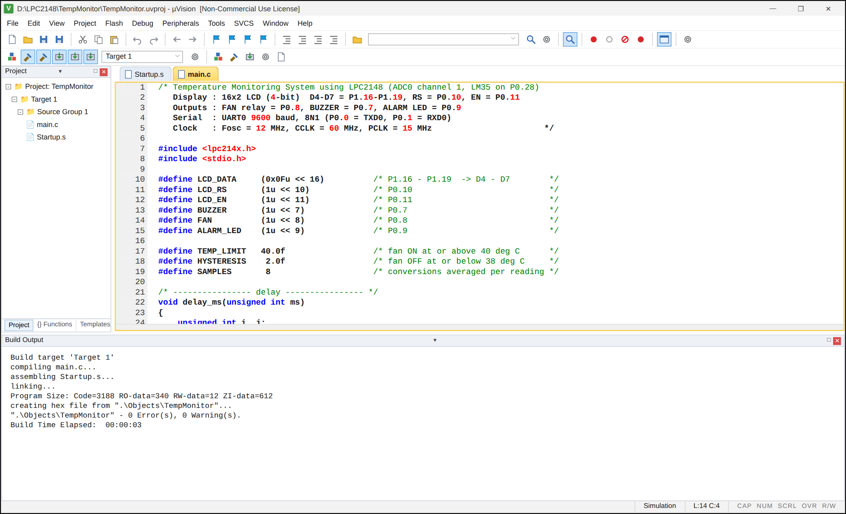
Fig. 1 - main.c is compiled and linked: 0 Error(s), 0 Warning(s); the HEX file is created.
Observation table
Actual temp (°C) | LM35 Vout (V) | ADC (dec) | ADC (hex) | Displayed temp (°C) | Fan / buzzer
25 | 0.250 | 78 | 0x04E | 25.2 | OFF
28 | 0.280 | 87 | 0x057 | 28.1 | OFF
30 | 0.300 | 93 | 0x05D | 30.0 | OFF
36 | 0.360 | 112 | 0x070 | 36.1 | OFF
39 | 0.390 | 121 | 0x079 | 39.0 | ON (hysteresis)
45 | 0.450 | 140 | 0x08C | 45.2 | ON

Output 2: Debugging main() at 28 °C
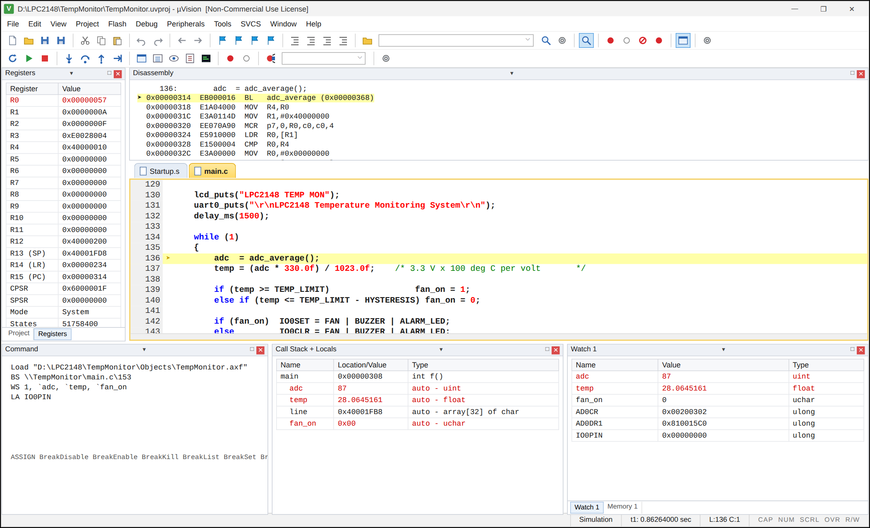
Fig. 2 - Execution stops in the main loop; Watch / Locals show adc = 87 (0x57) and temp = 28.0645 with fan_on = 0.
Output 3: A/D Converter 0 peripheral window (AD0.1 = 0.28 V)
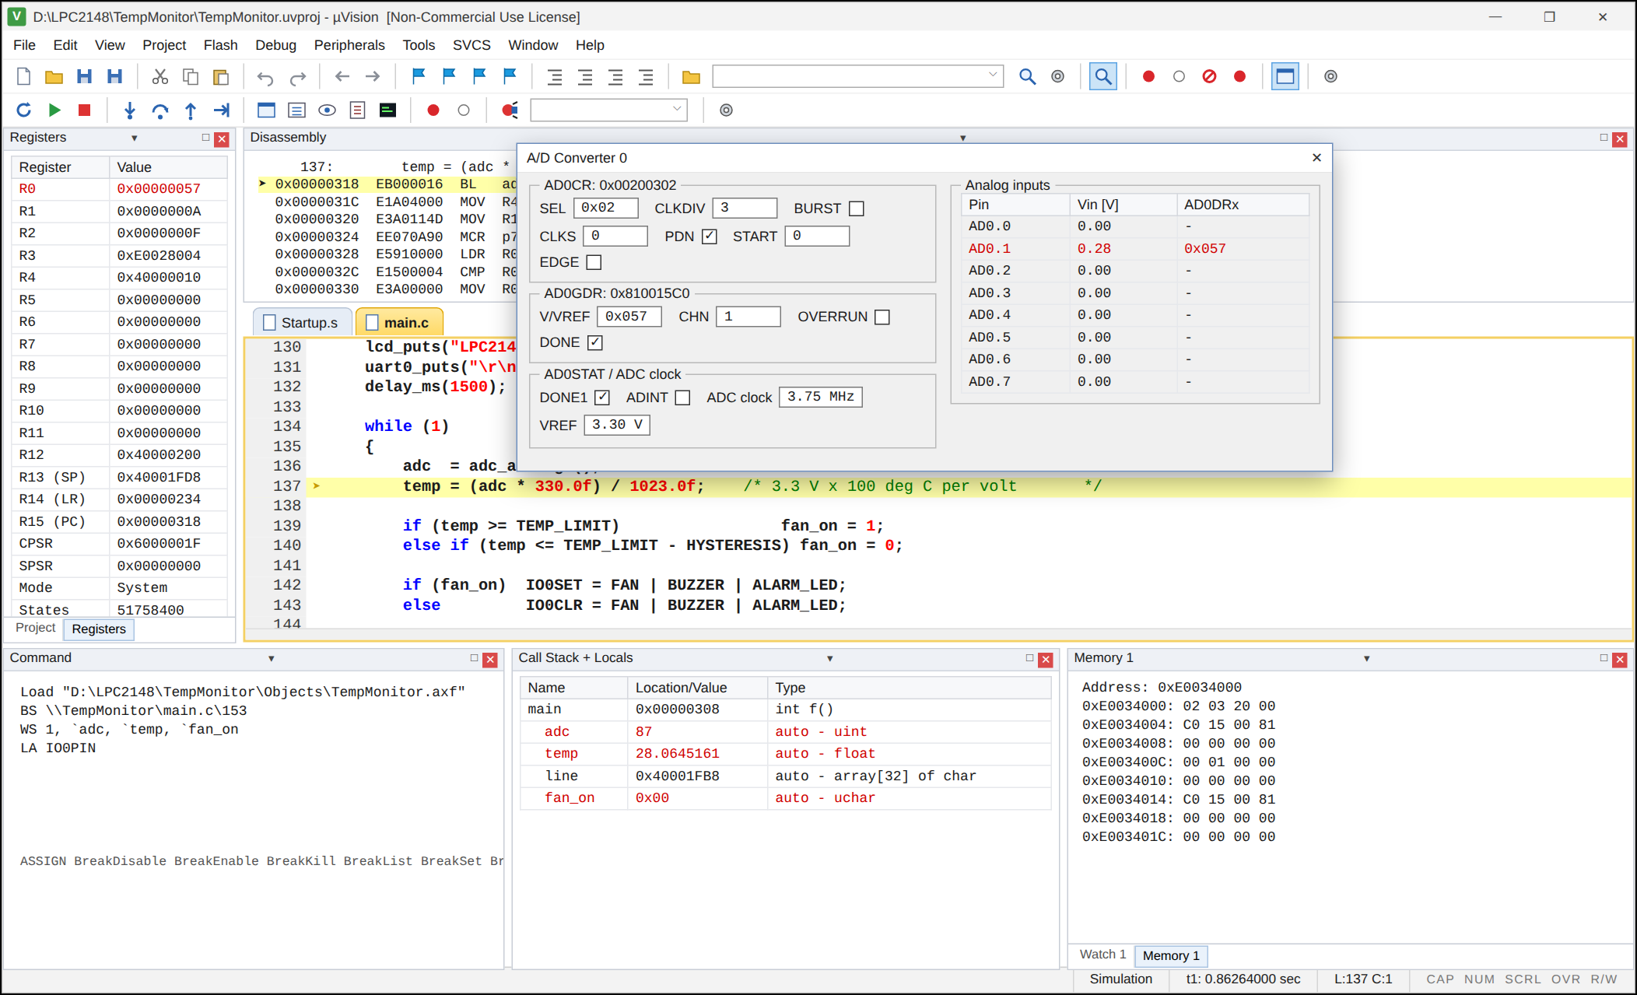
Fig. 3 - AD0CR = 0x00200302 (SEL = 0x02, CLKDIV = 3, PDN = 1); AD0GDR = 0x810015C0 with DONE = 1, CHN = 1 and result 0x057; the Memory window shows the same registers.
Output 4: UART #1 serial window while the temperature rises
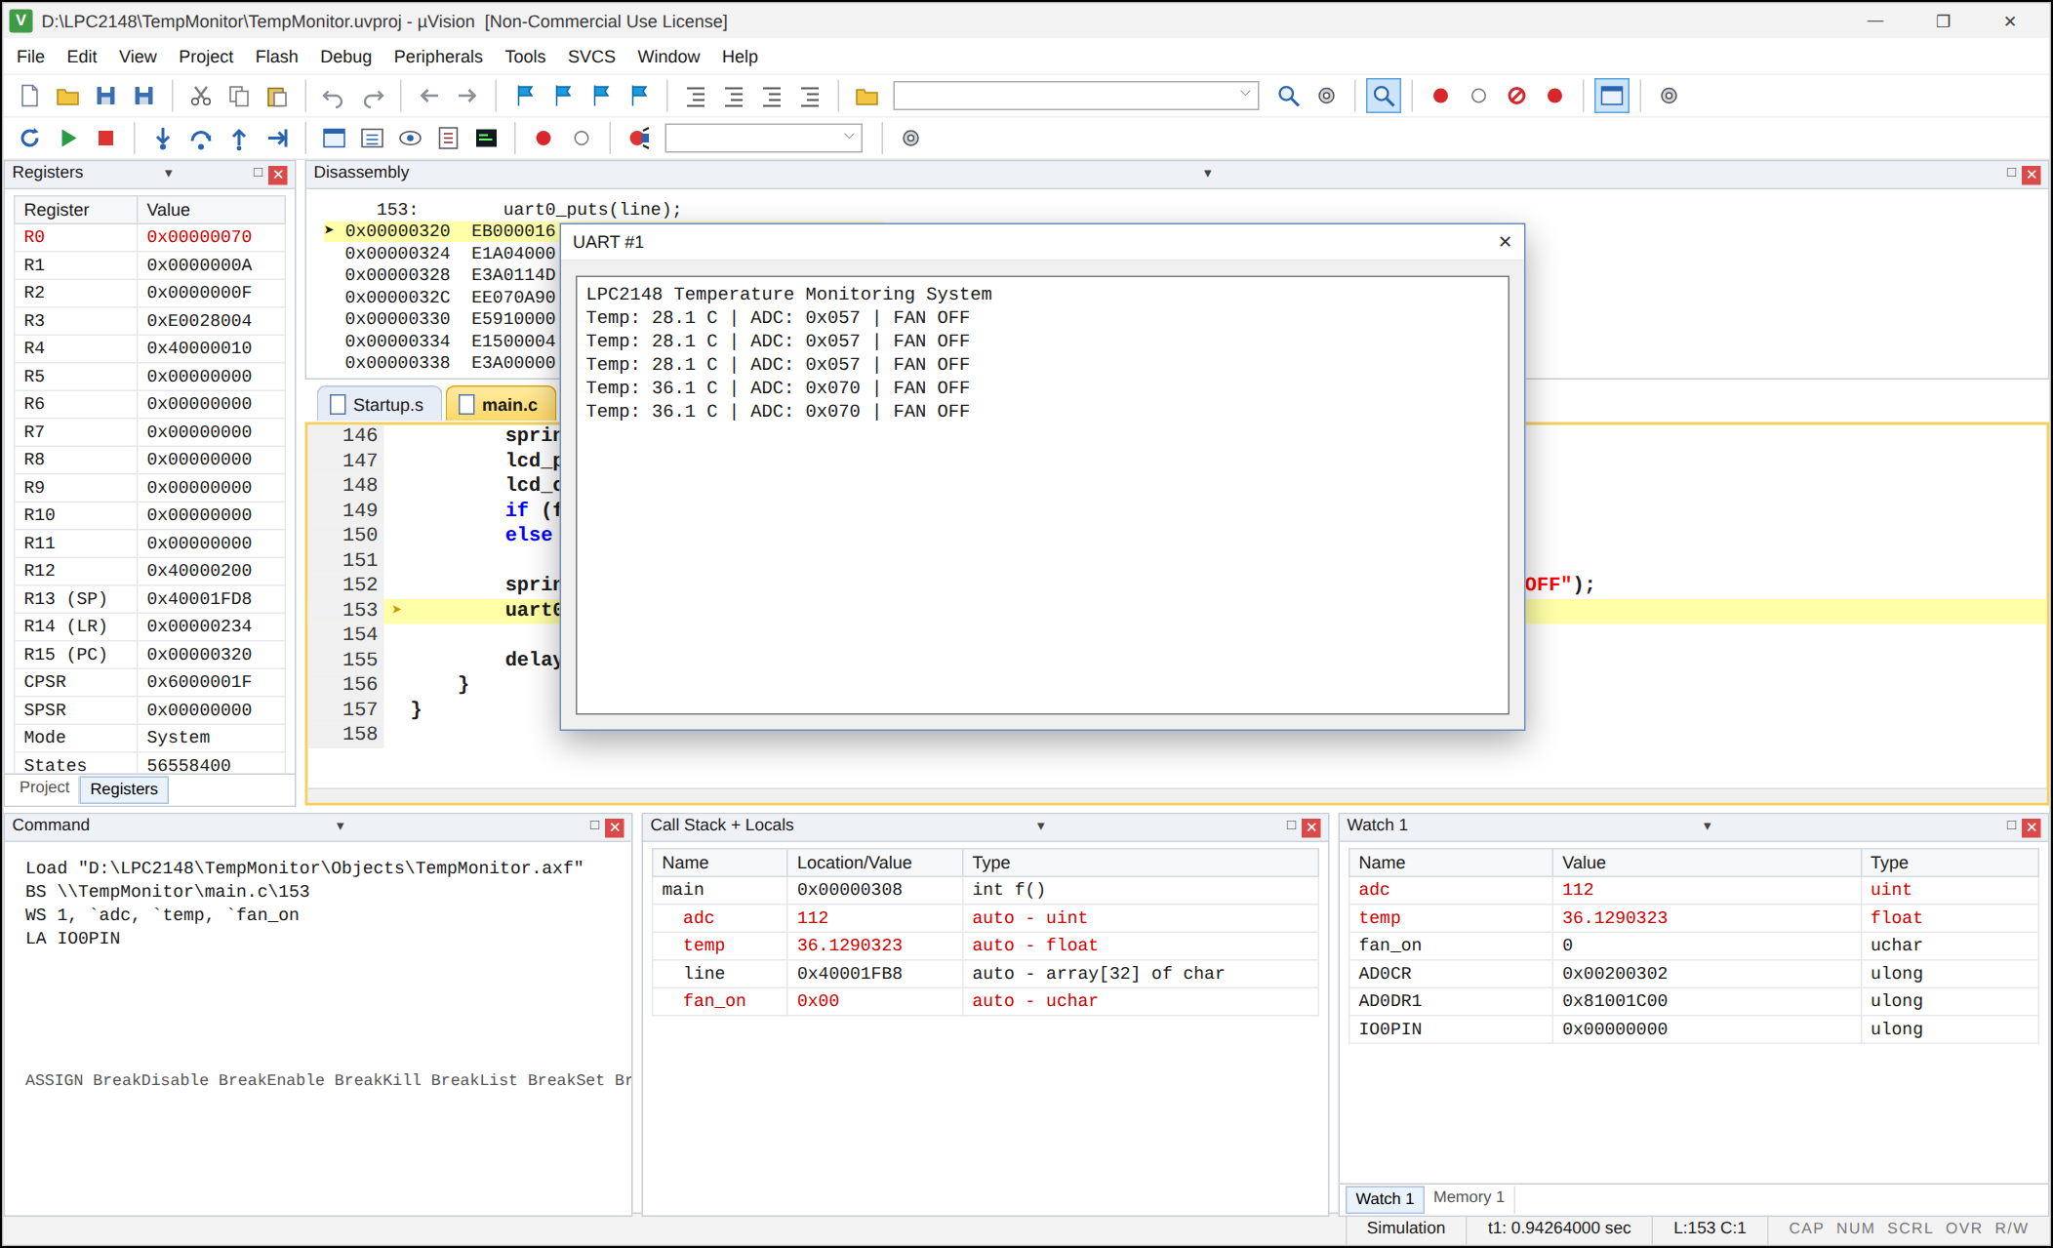
Fig. 4 - The program sends one line every cycle: Temp: 28.1 C ... 36.1 C with the ADC value and FAN OFF.
Output 5: Fan switched ON when the temperature reaches 40 °C
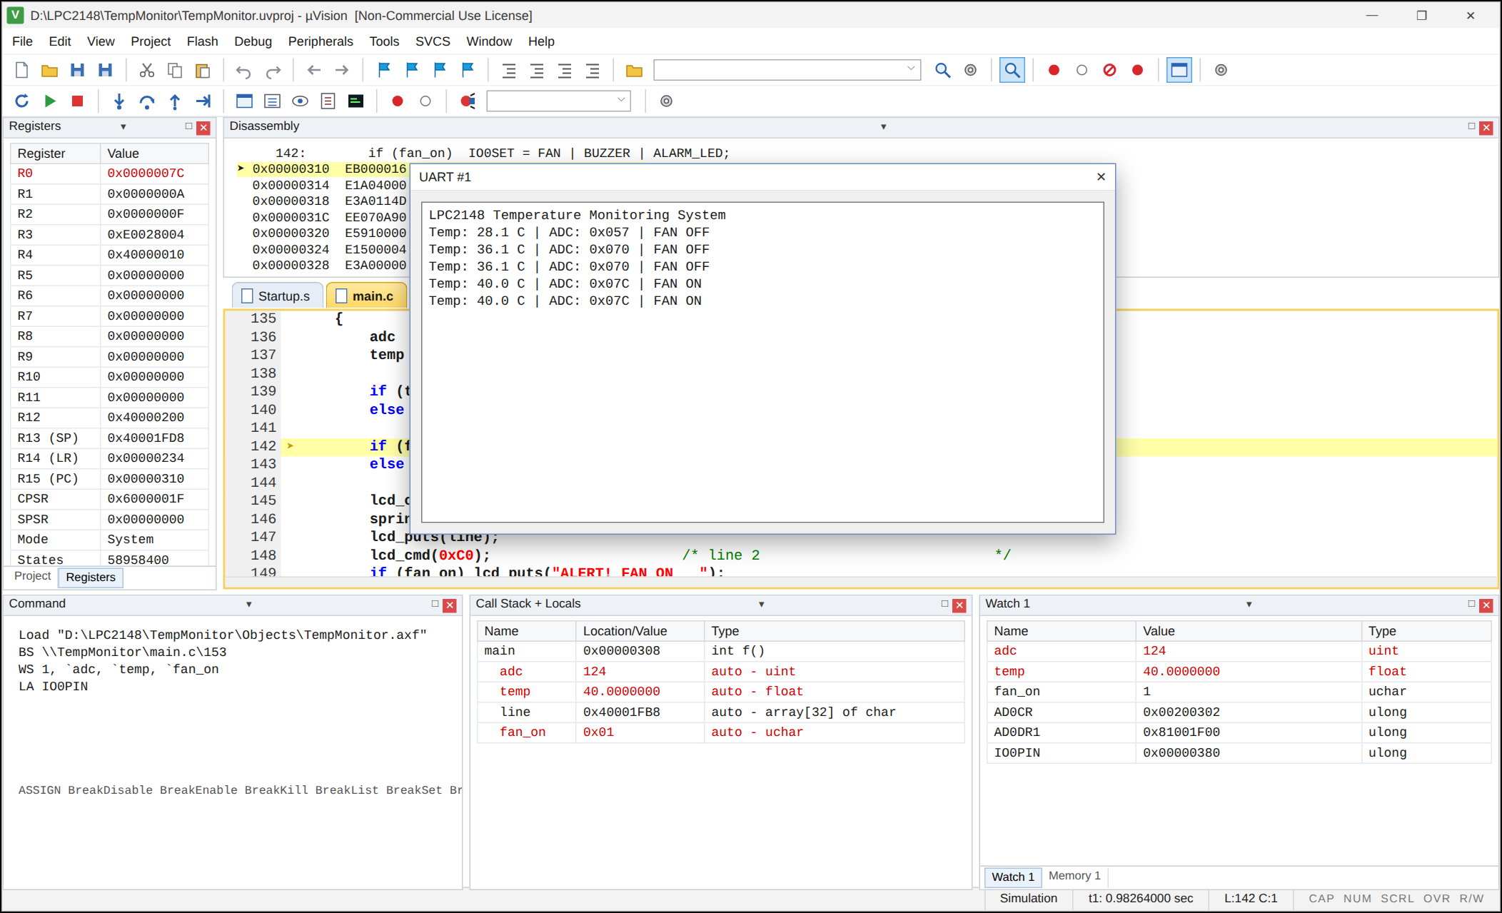
Fig. 5 - At 40.0 C (ADC = 0x07C) fan_on becomes 1 and the log shows FAN ON; the buzzer and LED are also driven.
Output 6: High temperature alarm at 45 °C
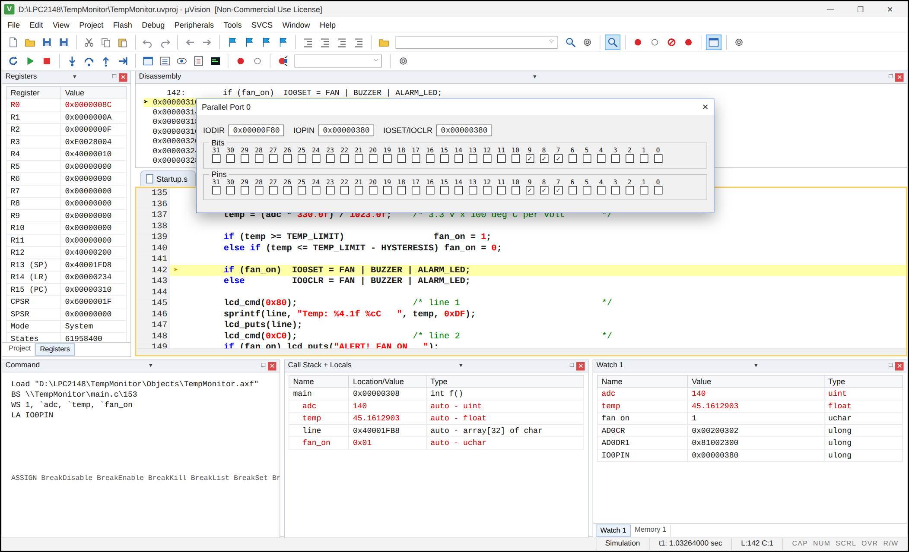
Fig. 6 - adc = 140 (0x8C), temp = 45.16, fan_on = 1; Parallel Port 0 shows P0.7, P0.8 and P0.9 set (IOPIN = 0x380): buzzer, fan relay and LED ON.
Output 7: Cooling down to 30 °C
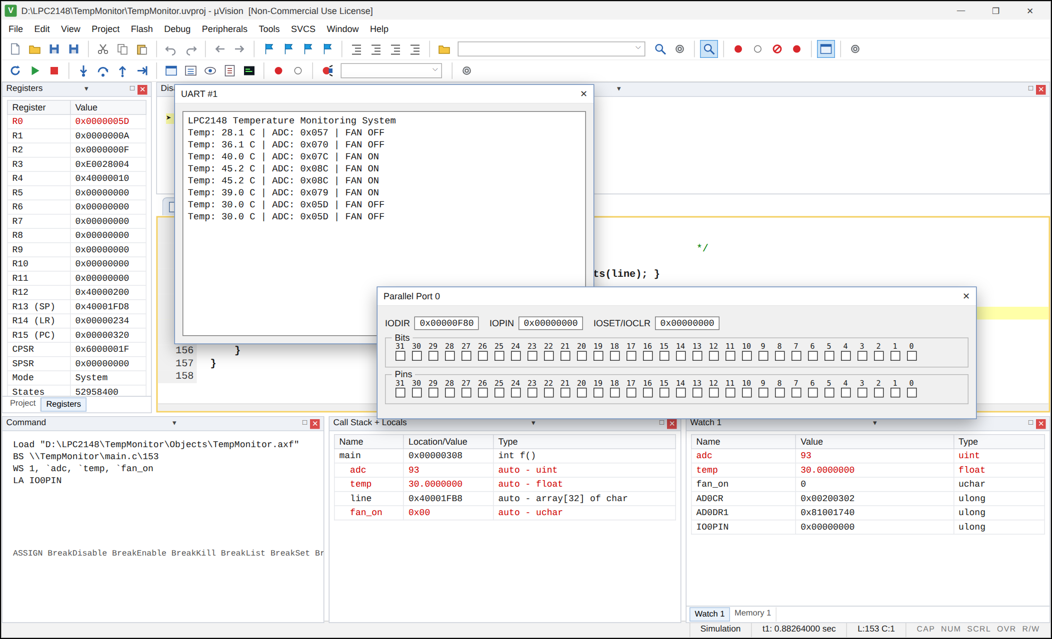
Fig. 7 - The log shows the hysteresis (39.0 C keeps the fan ON); at 30.0 C the fan is OFF and all Port 0 output bits are cleared.
6. DIAGRAMMATIC REPRESENTATION
6.1 Block diagram
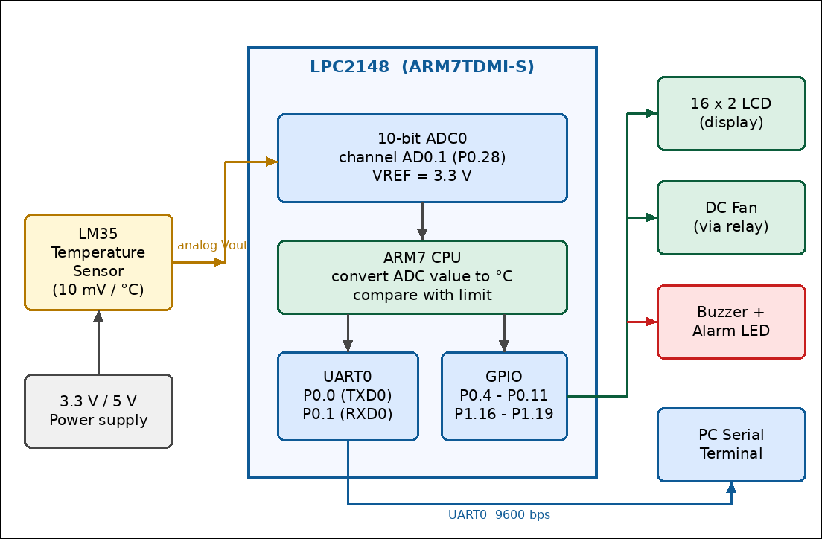
Fig. 10 - Block diagram of the temperature monitoring system.
6.2 Circuit connection diagram
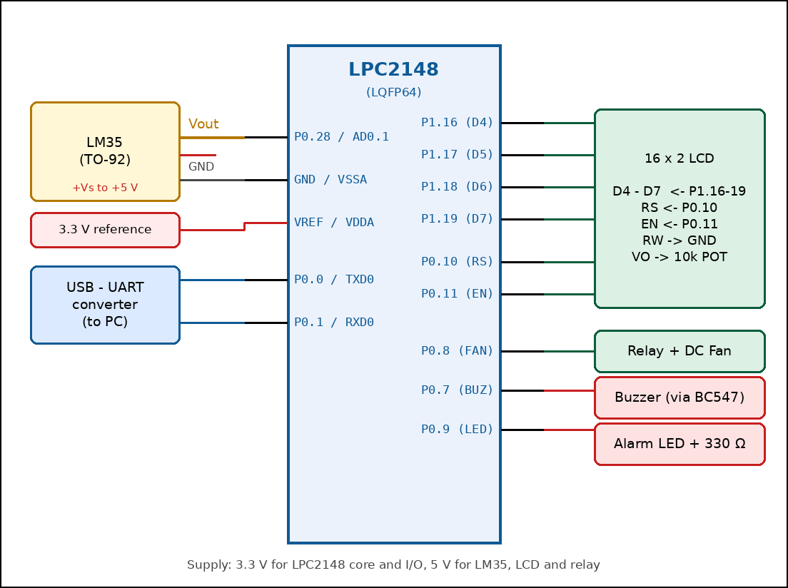
Fig. 11 - Connections of the LM35, LCD, fan, buzzer, LED and UART with the LPC2148.
6.3 Flowchart of the program
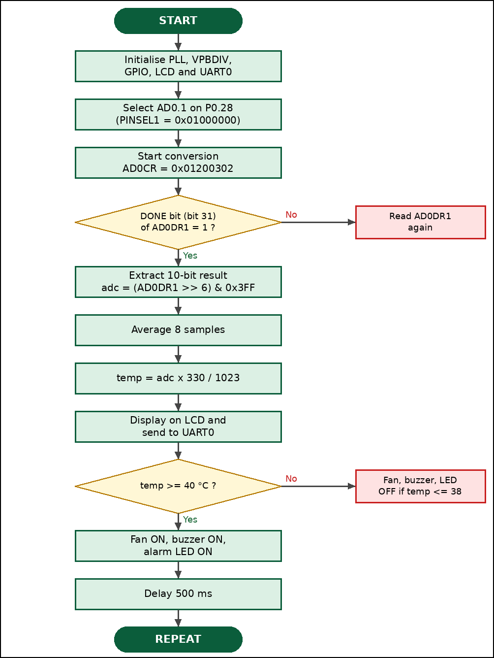
Fig. 12 - Flowchart of the firmware: ADC conversion, temperature calculation and alarm control.
7. CONCLUSION
A temperature monitoring system was designed using the LPC2148 microcontroller. The LM35 sensor produces 10 mV for every degree Celsius, the on-chip 10-bit ADC (channel AD0.1 on P0.28) converts this voltage into a digital value, and the program converts the value into degrees Celsius using T = ADC x 330 / 1023. The result is shown on a 16 x 2 LCD and on a serial terminal, and a fan, buzzer and alarm LED are controlled automatically with a hysteresis of 2 °C. The ADC was configured through PINSEL1 and AD0CR, and the result was read from bits 15:6 of AD0DR1 after the DONE flag was set. The outputs show that the readings follow the temperature accurately with a resolution of about 0.32 °C per count.
Advantages
• Low cost and compact design using the on-chip ADC, so no external converter is needed.
• Fast conversion (about 3 µs) and good resolution (10 bit).
• Automatic cooling and alarm without human attention.
• The data can be logged on a PC through the UART.
Limitations
• The LM35 reads up to 100 °C (LM35D) or 150 °C (LM35), which is enough only for general purpose monitoring.
• Long sensor wires pick up noise; averaging and a 0.1 µF capacitor at the ADC input are needed.
Future enhancements
• Use the burst mode of the ADC to monitor several sensors on different channels.
• Send the temperature to a mobile phone or cloud through GSM or Wi-Fi (ESP8266).
• Store the readings in an SD card with the real time clock time stamp.
• Control the fan speed with the PWM unit in proportion to the temperature.
References
S. No. | Reference
1 | NXP Semiconductors, LPC2141/42/44/46/48 User Manual UM10139 (ADC, PINSEL and UART chapters)
2 | Texas Instruments, LM35 Precision Centigrade Temperature Sensors data sheet
3 | HD44780U (LCD-II) dot matrix liquid crystal display controller data sheet
4 | Keil MDK-ARM documentation, ARM7TDMI-S programming guide

