VIRTUAL LABS - 2
PROGRAMMING FOR I/O INTERFACING (LED AND SWITCH INTERFACING)
AIM
To write a program for LED blinking through a push button using the PIC18F4550 series microcontroller.

OBJECTIVE
To demonstrate the use of the PIC18F4550 microcontroller's GPIO (General Purpose Input Output) pins for interfacing an input device (push button switch) and an output device (LED). The experiment aims to understand how the microcontroller reads the state of a push button and controls the LED accordingly.

PROCEDURE
- Open the Virtual Labs simulator.
- Select the Input Pin for the Switch.
- Select the Output Pin for the LED.
- Select the Switch Configuration.
- Select the LED Configuration.
- Click GENERATE CODE.
- Click COMPILE CODE.
- Click EXECUTE CODE.
- The MIMIC window opens.
- Connect the selected Output Pin to the LED Anode.
- Connect the LED Cathode to the resistor.
- Connect the selected Input Pin to the Switch.
- Click Check Connection.
- If the connection is incorrect, click Reset Connection and reconnect.
- Press and hold the Switch.
- Observe the LED and square wave output.
- Repeat the experiment with different pin configurations.

SIMULATIONS SCENARIO – 1:
INPUT PARAMETERS:

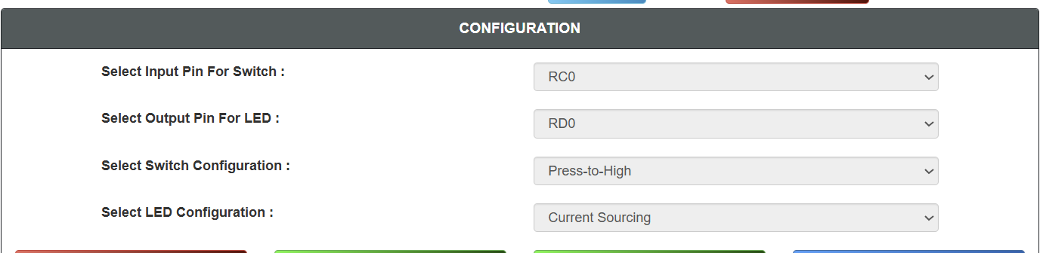

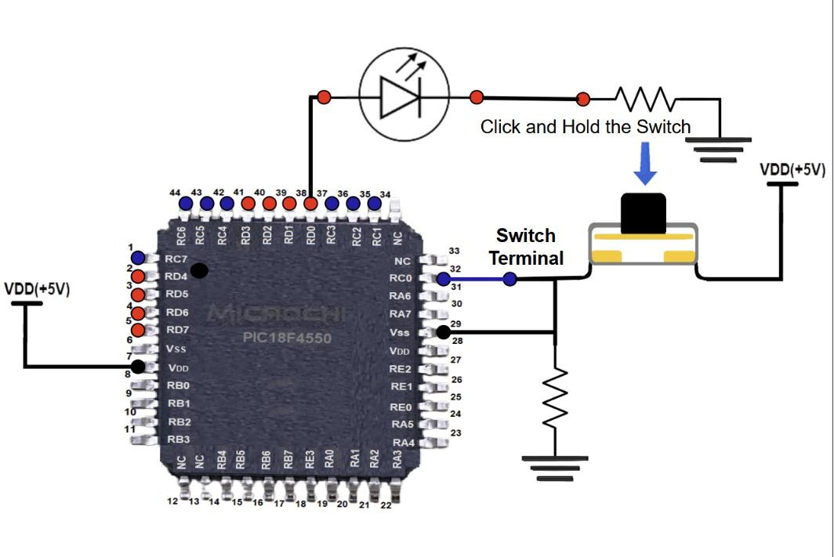
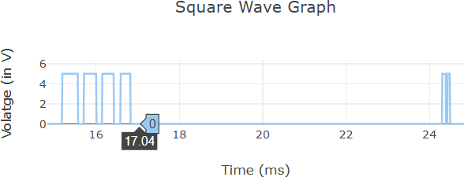

SCENARIO – 2:

INPUT PARAMETERS:

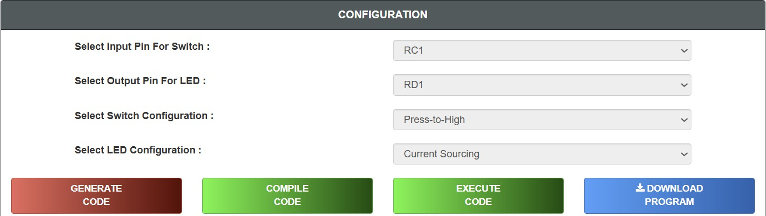

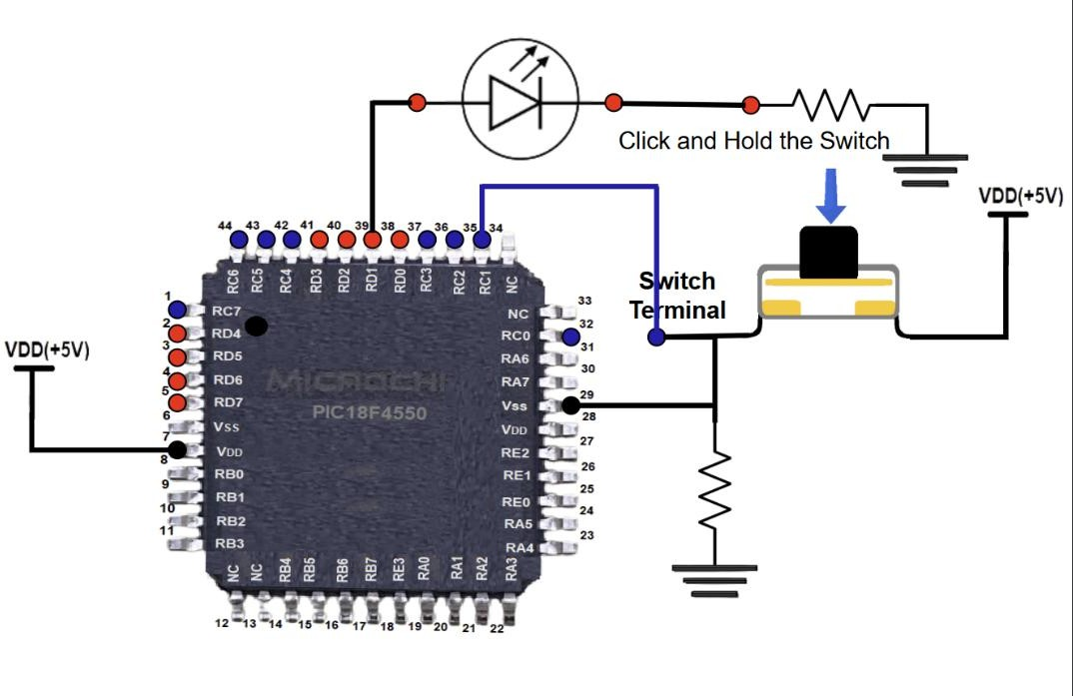

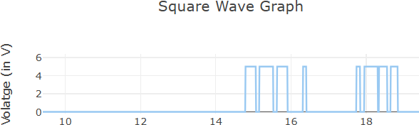

SCENARIO – 3:

INPUT PARAMETERS:

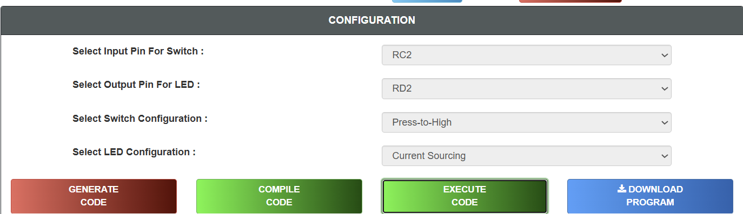

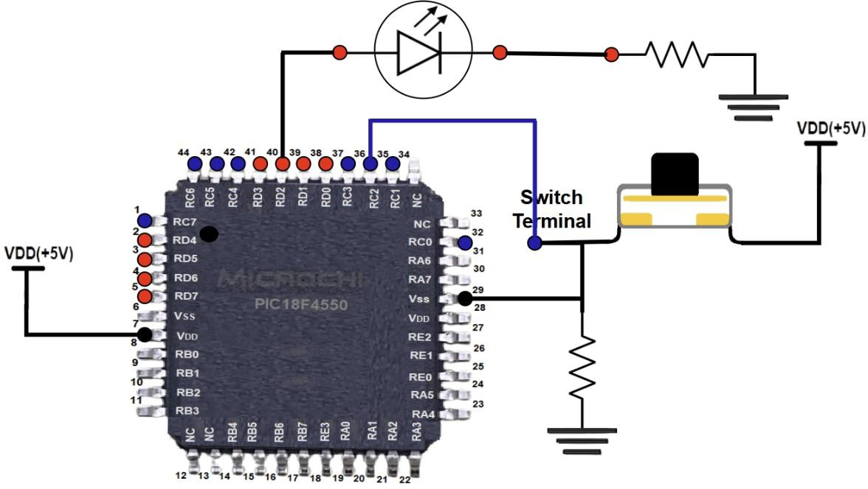

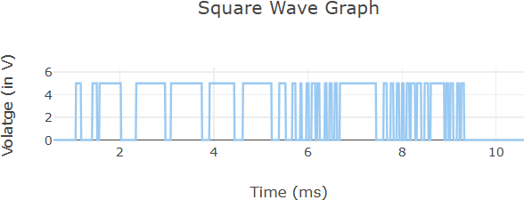

SCENARIO – 4:

INPUT PARAMETERS:

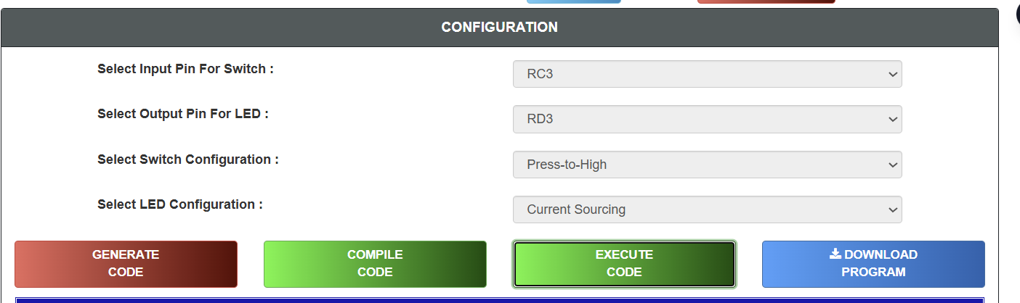

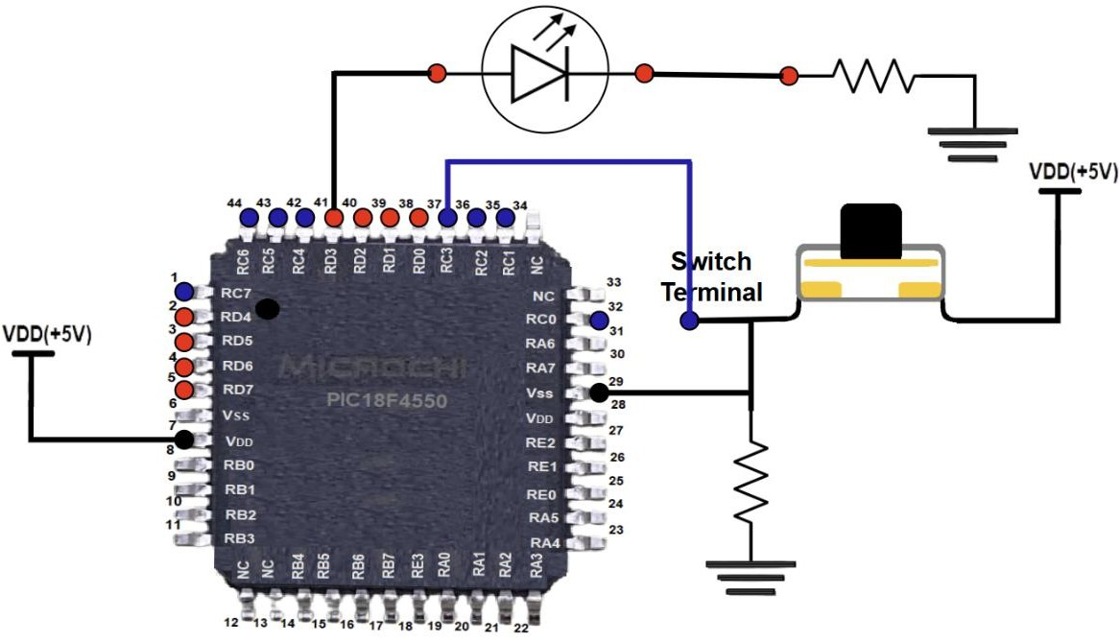

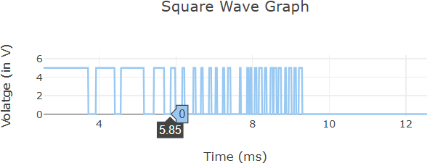

SCENARIO – 5:

INPUT PARAMETERS:

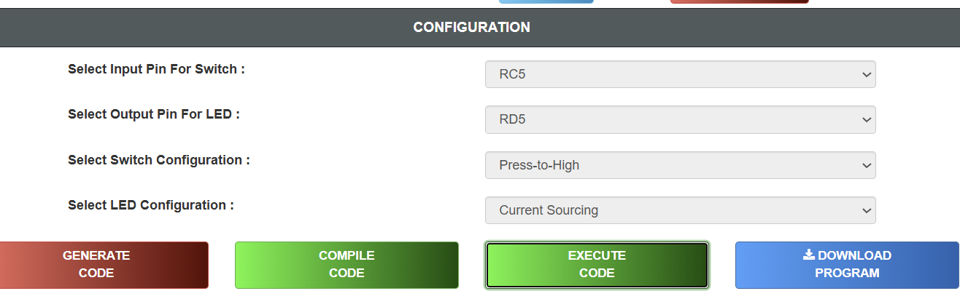

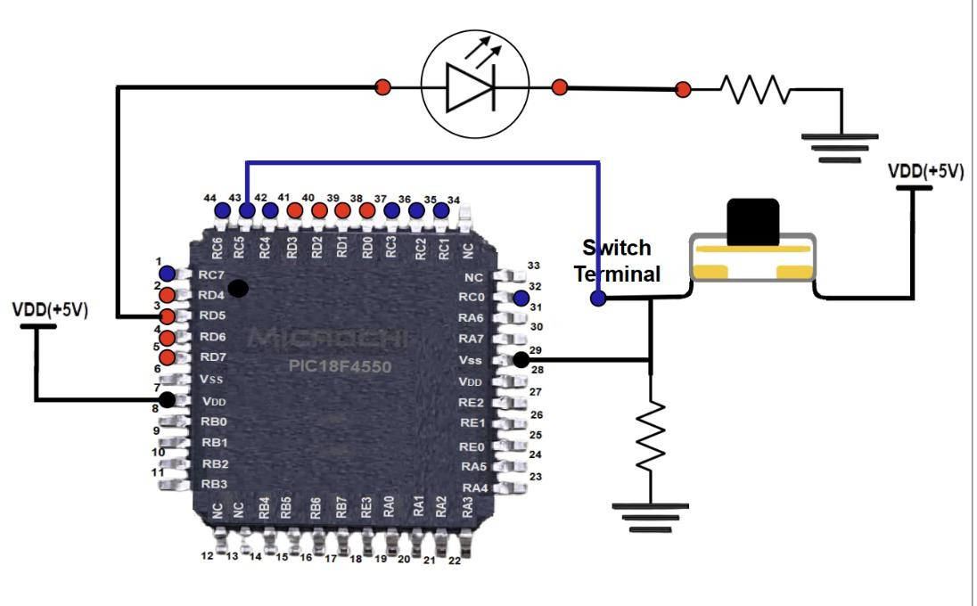

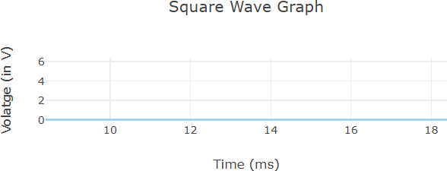

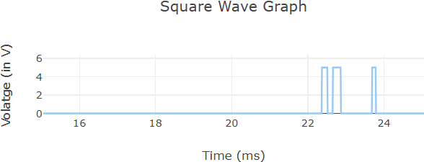

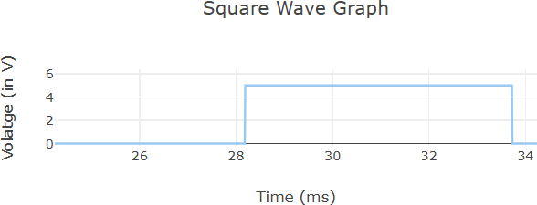

RESULT
Thus, the interfacing of a push button switch and an LED using the PIC18F4550 microcontroller was successfully studied. The GPIO pins correctly detected the switch input and controlled the LED output.

VIRTUAL LABS - 1
PROGRAMMING FOR DELAY GENERATION AND EFFECT OF CPU CLOCK
AIM
To study the effect of CPU clock on Microcontroller operations.
OBJECTIVE
To investigate the impact of varying the clock speed of a PIC18F4550 series microcontroller on the execution speed of instructions and to understand how CPU clock frequency affects the overall performance of the microcontroller.
PROCEDURE
- Open the Virtual Labs simulator.
- Select the required CPU Clock Frequency.
- Enter the Total Delay between 1 ms and 1000 ms.
- Enter the ON Delay and OFF Delay such that:
- Click SUBMIT.
- Select the required output pin.
- Select the LED Configuration.
- Click GENERATE CODE.
- Click COMPILE CODE.
- Click EXECUTE CODE.
- The MIMIC window opens.
- Connect the selected pin to the LED anode.
- Connect the LED cathode to the resistor.
- Click Check Connection.
- If the connection is incorrect, click Reset Connection and reconnect.
- Click Run.
- Observe the LED blinking and square wave output.
- Repeat the experiment with different clock frequencies.

SIMULATIONS:

SCENARIO – 1:

INPUT PARAMETERS:
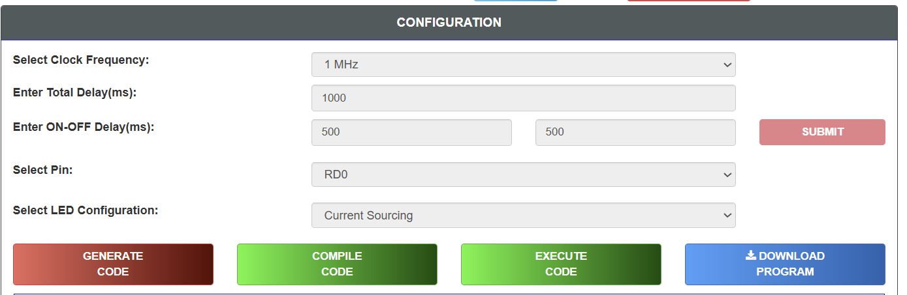

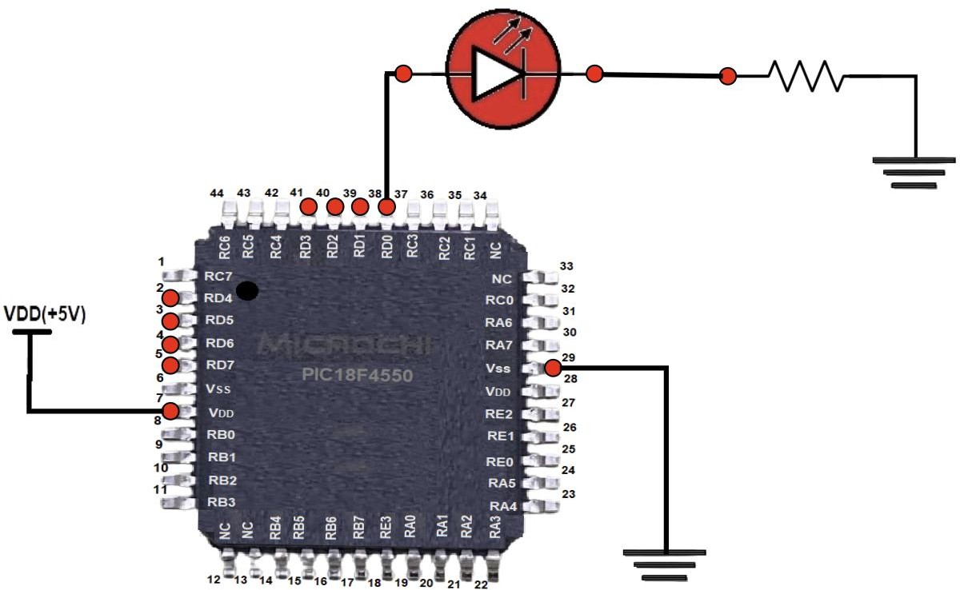

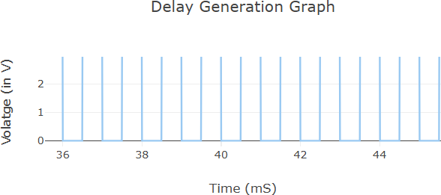

SCENARIO – 2:

INPUT PARAMETERS:

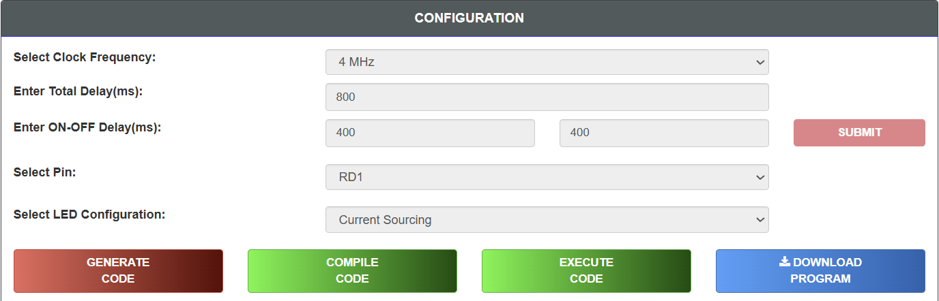

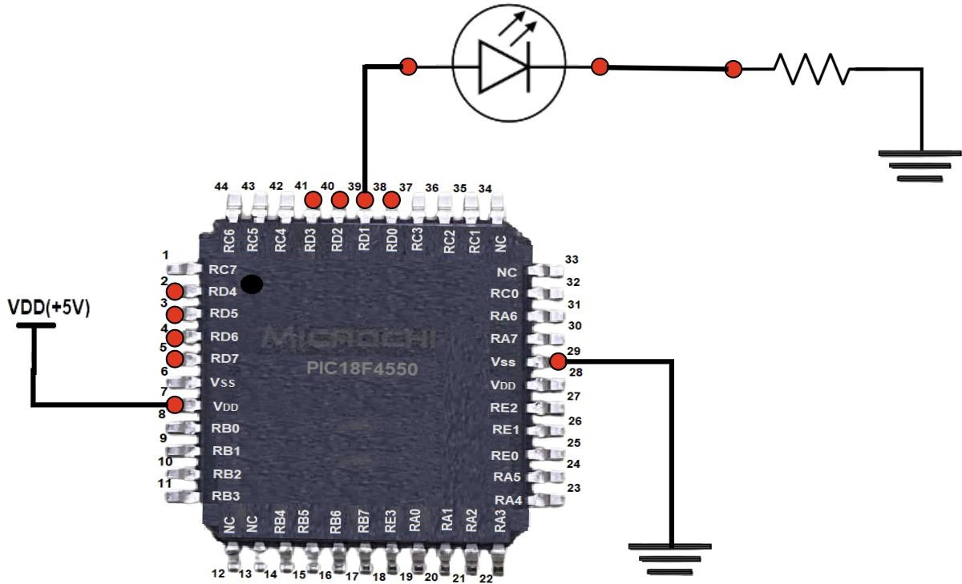

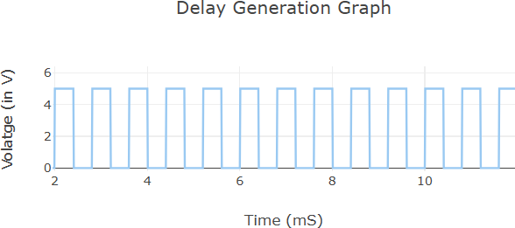

SCENARIO – 3:

INPUT PARAMETERS:
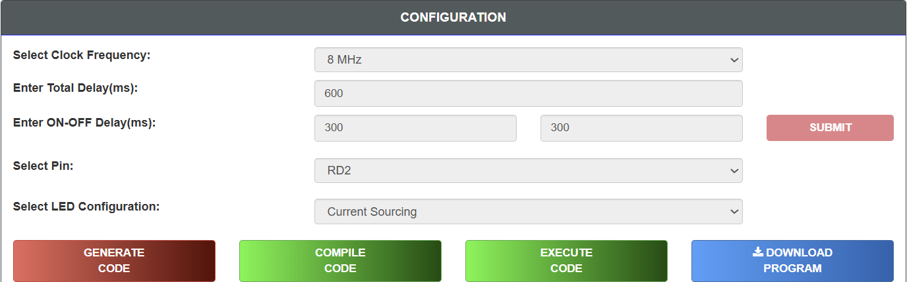

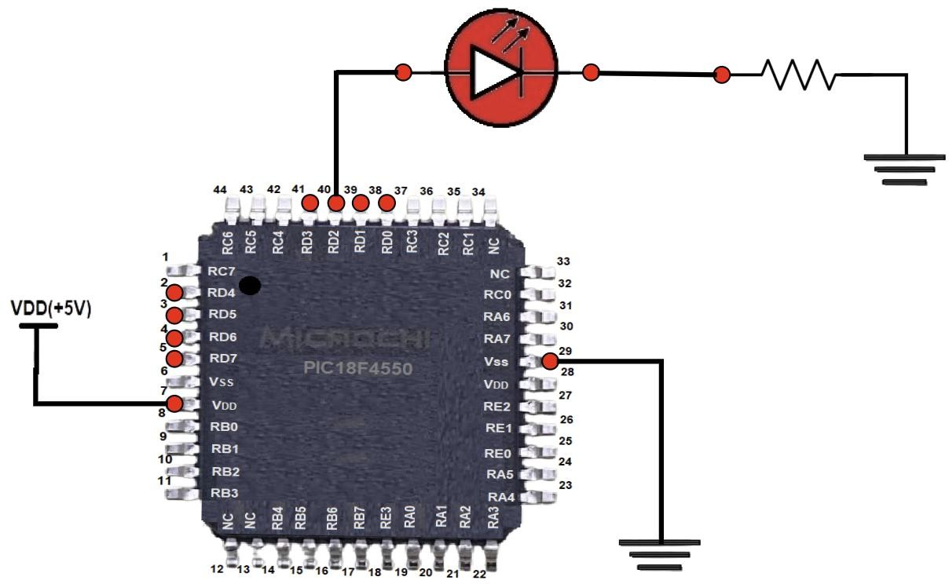

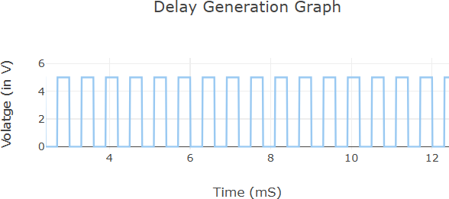

SCENARIO – 4:

INPUT PARAMETERS:
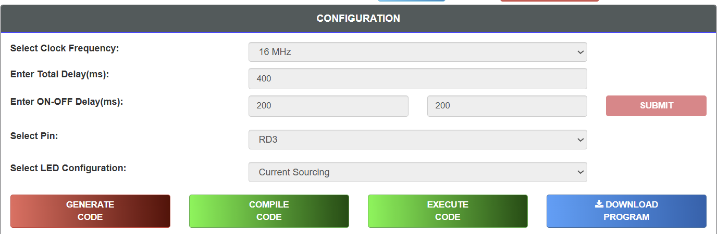

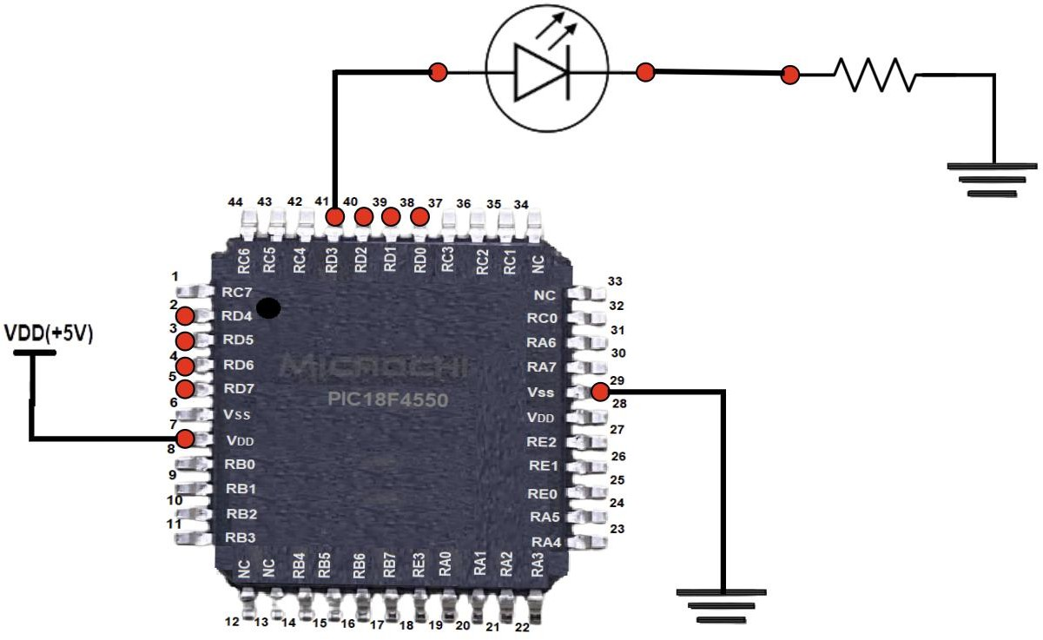

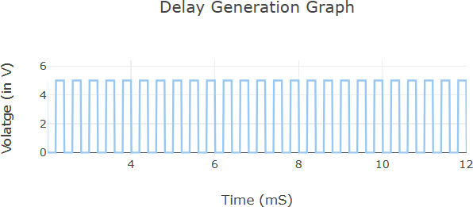

SCENARIO – 5:

INPUT PARAMETERS:

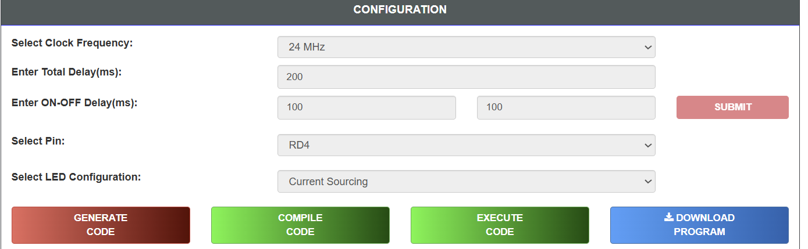

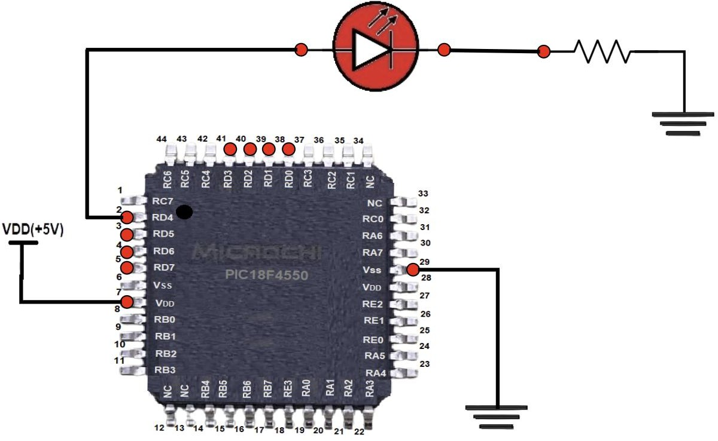

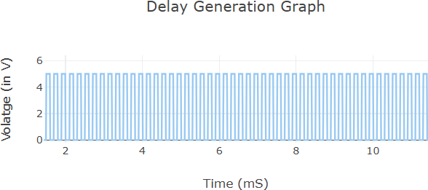

RESULT
Thus, the effect of CPU clock frequency on the operation of the PIC18F4550 microcontroller was studied successfully. It was observed that increasing the clock frequency decreases instruction execution time, resulting in faster LED blinking and quicker program execution.

VIRTUAL LABS – 3

PROGRAMMING WITH ON-CHIP TIMERS/COUNTERS
AIM
To study programming with on-chip Timers/Counters using the PIC18F4550 microcontroller.

OBJECTIVE
- To understand the basic concepts of Timer and Counter.
- To study Timer0 of the PIC18F4550 microcontroller.
- To understand the interrupt structure of the PIC18F4550.
- To generate accurate delays using Timer0 and interrupts.

PROCEDURE
- Select the Operating Frequency.
- Select the Timer.
- Select the Prescaler.
- Select Enable Interrupt.
- Enter ON Delay (in ms).
- Enter OFF Delay (in ms).
- Click GENERATE CODE.
- Click COMPILE CODE.
- Click EXECUTE CODE.
- The MIMIC window opens.
- Connect the output pin to the LED anode.
- Connect the LED cathode to the resistor.
- Click CHECK CONNECTION.
- If the connection is incorrect, click RESET CONNECTION and reconnect.
- Click RUN.
- Observe the LED blinking and square wave output.
- Click REFRESH to repeat the experimentSIMULATIONS

SIMULATIONS SCENARIO – 1
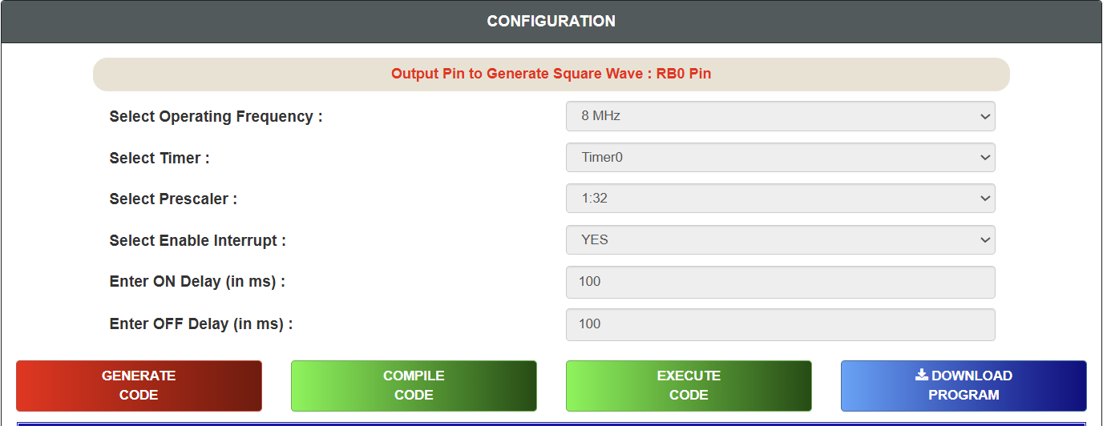
INPUT PARAMETERS

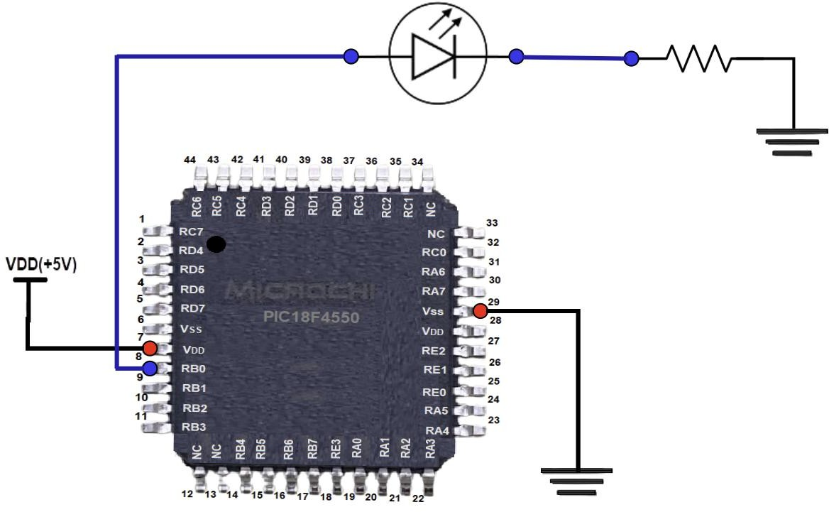

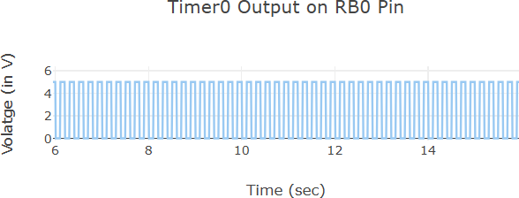

SCENARIO – 2
INPUT PARAMETERS
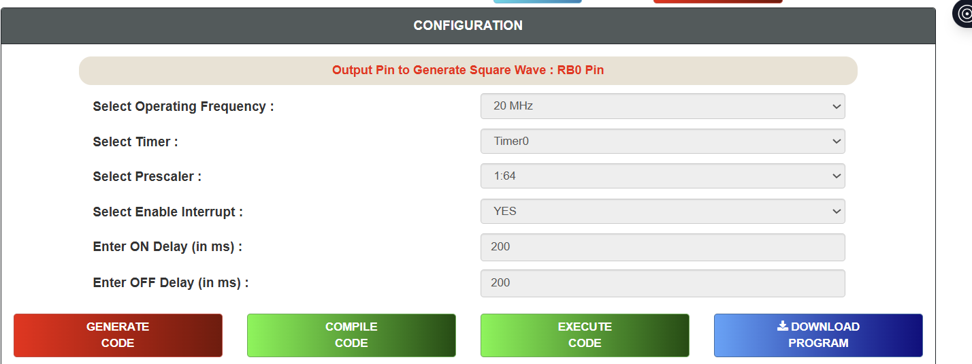

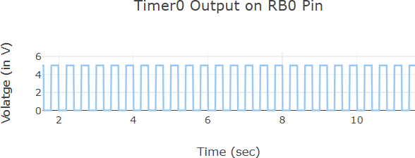

SCENARIO – 3
INPUT PARAMETERS

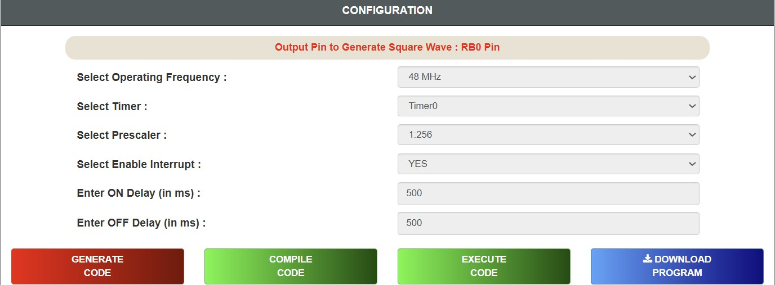

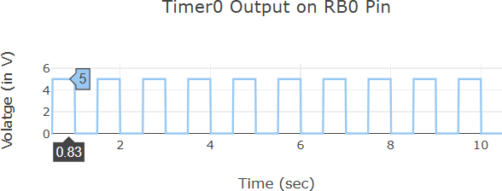

SCENARIO – 4

INPUT PARAMETERS

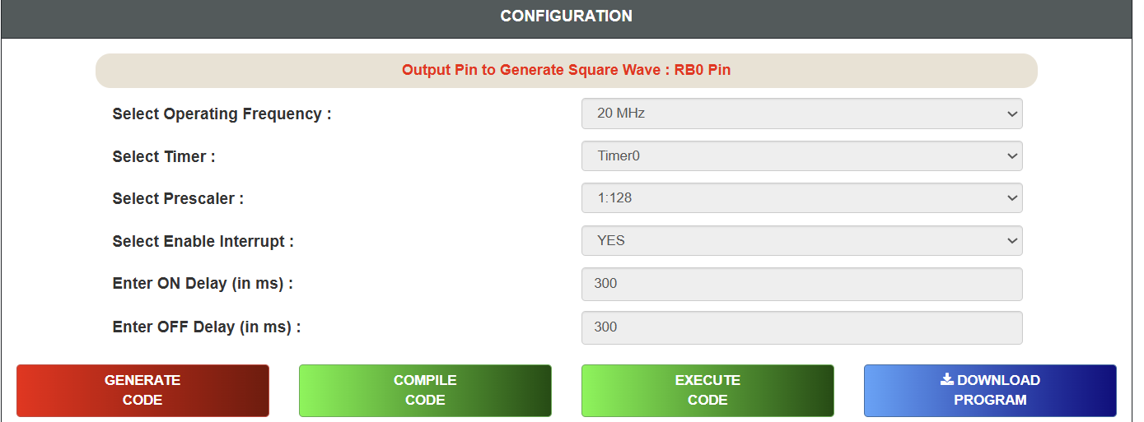

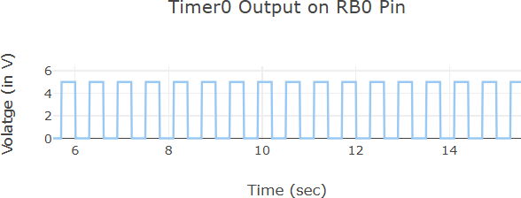

SCENARIO – 5

INPUT PARAMETERS

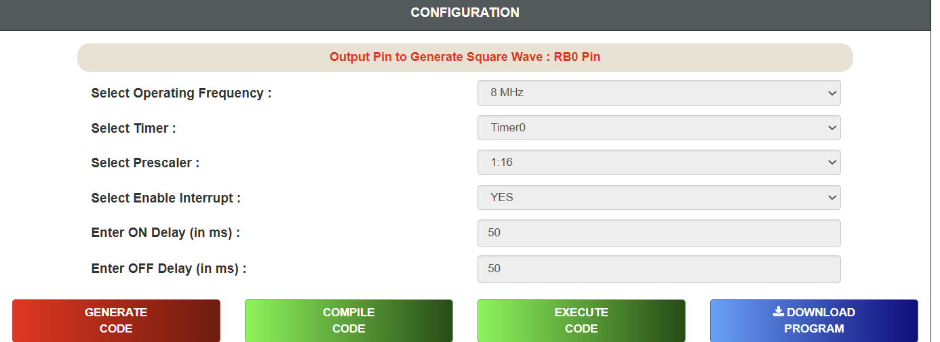

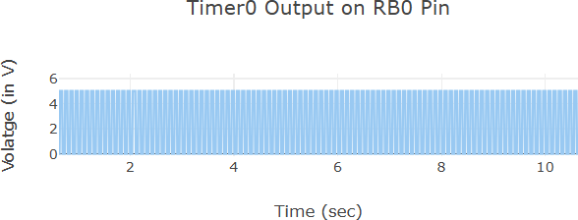

RESULT
Thus, programming with on-chip Timers/Counters using the PIC18F4550 microcontroller was studied successfully.

EX.NO.2 | STUDY ABOUT KEIL SOFTWARE
DATE: | STUDY ABOUT KEIL SOFTWARE
AIM
To study the Keil µVision Integrated Development Environment (IDE) and understand its features, components, installation procedure, project creation, compilation, debugging, and simulation of embedded C programs for microcontrollers.
APPARATUS / SOFTWARE REQUIRED
- Computer or Laptop
- Keil µVision IDE (Keil MDK)
- Windows Operating System
- ARM Cortex-M or 8051 Device Pack
- Embedded C Program

THEORY
Keil µVision is an Integrated Development Environment (IDE) developed for programming embedded
systems based on various microcontrollers such as 8051, ARM Cortex-M, C166, and others. It provides all the necessary tools required to develop, compile, debug, simulate, and download programs into microcontrollers.
Keil simplifies embedded software development by integrating source code editing, project management, compiler, linker, debugger, and simulator into a single application. It is widely used in educational institutions and industries for embedded system design and development.
COMPONENTS OF KEIL SOFTWARE

- µVision IDE:
The µVision IDE provides a user-friendly interface for creating and managing embedded projects. It contains the code editor, project manager, compiler, debugger, and simulator.
- Compiler:
The compiler converts Embedded C source code into object code that can be understood by the microcontroller.
- Assembler:
The assembler converts assembly language programs into machine language.
- Linker:
The linker combines multiple object files into a single executable file.
- Debugger:
The debugger is used to identify and remove errors from the program. It allows step-by-step execution, breakpoint setting, variable monitoring, and register inspection.
- Simulator:
The simulator allows execution of programs without connecting the actual hardware. It helps verify program functionality before downloading it into the microcontroller.
FEATURES OF KEIL SOFTWARE

- Simple and user-friendly interface
- Supports Embedded C and Assembly Language
- Fast program compilation
- Built-in simulator
- Powerful debugging facilities
- Supports thousands of microcontrollers
- Generates HEX files for programming microcontrollers
- Device database with manufacturer support
- Syntax highlighting and code completion

APPLICATIONS OF KEIL SOFTWARE
Keil software is used in the development of:
- Embedded systems
- IoT devices
- Robotics
- Automotive electronics
- Consumer electronics
- Medical instruments
- Industrial automation
- Home automation systems

WORKING OF KEIL SOFTWARE
The general development process in Keil is:
- Create a new project.
- Select the target microcontroller.
- Write the Embedded C program.
- Save the source file.
- Add the source file to the project.
- Compile (Build) the program.
- Correct compilation errors if any.
- Debug and simulate the program.
- Generate the HEX file.
- Download the HEX file into the microcontroller using a programmer.

FLOW DIAGRAM
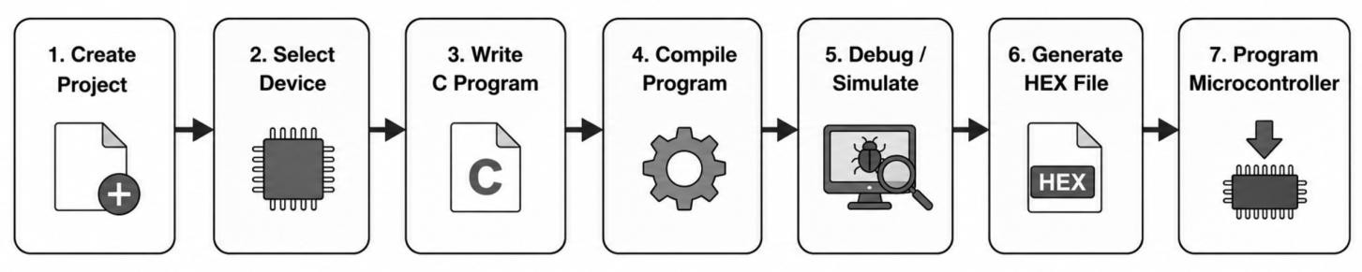

OBSERVATION

  - Keil IDE successfully creates embedded projects.
  - The compiler checks the program for syntax errors.
  - The debugger executes the program step by step.
  - The simulator allows testing without hardware.
  - A HEX file is generated after successful compilation.

ADVANTAGES
  - Easy to learn and operate
  - High-speed compiler
  - Powerful debugging tools
  - Supports a large number of microcontrollers
  - Integrated project management
  - Industry-standard embedded development software
LIMITATIONS
  - Full version requires a commercial license.
  - Primarily designed for embedded applications.
  - Some advanced features are available only in licensed versions.

RESULT
The Keil µVision IDE was successfully studied. Its components, features, project creation process, compilation, debugging, simulation, and HEX file generation were understood successfully.
.

EXPT. NO: 3 | ARITHMETIC AND LOGICAL OPERATIONS USING 8051 ASSEMBLY LANGUAGE IN KEIL µVISION
Date: 24/07/2026

AIM:
To develop and simulate 8051 Assembly language programs for performing arithmetic and logical operations using Keil µVision IDE.

DESCRIPTION:
Keil µVision is a software development environment used for programming and simulating 8051 microcontrollers. It provides tools for writing Assembly language programs, assembling source code, debugging errors, and observing register as well as memory contents through simulation.
In this experiment, Assembly language instructions were used to perform arithmetic operations such as addition, subtraction, multiplication, and division, along with logical operations including AND, OR, XOR, complement, rotate left, rotate right, clear accumulator, and carry flag operations. The simulator was used to verify the results by monitoring the accumulator, registers, and status flags.

PROGRAM:
ARITHMETIC OPERATIONS

1 (i): Addition without Carry Objective:
To add two hexadecimal numbers without generating a carry.

Input:
- 18H = 24
- 25H = 37

Calculation:
24 + 37 = 61

Result:
- 3DH = 61
- Carry = 0

Program:
CLR C
MOV A,#18H
ADD A,#25HMOV R0,A

Output:
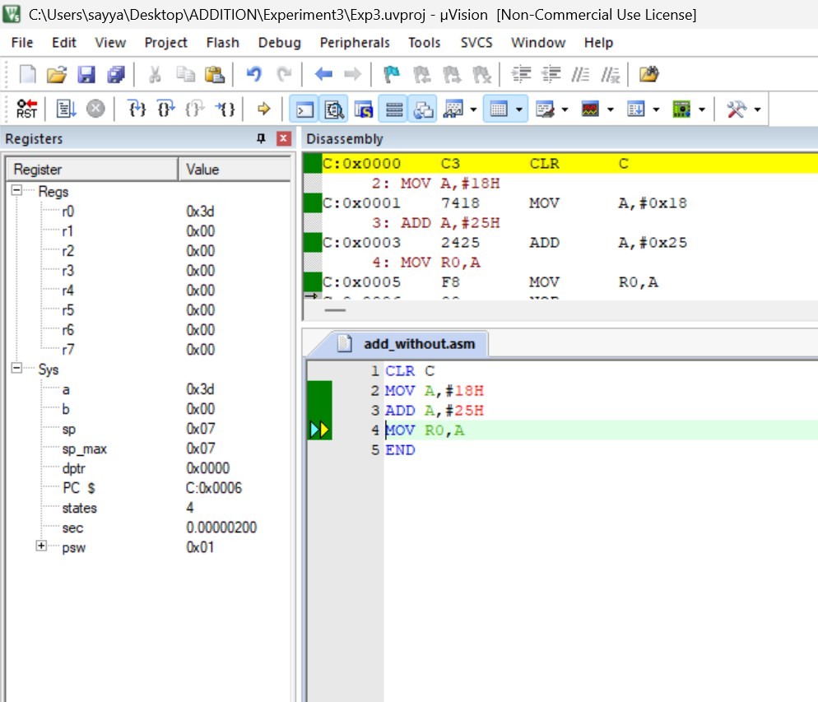

(ii): Addition with Carry Objective:
To perform addition of two hexadecimal numbers that produces a carry.

Input:
  - B2H = 178
  - 5AH = 90

Calculation:
178 + 90 = 268

Result:
  - R1 = 0CH
  - Carry = 1

Program:
CLR C
MOV A,#0B2H ADD A,#5AH MOV R1,A

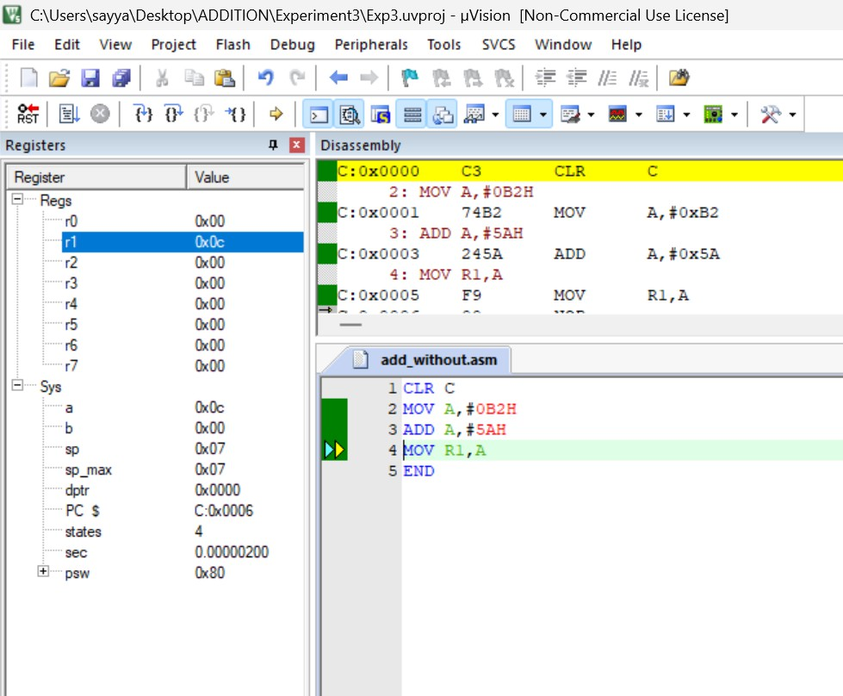
Output:

- (i): Subtraction without Borrow Objective:
To subtract one hexadecimal number from another without borrow.

Input:
  - 58H = 88
  - 1EH = 30

Calculation:
88 − 30 = 58

Result:
  - 3AH = 58
  - Borrow(Carry)=0

Program:
CLR C
MOV A,#58H SUBB A,#1EH MOV R2,A

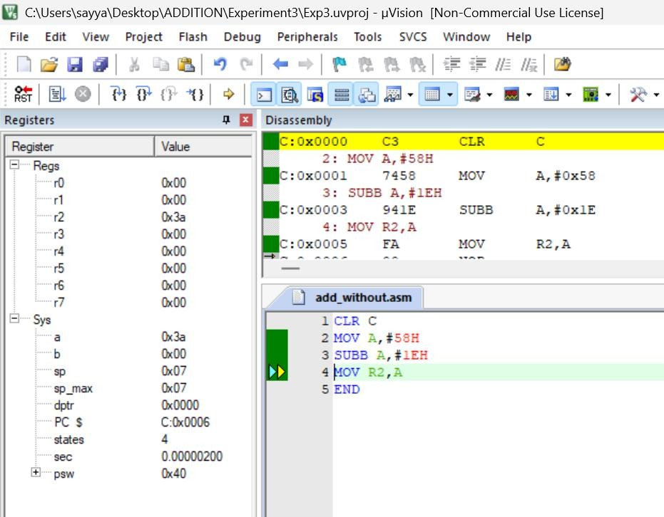
Output:

- (ii): Subtraction with Borrow Objective:
To subtract a greater hexadecimal value from a smaller one.

Input:
  - 2AH = 42
  - 45H = 69

Calculation:
42 − 69 = −27

Result:
  - E5H
  - Borrow(Carry)=1

Program:
CLR C
MOV A,#2AH SUBB A,#45H MOV R3,A

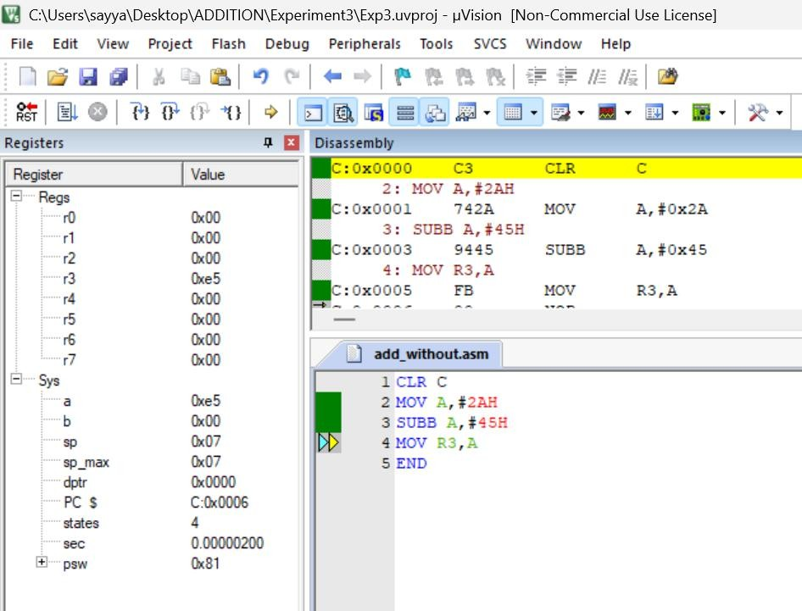
Output:

- (i): Multiplication without Overflow Objective:
To multiply two hexadecimal numbers without overflow.

Input:
  - 08H = 8
  - 06H = 6

Calculation:
8 × 6 = 48

Result:
  - A = 30H
  - B = 00H
Program: MOV A,#08H MOV B,#06H MUL AB MOV R4,A

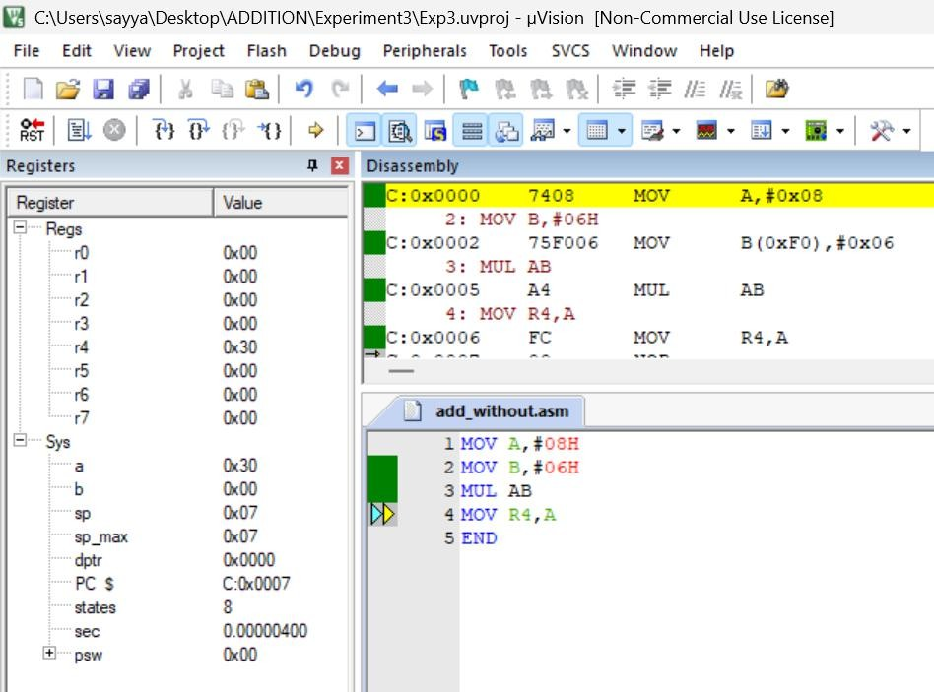
Output:

- (ii): Multiplication with Overflow Objective:
To multiply two hexadecimal numbers producing a 16-bit result.

Input:
  - 28H = 40
  - 14H = 20

Calculation:
40 × 20 = 800

Result:
  - A = 20H
  - B = 03H
Program: MOV A,#28H MOV B,#14H MUL AB MOV R5,A MOV R6,B

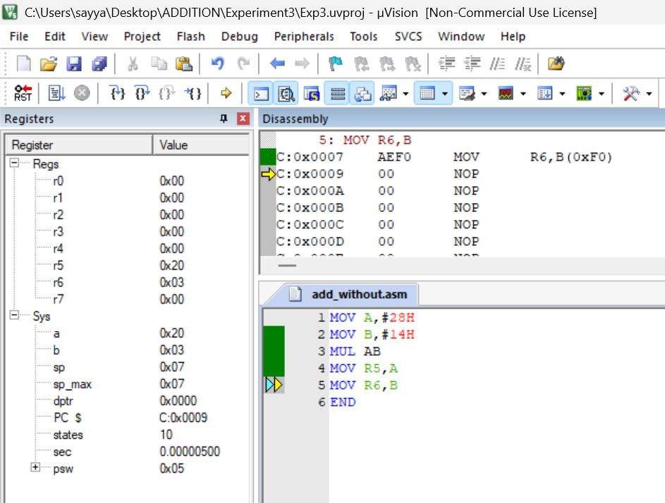
Output:

- (i): Division without Remainder Objective:
To divide two hexadecimal numbers exactly without remainder.

Input:
  - 40H = 64
  - 08H = 8

Calculation:
64 ÷ 8 = 8

Result:
  - Quotient = 08H
  - Remainder = 00H
Program: MOV A,#40H MOV B,#08H DIV AB MOV R7,A

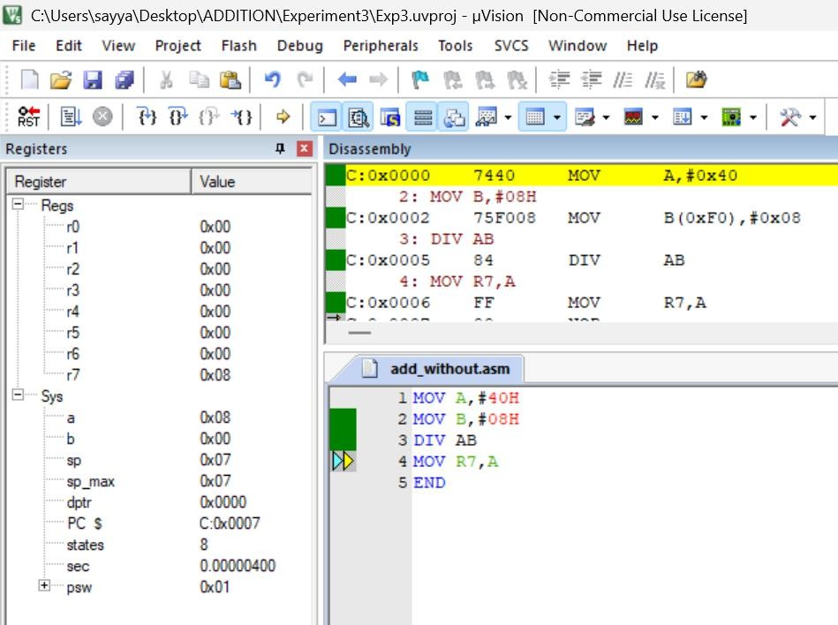
Output:

- (ii): Division with Remainder Objective:
To divide two hexadecimal numbers producing quotient and remainder.

Input:
  - 3BH = 59
  - 08H = 8

Calculation:
59 ÷ 8 = 7
Remainder = 3

Result:
  - Quotient = 07H
  - Remainder = 03H
Program: MOV A,#3BH MOV B,#08H DIV AB MOV R0,A MOV R1,B

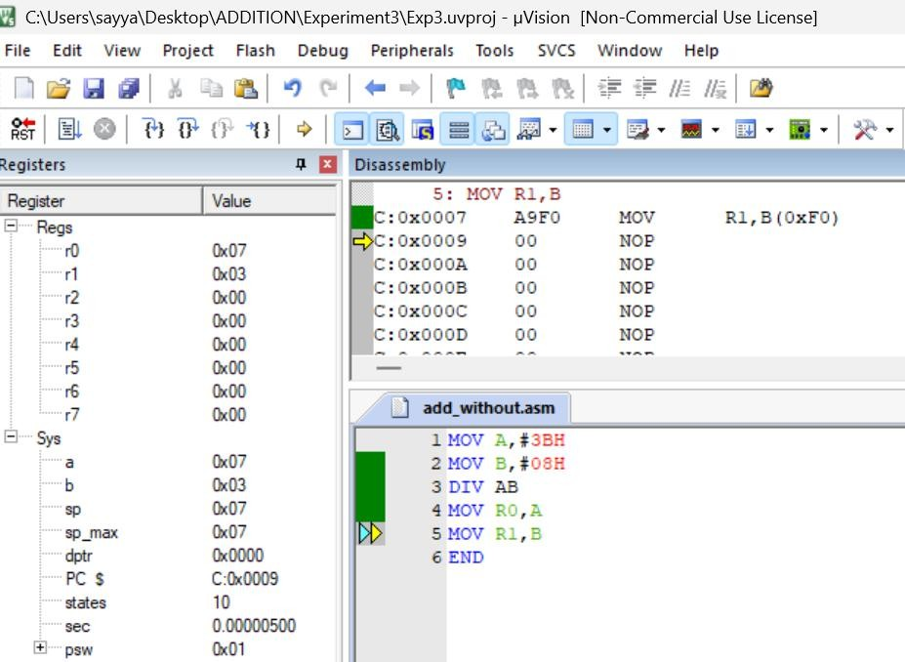
Output:

LOGICAL OPERATORS

(i): Logical AND Objective:
To perform a bitwise AND operation.

Input:
  - 5AH = 90
  - 3CH = 60

Calculation:
01011010
00111100

00011000

Result:
18H = 24
Program: MOV A,#5AH ANL A,#3CH MOV R2,A

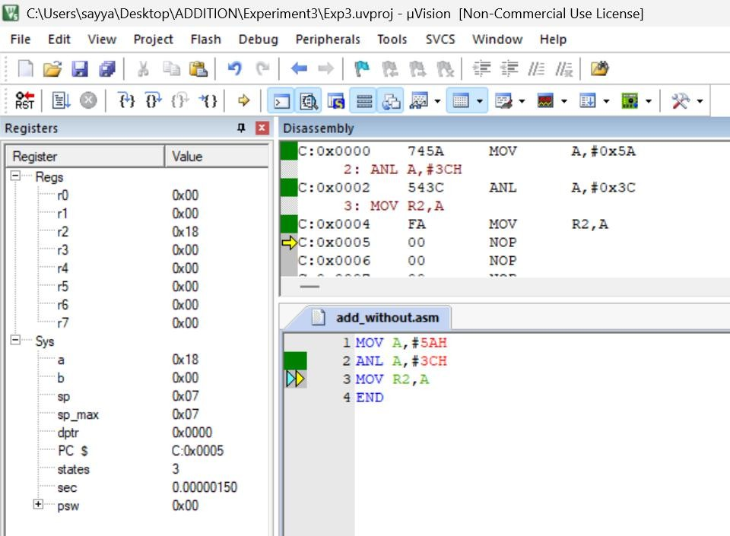
Output:

5 (ii): Logical OR Objective:
To perform a bitwise OR operation.

Input:
  - 44H = 68
  - 13H = 19

Calculation:
01000100
00010011

01010111

Result:
57H = 87
Program: MOV A,#44H ORL A,#13H MOV R3,A

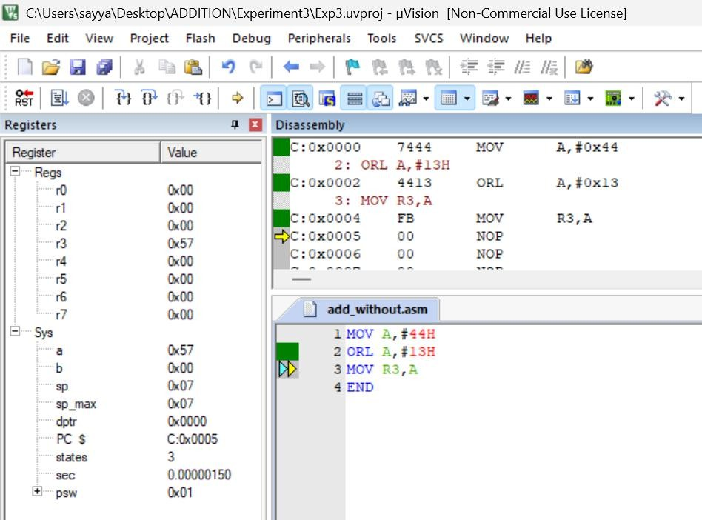
Output:

5 (iii): Logical XOR Objective:
To perform a bitwise Exclusive-OR operation.

Input:
  - 5AH = 90
  - 33H = 51

Calculation:
01011010
00110011

01101001

Result:
69H = 105
Program: MOV A,#5AH XRL A,#33H MOV R4,A

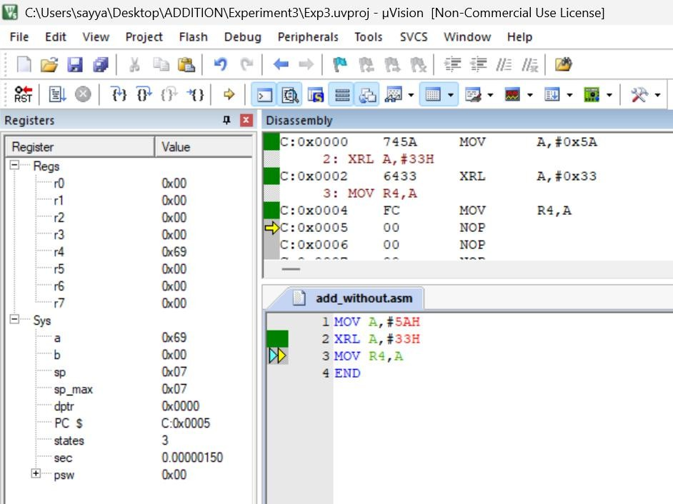
Output:

5 (iv): Complement Objective:
To complement every bit of the accumulator.

Input:
  - 55H = 85

Calculation:
01010101
↓ 10101010

Result:
AAH = 170
Program: MOV A,#55H CPL A
MOV R5,A

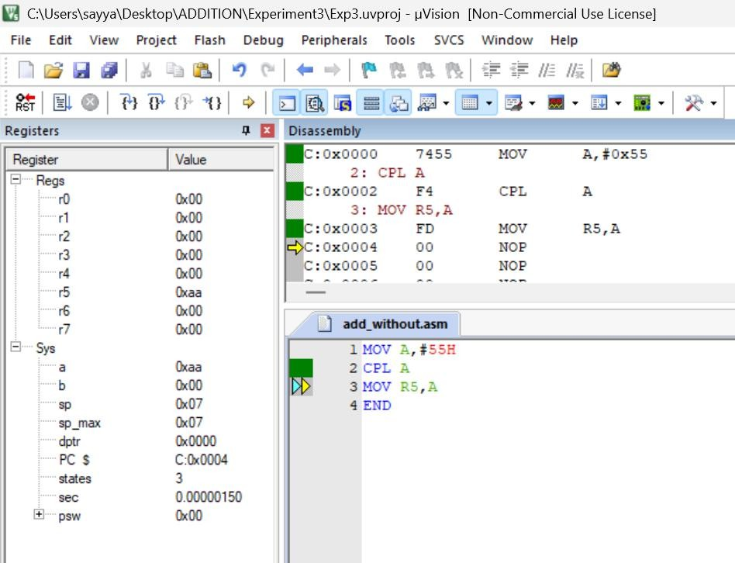
Output:

5 (v): Rotate Left Objective:
To rotate the accumulator bits one position to the left.

Input:
  - 31H = 49

Calculation:
00110001
↓ 01100010

Result:
62H = 98
Program: MOV A,#31H RL A
MOV R6,A

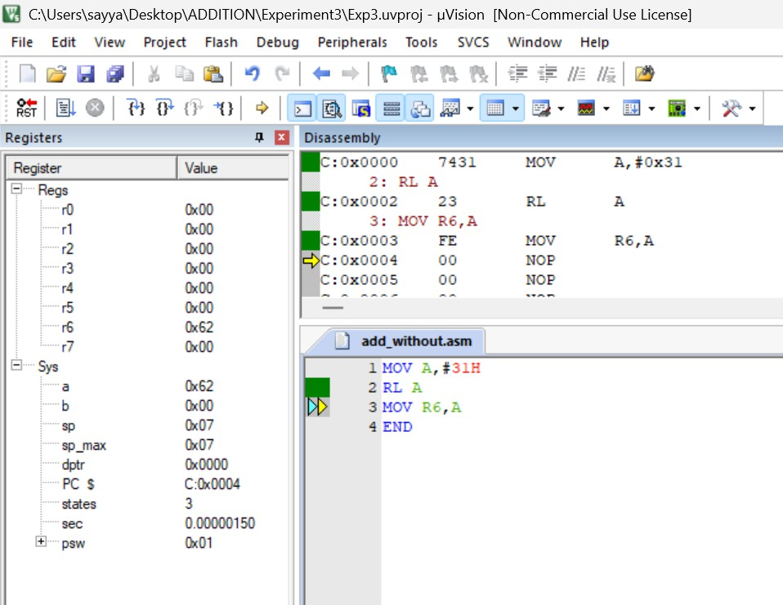
Output:

5 (vi): Rotate Right Objective:
To rotate the accumulator bits one position to the right.

Input:
  - 31H = 49

Calculation:
00110001
↓ 10011000

Result:
98H = 152
Program: MOV A,#31H RR A
MOV R7,A

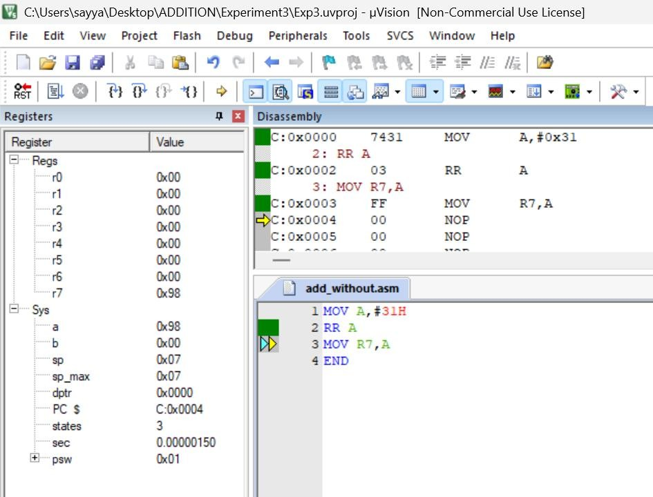
Output:

5 (vii): Clear Accumulator Objective:
To clear all the bits in the accumulator.

Input:
  - A = 55H

Calculation:
01010101
↓ 00000000

Result:
00H
Program: MOV A,#55H CLR A
MOV R0,A

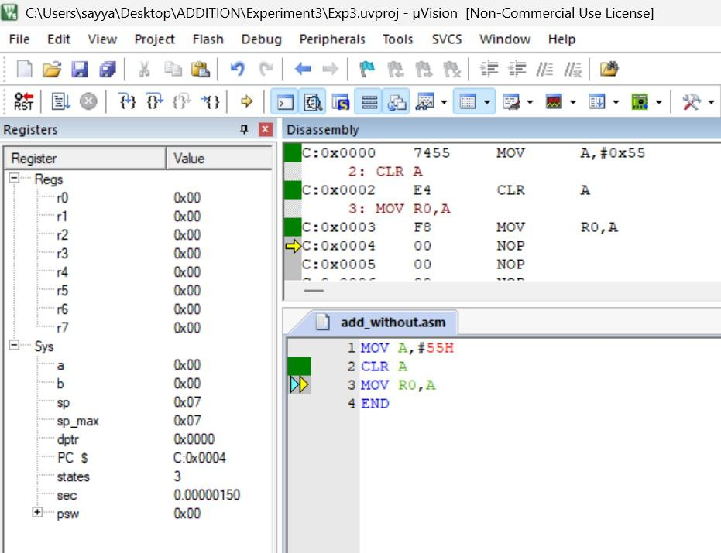
Output:

5 (viii): Set Carry Flag Objective:
To set the carry flag.

Result:
  - Carry = 1 Program: SETB C

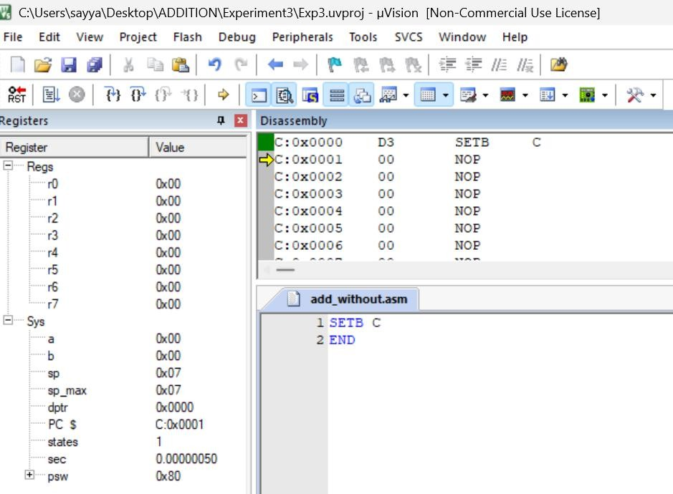
Output:

5 (ix): Clear Carry Flag Objective:
To clear the carry flag.

Result:
  - Carry = 0

Program:
CLR C
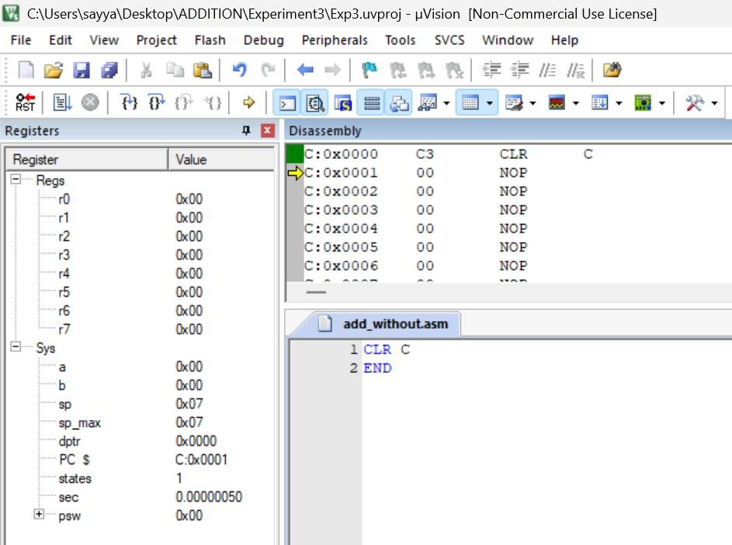
Output:

RESULT:
Thus, the arithmetic and logical operations were successfully implemented and verified using 8051 Assembly Language in Keil µVision IDE.

EXP NO.4 | 8051 ALP FOR DATA TRANSFER BETWEEN MEMORY BLOCKS
DATE: 07.08.26 | 8051 ALP FOR DATA TRANSFER BETWEEN MEMORY BLOCKS

- Transfer the Block of Data between two Memory Locations:

AIM:

To write an Assembly Language Program (ALP) to transfer a block of data from one internal memory location to another.

ALGORITHM:

  - Initialize the source memory address.
  - Initialize the destination memory address.
  - Load the counter with the number of bytes to be transferred.
  - Read one byte from the source location.
  - Store the byte in the destination location.
  - Increment both source and destination pointers.
  - Decrement the counter.
  - Repeat until the counter becomes zero.
  - Stop the program.

PROGRAM:

ORG 00H MOV R0,#60H MOV R1,#70H MOV R2,#04H
L1: MOV A,@R0 50
MOV @R1,A INC R0 INC R1 DJNZ R2,1
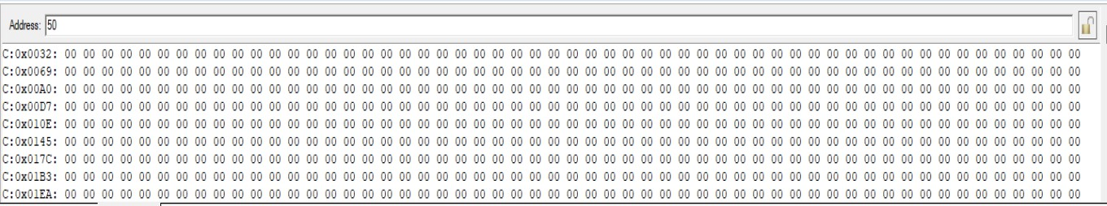
END

OUTPUT:

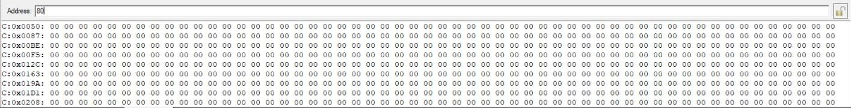

RESULT:
Thus, the block of data was successfully transferred from one internal memory location to another and verified successfully.

- Exchange (Swap) the Block of Data Between Two Memory Locations

AIM:
To write an Assembly Language Program (ALP) to exchange (swap) the contents of a block of data between two internal memory locations.

ALGORITHM:
  - Initialize the starting address of Block 1.
  - Initialize the starting address of Block 2.
  - Load the counter with the number of bytes.
  - Read one byte from Block 1 into the Accumulator.
  - Store it temporarily in Register B.
  - Read one byte from Block 2 into the Accumulator.
  - Move the contents of Register B to Block 2.
  - Move the Accumulator contents to Block 1.
  - Increment both memory pointers.
  - Decrement the counter.
  - Repeat until all bytes are exchanged.
  - Stop the program.

PROGRAM: ORG 00H MOV R0,#50H MOV R1,#80H MOV R2,#04H
L1: MOV A,@R0 MOV B,A MOV A,@R1 MOV @R0,A MOV A,B MOV @R1,A INC R0
INC R1 DJNZ R2,L1
END

OUTPUT:

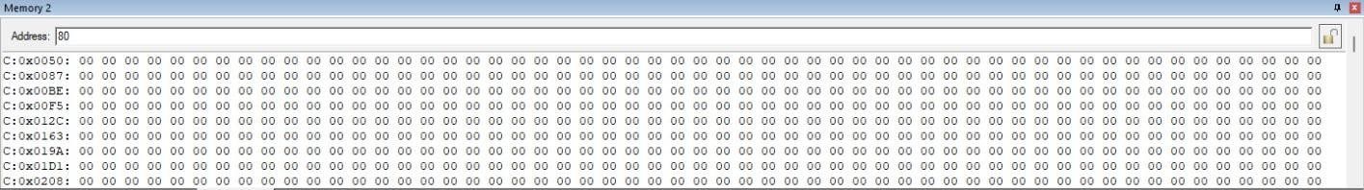
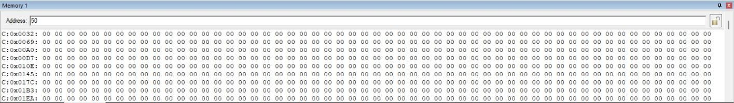

RESULT:
Thus, the contents of the two memory blocks were successfully exchanged and verified successfully.

EXP NO.5 | LARGEST AND SMALLEST NUMBER IN AN ARRAY USING 8051 ALP
DATE: 18.09.26 | LARGEST AND SMALLEST NUMBER IN AN ARRAY USING 8051 ALP

AIM:
To write and execute an 8051 Assembly Language program to find the largest and smallest numbers in an array and store the results in the specified memory location.

LARGEST NUMBER IN AN ARRAY ALGORITHM:
  - Start the program.
  - Load the number of array elements into register R2.
  - Initialize R0 with the starting address of the array.
  - Move the first array element into accumulator A.
  - Initialize R1 with the address of the next element.
  - Compare the current largest value in A with the next array element.
  - If the next element is larger, move it into A.
  - Increment the array pointer.
  - Repeat the comparison until all elements are checked.
  - Store the largest value from A into memory location 70H.
  - Stop.

INSTRUCTION:
ORG 00H MOV R2,50H DEC R2
MOV R0,#60H MOV A,@R0 MOV R1,#61H
L1: MOV 00H,@R1 CJNE A,00H,L2 L2: JNC L3
MOV A,@R1 L3: INC R1 DJNZ R2,L1 MOV 70H,A END

OUTPUT:
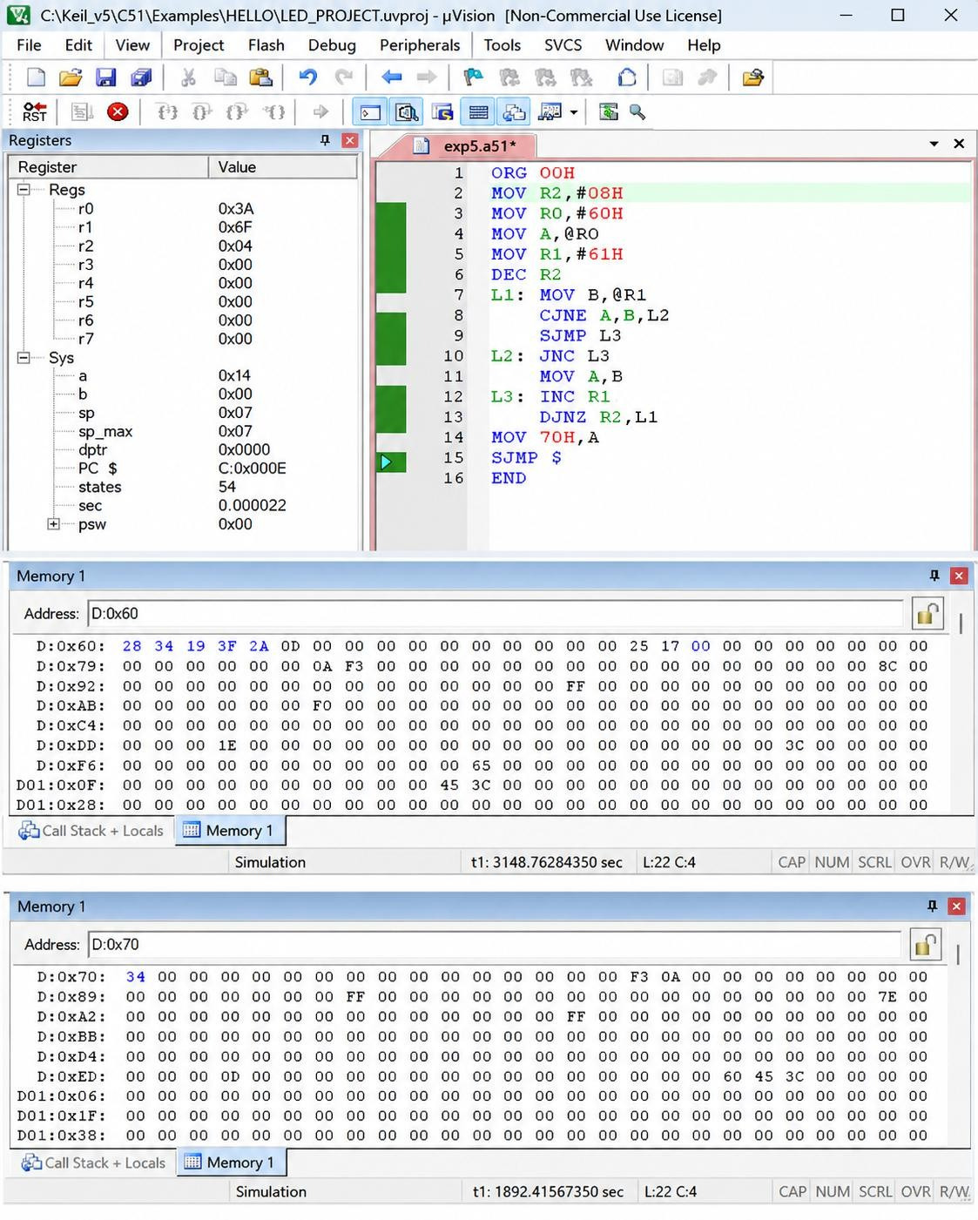

SMALLEST NUMBER IN AN ARRAY

Algorithm
  - Start the program.
  - Load the number of array elements into register R2.
  - Initialize R0 with the starting address of the array.
  - Move the first array element into accumulator A.
  - Initialize R1 with the address of the next element.
  - Compare the current largest value in A with the next array element.
  - If the next element is larger, move it into A.
  - Increment the array pointer.
  - Repeat the comparison until all elements are checked.
  - Store the largest value from A into memory location 70H.
  - Stop.

INSTRUCTION:
ORG 00H MOV R2,50H DEC R2
MOV R0,#60H MOV A,@R0 MOV R1,#61H
L1: MOV 00H,@R1 CJNE A,00H,L2 L2: JNC L3
MOV A,@R1 L3: INC R1 DJNZ R2,L1 MOV 70H,A END

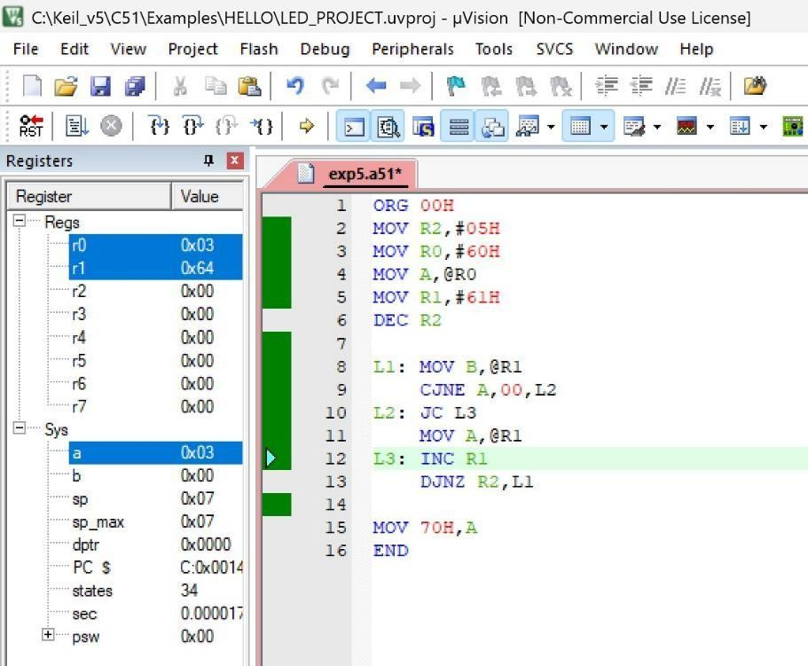
OUTPUT:

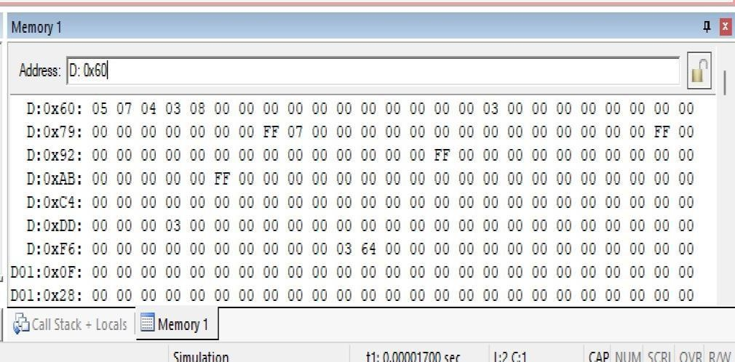

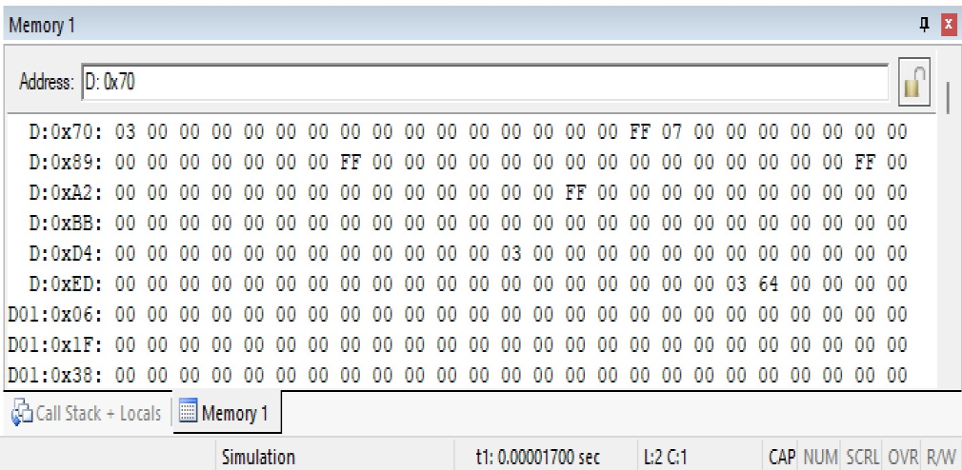

RESULT:
Thus, the 8051 Assembly Language programs for finding the largest and smallest numbers in an array were executed successfully.

EXP NO.6 | 8051 C PROGRAMMING FOR TIMER
DATE: 18.09.26 | 8051 C PROGRAMMING FOR TIMER

8051 TIMER MODE 1 WITH DELAY AIM:
To write and execute an 8051 C program using Timer 0 in Mode 1 to generate a delay and enable/disable a port pin.

ALGORITHM:
  - Start the program.
  - Define the port pin P1.0 as the test pin.
  - Configure Timer 0 in Mode 1 (16-bit timer mode).
  - Load the initial values into TH0 and TL0.
  - Start Timer 0.
  - Wait until the Timer 0 overflow flag TF0 is set.
  - Stop the timer and clear TF0.
  - Toggle the P1.0 pin.
  - Repeat the process continuously.

PROGRAM:
#include <reg51.h> sbit test = P1^0; void timer_delay()
{
TH0 = 0xFC; TL0 = 0x74; TR0 = 1;
while(TF0 == 0);
TR0 = 0;
TF0 = 0;
}
void main()
{
TMOD = 0x01;
while(1)
{
test = ~test; timer_delay();
}
}

OUTPUT:

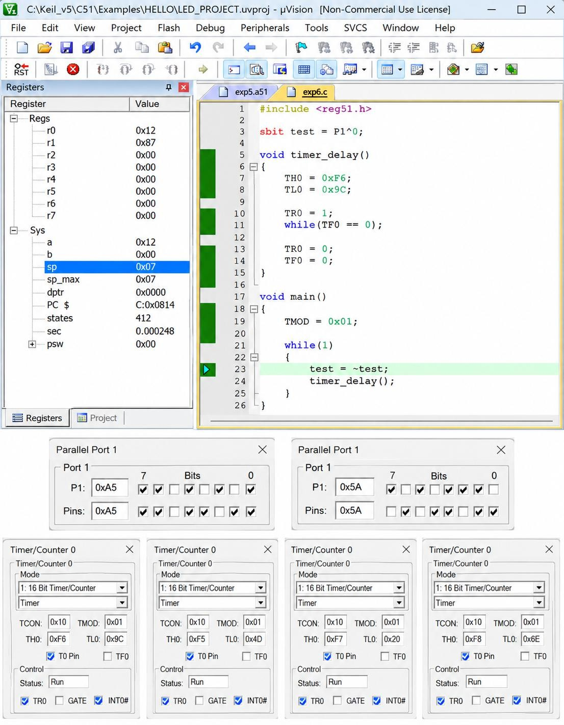

TIMER-BASED INTERRUPT TO TOGGLE OUTPUT PIN

AIM
To write and execute an 8051 C program using a timer-based interrupt to toggle an output pin at a fixed time interval.

ALGORITHM:
  - Start the program.
  - Define P1.0 as the output/test pin.
  - Configure Timer 0 in Mode 1.
  - Load TH0 and TL0 with the required initial values.
  - Enable the global interrupt.
  - Enable Timer 0 interrupt.
  - Start Timer 0.
  - When Timer 0 overflows, execute the interrupt service routine.
  - Toggle P1.0.
  - Reload TH0 and TL0.
  - Repeat the process continuously.

PROGRAM:
#include <reg51.h> sbit test = P1^0;
void Timer_init(void)
{
TMOD = 0x01; TH0 = 0x4C; TL0 = 0x00; TR0 = 1;
}
void Timer0_ISR(void) interrupt 1
{
test = ~test; TH0 = 0x4C; TL0 = 0x00;
}
int main(void)
{
EA = 1;
ET0 = 1;
Timer_init(); while(1);
}

OUTPUT:

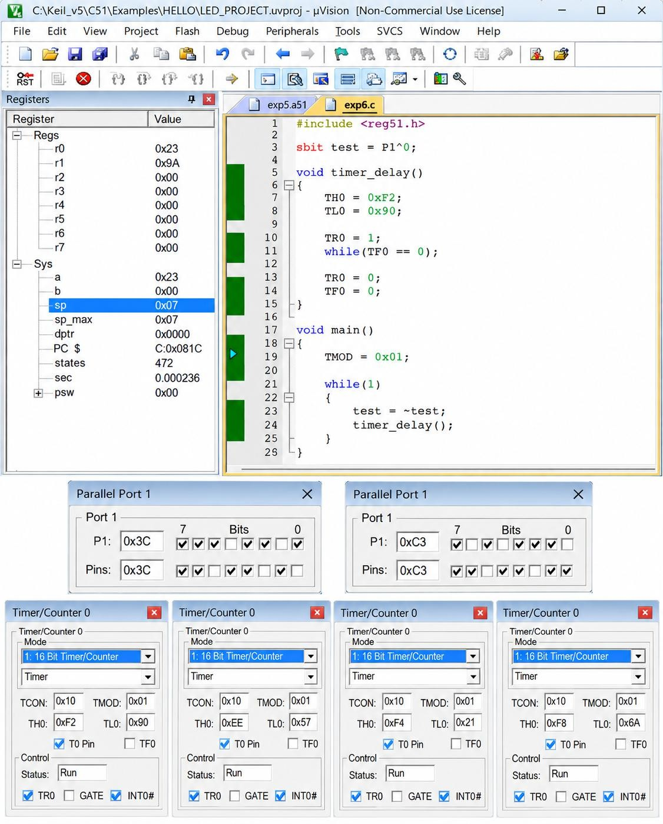

UART PROGRAMMING USING 8051

AIM:
To write and execute an 8051 C program for Universal Asynchronous Receiver Transmitter (UART) to transmit a character serially.

ALGORITHM:
  - Start the program.
  - Configure Timer 1 in Mode 2 for baud-rate generation.
  - Load the required value into TH1.
  - Configure the serial control register SCON.
  - Start Timer 1.
  - Load the character to be transmitted into SBUF.
  - Wait until the transmission interrupt flag TI is set.
  - Clear the TI flag.
  - Repeat the transmission continuously.

PROGRAM
#include <reg51.h> void main(void)
{
TMOD = 0x20; TH1 = 0xFA; SCON = 0x50; TR1 = 1;
while(1)
{

}
}

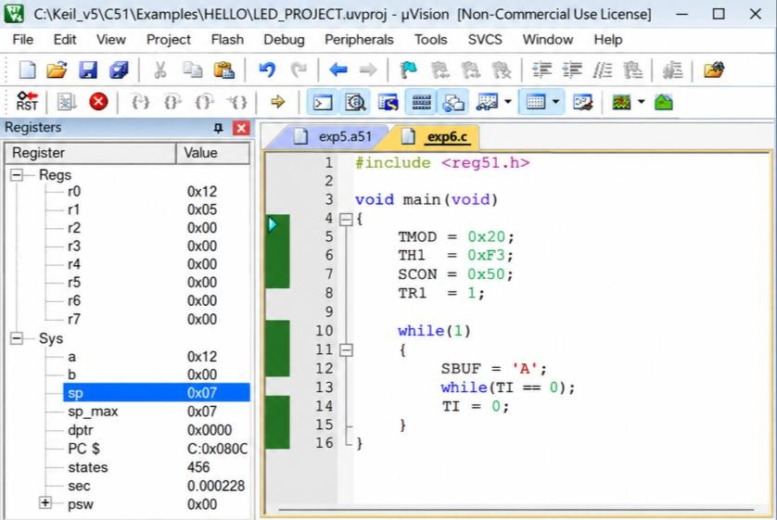
OUTPUT:
SBUF = 'B';
while(TI == 0);
TI = 0;

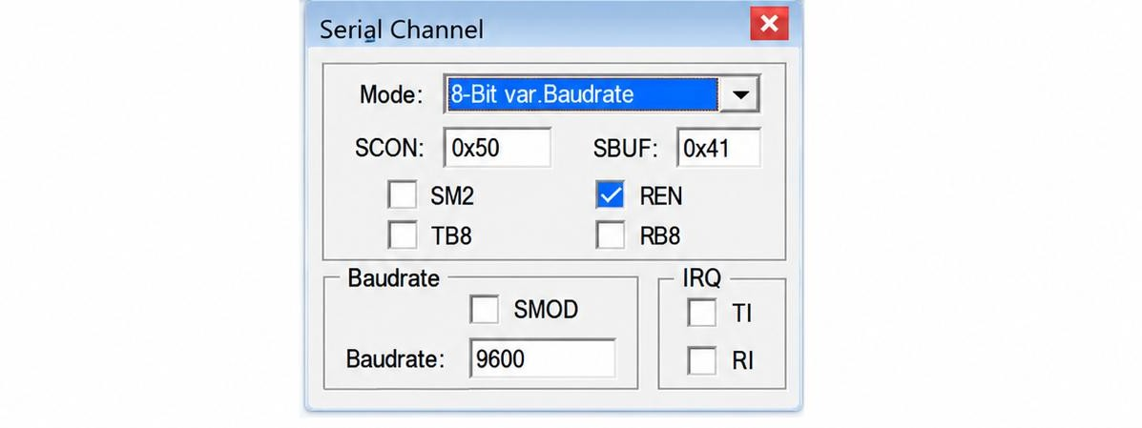

RESULT:
Thus, the 8051 C programs were successfully implemented for timer delay and port toggling, timer-based interrupt, and UART serial data transmission.

