MODULE 3 – NOTES

1. CONTENT CREATION: ENVIRONMENTAL DESIGN – AFFECTING BEHAVIOUR
1.1 Introduction
In Virtual Reality (VR), developers create a computer-generated environment that users can explore and interact with. However, creating a virtual world is not simply about making it visually attractive. The environment must also influence how users feel, where they look, what they notice, and how they behave.
Your staff notes explain that environmental design uses spatial layout, sensory stimuli, interaction mechanics and feedback systems to influence human behaviour. This idea is connected to environmental psychology and Human–Computer Interaction (HCI).
Let's understand how this works through a single example.
Imagine a VR application designed to train factory workers to respond to an emergency. The worker enters a virtual factory, hears an alarm, sees smoke and must find the emergency exit. The way the factory is designed can influence whether the worker notices the danger, feels urgency and chooses the correct exit.
This is the purpose of environmental design.
1.2 Content Creation
Content creation is the process of producing the digital elements that make up the virtual environment.
It includes creating 3D objects, characters, textures, lighting, sound effects, animations and interactive elements.
For example, in our virtual factory:
• 3D models represent machines, workers, doors and equipment.
• Textures make machine surfaces look like metal or plastic.
• Lighting creates the appearance of a bright factory or a dark emergency area.
• Audio creates alarms, machine noises and warning signals.
• Animation shows moving machinery, smoke or people.
• Interactive elements allow the user to open doors, operate equipment and activate emergency controls.
These elements form the content that the user experiences.
The important distinction: Content creation produces the elements; environmental design decides how those elements are organised and used to influence the user.
1.3 Environmental Design
Environmental design is the deliberate arrangement of a virtual environment to achieve particular user experiences and behavioural responses.
It has several important aspects.
A. SPATIAL DESIGN AND BEHAVIOURAL GUIDANCE
Spatial design concerns the geometry, layout and arrangement of the environment.
The size of rooms, width of pathways, placement of objects and visibility of exits can influence user movement and decisions.
Consider two situations:
• A wide, well-lit corridor encourages exploration and easy movement.
• A narrow, dark corridor may make users cautious and cause them to move more slowly.
Similarly, a glowing virtual lever may suggest that it can be pulled. This is called an affordance — a feature or cue that suggests how an object can be used.
In an AR navigation application, directional arrows can guide users along a route without requiring them to read lengthy instructions.
B. SENSORY STIMULI AND EMOTIONAL INFLUENCE
A virtual environment can affect emotions by stimulating different senses.
Sensory stimuli are signals received through senses such as vision, hearing and touch.
• LIGHTING: Bright lighting can improve visibility, while dim lighting may create suspense.
• COLOURS: Warm colours and suitable colour schemes can create a relaxing atmosphere.
• AMBIENT SOUNDS: Birds and gentle music can create calmness, while sudden alarms can create alertness or fear.
• HAPTIC FEEDBACK: Vibrations can simulate physical events such as ground tremors.
For example, in a VR earthquake simulation, the user sees objects shaking, hears rumbling sounds and feels vibration through a controller. These combined signals make the event more convincing and encourage the user to seek shelter.
In clinical VR therapy, developers can also expose users gradually to virtual heights or enclosed spaces to support systematic desensitisation of phobias.
C. COGNITIVE LOAD AND ATTENTION CONTROL
Cognitive load is the amount of mental effort required to process information and perform a task.
Suppose a VR aircraft cockpit contains dozens of flashing indicators, unnecessary animations and multiple warning sounds. The pilot may struggle to identify the most important information.
This happens because the environment demands more attention than the user can comfortably manage.
To avoid this problem, designers use:
• VISUAL HIGHLIGHTING: Makes important objects stand out.
• SALIENCY MAPPING: Helps identify visually prominent or attention-demanding regions.
• DYNAMIC INDICATORS: Highlight controls when action is required.
• AUDITORY PROMPTS: Use warning sounds to draw attention to important events.
For example, a flashing warning indicator and a directional alarm can help a trainee locate a critical cockpit control quickly.
D. BEHAVIOURAL CONDITIONING THROUGH ENVIRONMENTAL FEEDBACK
Behavioural conditioning involves influencing future behaviour through the feedback received after an action.
In VR and AR, the system can reward correct actions or indicate mistakes immediately.
For example, imagine a VR rehabilitation application in which a patient practises moving their arm.
1. The patient performs the movement.
2. The system measures the movement.
3. If the movement is correct, a positive visual or haptic response is provided.
4. The patient learns which movement is correct and is encouraged to repeat it.
Similarly, an AR assembly application can display a green indicator when a component is fitted correctly and a red overlay when it is installed incorrectly.
This feedback helps users recognise mistakes and correct their behaviour.
E. SOCIAL AND COLLABORATIVE BEHAVIOUR
Environmental design can also influence how people interact with one another in shared VR environments.
For example:
• Circular seating arrangements in a virtual classroom can encourage group discussion.
• Leaderboards in a VR learning application can encourage competition.
• Avatar gestures and gaze direction can communicate attention and intention.
• The distance between avatars can influence how users interact socially.
Therefore, the design of a shared virtual space can encourage cooperation, competition or discussion.
1.4 Complete Working Example
Consider a VR factory safety-training application.
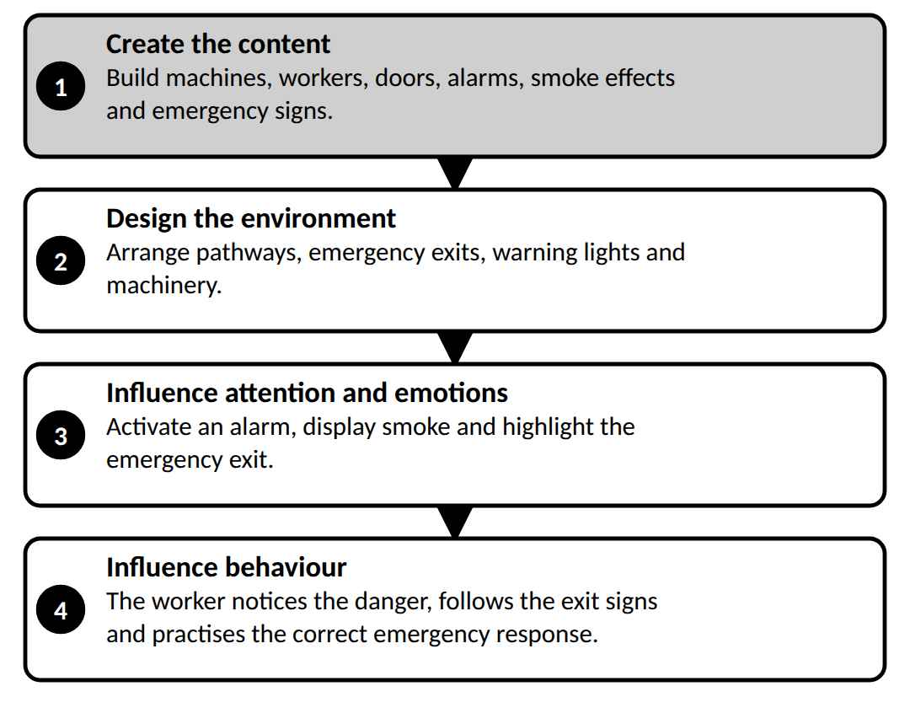
1.5 Conclusion
Content creation provides the digital elements of VR, while environmental design arranges these elements to influence attention, emotions, decisions and actions. Through spatial guidance, sensory stimuli, attention control, feedback and social design, VR applications can support training, education, therapy and behaviour development.
2. INTERACTION: HUMAN-CENTRED INTERACTION – INTERACTION PATTERNS AND TECHNIQUES
2.1 Introduction
Interaction is what allows users to do something inside a virtual environment rather than merely watch it.
For example, in a VR laboratory, a student should be able to pick up a test tube, turn a valve, press a button and observe the result.
If these actions require complicated controls, the student will spend more time learning the interface than learning the experiment.
Therefore, VR interaction must be designed around the user. This leads to three connected ideas:
1. Human-centred interaction
2. Interaction patterns
3. Interaction techniques
2.2 Human-Centred Interaction
Human-centred interaction is an approach to designing interactive systems by considering the user's needs, abilities, expectations, comfort and limitations.
The main idea is simple: instead of forcing users to adapt to complicated technology, developers should design the technology to suit users.
A. UNDERSTANDING THE USER
Before developing the interaction, designers consider:
• Who will use the application?
• What tasks must they perform?
• What do they already know?
• What physical or cognitive limitations might they have?
• What environment will they use the system in?
For example, a VR application for school students should use simpler controls and clearer instructions than a complex industrial simulation designed for trained engineers.
B. NATURAL INTERACTION
Where appropriate, VR interactions should resemble familiar physical actions.
In a real laboratory, a student turns a valve by gripping and rotating it. A VR laboratory can reproduce the same action using hand tracking or a controller.
This makes the interaction easier to understand because it uses familiar movements.
C. FEEDBACK
Feedback tells users what happened after they performed an action.
Suppose a user presses a virtual switch. If nothing changes, the user may wonder whether the switch worked.
The system can provide feedback through:
• A change in colour
• An animation
• A sound
• A controller vibration
• A change in the virtual environment
For example, when a student activates a virtual machine, the switch changes position and the machine starts running.
D. USABILITY AND ACCESSIBILITY
Usability refers to how easily and effectively users can achieve their goals.
Accessibility means designing interactions so that people with different abilities can use the application.
Developers can improve both by providing clear instructions, readable text, adjustable controls and alternative input methods where appropriate.
E. COMFORT AND SAFETY
VR users may experience physical fatigue or discomfort if interactions require repeated stretching, awkward movements or excessive head turning.
A human-centred design therefore considers reach, posture, movement, session duration and possible discomfort.
For example, frequently used virtual buttons should be placed within a comfortable reach rather than far above the user's head.
2.3 Interaction Patterns
An interaction pattern is a reusable design solution for a common interaction problem.
Instead of inventing a completely new method for every task, developers can reuse familiar patterns across applications.
A. SELECTION PATTERN
Selection allows a user to choose an object or option.
For example, a student points towards a virtual chemical bottle and selects it.
The system must identify which object the user intends to select.
B. MANIPULATION PATTERN
Manipulation allows users to change an object's position, orientation or other properties.
For example, a student picks up a virtual test tube, rotates it and places it inside a rack.
C. NAVIGATION PATTERN
Navigation allows users to move through a virtual environment.
For example, a trainee walks around a virtual factory or selects a destination and teleports there.
D. COMMAND AND MENU PATTERN
Users choose a command or setting from a menu.
For example, a student selects Start Experiment from a floating menu.
E. FEEDBACK PATTERN
The system communicates the result of an interaction.
For example, a virtual indicator turns green when the student completes a procedure correctly.
These patterns make the system more predictable because users can learn a common interaction method and reuse it.
2.4 Interaction Techniques
An interaction technique is the specific technical method used to carry out an interaction.
The difference is important:
• Selection is an interaction pattern.
• Ray casting is one technique used to perform selection.
A. RAY CASTING
Ray casting uses an imaginary ray projected from a controller, hand or viewpoint towards an object.
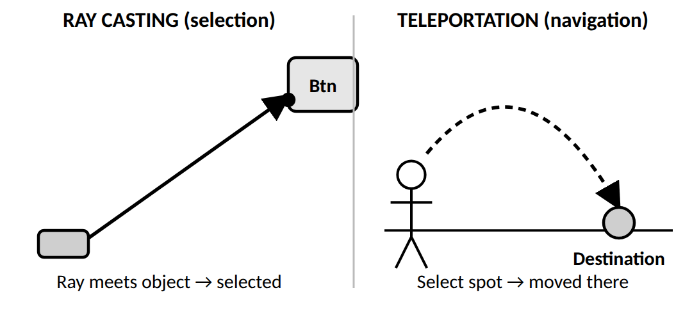
When the ray intersects a selectable object, the system identifies the target.
Example: A user points a controller at a distant button in a VR control room and presses the trigger to select it.
Why it is useful: The user can select distant objects without walking towards them.
B. DIRECT MANIPULATION
Direct manipulation allows users to interact with an object by reaching towards it and moving it directly.
The system tracks the user's hand or controller and updates the object's position or orientation.
Example: A student grabs a virtual beaker, moves it to a table and rotates it to inspect its contents.
Why it is useful: It resembles real-world interaction and is suitable for picking up and arranging objects.
C. GESTURE-BASED INTERACTION
Gesture-based interaction recognises hand or body movements and converts them into commands.
For example, waving a hand might open a menu, while a recognised hand gesture might activate a virtual control.
The system uses cameras or tracking sensors to detect the gesture.
D. GAZE-BASED INTERACTION
Gaze-based interaction uses the direction of the user's eyes or viewpoint to identify the object they are looking at.
The user may then confirm the selection using a button, controller or a specified gaze duration.
For example, a user looks at a virtual instruction panel and presses a controller button to open it.
E. TELEPORTATION
Teleportation is a navigation technique in which the user selects a destination and is moved there without physically travelling through the intermediate space.
For example, a user points to a location in a large virtual factory and teleports to that location.
Teleportation can reduce the need for continuous artificial movement and may be more comfortable for some users.
2.5 Complete Working Example
Imagine a VR training application for operating industrial machinery.
1. The designer studies the operator's needs and makes the controls easy to understand. This is human-centred interaction.
2. The operator selects a machine control. This uses the selection pattern.
3. The operator points a controller at a distant switch. This uses ray casting.
4. The operator activates the switch and sees the machine start. This is feedback.
5. The operator moves to another part of the factory using teleportation. This is a navigation technique.
The example shows how human-centred design, interaction patterns and interaction techniques work together.
2.6 Conclusion
Human-centred interaction ensures that VR systems meet user needs and provide comfortable, understandable controls. Interaction patterns provide reusable solutions to common tasks, while interaction techniques explain how those tasks are performed. Together, they improve usability, accuracy, accessibility and immersion.
3. ITERATIVE DESIGN: DEFINE, MAKE AND LEARN STAGES
3.1 Introduction
When developers build a VR application for the first time, they cannot always predict how real users will respond to it.
A control that looks easy to the developer may be difficult for a student to use. A virtual environment may look realistic but cause discomfort when users move around.
If developers release the application without testing it, these problems may remain undiscovered.
Iterative design solves this problem by repeatedly developing, testing and improving the application.
The three stages are Define, Make and Learn.
3.2 Stage 1 — Define
The Define stage identifies the problem to be solved, the target users and the requirements of the VR application.
The developer first asks: What are we trying to achieve, and what should the user be able to do?
ACTIVITIES IN THE DEFINE STAGE
A. IDENTIFY THE PROBLEM
Determine why the application is required.
Example: Students cannot safely practise certain experiments using real laboratory equipment.
B. UNDERSTAND THE USERS
Identify their knowledge, abilities, expectations and limitations.
Example: Students may have little experience operating laboratory equipment.
C. DEFINE REQUIREMENTS
Specify the functions and interactions the application must support.
Example: Students must be able to select equipment, perform steps in the correct order and receive feedback when they make mistakes.
D. ESTABLISH SUCCESS CRITERIA
Decide how to measure whether the application works well.
Possible criteria include task completion, accuracy, usability, learning improvement and user comfort.
OUTPUT OF THE DEFINE STAGE
The result is a clear understanding of the problem, the intended users and the requirements for the first prototype.
3.3 Stage 2 — Make
The Make stage converts the defined requirements into a prototype or working VR application.
A prototype is an early version of a product that allows developers to test their ideas before completing the final system.
ACTIVITIES IN THE MAKE STAGE
A. CREATE THE ENVIRONMENT
Developers create the virtual room, laboratory, factory or other environment.
B. BUILD DIGITAL ASSETS
They create or import 3D objects, textures, lighting and animations.
C. IMPLEMENT INTERACTIONS
They add selection, manipulation, navigation and other controls.
D. ADD FEEDBACK
They implement visual indicators, sounds or other responses to user actions.
E. BUILD THE PROTOTYPE
The features are integrated into a testable application.
EXAMPLE
For the virtual laboratory, developers create a room, virtual test tubes, laboratory equipment, control panels and instructions. Students can interact with the equipment and complete a basic experiment.
The prototype may not contain every planned feature. Its purpose is to test the main ideas.
3.4 Stage 3 — Learn
The Learn stage determines whether the prototype meets the requirements by observing users and evaluating their performance.
Developers do not simply ask whether users like the application. They also investigate whether users can perform the required tasks effectively.
ACTIVITIES IN THE LEARN STAGE
A. USER TESTING
Ask representative users to complete tasks using the prototype.
B. OBSERVE BEHAVIOUR
Check where users hesitate, make mistakes or struggle to understand controls.
C. COLLECT FEEDBACK
Gather comments about interaction, navigation, comfort and usability.
D. EVALUATE PERFORMANCE
Measure task completion, errors, time taken and other relevant criteria.
E. IDENTIFY IMPROVEMENTS
Use the findings to determine what should change in the next version.
EXAMPLE
During testing, students report that the virtual test tubes are difficult to grab. They also find the instructions confusing.
Developers learn that the object selection and instruction design need improvement.
The feedback becomes the starting point for the next development cycle.
3.5 The Complete Iterative Design Cycle
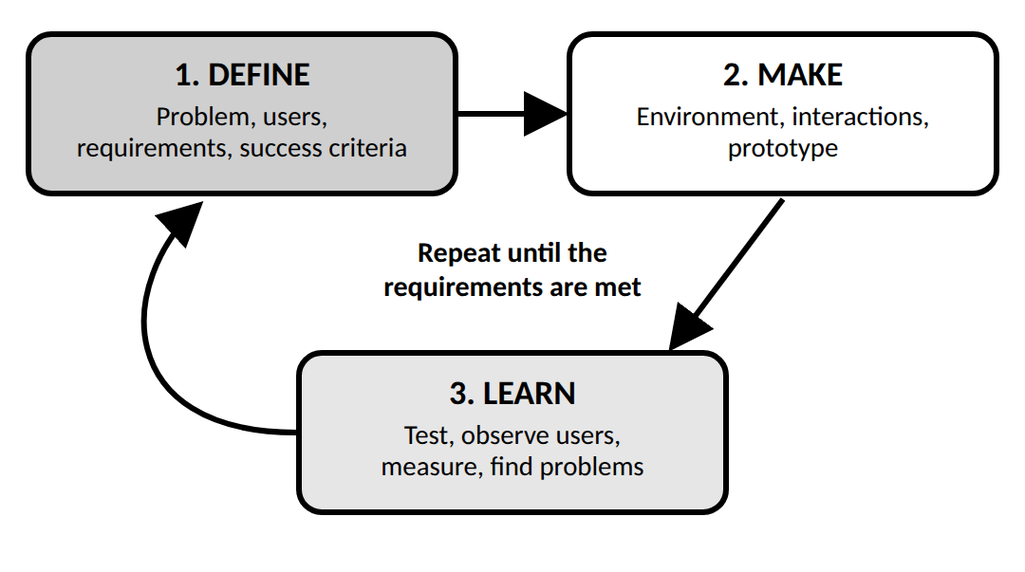
1. DEFINE
Identify the problem, understand users, define requirements and set success criteria.
2. MAKE
Create the environment, implement interactions and build a prototype.
3. LEARN
Test the prototype, observe users, measure performance and identify problems.
The findings lead to a new Define stage, followed by another Make and Learn cycle.
The cycle is repeated until the application satisfies its requirements to an acceptable level.
3.6 Why Is Iterative Design Important in VR?
1. EARLY PROBLEM DETECTION
Developers discover confusing controls or technical problems before the final release.
2. IMPROVED USABILITY
User feedback helps make controls, menus and navigation easier to understand.
3. BETTER COMFORT
Testing can reveal discomfort caused by movement, interaction or visual performance.
4. REDUCED DEVELOPMENT RISK
Developers can test assumptions before investing time in a complete application.
5. CONTINUOUS IMPROVEMENT
Each iteration provides new information that can be used to improve the next version.
6. BETTER ALIGNMENT WITH USER REQUIREMENTS
The final application is based on actual user needs and testing results rather than assumptions alone.
3.7 Conclusion
Iterative design is a continuous improvement process used to develop effective VR applications. In the Define stage, developers identify user needs and requirements. In the Make stage, they create a prototype. In the Learn stage, they test it and use the results to plan improvements. Repeating these stages produces a more usable, reliable and comfortable VR experience.
4. ADVERSE HEALTH EFFECTS: MOTION SICKNESS – HARDWARE CHALLENGES – LATENCY
4.1 Introduction
VR creates an immersive experience by displaying a virtual environment that responds to the user's movements.
For the experience to feel natural, the headset must track movement accurately, render the scene quickly and display the updated image without noticeable delay.
If the visual scene does not match the user's physical movements, the brain may receive conflicting information. Some users may then experience dizziness, nausea or other discomfort.
This topic covers three connected areas:
1. Adverse health effects, particularly motion sickness
2. Hardware challenges
3. Latency
4.2 Adverse Health Effects: Motion Sickness
WHAT IS MOTION SICKNESS IN VR?
VR motion sickness is discomfort experienced by some users when the virtual movement they see conflicts with the movement signals received from their body.
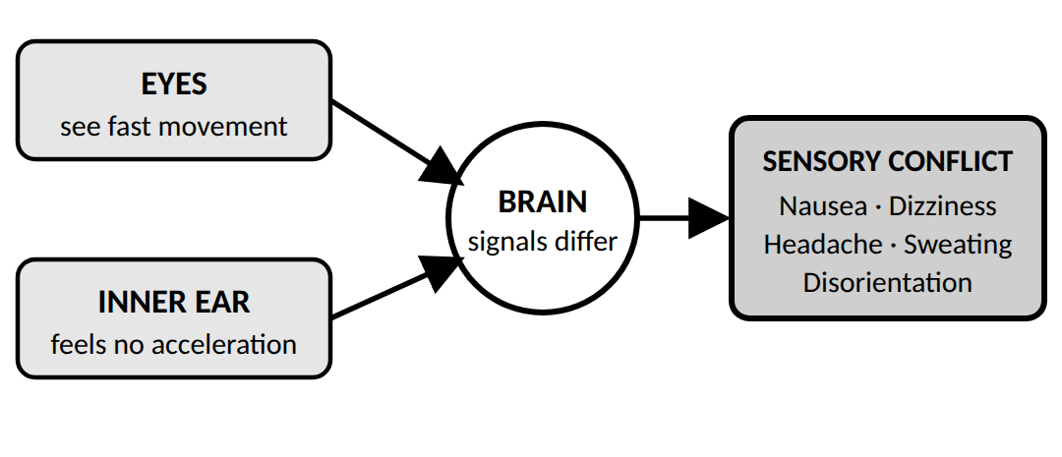
To understand this, remember that the brain uses the eyes, inner ear and other sensory systems to understand movement and balance.
Suppose you are sitting on a chair and wearing a VR headset. The headset displays a virtual roller coaster moving rapidly around a track.
Your eyes see rapid movement, but your inner ear does not detect the same physical acceleration. The difference between these signals can cause sensory conflict.
This can lead to VR motion sickness.
SYMPTOMS
Common symptoms include:
• Nausea
• Dizziness
• Headache
• Sweating
• Eye strain
• Disorientation
• Loss of balance
The severity varies between users and depends on factors such as the application, movement design and individual sensitivity.
CAUSES OF MOTION SICKNESS
A. SENSORY CONFLICT
The visual system indicates movement while the vestibular system in the inner ear senses little or different movement.
B. HIGH LATENCY
When the virtual scene responds late to a head movement, the visual information does not match the user's current position.
C. UNNATURAL MOVEMENT
Sudden acceleration, rapid rotation or forced camera movement can make users uncomfortable.
D. UNSTABLE FRAME RATE
When the display receives frames irregularly, the scene may appear jerky or inconsistent.
E. POORLY SYNCHRONISED FEEDBACK
If visual, auditory and haptic responses occur at different times, the experience can feel unnatural.
HOW CAN MOTION SICKNESS BE REDUCED?
1. Maintain a stable frame rate.
2. Reduce motion-to-photon latency.
3. Use accurate head tracking.
4. Avoid unnecessary rapid camera movements.
5. Offer comfortable movement methods, such as teleportation.
6. Allow users to take breaks and adjust comfort settings.
Important: These methods reduce risk, but they cannot guarantee that every user will remain comfortable.
4.3 Hardware Challenges in VR
VR applications depend on several hardware components working together. These include the headset display, lenses, tracking sensors, controllers, processor and graphics hardware.
Each component has its own technical limitations.
A. DISPLAY RESOLUTION
Resolution determines how much visual detail the display can show.
If the resolution is too low, text and objects may appear blurry or pixelated. This reduces realism and can make small objects difficult to identify.
Example: In a VR medical-training application, low resolution may make it difficult to read small labels on virtual equipment.
B. REFRESH RATE AND FRAME RATE
The refresh rate is how often the display updates per second, measured in hertz (Hz).
The frame rate is how many frames the graphics system produces per second, measured in frames per second (FPS).
These measurements are related but not identical.
If the application cannot produce frames consistently, motion may appear uneven. Higher and stable frame rates are generally important for comfortable VR; the appropriate target depends on the headset and application.
C. TRACKING ACCURACY
Tracking systems measure head, hand or controller movement.
If tracking is inaccurate, virtual objects may appear to drift or move incorrectly relative to the user.
Example: When a user reaches for a virtual tool, poor hand tracking may cause the tool to appear in the wrong location.
D. PROCESSING AND RENDERING POWER
The processor and graphics hardware must calculate the scene and produce images quickly.
Complex 3D models, detailed textures, realistic lighting and many moving objects increase the rendering workload.
If the hardware cannot handle the workload, the application may drop frames or respond slowly.
Developers can reduce the workload by optimising models, simplifying unnecessary details and using efficient rendering methods.
E. WEIGHT, ERGONOMICS AND BATTERY LIFE
The headset must also be comfortable to wear.
Excessive weight, poor fit and uncomfortable straps may cause fatigue. For standalone headsets, limited battery life can restrict the duration of a session.
SUMMARY OF HARDWARE CHALLENGES
Hardware component | Possible problem | Result
Display | Low resolution | Blurry visuals
Display and graphics system | Unstable frame rate | Jerky motion
Tracking sensors | Inaccurate measurements | Object drift
Processor and GPU | Insufficient performance | Delayed or dropped frames
Headset design | Excessive weight or poor fit | Physical discomfort
Battery | Limited operating time | Shorter sessions

4.4 Latency in VR
DEFINITION
Latency is the delay between a user's action or an input from a sensor and the corresponding response from the VR system.
One particularly important type is motion-to-photon latency. This is the time between a user's physical head movement and the corresponding updated image appearing on the display.
HOW LATENCY OCCURS
Imagine turning your head to the left while wearing a VR headset.
The system must complete several operations:
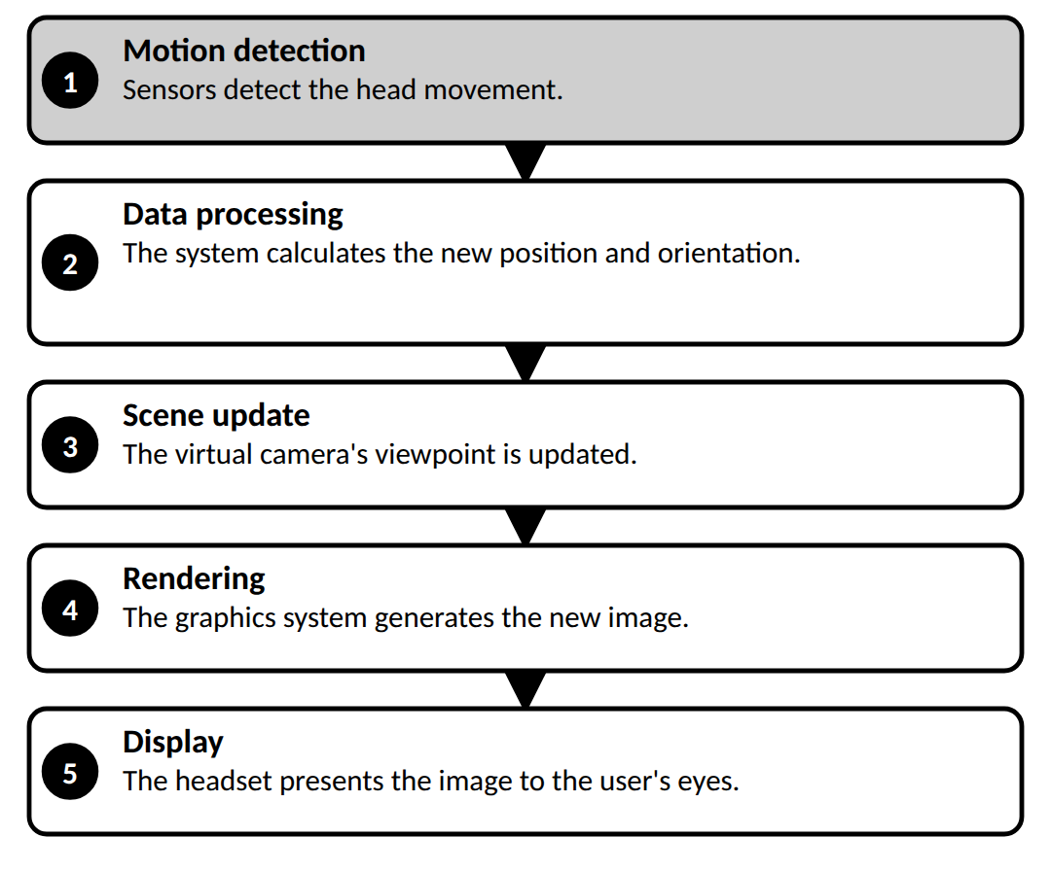
Each stage requires time. The combined delay contributes to the response latency.
WHAT HAPPENS WHEN LATENCY IS HIGH?
Suppose the user turns their head, but the virtual scene updates only after a noticeable delay.
The scene appears to lag behind the user's movement. The visual information no longer matches the user's current head position, which can reduce immersion and increase discomfort.
Possible effects include:
• Delayed visual response
• Reduced interaction accuracy
• Unstable or unnatural scene movement
• Increased risk of motion sickness
HOW CAN LATENCY BE REDUCED?
A. OPTIMISE RENDERING
Simplify unnecessary details and use efficient graphics techniques so that frames can be generated quickly.
B. IMPROVE TRACKING
Use accurate, responsive sensors to measure user movement.
C. MAINTAIN A STABLE FRAME RATE
Ensure the graphics system produces frames consistently.
D. REDUCE PROCESSING OVERHEAD
Avoid unnecessary calculations that delay the visual update.
E. USE PREDICTIVE TECHNIQUES
Where supported, techniques such as asynchronous timewarp can adjust a rendered image using more recent head-pose information to reduce perceived delay.
Your staff's VR/AR notes also identify low latency—ideally below approximately 20 milliseconds in the described context—as important for preserving temporal consistency and reducing perceptual mismatch. This is a design target, not a guarantee that motion sickness will be eliminated.
4.5 Relationship Between Motion Sickness, Hardware and Latency
These concepts are related, but they are not identical.
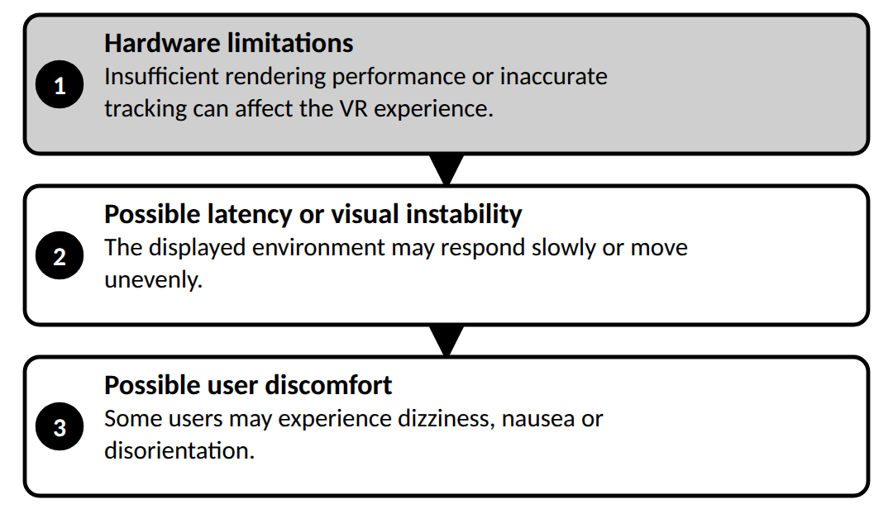
However, motion sickness can also occur when latency is low because sensory conflict and individual sensitivity may still be involved. Likewise, not every hardware problem causes latency.
4.6 Conclusion
Motion sickness, hardware limitations and latency are important challenges in VR development. Motion sickness can result from conflicting sensory signals, while hardware limitations can affect visual quality, tracking and rendering performance. Latency delays the response between user movement and the displayed scene. Accurate tracking, efficient rendering, stable frame rates and comfortable interaction design help create safer and more responsive VR experiences.
MODULE 4 NOTES

You're absolutely right. I missed Head-Mounted Displays (HMDs) in the display types, even though they are explicitly listed in your staff's PDF. I'll correct that and include the full set of headings and subheadings supported by the reference material.
COMPONENTS OF AUGMENTED REALITY — COMPLETE 5-MARK NOTES
1. Displays in Virtual and Augmented Reality
DEFINITION
Displays are the primary output devices in VR and AR systems. They present computer-generated imagery to the user's eyes and act as the window between the virtual or augmented world and the user.
The quality of a display affects immersion, image clarity, comfort and responsiveness.
CLASSIFICATION OF DISPLAYS
1. HEAD-MOUNTED DISPLAYS (HMDS)
HMDs are wearable devices that cover the user's eyes and provide a stereoscopic 3D view. Each eye receives a slightly different image, called binocular disparity, which helps create the perception of depth. The system also tracks head movement and updates the displayed image.
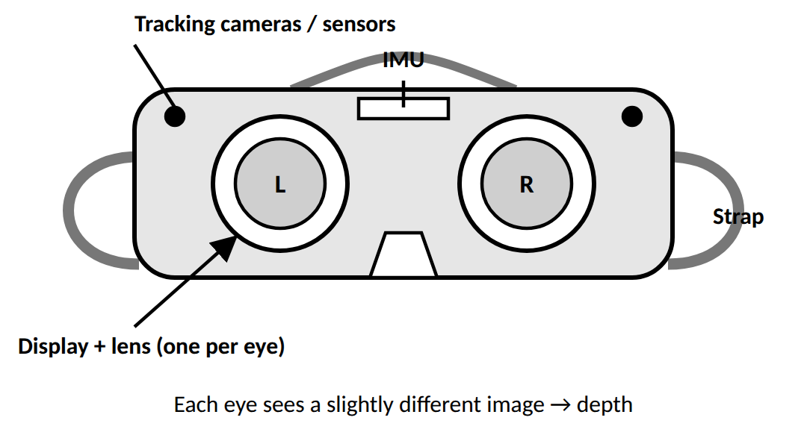
• EXAMPLES: Meta Quest 3, HTC Vive Pro and PlayStation VR2.
• APPLICATIONS: Gaming, training simulators and telepresence.
• KEY PARAMETERS IN THE STAFF NOTES: Quest 3 resolution of 1832 × 1920 per eye, refresh rate of 90–120 Hz, typical FOV of 100–120°, and low latency.
2. OPTICAL SEE-THROUGH DISPLAYS
These displays allow users to see the real world directly while digital information is overlaid using transparent optical elements, such as waveguides or semi-transparent mirrors.
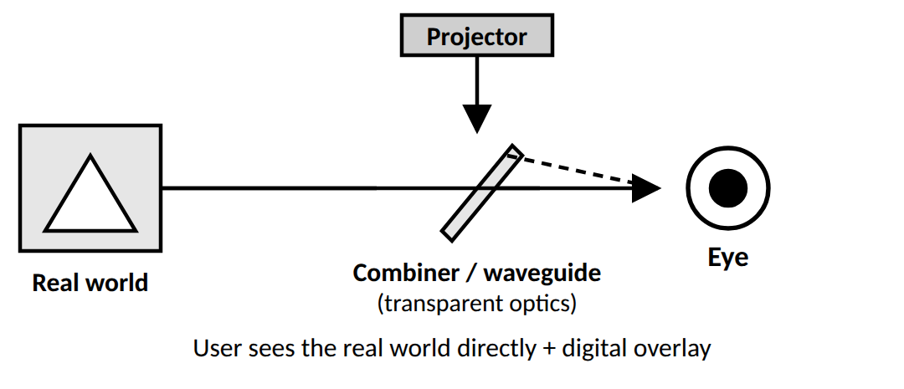
• EXAMPLES: Microsoft HoloLens 2 and Magic Leap 2.
• CHALLENGE: Correct depth alignment and sufficient brightness, especially outdoors.
3. VIDEO SEE-THROUGH DISPLAYS
Cameras capture the real environment. The system processes the video, combines it with digital content and displays the combined image to the user.
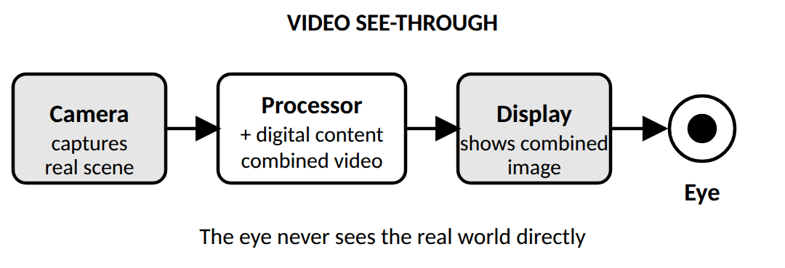
• EXAMPLE: Varjo XR-4 mixed-reality headset.
• APPLICATION: Industrial training and precise AR-assisted assembly.
4. PROJECTION-BASED DISPLAYS
Projectors cast visual information onto physical surfaces, creating a shared immersive environment without requiring every user to wear a headset.
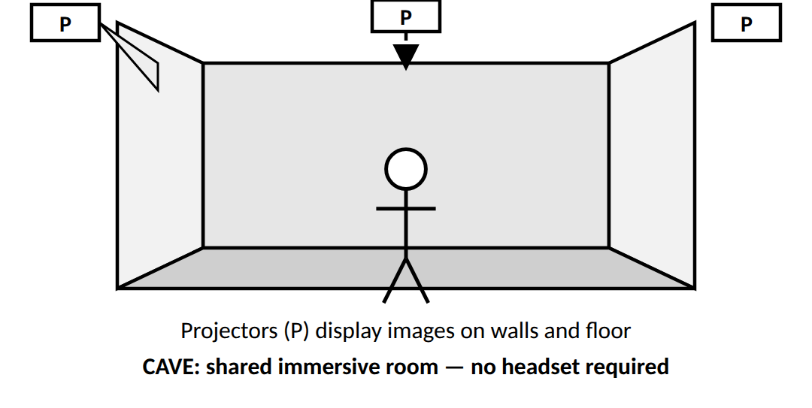
• EXAMPLE: CAVE (Cave Automatic Virtual Environment) systems using synchronised projectors on walls and floors.
• APPLICATION: Engineering design and large-scale visualisation.
5. MONITOR-BASED DISPLAYS
These use ordinary computer screens to display virtual environments. They are generally non-immersive or semi-immersive and are suitable for desktop-based applications.
• EXAMPLE: Desktop VR training or 3D modelling using Blender.
• ADVANTAGE: Cost-effective and does not require a head-mounted device.
KEY DISPLAY PARAMETERS
• FIELD OF VIEW (FOV): The amount of the scene visible at once.
• RESOLUTION: Determines image sharpness; higher resolution can reduce the screen-door effect.
• REFRESH RATE: The number of display updates per second; stable, high refresh rates support smooth motion.
• LATENCY: The delay between a user's action and the display response.
• INTERPUPILLARY DISTANCE (IPD): The distance between the centres of the pupils; adjustable lens spacing helps provide proper depth perception.
Conclusion: Different display types serve different AR/VR needs. Their resolution, FOV, refresh rate, latency and ergonomics affect visual quality and user comfort.
2. Tracking in Augmented Reality
DEFINITION AND IMPORTANCE
Tracking continuously estimates the position and orientation, or pose, of the camera or user relative to the physical environment.
For example, when a virtual chair is placed on a real floor, it should remain anchored there as the user moves around. Tracking enables the system to update the chair's position on the screen accordingly.
Accurate tracking provides stable registration, natural interaction and fewer visual errors.
TYPES OF TRACKING METHODS
1. SENSOR-BASED TRACKING
Uses inertial sensors to estimate device motion.
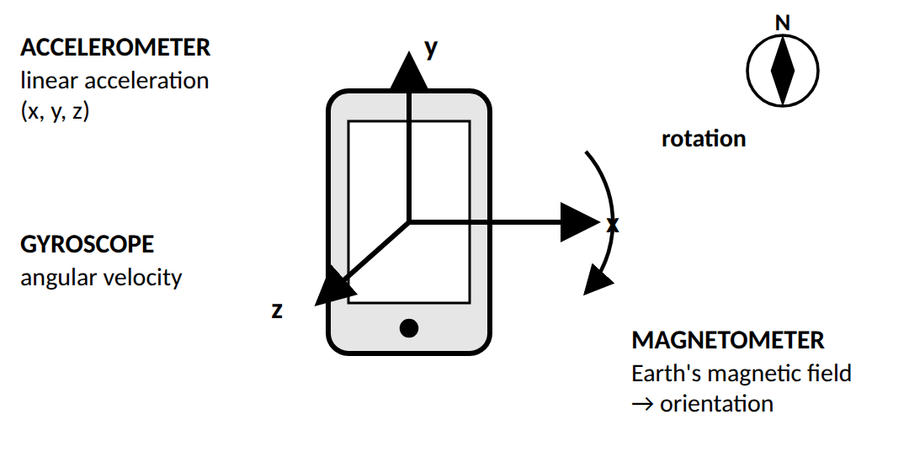
• ACCELEROMETER: Measures linear acceleration along the x, y and z directions.
• GYROSCOPE: Measures angular velocity, or rotational movement.
• MAGNETOMETER: Measures Earth's magnetic field to help determine orientation.
Example: A phone detects tilting and rotation so the AR view can respond.
2. VISION-BASED TRACKING
Uses computer vision to analyse camera images and identify reference points or patterns.
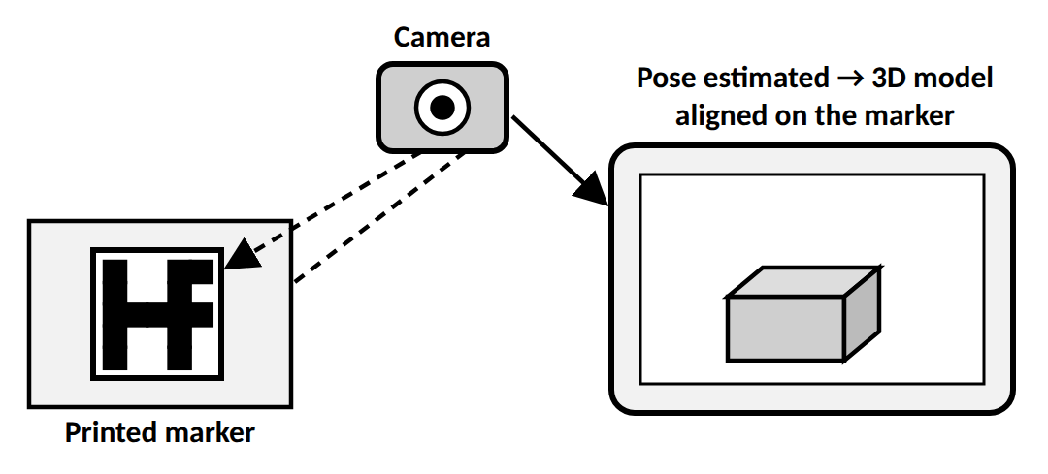
It includes:
• MARKER-BASED TRACKING: Uses predefined images or symbols, such as QR codes or fiducial markers, to estimate camera pose. Example: displaying a 3D car model when a printed image is recognised.
• MARKERLESS TRACKING (FEATURE-BASED): Detects natural features such as corners, edges and textures without requiring a special marker. Example: anchoring a virtual object to a detected floor.
3. HYBRID TRACKING
Combines sensor-based and vision-based tracking. Inertial sensors provide fast movement measurements, while camera-based tracking helps improve positional accuracy.
Example: Microsoft HoloLens uses SLAM approaches that combine visual and inertial information.
TRACKING PIPELINE
1. DATA ACQUISITION: Capture camera images and sensor data.
2. FEATURE DETECTION: Identify distinctive points, such as corners and edges.
3. FEATURE MATCHING: Track these points across successive frames.
4. POSE ESTIMATION: Calculate the device's position and orientation.
5. RENDERING UPDATE: Update virtual content to maintain alignment.
Conclusion: Tracking enables AR content to stay aligned with the real environment. Sensor-based, vision-based and hybrid methods provide different ways to estimate the user's position and movement.
3. Computer Vision for Augmented Reality
DEFINITION
Computer Vision (CV) enables computers to interpret and process visual information from images and videos. In AR, it helps systems recognise objects, track movement, detect surfaces and place virtual content in suitable real-world locations.
ROLES OF COMPUTER VISION
1. OBJECT DETECTION AND RECOGNITION: Identifies real-world objects, images or faces.
2. FEATURE TRACKING AND POSE ESTIMATION: Determines camera position and orientation relative to physical features.
3. SCENE RECONSTRUCTION AND MAPPING: Builds a representation of the environment for virtual object placement.
4. SEGMENTATION AND OCCLUSION HANDLING: Separates objects and backgrounds so real objects can correctly appear in front of virtual objects.
5. DEPTH ESTIMATION: Determines how far objects are from the camera.
KEY COMPUTER VISION TECHNIQUES
A. FEATURE DETECTION AND MATCHING
Identifies distinctive points or patterns across images. Algorithms listed in the staff notes include SIFT (Scale-Invariant Feature Transform), SURF (Speeded-Up Robust Features) and ORB (Oriented FAST and Rotated BRIEF).
Purpose: Supports stable tracking and accurate virtual object alignment.
B. POSE ESTIMATION
Calculates the camera's position and orientation, including its six degrees of freedom (6DoF): three positional axes and three rotational axes.
Techniques include:
• PNP (PERSPECTIVE-N-POINT): Estimates camera pose from corresponding 3D points and their 2D image locations.
• VISUAL-INERTIAL ODOMETRY (VIO): Combines camera and inertial sensor data.
C. IMAGE AND OBJECT RECOGNITION
Uses machine learning or deep learning, including CNNs (Convolutional Neural Networks), to identify known images and objects.
Example: An AR museum app recognises a painting and displays an animation about the artist.
Tools and frameworks listed in the notes include TensorFlow, OpenCV, ARToolKit and Vuforia.
D. SIMULTANEOUS LOCALIZATION AND MAPPING (SLAM)
SLAM builds a map of the environment while simultaneously estimating the device's position within that map.
Example: Detecting walls and floors so virtual furniture can be placed stably.
E. DEPTH SENSING AND SCENE RECONSTRUCTION
Estimates the distance of objects from the camera and helps reconstruct the scene's 3D geometry.
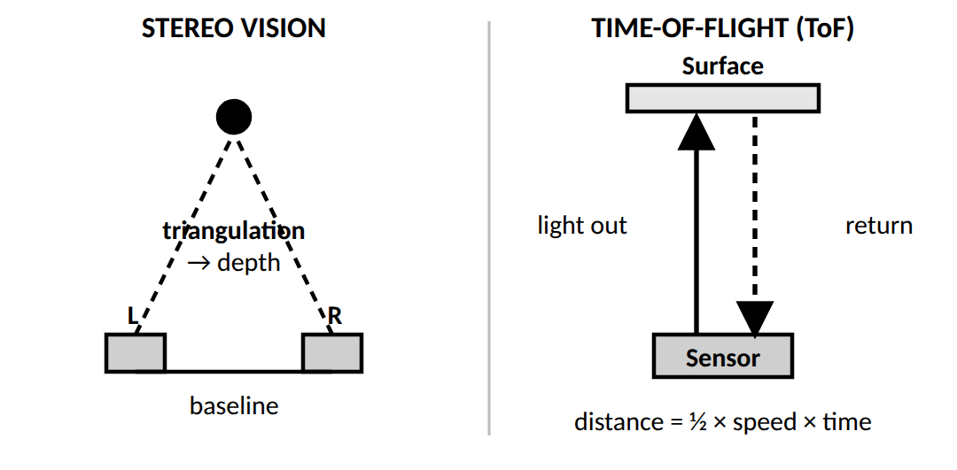
Methods include:
• STEREO VISION: Uses two cameras to estimate depth through triangulation.
• TIME-OF-FLIGHT (TOF): Measures the time taken for light to travel to a surface and return.
• STRUCTURED LIGHT: Projects infrared patterns and analyses their deformation to estimate depth.
F. SEGMENTATION AND OCCLUSION HANDLING
Segmentation separates parts of a scene, such as a person and the background. Occlusion handling ensures that nearer real objects correctly block virtual objects behind them.
Example: An AR hat appears in front of a person's head rather than incorrectly behind it.
COMPUTER VISION PIPELINE
1. Image capture.
2. Preprocessing, such as noise reduction and colour normalisation.
3. Feature detection.
4. Feature matching.
5. Pose estimation.
6. Rendering of aligned virtual content.
Conclusion: Computer vision allows AR systems to interpret the physical environment and maintain context-aware, correctly positioned digital content.
4. Visual Coherence, Diminished Reality and Camera Simulation
A. VISUAL COHERENCE
Visual coherence is the degree of perceptual harmony between real surroundings and virtual content. Virtual objects should look as though they naturally belong in the physical environment.
Its main factors are:
1. LIGHTING CONSISTENCY: Virtual objects should reflect and cast light consistently with the surroundings.
2. COLOUR AND TONE MATCHING: Hue, brightness and contrast should suit the real scene.
3. DEPTH AND OCCLUSION HANDLING: Real and virtual objects should overlap correctly according to their positions.
4. SHADOW INTEGRATION: Virtual shadows should match the real lighting setup.
5. TEXTURE MAPPING AND SHADING: Virtual surfaces should have suitable texture, finish and reflectivity.
Example: A virtual lamp placed in a real room should have appropriate lighting and cast a shadow consistent with the room's light source.
B. DIMINISHED REALITY (DR)
Diminished Reality removes or modifies selected real-world objects from the user's view and reconstructs the background behind them.
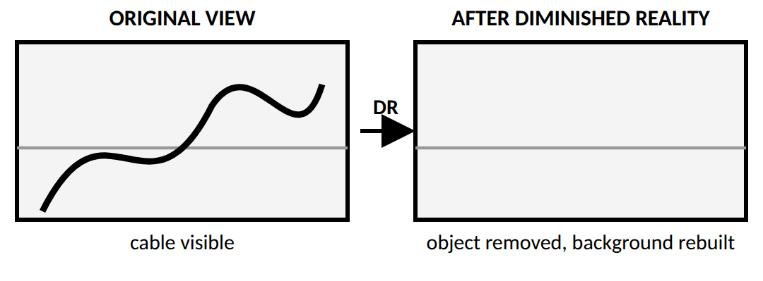
Unlike ordinary AR, which adds digital elements, DR can remove existing elements from the scene.
WORKFLOW
1. SCENE CAPTURE: Capture the live camera view.
2. OBJECT DETECTION AND SEGMENTATION: Identify the object to remove.
3. BACKGROUND ESTIMATION: Estimate the hidden background using surrounding image information, optical flow or depth-based modelling.
4. INPAINTING OR RECONSTRUCTION: Fill the missing region using image reconstruction algorithms.
5. RENDERING AND DISPLAY: Display the modified scene with the object removed.
ALGORITHMS AND TECHNIQUES
• IMAGE INPAINTING: Reconstructs missing image regions. Methods in the notes include Navier–Stokes-based diffusion, PatchMatch and deep-learning approaches such as GANs.
• DEPTH-BASED REMOVAL: Uses depth information, including LiDAR, to identify foreground objects and reconstruct occluded regions.
• TEMPORAL CONSISTENCY: Maintains a stable background across video frames to reduce flickering and distortion.
Example: A DR system removes a microphone or cable from a live camera view and reconstructs the background.
C. CAMERA SIMULATION
Camera simulation digitally models a physical camera's geometry and optical behaviour so virtual content can be rendered with the correct perspective and scale.
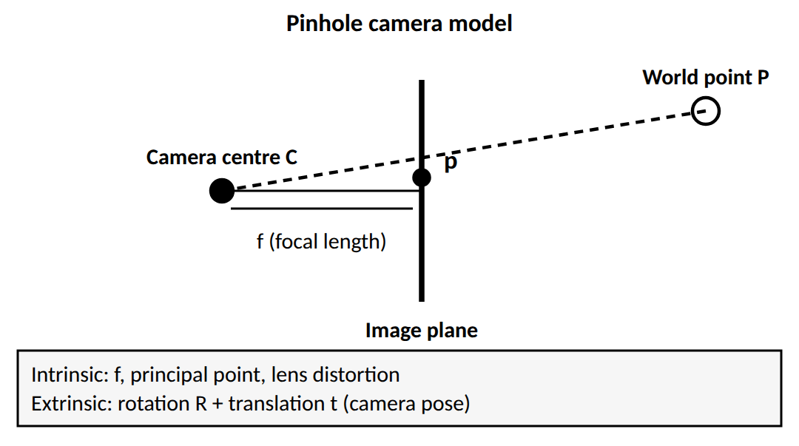
It uses two main groups of camera parameters:
• INTRINSIC PARAMETERS: Internal properties such as focal length, sensor size and lens distortion.
• EXTRINSIC PARAMETERS: Camera position and orientation in space.
COMPONENTS OF CAMERA SIMULATION
1. FIELD OF VIEW (FOV): The angular extent of the visible scene. Matching FOV helps maintain appropriate scale and depth perception.
2. FOCAL LENGTH AND ASPECT RATIO: Focal length affects magnification and perspective; aspect ratio defines image width relative to height.
3. LENS DISTORTION MODELLING: Models or corrects barrel and pincushion distortion caused by real lenses.
4. DEPTH OF FIELD (DOF): The range of distances that appear sharply focused. Simulating it can help direct attention and improve realism.
5. EXPOSURE, LIGHTING AND COLOUR MATCHING: Adjusts exposure, white balance, tone mapping and HDR settings so virtual elements match the real illumination.
CAMERA CALIBRATION
Calibration establishes the relationship between 3D world coordinates and 2D image coordinates.
• INTRINSIC CALIBRATION: Determines focal length, principal point, skew and distortion coefficients.
• EXTRINSIC CALIBRATION: Determines camera translation and rotation relative to the world or tracking system.
Example: In an AR navigation app, virtual arrows should appear to sit on the road rather than float in front of it. Camera modelling and calibration help achieve the correct perspective and alignment.
Conclusion: Visual coherence integrates digital and physical visuals, DR removes unwanted scene elements, and camera simulation reproduces camera behaviour to support realistic rendering.
5. Interaction: Output and Input Modalities
Your staff PDF discusses these modalities in the context of VR-based industrial training simulators. The same interaction principles can also be applied to AR systems.
DEFINITION
Interaction modalities are the ways users provide input to a system and receive responses from it.
• Output modalities deliver sensory feedback.
• Input modalities capture the user's physical or behavioural actions.
Their purpose is to reproduce relevant visual, auditory and physical cues so users can interact naturally and develop operational skills.
A. OUTPUT MODALITIES
1. Visual Output
• HEAD-MOUNTED DISPLAYS (HMDS): Provide stereoscopic 3D visuals and depth perception. Examples include Meta Quest 3 and HTC Vive Pro.
• PROJECTION-BASED VR (CAVE): Uses multiple projected surfaces for room-scale visualisation.
• Eye-tracking integration and foveated rendering: Foveated rendering concentrates high visual detail around the user's gaze, improving efficiency.
Example: In a forklift simulator, visual depth cues help the operator estimate the distance to a pallet.
2. Auditory Output
• SPATIAL AUDIO SYSTEMS: Make sounds appear to come from particular directions.
• VOICE FEEDBACK SYSTEMS: Provide spoken instructions and procedural guidance.
Example: A trainee hears an alarm from the direction of a simulated machine fault.
3. Haptic Feedback
• HAPTIC GLOVES AND CONTROLLERS: Simulate touch when gripping tools, turning valves or pressing buttons.
• FORCE-FEEDBACK EXOSKELETONS: Simulate physical forces encountered during machinery operation.
Example: Haptic gloves simulate tool resistance during a CNC machine training exercise.
B. INPUT MODALITIES
1. Motion and Positional Tracking
• SIX DEGREES OF FREEDOM (6DOF): Tracks position along x,y,z and orientation through pitch, yaw and roll.
• INERTIAL MEASUREMENT UNITS (IMUS): Track movement and can support analysis of posture and reaction time.
• OPTICAL MARKER-BASED TRACKING: Uses cameras to track tools or body movements.
2. Gesture and Hand Tracking
• Computer vision recognises hand and finger movements.
• Hybrid hand controllers combine gesture recognition with physical buttons.
Example: A trainee uses a hand gesture to control a virtual machine without touching a physical switch.
3. Voice and Natural-Language Input
• Voice commands allow hands-free operation.
• Speech-recognition systems interpret spoken instructions.
Example: A technician says, “Activate cooling system,” while monitoring virtual gauges.
4. Eye and Head Tracking
• Eye tracking identifies the user's gaze for focus-based interaction.
• Head tracking measures head movement for viewpoint control and navigation.
C. INTEGRATING INPUT AND OUTPUT
In a hydraulic-press simulator, a trainee uses haptic gloves to grip levers, observes gauge readings visually, and hears spatial audio representing machine vibrations. Coordinating these inputs and outputs creates a multisensory feedback loop.
Conclusion: Input modalities capture user actions, while output modalities provide visual, auditory and haptic responses. Their integration improves immersion, responsiveness, motor learning and operational efficiency.
6. Augmented Paper
DEFINITION
Augmented Paper integrates physical documents or printed media with digital, interactive AR content. It connects paper-based information with 3D models, animations and multimedia.
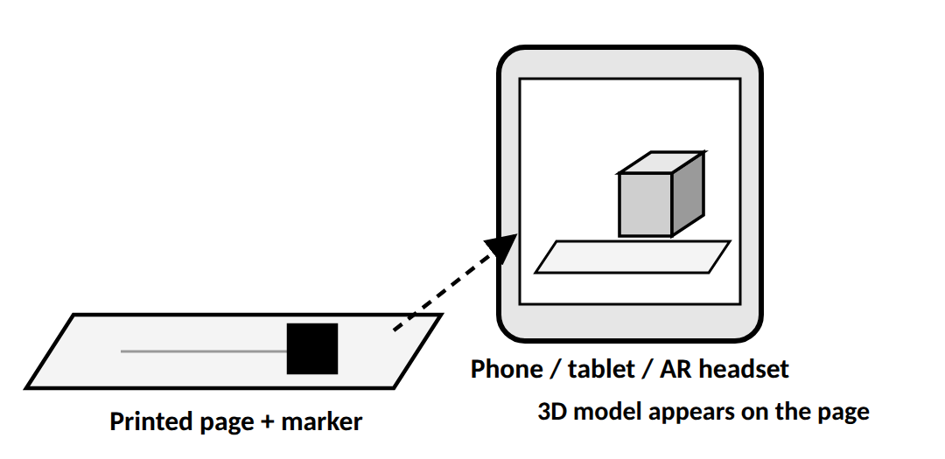
WORKING PROCESS
1. A user views a printed page through a smartphone, tablet or AR headset.
2. The camera captures the page.
3. Computer vision and image tracking identify a printed marker or pattern.
4. The system estimates the marker's position and orientation.
5. Digital content is displayed in alignment with the printed material.
TECHNOLOGIES USED
AR development tools such as Vuforia and ARCore can support image recognition, tracking and alignment. Printed markers act as reference points for the digital content.
APPLICATIONS
• EDUCATION: A textbook diagram displays an interactive 3D model.
• ENGINEERING: A printed drawing reveals a rotating mechanical component.
• ARCHITECTURE: A blueprint displays a 3D building or walkthrough.
• MAINTENANCE: A printed manual displays animations explaining repair steps.
Example: A student points a phone at an engineering drawing and sees a 3D mechanical part that can be rotated and examined from different angles.
Conclusion: Augmented Paper enhances traditional documents with interactive digital content, improving visualisation, learning and understanding.
7. Calibration and Registration
DEFINITION
Calibration and registration are foundational processes used to align virtual content accurately with the real world.
A. CALIBRATION
Calibration adjusts the camera and sensor parameters to reduce measurement errors and determine how the system observes the physical environment.
It includes:
• INTRINSIC PARAMETERS: Focal length, optical centre and lens distortion.
• EXTRINSIC PARAMETERS: Position and orientation relative to the world or tracking system.
Poor calibration can cause scale inaccuracies, drift and misalignment.
B. REGISTRATION
Registration aligns virtual objects with their corresponding real-world objects or positions in real time.
It requires tracking the user's viewpoint and relevant environmental references.
Example: In an AR surgery simulation, a virtual organ must remain accurately aligned with the patient's anatomy as the surgeon changes viewpoint.
TECHNIQUES USED
1. MARKER-BASED TRACKING: Uses known markers to estimate position and alignment.
2. SLAM: Simultaneously maps the environment and estimates the device's position.
3. SENSOR FUSION: Combines information from IMUs, GPS and optical tracking where appropriate.
REGISTRATION QUALITY
The effectiveness of registration depends on factors such as latency, stability and visual coherence. Accurate registration is essential for spatial realism and user trust.
DIFFERENCE
Calibration | Registration
Establishes accurate camera and sensor parameters. | Aligns virtual content with the real world.
Corrects measurement and geometric errors. | Maintains the intended spatial placement of virtual objects.

Conclusion: Calibration ensures accurate measurements, while registration places virtual objects correctly relative to physical objects. Both are required for dependable AR applications.
8. Modeling and Annotation
DEFINITION
Modeling creates digital representations of objects, spaces or characters. Annotation adds contextual information, such as labels, instructions and interactive notes, to improve understanding.
A. MODELING
3D modeling involves creating the geometry and appearance of digital objects.
The process may include:
1. Defining the object's shape and dimensions.
2. Applying textures and materials.
3. Setting accurate scale.
4. Adding suitable visual or physics-based properties.
5. Integrating the model into the AR application.
Tools listed in the staff notes include Blender, Maya and Unity 3D.
Example: An industrial AR application contains a 3D model of a machine with separately modelled components.
B. ANNOTATION
Annotation provides useful information about the model or object, including:
• LABELS: Identify individual components.
• INSTRUCTIONS: Explain how to perform a task.
• OPERATIONAL INFORMATION: Describe functions and operating limits.
• MAINTENANCE NOTES: Explain inspection or repair steps.
• INTERACTIVE NOTES: Display information when the user selects a component.
Example: A technician selects a virtual machine component and sees its function, operating limits and maintenance instructions.
APPLICATIONS
• Education and anatomy visualisation
• Industrial maintenance
• Engineering design
• Architecture
• Equipment training
Conclusion: Modeling creates the digital object, while annotation adds information that explains the object's parts and functions. Together, they support learning, inspection and practical work.
9. Navigation in Augmented Reality
The retrieved staff PDF pages do not contain a dedicated section titled Navigation. The following is a general explanation of the syllabus topic, not a summary of a specific navigation section in that PDF.
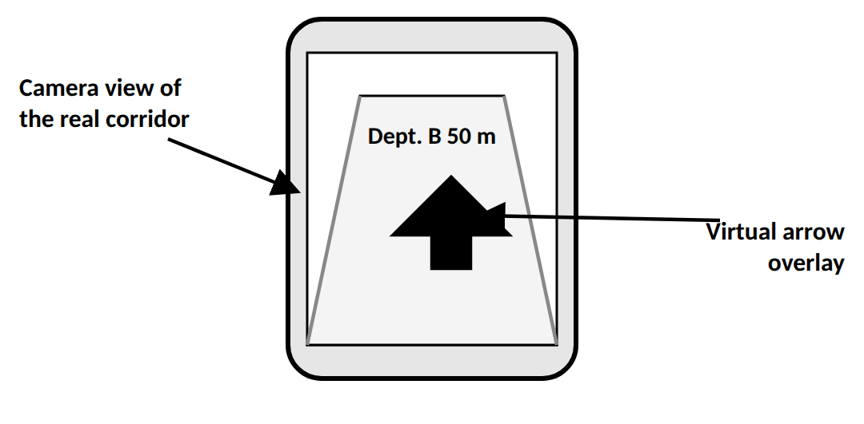
DEFINITION
AR navigation guides users through real-world environments by placing digital directions, arrows, labels or markers over the user's view.
WORKING PROCESS
1. DETERMINE LOCATION: Estimate the user's current position using available positioning systems.
2. IDENTIFY DESTINATION: The user selects where they want to go.
3. CALCULATE ROUTE: The application obtains or calculates a suitable route.
4. TRACK MOVEMENT: Sensors and computer vision update the user's position and orientation.
5. DISPLAY GUIDANCE: Arrows or labels appear over the real-world view.
6. UPDATE DIRECTIONS: The system changes guidance as the user moves or changes direction.
TYPES
• OUTDOOR NAVIGATION: Uses GPS, maps and visual tracking to guide users along streets or paths.
• INDOOR NAVIGATION: Uses visual features, markers or indoor positioning because GPS may be unreliable inside buildings.
• POINT-OF-INTEREST NAVIGATION: Guides users towards a specific object or location.
EXAMPLE
A visitor at a large hospital selects a department on a phone. The AR application displays arrows on the camera view to guide the visitor along the corridor.
CHALLENGES
• GPS may be inaccurate indoors.
• Tracking errors can misalign arrows.
• Lighting and environmental changes can affect camera tracking.
• Continuous sensing can consume battery power.
Conclusion: AR navigation combines positioning, tracking, route information and visual overlays to guide users through real environments.
10. Collaboration in Augmented Reality
The retrieved staff PDF pages do not contain a dedicated section titled Collaboration. The following is a general explanation of the syllabus topic, rather than a claim about the exact wording of your staff's PDF.
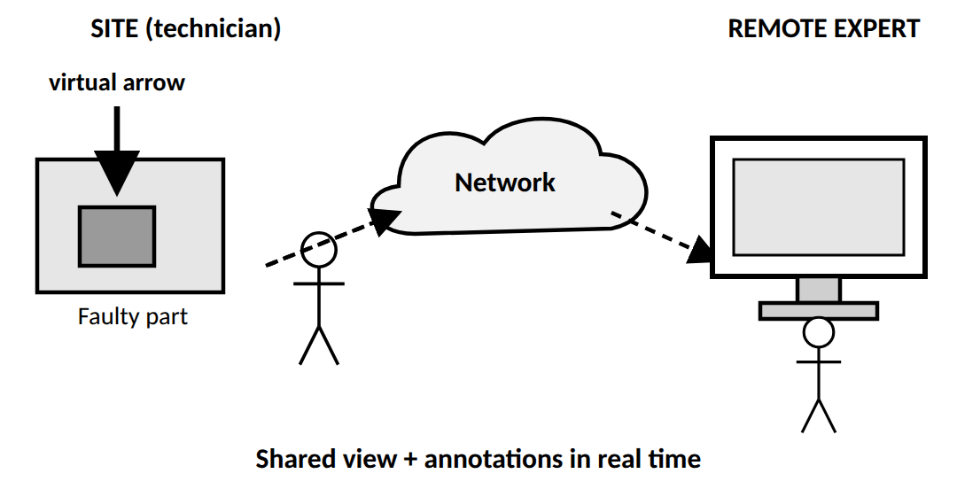
DEFINITION
Collaboration in AR allows multiple users to work together by sharing digital objects, annotations and information connected to a physical environment.
Users may work in the same place or collaborate remotely.
TYPES OF COLLABORATION
1. CO-LOCATED COLLABORATION
Users in the same physical space view or interact with shared AR content.
Example: Two engineers inspect a machine while viewing the same virtual labels.
2. REMOTE COLLABORATION
Users in different locations share visual information and communicate through an AR system.
Example: A remote expert guides a technician by placing a virtual arrow beside a faulty component.
WORKING PROCESS
1. Users connect through an AR application.
2. The system establishes a shared reference to the environment.
3. Virtual objects and annotations are aligned to relevant locations.
4. Users communicate through audio, video, text or gestures.
5. Changes and annotations are synchronised so participants can see updated information.
TECHNOLOGIES INVOLVED
• Camera and object tracking
• Shared spatial mapping
• Network communication
• Real-time data synchronisation
• Audio and video communication
ADVANTAGES
• Enables remote assistance.
• Improves teamwork and information sharing.
• Reduces travel and training costs.
• Supports collaborative design and problem-solving.
CHALLENGES
• Network delays can cause inconsistent updates.
• Shared objects require accurate spatial alignment.
• Privacy and security must be maintained.
• Different devices may have different tracking capabilities.
Conclusion: Collaborative AR enables multiple users to share spatial information and work together. It supports remote assistance, engineering, education and joint problem-solving.
MODULE 5 – NOTES

UNIT: EXPLORE CREATION IN AR–VR
I’ve used your VRAR Module 5 PDF as the main reference. The first three topics are written as 10-mark answers, focusing on the actual working process rather than just advantages and limitations. The six tools in Topic 4 are kept as separate 3-mark answers, with a definition, working/features, and an example.
PART A — 10-MARK NOTES
1. Consuming Content in Virtual and Augmented Reality
1. DEFINITION
Consuming content in Virtual Reality (VR) and Augmented Reality (AR) refers to how users experience, interact with, and understand immersive digital content.
Unlike traditional 2D screens, VR and AR allow users to view content in three-dimensional space, look around, and interact with virtual objects.
2. CONSUMING CONTENT IN VIRTUAL REALITY (VR)
In VR, the user enters a computer-generated environment that replaces or largely blocks the view of the real world.
WORKING PROCESS:
1. CONTENT CREATION: A virtual environment containing 3D objects, surroundings, sounds, and animations is created.
2. CONTENT RENDERING: A VR application renders the environment from the user's viewpoint.
3. DISPLAY THROUGH HMD: A Head-Mounted Display (HMD), such as Meta Quest or HTC Vive, presents the virtual scene to the user's eyes.
4. TRACKING: Sensors track the user's head position and orientation. The displayed view changes as the user looks around.
5. INTERACTION: Controllers or hand gestures allow the user to select objects, operate tools, and perform actions.
6. FEEDBACK: The system updates the visuals, sounds, and other responses according to the user's actions.
Example: In a VR firefighting simulation, a trainee wears a headset, enters a virtual burning building, identifies hazards, and practises fire-safety procedures without entering a real dangerous environment.
3. CONSUMING CONTENT IN AUGMENTED REALITY (AR)
In AR, digital information is overlaid on the real-world environment. The user can continue seeing the physical surroundings while viewing virtual objects or information.
WORKING PROCESS:
1. CAPTURE THE REAL WORLD: A smartphone camera or AR headset captures the surroundings.
2. UNDERSTAND THE ENVIRONMENT: The AR system analyses camera images and sensor data to detect features, surfaces, or markers.
3. TRACK THE DEVICE: Motion tracking estimates the device's position and orientation.
4. PLACE VIRTUAL CONTENT: A digital object, label, animation, or instruction is positioned relative to the real environment.
5. RENDER THE COMBINED VIEW: The display shows the real scene together with the virtual content.
6. UPDATE CONTINUOUSLY: When the user or device moves, tracking and rendering update the virtual content so it remains aligned with the surroundings.
Example: An AR interior-design application lets a user place a virtual sofa in a real living room and view how it fits before purchasing furniture.
4. MAIN FORMS OF VR/AR CONTENT
• SIMULATIONS: Reproduce real activities for training and practice.
• VIRTUAL TOURS: Allow users to explore museums, buildings, or tourist destinations.
• GAMES AND ENTERTAINMENT: Provide interactive virtual experiences.
• EDUCATIONAL VISUALISATIONS: Display 3D objects such as molecules, organs, or machines.
• NAVIGATION: Display directions and arrows over the real-world view.
• INDUSTRIAL GUIDANCE: Overlay assembly instructions and equipment information onto physical machinery.
5. FACTORS AFFECTING CONTENT CONSUMPTION
1. USER COMFORT: The headset or device should be comfortable for extended use.
2. LOW LATENCY: The display must respond quickly to head or device movement.
3. WIDE FIELD OF VIEW (FOV): A wider view can make the experience more immersive.
4. CONTEXT RELEVANCE: The content should match the user's surroundings and task.
5. INTUITIVE INTERACTION: Users should be able to operate the system naturally through controllers, gestures, or touch.
CONCLUSION
VR content allows users to experience a computer-generated world, whereas AR content adds digital information to the real world. Both depend on suitable displays, tracking, rendering, and interaction to provide meaningful immersive experiences.
2. Evaluating and Planning VR and AR Projects
1. DEFINITION
Evaluating and planning a VR/AR project means checking its feasibility and preparing its requirements, technology, content, budget, and testing strategy before development begins.
The aim is to ensure that the final application meets user needs and works correctly on the intended devices.
2. STEPS INVOLVED IN EVALUATION AND PLANNING
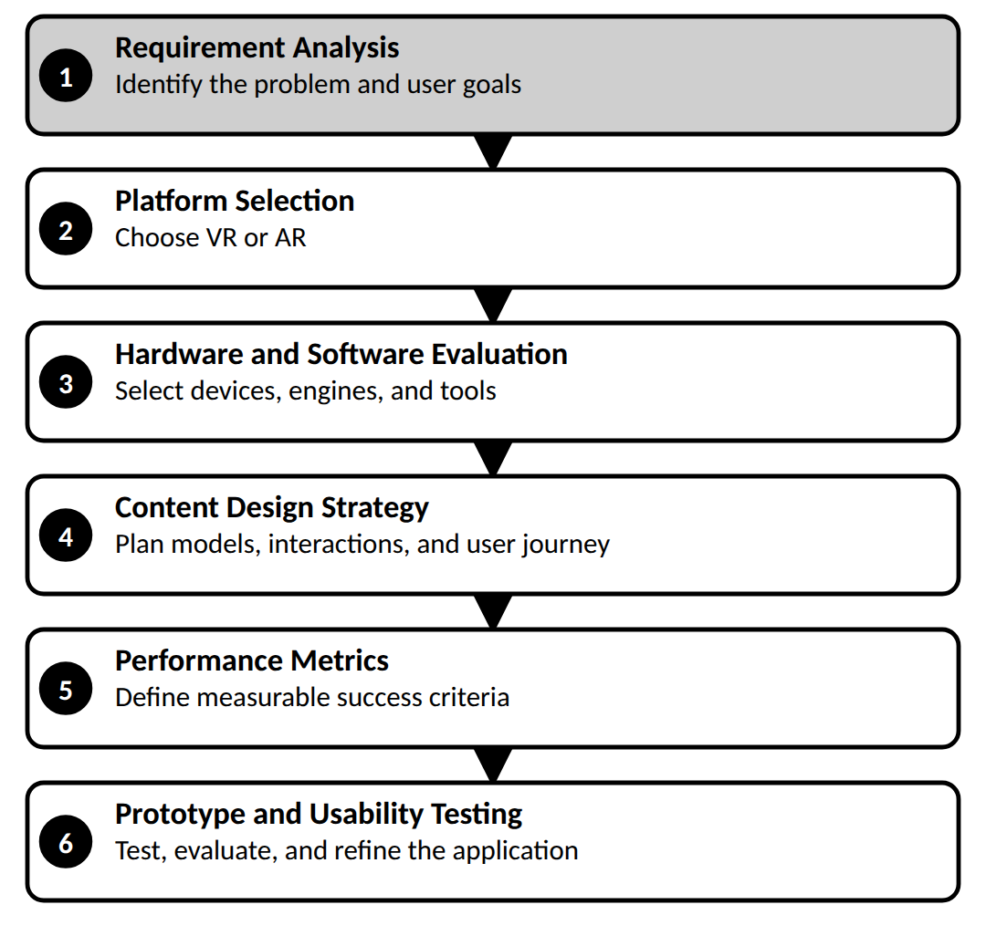
3. REQUIREMENT ANALYSIS
First, the developer identifies the problem to be solved and the users who will use the application.
Requirements may include:
• Purpose of the application.
• Target users and their needs.
• Required features and interactions.
• Expected learning or task outcomes.
Example: A VR anatomy lab may aim to improve students' understanding of the position and structure of human organs using interactive 3D visualisation.
4. PLATFORM SELECTION
The developer decides whether VR or AR is more suitable for the task.
• VR: Selected when the user needs a fully computer-generated environment, such as flight simulation or virtual laboratory training.
• AR: Selected when the user needs digital information overlaid on real objects, such as equipment repair instructions or furniture placement.
The decision depends on the project objective and how the user needs to interact with the environment.
5. HARDWARE EVALUATION
The hardware must be compatible with the application's requirements and its intended users.
The developer evaluates:
• HMDS: For immersive VR experiences.
• CAMERAS: For capturing the environment in AR.
• SENSORS: For tracking position and orientation.
• CONTROLLERS: For selecting objects and performing actions.
• PROCESSING CAPABILITY: To render 3D scenes smoothly.
The selected hardware must support the required tracking accuracy, display quality, and interaction methods.
6. SOFTWARE AND TOOL SELECTION
Suitable development tools are selected based on the project's needs.
• UNITY 3D: For building interactive 3D environments and VR/AR applications.
• BLENDER: For creating 3D models, textures, and animations.
• ARCORE: For supported Android mobile AR features.
• VUFORIA: For marker/image-target-based AR and object tracking.
For example, an AR machinery-maintenance application could use Blender for the 3D machine model, Unity for the application, and Vuforia for recognising a printed image target.
7. CONTENT DESIGN STRATEGY
The developer plans how the experience should look and behave.
This includes:
• REALISM: Decide how realistic the models and environment should be.
• INTERACTIVITY: Decide whether users can select, move, rotate, or operate objects.
• USER JOURNEY: Arrange the sequence of actions the user follows.
• NARRATIVE FLOW: Organise instructions or events in a logical order.
• FEEDBACK: Decide how the system responds to user actions through visual, audio, or haptic cues.
A clear content strategy prevents the experience from becoming confusing or unnecessarily complicated.
8. PERFORMANCE METRICS
Before development and testing, measurable criteria are established to evaluate the application.
Important metrics include:
• FRAME RATE: How smoothly the scene is displayed.
• RESPONSE TIME: How quickly the application reacts to user input.
• TRACKING AND OVERLAY ACCURACY: Whether virtual objects remain correctly aligned.
• USER ENGAGEMENT: Whether users interact with and complete the experience.
• TASK PERFORMANCE: Whether the application helps users perform the intended task correctly.
9. PROTOTYPING AND USABILITY TESTING
A prototype is an early version of the application created to test its basic functionality and interactions.
The developer observes users interacting with it, identifies problems, and makes improvements before final development.
Example: In an AR industrial-training project, the prototype is tested to check whether digital instructions align correctly with the machinery and whether workers complete tasks more accurately.
CONCLUSION
Evaluating and planning establishes the project's requirements, platform, hardware, tools, design, and performance criteria. Prototyping and usability testing then help confirm that the application is practical, usable, and effective before final deployment.
3. Creating Content for Virtual and Augmented Reality
1. DEFINITION
Creating content for VR and AR involves designing and developing interactive 3D environments, objects, animations, and feedback systems that users can experience in virtual or real-world surroundings.
It combines artistic design with technical development. Tools such as Blender are used to create digital assets, while Unity or Unreal Engine can assemble those assets into an interactive application.
2. STEPS INVOLVED IN CREATING VR/AR CONTENT
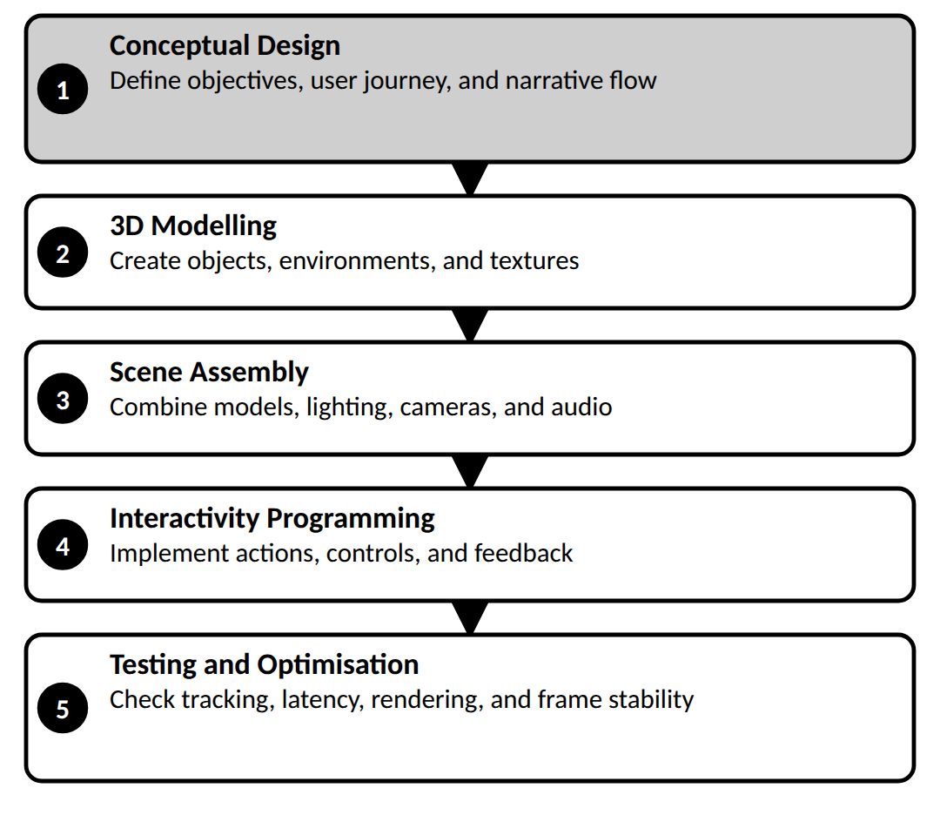
3. CONCEPTUAL DESIGN
The first step is to decide what the application should achieve and how the user will experience it.
The developer defines:
• OBJECTIVE: The purpose of the application.
• TARGET USERS: The people who will use it.
• USER JOURNEY: The sequence of actions the user follows.
• NARRATIVE FLOW: How instructions, events, or information are presented.
• INTERACTION PLAN: How users will select or manipulate virtual objects.
Example: For a VR machine-training application, the user journey might be: enter the virtual workshop → inspect the machine → select a component → perform the operation → receive feedback.
4. 3D MODELLING
In this step, the developer creates the digital objects and environments required for the application.
Software such as Blender or Maya can be used to create:
• 3D objects and machine components.
• Buildings, rooms, and virtual environments.
• Characters and avatars.
• Textures and surface details.
• Animations and object movements.
The models should have suitable dimensions, scale, textures, and detail. They can then be exported to a development engine for integration.
Example: A virtual assembly-line project may require 3D models of a conveyor belt, robotic arm, tools, and products.
5. SCENE ASSEMBLY
After modelling, the digital assets are imported into a real-time development engine such as Unity or Unreal Engine.
The developer then:
1. Places the 3D models in the virtual scene.
2. Sets their position, rotation, and scale.
3. Adds lighting, materials, and textures.
4. Configures cameras and viewpoints.
5. Adds sound effects or background audio.
6. Organises objects and scene elements so that the environment behaves as intended.
In VR, the scene is prepared for an immersive viewpoint. In AR, virtual objects must also be placed and aligned with the real environment.
6. INTERACTIVITY PROGRAMMING
A 3D scene becomes an interactive VR/AR application when users can perform actions and receive responses.
Programming is used to implement:
• Object selection and manipulation.
• Controller and hand-gesture inputs.
• Gaze-based interaction.
• Button presses and menu navigation.
• Animation triggered by user actions.
• Collision detection and object behaviour.
• Visual, audio, or haptic feedback.
Unity commonly uses C# scripting to define these behaviours.
Example: When a trainee selects a virtual machine component, the application highlights it, displays its name, and presents the instructions for operating it.
7. TESTING AND OPTIMISATION
The application is tested to confirm that the content works correctly on the intended hardware.
The developer checks:
• RENDERING QUALITY: Whether models, textures, and lighting appear correctly.
• FRAME STABILITY: Whether the scene updates smoothly.
• LATENCY: Whether the display responds quickly to user movement.
• TRACKING ACCURACY: Whether virtual objects remain aligned with the environment.
• INTERACTION CORRECTNESS: Whether buttons, gestures, and controls work as expected.
• USABILITY: Whether users can understand and complete the required tasks.
If performance is poor, the developer may reduce unnecessary model detail, optimise textures, simplify scene complexity, or improve the interaction logic.
8. DEPLOYMENT
After testing and optimisation, the application is built for its target platform, such as a VR headset, Android smartphone, or compatible AR device. It is then tested on the actual target hardware to confirm that the experience behaves correctly.
EXAMPLE: CREATING A VR INDUSTRIAL-TRAINING APPLICATION
1. CONCEPTUAL DESIGN: Plan a virtual assembly-line training task.
2. 3D MODELLING: Create models of machines and tools using Blender.
3. SCENE ASSEMBLY: Import the models into Unity and arrange the factory environment.
4. PROGRAMMING: Add controller interactions so the trainee can select and operate components.
5. TESTING: Check frame rate, response time, and correct operation.
6. DEPLOYMENT: Build and run the application on the target VR headset.
CONCLUSION
VR/AR content creation follows a systematic process: conceptual design, 3D modelling, scene assembly, interactivity programming, testing, optimisation, and deployment. Each stage contributes to a functional and engaging immersive experience.
PART B — 3-MARK NOTES
4. Basics of VR/AR Development Tools and Frameworks
4.1 Unity 3D
Definition: Unity 3D is a real-time game engine used to create interactive 3D environments, games, and VR/AR applications.
WORKING / FEATURES:
• Provides a Scene editor to arrange 3D objects, lights, cameras, and environments.
• Uses C# scripting to implement interactions and application logic.
• Supports VR/AR development through SDKs such as ARCore and Vuforia.
Example: Creating a VR assembly-line simulator for industrial training.
4.2 React 360
Definition: React 360 is a web-based framework built using React concepts and WebVR-era technology for creating immersive 360-degree experiences accessible through browsers.
WORKING / FEATURES:
• Uses web technologies and React-based components to build interactive experiences.
• Supports 360-degree scenes, images, and user interface elements.
• Suitable for browser-based virtual tours, storytelling, and educational visualisations.
Example: A browser-based virtual tour of a museum or tourist destination.
Note: React 360 is a legacy framework; this is the framework described in your syllabus PDF.
4.3 Google ARCore
Definition: Google ARCore is Google's platform for developing augmented reality applications on supported Android and other compatible devices.
WORKING / FEATURES:
• MOTION TRACKING: Estimates the device's position and orientation.
• ENVIRONMENTAL UNDERSTANDING: Detects surfaces and helps place virtual objects.
• LIGHT ESTIMATION: Estimates environmental lighting so virtual objects can appear more realistic.
Example: An interior-design app that lets users visualise virtual furniture in their real living room.
4.4 Vuforia
Definition: Vuforia is an AR software development kit (SDK) used to recognise image targets, certain 3D objects, and supported surfaces to display digital content.
WORKING / FEATURES:
• Detects a predefined image or target using the device camera.
• Tracks the target's position and orientation.
• Displays aligned 3D models, animations, or instructions over the recognised target.
Example: Pointing a smartphone at a printed machinery diagram to display an animated 3D model of the machine's components.
4.5 Amazon Sumerian
Definition: Amazon Sumerian was a cloud-based platform designed to create and publish browser-based 3D, AR, and VR experiences with limited coding.
WORKING / FEATURES:
• Provides tools for building 3D scenes and adding objects and virtual characters.
• Supports interactive experiences and integrations with AWS services.
• Its documented integrations included Amazon Lex for conversational interactions and Amazon Polly for speech.
Example: A virtual customer-service character that responds to user questions.
Note: Amazon Sumerian was discontinued by AWS in 2025. For your exam, learn the definition and features described in your staff PDF.
4.6 Blender
Definition: Blender is a free, open-source 3D creation suite used for modelling, texturing, animation, and rendering.
WORKING / FEATURES:
• Creates 3D objects, environments, characters, and machinery.
• Adds materials, textures, lighting, and animations.
• Exports 3D assets for integration into engines such as Unity and Unreal Engine.
Example: Creating a detailed 3D engine model in Blender and importing it into Unity for an AR maintenance application.

