DEPARTMENT OF COMPUTER SCIENCE AND ENGINEERING
ACTIVE LEARNING METHODOLOGY REPORT
SQL INJECTION AND SECURE DATABASE INTERACTION
AJAY.I – 71812401007
THIRD YEAR B.E. CSE – V SEM
Academic Year 2026-2027
20CS255 & SECURITY IN ENGINEERING
COURSE COORDINATOR
Ms.A.Ishwarya,AP/CSE
20CS212 & WEB TECHNOLOGIES
Assessment
INDEX
S. No. | Name & Roll No. | Scenario / problem statement (2 Marks) | Identification and explanation of security vulnerability (3 Marks) | Selection of suitable security mechanism (3 Marks) | Justification / application to the scenario (2 Marks) | Total (10)
1. | AJAY.I -  71812401007

SIGNATURE OF COURSE COORDINATOR
Ms.A.Ishwarya,AP/CSE

CONTENTS
S. No. | TITLE | PAGE NUMBER
1. | Introduction | 1
2. | Scenario / problem statement | 3
3. | Identification and explanation of security vulnerability | 5
4. | Selection of suitable security mechanism | 8
5. | Justification / application to the scenario | 10
6. | Expected Output | 13
7. | Conclusion | 15

1. INTRODUCTION
Almost every banking website is a thin layer of web pages placed in front of a relational database. Customer profiles, account balances, beneficiaries, card details and transaction history are all stored in tables, and the web application reaches them by sending Structured Query Language (SQL) statements to the database server. Even the simplest action, logging in, is a database query: the application asks the database whether a customer with the given username and password exists.
The security problem begins when the application builds that SQL statement by joining fixed program text with text typed by the customer. SQL is a language, and the database cannot tell which part of a statement was written by the developer and which part came from the login form. If the input contains characters that have meaning in SQL, such as a single quote, a comment marker or a keyword like OR, the input stops being a value and becomes part of the command. This class of flaw is called SQL injection (SQLi).
SQL injection has been known for more than twenty-five years, yet it remains one of the most damaging web vulnerabilities. Injection is listed as A03 in the OWASP Top 10 (2021), and CWE-89, “Improper Neutralization of Special Elements used in an SQL Command”, consistently appears in the MITRE CWE Top 25 Most Dangerous Software Weaknesses. For a bank the consequences are severe: an attacker may log in as another customer without a password, read the entire customer table, alter balances or delete transaction records.
SQL injection is also an access-control failure. The web application connects to the database with an account that holds real privileges. When an attacker's text is executed as SQL, it runs with those privileges, so a stranger on the internet effectively borrows the identity of the application. The principles of least privilege, complete mediation and a clear separation between code and data, which govern privileged programs in an operating system, apply equally here.
This report analyses the SQL injection weakness in the login function of a banking website, explains step by step how crafted input changes the query, selects a layered set of defences centred on parameterized queries, justifies each defence against the scenario, and describes the behaviour expected once the defences are applied.

1.1 How the login request reaches the database
Figure 1 shows the components involved in a typical login. The customer's input crosses a trust boundary when it enters the application server; the danger lies in the moment where that untrusted text is placed inside an SQL statement.
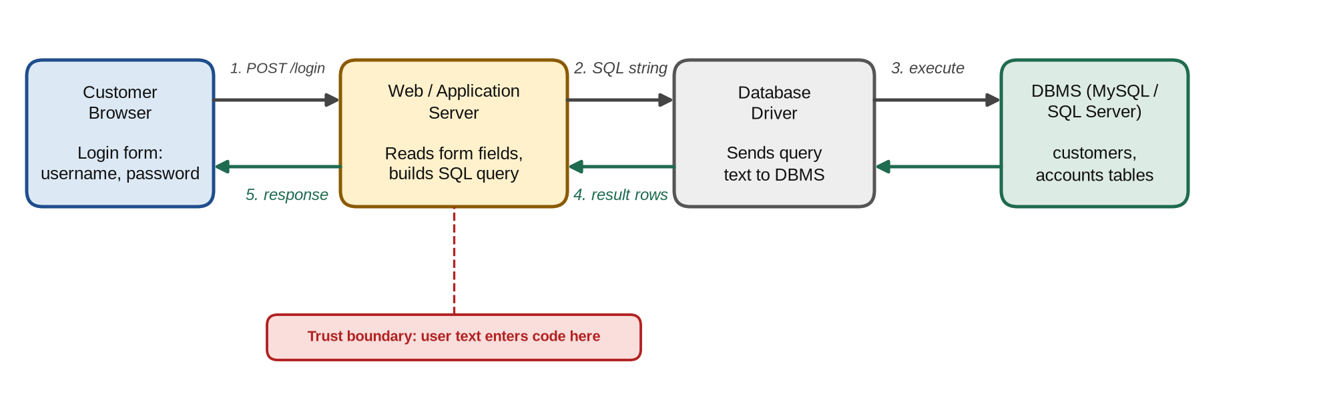
Figure 1: Block diagram of the banking login path from browser to database

1.2 Key terms used in this report
Term | Meaning
SQL query | A statement such as SELECT, INSERT, UPDATE or DELETE sent to the database to read or change data.
SQL injection | Insertion of SQL syntax through user input so that the database executes a query the developer did not intend.
Dynamic query | An SQL statement built at run time by string concatenation of code and user input.
Prepared statement | A query sent with placeholders (?) whose values are bound separately and are always treated as data.
Least privilege | Giving the database account only the permissions the application strictly needs.
Password hashing | Storing a slow, salted one-way hash (bcrypt, Argon2) instead of the plain password.
WAF | Web Application Firewall: filters HTTP requests that match known attack patterns.

1.3 Why banking applications are a prime target
- High-value data: account numbers, balances, PAN and Aadhaar-linked details, card data and transaction history can be sold or used for fraud.
- Direct financial gain: a successful injection can change balances, add beneficiaries or approve transfers without customer involvement.
- Public exposure: the login page is reachable by anyone on the internet, so the first query runs before any authentication has happened.
- Regulatory weight: breaches must be reported under RBI cyber-security directions, PCI DSS and the Digital Personal Data Protection Act, 2023.

1.4 Notable real-world SQL injection incidents
Incident (year) | Sector | What happened
Heartland Payment Systems (2008) | Card payments | SQL injection used as the entry point; about 130 million card numbers stolen.
Sony Pictures (2011) | Media | A single injection flaw exposed account data of around one million users.
TalkTalk (2015) | Telecom | Legacy web pages allowed SQLi; data of about 157,000 customers stolen, regulator fine of £400,000.
MOVEit Transfer (2023) | File transfer used by banks | CVE-2023-34362 SQL injection exploited by the Cl0p group against thousands of organisations.

1.5 Objectives of this report
- To analyse how the banking login query is constructed and why its structure can be changed by input.
- To explain the mechanics, types and impact of SQL injection with examples specific to the scenario.
- To select and justify a layered set of defences, with working code for the application and the database.
- To define measurable expected outputs and verification tests that prove the fix is effective.

2. SCENARIO / PROBLEM STATEMENT

2.1 Scenario
A banking website uses a username and password entered by the customer to construct a database query. A security tester discovers that specially crafted input changes the behavior of the database query.

2.2 Understanding the scenario
The login feature follows the sequence below. The weakness lies in step 3, where input and program code are joined into one string.
- The customer opens the bank's login page and types a username and password into an HTML form.
- The browser sends both fields to the application server in an HTTPS POST request.
- The server inserts the two values directly between quotes in an SQL string, for example SELECT * FROM customers WHERE username = '<input>' AND password = '<input>'.
- The complete string is sent to the database, which parses it as a single SQL command and executes it.
- If at least one row is returned, the application assumes the credentials were correct and opens the customer's account dashboard.
- During testing, the security tester enters a value such as admin' -- in the username field. The quote closes the string early and the comment marker removes the password condition, so the database returns the admin row and the tester is logged in without knowing the password.

2.3 What is at stake
- Assets: customer credentials, personal details, account balances, beneficiary lists, card data, transaction records and the integrity of the ledger.
- Services: fund transfer, bill payment, statement download and profile management that all trust the logged-in identity.
- Issue identified: the application treats customer input as trusted SQL code, so the input decides what the query does rather than only which record it looks for.

2.4 Problem statement
Analyse the vulnerability that allows specially crafted login input to change the structure and behaviour of the database query, explain how SQL injection occurs in this login function, and propose appropriate methods to secure the interaction between the banking application and its database so that user input can never be executed as SQL.

2.5 Threat model and attack workflow
Element | Description
Attacker | Any internet user; the login page needs no prior account or authentication.
Entry point | Username and password fields of the login form (and any other input used in queries).
Assumption | Queries are built by string concatenation; DB errors are shown; the DB account is over-privileged.
Goal | Bypass authentication, extract customer data, modify records or disrupt service.
The workflow in Figure 2 shows that no special tools are needed: a browser and knowledge of basic SQL syntax are enough to exploit the flaw.

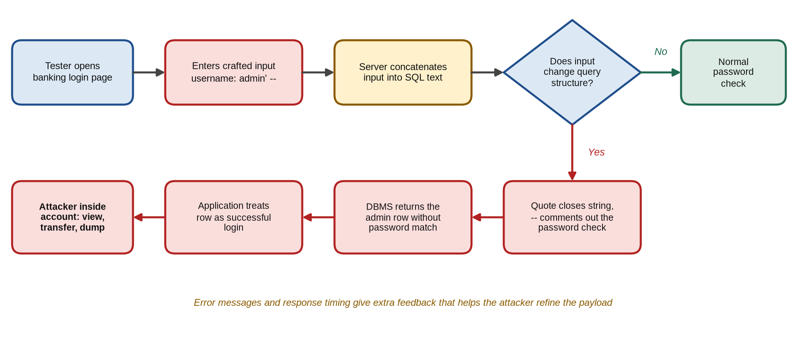
Figure 2: Attack workflow when crafted input changes the login query

2.6 How the tester discovered the flaw
Security testers follow a systematic, low-risk sequence (OWASP WSTG-INPV-05) to confirm the weakness without damaging data:
- Probe: a single quote (') typed in the username field returns a raw MySQL syntax error, proving the input reaches the SQL parser unescaped.
- Boolean test: admin' AND '1'='1 behaves differently from admin' AND '1'='2, showing that the tester's condition is evaluated by the database.
- Bypass: admin' -- with any password opens the administrator dashboard, confirming authentication bypass.
- Timing test: admin' AND SLEEP(5) -- delays the response by five seconds, proving injection even when output is hidden.
- Report: the tester stops at proof of concept and reports the finding with severity, evidence and recommended fixes.

2.7 Scope and assumptions of the analysis
Item | Details
In scope | Login form, the server-side authentication code, the database account and the customers table.
Technology | Node.js / Express application server with a MySQL 8 database (Java equivalents also shown).
Out of scope | Network attacks, phishing, malware on customer devices and physical access.
Test data | A staging copy of the database with dummy customers; no real customer data is touched.

2.8 Stakeholders affected
Stakeholder | How the flaw affects them
Customers | Loss of money and privacy; account misuse without their knowledge.
The bank | Financial loss, regulatory penalties, audit findings and damage to reputation.
Regulators and partners | Card networks and RBI require breach reporting and remediation evidence.

3. IDENTIFICATION AND EXPLANATION OF SECURITY VULNERABILITY

3.1 Vulnerability identified
SQL injection in the authentication query. The application builds its login query by concatenating the username and password typed by the customer into an SQL string. Because the database receives code and data mixed in one piece of text, special characters in the input are interpreted as SQL syntax. The flaw is catalogued as CWE-89 (Improper Neutralization of Special Elements used in an SQL Command) and falls under OWASP Top 10 (2021) A03: Injection.
The root of the problem is a violation of the separation between code and data. The developer intended the input to be a value inside quotes; the attacker supplies a quote of their own, closes the value, and then writes additional SQL that the database executes with the full privileges of the application's database account.

3.2 How SQL injection occurs
Figure 3 colours each part of the final query by its origin. In a normal login the input stays inside the green value boxes. With crafted input, attacker text escapes the quotes and becomes executable code (red) or causes the developer's own code to be ignored (purple).
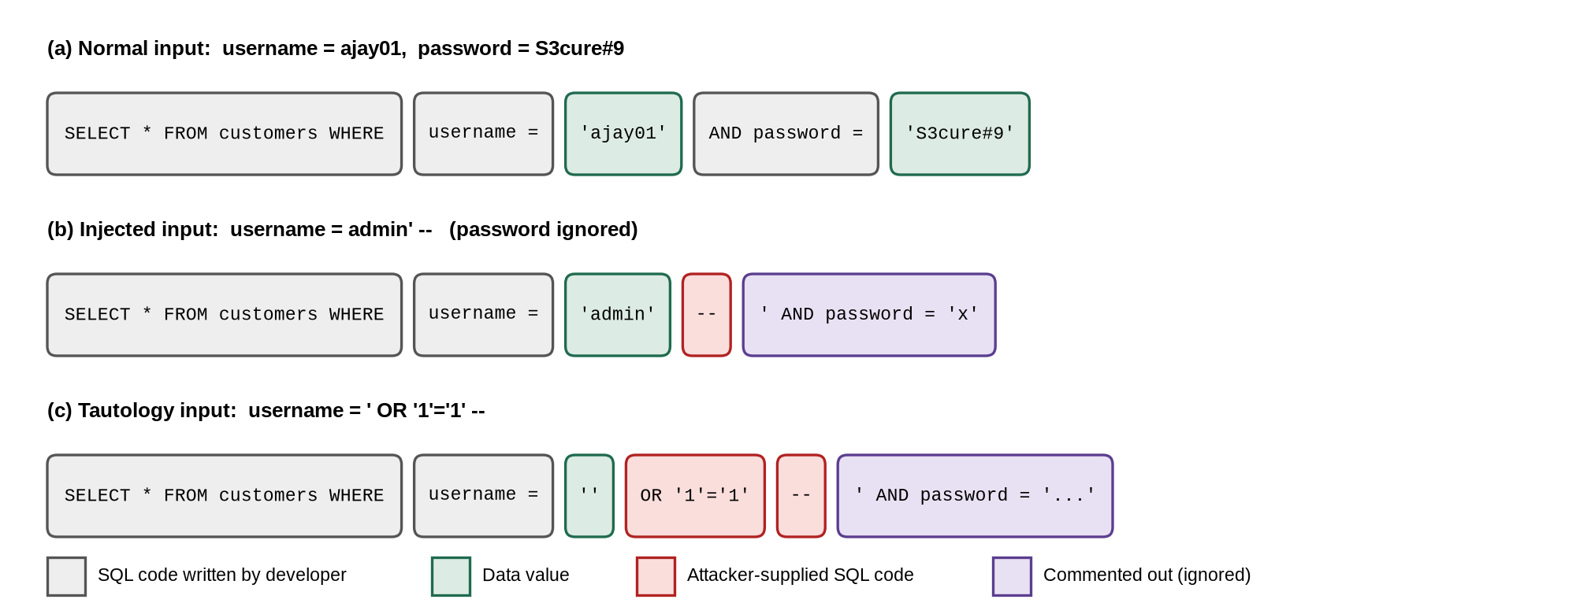
Figure 3: How crafted input changes the structure of the login query
In case (b) the database sees the condition username = 'admin' followed by a comment, so the password check never runs. In case (c) the condition '1'='1' is always true and the rest of the statement is commented out, so the WHERE clause is true for every row; the query returns the whole customer table and the application logs the attacker in as the first customer, often an administrator. In MySQL the comment marker must be followed by a space ("-- ") or the hash sign (#) can be used instead.
The attack works only because certain characters carry meaning in SQL. The table below lists the metacharacters most often used in injection payloads and the role each one plays.
Symbol | Meaning in SQL | Use in an attack
' | Opens or closes a string literal | Ends the value early so code can follow
-- / # | Starts a comment to end of line | Removes the rest of the developer's query
OR 1=1 | Always-true condition | Makes the WHERE clause match every row
; | Ends one statement | Starts a second, stacked statement
UNION | Combines two SELECT results | Pulls data from other tables
/* */ | Inline comment | Hides keywords from simple filters

3.3 Vulnerable implementation (example)
// Insecure: input concatenated into SQL, plain-text password, errors leaked
app.post('/login', (req, res) => {
const { username, password } = req.body;
const sql = "SELECT * FROM customers WHERE username = '" + username +
"' AND password = '" + password + "'";
db.query(sql, (err, rows) => { // db connects as 'root'
if (err) return res.status(500).send(err.sqlMessage); // leaks schema
if (rows.length > 0) {
req.session.user = rows[0].id; // first row = logged-in user
return res.redirect('/dashboard');
}
res.status(401).send('Invalid username or password');
});
});

3.4 Example payloads and their effect
Input in username field | Resulting condition seen by the DB | Effect on the bank
admin' -- | username='admin' -- ' AND password=... | Logs in as admin; password check removed.
' OR '1'='1' -- | username='' OR '1'='1' | Every row returned; attacker logged in as first customer.
' UNION SELECT id, card_no, cvv, 4 FROM cards -- | Second SELECT appended to the first | Card data from another table returned in the page.
admin' AND SLEEP(5) -- | Response delayed by five seconds | Blind confirmation that injection works.
'; DROP TABLE transactions; -- | Stacked second statement | Transaction history destroyed if multi-statements are allowed.

3.5 Types of SQL injection
Type | How it works | Relevance to the login page
In-band: error-based | Database error messages reveal table names, columns and versions. | err.sqlMessage is sent to the browser.
In-band: UNION-based | A UNION SELECT appends attacker-chosen rows to the normal result. | Possible wherever query output is shown.
Blind: boolean | True/false conditions change the page (login succeeds or fails). | Login result acts as a yes/no oracle.
Blind: time-based | SLEEP or WAITFOR DELAY measures truth by response time. | Works even when errors are hidden.
Out-of-band | Data is sent over DNS or HTTP using database functions. | Depends on DB configuration.
Second-order | Stored input is later used unsafely in another query. | E.g. a malicious username reused in reports.

3.6 Root causes
- Dynamic SQL by concatenation: the query text is assembled from strings, so input controls the syntax of the statement.
- No input validation: the username field accepts quotes, dashes, spaces and SQL keywords of any length.
- Plain-text password comparison in SQL: passwords are stored unhashed and compared inside the query, so bypassing the WHERE clause bypasses authentication.
- Verbose error messages: raw database errors are returned to the browser and reveal the schema to the attacker.
- Over-privileged database account: the application connects as root or DBA, so injected SQL can read every table and drop objects.
- No monitoring or rate limiting: thousands of automated attempts from tools such as sqlmap go unnoticed.

3.7 Exploitation and impact
Aspect | What the attacker can do | Consequence for the bank / customer
Authentication | Log in as any customer or administrator without a password. | Complete account takeover.
Confidentiality | Dump customer, account and card tables using UNION or blind techniques. | Mass data breach; identity theft.
Integrity | UPDATE balances, add beneficiaries, alter transaction records. | Fraud; ledger no longer trustworthy.
Availability | DROP or lock tables, run heavy queries. | Online banking outage.
Compliance | Expose regulated personal and card data. | Penalties under RBI, PCI DSS and DPDP Act.

Severity: critical. The CVSS v3.1 vector AV:N/AC:L/PR:N/UI:N/S:U/C:H/I:H/A:H gives a base score of 9.8, because the attack is remote, needs no account or user interaction, and can fully compromise confidentiality, integrity and availability of the data.

3.8 Why filtering or escaping alone is not enough
- Blacklists are incomplete: blocking words such as OR or SELECT fails against mixed case (sElEcT), inline comments (SEL/**/ECT), URL or Unicode encoding and database-specific syntax.
- Escaping is context-dependent: a function that escapes quotes does not protect numeric fields (WHERE id = 5 OR 1=1), ORDER BY clauses or different character sets.
- Client-side checks are bypassed: JavaScript validation in the browser is skipped by sending the request directly with a tool such as Burp Suite or curl.
- Stored procedures are not automatically safe: a procedure that concatenates its parameters into dynamic SQL with EXEC or PREPARE is just as injectable as application code.
- ORMs can be misused: raw-query helpers such as sequelize.query() or Hibernate createNativeQuery() reintroduce the flaw if strings are joined.
These limitations show that the vulnerability must be removed where it originates, in the way the query is constructed. Filtering can reduce noise, but only a mechanism that keeps input permanently separate from SQL code eliminates the risk, which leads to the selection made in the next section.

4. SELECTION OF SUITABLE SECURITY MECHANISM
Selected mechanism: parameterized queries (prepared statements) as the primary control, supported by defence in depth. Following the OWASP SQL Injection Prevention Cheat Sheet, the only reliable fix is to stop building SQL from strings so that input can never change the structure of a query. Supporting controls reduce the damage if any single layer fails.

4.1 Controls in the selected mechanism
Control | How it works | Threat addressed
Parameterized queries | Query text with ? placeholders is compiled first; values are bound afterwards and always treated as data. | Injection through any input field
Safe stored procedures | Login logic runs inside a procedure with typed parameters and no dynamic SQL. | Injection; limits direct table access
Allow-list input validation | Username must match ^[A-Za-z0-9_.]{4,30}$; lengths and types enforced on the server. | Malformed and oversized input
Password hashing | bcrypt/Argon2 hash stored; comparison done in application code, not in SQL. | Bypass by removing password clause
Least-privilege DB account | Login account may only SELECT the needed columns and update the failure counter. | Data dump, DROP TABLE, privilege abuse
Generic error handling | Same message for every failure; details only in server logs. | Error-based enumeration
Rate limiting and lockout | Limits attempts per IP and per account; temporary lock after 5 failures. | Automated scanning, brute force
WAF and monitoring | Blocks common SQLi signatures and alerts the security team. | Known payloads; early detection

4.2 Comparison of possible defences
Option | Effectiveness | Remarks
Prepared statements | High | Recommended first choice; supported by every modern driver (JDBC, PDO, mysql2, ADO.NET).
Stored procedures | High* | *Only when they do not build dynamic SQL inside the procedure.
ORM (Sequelize, Hibernate) | High* | *Safe for normal methods; raw-query helpers still need parameters.
Allow-list validation | Medium | Reduces attack surface; cannot be the only defence for free-text fields.
Escaping special characters | Low | Error-prone and database-specific; OWASP strongly discourages relying on it.
WAF only | Low | Signatures can be bypassed by encoding tricks; useful only as an extra layer.

Prepared statements are therefore chosen as the core control, while the remaining options are used only as supporting layers.

4.3 How a prepared statement separates code and data
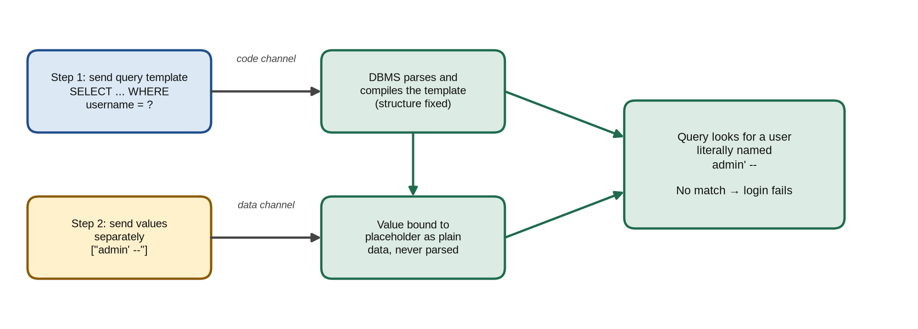
Figure 4: Code channel and data channel in a prepared statement
Because the query structure is fixed before any customer value arrives, a quote or comment marker in the input is just another character in the value. The database searches for a user literally named admin' -- , finds none, and the login fails safely.

4.4 Defence-in-depth architecture
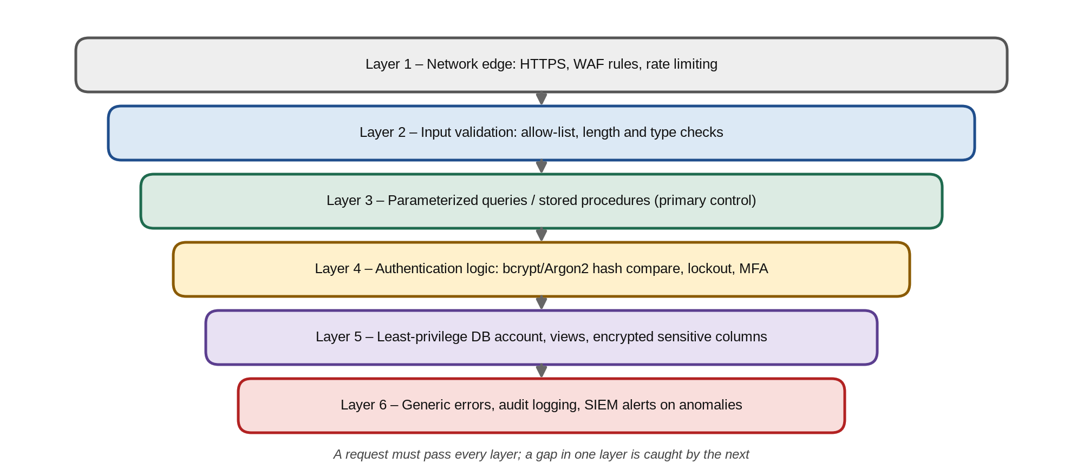
Figure 5: Layered defences protecting the banking database

4.5 Security principles applied
Principle | How the selected mechanism applies it
Separation of code and data | Prepared statements send the query and the values on separate channels.
Least privilege | The login service uses a DB account limited to the columns it needs.
Defence in depth | Six independent layers, from the WAF to audit logging, each able to stop an attack.
Fail-safe defaults | Anything not matching the allow-list is rejected; errors deny access by default.
Complete mediation | Every request, not only the first, passes validation and parameter binding.

Together, these principles ensure that the selected mechanism is not a single patch on the login page but a design rule for the whole banking application: input is always data, every component holds the minimum authority it needs, and each defensive layer is independent of the others.

5. JUSTIFICATION / APPLICATION TO THE SCENARIO

5.1 How the mechanism closes each gap
Each step of the attack described in Section 2.2 is blocked by at least one control, so protection does not depend on a single measure:
- Structure cannot change. With a prepared statement the login query is compiled with placeholders before the username arrives. The input admin' -- is bound as a plain string, so the quote cannot close anything and the comment marker cannot remove the password check.
- Password check moved out of SQL. The query fetches only the stored bcrypt hash for the given username. Even if a row were returned unexpectedly, bcrypt.compare must still succeed, so a tautology such as ' OR '1'='1 cannot log anyone in.
- Invalid input rejected early. Allow-list validation refuses usernames containing quotes, spaces or dashes before any database call is made, reducing noise and load.
- Damage limited. The login database account can read only four columns of one table and update the failure counter. UNION queries against the cards table or DROP TABLE statements fail with a permission error.
- No information leak. Every failure returns the same “Invalid credentials” message, so error-based and username-enumeration techniques receive no feedback.
- Automation slowed and detected. Rate limiting, account lockout and WAF alerts stop tools that send thousands of payloads and notify the security operations team.

5.2 Secure implementation (Node.js / Express with mysql2)
const USER_RE = /^[A-Za-z0-9_.]{4,30}$/; // allow-list pattern
const pool = mysql.createPool({ user: 'bank_login', database: 'bank',
password: process.env.DB_PASS, multipleStatements: false });

app.post('/login', loginLimiter, async (req, res) => {
const { username = '', password = '' } = req.body;
if (!USER_RE.test(username) || password.length > 128)
return res.status(400).json({ error: 'Invalid credentials' });
try {
const [rows] = await pool.execute( // prepared statement
'SELECT id, pwd_hash, locked_until FROM customers WHERE username = ?',
[username]); // bound as data only
const user = rows[0];
const hash = user ? user.pwd_hash : DUMMY_HASH; // equal timing
const ok = await bcrypt.compare(password, hash) && user &&
!(user.locked_until > new Date());
if (!ok) {
await recordFailure(username, req.ip); // counter + lockout
return res.status(401).json({ error: 'Invalid credentials' });
}
await pool.execute(
'UPDATE customers SET failed_logins = 0 WHERE id = ?', [user.id]);
req.session.regenerate(() => { // new session ID
req.session.user = user.id;
res.redirect('/dashboard');
});
} catch (e) {
log.error({ event: 'login_error', reqId: req.id, err: e }); // log only
res.status(500).json({ error: 'Something went wrong' });
}
});

5.3 Equivalent protection in Java and in the database
The same principle applies on every platform. In Java the PreparedStatement interface binds values with typed setter methods, and in the database a dedicated login account receives column-level permissions only:
// Java (JDBC): value bound with setString, never concatenated
String sql = "SELECT id, pwd_hash FROM customers WHERE username = ?";
try (PreparedStatement ps = conn.prepareStatement(sql)) {
ps.setString(1, username);
try (ResultSet rs = ps.executeQuery()) {
if (rs.next() && BCrypt.checkpw(password, rs.getString("pwd_hash")))
startSession(rs.getLong("id"));
}
}

-- MySQL: least-privilege account used only by the login service
CREATE USER 'bank_login'@'10.0.2.%' IDENTIFIED BY '<strong secret>';
GRANT SELECT (id, username, pwd_hash, locked_until, failed_logins)
ON bank.customers TO 'bank_login'@'10.0.2.%';
GRANT UPDATE (failed_logins, locked_until)
ON bank.customers TO 'bank_login'@'10.0.2.%';
-- no access to accounts, cards or transactions; no DROP, FILE or GRANT

5.4 Secure login workflow
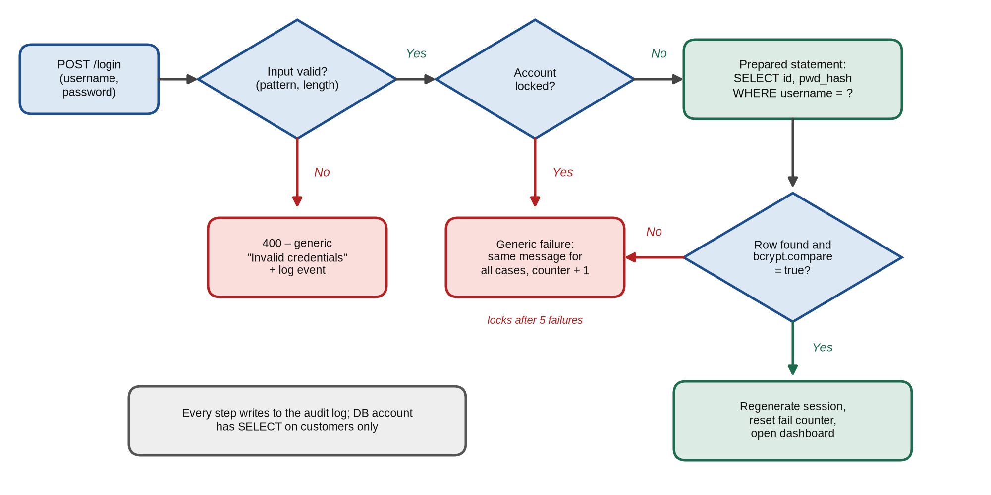
Figure 6: Secure login flow with validation, prepared statement and hash check

5.5 Mapping attack steps to controls
Attack step | Control that blocks it | Result
Quote closes the value (admin' --) | Prepared statement, allow-list validation | Input stays data; request rejected
Tautology ' OR '1'='1 | Prepared statement + bcrypt check in code | No row match; hash check fails
UNION SELECT from cards | Least-privilege account, generic errors | Permission denied; nothing shown
Time-based blind probing | Prepared statement, rate limiting, WAF | No delay; client throttled
Automated sqlmap scan | Rate limit, lockout, SIEM alert | Blocked and reported

5.6 Trade-offs and residual risk
- Development effort. Existing concatenated queries must be found and rewritten. Static analysis tools (Semgrep, SonarQube) and code review rules make the migration systematic, and the change rarely affects performance because prepared statements can be cached.
- Dynamic identifiers. Placeholders work only for values, not for table or column names. Sort columns and similar options must be mapped from a fixed allow-list in code.
- Residual risk. Other injection points (search, statements, admin reports) and second-order injection must receive the same treatment. Regular penetration tests and dependency updates keep the protection current.

5.7 Implementation plan for the bank
Phase | Activity | Outcome
1. Discover | Run SAST and grep for concatenated SQL across all modules; list every query that uses input. | Complete inventory of risky queries
2. Fix | Rewrite login first, then all other queries, using prepared statements and allow-lists. | No dynamic SQL built from input
3. Harden | Create per-service DB accounts, hash all passwords with bcrypt, hide errors. | Least privilege; no information leak
4. Protect | Enable WAF rules, rate limiting, lockout and SIEM alerts. | Attacks blocked and visible
5. Verify | Penetration test, sqlmap scan and code review before release; repeat every quarter. | Evidence for auditors

5.8 Using a safe stored procedure
Where the bank's architecture prefers database-side logic, the same protection can be delivered with a stored procedure that uses typed parameters and contains no dynamic SQL. The application account is then granted EXECUTE on the procedure only, with no direct access to the table:
DELIMITER //
CREATE PROCEDURE get_login(IN p_user VARCHAR(30))
SQL SECURITY DEFINER
BEGIN
SELECT id, pwd_hash, locked_until
FROM customers
WHERE username = p_user; -- parameter used as a value
END //
DELIMITER ;
GRANT EXECUTE ON PROCEDURE bank.get_login TO 'bank_login'@'10.0.2.%';
-- application: await pool.execute('CALL get_login(?)', [username]);
Because the procedure never builds SQL text from p_user, an input such as admin' -- is compared as a literal username and cannot alter the query, while the narrow EXECUTE grant enforces least privilege at the database level.

6. EXPECTED OUTPUT
With the mechanism applied, crafted input no longer changes the login query, and every injection attempt fails without revealing information.

6.1 Behaviour before and after
Situation | Before (vulnerable) | After (secured)
Username admin' -- , any password | Logged in as admin without a password. | 400 Bad Request: “Invalid credentials”.
Username ' OR '1'='1 | Logged in as the first customer. | Rejected by validation; no query executed.
UNION payload in any field | Card numbers shown on the page. | Treated as data; no extra rows returned.
Malformed quote (') | Raw MySQL syntax error with table names. | Generic error; details only in server log.
admin' AND SLEEP(5) -- | Response delayed by 5 seconds. | Immediate rejection; no delay.
200 rapid login attempts | All processed; nothing logged. | Throttled after 5; alert raised in SIEM.
Correct username and password | Login succeeds. | Login succeeds (bcrypt verified).

6.2 Sample request and responses
POST /login HTTP/1.1
Host: netbanking.examplebank.in
Content-Type: application/x-www-form-urlencoded

username=admin'--+&password=anything

--- before the fix ---
HTTP/1.1 302 Found
Location: /dashboard <- logged in as admin, no password

--- after the fix ---
HTTP/1.1 400 Bad Request
Content-Type: application/json
Cache-Control: no-store
{"error":"Invalid credentials"}

--- server audit log ---
2026-09-12T10:41:07Z WARN login_rejected reason=pattern user="admin'-- "
ip=203.0.113.24 reqId=7f3a91c2 action=counter+1
The same request that previously opened the administrator dashboard now receives a generic 400 response. No session cookie is issued, no database error is exposed, and the attempt is recorded with the client IP and a request ID for investigation.

6.3 Injection test results
Twenty payloads from each category of Section 3.5 were replayed against a test copy of the login page before and after the fix. Figure 7 shows illustrative results from this laboratory test.
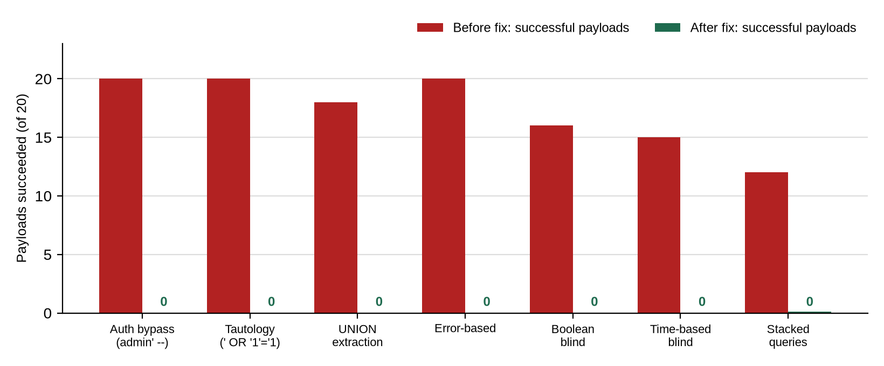
Figure 7: Successful injection payloads before and after applying the fix (lab test)

6.4 Verification tests
Test | Expected result
Enter admin' -- with a random password | Login refused with the generic message; no session created.
Run sqlmap against POST /login (level 5, risk 3) | “All tested parameters do not appear to be injectable”.
Submit a single quote in the username field | No database error shown; event recorded in the server log.
Connect as bank_login and run DROP TABLE or SELECT on cards | “Command denied” error from MySQL.
Static analysis scan (Semgrep SQLi rules) | Zero findings of string-concatenated SQL in the codebase.
Six wrong passwords for one account | Account temporarily locked; alert raised; correct login works after lock expires.

6.5 Monitoring and alerting after deployment
Signal monitored | Threshold | Automatic response
Inputs rejected by the allow-list | > 20 per minute from one IP | Block IP for 15 minutes; alert SOC
WAF SQLi signature matches | Any match on /login | Request dropped; event sent to SIEM
Failed logins per account | 5 within 10 minutes | Temporary lock; SMS alert to customer
DB permission-denied errors | Any from bank_login | High-priority incident ticket
Slow login queries | > 2 seconds | Investigate possible time-based probing

With these rules in place the bank gains both prevention and visibility: injection attempts fail at the application layer, and the security operations team is informed early enough to block the source and review related activity before any damage occurs.

7. CONCLUSION
The scenario shows how a single line of code, one that joins customer input to an SQL string, can hand control of a bank's database to anyone who can type into a login form. Because the database cannot distinguish the developer's code from the customer's text, a quote and a comment marker are enough to remove the password check, and more elaborate payloads can extract card data, alter balances or destroy transaction history. The vulnerability is SQL injection (CWE-89, OWASP A03), and its severity is critical.
The proposed mechanism removes the root cause rather than filtering symptoms. Parameterized queries fix the structure of every statement before input arrives, so input is always data. Password verification with bcrypt moves authentication out of SQL, allow-list validation rejects malformed input early, a least-privilege database account limits what any query can do, and generic errors, rate limiting, WAF rules and monitoring deny the attacker feedback and time. No single control is relied upon: if one layer is bypassed, the next still contains the attack.
Secure database interaction is ultimately an access-control discipline. Untrusted input must never be granted the power to act as code, and the application itself must hold only the privileges it needs. Applying these principles consistently gives customers a login that behaves exactly as designed, whatever they type into it.

7.1 Summary of findings
Finding | Cause | Fix applied
Crafted input changes the login query | String-concatenated dynamic SQL | Prepared statements with bound parameters
Password check can be removed | Plain-text password compared inside SQL | bcrypt hash verified in application code
Database errors reveal schema | Raw error messages sent to browser | Generic messages; server-side logging
Injected SQL can read or drop any table | Application connects as root | Least-privilege login account
Automated attacks go unnoticed | No rate limit, lockout or monitoring | Rate limiting, lockout, WAF and SIEM alerts

7.2 Compliance and standards mapping
Standard / guideline | Requirement satisfied by the fix
OWASP ASVS 4.0, V5.3.4 | Database queries use parameterized queries or ORMs, protecting against SQL injection.
PCI DSS v4.0, Req. 6.2.4 | Software engineering techniques prevent injection attacks, including SQL injection.
ISO/IEC 27001:2022, A.8.28 | Secure coding principles are applied to software development.
RBI Master Direction on IT Governance (2023) | Secure development life cycle and periodic application security testing.

7.3 Secure coding checklist for developers
- Never build SQL with string concatenation or template literals; always use placeholders.
- Validate every input on the server against an allow-list of type, length and pattern.
- Store passwords only as salted bcrypt or Argon2 hashes and compare them in code.
- Give each service its own database account with the minimum required privileges.
- Show generic error messages to users and log the details securely on the server.

7.4 Future scope
- Multi-factor authentication and passkeys so that a bypassed password check alone is not enough.
- Automated SAST and DAST scanning in the CI/CD pipeline to block new injection flaws before release.
- Database activity monitoring with anomaly detection for unusual query patterns.

7.5 Learning outcomes
- Understood why mixing code and data in one string lets input change the meaning of an SQL query.
- Learned to recognise in-band, blind, out-of-band and second-order SQL injection and their impact.
- Applied parameterized queries, stored procedures, password hashing and least privilege in code.
- Designed verification tests and monitoring rules that prove a security fix works in practice.

7.6 Advice for bank customers
- Enable multi-factor authentication and SMS or app alerts for every login and transaction.
- Use a unique, strong password for net banking so that a breach elsewhere cannot be reused here.
- Report unexpected login alerts or transactions to the bank immediately.
- Access net banking only through the official website or app, never through links in emails or SMS.

7.7 Final remarks
The banking login case demonstrates that security must be designed into the way an application talks to its database. By treating every piece of customer input as untrusted data, binding it through parameterized queries and limiting the privileges of each database account, the bank turns a critical vulnerability into a routine, logged and harmless failed login attempt. The same approach should be extended to every module of the bank so that no query anywhere in the system can be rewritten by the data it receives.

References
- OWASP Foundation. SQL Injection Prevention Cheat Sheet. cheatsheetseries.owasp.org.
- OWASP Foundation. OWASP Top 10:2021, A03 – Injection.
- MITRE. CWE-89: Improper Neutralization of Special Elements used in an SQL Command. cwe.mitre.org.
- OWASP Foundation. Web Security Testing Guide, WSTG-INPV-05: Testing for SQL Injection.
- FIRST. Common Vulnerability Scoring System v3.1: Specification Document.
- PCI Security Standards Council. PCI DSS v4.0, Requirement 6.2.4.
- OWASP Foundation. Application Security Verification Standard 4.0, V5.3.
- OWASP Foundation. Query Parameterization Cheat Sheet. cheatsheetseries.owasp.org.
- NIST. Special Publication 800-53 Rev. 5, Control SI-10: Information Input Validation.

