Table of Contents

1. Objective

* The problem statement
* Introduction to Virtual Classroom System

1. Project Category/Area of application
2. Tools/Platform/Languages to be used

* Tools/Platform
* Languages/Technologies
* About PHP
* About AJAX
* About IBM DB2

1. Analysis

* Modules
* Data Flow Diagrams

1. Future Scope

Objective

**The Problem Statement:**

In the modern times, India is lacking far behind in the global standards of imparting technical and professional education. The reason behind this lack of awareness about quality education, lack of accessibility, absence of basic infrastructure and bureaucracy in government educational organizations.

Most of the people in the country are either completely in the dark or have a vague idea about how to get quality education. They don’t know why they should get it because they do not have any idea about how beneficial professional education can be. As a result only a handful of the Indian population is able to obtain quality education, leaving the rest devoid of it.

Many of the people in the country, who actually are aware about the education options, are unable to obtain the benefits from them because of the educational institutions either being too far away or simply being too costly to afford. Many of the professionals who want to extend their knowledge are unable to do so because they simply cannot find time enough to attend traditional institutions which impart quality education.

Thus, there is need to spread awareness about quality professional education. There is also a need to make this quality education easily available to the masses.

**Introduction to Virtual Classroom System:**

With the above mentioned problems in view, we propose the introduction of a Virtual Classroom System, to meet the demands of providing professional education to the masses in a non-traditional manner.

The faculty teaches the registered students through an online interactive portal called “Whiteboard.” The faculty or the teachers can use the whiteboard to broadcast relevant images, diagrams, presentations, text and other materials to the students connected to him in the session. The students and the faculty can interact with each other through a handy chat server.

Besides these features each student and faculty has his/her own profile. They can keep track of their progress in this manner. Tests can be prepared as per the faculty on a regular basis to keep the students brushed up and familiar with the courses they are pursuing.

All the classes that the student has registered for can be viewed by him later on through downloadable video files or through PPTs.

This project aims to provide the benefits of a classroom based education without the student being physically present in a conventional classroom. It is an attempt to re-invent the distant learning programme.

Project Category/Area of Application:

This project is categorized as an Online Interactive software together with Relational Database Management System (RDBMS). As the most sought after requirement of the Virtual Classroom System is its reliability, robustness, security, completeness and authenticity of data.

Tools / Platform / Languages to be used:

**Tools/Platform:**

**Expected Hardware Requirements(Server Side):**

Intel Series Processor(1.8 GHz or Higher)

128 MB RAM

80 GB HDD, for effective storage

**Expected Software Requirements(Server Side):**

Operating System: Microsoft Windows(XP/Vista/Seven)

Apache Web Server

PHP

IBM DB2 Database Express C

Mozilla Firefox(expected for best performance)

**Expected Software Requirement(Client Side):**

HTML 5 supported browser(Mozilla Firefox 3.5)

**Languages/Technologies:**

* HTML5 is to be used to build the web pages.
* PHP is to be used for server side scripting.
* AJAX(Asynchronous Javascript And Xml) is to be used to provide dynamic content to the website.
* IBM DB2 Express C is to be used to provide a database at the backend of the application.

**About PHP:**

**PHP: Hypertext Preprocessor** is a widely used, general-purpose [scripting language](http://en.wikipedia.org/wiki/Scripting_language) that was originally designed for [web development](http://en.wikipedia.org/wiki/Web_development) to produce [dynamic web pages](http://en.wikipedia.org/wiki/Dynamic_web_page). For this purpose, PHP code is embedded into the [HTML](http://en.wikipedia.org/wiki/HTML) source document and interpreted by a [web server](http://en.wikipedia.org/wiki/Web_server) with a PHP processor module, which generates the [web page](http://en.wikipedia.org/wiki/Web_page) document. As a general-purpose programming language, PHP code is processed by an interpreter application in [command-line](http://en.wikipedia.org/wiki/Command-line) mode performing desired operating system operations and producing program output on its standard output channel. It may also function as a graphical application. PHP is available as a processor for most modern web servers and as a standalone interpreter on most [operating systems](http://en.wikipedia.org/wiki/Operating_systems) and [computing platforms](http://en.wikipedia.org/wiki/Platform_%28computing%29).

PHP was originally created by [Rasmus Lerdorf](http://en.wikipedia.org/wiki/Rasmus_Lerdorf) in 1995 and has been in continuous development ever since. The main implementation of PHP is now produced by the PHP Group and serves as the [*de facto* standard](http://en.wikipedia.org/wiki/De_facto_standard) for PHP as there is no [formal specification](http://en.wikipedia.org/wiki/Formal_specification). PHP is [free software](http://en.wikipedia.org/wiki/Free_software) released under the [PHP License](http://en.wikipedia.org/wiki/PHP_License).

PHP is a general-purpose scripting language that is especially suited to [server-side](http://en.wikipedia.org/wiki/Server-side_scripting) [web development](http://en.wikipedia.org/wiki/Web_development) where PHP generally runs on a [web server](http://en.wikipedia.org/wiki/Web_server). Any PHP code in a requested file is [executed](http://en.wikipedia.org/wiki/Execution_%28computing%29) by the PHP runtime, usually to create [dynamic web page](http://en.wikipedia.org/wiki/Dynamic_web_page) content. It can also be used for [command-line](http://en.wikipedia.org/wiki/Command-line) scripting and [client-side](http://en.wikipedia.org/wiki/Client-side) [GUI](http://en.wikipedia.org/wiki/Graphical_user_interface) applications. PHP can be deployed on most [web servers](http://en.wikipedia.org/wiki/Web_server), many [operating systems](http://en.wikipedia.org/wiki/Operating_system) and [platforms](http://en.wikipedia.org/wiki/Platform_%28computing%29), and can be used with many [relational database management systems](http://en.wikipedia.org/wiki/Relational_database_management_system) (RDBMS). It is available free of charge, and the PHP Group provides the complete source code for users to build, customize and extend for their own use.[[31]](http://en.wikipedia.org/wiki/PHP#cite_note-foundations-30)

PHP primarily acts as a [filter](http://en.wikipedia.org/wiki/Filter_%28software%29),[[32]](http://en.wikipedia.org/wiki/PHP" \l "cite_note-31) taking input from a file or stream containing text and/or PHP instructions and outputs another stream of data; most commonly the output will be HTML. Since PHP 4, the PHP [parser](http://en.wikipedia.org/wiki/Parser) [compiles](http://en.wikipedia.org/wiki/Compiler) input to produce [bytecode](http://en.wikipedia.org/wiki/Bytecode) for processing by the [Zend Engine](http://en.wikipedia.org/wiki/Zend_Engine), giving improved performance over its [interpreter](http://en.wikipedia.org/wiki/Interpreter_%28computing%29) predecessor.

**About AJAX:**

**Ajax** (shorthand for [Asynchronous](http://en.wikipedia.org/wiki/Asynchronous_I/O) [JavaScript](http://en.wikipedia.org/wiki/JavaScript) and [XML](http://en.wikipedia.org/wiki/XML)) is a group of interrelated [web development](http://en.wikipedia.org/wiki/Web_development) techniques used on the [client-side](http://en.wikipedia.org/wiki/Client-side) to create interactive [web applications](http://en.wikipedia.org/wiki/Web_application). With Ajax, [web applications](http://en.wikipedia.org/wiki/Web_application) can retrieve data from the [server](http://en.wikipedia.org/wiki/Web_server) asynchronously in the background without interfering with the display and behavior of the existing page. The use of Ajax techniques has led to an increase in interactive or dynamic interfaces on web pages. Data is usually retrieved using the [*XMLHttpRequest*](http://en.wikipedia.org/wiki/XMLHttpRequest) [object](http://en.wikipedia.org/wiki/Object_%28computer_science%29). Despite the name, the use of [XML](http://en.wikipedia.org/wiki/XML) is not actually required, and the requests do not need to be [asynchronous](http://en.wikipedia.org/wiki/Asynchrony).[[2]](http://en.wikipedia.org/wiki/Ajax_%28programming%29#cite_note-wrox-1)

Like [DHTML](http://en.wikipedia.org/wiki/Dynamic_HTML) and [LAMP](http://en.wikipedia.org/wiki/LAMP_%28software_bundle%29), Ajax is not a technology in itself, but a group of technologies. Ajax uses a combination of [HTML](http://en.wikipedia.org/wiki/HTML) and [CSS](http://en.wikipedia.org/wiki/Cascading_Style_Sheets) to mark up and style information. The [DOM](http://en.wikipedia.org/wiki/Document_Object_Model) is accessed with [JavaScript](http://en.wikipedia.org/wiki/JavaScript) to dynamically display, and to allow the user to interact with, the information presented. JavaScript and the XMLHttpRequest object provide a method for exchanging data asynchronously between browser and server to avoid full page reloads.

**About Oracle 10G Express Edition:**

The Oracle 10G Express Edition is a [relational model](http://en.wikipedia.org/wiki/Relational_model) [database server](http://en.wikipedia.org/wiki/Database_server) developed by Oracle Inc. It primarily runs on [Linux](http://en.wikipedia.org/wiki/Linux) and [Windows](http://en.wikipedia.org/wiki/Microsoft_Windows) servers. Oracle 10G can be administered from either the command-line or a GUI. The command-line interface requires more knowledge of the product but can be more easily scripted and automated. The GUI is a multi-platform Java client that contains a variety of wizards suitable for novice users. Oracle 10G supports both SQL,PLSQL and [Postgre](http://en.wikipedia.org/wiki/XQuery) SQL..

.

Analysis

**Modules:**

1. **User Profile Module:**

This module is used to register and manage user profiles. It includes registration and profile maintenance of profiles of both the faculty and the enrolled students. Students can use this module to attend classes, keep track of their academic progress, secure login, take tests and access other important information.

1. **Classroom Module:**

This module is used to establish a classroom session between a faculty and the students allotted to the faculty member. It contains the whiteboard and the chat server which is used to conduct the lectures and the exchange of information between the students and the faculty.

The faculty can use the whiteboard to conduct the classes just like a traditional classroom. The whiteboard can be used by the faculty to broadcast its contents to all the users connected to the faculty in the classroom session.

1. **Test Module:**

This module is used by the students to take tests as assigned to them by their respective faculties in order to measure their academic progress. Faculties can assign the tests to the class he/she is taking, and the students can access these tests when they log in to the web site.

The tests are allotted several different time slots in a day. The students can log in at their preferred time slot and take the test. Their scores are automatically generated according to the solution set provided by the faculty. These scores can then be updated in the students’ profile.

1. **Scheduler Module:**

This module is used by the faculty members to schedule a class or a test in distinct time slots. The faculty can take classes on a subject several times in a day, and students can access those classes according to the time-slot of their preference. This can be achieved by creating a weekly calendar of the activities.

1. **Miscellaneous Module:**

This module can help the students to download videos of previous classes, presentations, assignments, solutions of tests, study material and other miscellaneous information.

1. **Reports Module:**

This module can be used to display reports such as test results, progress reports of a particular student, faculty profile, student’s rankings according to performance, etc.

1. **Notice Board Module:**

This module can be used to post important information and notices which can be either from the administrator or the faculty members, and is directed to all the users of the system. Some of the examples of such notices include updates about amendments in the web site, change in class timings, announcements of tests, etc.

**Data Flow Diagrams:**

**Level Zero DFD:**

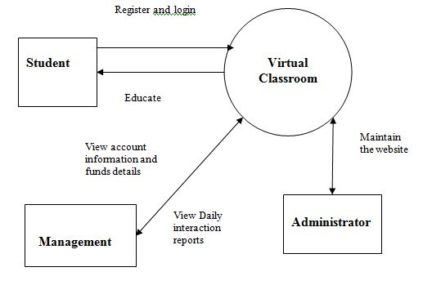

**Level Zero DFD**

**Level One DFD:**

**Student Side:**

**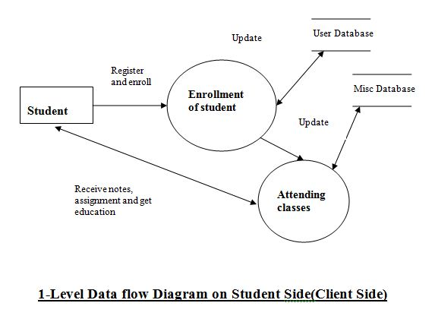**

**Teacher Side:**

**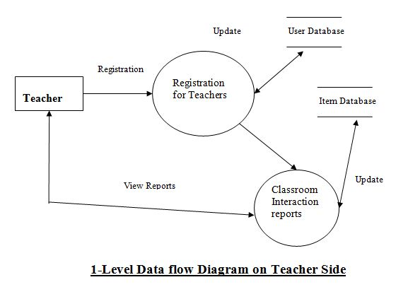**

Future Scope

The Virtual Classroom system is a project of imminent importance as it is a project with huge future prospects. It is the first of many steps to re-invent the education system in the country and to enhance the education rate at a magnanimous level.

This project can be further enhanced in a number of ways. The whiteboard can be further worked upon to support full classroom features.

Personalised versions of the project can be used directly by institutions to provide education through the web.

The application can be designed to provide full functionalities of an institution dedicated to impart quality education.

With these ideals in mind, we propose this project to be the pioneer in the movement for intelligent-education system.