On-The-Job Training (OJT) Report on
KinaHub E-commerce at
Shivapuri Secondary School, Maharajgunj, Kathmandu

A Report Submitted
In the Partial Fulfillment of the Requirement for the Degree
Computer Engineering under Technical and Vocational Stream
Secondary Level Education (Grade - 10)

Submitted By:
Bikram Gole

Submitted To:
Department of Technical and Vocational Stream
National Examination Board
Sanothimi, Bhaktapur

Asar, 2083

CERTIFICATE OF APPROVAL
This is to certify that the On-the-Job Training (OJT) report entitled "KinaHub E-commerce Platform" submitted by Mr. Bikram Gole, a student of Grade 10 at Shivapuri Secondary School, is an authentic record of the work carried out by him under my supervision and guidance during the academic year 2082/83 B.S.
This project demonstrates the practical application of modern web development concepts including frontend design, backend logic, and AI integration. The work was performed as part of the Grade 10 Computer Engineering curriculum and reflects a high level of dedication and technical skill.
This report is approved for the partial fulfillment of the requirements for the Grade 10 level in the Computer Engineering program under the Technical Stream for the academic year 2082 B.S is accepted.

.........................
External Evaluator
IT Instructor
Maharajgunj, Kathmandu, Nepal

CERTIFICATE OF ON THE JOB TRAINING
This is to certify that Mr. Bikram Gole, a student of Grade 10 at Shivapuri Secondary School, has successfully completed his On-the-Job Training (OJT) as part of the Computer Engineering curriculum under the Technical Stream for the academic year 2082B.S.
During the training period, he was actively involved in the design and development of the project titled "KinaHub E-commerce Platform." His work included practical implementation of modern technologies such as frontend development, backend system design, database management, and basic AI integration.
Throughout the training, he demonstrated a strong sense of responsibility, dedication, and eagerness to learn. His ability to apply theoretical knowledge into practical work is commendable. He maintained good discipline and showed professional behavior during the entire training period.
We wish him success in his future academic and professional endeavors.

.........................
Supervisor
Er. Sagun Babu Adhikari
IT Instructor

DECLARATION
I, Bikram Gole, a student of Grade 10, hereby declare that the OJT report entitled 'KinaHub E-commerce Platform' submitted to the Department of Computer Engineering, Shivapuri Secondary School, is my original work. The project was developed independently during my practice sessions at school, applying the principles of UI/UX design and programming I have learned in class.
I have followed all the institutional guidelines provided by the school and the National Education Board (NEB) during the preparation of this report. All information used from external sources has been duly acknowledged.
.........................
Mr. Bikram Gole
Shivapuri Secondary School
Maharajgunj-10, Kathmandu

PREFACE
The present report is the outcome of the On-the-Job Training (OJT) project titled 'KinaHub - Local E-commerce & CRM'. It is prepared as a key practical component of the Grade 10 Computer Engineering curriculum at Shivapuri Secondary School. The training was designed to provide students with hands-on experience in the rapidly evolving field of software development and digital entrepreneurship.
This report reflects the practical exposure I gained while building a full-stack e-commerce solution. In an era where local businesses are struggling to compete with global giants, KinaHub aims to provide a localized platform that is both technically robust and user-friendly. The development process involved mastering React for the dynamic frontend, Django for the secure backend API, and integrating client-side AI assistants to guide user decisions. This OJT has been a bridge between theoretical classroom concepts and the real-world application of engineering principles.
Building KinaHub allowed me to understand the complexities of real-world software, from database management to handling asynchronous operations and global state. Beyond technical skills, it taught me the importance of UI/UX design in creating accessible digital tools for the local community. This experience has deepened my passion for technology and provided me with a solid foundation for my future career in computer engineering.

ACKNOWLEDGEMENT
This OJT report would not have been possible without the support and guidance of several individuals and institutions. First and foremost, I express my heartfelt gratitude to Er. Sagun Babu Adhikari for his continuous guidance, constructive feedback, and mentorship throughout the project. His expertise in modern software architecture and his encouragement helped me improve my technical skills and complete the project successfully.
I would also like to express my sincere gratitude to our respected Principal, Mrs. Sindhu Tuladha, for her valuable support, encouragement, and for creating a positive academic environment that made this training possible.
I would also like to thank Shivapuri Secondary School for providing the technical infrastructure and a supportive environment for this OJT. The Department of Computer Engineering has been instrumental in providing the foundational knowledge required to tackle such a complex project. I am grateful to my teachers for their constant supervision and for encouraging me to explore beyond the standard curriculum.
Finally, I extend my deepest gratitude to my parents and family for their constant support, motivation, and encouragement during this OJT. Their belief in my potential has been my greatest source of inspiration throughout this journey.

TABLE OF CONTENTS
Topic Page No.
CERTIFICATE OF APPROVAL ii
CERTIFICATE OF ON THE JOB TRAINING iii
DECLARATION iv
PREFACE v
ACKNOWLEDGEMENT vi
TABLE OF CONTENTS vii
ABBREVIATIONS ix
Chapter: 1 Introduction 1
1.1 Project Overview 1
1.2 Problem Statement 1
1.3 Project Objectives 1
1.4 Project Scope 2
Chapter: 2 OJT Workplace & Context 3
Chapter: 3 Technology & Technical Implementation 4
3.1 Technology Stack Details 4
3.2 Backend Data Models 4
3.3 Visual Showcase & UI Analysis 5
3.3.1 Advanced Landing Page Implementation 5
3.3.2 Featured Products Section 6
3.3.3 Category Discovery System 6
3.3.4 Advanced Filtering & Sorting 7
3.3.5 Instant Full-Text Search 7
3.3.6 Kina AI Intelligence Integration 8
3.3.8 Detailed Product Architecture 9
3.3.9 Logic-Heavy Multi-Store Cart 9
3.3.10 Secure Multi-Step Checkout 10
3.3.11 Customer Feedback & Review System 10
3.3.12 Responsive Navigation & Meta Links 11
Chapter: 4 OJT Summary & Learning 12
4.1 Observations & Analysis 12
4.2 Technical Skills Acquired 12
Chapter: 5 Conclusion, Recommendation & Suggestion 13
5.1 Conclusion 13
5.2 Limitations 13
5.3 Future Enhancements 14
5.4 Recommendations 14
5.5 Suggestions 14
References 14

ABBREVIATIONS
OJT : On-the-Job Training
CRM : Customer Relationship Management
API : Application Programming Interface
JWT : JSON Web Token
SPA : Single Page Application
DRF : Django REST Framework
ORM : Object-Relational Mapping
LLM : Large Language Model
UI/UX : User Interface / User Experience

Chapter: 1 Introduction

1.1 Project Overview
KinaHub is a modern, local-first e-commerce and CRM platform. While global platforms like Amazon focus on wide-scale logistics, KinaHub is designed to empower local sellers and neighborhoods. It bridges the gap between local physical stores and the digital shopping space.
The project was conceived as a Grade 10 OJT project to demonstrate how modern web technologies can be combined to solve local community problems. KinaHub features a dynamic storefront, a multi-seller cart system, and a specialized 'Kina AI' shopping assistant that provides real-time advice based on localized delivery fees and product data.

1.2 Problem Statement
The current local retail market in Nepal faces several digital barriers:
- Visibility Gap: Local small-scale stores often lack the technical resources to set up an online storefront, making them invisible to digital-first customers.
- Logistical Complexity: Customers ordering from multiple nearby stores often face high and disjointed delivery fees because platforms do not optimize for local seller proximity.
- Lack of Personalized Guidance: Traditional e-commerce platforms offer generic recommendations, whereas local shoppers often need specific advice on value and localized convenience.

1.3 Project Objectives
The primary objectives of the KinaHub project were:
- To build a responsive and interactive frontend using React and Tailwind CSS.
- To implement a secure and scalable backend using the Django REST Framework.
- To integrate an AI assistant using the OpenRouter API to provide rule-based shopping advice.
- To simplify business management for local sellers through an intuitive CRM dashboard.

1.4 Project Scope
The project scope covers the end-to-end development of an e-commerce platform. This includes user authentication (JWT), product listing and categorization, brand management, multi-seller cart optimization, and a comprehensive seller dashboard. The scope is limited to a functional prototype suitable for local testing and school demonstrations.

Chapter: 2 OJT Workplace & Context
The On-the-Job Training (OJT) was conducted in the Computer Engineering Department of Shivapuri Secondary School, Maharajgunj, Kathmandu, during the academic year 2082/83. The training environment was designed to provide practical exposure to software development, allowing students to apply classroom knowledge in a real-world project setting. The school provided the necessary computer systems, internet access, and technical resources required for the successful completion of the project.
The development of the KinaHub platform followed a structured workflow based on Agile development principles. The project was divided into manageable tasks such as user authentication, product management, cart functionality, checkout processing, seller dashboard development, and AI integration. Regular testing, debugging, and documentation review were carried out throughout the development process to ensure system reliability and performance.
During the OJT, I gained valuable experience in full-stack web development using React, TypeScript, Django, and Django REST Framework. The project provided hands-on exposure to database management, API development, responsive user interface design, and AI-powered features. This practical learning environment enhanced both my technical knowledge and problem-solving abilities, helping me understand the complete software development lifecycle.

Chapter: 3 Technology & Technical Implementation

3.1 Technology Stack Details
The KinaHub platform is built using a decoupled architecture, ensuring that the frontend and backend can evolve independently. The technical stack includes:
- Frontend: React.js with TypeScript. TypeScript was used to ensure type safety, reducing bugs in complex state management scenarios. Vite was used as the build tool for fast development cycles.
- Backend: Django. Django's powerful ORM was used for database management and the Django REST Framework (DRF) serves JSON data to the React frontend.
- AI Layer: OpenRouter API. This allows the client-side to communicate with large language models like Gemma and Nemotron without requiring heavy server-side processing.

3.2 Backend Data Models
The backend architecture is centered around several key models:
- Product Model: Stores item names, slugs, prices, stock levels, and store relations. It includes properties like 'current_price' to handle discounts dynamically.
- Store Model: Manages seller information, including delivery rules, banners, and logos.
- Category/Brand Models: Allow for structured product organization, essential for the filtering system used in the frontend.
- Review Model: Implements a verified purchase system where users can leave ratings and media feedback to build community trust.

3.3 Visual Showcase & UI Analysis
The following sub-sections present each major module of the KinaHub platform with annotated screenshots. Each component was designed with user experience as the primary focus, ensuring that the platform remains accessible and intuitive for local sellers and buyers alike.

3.3.1 Advanced Landing Page Implementation
The KinaHub landing page is designed for high impact and clear navigation.
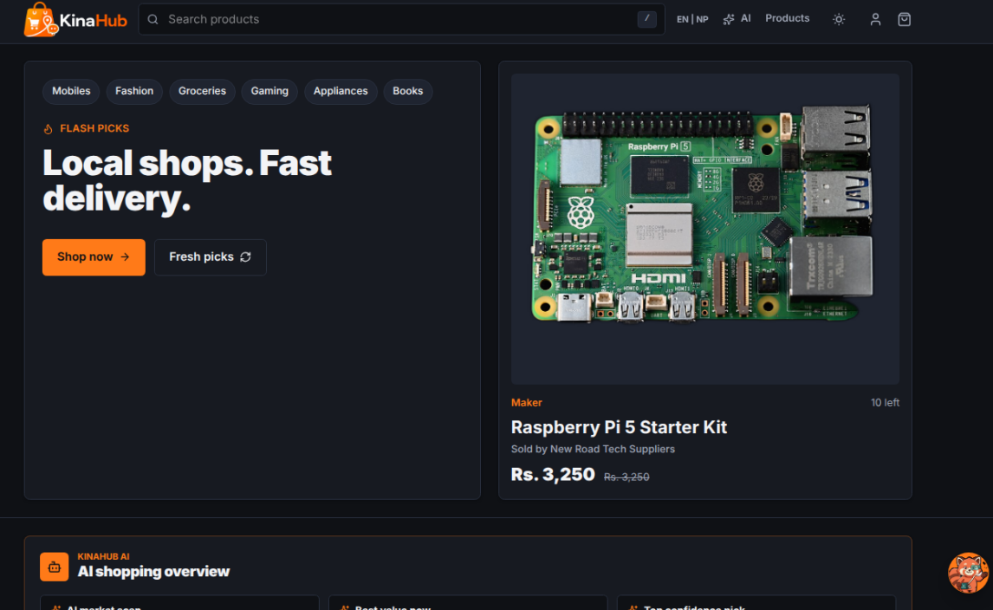

3.3.2 Featured Products Section
The Featured Products section showcases high-priority items using a curated grid layout.


3.3.3 Category Discovery System
The Categories page provides a structured entry point for users to browse products by type.
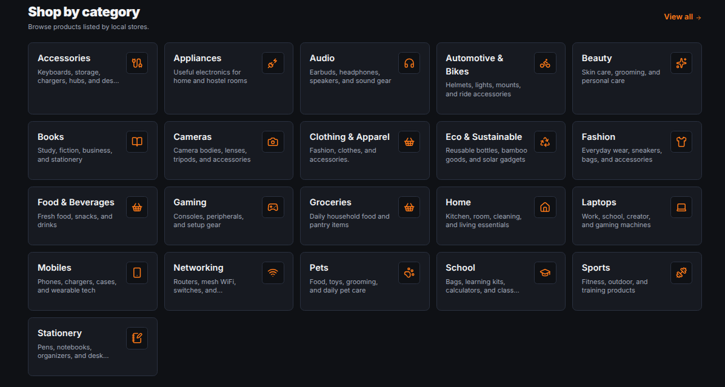

3.3.4 Advanced Filtering & Sorting
The filtering system allows users to narrow down product lists by price range, brand, and rating.
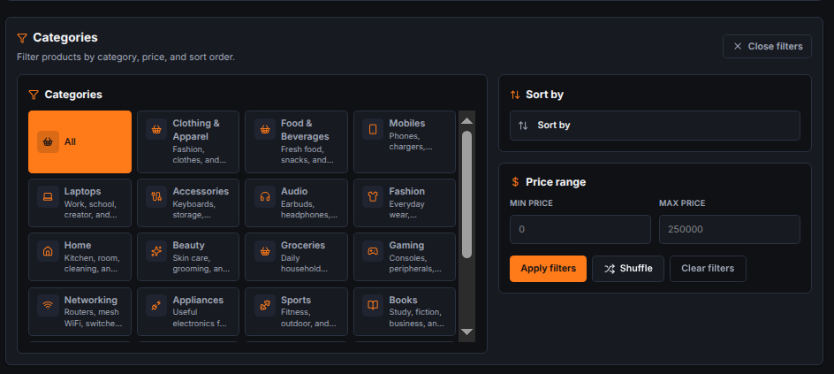

3.3.5 Instant Full-Text Search
The search interface features an instant, as-you-type result preview.
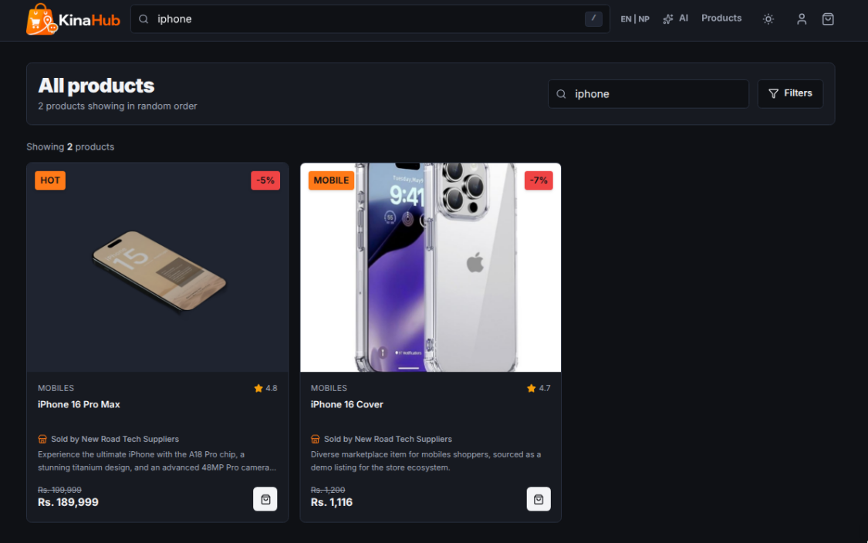

3.3.6 Kina AI Intelligence Integration
The Kina AI assistant represents a sophisticated integration of external LLMs with local business rules.
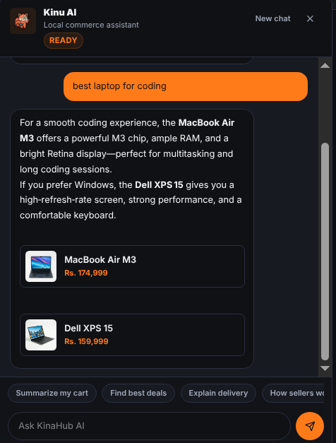
3.3.7 Complex Seller CRM Dashboard
The dashboard is a comprehensive management suite for local sellers.
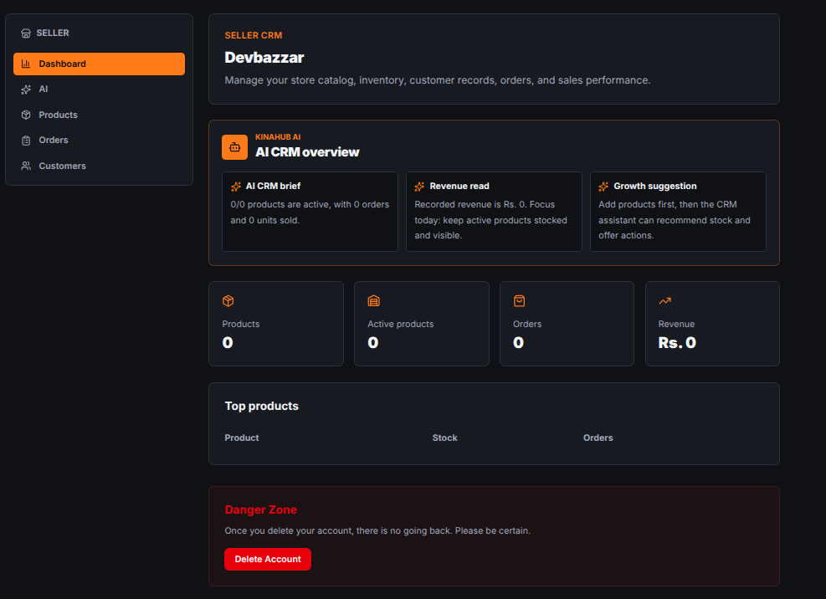

3.3.8 Detailed Product Architecture
The product detail page is the final step before the cart.
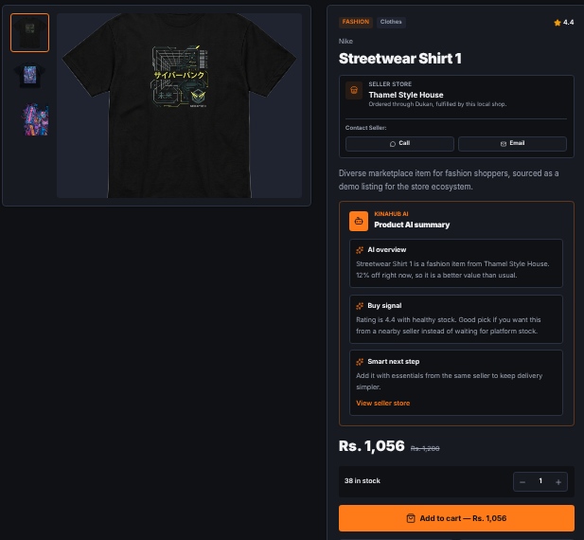

3.3.9 Logic-Heavy Multi-Store Cart
The cart is the most complex part of the frontend.
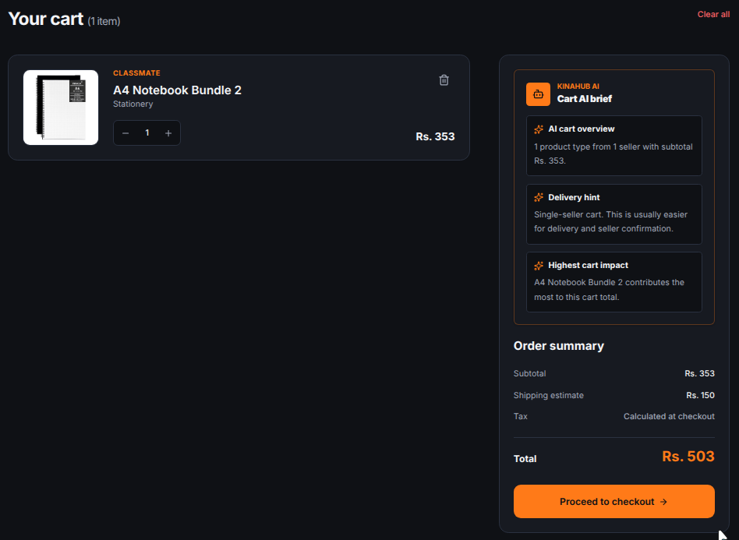

3.3.10 Secure Multi-Step Checkout
The checkout page is a multi-step process designed for high security and low friction.
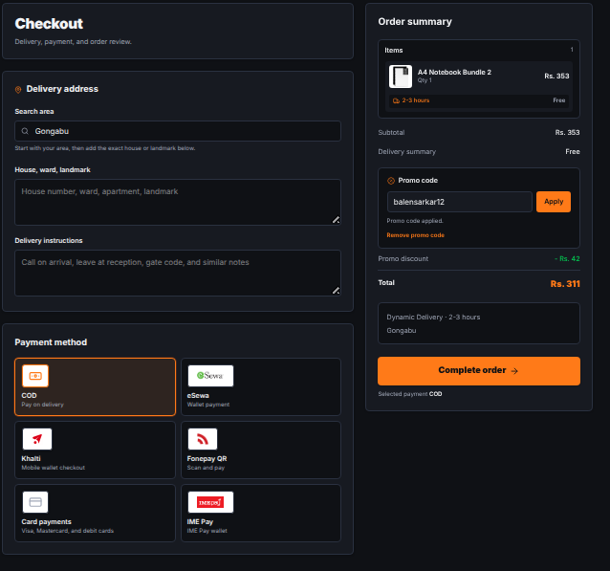

3.3.11 Customer Feedback & Review System
The reviews section builds social proof and trust.
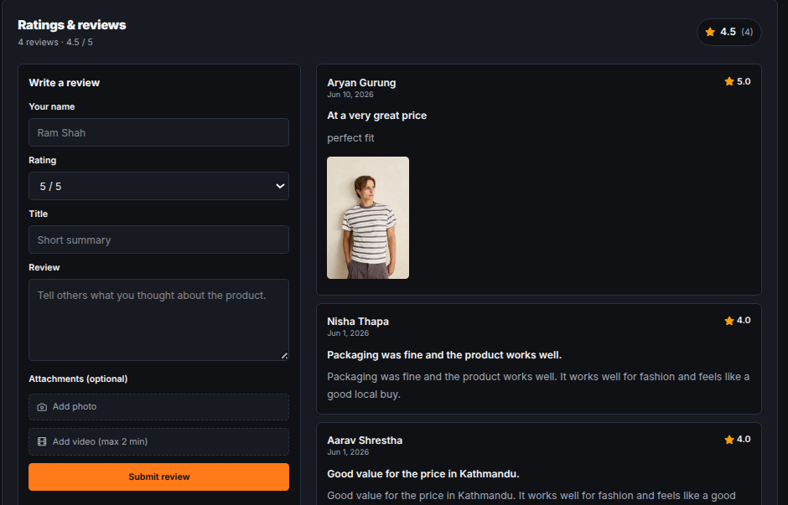

3.3.12 Responsive Navigation & Meta Links
The responsive footer provides essential navigation links, social media integration, and company information.
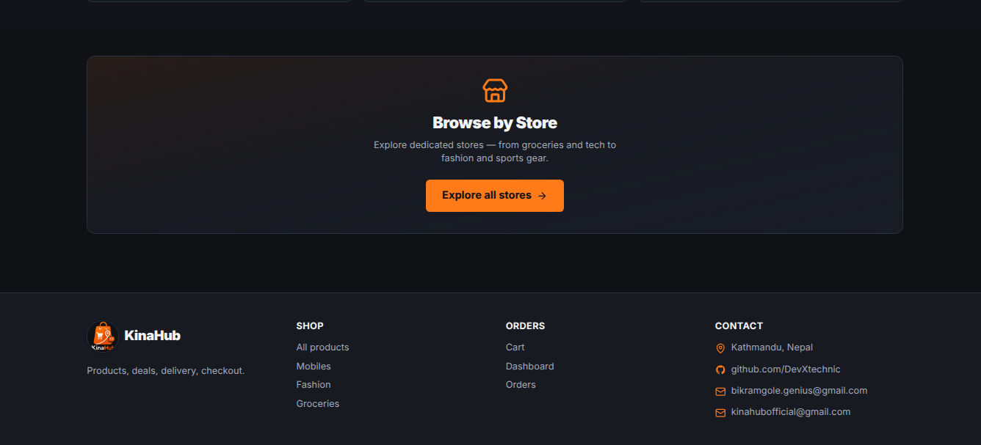

Chapter: 4 OJT Summary & Learning

4.1 Observations & Analysis
Throughout the OJT, I observed how modern web development is shifting towards client-side intelligence. By moving complex logic such as cart optimization to the frontend, a snappier user experience is achievable. I also analysed how critical slug-based routing is for SEO and user readability, which led to the implementation of automatic slug generation in Django using the 'slugify' utility.

4.2 Technical Skills Acquired
Working on KinaHub, I have mastered several key skills:
- Full-stack Integration: Connecting a Django REST backend with a Vite-powered React frontend.
- Advanced CSS: Using Tailwind CSS for building responsive, theme-aware interfaces.
- AI Orchestration: Designing prompts and handling streaming responses from the OpenRouter API.
- Version Control: Maintaining a clean development history and managing different features via Git.

Chapter: 5 Conclusion, Recommendation & Suggestion

5.1 Conclusion
The KinaHub project has successfully achieved its goals of building a functional, local-first e-commerce platform. For a Grade 10 student, this OJT has been a transformative experience, bridging the gap between school-level ICT and professional software engineering. KinaHub stands as a proof-of-concept for how localized technology can empower communities, giving local businesses the digital visibility they deserve.

5.2 Limitations
Although the KinaHub OJT project was highly beneficial, certain limitations were encountered during its development:
- Prototype Scope: The project was limited to a functional prototype; full production deployment with integrated payment gateways was not achieved within the OJT period.
- Connectivity Issues: Intermittent internet connectivity at school occasionally disrupted live API testing and deployment workflows.
- Time Constraints: Limited OJT duration prevented deeper exploration of AI fine-tuning and advanced performance optimization strategies.

5.3 Future Enhancements
The KinaHub platform has strong potential for future development. The following enhancements are planned:
- Real-time Notifications: Integrating WebSockets to notify sellers of new orders instantly.
- PWA Support: Converting KinaHub into a Progressive Web App so users can shop offline and receive push notifications.
- Enhanced AI Model: Training a specialized model on local product data to provide even more accurate value and price assessments.

5.4 Recommendations
Based on the OJT experience with KinaHub, the following recommendations are offered to improve future projects:
- Better Infrastructure: Schools should provide stable, high-speed internet and dedicated lab computers to support full-stack development OJT projects.
- Extended OJT Duration: Allocating more time for OJT would allow students to implement more advanced features, conduct thorough testing, and refine documentation quality.
- Regular Workshops: Conducting regular workshops on modern web technologies, version control, and deployment would better prepare students for real-world development projects.

5.5 Suggestions
From the KinaHub OJT experience, the following suggestions are offered to future trainees and institutions:
- Learn Fundamentals First: Future trainees should ensure strong foundational knowledge of HTML, CSS, JavaScript, and Python/Django before starting a full-stack OJT project.
- Maintain a Daily Logbook: Students should keep a daily development log to track progress, document bugs, and record learning milestones throughout the OJT period.
- Use Version Control from Day One: Adopting Git and GitHub from the very beginning of the project ensures clean commit history, easier collaboration, and a professional portfolio for future opportunities.

References
1. Django REST Framework (Backend API): https://www.django-rest-framework.org/
2. React (Frontend Library): https://react.dev
3. OpenRouter API (AI Orchestration): https://openrouter.ai

