REVA UNIVERSITY
Bengaluru, India
_______________________________________________________

SCHOOL OF COMPUTER SCIENCE AND ENGINEERING

Assignment Report
On

Solar System AR Explorer —
Interactive 3D & Augmented Reality Web Experience

_______________________________________________________

Submitted in fulfillment of the requirements for the award of the Degree of
Bachelor of Technology

Submitted by

Ashwin S (R23EF038)
Argho Kumar (R23EF029)
Ankur Goswami (R23EF026)

Under the guidance of

Dr. Selvan C
Associate Professor
School of CSE

2026

_______________________________________________________

Rukmini Knowledge Park, Kattigenahalli, Yelahanka,
Bengaluru-560064
www.reva.edu.in

1. INTRODUCTION
The field of astronomy and space science education has increasingly adopted digital technologies to improve visualization and interactive learning. Traditional methods of teaching the solar system often rely on static diagrams and textbooks, making it difficult for students to appreciate the true scale, movement, and beauty of our planetary system.
Understanding orbital mechanics, planetary sizes, distances, and other astronomical parameters is essential for anyone studying space science or physics. However, without proper visualization tools, these concepts remain abstract and difficult to grasp.
This project aims to develop an interactive web-based Solar System AR Explorer that visually represents the solar system using a 3D model and augmented reality technology. The system allows users to explore all eight planets and the Sun, view real-time orbital animations, and place the entire solar system in their physical environment using AR on a mobile device.
The project also demonstrates the use of modern web technologies to create immersive educational experiences directly in the browser without requiring any special hardware or software installation.
2. PROBLEM STATEMENT
Visualizing the solar system in three dimensions and understanding the relative positions, sizes, and orbital behavior of planets is challenging with conventional educational tools. Many existing planetarium applications require expensive dedicated hardware or specialized software installations.
Students and enthusiasts often find it difficult to appreciate the true scale and dynamics of the solar system from static images or 2D diagrams.
Therefore, there is a need for an interactive system that can simulate the solar system in real-time 3D and allow users to explore it through Augmented Reality. The system should be accessible on any modern smartphone or computer browser without installation.
The proposed solution is a web-based Solar System AR Explorer that renders all planets with accurate textures and orbital animations, provides planet information cards with scientific data, and enables users to place the solar system in their real-world environment using WebXR-based AR.
3. TECHNOLOGIES USED
The project uses the following technologies:
HTML5
HTML5 is used to structure the web page and create the layout of the solar system interface and AR viewer.
CSS3
CSS3 is used for styling the dashboard, creating the glassmorphism UI effects, animated star background, and responsive layout for both desktop and mobile devices.
JavaScript (ES6+)
JavaScript handles the application logic including orbital animation calculations, planet selection, info card rendering, speed control, and AR mode management.
Google Model Viewer
Google Model Viewer (v3.5.0) is a web component library used to render the 3D solar system GLB model, manage camera controls, and provide WebXR-based AR functionality on supported devices.
Three.js / WebXR
Three.js provides the underlying 3D scene management. WebXR enables the augmented reality session, allowing users to place the 3D solar system model in their physical environment using their smartphone camera.
Blender
Blender was used to create the 3D solar system model including all planet meshes, orbital path rings, Saturn’s rings, and baked animations. The model was exported in GLB format.
QRCode.js
QRCode.js is used to generate a scannable QR code that allows mobile users to instantly open the application on their smartphone for AR viewing.
Vercel
Vercel is used for hosting and deploying the application, providing a globally accessible public URL at ar-solar-system.vercel.app.
4. SYSTEM ARCHITECTURE
The system consists of the following main components:
User Interface Module
The user interface contains the solar system viewer, planet selection buttons, speed control slider, and AR access button. The UI uses glassmorphism design with a dark space theme.
3D Visualization Module
The 3D solar system model is loaded and rendered using Google Model Viewer. Lighting, camera position, and orbital animations are configured to provide a realistic representation of the solar system with all eight planets orbiting the Sun.
Orbital Animation Module
A custom JavaScript animation loop calculates and updates planet positions in real-time based on their orbital periods. The speed can be adjusted using a slider control from 0x to 0.1x simulation speed.
Planet Information Module
When a planet is selected, an information card is displayed showing the planet's name, type, key statistics (distance from Sun, orbital period, number of moons, diameter), and an interesting scientific fact.
AR Visualization Module
The WebXR-based AR module allows mobile users to place the 3D solar system model in their real-world environment. A QR code provides instant mobile access to the deployed application.
5. CODE SNIPPETS
[This section will show screenshots of the code - placeholder: Include a screenshot of the index.html showing the model-viewer setup and orbit animation code]
Key code excerpts from the project:
The orbital animation loop calculates planet positions using trigonometric functions based on elapsed simulation time and each planet's orbital period.
The AR mode is triggered via the model-viewer's built-in WebXR integration, which handles surface detection and model placement automatically on supported devices.
6. OUTPUT
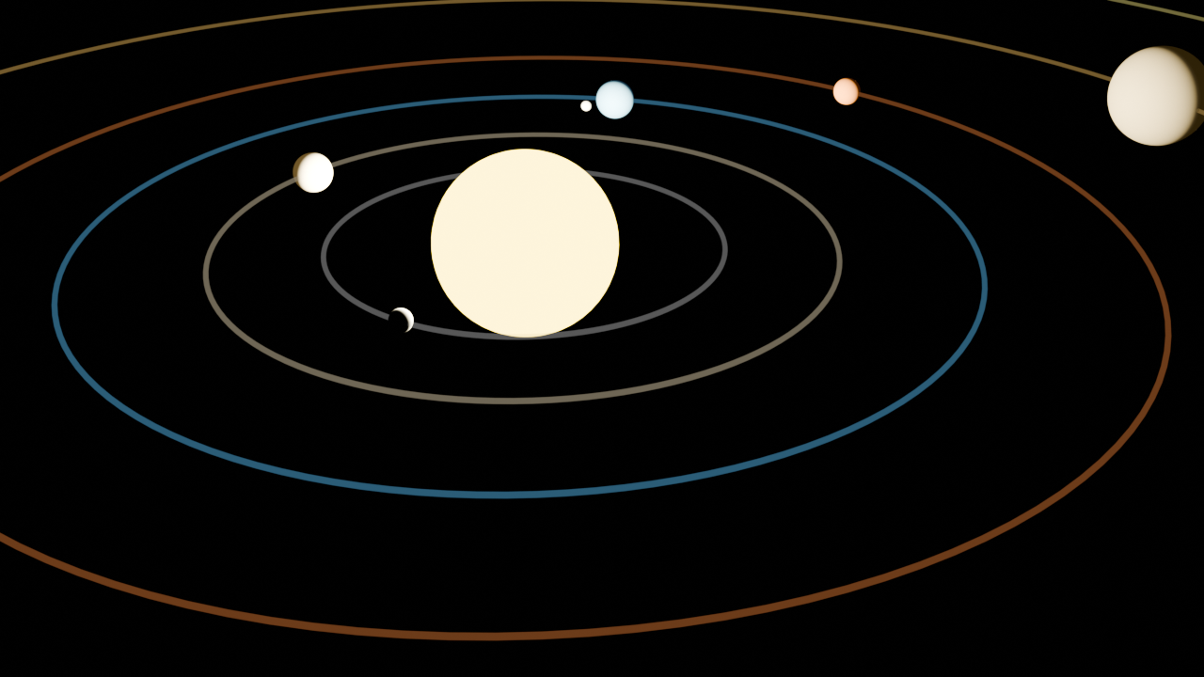
The application displays a fully interactive 3D solar system with:
- All 8 planets and the Sun with accurate textures
- Animated orbital paths with adjustable speed
- Planet selection buttons at the bottom
- Speed control slider in the top bar
- "View in AR" button for mobile AR experience
7. FUTURE SCOPE
The project can be further improved by adding features such as realistic planet size scaling, accurate orbital period ratios, moon systems for each planet, and audio narration for educational content.
The system can be extended to include a virtual tour mode that guides users through each planet with detailed explanations, and multiplayer capabilities for collaborative space exploration.
Integration with real-time NASA data feeds could allow the system to display actual current planetary positions and upcoming astronomical events.

8. CONCLUSION
The Solar System AR Explorer successfully demonstrates how modern web technologies can be used to build immersive educational experiences accessible to anyone with a smartphone or computer.
The system provides an engaging and interactive representation of our solar system, allowing users to explore planetary orbits, learn scientific facts about each planet, and place the entire solar system in their physical environment using augmented reality.
By combining 3D visualization with WebXR augmented reality and a clean educational interface, the project offers an innovative tool for understanding astronomy and inspiring interest in space science.

