1. Table should not be expanded when page loads
2. Submit button to be disabled and Grayed out
3. Add New Student Button should add new student with dummy values

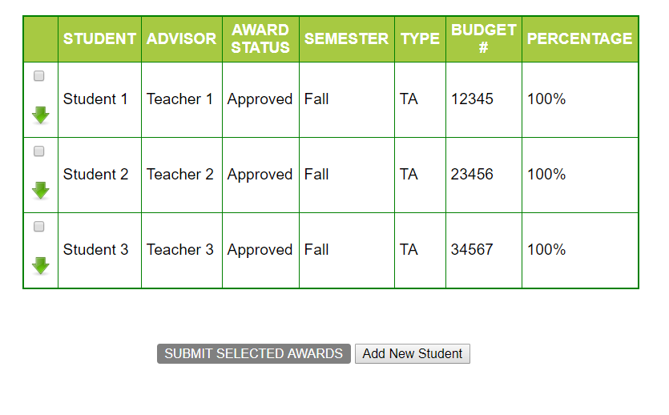

1. On selecting any of the check-boxes,  
   i] Background color to be changed for the particular row and   
   ii]Submit button to turn Orange.   
   iii]A delete button should get added dynamically in DELETE column and should delete the entire row when clicked.

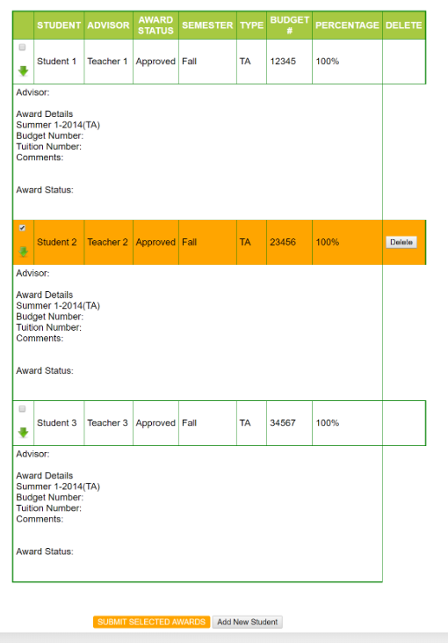

1. Deselecting the check box will make the row white again. Also, if none of the rows are selected, the Submit button should be Grayed out again(disabled). (i.e., if 1 or more of the check-boxes are selected, the Submit button will be enabled and background color will be orange. If none are selected, it will be disabled and background set to Gray)

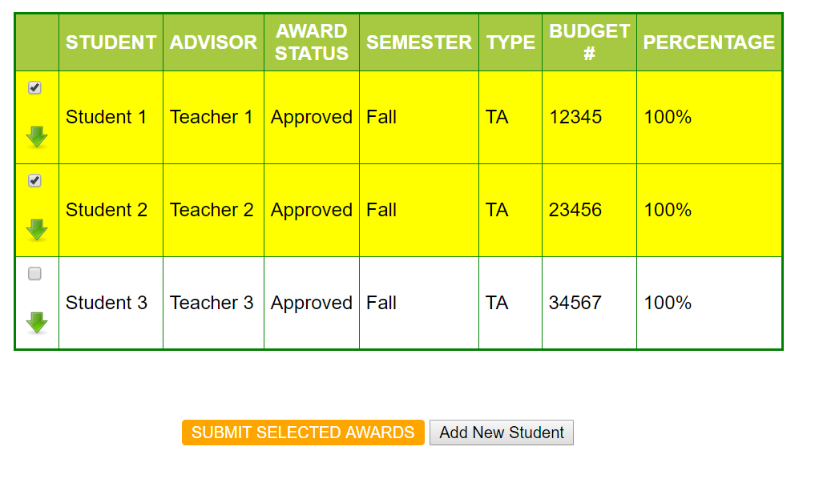

1. Clicking on any of the green arrows will expand the particular row. Clicking it again will collapse it (i.e., toggle view on click)

