Automobile Air Conditioning harnessing Shock Absorber action

GUIDE: DR. N. ASHOK KUMAR

ARUN V T

ASHWIN VISHNU M

GOKULDAS NANDAKUMAR

SAJU V J

# ABSTRACT

The conventional vapour compression AC system in automobiles relies on engine output for compressor work.

The energy associated with shock absorber action, is lost as viscous dissipation in conventional systems. By replacing this shock absorber to act as a reciprocating air compressor, to drive an air conditioning system, we can avoid the dependence on engine power.

Based on theoretical calculations on Reversed Brayton cycle, it has been found that, it is possible to achieve a cooling capacity of 1 Ton of Refrigeration, with a COP of 2.71. For this we require the modified shock absorber to generate an air pressure of 3 bar after compression.

# REVERSED BRAYTON CYCLE

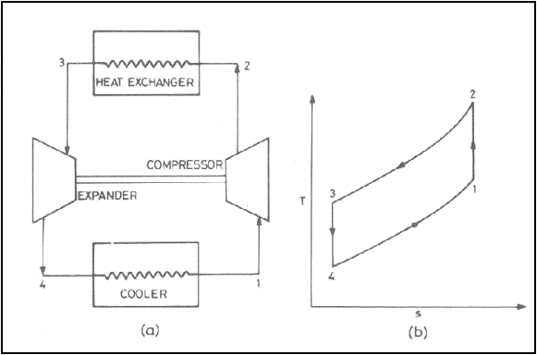

# EXPERIMENTAL SETUP

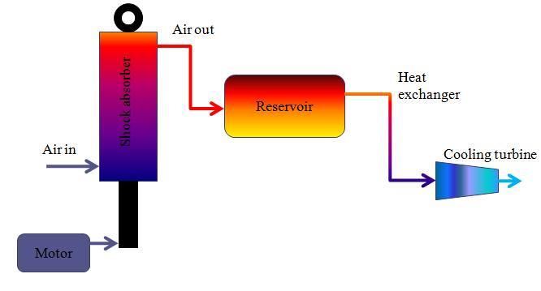

A Maruti 800 rear shock absorber is modified to act as a reciprocating air compressor. This is done by replacing the damping components within the shock absorber cylinder, with a piston head. An inlet and a delivery port are drilled into the cylinder.

The shock absorber is firmly mounted on a frame. It is then driven using a cam powered by an electric motor.

The compressed air is stored in a reservoir at a pressure of 3 bar and temperature higher than ambient condition.

Then, the air is passed into heat exchanger to reject heat to ambient air, isobarically.

To achieve the drop in temperature, the high pressure air is expanded using a cooling turbine, isentropically. Air pressure drops to atmospheric pressure, and the temperature is below ambient condition.

The refrigerating capacity of the cooled air per unit mass, and COP of the system has to be evaluated experimentally.

# SCOPE AND OTHER POSSIBLE APPLICATIONS

* Cooled air can be used to improve heat transfer from Radiator/Cylinder block walls.
* Cooled air, being denser, can be mixed into to air inlet manifold to improve the volumetric efficiency of the engine.
* Small cold storage chambers can work on this system.

# REFERENCES

* A rotary vane open reversed Brayton cycle air conditioning and refrigeration system, Edwards T.C, Purdue University 1970
* Analysis of the roto-cooler air-conditioning system, Yuan Mao Huang, National Taiwan University
* “[MIT Students Create Energy-Harvesting Shock Absorbers](http://www.dailytech.com/MIT+Students+Create+EnergyHarvesting+Shock+Absorbers/article14252.htm)”,

Daily Tech, Feb 12 2009