# **INTRODUCTION**

A typical automotive air conditioning system works based on Vapour compression refrigeration. A swivel plate compressor is the heart of the system. The job of the compressor is to circulate the refrigerant, typically R-134 through the rest of the system. The compressor is run off the engine power through belt drive and is turned on and off by an electric clutch which is controlled by the thermostat of the air conditioner. In addition to that, the blower and fan, mounted along with the evaporator and condenser coils respectively, requires electricity, which in turn is engine power stored in the battery.

In a 2003, Kaynakh et al., showed experimentally the variation of performance of the automotive air-conditioning system, based on the change in various parameters [Appendix 1]. It was observed that at an ambient temperature of around 20oC, the system has a cooling capacity of 3 kW, consumes a power of 1.3 kW and the system works with a COP of 1.8.Thus the vapour compression refrigeration system draws power from the engine shaft for its working which in turns reduces the power available for driving the vehicle.

Analyzing a vehicle as a thermodynamic system we find that there are different sources through which energy is generated and lost which is not available as useful work for propelling the vehicle. Developing a new air conditioning system that can utilize the various sources through energy lost in a vehicle, such as the energy absorbed and dissipated as heat energy in the shock absorber avoids the dependence on engine power which means considerable improvement in the overall engine efficiency and fuel economy.

The new air conditioning system must have a COP and cooling capacity as comparable with the existing vapour compression system; to be effective. Our aim through this project is to study the possibility of such a refrigeration system that utilizes the energy lost in shock absorbers in automobiles and to develop a prototype.

## **CONVENTIONAL AUTOMOTIVE AIR CONDITIONING**

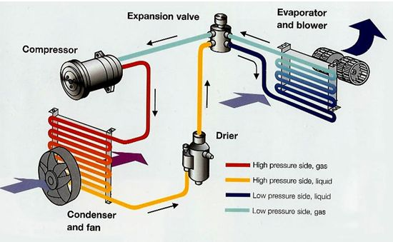

Figure 1: Automobile air conditioning system

The automobile air conditioning system is used to provide adequate comfort cooling to the passengers in the conditioned space under a wide variety of ambient conditions. The cooling load is affected by many factors as outdoor temperature and humidity, air leakage into the conditioned space, number of occupants, quantity of fresh air taken and sun load. The load factors are constantly and rapidly changing as the automobile moves at different speed and through all kinds of surroundings. The cooling capacity of the air conditioning system ranges from 1 to 4 tons.

Many of the components in the automobile air conditioning system have not changed from the room air conditioning system but have become more sophisticated and combinations of some components have changed. The basic components of an automobile air conditioning system are as follows.

### Compressor

All major automobile manufactures use either a 2 or 6 cylinder compressor driven by engine crank shaft pulley by a belt drive.

Magnetic clutches are commonly used so that the compressor can be disengaged when air- conditioning is not required and in many cases is cycled for temperature control. They operates basically on the principle of electromagnetism.

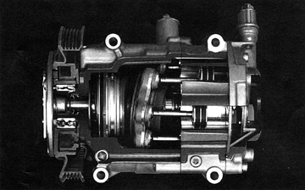

Figure 2: Cut-away view of a 6-cylinder compressor

### Condenser

The purpose of the condenser is to receive the hot high- pressure refrigerant from compressor and condense into a liquid.

In most automotive air conditioning systems, the condenser is located in front of the radiator. The high temperature refrigerant gas forced from the compressor into the condenser turns into liquid as it is cooled by the air flowing across the condenser fins. The high pressure refrigerant liquid from the condenser flows into the receiver drier unit.

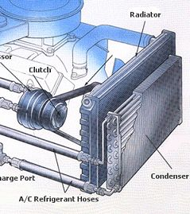

Figure 3: Condenser

### Receiver- Drier

Automobile air- conditioner units are more susceptible to leak than other units because of vibrations. Over a period of time, small leaks will occur requiring the addition of refrigerant. Also, the evaporator requirements vary because of the changing heat load.

A small receiver is used in the system to compensate for these variables. Refrigerant is stored in the receiver until it is needed by the evaporator. Nearly one kg extra refrigerant is added in the system to take the overloads.

### Expansion Valve

Before the high pressure liquid refrigerant reaches the evaporator, the refrigerant is under 7 to 17 bar as it leaves receiver. The rate of liquid refrigerant evaporation is controlled by expansion valve positioned in the lines between the receiver and the evaporator. The expansion valve meters just enough refrigerant into the evaporator to meet cooling requirements and reduce the pressure on the refrigerant to cause evaporation.

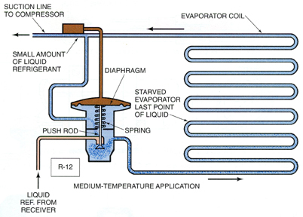

Figure 4: Expansion valve and Evaporator coils

### Evaporator and Blower

Evaporator is a place where the refrigerant evaporates and absorbs heat from the air passed over it. Air is forced to flow over the evaporator with the help of a blower and cooled before distributing in the automobile seating space.

The design of evaporator is more critical as the space limitations are severe and worse than compact room- conditioners. The demand for extreme compactness means that highly efficient heat transfer surface is necessary. In addition to this, the fan power should not exceed 150 watts because of the heavy electrical load on the generator.

## SHOCK ABSORBER

A shock absorber is a mechanical device designed to smooth out or damp shock impulse, and dissipate kinetic energy. A shock absorber is basically an **oil pump** placed between the frame of the car and the wheels. The upper mount of the shock connects to the frame, while the lower mount connects to the axle, near the wheel. The upper mount is connected to a piston rod, which in turn is connected to a piston, which in turn sits in a tube filled with hydraulic fluid. The inner tube is known as the pressure tube, and the outer tube is known as the reserve tube. The reserve tube stores excess hydraulic fluid.

When the car wheel encounters a bump in the road and causes the spring to coil and uncoil, the energy of the spring is transferred to the shock absorber through the upper mount, down through the piston rod and into the piston. Orifices perforate the piston and allow fluid to leak through as the piston moves up and down in the pressure tube. Because the orifices are relatively tiny, only a small amount of fluid, under great pressure, passes through. This causes fluid friction which slows down the piston, which in turn slows down the spring. This process is known as **dampening**.

Shock absorbers slow down and reduce the magnitude of vibratory motions by turning the kinetic energy of suspension movement into heat energy that can be dissipated through hydraulic fluid.

Unless a **dampening structure** is present, a car spring will extend and release the energy it absorbs from a bump at an uncontrolled rate. The spring­ will continue to bounce at its natural frequency until all of the energy originally put into it is used up. A suspension built on springs alone would make for an extremely bouncy ride and, depending on the terrain, an uncontrollable car.

Shock absorbers work in two cycles -- the **compression cycle** and the **extension cycle**. The compression cycle occurs as the piston moves downward, compressing the hydraulic fluid in the chamber below the piston. The extension cycle occurs as the piston moves toward the top of the pressure tube, compressing the fluid in the chamber above the piston. A typical car or light truck will have more resistance during its extension cycle than its compression cycle.

All modern shock absorbers are **velocity-sensitive.** That meansthe faster the suspension moves, the more resistance the shock absorber provides. This enables shocks to adjust to road conditions and to control all of the unwanted motions that can occur in a moving vehicle, including bounce, sway, brake dive and acceleration squat.

Shock absorbers are mainly of two types, namely mono tube shock absorbers and twin tube shock absorbers. The twin tube design is the most commonly used.

### Twin- Tube Shock Absorber

The main components are:

* outer tube, also called reservoir tube
* inner tube, also called cylinder
* piston connected to a piston rod
* bottom valve, also called foot-valve
* piston rod guide

When the piston rod is pushed in, oil flows without resistance from below the piston through the outlets and the non-return valve to the area above the piston. Simultaneously, a quantity of oil is displaced by the volume of the rod entering the cylinder. This volume of oil is forced to flow through the bottom valve into the reservoir tube filled with air (1 bar) or nitrogen gas (4-8 bar). The resistance, encountered by the oil on passing through the foot-valve, generates the bump damping.

When the piston rod is pulled out, the oil above the piston is pressurized and forced to flow through the piston. The resistance, encountered by the oil on passing through the piston, generates the rebound damping. Simultaneously, some oil flows back, without resistance, from the reservoir tube through the foot-valve to the lower part of the cylinder to compensate for the volume of the piston rod emerging from the cylinder

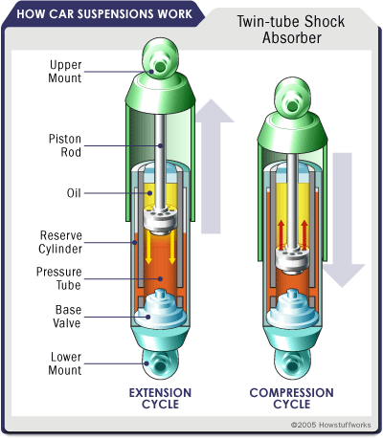

Figure 5: Twin- Tube Shock Absorber

### Mono- Tube Shock Absorber

Unlike the twin-tube damper, the mono-tube shock has no reservoir tube. There is still a need to store the oil that is displaced by the rod when entering the cylinder. This is achieved by making the oil capacity of the cylinder adaptable. Therefore the cylinder is not completely filled with oil; the lower part contains gas, usually nitrogen, under 20-30 bar. Gas and oil are separated by the floating piston (15).

When the piston rod is pushed in, the floating piston is also forced down by the displacement of the piston rod, thus slightly increasing pressure in both gas and oil section. Also, the oil below the piston is forced to flow through the piston. The resistance encountered in this manner generates the bump damping.

When the piston rod is pulled out, the oil between piston and guide is forced to flow through the piston. The resistance encountered in this manner generates the rebound damping. At the same time, part of the piston rod will emerge from the cylinder and the floating piston will move upwards.

The important parts of mono-tube shock absorber are,

1. Piston rod

2. Piston

3. Piston rod guide

4. Piston rod seal

5. Inner Cylinder

6. Reservoir tube

7. Foot valve

8. Bypass valve

9. Bypass spring

10. Adjusting nut

11. Adjusting knob

12. Adjusting detent

13. Compression valve assembly

14. Rebound valve assembly

15. Floating piston

16. Dust cover

17. Adjusting rod

18. Dust cap

19. Non return valve

20. Non return valve

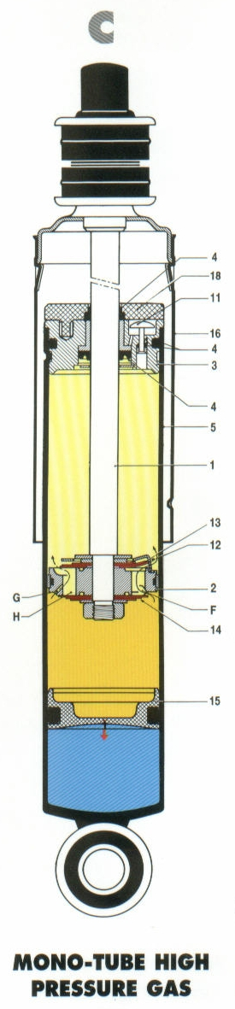

Figure 6: Mono- Tube Shock Absorber

# **MODIFIED SHOCK ABSORBER**

Shock absorbers are mechanical devices which absorbs or dissipate energy. These are an important part of automobile suspensions where the effect of rough ground is reduced by absorbing the energy and dissipating it into the atmosphere as heat. Our aim is to harvest this wasted energy and convert it into useful work. The idea is to modify the shock absorber to act as reciprocating air compressor to compress air and store in a tank at required pressure.

The shock absorber is modified by removing the oil reservoir, piston and piston valve. The oil is also drained. The original piston head at the end of piston rod is replaced with an aluminium piston head of diameter equal to the inner diameter of the shock absorber cylinder. The cylinder is also provided with two 5mm holes at the top and at the body 70mm from the top as shown in the figure. The hole at the top is provided to deliver the compressed air to the non return valve. The other hole act as an inlet port to the atmospheric air to enter the cylinder during the suction stroke of the piston. The position of the inlet port is based on the experimental data collected.

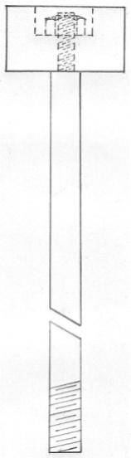The working of the modified shock absorber is like an air compressor. When the car rides into a bump or ditch the piston rod of the shock absorber absorbs the energy and moves up and down. The upward movement is used to compress the air trapped inside the cylinder. When the air inside the cylinder reaches the required pressure the valve at the top opens and the compressed air is delivered into the storage tank. As the car rides the piston rod is pushed back by the suspension spring and the inlet port uncovers. The partial vacuum created inside the cylinder while the downward movement of the piston rod causes the atmospheric air to get sucked into the cylinder as the port uncovers. This process repeats and the air gets compressed in the storage tank to the required pressure and at a temperature above the atmospheric temperature.

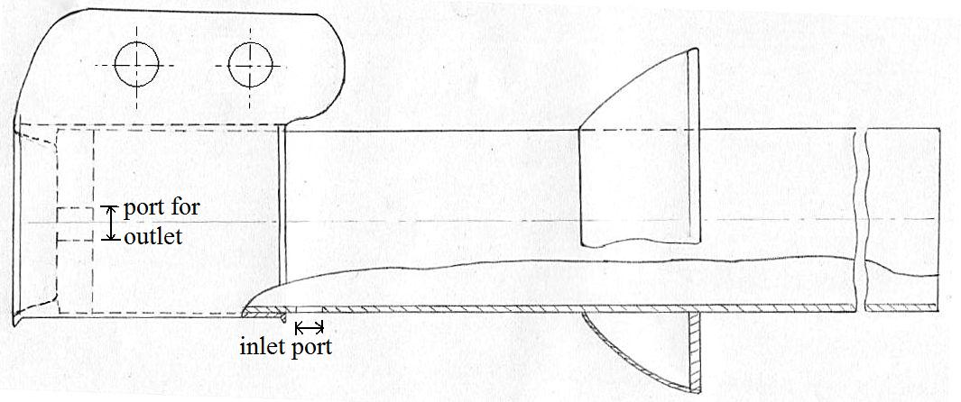

Figure 7: Modified Shock Absorber

# **ON-ROAD OPERATIONAL CHARACTERISTICS OF AN AUTOMOBILE SUSPENSION**

The behaviour of a vehicle’s conventional suspension system had to be determined on road, before an experimental setup can be designed and fabricated. An optical sensor comprising of an array of seven Light Dependent Resistors (LDR), and a LED light source is used to find out the characteristics of shock absorber on different road conditions.

## **Light Dependent Resistors**

A light dependent resistor (LDR) or photoresistor is a resistor whose resistance decreases with increasing incident light intensity. It can also be referred to as a photoconductor. It is made of a high resistance semiconductor. If light falling on the device is of high enough frequency, photons absorbed by the semiconductor give bound electrons enough energy to jump into the conduction band. The resulting free electron and its hole partner conduct electricity, thereby lowering resistance.

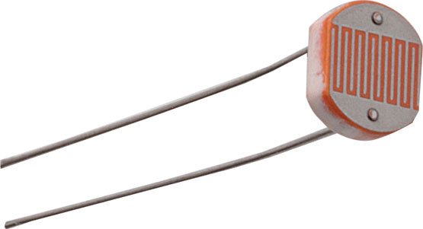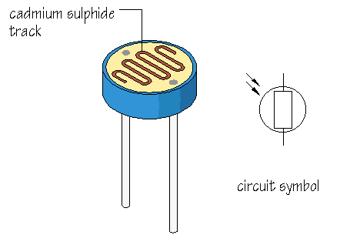

Figure 8: Light Dependant Resistor

## **Electronic Sensor**

An array of seven LDRs constitutes the electronic sensor which measures the stroke length of the shock absorber. The LDRs is placed 15mm apart which gives a resolution of 15mm. The electronic sensor is mounted on the vehicle’s underbody, while the light source moves along with the suspension links. The light source is placed such that it points at the 4th LDR of the sensor array while the vehicle is unloaded, giving the zero reference point. When the suspension moves up and down the light source follows and triggers individual LDRs giving the stroke length above or below the reference zero. The small resolution of the electronic sensor helps in filtering small movements of the suspension. The stroke length of the shock absorber piston rod, with respect to the vehicle’s body is thus detected.

The signals generated by the LDRs are fed parallel to the input pins of an ATMEGA-32 microcontroller, which is programmed to provide an output corresponding to each LDR being saturated. The output is then converted into a decimal output ranging from 0 to 6, corresponding to each LDR. In case of error, an output of 55 is generated.

|  |  |  |  |
| --- | --- | --- | --- |
| Saturated LDR | Input signal | Microcontroller output | Distance moved (in mm) |
| None  1st  2nd  3rd  4th  5th  6th  7th  More than one LDR | 0000000  1000000  0100000  0010000  0001000  0000100  0000010  0000001  Eg:0100100 | 55  00  01  02  03  04  05  06  55 | ---  +45  +30  +15  0  -15  -30  -45  Previous value |

Table 1: Output of Sensor Array

The microcontroller is clocked to generate an output every 50 milliseconds. Using a computer interface, the plot of shock absorber displacement against time is obtained. Software used for interfacing with computer were “QT SDK” & “Device monitor studio”.

## **Computer interface Circuit**

The block diagram of the circuit is shown here. The electronic sensor and the microcontroller are given a regulated voltage of 5V using a 9V battery and a voltage regulator. The sensitivity of each LDR on the electronic sensor is regulated by individual potentiometers. The electronic sensor is triggered by a LED as the light source. The output of the each LDR from the sensor is given to the input of the microcontroller. The microcontroller coverts the input analog signals into the corresponding digital signals. MAX232 IC is used to interface the microcontroller to serial port through which a serial cable connects the same with the computer.

clock

LED

LDR array

Voltage regulator

9V

Serial Port RS 232

ATMEGA 32 microcontroller

MAX232

Figure 9: Block diagram of the circuit

# **OBSERVATIONS**

X axis: TIME ELAPSED IN mm:ss.ms

Y axis: DISPLACEMENT IN CM

Figure 10: Displacement of shock absorber on normal road

Figure 11: Displacement of shock absorber on rough road

Figure 12: Displacement of shock absorber on off- road

## **Results**

Mean Swept Length = 4.749 cm

≈ 5 cm

Mean Frequency of oscillations = 1.49 Hz

Required Crank speed = 1.49×60= 89 rpm

≈ 90 rpm

## Energy Absorbed in the suspension system

Mass of the vehicle, M=650kg (curb weight of Maruti 800)

Displacement per second, h = 50× 1.49 =74.5 mm

Energy absorbed by the suspension system = Mgh = 650× 9.8× 74.5× 10-2

= 4745.94 watts

Energy absorbed in a single suspension =4745.94/ 4 =1186.48 watts

# **DESIGN OF THE EXPERIMENTAL SETUP**

## Calculation of Optimum Pressure after compression

Taking Reversed Brayton cycle as the ideal working cycle, and fixing the inlet temperature, T1 as 30oC:

|  |  |  |  |  |  |  |  |  |  |  |  |  |  |  |
| --- | --- | --- | --- | --- | --- | --- | --- | --- | --- | --- | --- | --- | --- | --- |
| P1 | | P2 | e | T1 | T2 | T3 | T4 | WC | WT | NET W | QR | QA | COP | MASS FLOW |
| 1 | 2.0 | 0.8 | 303 | 369.3 | 316.2 | 259.4 | 66.69 | 57.11 | 9.59 | 53.35 | 43.77 | 4.57 | 0.080 |
| 1 | 3.0 | 0.8 | 303 | 414.7 | 325.3 | 237.7 | 112.2 | 88.09 | 24.20 | 89.83 | 65.63 | 2.71 | 0.053 |
| 1 | 4.0 | 0.8 | 303 | 450.2 | 332.4 | 223.7 | 147.9 | 109.2 | 38.72 | 118.3 | 79.67 | 2.06 | 0.044 |
| 1 | 5.0 | 0.8 | 303 | 479.9 | 338.3 | 213.6 | 177.7 | 125.3 | 52.43 | 142.2 | 89.80 | 1.71 | 0.039 |
| 1 | 6.0 | 0.8 | 303 | 505.5 | 343.5 | 205.8 | 203.5 | 138.3 | 65.25 | 162.8 | 97.61 | 1.50 | 0.036 |
| 1 | 7.0 | 0.8 | 303 | 528.3 | 348.0 | 199.6 | 226.4 | 149.1 | 77.26 | 181.1 | 103.9 | 1.34 | 0.034 |
| 1 | 8.0 | 0.8 | 303 | 548.8 | 352.1 | 194.4 | 247.1 | 158.5 | 88.55 | 197.6 | 109.1 | 1.23 | 0.032 |
| 1 | 9.0 | 0.8 | 303 | 567.6 | 355.9 | 189.9 | 265.9 | 166.7 | 99.20 | 212.7 | 113.5 | 1.14 | 0.031 |
| 1 | 10 | 0.8 | 303 | 585.0 | 359.4 | 186.1 | 283.4 | 174.1 | 109.3 | 226.7 | 117.4 | 1.07 | 0.030 |

Where.

P1 = Inlet pressure, in bar

P2 = Pressure after compression, in bar

ε = Effectiveness of the heat exchanger

T1 = Temperature at inlet, in Kelvin

T2 = Temperature after isentropic compression, in Kelvin

T3 = Temperature at the exit of Heat exchanger, in Kelvin

T4 = Temperature after isentropic expansion

WC = Work absorbed in compression, in Joule

WT = Work done in expansion, in Joule

NET W = WT-WC

QR = Heat rejected by the heat exchanger, in Joule

QA = Heat absorbed from the cabin, in Joule

COP = Coefficient of Performance

Mass Flow = Mass flow rate of air required for 1 Ton of refrigeration, in kg/s

Figure 13 Variation of COP with respect to P2 (bar)

Figure 14 Variation of Heat absorbed with respect to P2 (bar)

The optimum value of P2 was taken as 2.6 bar.

## Calculation of Clearance Volume

Stroke length = 50mm

Required P2 = 2.6 bar

Using, P1V1γ=P2V2γ

P1×= P2×

= 30.15mm

*Take clearance length as 30mm.*

i.e. V2 = 3.77× 10-5 m3

Where, P1 = atmospheric pressure, in bar

V1 = volume inside the cylinder before compression, in m3

P2 = pressure inside the cylinder after compression, in bar

V2 = clearance volume, in m3

γ = isentropic index

d = internal diameter of the cylinder, in m

L1= sum of stroke length and clearance length L2

## Piston Head

Thickness of the piston head, using, $t = 0.43d√\left(\frac{p}{σ}\right)$

$t = 0.43×40√\left(\frac{.26}{38}\right)$

t = 1.42 mm

using the formula, t = 0.032d + 1.5 mm

t = 2.78 mm

*take thickness of the piston head as, t = 5mm.*

Where, d = internal diameter of the shock absorber cylinder, in mm

p = maximum internal pressure developed, i.e. 2.6 bar

σ = maximum allowable tensile stress for aluminium alloys, taking 38 MN/m2

## Power Required by the Motor

Weight of the reciprocating parts, W $≈$ 1kg = 9.8 N

Velocity of crank, v = $\frac{πDN}{60}$

= $\frac{π×0.05×90}{60}$

= 0.24 m/s

Where, D = stroke length of the crank

N = speed of the crankshaft in rpm

Inertia force of reciprocating parts,

$F_{i}=\frac{Wv^{2}}{rg}\left(\cos{θ}±\frac{\cos{2θ}}{n}\right)$

$=\frac{9.8×{0.24}^{2}}{0.025×9.8}\left(1.33\right)$

= 0.031 N

Where, r = radius of the crank, i.e. 0.025 m

g = acceleration due to gravity

n = $\frac{l}{r}$ ratio, assuming n = 3

Maximum value of $\left(\cos{θ}±\frac{\cos{2θ}}{n}\right)$ = 1.33, for $θ$ = 0̊

Load on the piston due to gas pressure,

$F_{L}=p\frac{{πd}^{2}}{4}$

$$=2.6×{10}^{5×}\frac{{π×0.04}^{2}}{4}$$

= 326.73 N

Piston effort, $F_{P}=F_{L}-F_{i}-R_{F}$

Neglecting frictional resistance, $R_{F}$,

$F_{P}$ = 326.73 – 0.031

= 326.7 N

Maximum turning moment, $T= F_{P}\left[\frac{\sin\left(θ+∅\right)}{\cos{∅}}\right]×r$

= 326.7 × 1.05 × .025

= 8.57 Nm

Where, $\sin{∅}=\frac{\sin{θ}}{n}$ and $\frac{\sin\left(θ+∅\right)}{\cos{∅}}$ maximizes when $θ=70°$ and $∅=18°$

Power required to drive the piston,

$P=\frac{2πNT}{60}$

$$=\frac{2π×90×8.57}{60}$$

= 80.77 W

$≈$ 0.108 hp

## Speed Reduction Using Belt Drive

Speed of the motor, N1 = 900 rpm

Required speed, N2 = 89.26 rpm $≅$ 90 rpm (experimental data)

Diameter of the small pulley, d1 = 30 mm

Using, N1 d1 = N2 d2

900 × 30 = 90 × d2

i.e. d2 = 300 mm.

*i.e. diameter of the larger pulley at the crankshaft d2 = 350 mm*

## Crank and crankshaft

Diameter of the crank shaft, ${ d}_{cs}=\sqrt[3]{\frac{16T}{{πτ}_{d}}}$

$$=\sqrt[3]{\frac{16×8.57}{π×55}}$$

*Take crank shaft diameter as ${ d}_{cs}=$ 10mm*

Where, $τ_{d}$ = shear stress of the crank shaft material, assuming 55MN/m2 (for automobile crank shaft)

Force on crank arm, $F_{c}=\frac{F_{P}}{\cos{∅}}$

$=\frac{326.7}{\cos{19.5}}$

=346.58 N

Diameter of the crank pin, $d_{pin}=\sqrt[4]{\frac{16F_{c}^{2}}{πP_{bc}σ_{b}} }$

$= \sqrt[4]{\frac{16×{346.58}^{2}}{π×2.5×55}}$

= 8.2 mm

*Take crank pin diameter as dpin = 10 mm*

Length of crank pin, *Lpin* =

=

= 13.8 mm

*Take length of crank pin as Lpin = 15 mm*

## Storage Tank

Material: Cast iron (heat treated)

Allowable stress: 78.5MN/m2

Factor of safety: 2

Circumferential tensile stress: $σ=\frac{pd}{2t}$

i.e. $\frac{78.5×{10}^{6}}{2}$ = $\frac{2.6×{10}^{5} × 0.15}{2×t}$

i.e. t = 4.9mm

*Taking a thickness of 6mm*

## Heat exchanger

Assuming isentropic compression from 1 bar to 2.6 bar, we have the following:

Temperature at the inlet of the heat exchanger, Ti = 398 K

Mass flow rate, mi = = = 1.28×10-4 kg/s

To design a cross-flow heat exchanger, we assume the following data:

Effectiveness, ε = 80%

NTU, N = 2

Internal diameter of Copper tube = 10 mm = 0.01 m

External diameter of Copper tube = 11.6 mm = 0.0116 m

Transverse area occupied by the heat exchanger tubes = 20cm x 20cm = .04 m2

Velocity of external flow, vo = 60 km/h = 16.67 m/s

Temperature at outlet of heat exchanger = 322 K

Bulk mean temperature of internal flow = 360 K

Velocity of internal flow, vi = = = 0.648 m/s

External mass flow rate, mo =vo = 1.167×.04×16.67 = 0.778 kg/s

Heat capacity Cmin = miCp = ×1005 = 0.12864 J/s

Cmax= moCp = 0.778×1005 = 781.89 J/s

*C* = $\frac{C_{min}}{C_{max}}=\frac{0..12864}{781.89}=1.6×{10}^{-4}$

Internal flow

Reynolds No, Re = $\frac{vD}{υ}= \frac{0.648×0.01}{18.97×{10}^{-6}}=340$

Prandtl No, Pr = 0.69, ${Nu}_{D}=4.36$

Internal heat transfer coefficient, hi = 13.64 W/m2-K

External flow

Consider flow over a bank of staggered tubes with,

Transverse pitch, St = 30 mm

Longitudinal pitch, Sl = 30 mm

Maximum velocity, vmax = = m/s

Reynolds No, Re = $\frac{v_{max}D}{υ}= \frac{27.18×0.0116}{16×{10}^{-6}}=19705.5$

$${Nu}_{D}=0.421{{Re}_{D}}^{0.574}$$

External heat transfer coefficient, ho = 283.3 W/m2-K

Overall heat transfer coefficient

Conductivity of Copper at 60oC = 382 W/m-K

Overall heat transfer coefficient with respect to internal diameter,

$$U_{i}= {\left(\frac{1}{h_{i}}+\frac{r_{i}}{k}ln\left(\frac{r_{o}}{r_{i}}\right)+\frac{r_{i}}{r_{o}}\frac{1}{h_{o}}\right)}^{-1}$$

$$= {\left(\frac{1}{13.64}+\frac{.005}{382}ln\left(\frac{.0058}{.005}\right)+\frac{.005}{.0058}×\frac{1}{283.3}\right)}^{-1}$$

= 13.96 W/m2-K

Length of the heat exchanger piping = 58.7 cm ≈ 60 cm

# **EXPERIMENTAL SETUP**

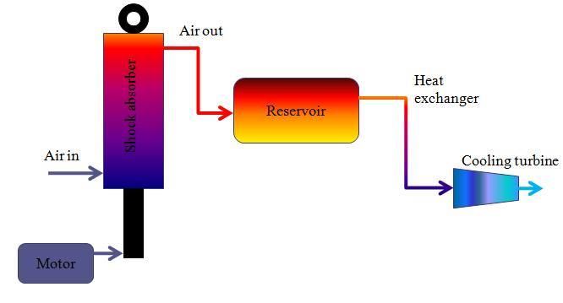

Figure 15: Block diagram of the experimental setup

A Maruti 800 rear shock absorber is modified to act as a reciprocating air compressor. This is done by replacing the damping components within the shock absorber cylinder, with a piston head. An inlet and a delivery port are drilled into the cylinder The inlet port is kept always open and the delivery port is regulated with help of a air pilot valve at each compression strokes. The position of the inlet port is 70mm from the top of the cylinder which is obtained from the experimental data collected. A motor is used to simulate the road conditions with the help of a crank and crankshaft. Speed of the motor is reduced to 90rpm, which is obtained from the experiment, using suitable belt and pulley.

The intake air is compressed and is stored in a reservoir at a pressure of 2.6 bar and at a temperature higher than the atmospheric condition. The reservoir is provided with an inlet port which is connected to the outlet valve of the shock absorber cylinder. A delivery valve is also provided at the other end of the reservoir to control the flow of the compressed air.

Then, the compressed air is passed through the heat exchanger to reject heat to ambient air, isobarically. To achieve the drop in temperature, the high pressure air is expanded using a cooling turbine, isentropically. Air pressure drops to atmospheric pressure, and the temperature is below ambient condition.

The refrigerating capacity of the cooled air per unit mass, and COP of the system has to be evaluated experimentally.

## Specification of the Experimental Setup

Shock absorber

Inlet air port: Diameter 5 mm, situated 70 mm away from IDC

Delivery valve: Air pilot valve

Stroke = 50 mm

RPM = 90 rpm

Free air delivery = 0.11 litres/second

Storage tank

Capacity = 5 litre

Wall thickness = 6 mm

Heat exchanger

Material: Copper

Outer Diameter = 11.6 mm

Internal Diameter = 10 mm

Length of piping = 60 cm

# **RESULT**

On-road experiments suggested that a car suspension oscillates with a stroke of 5 cm with a frequency of 1.49 Hz. Accordingly, an experimental setup was designed to provide the required compression of air, with the shock absorber piston simulating the road conditions.

Calculations based on Reversed Brayton cycle showed that the optimum pressure after compression was 2.6 bar. The shock absorber was able to generate this pressure under experimental conditions. The cooling capacity and COP of the system using the single shock absorber is calculated theoretically using the values obtained from the experiment.

## **Cooling capacity and COP**

Theoretical temperature after isentropic expansion, T 3= 245 K

Heat absorbed = $mC_{p}(T_{amb}-T_{3})$

$=1.28×{10}^{-4}×1005×($ 303 – 245) $=7.46 W$

Cooing Capacity, Q = $\frac{7.46}{1000×3.5}$ = 0.002 TR

COP = $\frac{Heat absorbed }{Power consumed}$ = $\frac{7.46}{80.77}$ = 0.1

# **CONCLUSION**

Even though the experimental setup was able to generate a compression of 2.6 bar the cooling capacity and COP were found to be 0.002TR and 0.1 respectively. This is much less than the theoretically calculated values. This is due to the low flow rate of air with single modified shock absorber. The flow rate obtained from the experimental setup was 0.11 litres/second.

The mass flow rate and hence the cooling capacity and COP can be increased by increasing the number of modified shock absorbers in a vehicle. This system may not be enough for cabin cooling in small cars but can provide cabin air conditioning in multi- axle trucks where a number of shock absorbers can be modified for air conditioning purpose and also the cooling cabin is small in volume.

It is to be noted that the proposed system used fewer components compared to Vapour Compression air conditioning. This system can be employed in military vehicles and also off road vehicles where the weight of the vehicle is a concern; and the system can reduce the overall weight of air conditioning equipment in the vehicle. The rough terrain through which these vehicles are put to service further improves the efficacy of the system.

# **APPENDIX**

## Performance of conventional automotive air conditioning system



# **REFERENCES**

* An Experimental Analysis of Automotive Air Conditioning system

O. Kaynakh and I. Horuz, 2003

* The Shock Absorber handbook, John C. Dixon

Publisher: John Wiley and Sons, 2007

* Working of a Shock Absorber

Popular Mechanics, July 1991

* Pressure effects on Cross flow

V. Ganapathy, Bharat Heavy Electricals Ltd., Tiruchirapalli, India

* Design Data Hand Book, K. Mahadevan & K. Balaveera Reddy

Publisher: CBS Publishers, 2005

* Heat and Mass Transfer Data Book, C.P. Kothandaraman & S. Subramanyam

Publisher: New Age International Publishers, 2004

* A rotary vane open reversed Brayton cycle air conditioning and refrigeration system, Edwards T.C, Purdue University 1970
* Analysis of the roto-cooler air-conditioning system

Yuan Mao Huang, National Taiwan University

* “[MIT Students Create Energy-Harvesting Shock Absorbers](http://www.dailytech.com/MIT+Students+Create+EnergyHarvesting+Shock+Absorbers/article14252.htm)”,

Daily Tech, Feb 12 2009