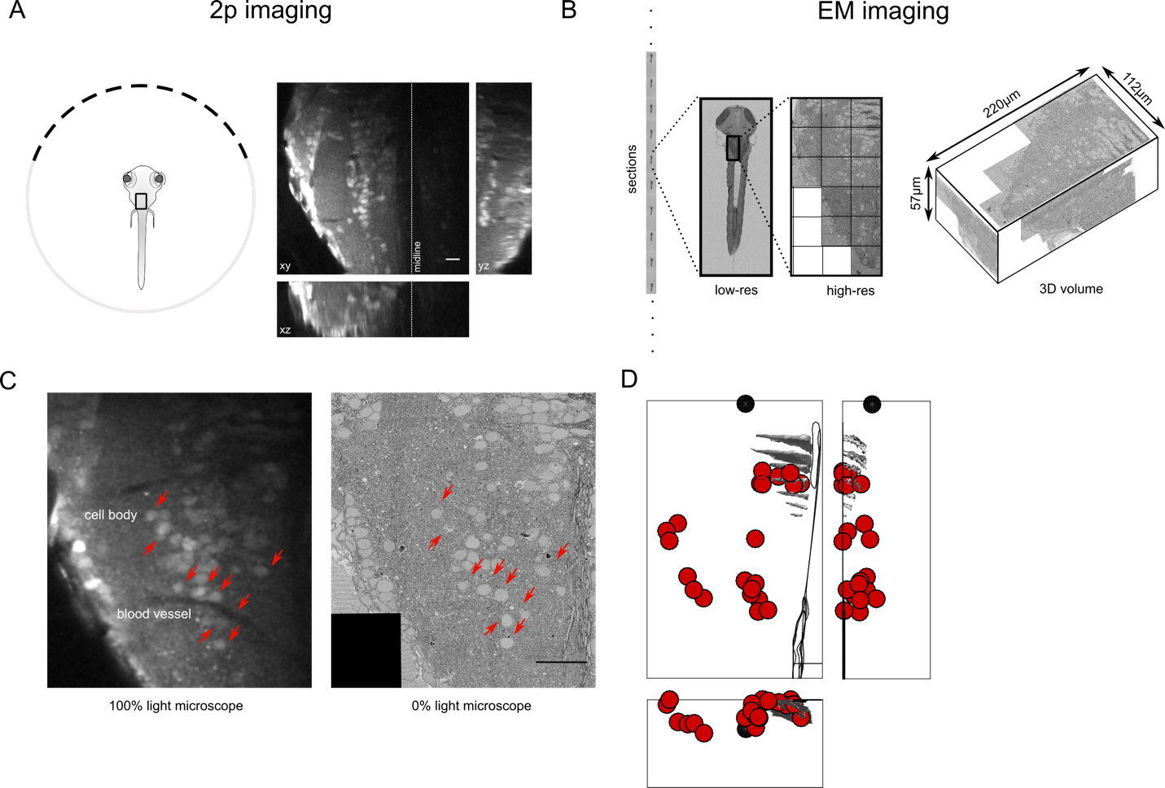

Figure1: Registration of functionally imaged larval zebrafish to serial electron microscope images. (A) Schematic of the experimental setup with an example of the functional data that is obtained from two-photon light microscopy of calcium dye, during saccadic behavior. (B) Serial electron microscopy of same zebrafish from A, sections are collected on tape in an automated manner, images at low-res are use to align the sections, followed by images at high-resolution over the region of interest. 3D volume of the imaged area. (C) Registration of LM volume to EM volume to locate the cells that were involved in the behavior. Arrows indicate the same features in both LM and EM. (D) Anatomical location of all cell bodies involved in the behavior along with anatomical landmarks from the EM volume. (E) Functional data showing the average saccadic response for all cells.

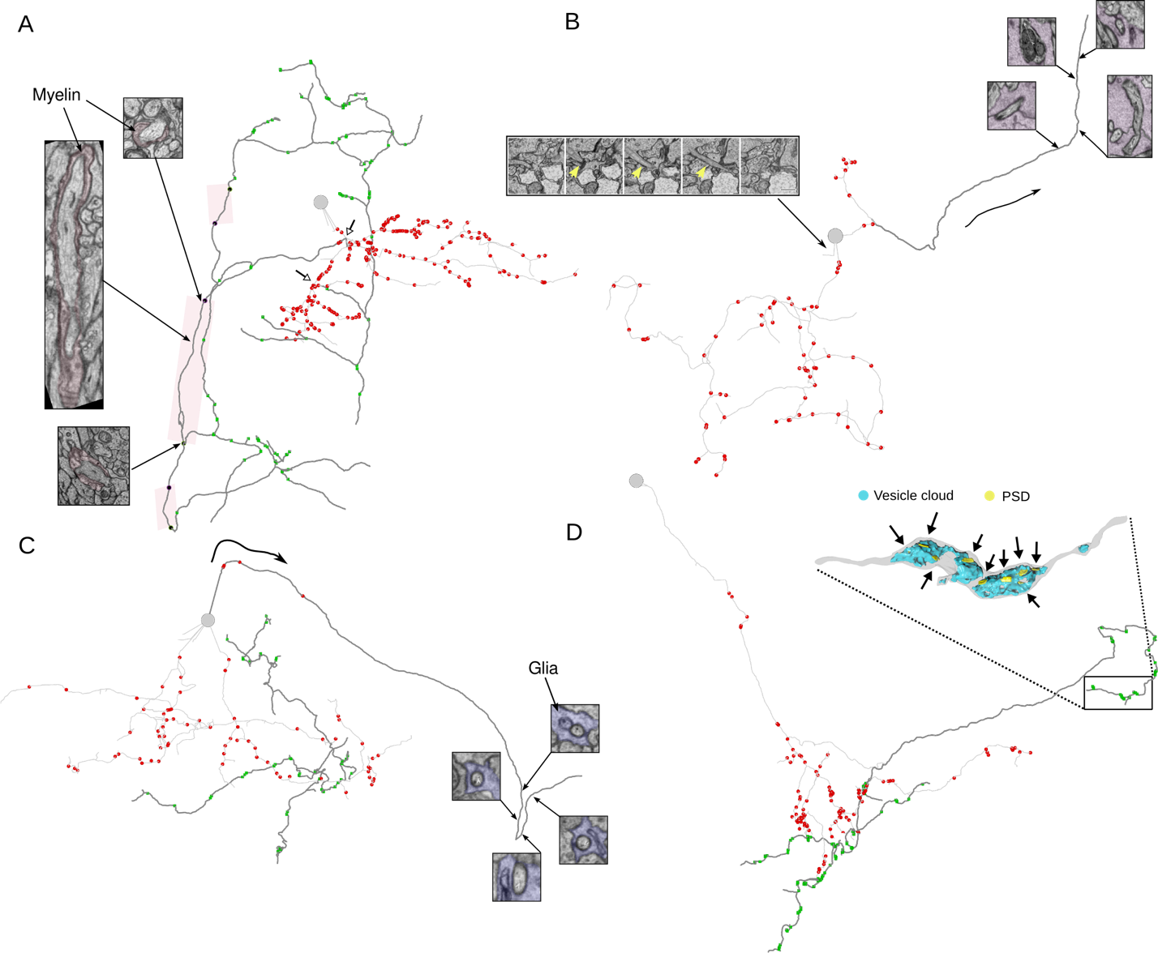

Figure 2: VPNI cell anatomical features, reconstructed from EM volume. (A) Example of VPNI cell showing axon (dark segments) and dendrite (light segments) with pre and postsynaptic locations. Parts of the axon of this VPNI cell are myelinated. Insets, (black dots) show the start, middle and the end of a myelinated segment of the axon. Other myelinated segments are highlighted in the colored box. Open arrow heads show the location of axon initiation zones along the neurite. (B) Example VPNI cell with putative-axon that is engulfed by glial processes before crossing the midline (inset right- colored segments are glial). Microtubule rich neurite that emerges from cell somata show in left inset. (C) VPNI cells with putative-axon that is engulfed by glia before midline crossing (right inset). Ipsilateral axon and dendrite also present for this VPNI cell. (D) VPNI cells with single neurite that branches to give rise to axon and dendrites. Axon is studded with presynaptic sites that are clustered along neurite. Inset is a 3D reconstruction of axon termination zone with large vesicle cloud with multiple post synaptic densities opposed to the vesicles.

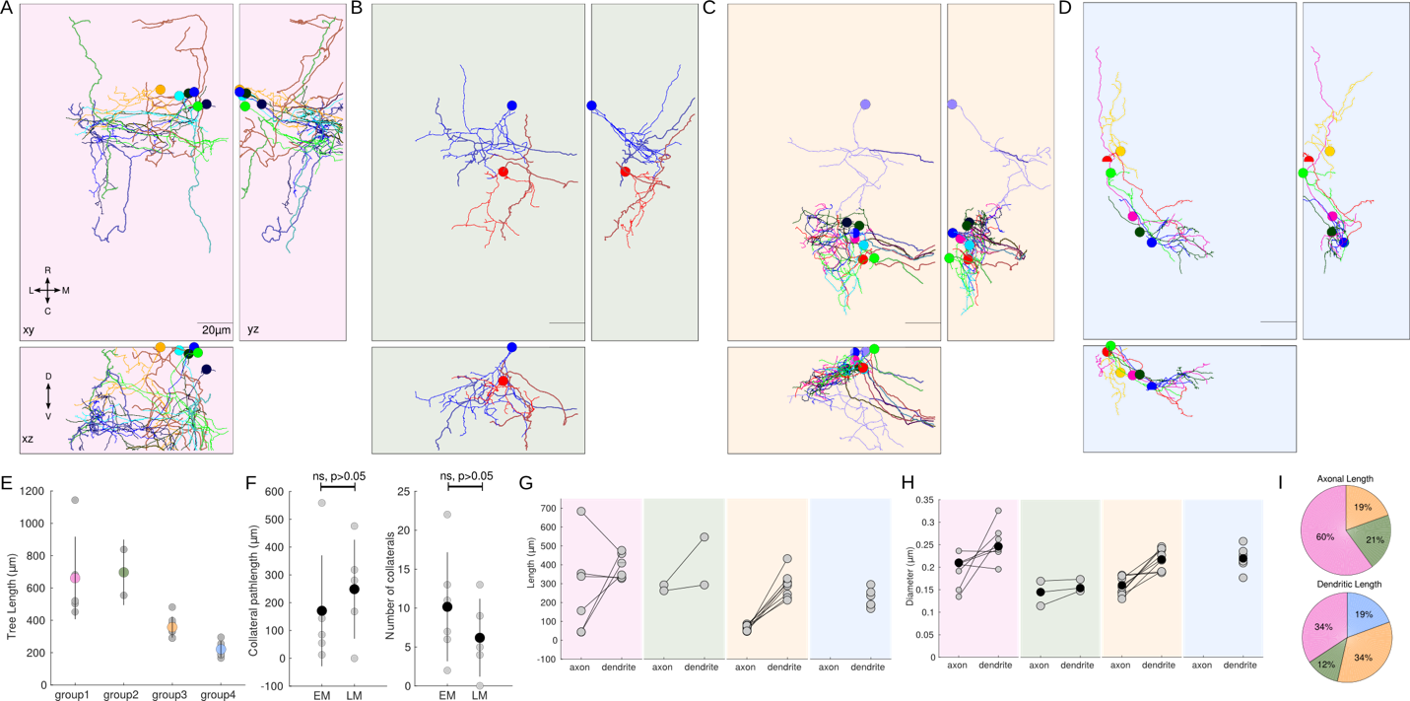

Figure 3: VPNI cells with distinct axonal projection patterns. (A) VPNI cell with ipsilateral projecting axons- group1. (B) VPNI cells with ipsilaterally projection axons and midline crossing putative-axon – group2. (C) VPNI cells with midline crossing putative-axon – group3. (D) VPNI cells with unknown axonal projection – group4. (E) Average tree length of integrator neurons from each group. (F) Number and length of axonal collaterals for ipsilaterally projecting axons reconstructed from EM and dye fill LM volumes. (G) Range of axonal and dendritic lengths for each group. (H) Average diameter of axon and dendrite for each group. Scale bar is 20um.

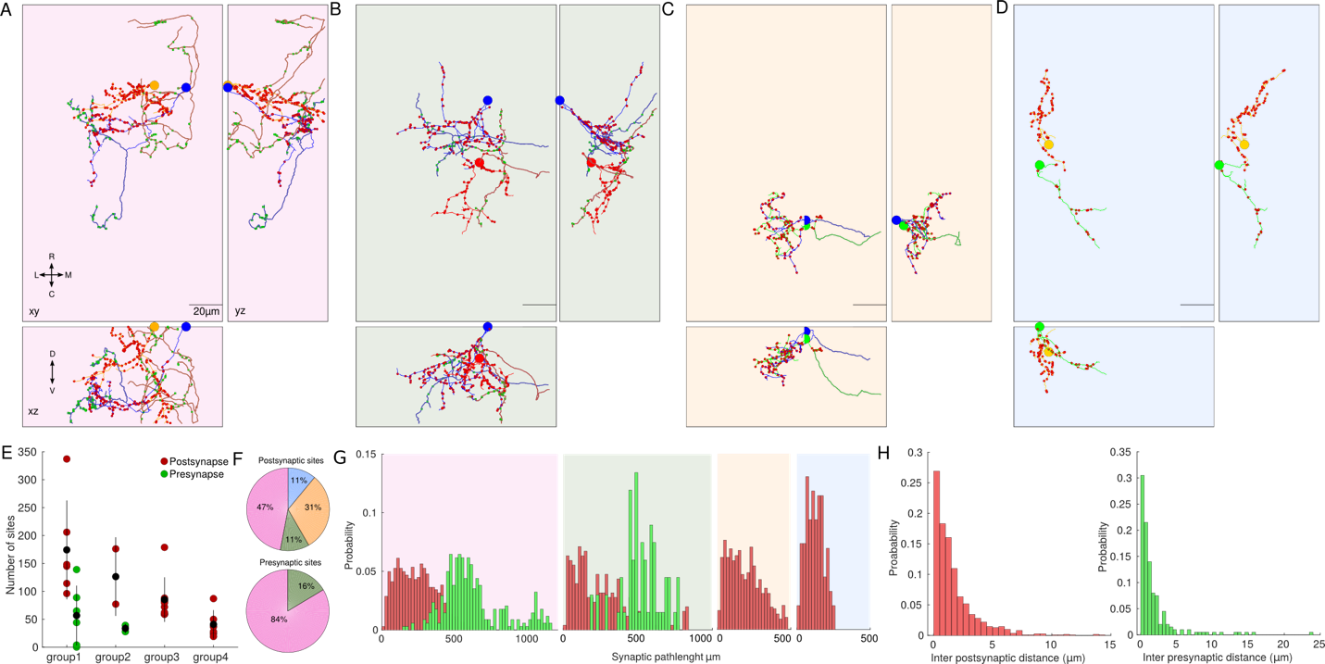

Figure 4: Synaptic distributions for VPNI cell groups. (A) Two representative VPNI cells with ipsilaterally projecting axons along with pre and postsynaptic sites. (B) VPNI cell with ipsilateral axon and contralateral putative axon. (C) Cells with contralateral putative-axon. (D) cells with unkown axonal projections. (E) Average number of synapses for each group. (F) Fraction of pre and postsynapses from each group. (G) Distribution of pre and postsynaptic path-lengths for each group. (H) Distribution of inter-post and presynaptic sites.

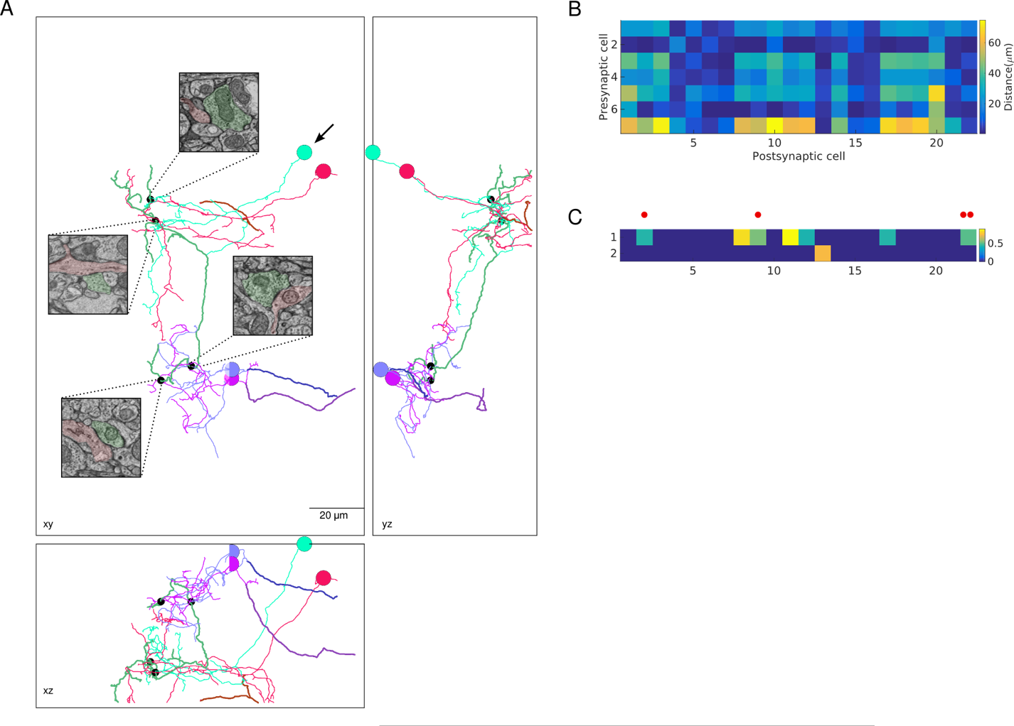

Figure 5: Synaptic connections between VPNI cells from different groups. (A) Three views of direct synaptic connections between VPNI cells form different groups. Presynaptic cell form group1 (arrow) makes synapses onto other group1 cells (pink) and onto group3 cells. (B) Minimum distance between axons of presynaptic trees and dendrites of postsynaptic trees. (C) Presynaptic trees that contain nodes that are within 1 um of a postsynaptic tree. Red dots are synapses that are show in A.