Scilab

Language Basics
Exercises:
1. Plot the position and velocity of a body falling from a height h = 100m.
2. The diode equation is given by

Where I_{o} is the reverse saturation current, V_{D} is the voltage across the diode,η is a constant and V_{T} is the voltage equivalent of temperature. Plot the variation of current as the voltage across the diode varies from -10V to 10V and a temperature of 298K. Let η = 1 and V_{T} is given by kT/q where k is Boltzmann's constant, T is the absolute temperature and q is the charge on the electron.

3. Calculate the area of a circle of radius 2.

4. Calculate the complex voltage across the capacitor in a series RLC network with input voltage = V at a frequency 60Hz. R = 100kΩ, L = 1mH and C = 12pF. Plot the variation of impedance with angular frequency.

5. Calculate the current through R5 and the voltage across it (use Martin's Rule for now even though it's inefficient).
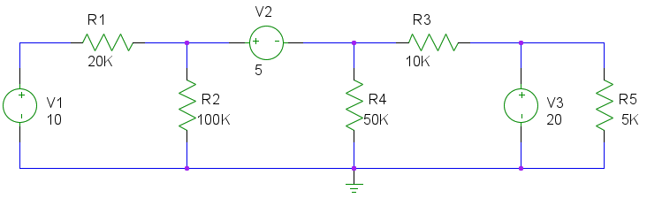
6. Write a quadratic equation solving function. To solve the equation the function needs to be called as solveQuad(a, b, c).

7. Define the following piece-wise function in Scilab:
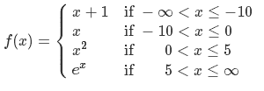

Also plot the function from x = -100 to 100

8. A rose curve is defined as:

or

If n is odd, the rose will have n petals and if it is even it will have 2n petals. Produce the following plots:
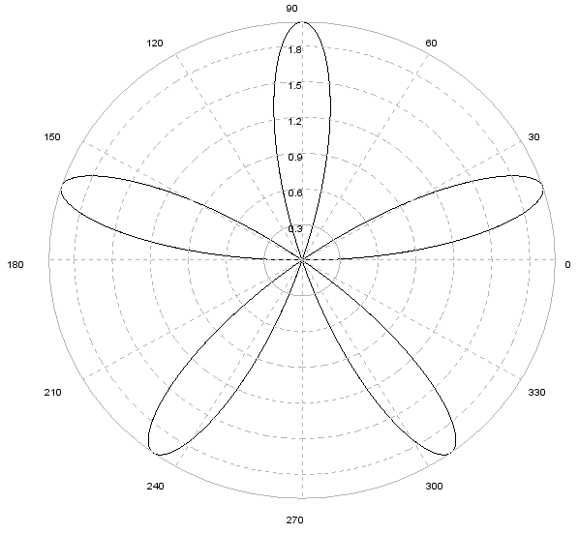

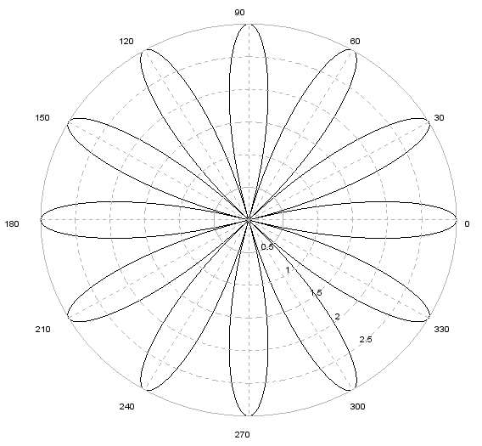
9. Find the sum of the series (use loops):

from n = 7 to 220.

10. Use the rand() function to produce random numbers. Stop the process if the number produced is greater than 0.5. Do this 100 times and create a plot which has the size of the array on the x-axis and the number of vectors having a particular size on the y-axis. What do you observe? Do this again for a larger number of times. What do you observe? What happens if you change the comparison point from 0.8 to some other number?

11. Derive the equation of a projectile with initial velocity vector:
or
The equation should calculate the height of the object given the position. The velocity vector will appear as constants. Keep the magnitude of the velocity constant. Vary the angle of elevation from 0º to 90º in steps of 10º. Plot all the curves. What do you observe?
12. Consider an RC circuit with R = 100KΩ and C = 12pF. In the s-domain, what is the expression for the output across the capacitor for an input = 1V. Plot this verse s. What kind of plot do you use?

13. Calculate the sine of π radians. What do you get? Is this correct?

14. Create a square matrix M of any order and fill it with random values (make sure it isn't singular though!). Find its inverse. Multiply the two. What should you expect? What do you get? Why?

15. Remember we talked about algorithm complexity on Day 2? Here are a couple:
Constant time = 1
Linear =
Logarithmic = (Base 2)
Linearithmic = (Base 2 again)
Quadratic =
Exponential =
There can be algorithms that can worse than these (factorial complexity!). Plot these curves for large n (about 1E6). Do this one by one (on the same plot). See what happens to the previous plots. Do you now see why algorithm design is so important?

Mathematics
1. Solve question 5 in the previous segment using Cramer's rule.

2. Now do it using Scilab's built in equation solver.

3. Lets do it one more time to cement it in! Solve the following system of equations:
7x – 2y + 1z = 31
4x + 3y – 2z = 9
-2x + 11y + 4z = 23

4. Verify the Cayley-Hamilton Theorem for the matrix. Hope you know what it is :-).

5. Generate a square matrix of size 50. Find its eigenvalues (and eigenvectors if you like). Sort them in descending order and produce the bar chart.

6. Calculate the angle between the vectors &

7. Compute the rank of the matrix

8. Tomorrow you will need to compute various kinds of inputs for systems. Generate vectors which correspond to impulse, step, ramp and exponential (base 0.9 inputs. Let the size of the vector be 100.

9. Calculate the 5th roots of unity. Plot them on the complex plan.
10. The logistic equation is defined as

It is used as a simple model for population growth. The linear term accounts for the fact that as the population increases, more offspring will be born. However, large numbers will cause competition and lower the population. This is accounted for in the quadratic term.
Set A = 12 and B = 3. Plot the variation of population with time (t = 0 to 5. Vary the initial population from 0 to 10 (in steps of 1). Compare the plots.
The above differential equation is called an Autonomous ODE.

11. You've studied about the concept of half life and first order decay in radio activity (and also in chemical kinetics). Plot the variation of the amount of Barium – 139 over a week if we begin with 1g. The half life for Ba-139 is 82.7 min.

12. Solve the following differential equation and plot the solution.

13. We know that the differential equation for the current in a series RLC circuit (with no source) is given by:

Let R = 100Ω, L = 1mH and C = 10F. If the initial current in the system is 2A and unchanging, how does the current change over time? What kind of behavior is this?

14. Suppose we now remove all energy in the circuit and then connect an exponentially decaying input source of, how does the current vary with time?

15. Solve the initial value problem:

