A REAL TIME RESEARCH PROJECT
Report On

IDENTIFYING BRAND INFLUENCER / ON SOCIAL MEDIA TRIP DURATION PREDICTION
submitted in the partial fulfillment of the requirement for the award of degree.
Bachelor of Technology (B.Tech.) in Computer Science and Engineering(AI-ML)
2025-26

Submitted By

Student Name | HT NO
SK. Ashwitha | 24M61A6652

Under the Esteemed Guidance of
Dr. K. SPOORTHY, Qualification
Assistant Professor


Department of Computer Science and Engineering
SWARNA BHARATHI INSTITUE OF SCIENCE & TECHNOLOGY (AUTONOMOUS)
Accredited by NAAC A+
(Accredited by NAAC A+, Approved by AICTE, New Delhi, Affiliated to JNTUH)
Pakabanda Bazar, Mamatha Hospital Road, KHAMMAM-507002.
2025-2026

A
REAL TIME Project Report On

IDENTIFYING BRAND INFLUENCER / ON SOCIAL MEDIA TRIP DURATION PREDICTION

Submitted to JNTUH, HYDERABAD in partial fulfillment for the award of
B.Tech. Degree in Computer Science and Engineering(AI-ML), 2025-26 Submitted By

Student Name | HT NO
SK. ASHWITHA | 24M61A6652

Under the esteemed guidance of
Dr. K. SPOORTHY, Qualification
Assistant Professor

Department of Computer Science and Engineering (AI-ML),
SWARNA BHARATHI INSTITUE OF SCIENCE & TECHNOLOGY (AUTONOMOUS)
Accredited by NAAC A+
(Accredited by NAAC A+, Approved by AICTE, New Delhi, Affiliated to JNTUH)
Pakabanda Bazar, Mamatha Hospital Road, KHAMMAM-507002.
2025-2026

SWARNA BHARATHI INSTITUE OF SCIENCE & TECHNOLOGY (AUTONOMOUS)
(Accredited by NAAC A+, Approved by AICTE, New Delhi, Affiliated to JNTUH)
Pakabanda Bazar, Mamatha Hospital Road, KHAMMAM-507002.

2025-2026
Department of Computer Science and Engineering (AI-ML),

CERTIFICATE

This is to certify that the project report entitled “IDENTIFYING BRAND INFLUENCER ON SOCIAL MEDIA” that is submitted by SK. ASHWITHA bearing Roll No 24M61A6652
in partial fulfillment for the award of the Degree of Bachelor of Technology in COMPUTER SCIENCE AND ENGINEERING (AI-ML), to the Jawaharlal Nehru Technological University is a record of bona fide work carried out by her under my guidance and supervision. The results embodied in this project report have not been submitted to any other University or Institute for the award of any degree or diploma.

Date: 05-04-2026

(Internal Guide) Head Of the Department
(Dr. K. SPOORTHY) | (Dr. K. Spoorthy)
Associate Professor | HOD &Associate Professor
External Examiner | Dr.G. Raj Kumar M.Tech, Ph.D
 | Principal

CERTIFICATE GIVEN by TRAINER

ACKNOWLEDGMENT

The satisfaction that accompanies the successful completion of any task would be incomplete without the mention of the people who made it possible and whose constant guidance and encouragement crown all the efforts success.
I thank my guide (Dr. K. Spoorthy) for his / her support in completion of my Project Work. I wish to express my sincere thanks to Head Of the Department Dr. K. Spoorthy and also to my Principal Dr. G. Raj Kumar, for providing me the facilities to complete the Project Work.
I would like to express my sincere gratitude to Mr. G. Praveen Kumar, Director, SBIT for his consistent encouragement and support throughout the Project work.
Last but not least, I express my heartful thanks to all my staff and friends for their constant support, encouragement and valuable contribution in the completion of this Project Work. My sincere thanks to Sri. G. Krishna, Chairman, SBIT and Name of the Company. the members of the
organization.

Ashwitha (24M61A6652)

ABSTRACT

This project explores the application of dynamic pricing algorithms in rideshare industries and examines the key variables that influence trip prices by analyzing Uber and Lyft Dataset of Boston in 2018. This dataset contains Uber and Lyft data mainly from November and December 2018. It contains essential variables such like distance and price for rideshare price prediction, together with many other variables which could be included in regression model such as weather and hours in the day. The Ordinary Least Square regression method is used in this paper, and results shows that the most influential and statistically significant variables on price are the distance of trip and surge multiplier which indicates traffic surge. The regression result is in accordance with the intuition that price is positively correlated with distance and price goes up during surge time. The result implies that the dynamic pricing algorithm that adjusts live prices heavily relies on the current traffic condition and distance of the trip, while the price is not determined by hour of the trip during the day and temperature.

This project focuses on predicting trip duration and ride price for ride-hailing services like Uber and Lyft using machine learning techniques. By analyzing historical trip data such as distance, time, weather, and demand, the system builds predictive models to estimate trip duration and fare.
The project helps:

- Improve ride fare estimation
- Optimize driver allocation
- Enhance user experience

DECLARATION

We hereby declare that the Real Time project report “Identifying Brand Influencer on Social Media” recorded in this project is based on our work carried out at the "SWARNA BHARATHI INSTITUTE OF SCIENCE & TECHNOLOGY", Khammam during
the B.Tech course.

Date: 05-04-2026
Place: Khammam

Reported by, SK. ASHWITHA

A Project Report On
Brand Influencer Trip Duration Prediction
submitted as part of the academic requirements for the course
Bachelor of Technology (B.Tech.) in
Computer Science and Engineering (Artificial Intelligence and Machine Learning),
2025-2026

Submitted By SK. Ashwitha



Department of Artificial Intelligence and Machine Learning)

SWARNA BHARATHI INSTITUE OF SCIENCE & TECHNOLOGY

Accredited by NAAC A+
(Accredited by NAAC A+, Approved by AICTE, New Delhi, Affiliated to JNTUH)
Pakabanda Bazar, Mamatha Hospital Road, KHAMMAM-507002.
2025-2026

REAL TIME PROJECT COMPLETION

TThhiiss isistotocecretriftfyiyfythtahtaKtK,aDPn,uNrgiaaDgaDurSegaeaipGiDkiearieApHikkTaasNhHOyTa: N2H3OMT: 62N13OAM0:625132AM60,6512A6,0546 ,
Department of Computer Science and Engineering, Swarna Bharathi Institute of

Science & Technology, Khammam have successfully completed the real-time project titled “Identifying Brand Influencer Duration Prediction” in the partial fulfillment of the B.Tech Degree under our supervision.

Authorized Signatory

CLASS INCHARGE

TABLE OF CONTENTS

List of Figures | - | 5
Abstraction | - | 6
CHAPTER | TITLE | PAGE NO

Introduction 7

Literature Survey 8-9
  - survey highlights
  - Comparison to Other Educational Apps

System Analysis 10-12
- Existing System
- Proposed System

- Social Feasibility
- Functional and
- Non-Functional Requirements

Software Requirements 13
- Software and Hardware Requirements

Software Design 14-16
- System Overview

- Technical Requirements

- System Implementation 17-27

 | ▪ | User Module
 | ▪ | Animal Module
 | ▪  ▪ | Alphabet Module Game Module
 | ▪ | Audio Module
 | ▪ | Database Module
7. | Coding |  | 28-30
8. | Testing |  | 31-33
9. | Experimental Results |  | 34-40
10 | Conclusion |  | 41

List of Figures

Figure 9.1 Heatmap

Figure 9.2 Bar Figure 9.3 Box Plot Figure 9.4 Pie Chart Figure 9.5 Count plot Figure 9.6 Scatter

ABSTRACT

This project explores the application of dynamic pricing algorithms in rideshare industries and examines the key variables that influence trip prices by analyzing Uber and Lyft Dataset of Boston in 2018. This dataset contains Uber and Lyft data mainly from November and December 2018. It contains essential variables such like distance and price for rideshare price prediction, together with many other variables which could be included in regression model such as weather and hours in the day. The Ordinary Least Square regression method is used in this paper, and results shows that the most influential and statistically significant variables on price are the distance of trip and surge multiplier which indicates traffic surge. The regression result is in accordance with the intuition that price is positively correlated with distance and price goes up during surge time. The result implies that the dynamic pricing algorithm that adjusts live prices heavily relies on the current traffic condition and distance of the trip, while the price is not determined by hour of the trip during the day and temperature.

This project focuses on predicting trip duration and ride price for ride-hailing services like Uber and Lyft using machine learning techniques. By analyzing historical trip data such as distance, time, weather, and demand, the system builds predictive models to estimate trip duration and fare.
The project helps:
- Improve ride fare estimation
- Optimize driver allocation
- Enhance user experience

CHAPTER-01 INTRODUCTION TO IDENTIFYING BRAND INFLUENCER & ON SOCIAL MEDIA INFLUENCER IDENTIFICATION ON SOCIAL MEDIA

Imagine a tourist finished the Thanksgiving break and arrived at the airport. When the tourist tried to request a ride home using Uber or Lyft, the price is higher than the cost of the same trip a few weeks ago.
This is because of the dynamic pricing algorithm of ridesharing companies that adjust the fare rate based on a number of variables such as time, traffic, the demand of riders, and the supply of drivers.

In the example, because of the Thanksgiving break, there might be more riders and fewer drivers.
Therefore the dynamic pricing algorithm raises the price of the tourist's trip home.
The core idea of the dynamic pricing algorithm lies behind the idea of supply and demand, for example, when this tourist tried to request a ride home, the ride is valued more than the amount of money paid for the trip fare.
However, if the dynamic pricing algorithm was not designed well and raised the price too high, the tourist might not be willing to request such an overpriced ride anymore and might deviate to public transportation as an alternative.

Therefore, in this case, the tourist values the trip fare more than the ride and stops requesting a ride, thus the ridesharing company loses a potential customer.
This problem raises further questions: is the strategy of dynamic pricing guaranteed to bring more profit, and how the dynamic price can be determined such that the rideshare company could make more profit, while the customers are still willing to pay for the raised fare?
Whether or not industries make more profit through dynamic pricing is not a trivial problem.
Although the possibility that dynamic pricing does not bring more profit might be unintuitive at first thought, industries might be worse off if they employ a dynamic price instead of a fixed price, if their dynamic pricing is poorly designed.
Motivated by the questions above, this paper explores how ridesharing companies dynamically adjust the price of trips.

CHAPTER-02 LITERATURE SURVEY

Kockelman, K., and S. Chen (2017).

Dynamics of price fluctuation and surge pricing in the ride-hailing industry. 95, 296- 314, Transportation Research Part B: Methodological. With an emphasis on Uber, this paper explores the mechanics of surge pricing and price dispersion in the ride-hailing business. The authors examine the connections between surge pricing, demand-supply dynamics, and price dispersion using a sizable dataset of Uber trip data. The findings draw attention to the variables that affect fare fluctuation and surge pricing. (2017) Hall,
J. V.,

Palsson, & Price.

Is Uber a replacement for or addition to public transportation? Urban Economics Journal, 108,36– 50. This study examines the interaction between Uber and public transportation to determine whether Uber is are placement for or addition
to conventional public transportation. The authors examine ridership patterns and fare information using data from Uber and public transit organisations. The study sheds light on the variables, such as fare pricing, that affect travellers’ decisions
between Uber and public transportation (2016).

Rayle, L., Dai, D., Chan, N., Cervero, R., and Shaheen.

A better cab, merely? a comparison of ride sharing, transit, and taxi options in San Francisco based on surveys. 168– 178 in Transportation Policy,45.

This study compares ridesharing services like Uber, public transportation, and taxis in San Francisco using survey data. In order to comprehend users' perspectives
and preferences, the study looks at a number of variables, such as fare price, convenience, and overall satisfaction. The results shed light on how fare pricing influences users' decisions regarding various modes of transportation.

Yan, Z., C. Sun, S. Zhu, & D. Zhu (2018).
What impact do weather conditions have on cab and ride-sharing trips? the city of New York as evidence. Emerging Technologies in Transportation Research, 91,297-
311. Demand for transport services and fares may be affected by weather conditions.

This study looks at how the weather affects cab and ride-hailing (Uber) travels in New York City. To investigate the connection between weather factors (such precipitation and temperature) and fare amounts, the authors examine travel data as well as meteorological data. The results shed light on how the weather affects fare variability. (2017) Wang, X., and Sobhani, A

CHAPTER-03

SYSTEM ANALYSIS

EXISTING SYSTEM
In current ride-hailing platforms like Uber and Lyft, trip duration and fare estimation are primarily based on predefined algorithms that consider distance, time, and basic traffic conditions. These systems often rely on static rules or limited real-time data, which may not always provide accurate predictions.
Traditional approaches do not fully utilize historical data patterns, machine learning models, or advanced analytics. As a result, predictions can sometimes be inconsistent due to variations in traffic, weather conditions, and demand fluctuations.

Disadvantages
    - Limited accuracy in fare and duration prediction
    - Does not effectively use historical data
    - Unable to adapt to real-time changes dynamically
    - Less efficient in handling peak-hour demand
    - Lack of intelligent decision-making

PROPOSED SYSTEM
The proposed system uses machine learning techniques to predict trip duration and price more accurately. By analyzing historical ride data, the system identifies patterns and relationships between variables such as distance, time, cab type, and demand.
The system processes input data, applies data cleaning and preprocessing techniques, and uses trained models to generate predictions. Machine learning algorithms like Linear Regression are used to improve prediction accuracy.

Advantages of Proposed System
- Improved prediction accuracy
- Utilizes historical and real-time data
- Scalable and efficient system
- Faster processing and response time

FUNCTIONAL REQUIREMENTS

Functional requirements describe the operations performed by the system:
- The system should accept user inputs such as distance, time, and cab type
- It should preprocess and clean the input data
- The system should predict trip duration and price
- It should display the predicted results to the user
- The system should allow model training and evaluation

NON-FUNCTIONAL REQUIREMENTS

Non-functional requirements define system performance and constraints:

Performance
- The system should provide quick predictions
- High accuracy in results

Scalability
- The system should handle large datasets efficiently

Reliability
- The system should produce consistent results

Usability
- Easy to use interface and understandable output

FEASIBILITY ANALYSIS

Feasibility analysis is an important step in system development that determines whether the proposed system is practical, economical, and technically viable. It helps ensure that the system can be successfully implemented without causing unnecessary burden on resources.

The feasibility of the Uber & Lyft Trip Duration and Price Prediction system is analyzed based on the following factors:
- ECONOMICAL FEASIBILITY
- TECHNICAL FEASIBILITY
- SOCIAL FEASIBILITY

ECONOMICAL FEASIBILITY

Economic feasibility evaluates the cost-effectiveness of the system. The proposed system is highly economical because it uses open-source tools and technologies such as Python, Kaggle, and machine learning libraries.
      - No expensive software licenses are required
      - Development cost is minimal
      - Maintenance cost is low
      - Suitable for students and small-scale projects
Thus, the system can be developed and deployed within a limited budget.

TECHNICAL FEASIBILITY
Technical feasibility checks whether the required technology and resources are available to develop the system.
      - Uses widely available tools like Python, Pandas, and Scikit-learn
      - Can be implemented on standard computers with basic configurations
      - Kaggle platform provides free computational resources
      - Easy integration of machine learning models
Therefore, the system is technically feasible and easy to implement.

SOCIAL FEASIBILITY
Social feasibility determines whether the system is acceptable to users and beneficial to society.
      - Provides accurate fare and time estimation for users
      - Improves user satisfaction and trust
      - Helps drivers and companies in better planning
      - Easy to understand and use
The system is user-friendly and widely acceptable, making it socially feasible.

CHAPTER-04 SOFTWARE REQUIREMENTS

SOFTWARE REQUIREMENTS

    - Operating System: Windows 11 Home Single Language
    - Coding Language: Python

    - Tool: Kaggle

    - Back-end: Python-Machine Learning

HARDWARE REQUIREMENTS

    - Processor: 13th Gen Intel(R) Core(TM) i5-1334U (1.30 GHz)

    - RAM: 2 GB
    - Keyboard

    - Mouse

    - Storage: 16 GB or more of internal storage

CHAPTER-05

SOFTWARE DESIGN

System Overview

The Identifying Brand Influencer on Social Media System is designed to analyze historical ride data and predict trip duration and fare using machine learning techniques. The system processes user inputs such as distance, time, and cab type, and provides accurate predictions based on trained models.
The application follows a structured workflow that includes data collection, preprocessing, model training, and prediction. The system ensures efficient data handling and quick response time for generating results.

Functional Requirements

- Data Input Module
  - Accepts input features such as distance, time, and cab type
  - Allows loading of dataset from Kaggle

Data Preprocessing Module
  - Handles missing values
  - Converts categorical data into numerical format
  - Cleans and prepares data for model training

Model Training Module
  - Trains machine learning models using historical data
  - Uses algorithms such as Linear Regression

Prediction Module
  - Predicts trip duration and price
  - Displays output results to the user

Evaluation Module
  - Evaluates model performance using metrics like R² score
  - Compares predicted and actual values

Non-Functional Requirements
- Performance
  - The system should provide fast and accurate predictions

Scalability

  - Capable of handling large datasets efficiently

Reliability
  - Provides consistent and dependable results

Usability
  - Easy to use and understand interface
  - ​

Technical Requirements
Front-end: Jupyter Notebook / Kaggle Interface
- Back-end: Python

Libraries Used:
  - Pandas
  - NumPy
  - Matplotlib
  - Scikit-learn

Database Design

The dataset acts as the database and contains the following key attributes:
- Distance
- Price
- Cab Type
- Time (Hour/Date)
- Source and Destination
The data is stored in CSV format and processed using Python.

System Architecture
The system architecture consists of the following components:
- Input Layer – Accepts dataset and user inputs
- Processing Layer – Performs data cleaning and feature engineering
- Model Layer – Applies machine learning algorithms
- Output Layer – Displays predicted results

User Interface
The user interface is simple and interactive, consisting of:
  - Input section for entering trip details
  - Dataset visualization (graphs and charts)
  - Output section displaying predictions

Testing and Quality Assurance
The system undergoes various testing methods:
  - Unit Testing: Testing individual components
  - Integration Testing: Ensuring modules work together
  - Model Testing: Evaluating prediction accuracy

CHAPTER-06 SYSTEM IMPLEMENTATION

Number of Modules: 5

- Data Collection Module
- Data Preprocessing Module
- Model Training Module
- Prediction Module
- Evaluation Module

Module Functions:

- Data Collection Module
This module is responsible for collecting the dataset required for the project. The dataset is obtained from Kaggle and contains information about Uber and Lyft rides such as distance, price, time, and cab type.

Functions:
  - Load dataset
  - Display dataset structure
  - Handle file input

Data Preprocessing Module
This module prepares the data for machine learning by cleaning and transforming it.

Functions:
- Remove missing values
- Handle inconsistent data
- Convert categorical variables into numerical format
- Select important features

Model Training Module
This module builds and trains the machine learning model using historical data.

Functions:
- Split dataset into training and testing sets
- Apply algorithms (e.g., Linear Regression)

- Train the model

Prediction Module
This module uses the trained model to predict trip duration and price.

Functions:
- Accept input values (distance, time, cab type)
- Generate predictions
- Display results

Evaluation Module
This module evaluates the performance of the model.

Functions:
- Calculate accuracy (R² score)
- Compare predicted vs actual values
- Display performance metrics

Technologies Used in Implementation
- Programming Language: Python
- Platform: Kaggle / Jupyter Notebook

Libraries:
  - Pandas
  - NumPy
  - Matplotlib
  - Scikit-learn

Implementation Steps
- Import required libraries
- Load the dataset
- Perform data cleaning and preprocessing
- Apply feature selection
- Train the machine learning model
- Test the model using test data
- Evaluate performance
- Generate predictions

Sample Code Implementation

import pandas as pd import numpy as np
from sklearn.model_selection import train_test_split from sklearn.linear_model import LinearRegression from sklearn.metrics import r2_score
# Load dataset
df = pd.read_csv("cab_rides.csv")
# Data cleaning df = df.dropna()
# Feature selection
df = df[['distance', 'price', 'hour', 'cab_type']]
# Convert categorical data
df = pd.get_dummies(df, columns=['cab_type'])
# Split data
X = df.drop('price', axis=1) y = df['price']
X_train, X_test, y_train, y_test = train_test_split(X, y, test_size=0.2) # Train model
model = LinearRegression()
model.fit(X_train, y_train)
# Prediction
predictions = model.predict(X_test)
# Evaluation
print("R2 Score:", r2_score(y_test, predictions))

Output
- Predicted trip price
- Model accuracy score
- Comparison between actual and predicted value

PYTHON

Python is a popular programming language. It was created by Guido van Rossum, and released in 1991.

It is used for:
  - web development (server-side),
  - software development,
  - mathematics,
  - system scripting.

Key Aspects

Python works on different platforms (Windows, Mac, Linux, Raspberry Pi, etc.) .
  - Python has a simple syntax similar to the English language.
  - Python has syntax that allows developers to write programs with fewer lines than some other programming languages.
  - Python runs on an interpreter system, meaning that code can be executed as soon as it is written. This means that prototyping can be very quick.
  - Python can be treated in a procedural way, an object-oriented way or a functional way.
  - Python was designed for readability, and has some similarities to the English language with influence from mathematics.
  - Python uses new lines to complete a command, as opposed to other programming languages which often use semicolons or parentheses.
  - Python relies on indentation, using whitespace, to define scope; such as the scope of loops, functions and classes.

Other programming languages often use curly-brackets for this purpose.

Kaggle / Jupyter Notebook

Kaggle is a cloud-based platform that is widely used by data scientists and machine learning practitioners. It provides access to a large collection of datasets, including the Uber and Lyft dataset used in this project. Kaggle also offers free computational resources such as CPUs and GPUs, enabling users to perform data processing and model training without requiring high- end hardware. Additionally, Kaggle notebooks allow users to share their work, collaborate with others, and learn from community projects.
Jupyter Notebook is an open-source web-based application that allows users to create and share documents containing live code, equations, visualizations, and text. It is especially useful for data science projects because it supports step-by-step execution of code, making debugging and experimentation easier. Users can visualize data using graphs and charts directly within the notebook, which helps in better understanding of the dataset.

In this project, Kaggle and Jupyter Notebook are used to load the dataset, perform data cleaning, visualize patterns, train machine learning models, and evaluate their performance. These platforms make the entire workflow more interactive, efficient, and easy to understand.

Key Aspects
- Interactive coding environment

- Supports visualization and documentation

- Easy execution of code step-by-step
- Cloud-based access (Kaggle)
- No need for high-end hardware

Pandas

Pandas is a powerful Python library used for data manipulation and analysis. It provides data structures like Data Frames and Series, which help in organizing and handling structured data efficiently.
In this project, Pandas is used to load the dataset from a CSV file and perform various preprocessing tasks such as handling missing values, removing duplicates, and selecting important features. It also allows filtering, grouping, and transforming data easily.
Pandas plays a crucial role in preparing the dataset before applying machine learning algorithms. It ensures that the data is clean and properly formatted, which improves the accuracy of the model.
Another key feature of Pandas is its ability to handle large datasets with ease. It allows users to perform operations such as sorting, merging, and aggregating data quickly. This makes it easier to analyze relationships between different features like distance, price, and time.
Pandas also integrates well with other libraries such as NumPy and Matplotlib, making it a central tool in the data analysis process. By using Pandas, the project ensures efficient data handling and preparation, which is crucial for building accurate machine learning models.

Key Aspects
- Efficient data handling using Data Frames

- Easy data cleaning and preprocessing
- Supports large datasets
- Integration with other libraries

- Fast and flexible data operations

NumPy

NumPy is a fundamental library for numerical computations in Python. It provides support for multi-dimensional arrays and mathematical operations, making it essential for data processing.
In this project, NumPy is used for performing numerical calculations and handling array-based data. It is faster and more efficient than traditional Python lists, especially when dealing with large datasets.
NumPy also serves as the foundation for many other libraries, including Pandas and Scikit- learn. It helps in performing operations such as matrix multiplication, statistical calculations, and data transformations.
NumPy is also used in data preprocessing and feature engineering, where numerical transformations are required. Many machine learning algorithms rely on NumPy arrays for input data, making it an essential component of the system.
Another advantage of NumPy is its compatibility with other libraries such as Pandas and Scikit-learn. It forms the backbone of numerical computation in Python and plays a key role in implementing machine learning models.
Overall, NumPy enhances the performance and efficiency of the system by providing fast and reliable numerical operations.

Key Aspects
- High-performance numerical operations
- Supports multi-dimensional arrays
- Faster than standard Python lists

- Essential for machine learning
- Works well with other libraries

Matplotlib

Matplotlib is a widely used Python library for data visualization. It allows users to create graphs and charts that help in understanding data patterns and trends.

In this project, Matplotlib is used to visualize relationships between variables such as distance and price. Graphs like bar charts, line plots, and histograms are used to analyze the dataset.
Visualization helps in identifying trends, patterns, and outliers in the data, which is important for building accurate models. Matplotlib also allows customization of graphs, making them more informative and visually appealing.
Matplotlib also allows customization of graphs, such as adding titles, labels, and legends, which improves the readability of visual outputs. It is widely used in data science projects due to its flexibility and ease of use.

Key Aspects
- Used for data visualization
- Supports various types of graphs
- Helps in understanding data patterns
- Customizable charts and plots
- Easy integration with Pandas

Scikit-learn

Scikit-learn is a powerful machine learning library used for building predictive models. It provides a wide range of algorithms for regression, classification, and clustering.
In this project, Scikit-learn is used to implement machine learning models such as Linear Regression. It also provides tools for splitting data into training and testing sets, which is essential for evaluating model performance.
Scikit-learn includes various evaluation metrics such as R² score, which helps in measuring the accuracy of the model. It simplifies the process of model building and makes it easy to experiment with different algorithms.
Another advantage of Scikit-learn is its simplicity and ease of use. It provides a consistent interface for different algorithms, making it easy to switch between models and experiment with different techniques.
Overall, Scikit-learn plays a crucial role in the project by enabling the development of accurate and efficient machine learning models.

Key Aspects
- Provides machine learning algorithms
- Easy model training and testing
- Supports evaluation metrics
- User-friendly interface
- Widely used in data science

Machine Learning

Machine Learning (ML) is a subset of Artificial Intelligence that enables computers to learn from data and make decisions without explicit programming. It focuses on developing algorithms that can automatically improve performance by identifying patterns in data. ML plays a vital role in modern applications by providing intelligent solutions and accurate predictions.

Data is the core component of machine learning. The effectiveness of any ML model depends on the quality and quantity of data used. Data can be structured (tables, databases) or unstructured (images, text, audio), and proper preprocessing is required before training the model.
Machine learning is mainly classified into three types: supervised learning, unsupervised learning, and reinforcement learning. Supervised learning uses labeled data for prediction tasks, unsupervised learning identifies hidden patterns in unlabeled data, and reinforcement learning trains models using rewards and penalties based on actions.

Various algorithms such as Linear Regression, Decision Trees, Random Forest, and Neural Networks are used to build models. During the training phase, the model learns patterns from data, and its performance is evaluated using metrics like accuracy, precision, recall, and F1- score.
Feature engineering is another important aspect, where relevant input features are selected and transformed to improve model performance. Additionally, challenges like overfitting and underfitting must be handled carefully to ensure the model performs well on both training and new data.
Machine learning has wide applications in fields such as healthcare, finance, e-commerce, and transportation. In healthcare projects like HEALSPHERE, ML helps in predicting diseases and recommending suitable doctor specializations.

Key Aspects
- Data collection and preprocessing
- Types of learning (Supervised, Unsupervised, Reinforcement)

- Selection of appropriate algorithms
- Model training and testing
- Evaluation using performance metrics
- Feature engineering

- Handling overfitting and underfitting
- Real-world applications and scalability

CHAPTER-07 CODING
import pandas as pd
df=pd.read_csv("/kaggle/input/datasets/ravi72munde/uber-lyft-cab-prices/cab_rides.csv") df.head()

df.shape df.info() df.describe() df.dropna()
df.drop_duplicates() df.isnull() df.isnull().sum() df.columns
df

from sklearn.preprocessing import LabelEncoder encoder = LabelEncoder()
df['price'] = encoder.fit_transform(df['price']) df
import seaborn as sns
import matplotlib.pyplot as plt
sns.heatmap(df.corr(numeric_only=True), annot=True, cmap= 'coolwarm') plt.show()

df['distance'].value_counts()

df['distance'].value_counts().plot(kind='bar')

sns.boxplot(x='source', y='name', data=df) plt.title("name vs source")
plt.show()

price_counts = df['price'].value_counts()

# Plotpie chart
plt.pie(price_counts, labels=price_counts.index,autopct='%1.1f%%')

plt.title("price Distribution") plt.show()

import seaborn as sns
sns.countplot(x='destination', hue='distance', data=df) plt.title("destination vs distance")
plt.show()
plt.scatter(df['destination'],df['distance']) plt.xlabel("destination") plt.ylabel("distance") plt.title("destination vs distance") plt.show()
plt.hist(df['distance'], bins=20) plt.title("distance Distribution") plt.show()

sns.countplot(x='distance',hue='price', data=df) plt.title(" distance vs price")
plt.show()
df.info()
df.head()

from sklearn.preprocessing import LabelEncoder encoder = LabelEncoder() df['cab_type']=encoder.fit_transform(df['cab_type']) df['destination']=encoder.fit_transform(df['destination'])

df['source']=encoder.fit_transform(df['source']) df['id']=encoder.fit_transform(df['id']) df['product_id']=encoder.fit_transform(df['product_id']) df['name']=encoder.fit_transform(df['name']) df['distance']=encoder.fit_transform(df['distance']) df['surge_multiplier']=encoder.fit_transform(df['surge_multiplier']) df['time_stamp']=encoder.fit_transform(df['time_stamp']) df['price']=encoder.fit_transform(df['price'])

df.info()
df.head()

X=df[['distance' , 'cab_type' , 'time_stamp','destination' , 'source' , 'price' , 'surge_multiplier' , 'id' , 'product_id' , 'name']] #X=df.drop('price',axis=1)
y=df['price']
#X=df.drop('product_id',axis=1)
X.columns

from sklearn.model_selection import train_test_split
X_train, X_test, y_train, y_test=train_test_split(X,y,test_size=0.2,random_state=42)
from sklearn.preprocessing import StandardScaler scaler = StandardScaler() X_train=scaler.fit_transform(X_train)
X_test= scaler.transform(X_test) print(X_train)
from sklearn.linear_model import LinearRegression model = LinearRegression()
model.fit(X_train, y_train)

avg_cycles = y_test.mean()
print(f"Average Cycles in Data: {avg_cycles}")
from sklearn.model_selection import train_test_split
from sklearn.linear_model import LinearRegression
from sklearn.metrics import mean_squared_error, r2_score y_pred=model.predict(X_test)
print("MSE:", mean_squared_error(y_test, y_pred)) print("R2 Score:", r2_score(y_test, y_pred))

CHAPTER-08 TESTING

The purpose of testing is to discover errors. Testing is the process of trying to discover every conceivable fault or weakness in a work product. It provides a way to check the functionality of components, sub-assemblies, assemblies and/or a finished product It is the process of exercising software with the intent of ensuring that the Software system meets its requirements and user expectations and does not fail in an unacceptable manner. There are various types of test. Each test type addresses a specific testing requirement.

TYPES OF TESTS

Unit testing
Unit testing involves the design of test cases that validate that the internal program logic is functioning properly, and that program inputs produce valid outputs. All decision branches and internal code flow should be validated. It is the testing of individual software units of the application .it is done after the completion of an individual unit before integration. This is a structural testing, that relies on knowledge of its construction and is invasive. Unit tests perform basic tests at component level and test a specific business process, application, and/or system configuration. Unit tests ensure that each unique path of a business process performs accurately to the documented specifications and contains clearly defined inputs and expected results.

Integration Testing
Integration tests are designed to test integrated software components to determine if they actually run as one program. Testing is event driven and is more concerned with the basic outcome of screens or fields. Integration tests demonstrate that although the components were individually satisfaction, as shown by successfully unit testing, the combination of components is correct and consistent. Integration testing is specifically aimed at exposing the problems that arise from the combination of components.

The purpose of testing is to discover errors. Testing is the process of trying to discover every conceivable fault or weakness in a work product. It provides a way to check the functionality of components, sub-assemblies, assemblies and/or a finished product It is the process of exercising software with the intent of ensuring that the Software system meets

its requirements and user expectations and does not fail in an unacceptable manner. There are various types of test. Each test type addresses a specific testing requirement.

Functional Test
Functional tests provide systematic demonstrations that functions tested are available as specified by the business and technical requirements, system documentation, and user manuals.

Functional testing is centered on the following items: Valid Input: identified classes of valid input must be accepted. Invalid Input: identified classes of invalid input must be rejected. Functions: identified functions must be exercised. Output: identified classes of application outputs must be exercised. Systems/Procedures: interfacing systems or procedures must be invoked.

Organization and preparation of functional tests is focused on requirements, key functions, or special test cases. In addition, systematic coverage pertaining to identify Business process flows; data fields, predefined processes, and successive processes must be considered for testing. Before functional testing is complete, additional tests are identified and the effective value of current tests is determined.

System Test
System testing ensures that the entire integrated software system meets requirements. It tests a configuration to ensure known and predictable results. An example of system testing is the configuration oriented system integration test. System testing is based on process descriptions and flows, emphasizing pre-driven process links and integration points.

White Box Testing

White Box Testing is a testing in which in which the software tester has knowledge of the inner workings, structure and language of the software, or at least its purpose. It is purpose. It is used to test areas that cannot be reached from a black box level.

Black Box Testing
Black Box Testing is testing the software without any knowledge of the inner workings, structure or language of the module being tested. Black box tests, as most other kinds of tests, must be written from a definitive source document, such as specification or requirements document, such as specification or requirements document. It is a testing in which the software under test is treated, as a black box .you cannot “see” into it. The test provides inputs and responds to outputs without considering how the software works.

Acceptance Testing
User Acceptance Testing is a critical phase of any project and requires significant participation by the end user. It also ensures that the system meets the functional requirements.

Test Results:
All the test cases mentioned above passed successfully. No defects encountered. Functional tests provide systematic demonstrations that functions tested are available as specified by the business and technical requirements, system documentation, and user manuals.

CHAPTER-09 EXPERIMENTAL RESULTS

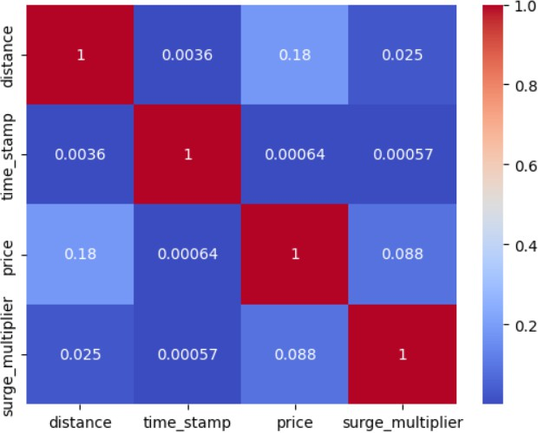

Figure 9.1 Heatmap

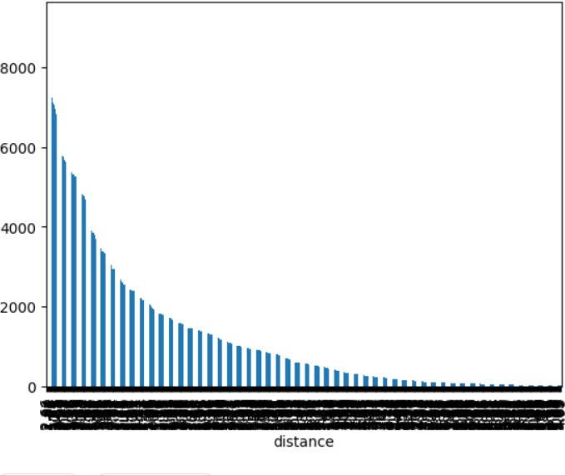

Figure 9.2 Bar

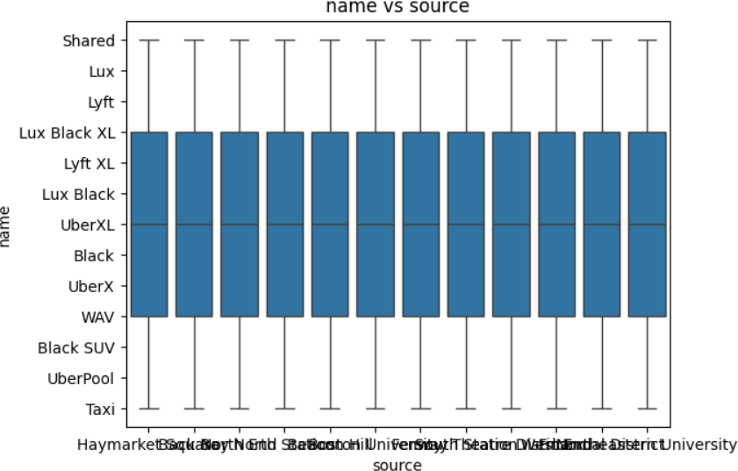

Figure 9.3 Box Plot

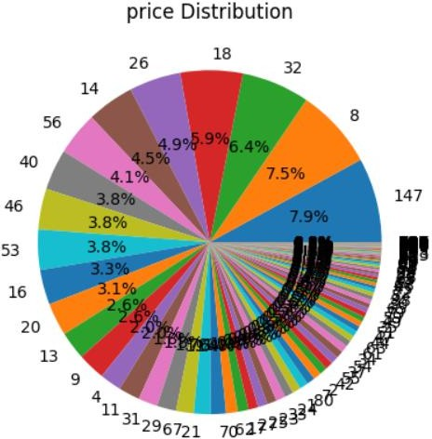

Figure 9.4 Pie Chart

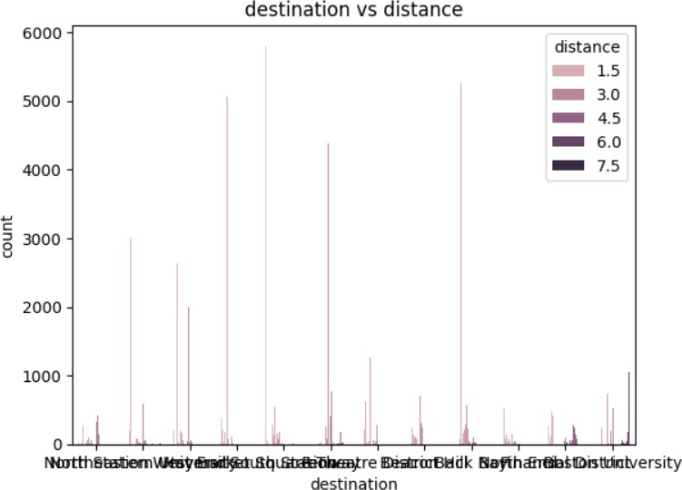

Figure 9.5 Count plot

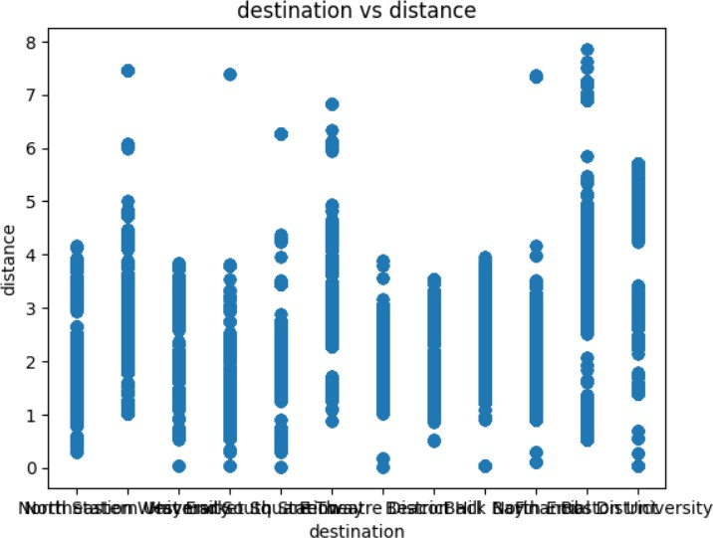

Figure 9.6 Scatter

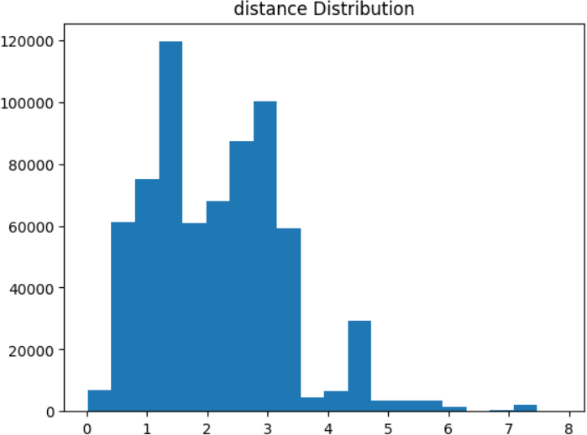

CHAPTER-10 CONCLUSION
In conclusion, the research article on Uber data analysis and price prediction using regression models and random forests produces an accurate fare prediction model and offers helpful insights into the elements driving fare costs. The approach, insights, model comparison, and useful consequences of the study are its contributions. A thorough technique for analyzing Uber data is introduced in the study paper, including data pretreatment, feature
engineering, model selection, evaluation, andinterpretation. This methodology provides a use ful framework for similar field analyses. The data reveals important elements that have a major impact on fare rates, including the distance travelled, the time of day,
the day of the week, surge pricing, and weather conditions. A greater understanding of these elements helps to clarify how the Uber ecosystem determines fares.

The effectiveness of regression models (more specifically, linear regression) and random forests for fare price prediction is compared in this work. The
research identifies each model's advantages and disadvantages by comparing them using appropriate measures, such as mean squared error (MSE), and then chooses the model that performs the best overall. Based on the chosen regression model or random forest model, the research study creates an accurate fee forecast model. This methodology offers useful benefits for Uber and its users by facilitating more precise fare estimation and well-informed decision-making. The article also offers useful implications for Uber in terms of fare estimation, dynamic pricing schemes,
and tariff structure optimisation.

Additionally, it helps Uber users organise their finances and comprehend fare variations. Overall, the study report advances the area by supplying perceptions on price pricing, creating a reliable model for predicting fare, and making useful recommendations for both Uber and its users. The research's approach and conclusions expand our understanding of data analysis, predictive modelling, and transportation economics,
and they may have applications that go beyond Uber to other ride-sharing services and modes of transportation.

