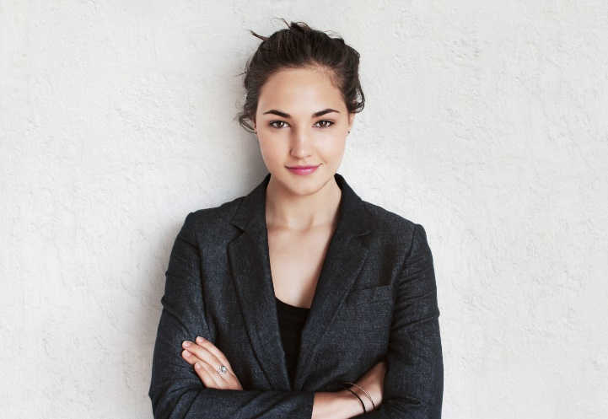

If you like this **free** resume template, please smash the like button for the YouTube algorithm 😊

<https://youtu.be/juKZ6GJKtCg>

Follow me on Instagram to find more **free** templates:

<https://www.instagram.com/techie.leon/>

**EXPERIENCE**

**Intern** **2018-present**

Tesla Inc., Fremont, CA

Describe your responsibilities and achievements

**Intern** **2016-2018**

Boeing, Pleasanton, CA

Describe your responsibilities and achievements

**Intern** **2014-2016**

Audi Palo Alto, Palo Alto, CA

Describe your responsibilities and achievements

**EDUCATION**

**M.Sc. Bioengineering** **2014-present**

Harvard University, Cambridge, MA

Clubs & Societies: Robotics Society, Business Club

**B.A. Applied Economics** **2010-2014**

Yale University, New Haven, CT

Graduated Summa Cum Laude

Clubs & Societies: Business Club

[Write down a professional summary or a resume objective. Note, that this part is different for every country.] Lorem ipsum dolor sit amet, consectetur adipiscing elit, sed do eiusmod tempor incididunt ut labore et dolore magna aliqua. Bibendum at varius vel pharetra. Quisque egestas diam in arcu cursus euismod quis viverra.

**JANE SMITH**

HOBBIES

SPANISH

◼◼◼◼◼

GERMAN

◼◼◼◼◼

ENGLISH

◼◼◼◼◼

LANGUAGES

MS Word, MS Excel

◼◼◼◼◼

PTC Creo, Catia

◼◼◼◼◼

Python, Java, CSS

◼◼◼◼◼



000-000-000



jane.smith@gmail.com



London, GB



janesmith.com

SKILLS

CONTACT