Assignment 1

Name – Ashutosh Chaudhary

Student ID – 8858206

Course Code – PROG 8173

## **Defects:**

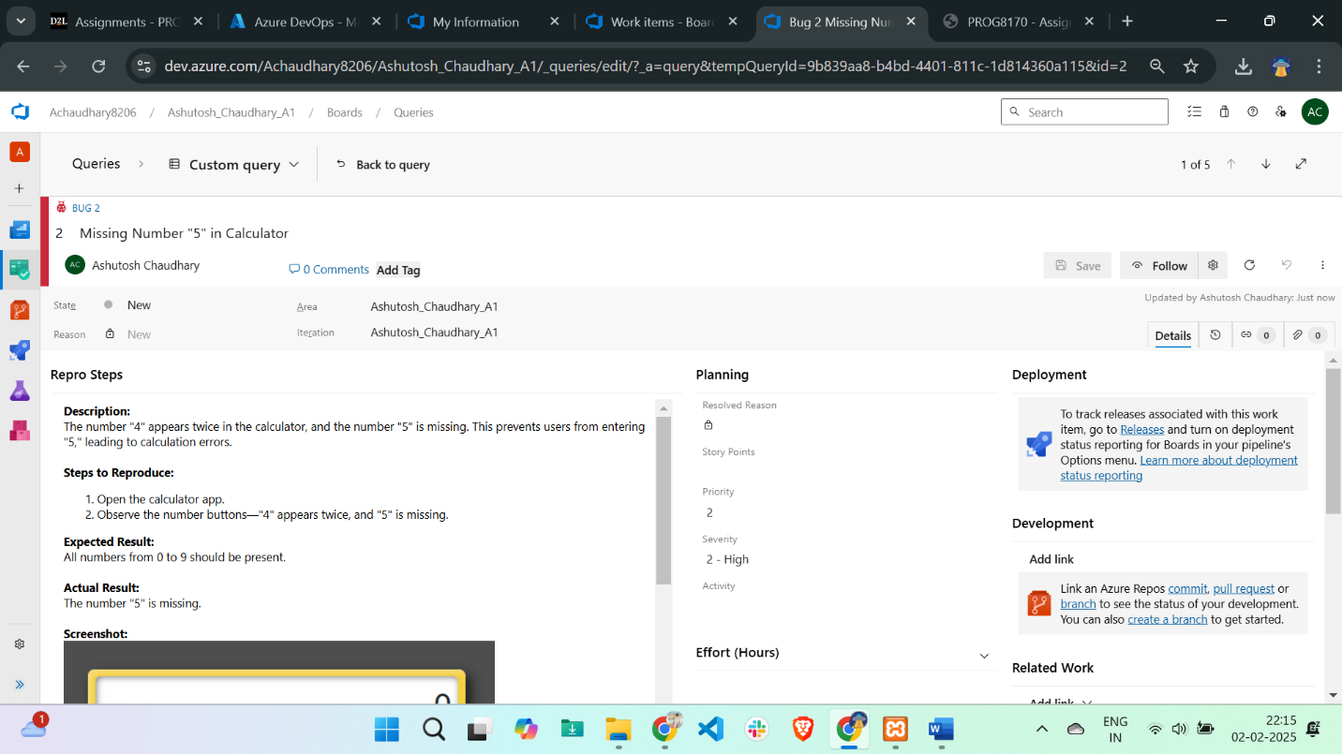

Defect 1: Duplicate Number Button (Missing "5")

Title: Missing Number "5" in Calculator

Description: The number "4" appears twice in the calculator, and the number "5" is missing. This prevents users from entering "5," leading to calculation errors.

Steps to Reproduce:

* Open the calculator app.
* Observe the number buttons—"4" appears twice, and "5" is missing.

Expected Result: All numbers from 0 to 9 should be present.

Actual Result: The number "5" is missing.

Severity: High

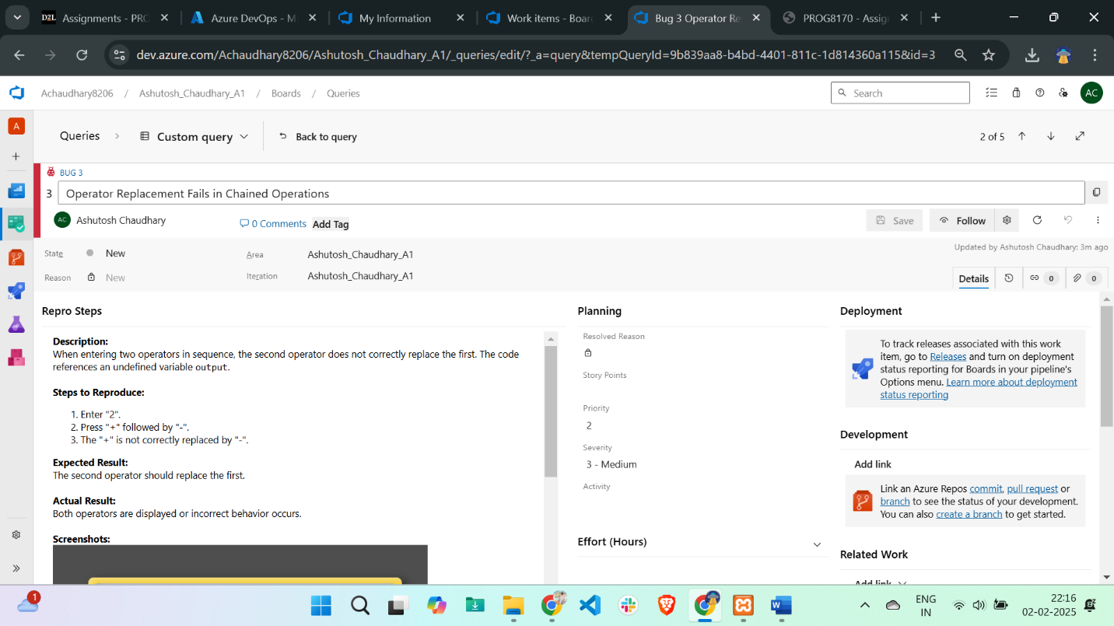

Defect 2: Incorrect Operator Replacement Logic

Title: Operator Replacement Fails in Chained Operations

Description: When entering two operators in sequence, the second operator does not correctly replace the first. The code references an undefined variable output.

Steps to Reproduce:

* Enter "2".
* Press "+" followed by "-".
* The "+" is not correctly replaced by "-".

Expected Result: The second operator should replace the first.

Actual Result: Both operators are displayed or incorrect behavior occurs.

Severity: Medium

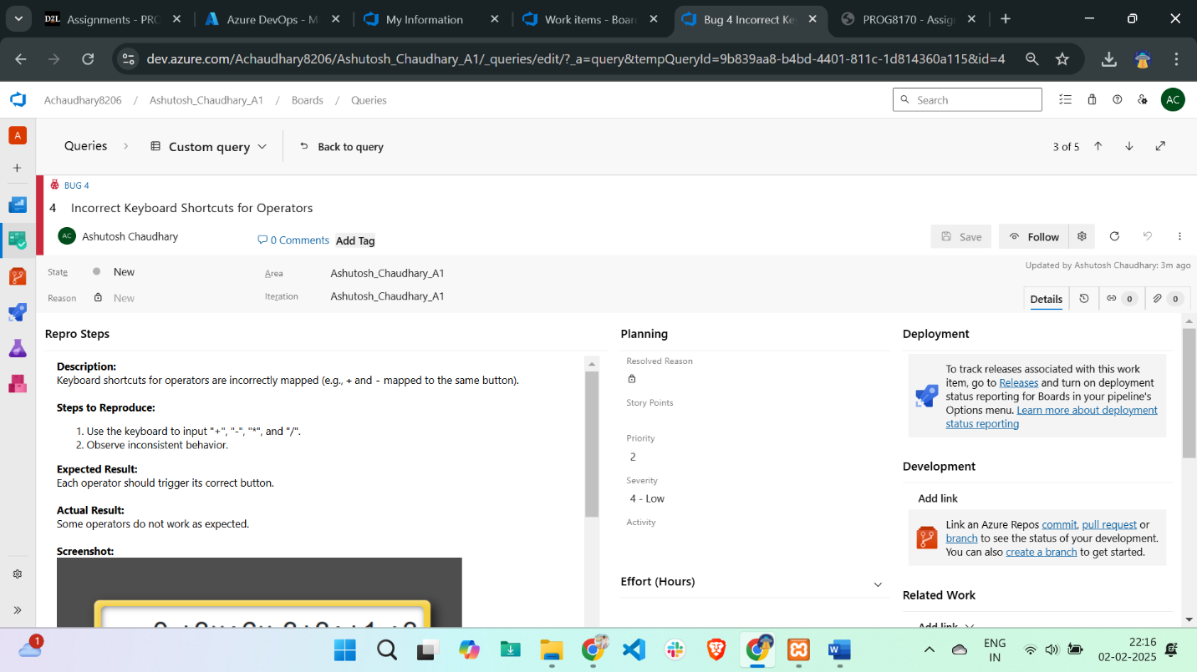

Defect 3: Inconsistent Keyboard Shortcut Mapping

Title: Incorrect Keyboard Shortcuts for Operators

Description: Keyboard shortcuts for operators are incorrectly mapped (e.g., + and - mapped to the same button).

Steps to Reproduce:

* Use the keyboard to input "+", "-", "*", and "/".
* Observe inconsistent behaviour.

Expected Result: Each operator should trigger its correct button.

Actual Result: Some operators do not work as expected.

Severity: Low

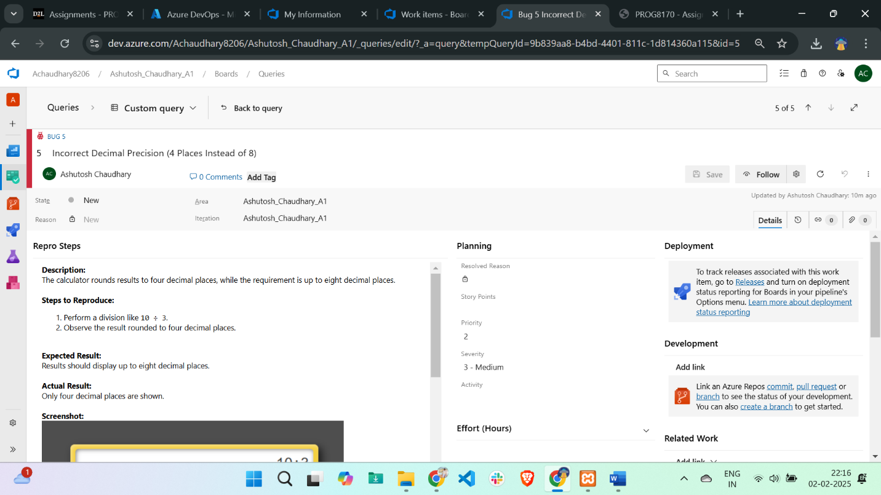

Defect 4: Incorrect Decimal Precision

Title: Incorrect Decimal Precision (4 Places Instead of 8)

Description: The calculator rounds results to four decimal places, while the requirement is up to eight decimal places.

Steps to Reproduce:

* Perform a division like 10 ÷ 3.
* Observe the result rounded to four decimal places.

Expected Result: Results should display up to eight decimal places.

Actual Result: Only four decimal places are shown.

Severity: Medium

## **Feature Request:**

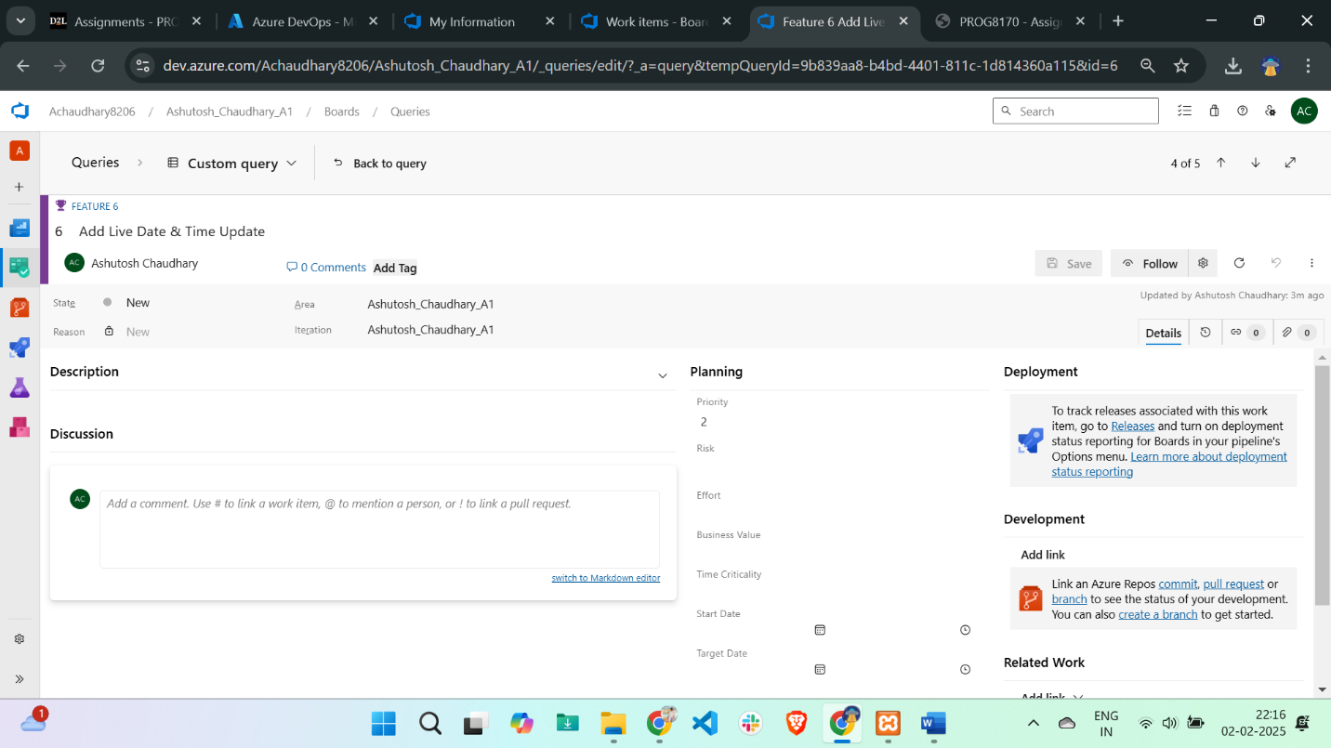

Feature Request: Live Date & Time Update

Title: Add Live Date & Time Update

Description: Implement real-time updating of date and time without refreshing the page.

Benefit: Enhances user experience by dynamically displaying the current date and time.

Priority: Medium

## **Query Result:**

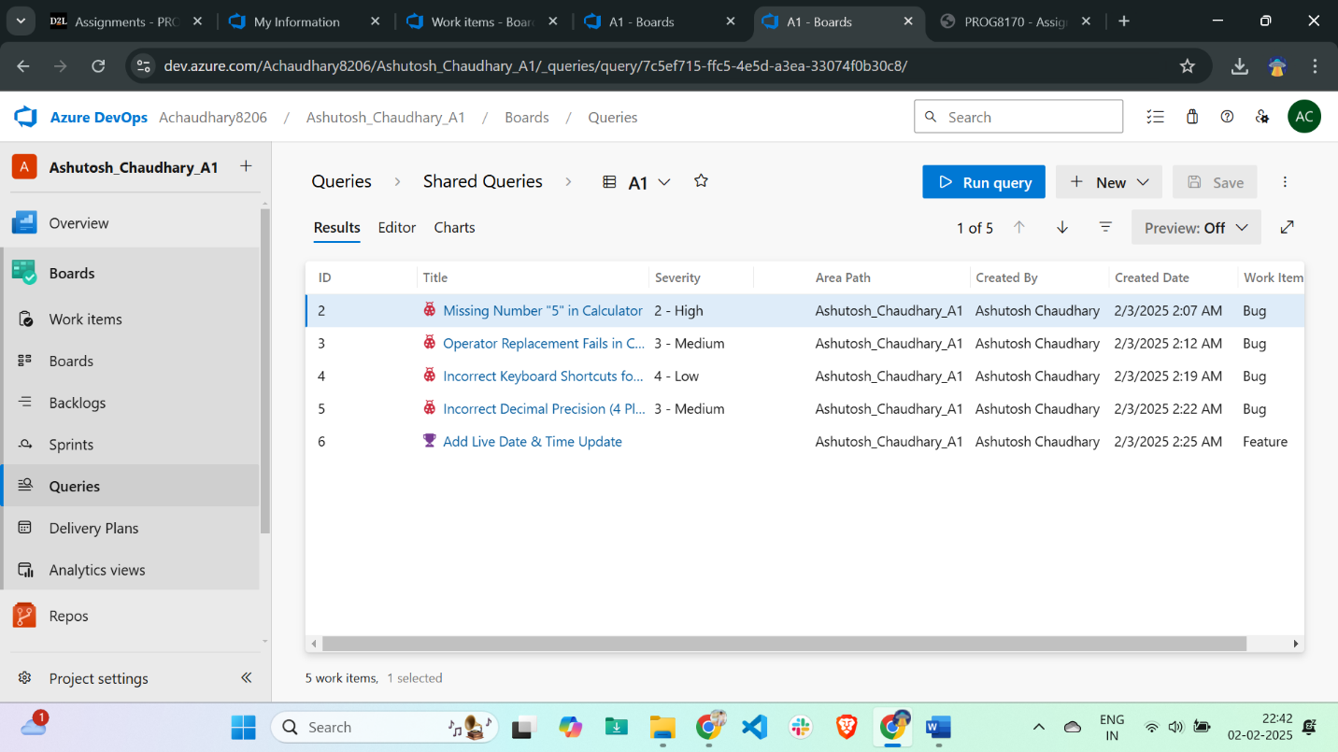

## **Pie Chart Screenshot:**

## **Analysis and Recommendation:**

**Analysis:**

Based on the defects logged, the application has several usability issues (e.g., keyboard shortcuts not working as expected, calculation errors). These issues would significantly affect user experience, especially in a critical tool like a calculator.

**Recommendation:**

Given the severity of the defects, I recommend not releasing the application yet. The issues need to be addressed, and further testing should be conducted to ensure the application functions properly across all supported platforms and browsers.