Assignment 2

Name – Ashutosh Chaudhary

Student ID – 8858206

Course Code – PROG 8173

We will use the following code for the testing.

using System;

using System.Collections.Generic;

using System.Linq;

using System.Text;

using System.Threading.Tasks;

using TriangleSolver;

using NUnit.Framework;

namespace TestTriangle

{

[TestFixture]

public class TestTriangle

{

[Test]

public void AnalyzeTriangle_AllSidesEqual_ReturnsEquilateral()

{

int sideA = 7;

int sideB = 7;

int sideC = 7;

string result = Triangle.AnalyzeTriangle(sideA, sideB, sideC);

Assert.That(result, Is.EqualTo("Equilateral triangle"));

}

[Test]

public void Analyzetriangle_TwoSidesEqual1_ReturnsIsosceles()

{

int sideA = 9;

int sideB = 9;

int sideC = 5;

string result = Triangle.AnalyzeTriangle(sideA, sideB, sideC);

Assert.That(result, Is.EqualTo("Isosceles triangle"));

}

[Test]

public void Analyzetriangle_TwoSidesEqual2_ReturnsIsosceles()

{

int sideA = 4;

int sideB = 4;

int sideC = 6;

string result = Triangle.AnalyzeTriangle(sideA, sideB, sideC);

Assert.That(result, Is.EqualTo("Isosceles triangle"));

}

[Test]

public void Analyzetriangle_TwoSidesEqual3_ReturnsIsosceles()

{

int sideA = 9;

int sideB = 9;

int sideC = 5;

string result = Triangle.AnalyzeTriangle(sideA, sideB, sideC);

Assert.That(result, Is.EqualTo("Isosceles triangle"));

}

[Test]

public void Analyzetriangle_AllSidesDifferent1_ReturnsScalene()

{

int sideA = 9;

int sideB = 7;

int sideC = 5;

string result = Triangle.AnalyzeTriangle(sideA, sideB, sideC);

Assert.That(result, Is.EqualTo("Scalene triangle"));

}

[Test]

public void Analyzetriangle_AllSidesDifferent2_ReturnsScalene()

{

int sideA = 6;

int sideB = 4;

int sideC = 8;

string result = Triangle.AnalyzeTriangle(sideA, sideB, sideC);

Assert.That(result, Is.EqualTo("Scalene triangle"));

}

[Test]

public void Analyzetriangle_AllSidesDifferent3_ReturnsScalene()

{

int sideA = 8;

int sideB = 6;

int sideC = 5;

string result = Triangle.AnalyzeTriangle(sideA, sideB, sideC);

Assert.That(result, Is.EqualTo("Scalene triangle"));

}

[Test]

public void Analyzetriangle_AllSidesDifferent4_ReturnsScalene()

{

int sideA = 8;

int sideB = 7;

int sideC = 5;

string result = Triangle.AnalyzeTriangle(sideA, sideB, sideC);

Assert.That(result, Is.EqualTo("Scalene triangle"));

}

[Test]

public void Analyzetriangle_AllSidesDifferent5_ReturnsScalene()

{

int sideA = 8;

int sideB = 3;

int sideC = 9;

string result = Triangle.AnalyzeTriangle(sideA, sideB, sideC);

Assert.That(result, Is.EqualTo("Scalene triangle"));

}

[Test]

public void Analyzetriangle_ZeroSide1_ReturnsError()

{

int sideA = 0;

int sideB = 3;

int sideC = 9;

string result = Triangle.AnalyzeTriangle(sideA, sideB, sideC);

Assert.That(result, Is.EqualTo("Invalid Triangle - a zero has been detected"));

}

[Test]

public void Analyzetriangle_ZeroSide2_ReturnsError()

{

int sideA = 2;

int sideB = 0;

int sideC = 8;

string result = Triangle.AnalyzeTriangle(sideA, sideB, sideC);

Assert.That(result, Is.EqualTo("Invalid Triangle - a zero has been detected"));

}

[Test]

public void Analyzetriangle_ZeroSide3_ReturnsError()

{

int sideA = 5;

int sideB = 6;

int sideC = 0;

string result = Triangle.AnalyzeTriangle(sideA, sideB, sideC);

Assert.That(result, Is.EqualTo("Invalid Triangle - a zero has been detected"));

}

[Test]

public void Analyzetriangle_InvalidTriangle1_ReturnsInvalid()

{

int sideA = 1;

int sideB = 2;

int sideC = 3;

string result = Triangle.AnalyzeTriangle(sideA, sideB, sideC);

Assert.That(result, Is.EqualTo("INVALID!!"));

}

[Test]

public void Analyzetriangle_InvalidTriangle2_ReturnsInvalid()

{

int sideA = 2;

int sideB = 3;

int sideC = 1;

string result = Triangle.AnalyzeTriangle(sideA, sideB, sideC);

Assert.That(result, Is.EqualTo("INVALID!!"));

}

[Test]

public void Analyzetriangle_InvalidTriangle3_ReturnsInvalid()

{

int sideA = 3;

int sideB = 2;

int sideC = 1;

string result = Triangle.AnalyzeTriangle(sideA, sideB, sideC);

Assert.That(result, Is.EqualTo("INVALID!!"));

}

}

}

So Firstly, we will open the solution provided to us as a zip file along with the assignment.

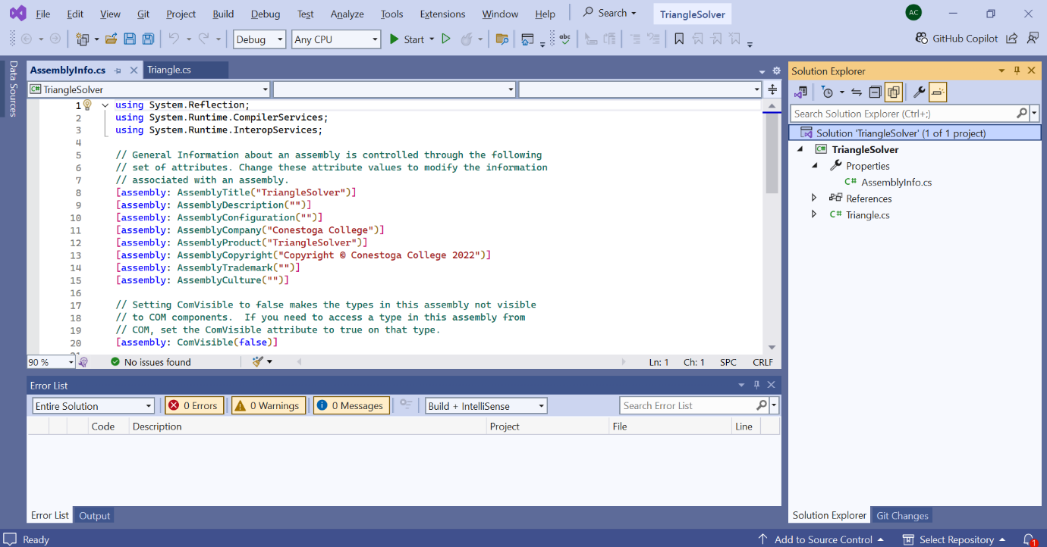

Now Add a new project into the same solution.

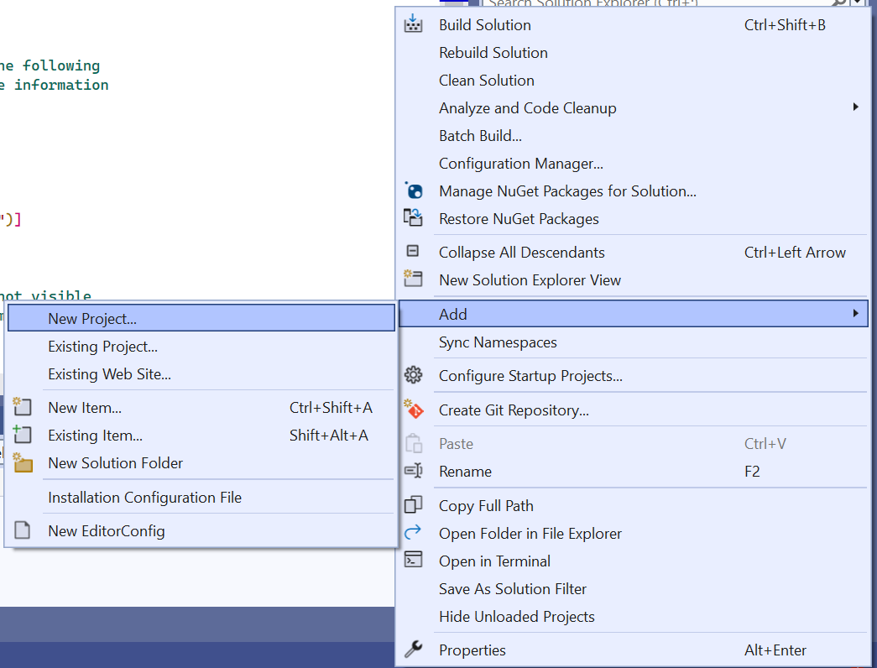

Configure the project for testing.

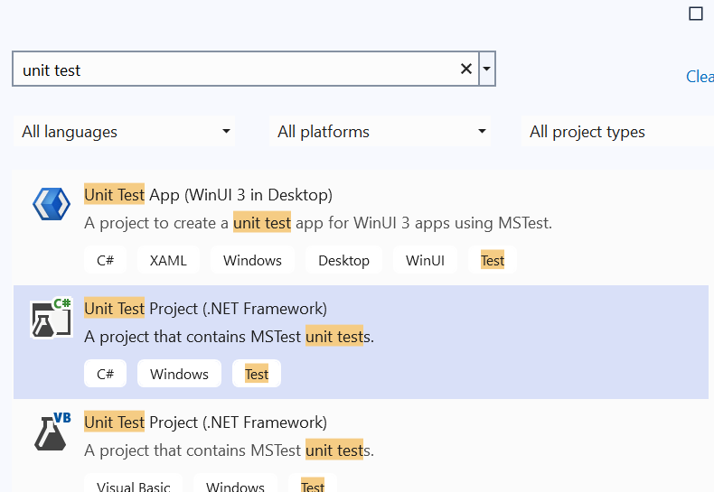

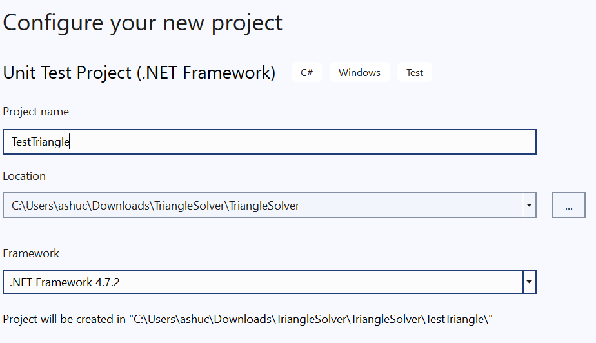

Create the project.

Then we will add the reference of this new project with the old and main project.

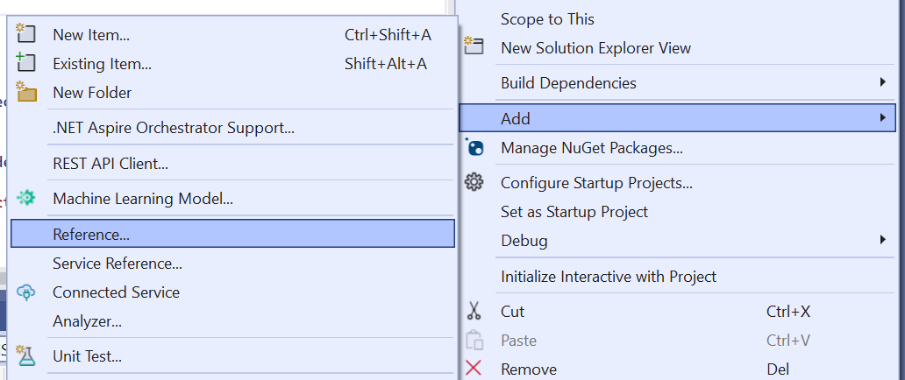

Select and add

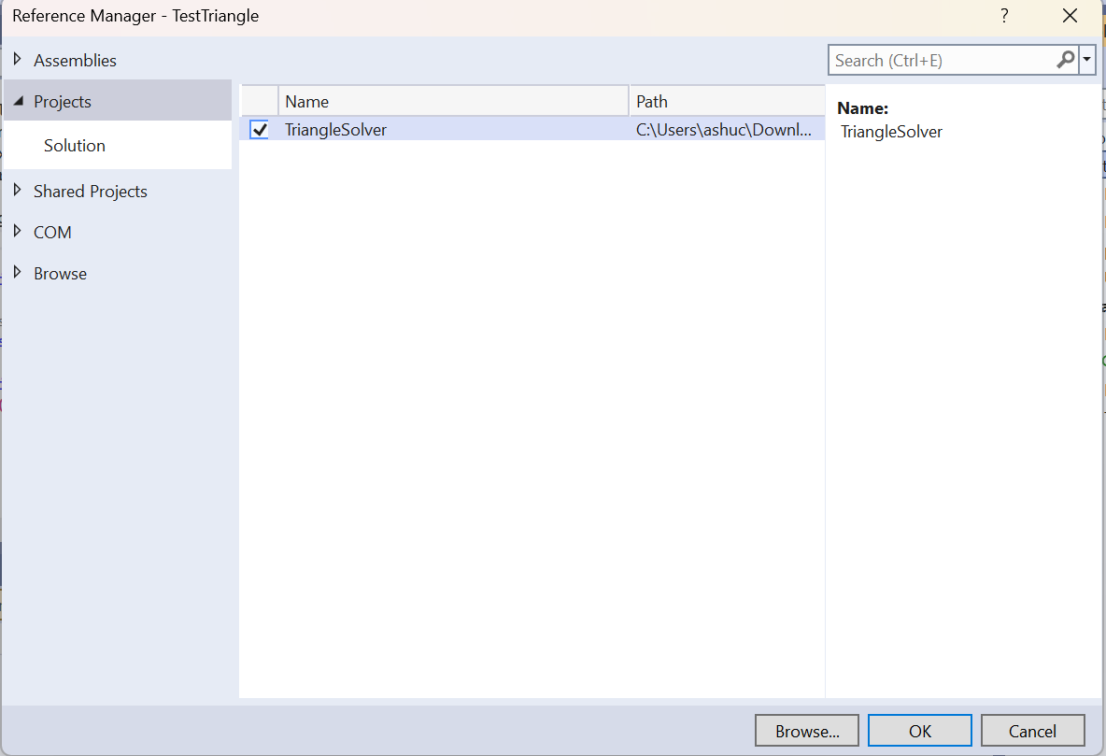

Now we will add packages.

Install 3 packages.

* NUnit
* NUnit3TestAdapter
* NUnit.Console

Select, accept and Install.

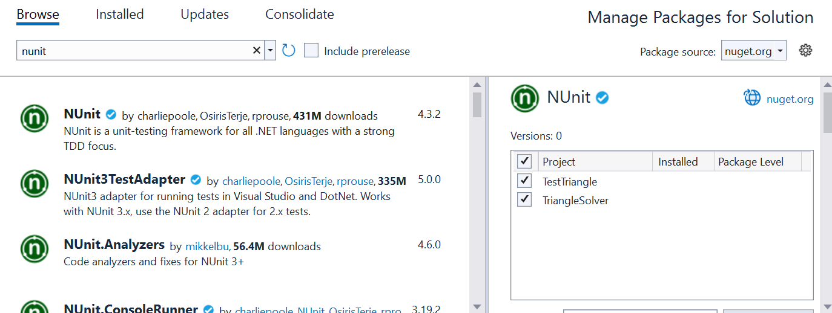

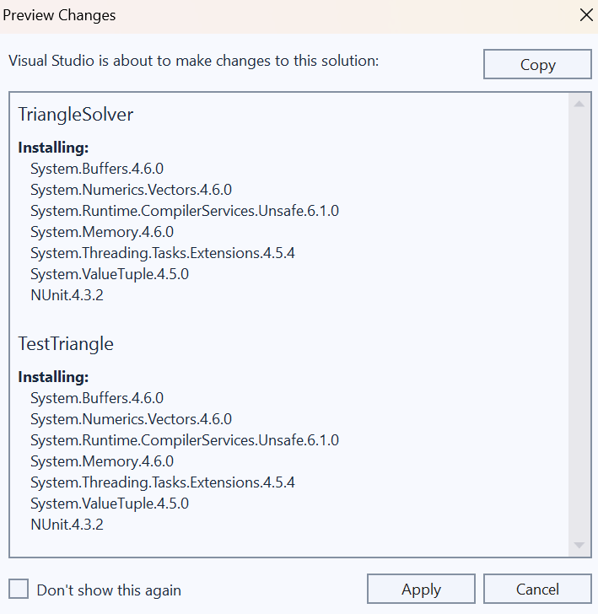

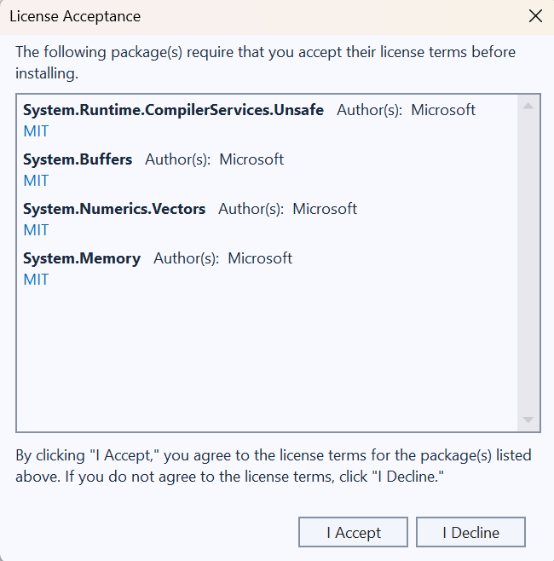

Add the following at top

Using TriangleSolver

Using NUnit.Framework

Then write the complete code as given above.

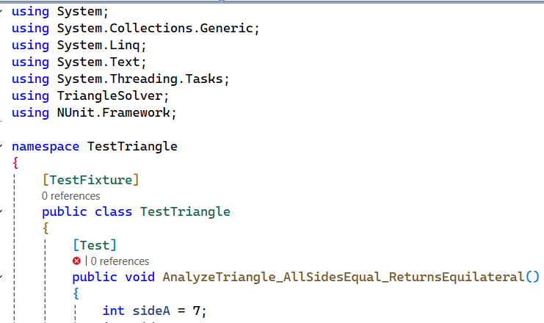

Now after this perform testing

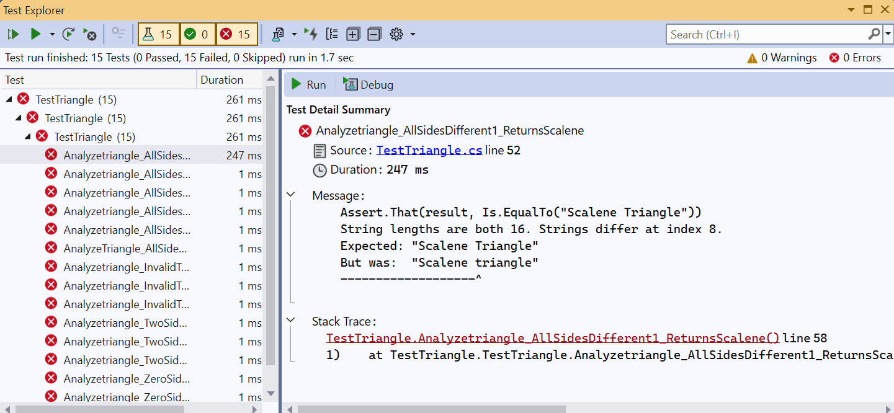

Testing failed as there were silly minute errors.

We will fix them and we will test again.

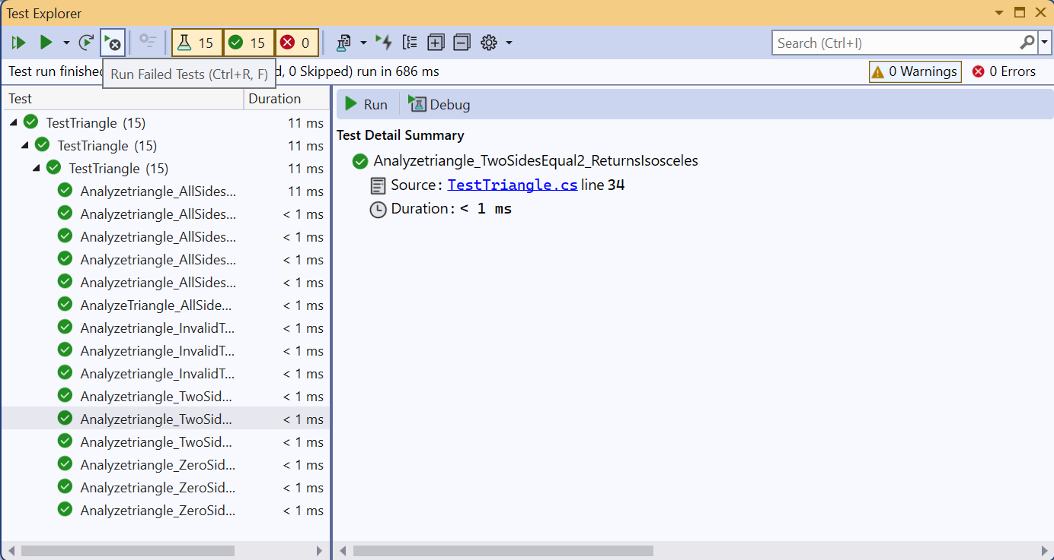

All Testing Done and Succeeded.

No Error now.