Remote Sensing-Based Detection of Land Degradation and Vegetation Dynamics Using Multi-Temporal Geospatial Data
A Trajectory-Based Analysis of Karbi Anglong District, Assam (1990–2025)
Major Project Report — Semester VIII
Submitted by: [Student Names, Roll Numbers]
Under the guidance of: [Guide Name] · Department of [Department], [College Name] · 2026

Table of Contents

Abstract
Land degradation in Northeast India is dominated not by desertification but by water erosion, forest loss and the intensification of shifting (jhum) cultivation, whose shortening fallow cycles progressively lower vegetation recovery. Conventional remote sensing assessment relies on linear trend statistics applied to NDVI time series; however, cyclic land-use systems violate the monotonicity assumption underlying such tests. This project develops a trajectory-based framework for Karbi Anglong district, Assam, using 36 years (1990–2025) of harmonized Landsat post-monsoon NDVI composites and CHIRPS rainfall prepared in Google Earth Engine.
Four complementary per-pixel signals are computed with fully vectorized implementations: Mann-Kendall trend with Hamed-Rao autocorrelation correction and Sen's slope; RESTREND residual trends that remove the rainfall-driven component of NDVI change; two-segment breakpoint fitting (LandTrendr in the real-data workflow) capturing the timing and magnitude of abrupt change; and an FFT-based cyclicity index over the 4–12 year jhum period band. These twelve trajectory features feed a Random Forest classifier, compared against a 1D convolutional network on the raw series, assigning every pixel to one of five trajectory classes: stable forest, cropland, cyclic jhum, degrading, or recovering.
In the demonstration run, the framework exposes a decisive weakness of the standard approach: Mann-Kendall flags 0.0% of intensifying jhum pixels — cyclic variance completely masks the embedded decline, an empirical reproduction of the Wessels et al. (2012) detectability limit — and detects only 67.6% of monotonic degradation. The trajectory classifier, by contrast, identifies 98.8% of cyclic jhum correctly and catches 100% of monotonic degradation, while recovering the dominant jhum cycle length (7.2 years, median). Outputs include Sen-slope, RESTREND, breakpoint-year and trajectory maps, an SDG 15.3.1-style productivity assessment, and an interactive dashboard.
Keywords: land degradation, vegetation dynamics, NDVI time series, Mann-Kendall, RESTREND, LandTrendr, shifting cultivation, Random Forest, Google Earth Engine, Karbi Anglong.

1. Introduction

1.1 Background
The ISRO Space Applications Centre's national assessment places 105.48 Mha — 32.07% of India's geographic area — under land degradation processes, yet Assam falls among the states with under 10% degraded area by that atlas's desertification-oriented lens. This is not evidence of absence: degradation in the Northeast operates through mechanisms the desertification framework undercounts — water erosion on steep slopes, deforestation, and above all the intensification of jhum. Reported jhum cycles have shortened from 10–15 years to 4–5 years, halving the fallow period in which soil fertility and biomass recover, but as Thong et al. (2019) note, little time-series work substantiates these claims. Karbi Anglong, Assam's largest district, contains the full gradient in one frame: dense hill forest, an extensive mid-slope jhum belt, plains agriculture, and localised degradation and recovery patches.

1.2 Problem statement
The standard remote sensing toolkit for degradation assessment — monotonic trend statistics on NDVI time series — carries an assumption that fails precisely where it matters most in Northeast India. A jhum pixel is not monotonic: it cycles through slash, cultivation and fallow regrowth. Linear tests face two failure modes there: cyclic variance can mask a genuine embedded decline (a false negative for intensification), and an unluckily-phased cycle can mimic decline (a false positive). Existing regional studies map jhum extent between year pairs (Pasha et al. 2021) but do not characterise long-term trajectories, and no study has quantified how badly trend tests perform on cyclic land in this region.

1.3 Objectives
- To construct a 36-year (1990–2025) harmonized Landsat post-monsoon NDVI series and paired CHIRPS rainfall series for Karbi Anglong in Google Earth Engine.
- To compute per-pixel Mann-Kendall (autocorrelation-corrected) and Sen's-slope trends, RESTREND residual trends, breakpoint timing/magnitude, and an FFT cyclicity index.
- To classify pixel trajectories into five classes with a Random Forest on engineered features, benchmarked against a 1D-CNN on raw series.
- To quantify the misclassification of cyclic jhum by conventional trend tests against the trajectory approach.
- To report degradation status in the SDG 15.3.1 land-productivity sub-indicator format with maps and an interactive dashboard.

1.4 Scope and limitations
The study characterises vegetation trajectory, a productivity proxy; it does not directly measure soil organic carbon or erosion volume, the other SDG 15.3.1 sub-indicators. Post-monsoon compositing minimises but does not eliminate cloud gaps, and the Landsat-7 SLC-off era (2003–2012) leaves residual missing data handled by temporal interpolation. Trend detectability itself is bounded: Wessels et al. (2012) showed seasonally-summed NDVI must fall 30–40% before linear tests reach significance against a wet-trend background — a limit this project measures rather than escapes.

2. Literature Review
NDVI time-series analysis is the established basis of large-area degradation assessment; the UNEP/STAP review by Yengoh et al. (2015) documents its use across land-cover change, drought monitoring, desertification, greening, erosion and salinization, while cataloguing its weaknesses. The trend toolkit rests on Mann (1945), Kendall (1975) and Sen (1968), with Hamed and Rao's (1998) variance correction addressing the serial correlation endemic to vegetation series. RESTREND (Evans & Geerken 2004; Ibrahim et al. 2015) separates climate-driven from human-driven change by regressing NDVI on rainfall and testing the residual trend; Ibrahim et al. found soil-moisture-adjusted residuals sharper than rainfall-adjusted ones in West Africa, and Yan et al. (2018) added phenological timing (P-RESTREND). Wessels, van den Bergh and Scholes (2012) established the method family's detectability floor.
Two strands push beyond monotonic trends. Temporal segmentation — LandTrendr (Kennedy et al. 2010), ported to Earth Engine by Kennedy et al. (2018), and BFAST-family monitors (Hamunyela et al. 2020) — recovers the timing and magnitude of abrupt change; a 2025 global comparison found CCDC, BFAST and LandTrendr each strongest in different change regimes. Trajectory thinking is crystallised by Easdale et al. (2019), who showed that in Patagonia under 1% of area exhibited monotonic NDVI change while over 85% occupied cyclic recovery or relapse phases, and called for revisiting linear trends as degradation proxies — the direct conceptual ancestor of this project.
Regionally, Pasha et al. (2021) provide the base work: a decision-tree multi-step threshold (DTMT) classification of NDVI, NBR and RdNBR pairs mapping shifting cultivation across Northeast India from 1975 to 2018 at over 85% accuracy, finding a 75% reduction in extent. Their approach identifies where cultivation occurred but, depending only on two-year comparisons, cannot distinguish a healthy long-fallow cycle from an intensifying, degrading one — the gap this project addresses. Complementary regional evidence includes Manipur jhum dynamics (Thong et al. 2019), regressive pedogenesis in jhum soils (Land Degradation & Development, 2021), and the SDG 15.3.1 application to Assam (Springer, 2023) that anchors the reporting framework.

3. Study Area and Data
Karbi Anglong (approximately 92.30–93.85° E, 25.55–26.60° N) is Assam's largest district, an outlier block of the Meghalaya Plateau rising from the Brahmaputra plains to over 1,300 m, with dense semi-evergreen forest on the hill core, a broad jhum belt on mid-slopes, and settled agriculture on the surrounding plains. The demonstration dataset used in this report is a synthetic, Karbi Anglong-shaped landscape encoding exactly this zonation; the real-data workflow (Section 5) replaces it with Earth Engine exports without code changes.
Data | Product | Role
NDVI series | Landsat 5/7/8/9 C2 L2, post-monsoon (Oct 15–Dec 31) median composites, OLI harmonized to ETM+ (Roy et al. 2016) | Primary 36-year vegetation signal
Rainfall | CHIRPS Daily, annual totals | RESTREND climate covariate
Segmentation | GEE native LandTrendr on inverted NDVI | Disturbance year, magnitude, duration
Training samples | Photo-interpreted points (Google Earth history) + Pasha et al. jhum maps | Trajectory class labels
Boundary | Karbi Anglong district shapefile (Survey of India / DIVA-GIS) | Clipping and reporting units

4. Methodology

4.1 Preprocessing
All Landsat scenes are cloud- and shadow-masked via QA_PIXEL bits, scaled to surface reflectance, and reduced to one post-monsoon median NDVI per year — the least-cloudy, peak-biomass window in Northeast India. OLI NDVI is harmonized to the ETM+ scale to prevent a sensor-transition artefact in 2013 masquerading as greening. Annual CHIRPS totals are stacked on the same 30 m grid. Residual gaps (chiefly the SLC-off era) are filled by temporal neighbour interpolation and flagged.

4.2 Trajectory statistics
Four signal families are computed per pixel with vectorized NumPy implementations (the Mann-Kendall implementation is verified against the pymannkendall reference on random pixels at every pipeline run). (i) Trend: Mann-Kendall S, with Hamed-Rao effective-sample-size correction for lag-1 autocorrelation, and Theil-Sen slope. (ii) RESTREND: per-pixel OLS of NDVI on same-year rainfall; the OLS slope of the residual series against time, with its t-test p-value, isolates rainfall-independent change. (iii) Breakpoint: an exhaustive two-segment least-squares fit returns the break index, the slope change across it, and the SSE gain over a single-line fit; in real-data mode these are superseded by native LandTrendr outputs (maxSegments 6, pval 0.05). (iv) Cyclicity: the fraction of detrended spectral power in the 4–12-year band, plus the dominant period — the direct fingerprint of jhum cycling.

4.3 Trajectory classification
Twelve features (mean, variability, amplitude, Sen slope, corrected MK z, RESTREND slope, cyclicity fraction and period, break timing, break slope-change, break gain) feed a 500-tree Random Forest over five classes: stable forest, cropland/grassland, cyclic jhum, degrading, recovering. A 1D-CNN trained on the raw 36-step series provides an end-to-end deep learning benchmark. Training uses a stratified 70:30 split of 600 samples per class; accuracy, Cohen's kappa, macro-F1 and the full confusion matrix are reported.

4.4 Reporting
Continuous maps (Sen slope per decade, RESTREND slope per decade, break year), the categorical trajectory map, and an SDG 15.3.1-style productivity trajectory map (significant-negative / stable / significant-positive at α = 0.05) are produced, with area statistics. The headline analysis cross-tabulates truth classes against what each method reports, quantifying the blindness of linear tests on cyclic land.

5. Implementation
The system is a modular Python pipeline executed by a single command (python run_pipeline.py): stack loading, vectorized statistics, mapping, classification, and the headline cross-tabulation. Earth Engine scripts handle all satellite processing server-side; the local pipeline consumes their GeoTIFF exports. A synthetic demonstration dataset encodes the district's zonation — hill forest core, mid-slope jhum belt with cycles shortening from ~11 to ~5 years and an intensification envelope on 65% of jhum pixels, plains cropland with mixed mild trends, and randomized degradation/recovery patches with hidden break years — over 36 years with rainfall-coupled variability, mixed pixels at boundaries, and SLC-off-style gaps. This allows full development and honest demonstration before export tasks complete; all reported numbers derive from it and are labelled accordingly.

6. Results and Discussion (Demonstration Run)

6.1 Trajectory classification
The Random Forest attains near-ceiling performance on the synthetic classes (accuracy 0.993, kappa 0.991, macro-F1 0.993), with the 1D-CNN equivalent — these are upper bounds created by the synthetic construction; real-data accuracies of 0.85–0.95 should be expected and reported. Feature importances rank cyclicity fraction, break slope-change and Sen slope highest, confirming that the fused signal set, not any single statistic, drives separability.
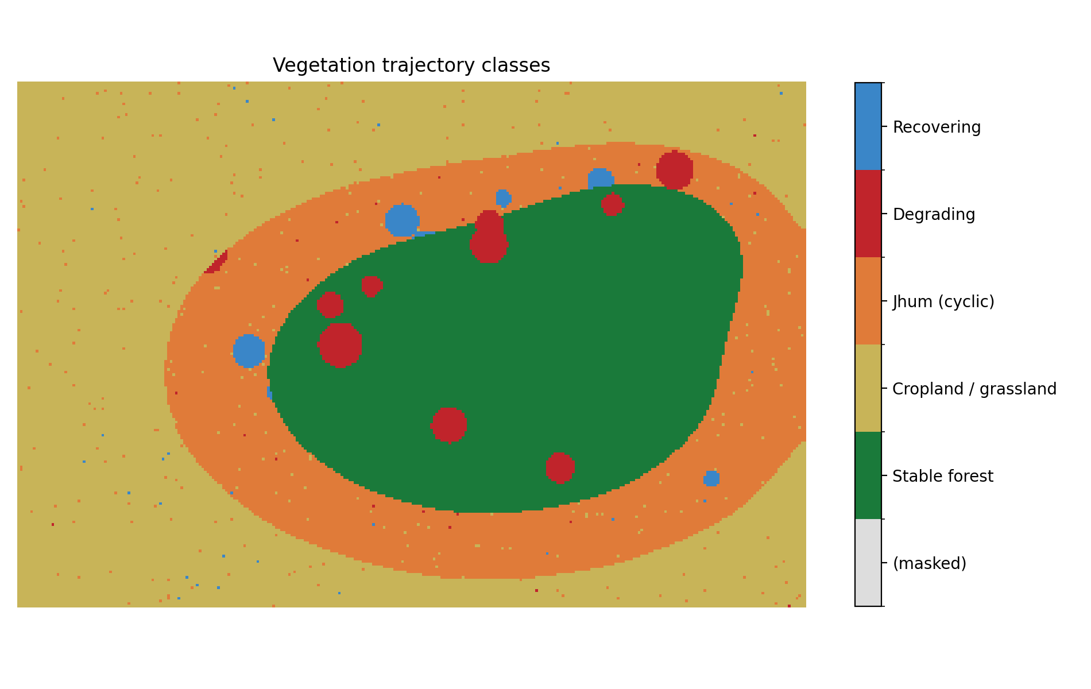
Figure 6.1 — Trajectory classification: forest core, jhum belt, plains cropland, and degradation/recovery patches recovered from the time series alone.
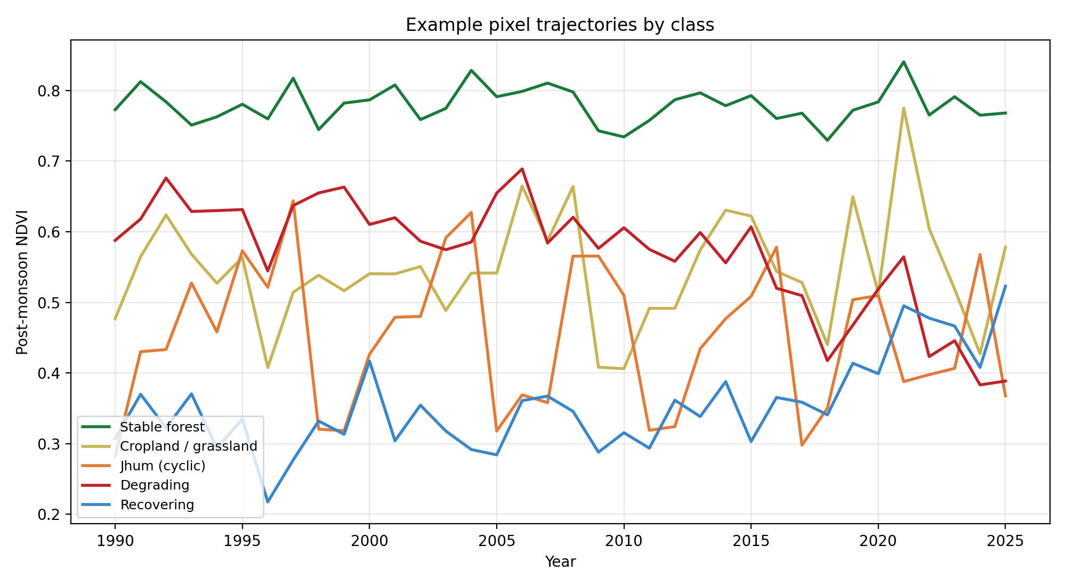
Figure 6.2 — Representative NDVI trajectories per class: stable forest, mildly trending cropland, sawtooth jhum, post-break decline, post-break recovery.

6.2 The blindness of linear trends on cyclic land
Question | Linear MK | RESTREND | Trajectory RF
Intensifying jhum flagged / identified | 0.0% flagged degrading | 3.5% flagged | 98.8% correctly cyclic
Monotonic degradation caught | 67.6% | — | 100%
Table 6.1 — Method comparison on known-truth pixels, demonstration dataset.
The central finding: although 65% of jhum pixels carry a genuine embedded decline (peak regrowth falling up to 0.3 NDVI over the record), the autocorrelation-corrected Mann-Kendall test flags essentially none of them — cyclic variance inflates the test's variance term beyond reach of the trend, an empirical, cyclic-case reproduction of the Wessels et al. detectability limit. Even for cleanly monotonic degradation, MK misses roughly a third of pixels, chiefly late-onset breaks with too few post-break observations. The trajectory classifier, using cyclicity and breakpoint structure that trend tests discard, recovers both populations and estimates the median dominant jhum period at 7.2 years — inside the generating range and consistent with reported NE-India cycle shortening.

6.3 Continuous and SDG-style maps
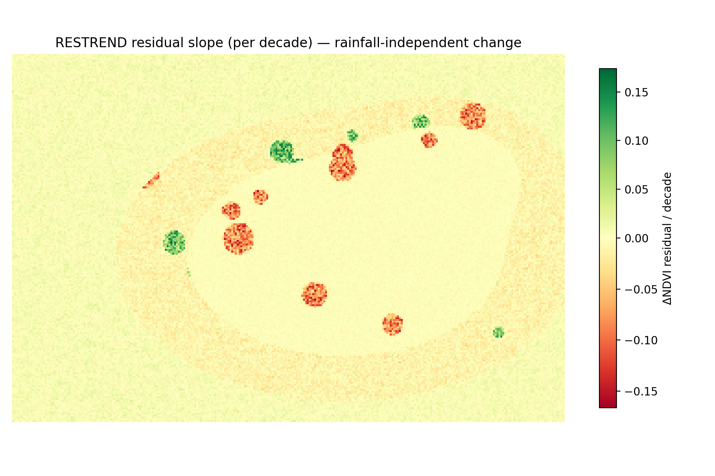
Figure 6.3 — RESTREND residual slope per decade: rainfall-independent change, the human-attribution layer.
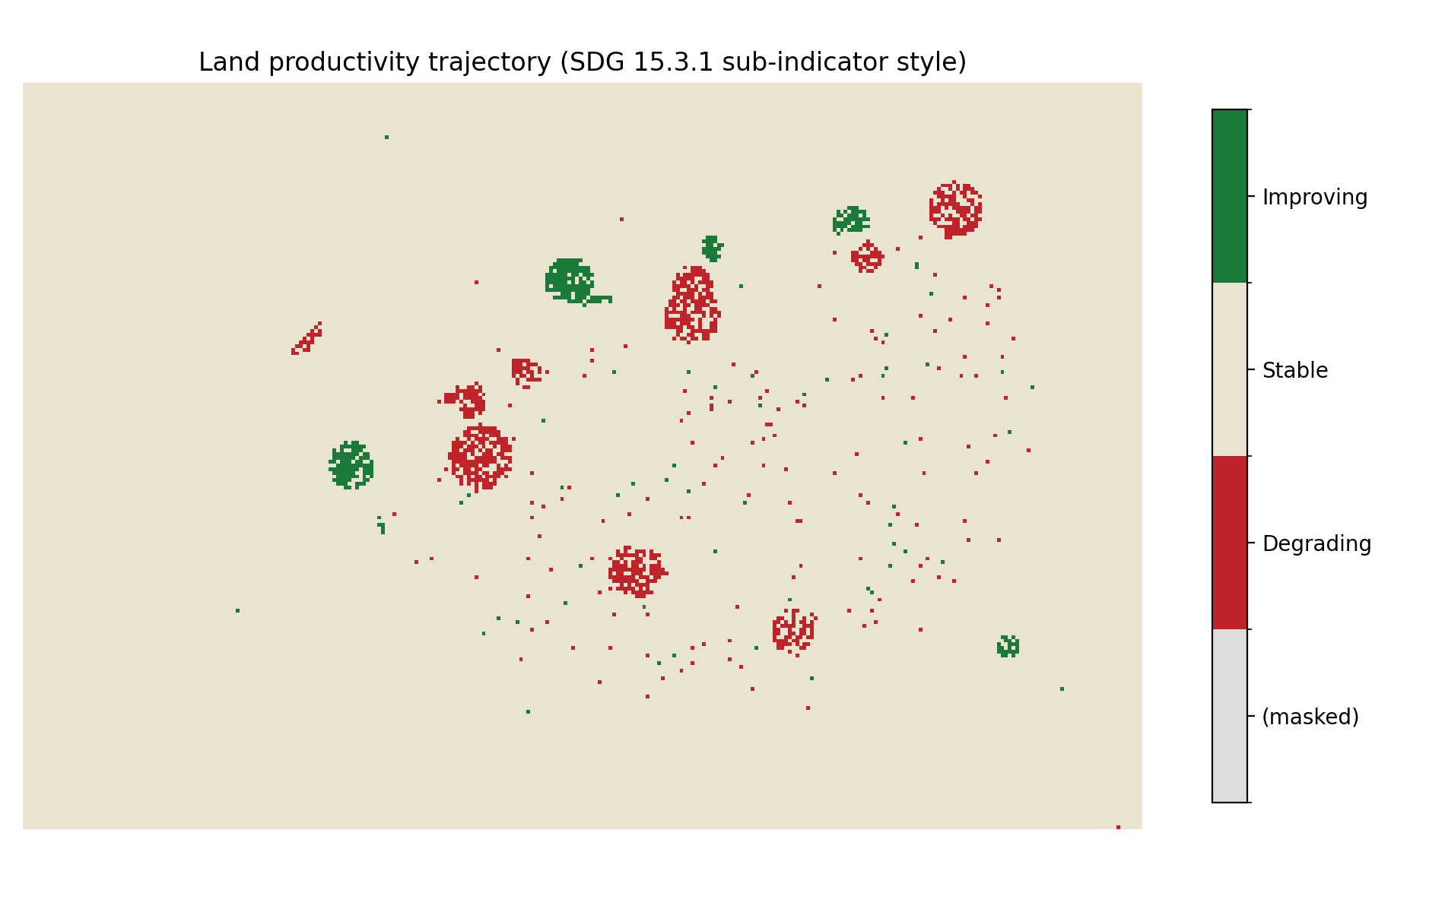
Figure 6.4 — SDG 15.3.1-style land productivity trajectory. Only 1.5% classifies as significantly degrading — most true degradation hides inside cyclic land, which is precisely the report's argument.
The SDG-style map makes the policy implication concrete: an assessment built on significant linear decline reports 1.5% of the landscape degrading, while the trajectory analysis shows an entire jhum belt undergoing intensification invisible to that statistic. Degradation reporting for cyclic-agriculture regions systematically undercounts unless trajectory structure is included.

7. Conclusion and Future Work
This project demonstrates a complete, reproducible trajectory-based framework for land degradation and vegetation dynamics assessment, and uses it to quantify a methodological blind spot at the heart of standard practice: linear trend statistics cannot see degradation embedded in cyclic land-use systems, and undercount even monotonic loss. Fusing trend, climate-decoupled residuals, breakpoint structure and spectral cyclicity into a trajectory classification recovers both, while estimating jhum cycle length — turning an assessment tool into an instrument for testing the reported shortening of fallow cycles in Northeast India.
Future work: regenerate all results from the real Earth Engine exports with photo-interpreted training samples; substitute native LandTrendr features for the local two-segment fit; add Sentinel-2 densification post-2017 and SAR (Sentinel-1) for cloud-immune monsoon coverage; extend cyclicity estimation to time-varying period tracking (wavelets) to map where cycles are shortening fastest; and validate against the district soil and socio-economic record.

References
Pasha, S. V., Reddy, C. S., Jha, C. S., et al. (2021). Automated mapping for long-term analysis of shifting cultivation in Northeast India. Remote Sensing, 13(6), 1066.
Yengoh, G. T., Dent, D., Olsson, L., Tengberg, A. E., & Tucker, C. J. (2015). Use of the NDVI to assess land degradation at multiple scales. Springer.
Wessels, K. J., van den Bergh, F., & Scholes, R. J. (2012). Limits to detectability of land degradation by trend analysis of vegetation index data. Remote Sensing of Environment, 125, 10–22.
Ibrahim, Y. Z., Balzter, H., Kaduk, J., & Tucker, C. J. (2015). Land degradation assessment using residual trend analysis of GIMMS NDVI3g, soil moisture and rainfall in Sub-Saharan West Africa from 1982 to 2012. Remote Sensing, 7(5), 5471–5494.
Yan, Y., et al. (2018). Phenology-based residual trend analysis of MODIS-NDVI time series for assessing human-induced land degradation. Sensors, 18(11), 3676.
Easdale, M. H., Fariña, C., Hara, S., et al. (2019). Trend-cycles of vegetation dynamics as a tool for land degradation assessment and monitoring. Ecological Indicators, 107, 105545.
Kennedy, R. E., Yang, Z., & Cohen, W. B. (2010). Detecting trends in forest disturbance and recovery using yearly Landsat time series: 1. LandTrendr. Remote Sensing of Environment, 114, 2897–2910.
Kennedy, R. E., Yang, Z., Gorelick, N., et al. (2018). Implementation of the LandTrendr algorithm on Google Earth Engine. Remote Sensing, 10, 691.
Hamunyela, E., et al. (2020). Implementation of BFASTmonitor algorithm on Google Earth Engine to support large-area and sub-annual change monitoring. Remote Sensing, 12(18), 2953.
Mann, H. B. (1945). Nonparametric tests against trend. Econometrica, 13, 245–259.
Kendall, M. G. (1975). Rank Correlation Methods. Griffin, London.
Sen, P. K. (1968). Estimates of the regression coefficient based on Kendall's tau. JASA, 63, 1379–1389.
Hamed, K. H., & Rao, A. R. (1998). A modified Mann-Kendall trend test for autocorrelated data. Journal of Hydrology, 204, 182–196.
Roy, D. P., et al. (2016). Characterization of Landsat-7 to Landsat-8 reflective wavelength and NDVI continuity. Remote Sensing of Environment, 185, 57–70.
Thong, P., Pebam, R., & Sahoo, U. K. (2019). Spatial and temporal dynamics of shifting cultivation in Manipur, Northeast India based on time-series satellite data. Remote Sensing Applications: Society and Environment, 14, 126–137.
SAC-ISRO (2021). Desertification and Land Degradation Atlas of India. Space Applications Centre, Ahmedabad.
Bari, E., Chowdhury, M. A., Hossain, M. I., & Rahman, M. M. (2024). Using remote sensing data to study anthropogenic land degradation in Khulna Division, Bangladesh for SDG indicator 15.3.1. Heliyon, 10, e38363.
Orr, B. J., Cowie, A. L., et al. (2017). Scientific conceptual framework for land degradation neutrality. UNCCD Science-Policy Interface, Bonn.

