Final Report Template

**Topic:** Covid 19 News Updates and Statistics

**Abstract:**

The application provide news and statistics to people in real time.

**Background:**

Internet and technology has provided us, on numerus occasions, ways and means of handling major life catastrophes. Ranging from the natural disaster alert on Facebook to the algorithm design for helicopters to drop out reliefs and emergency supplies to victims during the Venezuela mudslide 1979. The issue of the nCovid-19 pandemic should not be any different.

Like the aforementioned situations, there is the dying need of using technology, internet and Internet of Things to address rising issues and form a remedy. This project tend to tackle issues general relating to information dissemination/awareness.

**Main design:**

1. Main functions
2. MainActivity.java

It contains google API and information for User to register into the System once done its grants access to the user into the system function.

1. HomeActivity.java

Provide the navigation system for the whole application with bottom menu, which is then used for navigating the system from statistics information to news all round the world.

1. WorldFragment.java

Show information of aggregated cases and new cases for that day, it applies for death and recovered people in the world as well.

1. USFragment.java

Show information of aggregated cases and new cases for that day, it applies for death and recovered people in the US as well.

1. UserFragment.java

Show about User and how to log out.

1. News Fragment

Show news articles from all round the world.

1. Optional functions
2. SearchFragment.java

This is used to show statistics of all states in US.

**Evaluation (Function demonstration):**

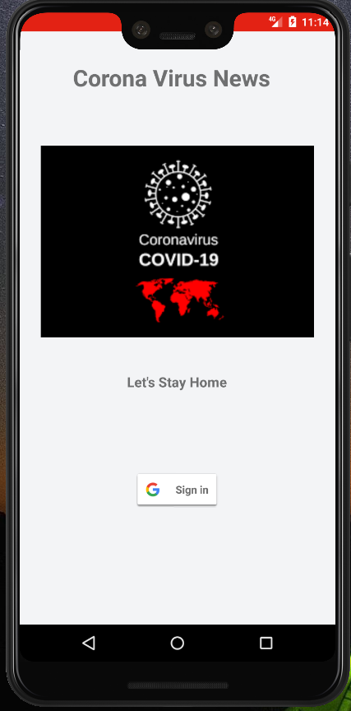

MainActivity.java (Main Page)

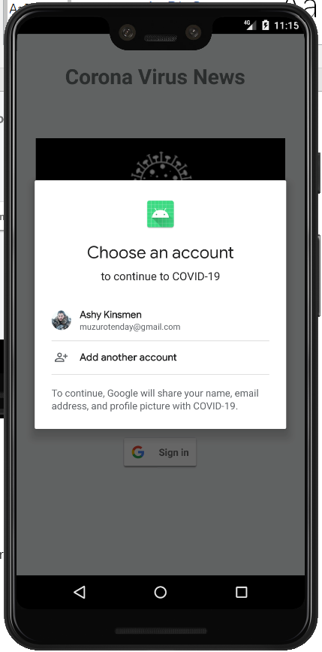

Requesting for Information from User (Google Account information for authentication)

9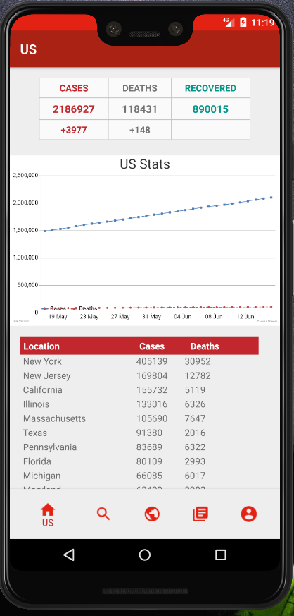

HomeActivity.java (Home page after the authentication has taken place then this page loads).

Show US information and States information and graphs.

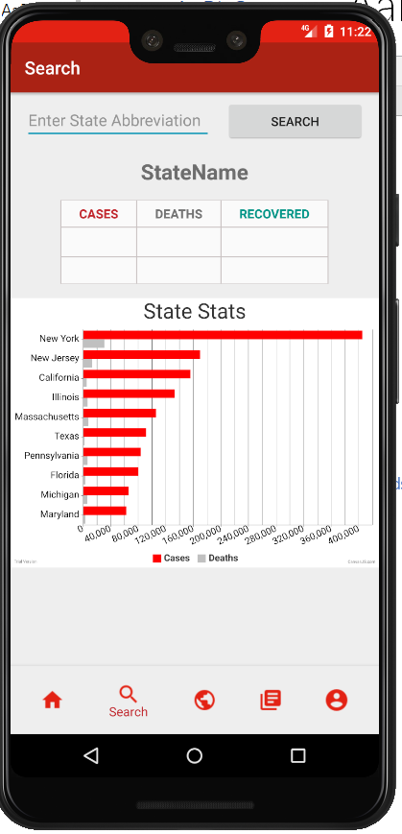

Before Search of State

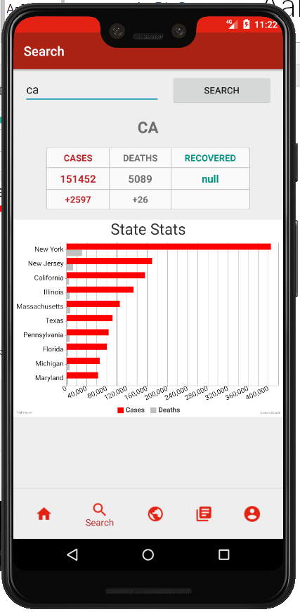

After the search of CA state.

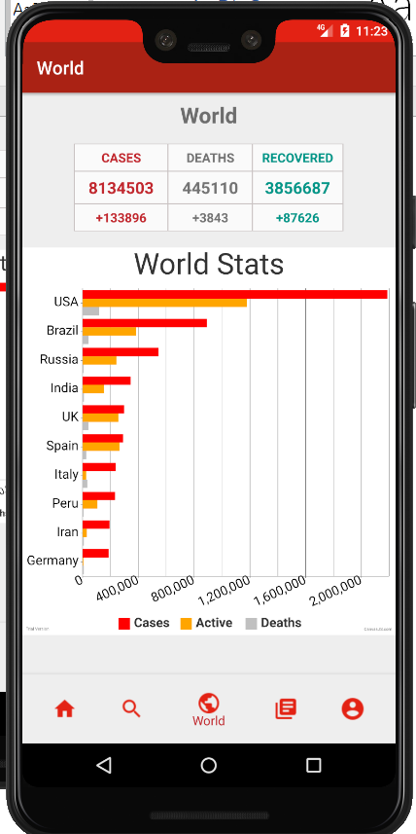

World Statistics starting from countries with much more cases to countries with fewer cases.

Shown in graph are mainly Cases , Active, Deaths numbers.

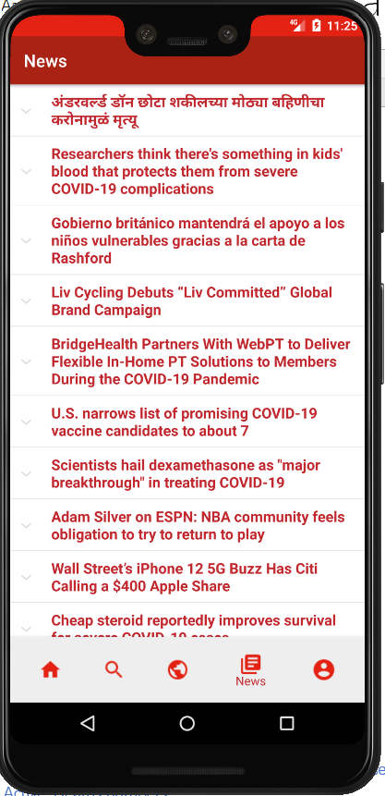

NewFragment.java (News from all around the world and different countries and different langauges)

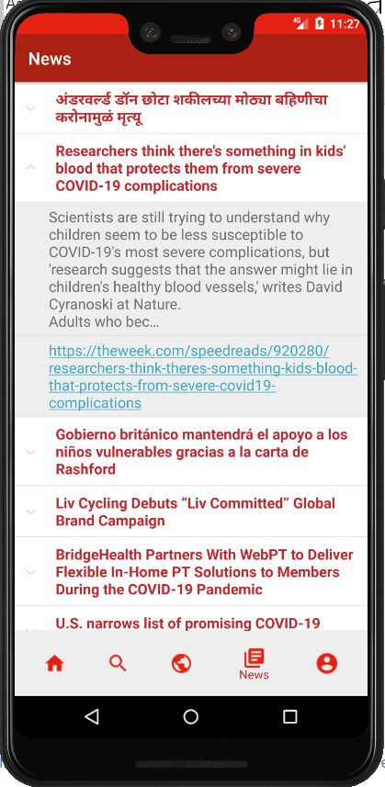

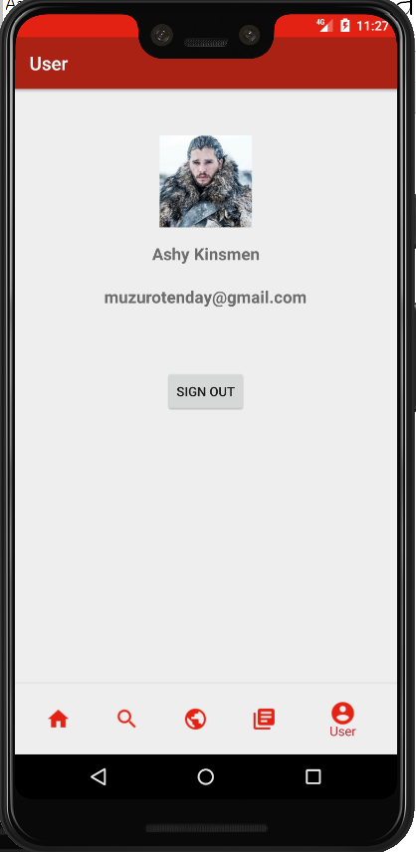

User.java (User page which allows the user to log out of the system cause user log in the first place for verification purpose and authentication )

**Conclusion and future work:**

In conclusion, the application was able to reach the initial goals which were to provide news and statistics in real time to users and at the same time provide security to the information the user accessing and the information user providing .But for future development I feel the application can have phone number, Facebook, WeChat authentication system for people without google accounts to be able to use the services as well. At the same time, I feel the application should have a recommendation system of food and exercising for Covid19 (hints or tips on daily basis to areas to avoid going).