GATE DA 2027
Probability & Statistics
Revision Notes
Concepts, thinking patterns, tricks and traps — no questions.
Read this, understand it, and the question bank becomes solvable.
How this is built around YOUR highlights
You highlighted 21 questions in the question bank. Every one of them sits in Topics 1 to 4 — and there are no marks at all from Topic 5 onwards.
So these notes do two jobs at once. The patterns you marked get extra, worked-through treatment in orange boxes. Topics 5 to 10, which you have not reached yet, get full first-time notes so you can learn them from scratch here.

Prepared for Ashutosh · August 2026

What is in here
Ten topics, then two reference pages. Topics 1 to 4 carry orange boxes for the patterns you highlighted; Topics 5 to 10 are written as first-time notes.
Topic | What it covers | Your status
1 · Counting & Basic Probability | Permutations, combinations, complements, the three formula-recall types | 3 marked
2 · Conditional & Joint Probability | Conditioning, independence, joint tables, joint densities on a triangle | 7 marked
3 · Bayes’ Theorem | Flipping the conditional, base rates, the 1,000-people method | 7 marked
4 · Discrete RV & PMF | The four distributions, Poisson windows, k-th trial, state method | 4 marked
5 · Continuous RV & PDF/CDF | Densities, CDFs, uniform, exponential, normal, transformations | not started
6 · t & Chi-Squared | Where they come from, degrees of freedom, shapes | not started
7 · CLT & Confidence Intervals | Standard error, interval structure, sample size, interpretation | not started
8 · Hypothesis Testing | Five steps, choosing the test, errors and power, p-values | not started
9 · Chi-Squared Test & Descriptive Stats | Goodness of fit, independence, mean/median/mode, correlation | not started
10 · Conditional Expectation & Covariance | Tower law, total variance, two-stage experiments, covariance algebra | not started
Formula sheet | Everything on one page for the last week | —
The traps | The twelve errors that cost the most marks | —

A note on how to read the boxes
- Blue boxes are the core idea — the thing you must understand.
- Green TRICK boxes are shortcuts that save time in the exam.
- Red TRAP boxes are the specific mistakes people actually make.
- Orange YOU MARKED THIS boxes are the patterns from your own highlights, worked through in detail.

What your highlights told me
Before the notes start, here is the diagnosis — because knowing why you are stuck is worth more than another hundred questions.
Your 21 marked questions are not random. They fall into eight repeating patterns. Almost every one of them is a question where the setup is the hard part and the arithmetic is easy. That is a very specific, very fixable weakness — and it is exactly what GATE DA rewards.
Where | The pattern you marked | What is actually hard about it
Topic 1 | Onto functions, no-two-consecutive-1s, derangements | These need a formula you either know or you do not. No amount of thinking derives them in 2 minutes.
Topic 2 | Joint PDF on a triangle (0 < x < y < 1) | The limits of integration change with the other variable. This is your single biggest gap — 5 of your 7 marks here.
Topic 2 | What does and does not imply independence | Covariance zero feels like independence. It is not.
Topic 2 | “The second ball drawn is white” | Looks like it needs a tree. It does not — symmetry kills it in one line.
Topic 3 | Disease / spam / taxi / two tests — all base-rate Bayes | Your instinct fights the answer. The rare group is tiny; the healthy group is huge.
Topic 3 | Monty Hall, Bayesian updating of a coin | Sequential evidence. Prior → evidence → new prior.
Topic 4 | Poisson over a different time window; recovering n and p | One line of setup that everyone forgets to do.
Topic 4 | “Exactly on the k-th trial”, expected tosses until HH | Needs a structure (split the trials, or set up states) rather than a formula.

The one sentence that ties them together
Every pattern you marked is one where the first thirty seconds decide the answer. Draw the region, write the prior, split the trials, name the state — do that step and the rest is arithmetic. Skip it and you are lost for four minutes.
So these notes spend most of their space on that first thirty seconds.

How to use these notes
- Read a topic fully once, slowly. Do not take notes on it — these are the notes.
- Close the page and try to say the “How to spot it” table out loud from memory. That table is the exam skill.
- Then go to that topic in the question bank and attempt it. When you get one wrong, come back to the Traps box — the answer is almost always sitting there.
- The last two pages are a formula sheet and a trap list. In the final week, read only those.

The five-second decision map
Before you write anything, place the question in one of four boxes. This single habit prevents most wrong-method errors.
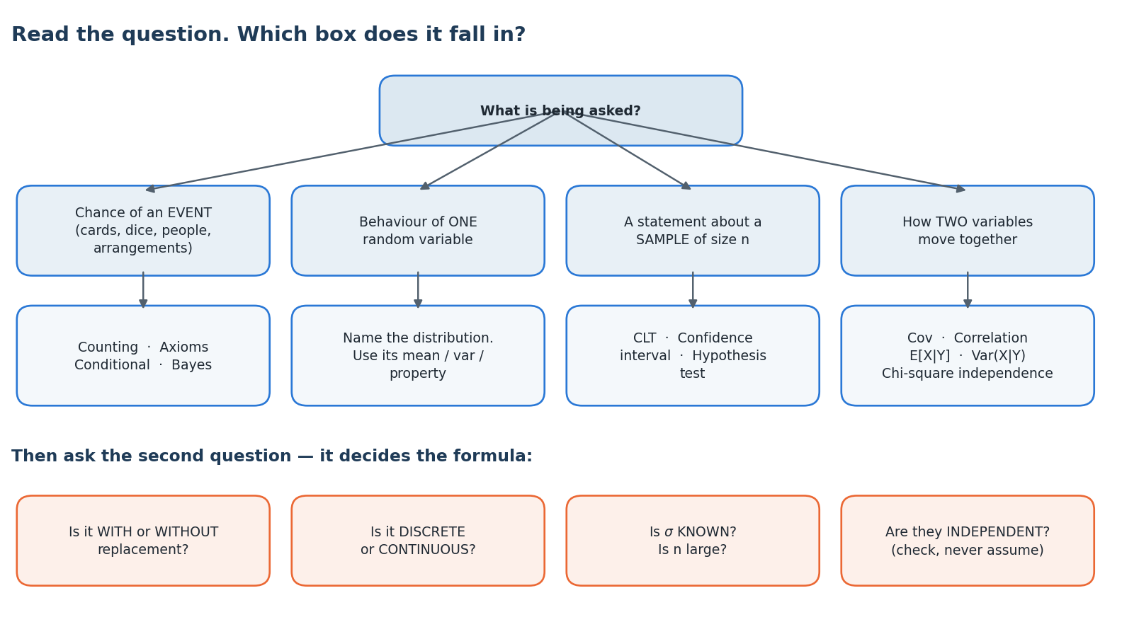
TRICK · Use the words in the question, not your instinct
- “Without replacement” → the trials are dependent; think conditional, or think symmetry.
- “Given that”, “if it is known that” → conditional probability. Circle what is given.
- “At least one” → take the complement immediately.
- “Per hour / per page / per week” → Poisson, and check the time window.
- “Until the first”, “exactly on the k-th” → geometric or negative binomial.
- “A random sample of size n” → you are in inference now: CLT, interval or test.
- “Is the population standard deviation given?” → yes means z, no means t.

Topic 1 · Counting & Basic Probability
Probability here is just careful counting. If you can count the favourable ways and the total ways, you are done.

The core idea
P(event) = (number of favourable outcomes) ÷ (total number of outcomes)
This is true only when every outcome is equally likely. A fair die, a well-shuffled deck, a random arrangement — fine. A biased coin, or “a randomly chosen student” where the groups are different sizes — not fine. When outcomes are not equally likely you must go back to the axioms and add up individual probabilities instead.

The counting toolkit
Situation | Use | Formula
Order matters (ranks, seats in a row, passwords) | Permutation | ⁿPᵣ = n! / (n−r)!
Order does not matter (committee, hand of cards) | Combination | ⁿCᵣ = n! / (r! (n−r)!)
Word with repeated letters | Divide by repeats | n! / (p! q! r! …)
People around a round table | Circular | (n−1)!
Identical items into distinct boxes | Stars and bars | C(n+k−1, k−1)
No two of a group together | Gap method | Arrange the others, then choose gaps
“At least one …” | Complement | 1 − P(none)

How to spot it and what to do
- Ask “does order matter?” first. Committee → no. Ranking, seating, arranging → yes. This one question removes half of all errors.
- Write the denominator first. The total number of outcomes is usually the easier count and it anchors everything.
- Then count the favourable ways. If this feels hard, try counting the opposite and subtracting.
- Sanity-check. Your answer must lie between 0 and 1, and the favourable count must not exceed the total.

TRICK · Three shortcuts that pay off almost every time
- “At least one” is always a complement. Never add up the cases. P(at least one blue) = 1 − P(no blue).
- Circular arrangements: nail one person down. Once you fix one seat, the problem becomes a straight-line arrangement of the remaining n−1.
- “No two together” → gap method. Seat the unrestricted people first (say k of them). They create k+1 gaps. Now choose gaps for the restricted ones.

YOU MARKED THIS · The three you highlighted — these are formula-recall, not reasoning
All three of your Topic 1 marks are questions you cannot derive in exam time. You either recognise them or you lose four minutes. Learn them as facts.
- Onto (surjective) functions from a set of size m onto a set of size n. Use inclusion–exclusion:
Number of onto functions = Σ (−1)ⁱ · C(n, i) · (n − i)ᵐ , i = 0 … n
- For m = 5 onto n = 3 this gives 3⁵ − 3·2⁵ + 3·1⁵ = 243 − 96 + 3 = 150. The logic: count all functions, throw away those that miss at least one target, add back what you over-subtracted.
- Binary strings with no two consecutive 1s. Let aₙ be the count for length n. A valid string ends in 0 (then anything valid of length n−1 in front) or ends in 01 (then anything valid of length n−2). So aₙ = aₙ₋₁ + aₙ₋₂ — it is Fibonacci. With a₁ = 2 and a₂ = 3, length 8 gives 55.
- Derangements — permutations where nothing is in its own place. Dₙ = n! · Σ (−1)ᵏ / k!. Memorise the small ones: D₁=0, D₂=1, D₃=2, D₄=9, D₅=44. Probability of a derangement of 5 = 44/120 = 11/30.

TRAP · What goes wrong here
- Using a permutation where a combination belongs. “How many committees of 3 from 7” is C(7,3)=35, not 210. If the question does not name roles, order does not matter.
- In inclusion–exclusion, forgetting to add back the triple overlap. For three sets: |A|+|B|+|C| − pairs + the triple.
- Treating outcomes as equally likely when they are not.
- Forgetting that “selecting 3 from 10 without replacement” has C(10,3) total outcomes, not 10³.

Topic 2 · Conditional & Joint Probability
This topic answers one question: when I learn something new, how should the probability change? Five of your seven marks here are the same underlying gap, so it gets the most space in these notes.

The core formulas
P(A | B) = P(A ∩ B) ÷ P(B) and so P(A ∩ B) = P(A | B) · P(B)
Read P(A|B) as: “shrink the world down to B, and ask what fraction of that smaller world is also A.” That picture is worth more than the formula. Conditioning is not a calculation, it is a change of denominator.
Idea | Statement | What it means in words
Independence | P(A ∩ B) = P(A)·P(B) | Knowing B tells you nothing about A.
Equivalent form | P(A | B) = P(A) | The conditional equals the unconditional.
Total probability | P(A) = Σ P(A | Bᵢ) · P(Bᵢ) | Split the world into cases, weight each one.
Mutually exclusive | P(A ∩ B) = 0 | They cannot both happen. This is the OPPOSITE of independent.

TRAP · Independent and mutually exclusive are not the same thing
If A and B are mutually exclusive and both have non-zero probability, they are strongly dependent — because knowing A happened tells you B definitely did not. Students mix these up constantly. Mutually exclusive means “no overlap on the Venn diagram”. Independent means “the overlap is exactly the product of the areas”.

Joint distributions: the table case
When X and Y are discrete you are given a grid of probabilities. Everything you need is a sum of that grid:
- Marginal of X = sum across the row. Marginal of Y = sum down the column.
- Conditional P(X = x | Y = y) = (the single cell) ÷ (the column total).
- Independence check: every cell must equal (its row total) × (its column total). If even one cell fails, they are dependent.
- E[X] = Σ x · (row total for x). You do not need the whole grid, just the margin.

Joint distributions: the continuous case — your weak spot
Here the grid becomes a surface f(x, y) sitting over a region, and sums become integrals. The formulas look intimidating but they are the same three ideas:
f_X(x) = ∫ f(x, y) dy f(x | y) = f(x, y) ÷ f_Y(y) P((X,Y) ∈ R) = ∬_R f dx dy
YOU MARKED THIS · The triangular region 0 < x < y < 1 — read this twice
You marked four separate questions built on this one region. It is not hard once you see it, but it is impossible to guess. Here is the whole thing.
Step 1 is always the same: draw the region. Not optional. The limits come from the picture, never from the algebra.

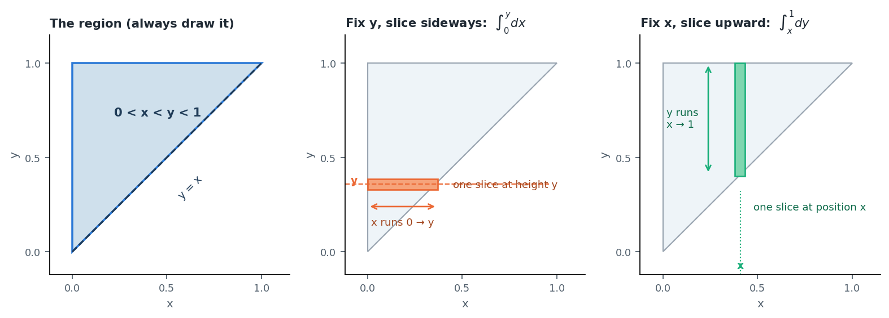
The region 0 < x < y < 1 is the triangle ABOVE the line y = x. Slice it either way — one direction is usually much easier.
YOU MARKED THIS · Working the triangle, step by step
Take the standard case: f(x, y) = 2 on the region 0 < x < y < 1, and 0 everywhere else. (Why 2? Because the triangle has area ½, and the total must be 1.)
- Marginal of Y — fix a height y, and sweep x from 0 up to y: f_Y(y) = ∫₀^y 2 dx = 2y, for 0 < y < 1.
- Marginal of X — fix a position x, and sweep y from x up to 1: f_X(x) = ∫ₓ¹ 2 dy = 2(1 − x), for 0 < x < 1.
- Conditional of X given Y = y = f(x,y) / f_Y(y) = 2 / 2y = 1/y for 0 < x < y. That is exactly a Uniform(0, y) distribution.
- So E[X | Y = y] = y/2 and Var(X | Y = y) = y²/12 — straight from the uniform, with no integration at all.
- P(Y > 0.5) = ∫₀.₅¹ 2y dy = [y²] from 0.5 to 1 = 1 − 0.25 = 0.75.

TRICK · The two shortcuts that make this topic fast
- If the support is not a rectangle, X and Y are NOT independent. Full stop. On the triangle, the range of x depends on y, so they cannot be independent no matter how nice f looks. You can answer an independence question instantly just by looking at the region.
- Once you recognise the conditional as a named distribution, stop integrating. Seeing “Uniform(0, y)” means you write down y/2 for the mean and y²/12 for the variance immediately. Most of the marks in these questions are for this recognition, not for calculus.

YOU MARKED THIS · What actually implies independence (your MSQ)
This is worth memorising as a list of four, because the MSQ form asks exactly this.
- f(x, y) = f_X(x)·f_Y(y) for all x, y → YES, this is the definition.
- F(x, y) = F_X(x)·F_Y(y) for all x, y → YES, the CDF version is equivalent.
- Cov(X, Y) = 0 → NO. Zero covariance only rules out a linear relationship.
- E[XY] = E[X]·E[Y] → NO. This is just the covariance condition rewritten.
The line to keep in your head: independence gives you zero covariance, but zero covariance does not give you independence.

YOU MARKED THIS · Two more you marked — both are one-liners once you see them
- “What is the probability the SECOND ball drawn is white?” Do not build a tree. By symmetry, before you look at anything, every position in the draw order is equally likely to hold any particular ball. So P(2nd is white) = P(1st is white) = 3/5 for 3 white out of 5. This works for the third, the last, any position — as long as nothing has been revealed.
- “If P(A | B) = P(A | Bᶜ), what follows?” A and B are independent. The reasoning: A’s chance is the same whether B happened or not, so B carries no information about A.

TRAP · What goes wrong here
- Assuming independence because the question did not say otherwise. Only assume it if the question says “independent”, or the physical setup forces it (separate coins, replacement).
- Swapping the conditional. P(positive | disease) and P(disease | positive) are wildly different numbers — this is the whole of Topic 3.
- On a non-rectangular region, writing constant limits for the inner integral. The inner limit must be a function of the outer variable.
- Forgetting to check that the joint density integrates to 1 — that check is often how the constant is found in the first place.

Topic 3 · Bayes’ Theorem
Bayes has appeared in every GATE DA paper so far. You marked seven questions here — and they are all the same question wearing different clothes.

What Bayes actually does
You are told how likely the evidence is under each cause. You want the reverse: given the evidence, how likely is each cause. That is the whole idea — Bayes flips the direction of the conditional.
P(cause | evidence) = P(evidence | cause) · P(cause) ÷ P(evidence)
The denominator is just the law of total probability — add up the evidence from every possible cause:
P(evidence) = Σ P(evidence | causeᵢ) · P(causeᵢ)

The three-step recipe
- Write the priors. How common is each cause before any evidence? (prevalence, machine share, proportion of spam)
- Write the likelihoods. Under each cause, how likely is the evidence you saw? (sensitivity, defect rate, word frequency)
- Multiply and normalise. Posterior for a cause = (its prior × its likelihood) ÷ (the sum of that product over all causes).

YOU MARKED THIS · The base-rate lesson — this is the heart of everything you marked
Disease screening, spam filters, the blue-taxi witness — you marked all of them, and they are one idea. When the cause is rare, the huge “innocent” group produces so many false positives that they swamp the true ones.
Do not fight this with formulas. Use a thousand people.

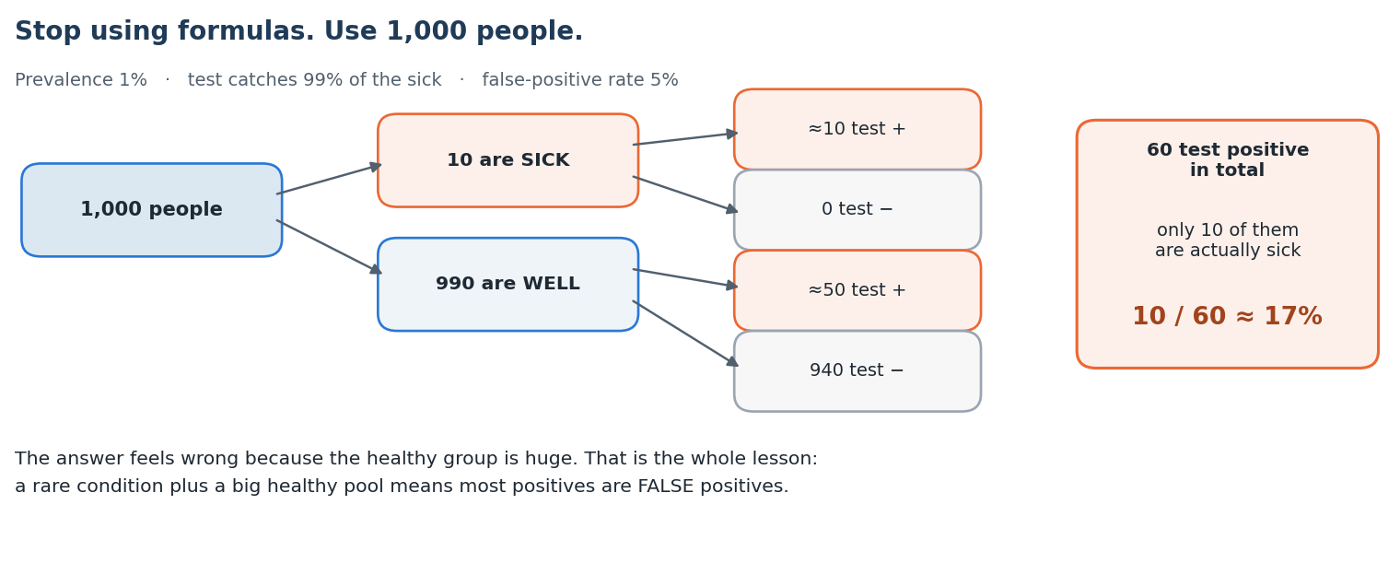
The natural-frequency method: turn every percentage into a count of people, then just read off the answer.
TRICK · The 1,000-people method — use this in the exam
Dividing decimals under time pressure causes mistakes. Counting people does not.
- Start with a round population — 1,000 or 10,000, whichever makes the prevalence a whole number.
- Split it by the prior: “10 are sick, 990 are well.”
- Apply the likelihoods to each group: “of the 10 sick, about 10 test positive; of the 990 well, 5% is about 50 test positive.”
- The answer is (the group you want) ÷ (everyone who matches the evidence): 10 ÷ 60 ≈ 17%.
It is faster than the formula, it is far harder to get wrong, and it makes the counter-intuitive answer feel obvious.

YOU MARKED THIS · The other variants you marked
- Two independent tests, both positive. The likelihoods multiply. If sensitivity is s and false-positive rate is (1−t), then P(both + | disease) = s² and P(both + | no disease) = (1−t)². Feed those into the same formula. A second test moves the posterior enormously — that is the point of retesting.
- Bayesian updating of a coin bias. The prior is over the parameter now, not over an event. Observe 3 heads: likelihood under θ=0.5 is 0.5³ = 0.125; under θ=0.8 it is 0.8³ = 0.512. Posterior for θ=0.8 = 0.512 ÷ (0.125 + 0.512) ≈ 0.80. Same recipe, different objects.
- Monty Hall. Forget the doors. You win by switching exactly when your first pick was wrong, which happens with probability 2/3. So switching wins 2/3 of the time. The host opening a goat door gives you no new information about your original pick — its probability was frozen at 1/3 the moment you chose.
- What raises the posterior P(disease | positive)? Higher prevalence ✓ · higher sensitivity ✓ · higher specificity ✓ · higher false-positive rate ✗ (that lowers it). Specificity and false-positive rate are the same dial turned opposite ways.

TRAP · What goes wrong here
- Confusing sensitivity with the answer. “The test is 99% accurate” is P(positive | disease). The question almost always asks P(disease | positive). These are different numbers and the gap is the entire question.
- Leaving the healthy-but-positive people out of the denominator. The denominator is everyone who tested positive, sick or not.
- Assuming a good test means a high posterior. With a rare disease, even an excellent test gives a posterior under 20%.
- Forgetting that the priors must cover every case and sum to 1.

Topic 4 · Discrete Random Variables & PMF
A discrete random variable is a list of values with a probability attached to each. Most marks here are pure recall of four named distributions — so learn the table cold.

The basics you build everything on
E[X] = Σ x · p(x) Var(X) = E[X²] − (E[X])² Σ p(x) = 1
That middle formula is the one you will use most. Computing E[X²] and subtracting the square of the mean is nearly always faster than working with E[(X − μ)²] directly.

The four named distributions
Distribution | Use it when | Mean | Variance
Bernoulli(p) | One trial, success or failure | p | p(1 − p)
Binomial(n, p) | n independent trials, count the successes | np | np(1 − p)
Poisson(λ) | Rare events in a fixed window of time or space | λ | λ
Geometric(p) | Trials until the first success | 1/p | (1 − p)/p²
Uniform on {1…n} | All n values equally likely | (n + 1)/2 | (n² − 1)/12

Two moment generating functions are worth memorising because they appear as direct 1-mark questions: Binomial → (1 − p + pe^t)ⁿ and Poisson → exp(λ(e^t − 1)).
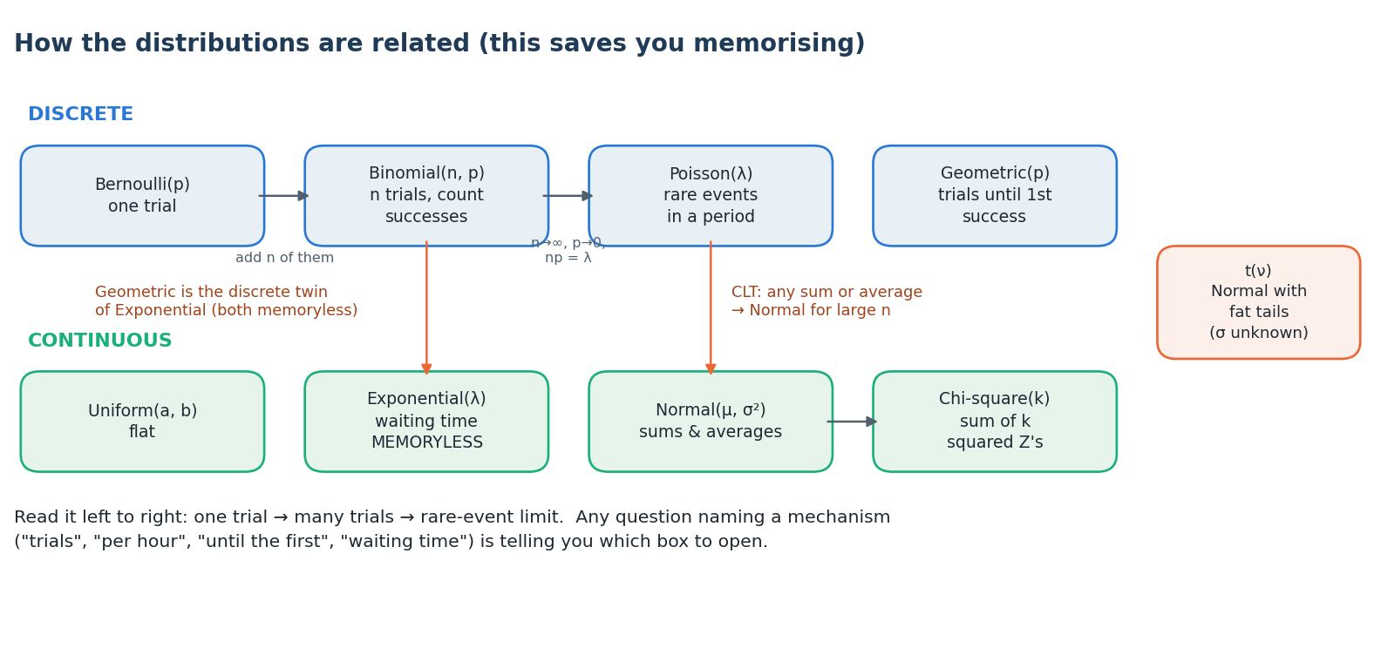
The distributions are not a list to memorise — they are a family. Knowing how they connect halves the work.
TRICK · Identify the distribution from the variance
- Variance < mean → Binomial (because np(1−p) < np).
- Variance = mean → Poisson. This is a defining property and a very common 1-mark MSQ option.
- Given the mean and variance of a binomial you can recover both parameters: divide variance by mean to get (1 − p), then n = mean ÷ p. For mean 6 and variance 4.2: 1 − p = 0.7, so p = 0.3 and n = 20.

YOU MARKED THIS · Poisson over a different window — the mistake everyone makes
λ scales with the window. If accidents happen at 2 per week and the question asks about a fortnight, then λ = 4, not 2. If defects are 3 per metre and you are given 50 cm, λ = 1.5.
Write the new λ on the page before you touch the formula. This single line is the difference between right and wrong on most Poisson questions, and it is the one you marked.
Also worth knowing: the sum of independent Poissons is Poisson, with the λ values simply added. Poisson(2) + Poisson(3) = Poisson(5).

YOU MARKED THIS · “Exactly on the k-th trial” — split it in two
You marked both the “second defective on the third test” question and the “third head on the fifth toss” question. They are the same shape.

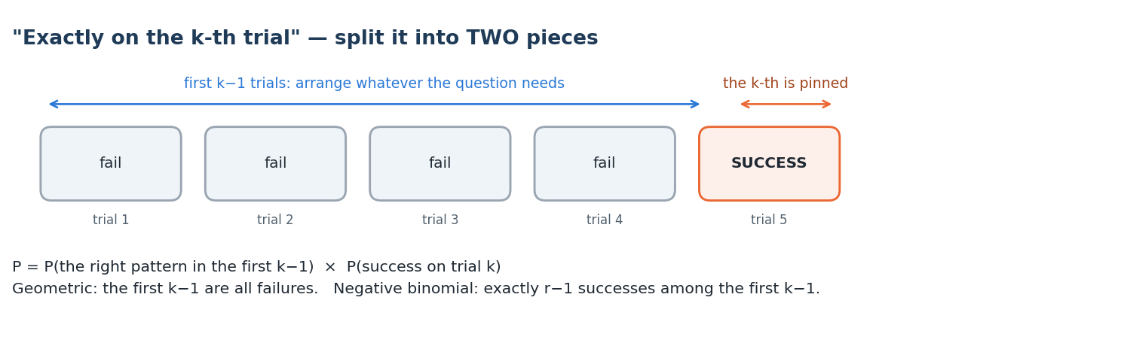
YOU MARKED THIS · How the split works
- The k-th trial is pinned — it must be the success that finishes the job. Its probability is just p.
- The first k−1 trials must contain exactly the right number of earlier successes, in any order. That is where the combination comes from.
- Third head on the fifth toss = C(4, 2) · (½)⁵ = 6/32 = 3/16. Choose which 2 of the first 4 tosses were heads, then the fifth is fixed.
- Geometric is the special case where all of the first k−1 are failures: P = (1−p)^{k−1} · p.
- Second defective on the third test (4 good, 2 defective, no replacement): exactly one defective in the first two tests, then the defective on the third. P = [C(2,1)·C(4,1) ÷ C(6,2)] × (1/4) = (8/15)(1/4) = 2/15 ≈ 0.133.

YOU MARKED THIS · Expected tosses until two heads in a row — think in states
There is no formula for this. There is a method, and it works for every “expected time until a pattern” question.

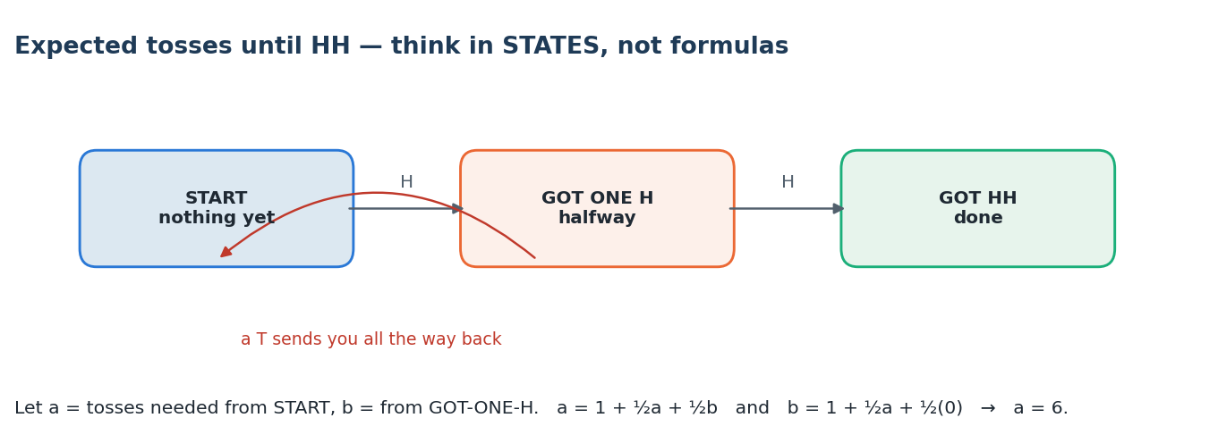
YOU MARKED THIS · The state method
- Name the states by how much progress you have made: nothing yet, one head so far, done.
- Let a = expected tosses from the start, b = expected tosses once you already have one head.
- From the start: you toss once, then with probability ½ you move to state b, with probability ½ you stay at the start. So a = 1 + ½b + ½a.
- From one head: you toss once, then with probability ½ you finish, with probability ½ you go all the way back. So b = 1 + ½(0) + ½a.
- Solve the two equations: a = 6.
The same method gives the classic results: expected rolls to see a 6 is 6, expected tosses for HH is 6, for HT is 4. The asymmetry surprises people — that is exactly why it is asked.

TRAP · What goes wrong here
- Writing Var = np for a binomial. It is np(1 − p).
- Not rescaling λ to the window given in the question.
- Geometric counted from 0 instead of 1. “Number of trials until the first success” has mean 1/p; “number of failures before the first success” has mean (1−p)/p. Read which one is asked.
- Calling Poisson memoryless. Geometric is the memoryless discrete distribution; Poisson is not.
- For the mode of a Binomial, use ⌊(n + 1)p⌋ — for n = 10, p = 0.35 that gives ⌊3.85⌋ = 3.

Topic 5 · Continuous Random Variables & PDF / CDF
You have no marks from here onward — so from this point the notes assume you are meeting the material for the first time, and go slower.

What changes when the variable is continuous
A discrete variable has a probability sitting on each value. A continuous one does not — it has a density. The probability of landing on any exact value is zero; only intervals have probability. Everything else follows from that one shift.
Discrete | Continuous | Comment
p(x) = P(X = x) | f(x), a density | f(x) is NOT a probability
Σ p(x) = 1 | ∫ f(x) dx = 1 | Total area under the curve is 1
P(X = a) > 0 possible | P(X = a) = 0 always | So < and ≤ mean the same thing
E[X] = Σ x p(x) | E[X] = ∫ x f(x) dx | Same idea, sum becomes integral

The density can be bigger than 1
This trips up almost everyone once. A Uniform(0, 0.5) distribution has f(x) = 2 across its range. That is perfectly legal — f is a rate of probability per unit length, and only the area has to be 1. Never reject an answer because a density came out above 1.

The CDF is your main tool
F(x) = P(X ≤ x) = ∫₋∞ˣ f(t) dt and f(x) = F′(x)
Four properties define a CDF, and they show up directly as MSQ options: it is non-decreasing, it is right-continuous, F(−∞) = 0 and F(+∞) = 1. It does not have to be continuous everywhere — a mixed distribution has jumps.
- P(a < X ≤ b) = F(b) − F(a) — this is usually faster than integrating the density.
- Median m solves F(m) = 0.5.
- To find an unknown constant in a density, set ∫ f = 1 and solve. Do this first, always.

The three distributions you must know
Distribution | Density | Mean | Variance
Uniform(a, b) | 1/(b − a) on [a, b] | (a + b)/2 | (b − a)²/12
Exponential(λ) | λe^(−λx), x > 0 | 1/λ | 1/λ²
Normal(μ, σ²) | the bell curve | μ | σ²

For the exponential, two more facts are worth memorising: F(x) = 1 − e^(−λx), so P(X > x) = e^(−λx); and the median is ln 2 / λ, which is smaller than the mean 1/λ because the distribution is right-skewed.
TRICK · Memorylessness — the exponential’s party trick
For an exponential, P(X > s + t | X > s) = P(X > t). A component that has already survived 2 years is exactly as likely to last another 3 as a brand-new one was to last 3.
The moment a question says “given it has already lasted …, what is the chance it lasts … more”, the answer is just P(X > the extra amount). Ignore the history entirely — that is the whole point.
The exponential is the only continuous distribution with this property, and the geometric is the only discrete one.

The normal distribution and the z-score
Every normal question becomes a standard-normal question through one step:
Z = (X − μ) ÷ σ , which is Normal(0, 1)
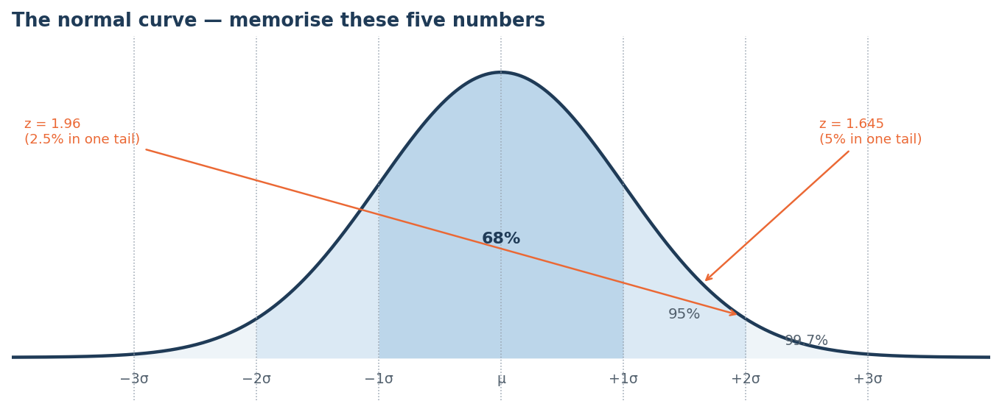
Learn these landmarks by heart — they answer a surprising number of 1-mark questions with no table at all.
- 68 – 95 – 99.7 for one, two and three standard deviations.
- z = 1.645 cuts off 5% in one tail; z = 1.96 cuts off 2.5%; z = 2.576 cuts off 0.5%.
- Φ(1) = 0.8413 and Φ(2) = 0.9772 — these two turn up again and again.
- By symmetry, Φ(−a) = 1 − Φ(a). The table only lists positive z for this reason.

TRICK · Working backwards from a probability
To find the value c with P(X > c) = α, do not hunt through the table body. Write c = μ + z_α · σ directly. For X ~ N(20, 4²) with α = 0.05: c = 20 + 1.645(4) = 26.58.

Transformations — when Y is a function of X
Do not memorise a formula. Use the CDF method, which always works:
- Write F_Y(y) = P(Y ≤ y), then substitute the definition of Y in terms of X.
- Rearrange the inequality until X sits alone in the middle.
- Now it is a statement about X, so replace it with F_X of something.
- Differentiate with respect to y to get the density f_Y(y).

Example of the shape of the working: if X ~ Uniform(0,1) and Y = X², then F_Y(y) = P(X² ≤ y) = P(X ≤ √y) = √y, so f_Y(y) = 1 ÷ (2√y). Two standard results worth recognising on sight: if U ~ Uniform(0,1) then −(1/λ)ln U is Exponential(λ), and if Z ~ N(0,1) then Z² is χ² with 1 degree of freedom.
TRAP · What goes wrong here
- Treating f(x) as a probability, or rejecting f(x) > 1.
- Forgetting to find the normalising constant before computing anything else.
- Using the density where the CDF is wanted — “P(X > 3)” needs 1 − F(3), not f(3).
- On a transformation, forgetting that the range of Y changes too. Always state the new support.

Topic 6 · The t and Chi-Squared Distributions
These two are not really “distributions to study” — they are tools that appear the moment you stop knowing the population standard deviation. Small topic, easy marks.

Where they come from
Distribution | Built from | Shape | Mean / Variance
χ² with k df | Z₁² + Z₂² + … + Z_k², independent standard normals | Non-negative, right-skewed, becomes normal as k grows | k / 2k
t with ν df | Z ÷ √(V/ν), where V ~ χ²_ν, independent | Symmetric about 0, fatter tails than normal | 0 / ν/(ν−2)

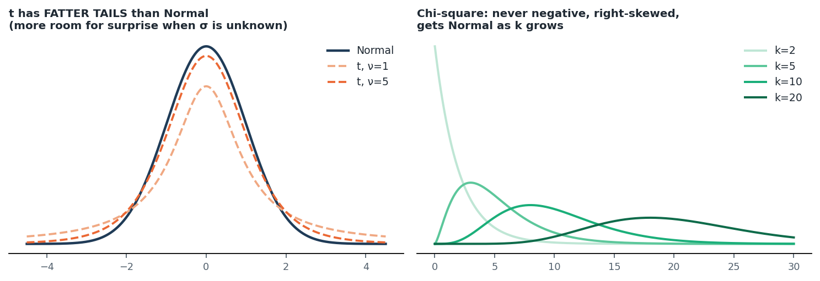
The t is a normal that has been made less confident. The chi-square lives on the positive side only.
The two facts that generate most questions
- Z² ~ χ² with 1 degree of freedom. Squaring a standard normal is the simplest chi-square there is.
- (n − 1)S² ÷ σ² ~ χ² with n − 1 degrees of freedom. This is the bridge from a sample variance to a chi-square, and it is why every variance question uses n − 1.

How to think about degrees of freedom
Degrees of freedom = how many values are genuinely free to vary. If you know the sample mean, then once n − 1 of the observations are fixed the last one is forced — so you have n − 1 free values. Every parameter you estimate from the data costs you one degree of freedom. That single sentence explains n − 1 for the sample variance, k − 1 for goodness of fit, and (r − 1)(c − 1) for a contingency table.
TRICK · Three quick checks
- As ν → ∞ the t row equals the z row. The bottom line of any t-table is 1.282, 1.645, 1.960, 2.326, 2.576. If your t critical value is smaller than the matching z, you have read the table wrong — t is always wider.
- χ² with 2 degrees of freedom is exactly an Exponential with mean 2. A neat identity that occasionally shows up.
- Mode of χ²_k is k − 2 (for k ≥ 2), while the mean is k. The gap between them is the skew.

TRAP · What goes wrong here
- Saying the t-distribution is skewed. It is symmetric — it is the chi-square that is skewed.
- Writing Var(t) = 1. It is ν/(ν−2), which is always greater than 1 and only approaches 1 for large ν.
- Using n instead of n − 1 for the degrees of freedom of a sample variance.
- Looking for a lower critical value of χ² and expecting a negative number — it cannot be negative.

Topic 7 · Central Limit Theorem & Confidence Intervals
This is where the paper stops asking about one observation and starts asking about a sample. Recognising that shift is most of the battle.

What the CLT actually says
Take any population with a finite variance — skewed, bimodal, ugly, it does not matter. Take samples of size n and compute the mean of each. Those means will be approximately normal, centred on μ, with standard deviation σ/√n. The bigger n gets, the better the approximation and the tighter the spread.
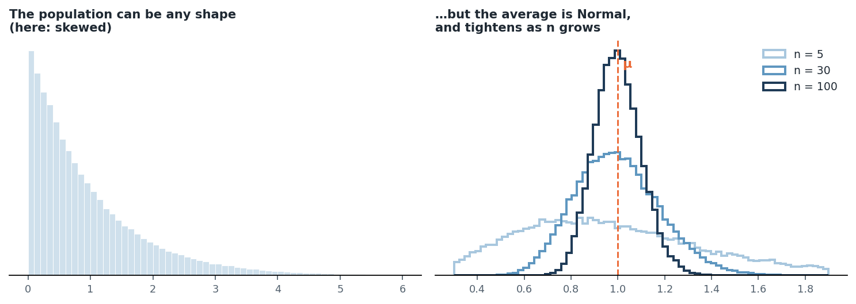
The population on the left is badly skewed. The averages on the right are normal anyway — and they tighten as n grows.
X̄ ≈ Normal( μ , σ² / n ) Standard error = σ / √n
The standard error is the single most important quantity here
Note the square root. The spread of the sample mean shrinks like 1/√n, not like 1/n. That is why quadrupling the sample size only halves your uncertainty — and it is the basis of nearly every sample-size question.

Confidence intervals
estimate ± (critical value) × (standard error)
That is the entire structure. Everything else is deciding which critical value and which standard error to use.
Situation | Critical value | Standard error
Mean, σ known (or n ≥ 30) | z (1.96 for 95%) | σ / √n
Mean, σ unknown and n small | t with n − 1 df | s / √n
Proportion | z | √( p̂(1 − p̂) / n )

TRICK · Sample size questions — one formula, one rule
To get a margin of error at most E:
n ≥ ( z · σ ÷ E )²
Always round UP, never to the nearest. If the formula gives 96.04 you need 97 — because 96 would not meet the requirement. This rounding is where the mark is usually lost.

TRAP · The interpretation trap — asked almost every year
“A 95% confidence interval” does not mean there is a 95% probability that μ lies in this particular interval. μ is a fixed number; it either is or is not in there.
The correct reading: if you repeated the whole sampling procedure many times, about 95% of the intervals you built would contain μ. The 95% is a property of the method, not of the one interval you are holding.

TRAP · Other things that go wrong
- Using σ/n instead of σ/√n.
- Thinking the CLT needs the population to be normal. It does not — that is the entire point of it. It only needs finite variance and a reasonably large n.
- Forgetting that raising the confidence level makes the interval wider, not narrower.

Topic 8 · Hypothesis Testing — z-test and t-test
A hypothesis test is a confidence interval asked as a yes-or-no question. Same machinery, different packaging.

The five steps, every time
- State H₀ and H₁. H₀ always carries the equality (μ = 100). H₁ is what you are trying to show.
- Choose α, usually 0.05. This is the risk of a false alarm you are willing to accept.
- Compute the test statistic: (estimate − hypothesised value) ÷ standard error.
- Compare — either the statistic against the critical value, or the p-value against α.
- Conclude in words, referring back to the original claim.

z or t = ( x̄ − μ₀ ) ÷ ( standard error )

Choosing the right test
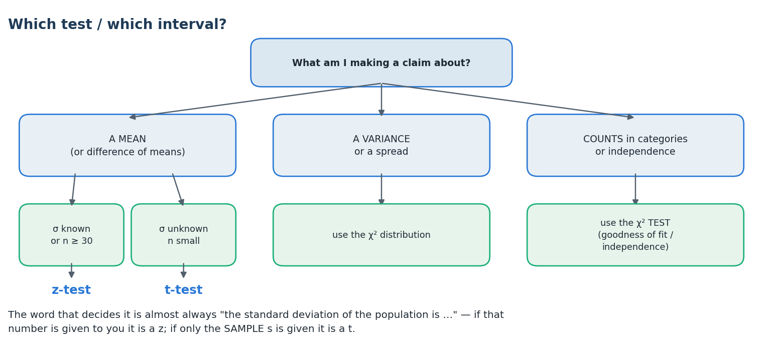
Degrees of freedom to remember: a one-sample or paired t-test on n observations has n − 1; a pooled two-sample t-test has n₁ + n₂ − 2. A paired test is a one-sample test on the differences — that is why 10 pairs gives 9, not 18.

The two errors, and power
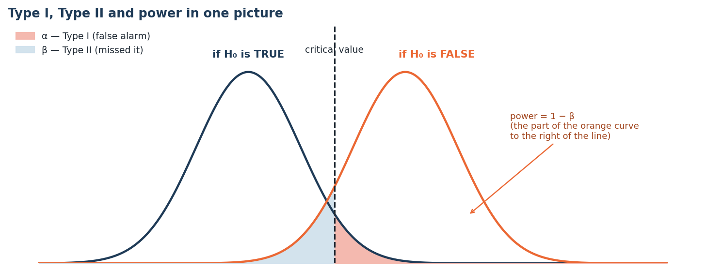
Name | What happened | Symbol
Type I error | You rejected H₀ when it was actually true — a false alarm | α
Type II error | You failed to reject H₀ when it was actually false — you missed it | β
Power | You correctly rejected a false H₀ — the test worked | 1 − β

TRICK · What raises power
- Bigger sample size — the surest lever, and the one with no downside.
- Bigger α — but you are buying power with a higher false-alarm rate.
- Bigger true effect — nothing you control, but easier effects are easier to detect.
- Smaller σ — less noise to see through.
Note that α and β trade against each other for a fixed n: lowering α raises β and therefore lowers power. Only increasing n improves both at once.

TRAP · The p-value traps — worth reading twice
- The p-value is not the probability that H₀ is true. It is the probability of seeing data at least this extreme assuming H₀ is true.
- You never “accept H₀”. You fail to reject it. Absence of evidence is not evidence of absence.
- α + β ≠ 1. They are conditional probabilities under two different scenarios, so they do not complement each other.
- A two-tailed p-value is twice the one-tailed one. Check which the question wants before doubling.
- Statistically significant does not mean practically important. A huge sample can make a trivial difference significant.

Topic 9 · Chi-Squared Test & Descriptive Statistics
Two loosely related things sit in this topic: a test for counted data, and the summary statistics that describe any data set.

The chi-squared test
Use it when your data are counts in categories — not measurements. There are two flavours and they share one statistic:
χ² = Σ ( Observed − Expected )² ÷ Expected
Flavour | Question it answers | Degrees of freedom
Goodness of fit | Do these counts match the distribution I expected? | k − 1 − (parameters estimated)
Test of independence | Are these two attributes related? | (r − 1)(c − 1)

For a contingency table, each expected count is (row total × column total) ÷ grand total. Two practical rules: the test is always right-tailed (a big χ² means a big mismatch), and every expected count should be at least 5 for the approximation to hold.
TRICK · Speed-ups
- The denominator is Expected, never Observed. This is the most common slip in the whole topic.
- In a 2 × 2 table all four differences (O − E) have the same magnitude, so compute one and reuse it.
- χ²₀.₀₅,₁ = 3.841 — memorise this one number; it decides most 2 × 2 independence questions on sight.

Descriptive statistics
Measure | What it tells you | Watch out for
Mean | The balance point | Dragged badly by outliers
Median | The middle value | Resistant to outliers
Mode | The most frequent value | May not exist or may not be unique
Range | Max − min | Uses only two values; very fragile
IQR = Q₃ − Q₁ | Spread of the middle half | Resistant to outliers
Variance / SD | Typical distance from the mean | Divide by n − 1 for a SAMPLE

Skewness — the ordering you must know
- Right-skewed (a long tail to the right): mode < median < mean.
- Left-skewed: mean < median < mode.
- Symmetric: all three coincide.
The mean is always pulled towards the tail. That one sentence reconstructs both orderings if you forget them.

TRICK · What a linear transformation does
If every value is changed to y = ax + b:
- the mean becomes a·mean + b,
- the standard deviation becomes |a|·SD — the shift b has no effect at all,
- the variance becomes a²·variance.
Adding a constant never changes any measure of spread. That is a very common 1-mark question.

Correlation
r = Cov(X, Y) ÷ ( σ_X · σ_Y )
- r always lies between −1 and +1, and it is unit-free.
- It measures linear association only. A perfect parabola can have r = 0.
- r = 0 does not mean independent — the same warning as in Topic 2.
- Multiplying either variable by a positive constant leaves r unchanged.

Topic 10 · Conditional Expectation, Variance & Covariance
This topic pays twice — it is asked directly, and it is buried inside the Machine Learning questions as well.

The two laws that do all the work
E[X] = E[ E[X | Y] ] (the tower law)
Var(X) = E[ Var(X | Y) ] + Var( E[X | Y] )
In words: to find an average, average the conditional averages. To find a variance, add the average of the within-group variance to the variance of the group averages. The second law is worth understanding rather than memorising — total variation splits into “spread inside each group” plus “spread between the groups”.
E[X | Y] is a random variable, not a number
This is the conceptual hurdle. E[X | Y = y] is a number — it depends on which y you plug in. But E[X | Y], with Y left as a variable, is a function of Y, and therefore itself random. That is why you can take its expectation (giving E[X]) and its variance (which appears in the second law).

Two-stage experiments — the signature question type
Whenever a question has the shape “first something random happens, and then, depending on that, something else random happens”, you are being asked to use the tower law. Do not try to enumerate every path.
- Name the first-stage variable (call it N or Y) and write down its mean and variance.
- Write the conditional mean and conditional variance of the second stage in terms of that variable.
- Apply the tower law for the mean, and the variance law for the variance.

For example: roll a die to get N, then toss a coin N times. E[heads] = E[N/2] = 3.5/2 = 1.75. For the variance: E[Var] = E[N/4] = 0.875 and Var(E) = Var(N/2) = (35/12)/4 ≈ 0.729, so the total is about 1.604. Trying to enumerate all the outcomes would take ten minutes.
TRICK · Results worth carrying in your head
- If N ~ Poisson(λ) and X | N ~ Binomial(N, p), then X ~ Poisson(λp). Thinning a Poisson keeps it Poisson. Mean and variance are both λp.
- If Y = aX + b with a ≠ 0, then the correlation is exactly +1 if a > 0 and −1 if a < 0 — regardless of the numbers.
- Cov(aX + b, cY + d) = ac · Cov(X, Y). The shifts b and d vanish.
- A conditional distribution that turns out to be Uniform, Bernoulli or Binomial lets you write its mean instantly — as with the triangle in Topic 2.

Covariance and variance algebra
Cov(X, Y) = E[XY] − E[X]·E[Y]
Var(aX + bY) = a²Var(X) + b²Var(Y) + 2ab·Cov(X, Y)
Two special cases follow immediately: Var(X + Y) = Var(X) + Var(Y) + 2Cov, and Var(X − Y) = Var(X) + Var(Y) − 2Cov. Notice that when X and Y are independent the variances add in both cases — subtracting the variables does not subtract the variances.
TRAP · What goes wrong here
- Var(aX) = a²Var(X), not a·Var(X). The single most common algebra slip in the topic.
- Writing Var(X − Y) = Var(X) − Var(Y). Variance is never subtracted for independent variables.
- Forgetting the 2ab·Cov term when the variables are dependent.
- Concluding independence from Cov = 0 — still false, still asked.
- Treating E[X | Y] as a constant. It is a function of Y.

One-page formula sheet
In the last week before the exam, read only this page and the next one.

Probability
Result | Formula
Conditional probability | P(A|B) = P(A∩B) / P(B)
Multiplication rule | P(A∩B) = P(A|B)P(B) = P(B|A)P(A)
Independence | P(A∩B) = P(A)P(B)
Inclusion–exclusion | P(A∪B) = P(A) + P(B) − P(A∩B)
Total probability | P(A) = Σ P(A|Bᵢ)P(Bᵢ)
Bayes | P(Bᵢ|A) = P(A|Bᵢ)P(Bᵢ) / Σ P(A|Bⱼ)P(Bⱼ)
Permutations / combinations | ⁿPᵣ = n!/(n−r)! · ⁿCᵣ = n!/(r!(n−r)!)
Stars and bars | x₁+…+x_k = n has C(n+k−1, k−1) solutions
Derangements | D₁…D₅ = 0, 1, 2, 9, 44

Distributions
Distribution | Mean | Variance | Note
Bernoulli(p) | p | p(1−p)
Binomial(n, p) | np | np(1−p) | MGF (1−p+pe^t)ⁿ · mode ⌊(n+1)p⌋
Poisson(λ) | λ | λ | MGF exp(λ(e^t−1)) · λ scales with the window
Geometric(p) | 1/p | (1−p)/p² | Memoryless
Uniform {1…n} | (n+1)/2 | (n²−1)/12
Uniform(a, b) | (a+b)/2 | (b−a)²/12
Exponential(λ) | 1/λ | 1/λ² | P(X>x)=e^(−λx) · median ln2/λ · memoryless
Normal(μ, σ²) | μ | σ² | Z = (X−μ)/σ
χ² with k df | k | 2k | mode k−2 · Z² is χ²₁
t with ν df | 0 | ν/(ν−2) | symmetric, fatter tails than normal

Expectation and variance
Result | Formula
Variance shortcut | Var(X) = E[X²] − (E[X])²
Linear transform | E[aX+b] = aE[X]+b · Var(aX+b) = a²Var(X)
Sum of two | Var(aX+bY) = a²Var(X) + b²Var(Y) + 2ab·Cov(X,Y)
Covariance | Cov(X,Y) = E[XY] − E[X]E[Y]
Correlation | ρ = Cov(X,Y) / (σ_X σ_Y), −1 ≤ ρ ≤ 1
Tower law | E[X] = E[E[X|Y]]
Law of total variance | Var(X) = E[Var(X|Y)] + Var(E[X|Y])

Inference
Result | Formula
Standard error of the mean | σ / √n
Confidence interval | estimate ± (critical value)(standard error)
Sample size for margin E | n ≥ (zσ / E)², always round UP
Test statistic | (estimate − hypothesised) / standard error
Sample variance to χ² | (n−1)S² / σ² ~ χ² with n−1 df
Chi-squared statistic | Σ (O − E)² / E, always right-tailed
Contingency df | (r−1)(c−1) · expected = row×col/total

Numbers to know without a table
Quantity | Value | Quantity | Value
z for 90% CI | 1.645 | Φ(1) | 0.8413
z for 95% CI | 1.960 | Φ(2) | 0.9772
z for 99% CI | 2.576 | Φ(1.5) | 0.9332
68 – 95 – 99.7 rule | 1σ, 2σ, 3σ | χ²₀.₀₅,₁ | 3.841

The traps, all in one place
If you get a question wrong, check this list before anything else. In practice most errors are on it.
TRAP · The twelve that cost the most marks
- Confusing P(A|B) with P(B|A). Sensitivity is not the same as the chance you are sick. This is the single most valuable distinction in the whole subject.
- Assuming independence because nothing said otherwise.
- Believing Cov = 0 means independent. It does not, and it is asked every year.
- Not rescaling λ when the Poisson window changes.
- Var(aX) = a·Var(X). It is a².
- Var(X − Y) = Var(X) − Var(Y). For independent variables the variances add.
- Using σ/n instead of σ/√n for the standard error.
- Rounding the sample size down. Always up.
- Saying “there is a 95% probability μ is in this interval.” The 95% belongs to the method, not the interval.
- Saying “we accept H₀”. You fail to reject.
- Using Observed in the denominator of the chi-squared statistic. It is Expected.
- Writing constant limits for the inner integral on a non-rectangular region.

The thirty-second habit
Before computing anything, write one line that names the structure of the question:
- “Region is a triangle, slice by y.”
- “Prior 1%, likelihood 99% and 5%.”
- “Pinned success on trial 5, choose 2 heads from the first 4.”
- “Two stages — use the tower law.”
- “σ unknown, n small — t with 8 df.”
Every question you highlighted becomes routine once that line is on the page. That habit, not extra formulas, is what will move your score.

