Loss Functions in Machine Learning
Complete revision notes · what each loss measures, when to use it, its gradient, and the picture behind it.
How to read these notes
A loss function scores how wrong a single prediction is. The cost / objective is its average over the data. Training = adjusting the model to make that average as small as possible.
For each loss you get: the formula, what it does, when to use it, its gradient (what actually drives learning), and the traps.
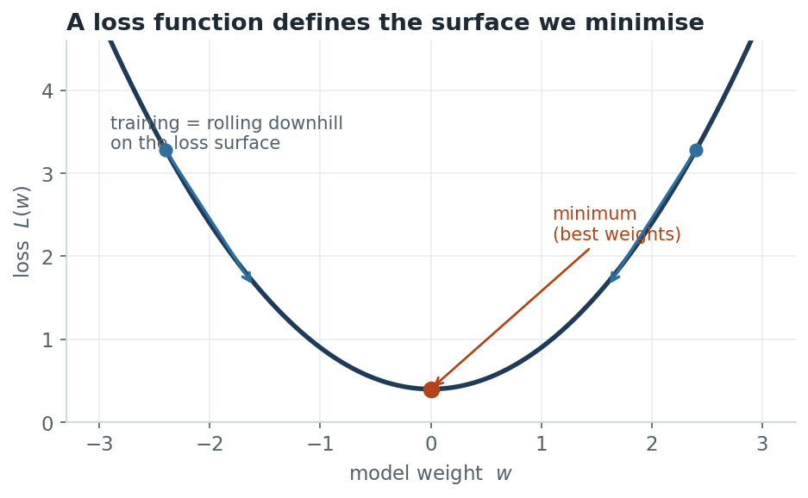
Figure 1. A loss function turns “how wrong are we?” into a surface; training rolls the weights downhill toward its minimum.

1 The big picture: loss vs cost, and the two families
The loss ℓ(y, ŷ) is computed on one example. The cost J is the mean loss over all N examples:
J(θ) = (1/N) Σᵢ ℓ( yᵢ , ŷᵢ )
Almost every loss falls into one of two groups, matched to the task:
  REGRESSION — predict a number
  - MSE squared error (default)
  - MAE absolute error (robust)
  - Huber blend of the two
  CLASSIFICATION — predict a class
  - Cross-entropy probabilistic (default)
  - Hinge margin-based (SVM)
  - KL divergence match distributions

2 Mean Squared Error (L2 loss)
ℓ = (y − ŷ)² J = (1/N) Σ (yᵢ − ŷᵢ)²
WHAT IT DOES
- Squares the error, so a mistake of 4 hurts 4× as much as a mistake of 2, not 2×. Big errors dominate.
- Smooth and convex for linear models — a single global minimum, easy to optimise.
- Minimising MSE makes the prediction converge to the mean of the target given the input.
GRADIENT
∂ℓ/∂ŷ = −2(y − ŷ)
The gradient grows with the error — large mistakes produce large updates. That speeds learning but lets a single outlier yank the fit toward itself.
WHEN TO USE / AVOID
- Use when errors are roughly Gaussian and there are few outliers; the default for most regression.
- Avoid when the data has heavy outliers — they get squared and dominate the loss.

3 Mean Absolute Error (L1 loss)
ℓ = |y − ŷ| J = (1/N) Σ |yᵢ − ŷᵢ|
WHAT IT DOES
- Penalises errors linearly — an error of 4 hurts exactly 2× an error of 2. Outliers are not amplified.
- Minimising MAE makes the prediction converge to the median of the target — which is why it is robust.
GRADIENT
∂ℓ/∂ŷ = −sign(y − ŷ) (±1, undefined at 0)
The gradient is constant in magnitude regardless of how big the error is. Robust, but it never eases off near the minimum, so convergence can be slower and it is non-differentiable at exactly zero error.
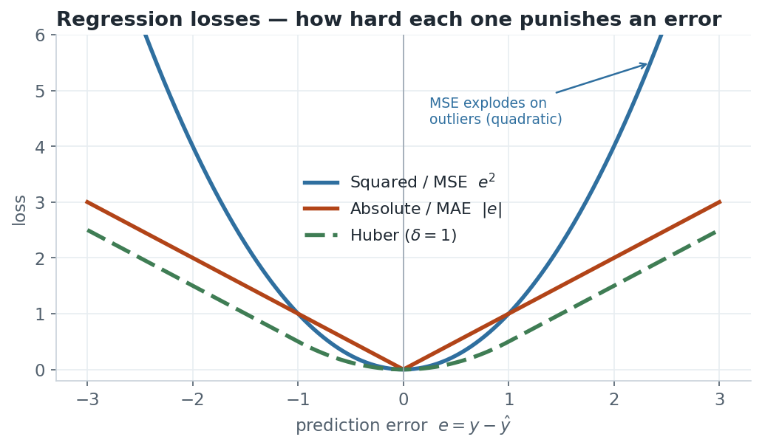
Figure 2. MSE (blue) curves upward and punishes large errors far more; MAE (orange) is a straight V; Huber (green) is MSE near zero and MAE far out.

4 Huber Loss (smooth L1)
Behaves like MSE for small errors (smooth, fast) and like MAE for large errors (robust). The switch happens at a threshold δ.
ℓ = ½(y−ŷ)² if |y−ŷ| ≤ δ
ℓ = δ|y−ŷ| − ½δ² if |y−ŷ| > δ
Why it is useful
You get MSE’s smooth, well-behaved gradient near the optimum and MAE’s resistance to outliers far from it. δ tunes where the switch happens. Log-Cosh loss is a smooth approximation with the same spirit and no threshold to pick.

5 Cross-Entropy / Log Loss (classification)
The default loss for classification. It compares a predicted probability against the true label and punishes confident wrong answers severely.
BINARY (TWO CLASSES)
ℓ = −[ y·log(ŷ) + (1−y)·log(1−ŷ) ]
MULTI-CLASS (K CLASSES, ONE-HOT Y)
ℓ = − Σₖ yₖ · log(ŷₖ)
WHAT IT DOES
- When the true class is 1 and you predict ŷ→0, −log(ŷ) → ∞ — being confidently wrong is punished without bound.
- Predicting the right class with high confidence gives a loss near zero.
- Paired with sigmoid (binary) or softmax (multi-class) to turn scores into probabilities.
GRADIENT (WITH SIGMOID/SOFTMAX)
∂ℓ/∂z = ŷ − y (predicted − true)
This is the clean, famous result: the gradient with respect to the pre-activation score is simply predicted minus target. No sigmoid derivative survives — which is exactly why sigmoid+cross-entropy trains well while sigmoid+MSE stalls.
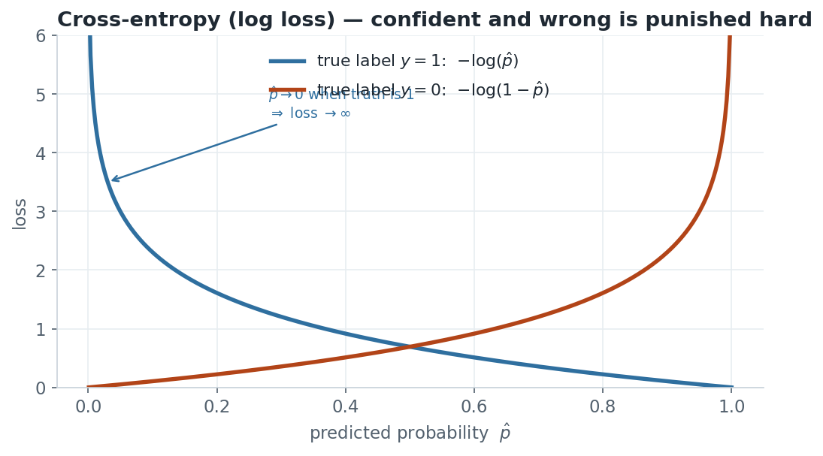
Figure 3. Cross-entropy shoots to infinity as the predicted probability moves toward the wrong end. Confidence in the wrong answer is expensive.
Why not MSE for classification?
With a sigmoid output, MSE is non-convex and its gradient contains σ′=σ(1−σ), which is almost zero when the neuron is saturated — so a badly-wrong, saturated output learns painfully slowly. Cross-entropy cancels that term and keeps learning fast.

6 Hinge Loss (SVM / max-margin)
ℓ = max(0, 1 − y·f(x)), y ∈ {−1, +1}
Here f(x)=wᵀx+b is the raw score and the product m = y·f(x) is the margin.
WHAT IT DOES
- Zero loss once a point is correct and beyond the margin (m ≥ 1). It only cares about points near or across the boundary — the support vectors.
- Linear penalty for points inside the margin or misclassified.
- Does not produce probabilities — it optimises the decision boundary directly.
(SUB)GRADIENT
∂ℓ/∂w = −y·x if m<1, else 0
Non-differentiable at m=1, so a subgradient is used. Points comfortably classified contribute nothing to the update.
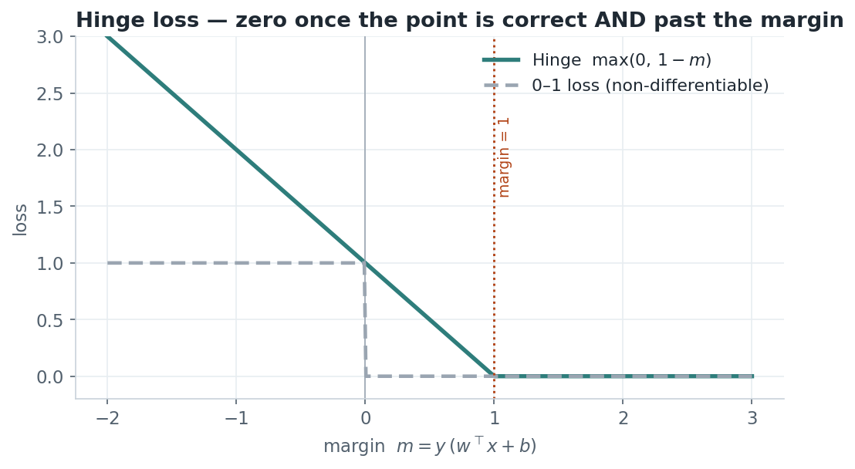
Figure 4. Hinge loss is a hinge: it drops to exactly zero once the margin exceeds 1, unlike the smooth cross-entropy.

7 The gradient is the point — a comparison
A loss is only useful through its gradient, because that is what the optimiser actually follows. Two losses can rank predictions the same way but learn very differently because their gradients differ.
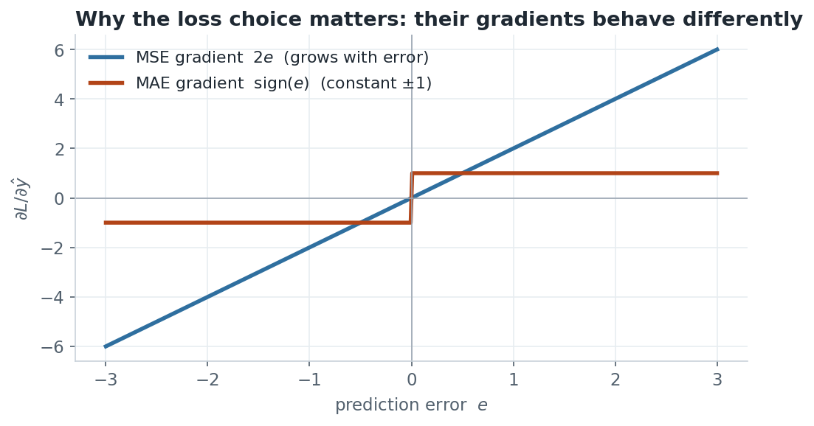
Figure 5. MSE’s gradient grows with the error (fast but outlier-sensitive); MAE’s is a constant ±1 (robust but never eases off).

8 One-page summary table
Loss | Formula | Use for | Gradient | Watch out
MSE (L2) | (y−ŷ)² | regression, few outliers | −2(y−ŷ) | outliers dominate
MAE (L1) | |y−ŷ| | regression, robust | −sign(y−ŷ) | non-smooth at 0
Huber | MSE near 0, MAE far | robust + smooth | piecewise | must pick δ
Cross-entropy | −Σ y·log ŷ | classification (probs) | ŷ − y | needs sigmoid/softmax
Hinge | max(0,1−y·f) | SVM, margins | −y·x if m<1 | no probabilities
KL divergence | Σ p·log(p/q) | match distributions | depends | asymmetric

GATE DA exam angle
- Compute a loss from given numbers — e.g. cross-entropy of ŷ=0.25 when y=1 is −log(0.25)≈1.39.
- Know the gradient ŷ−y for cross-entropy and −2(y−ŷ) for MSE — these appear directly.
- Match loss to task and justify robustness (MAE/Huber vs MSE on outliers).

