Gradient Descent & Optimizers
Complete revision notes · how models actually learn — the gradient, the learning rate, the variants, and the modern optimizers.
The one idea behind all of it
A loss function gives a surface. Gradient descent walks downhill on that surface by repeatedly stepping in the direction of steepest decrease — the negative gradient — until it reaches a minimum. Everything else on these pages is a smarter way of taking that step.
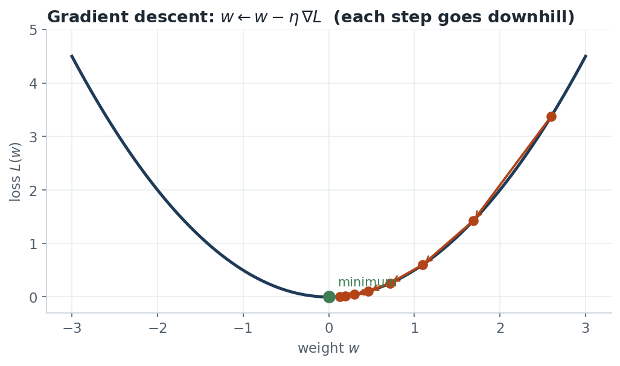
Figure 1. Each step moves the weight against the gradient; the steps shrink automatically as the slope flattens near the minimum.

1 The update rule
θ ← θ − η · ∇J(θ)
- ∇J(θ) — the gradient: the direction of steepest increase of the loss. We move the opposite way.
- η — the learning rate: how big a step to take (the most important hyperparameter).
- Repeat until the gradient is ≈ 0 (a minimum) or the loss stops improving.
Reading the gradient sign
If the slope is positive (loss rising as θ grows), −η∇J is negative, so θ decreases — and vice-versa. The rule always moves θ toward the bottom, from either side.

2 The learning rate η — the critical knob
- Too small → training crawls; may never reach the minimum in the time you have.
- Too large → steps overshoot the minimum, the loss bounces or diverges to infinity.
- Just right → steady, fast descent. Often found by trying 0.1, 0.01, 0.001 and watching the loss curve.
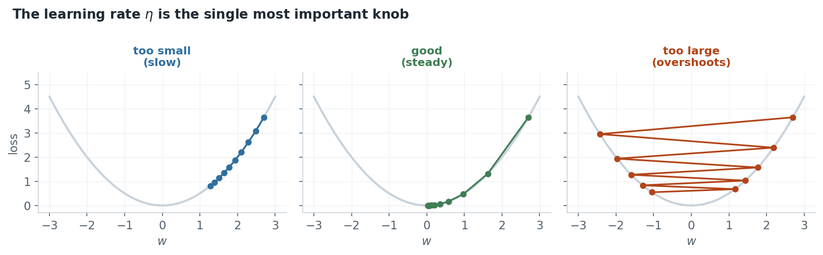
Figure 2. Same problem, three learning rates. Too small barely moves; too large overshoots and climbs the far wall; the middle one converges cleanly.
Learning-rate schedules
In practice η is often decayed over time — large early steps to move fast, small later steps to settle into the minimum. Common schedules: step decay, exponential decay, cosine annealing, and warm-up (start small, ramp up, then decay).

3 How much data per step: Batch, SGD, Mini-batch
The gradient is a sum over examples. How many you use per update defines three variants:
  BATCH GD
  - Uses ALL data per step
  - Smooth, exact direction
  - Slow & memory-heavy on big data
  STOCHASTIC (SGD)
  - ONE example per step
  - Very fast, noisy path
  - Noise can escape shallow minima
  MINI-BATCH
  - A small batch (32–256)
  - Best of both — the default
  - Uses vectorised hardware well

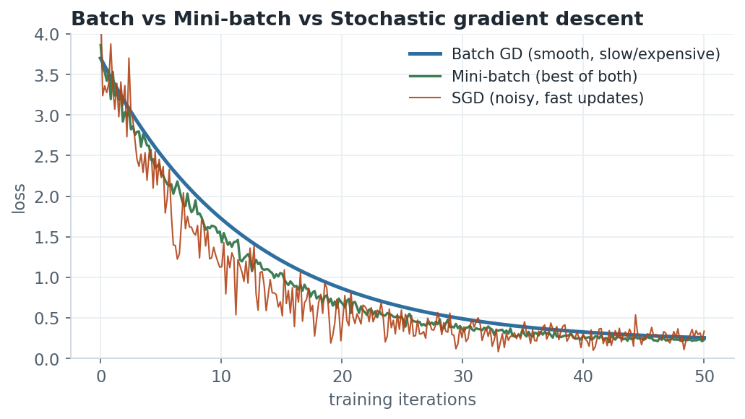
Figure 3. Batch GD descends smoothly but slowly; SGD is noisy but fast; mini-batch balances the two and is what almost everyone uses.

4 Momentum — beating the zig-zag
Plain SGD zig-zags across ravines (surfaces steep in one direction, shallow in another), wasting steps. Momentum accumulates a velocity — like a ball rolling downhill — so consistent directions build up speed and oscillations cancel out.
v ← β·v − η·∇J θ ← θ + v
- β (≈ 0.9) is the momentum coefficient — how much past velocity is retained.
- Nesterov momentum looks ahead before computing the gradient, usually converging a little faster.
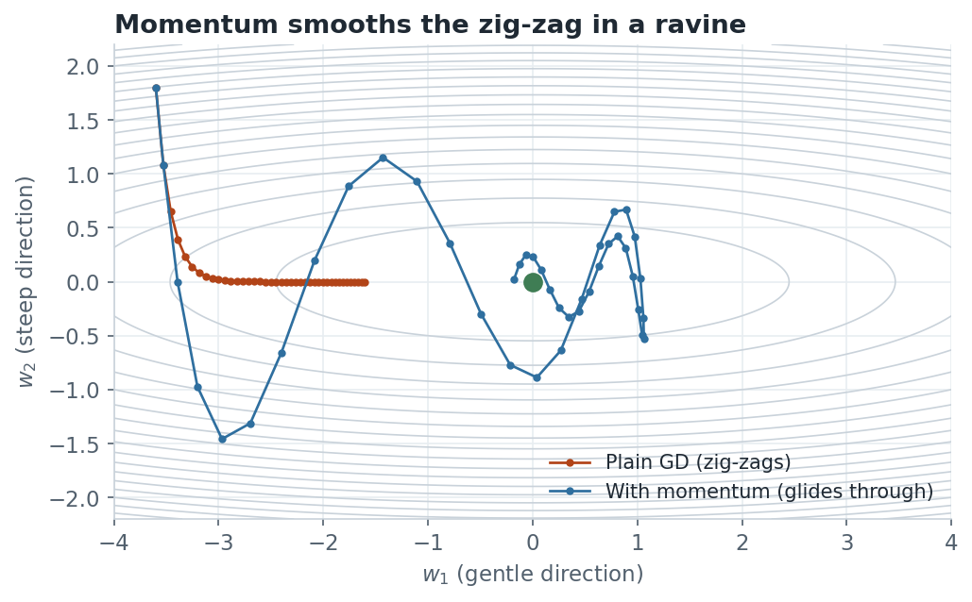
Figure 4. In a ravine, plain gradient descent (orange) bounces between the walls; momentum (blue) damps the oscillation and glides toward the minimum.

5 Adaptive optimizers: AdaGrad → RMSProp → Adam
These give each parameter its own learning rate, automatically scaled by how large that parameter's recent gradients have been. Big-gradient directions get smaller steps; quiet directions get larger ones.
ADAGRAD
- Divides the step by the square root of the sum of all past squared gradients.
- Problem: that sum only grows, so the effective rate shrinks to zero and learning stalls.
RMSPROP
- Fixes AdaGrad by using a decaying moving average of squared gradients instead of the full sum, so the rate never collapses.
ADAM (THE DEFAULT CHOICE TODAY)
Combines momentum (a moving average of the gradient, m) with RMSProp (a moving average of the squared gradient, v):
m ← β₁m + (1−β₁)g v ← β₂v + (1−β₂)g²
θ ← θ − η · m̂ / ( √v̂ + ε )
- Defaults β₁=0.9, β₂=0.999, ε=10⁻⁸ work well out of the box — its main appeal.
- m̂, v̂ are bias-corrected versions (important in the first few steps).
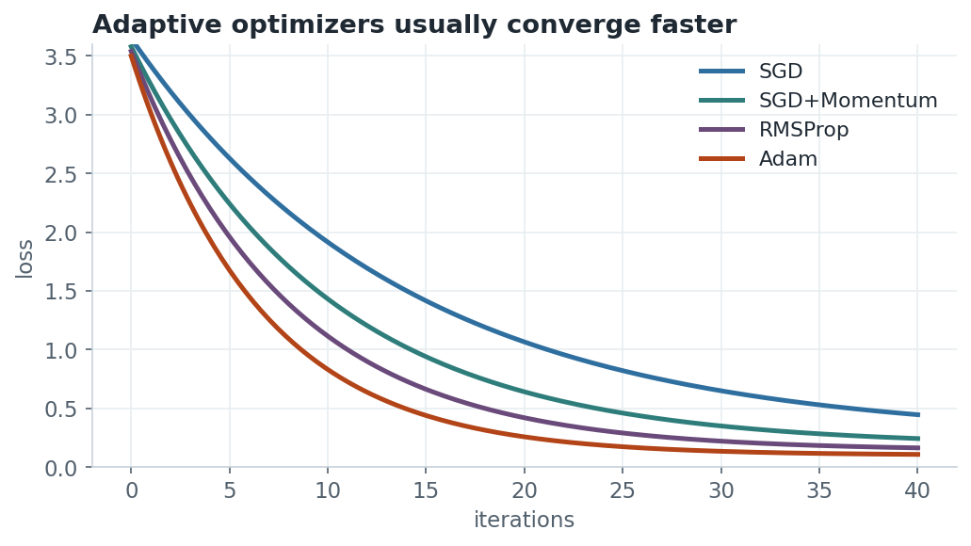
Figure 5. Adaptive methods (RMSProp, Adam) typically reach a low loss in fewer iterations than plain or momentum SGD.

6 Vanishing & exploding gradients
In deep networks the gradient is a product of many layer derivatives (chain rule). If those factors are consistently below 1, the product shrinks toward zero for early layers (vanishing); if above 1, it blows up (exploding).
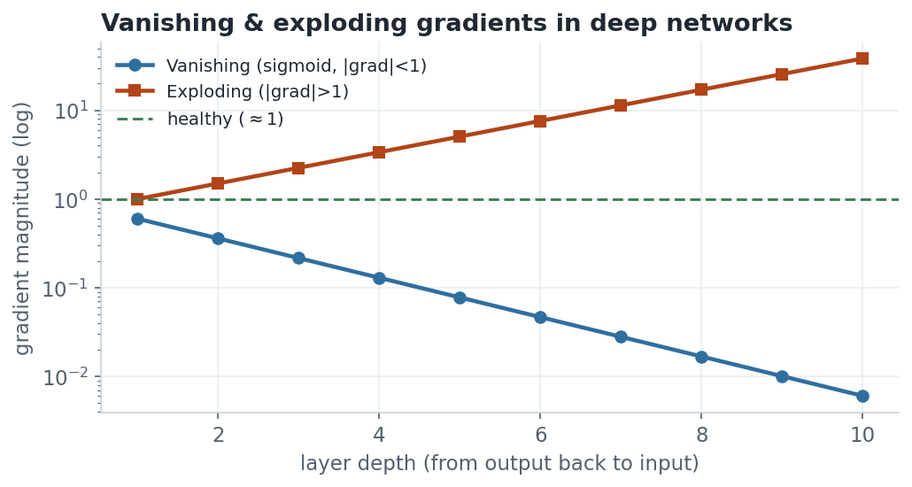
Figure 6. Multiplying many small derivatives vanishes the gradient (blue); many large ones explode it (orange). Either way, early layers fail to learn.
Fixes worth knowing
- ReLU activations (gradient 0 or 1) instead of sigmoid/tanh, which saturate near 0 and 1.
- Careful initialisation (Xavier/He) keeps the signal variance stable across layers.
- Batch normalisation and residual/skip connections keep gradients healthy.
- Gradient clipping caps exploding gradients at a threshold.

7 Where the gradients come from: backpropagation
Backpropagation is simply the chain rule applied right-to-left through the network. A forward pass computes the loss; a backward pass sends the gradient of the loss back through each layer, giving ∂L/∂w for every weight in one sweep.
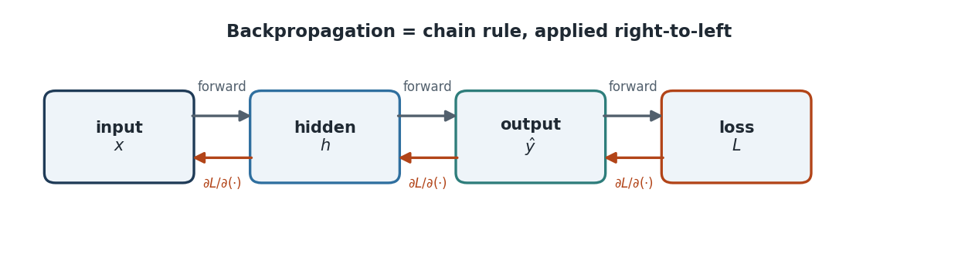
Figure 7. Forward pass (top) computes the prediction and loss; the backward pass (bottom) propagates ∂L/∂(·) back to every parameter.
GATE DA exam angle
- Take one GD step by hand: on f(w)=w², from w=4 with η=0.1, w ← 4 − 0.1·(2·4) = 3.2.
- Stability range on f=½w²: gradient descent converges for 0 < η < 2.
- Know the update rules for momentum and Adam, and why cross-entropy avoids vanishing gradients where MSE+sigmoid does not.

