Automated Testing

Blue Prism

Document Revision 1.0 (22-Mar-21)

Trademarks and copyrights

The information contained in this document is the proprietary and confidential information of Blue Prism Limited and should not be disclosed to a third party without the written consent of an authorised Blue Prism representative. No part of this document may be reproduced or transmitted in any form or by any means, electronic or mechanical, including photocopying without the written permission of Blue Prism Limited.

**© Blue Prism Limited, 2001 – 2021**®Blue Prism is a registered trademark of Blue Prism Limited

All trademarks are hereby acknowledged and are used to the benefit of their respective owners.   
Blue Prism is not responsible for the content of external websites referenced by this document.

Blue Prism Limited, 2 Cinnamon Park, Crab Lane, Warrington, WA2 0XP, United Kingdom  
Registered in England: Reg. No. 4260035. Tel: +44 870 879 3000. Web: www.blueprism.com

Contents

1. Introduction 3

2. Background 3

3. Software Installation 3

4. Pre-requisites 4

5. Blue Prism Steps 5

6. Demo Run 7

7. Limitations 7

8. License and Support 7

# Introduction

The purpose of this document is to provide a guide to set up components for Blue Prism Automated Testing.

# Background

The guide gives a simplistic set up which can be run and testing in lower environments. Users can choose to use the asset as is or modify it to make it more scalable. There are two components which need to be set up.

* 1. Blue Prism component
  2. Python Web service component

# Software Installation

|  |  |
| --- | --- |
| Term | Link |
| Blue Prism | Robotic Process Automation tool - <https://portal.blueprism.com/products/current>  (asset supports v6.6 - v6.10.1) |
| GIT | Source code repository. You need to have GIT installed in your system.  For this guide a public repo was created at:  <https://github.com/ashz30/BluePrism-Automated-Testing.git> |
| Python | Python Version 3.6.8 is used, Download link [here](https://www.python.org/downloads/release/python-368/).  Python IDE used is PyCharm. Download link [here](https://www.jetbrains.com/pycharm/download/). (users can also run the code without the IDE as a command line too) |
| Python Libraries | [pyodbc](https://pypi.org/project/pyodbc/) (installed with pip commands) – For Database operations.  [Flask](https://pypi.org/project/Flask/) (installed with pip commands) – only used for exposing python code as Web API’s.  [Jinja2](https://pypi.org/project/Jinja2/) (installed with pip commands)  [MarkupSafe](https://pypi.org/project/MarkupSafe/) (installed with pip commands)  [WerkZeug](https://pypi.org/project/Werkzeug/) (installed with pip commands)  [click](https://pypi.org/project/click/) (installed with pip commands)  [itsdangerous](https://pypi.org/project/itsdangerous/) (installed with pip commands)  (please refer to links above for any license information) |
|  |  |

# Pre-requisites

Prior to starting this process, the below steps need to be configured:

* Clone git repository - open cmd in a blank folder (mine is C:\GIT) and type

“git clone <https://github.com/ashz30/BluePrism-Automated-Testing.git>”

* Install Python, open any cmd window and run the below commands:
  + - * 1. Check python version – “python --version”

(if this does not show the correct python version, you will need to edit windows path to point to python folderand open a new cmd window to try again)

* + - * 1. “pip install [<libraryname>](https://pypi.org/project/pyodbc/)” (to download and install all python libraries – replace name with python library)
* User will need to install Blue Prism in any machine.
* The machine which runs the python web service needs to directly connect to Blue prism database with the windows credentials.

1. Python Web service set up steps.

* Once cloned this is the structure of the GIT folder –

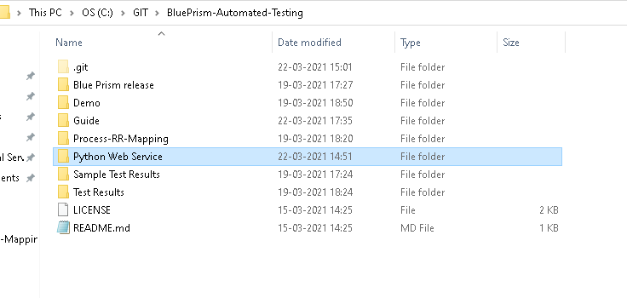

* Goto folder - GIT\BluePrism-Automated-Testing\Python Web Service (or your corresponding folder path).
* You should be able to view below files:

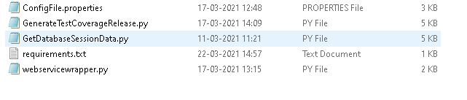

* Goto file **ConfigFile.properties**, and update these properties:
  + - server=<Blue Prism Database details> (for SQL statement runs present in last 2 properties)
    - database=<Blue Prism DBConn name as present in Automate.config> (for Test coverage release import)

Other properties can be left as is unless required. The machine which runs the python web service needs to directly connect to Blue prism database with the windows credentials. So the Windows user needs to have access to run the select sql’s present in the properties – testcoveragesql, processsessiondatasql objectsessiondatasql and sessiondatasql

* Open command line in folder ‘**Python Web Service’** and run command

‘python webservicewrapper.py’

alternately run webservicewrapper.py through the IDE (pycharm).

* Provided everything is set up correctly, it should start a web server in your local system.

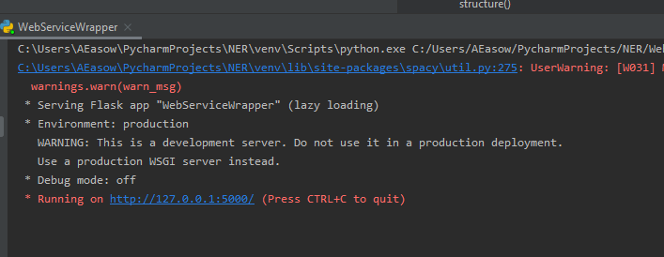

* Open your browser to goto link –

“[127.0.0.1:5000](http://127.0.0.1:5000/)"

Hit enter

* You should see the result “Hello World”

# Blue Prism Steps

* Open Blue Prism.
* Import release file in the folders –
  1. IT\BluePrism-Automated-Testing\Blue Prism release - C:\GIT\BluePrism-Automated-Testing\Python Web Service\release\Registration Process.bprelease (*for Demo only*)
  2. GIT\BluePrism-Automated-Testing\Blue Prism release\Test Suite Master v6.bprelease
* Update Excel - GIT\BluePrism-Automated-Testing\Process-RR-Mapping\Process-RR-Mapping.xlsx.
  1. Blue Prism Process name - Process to be tested
  2. Runtime Resource host – Hostname/IP of runtime resource
  3. Runtime Resource Port – Port of Runtime Resource
  4. SSO Flag – True if AD is used
  5. RR Credential Name – Credential name to be used if AD is not configured.
  6. DBConName – Connection name present in Runtime Resource Automate.config file.
  7. Start Up Param – Start up parameter for Blue Prism process in xml parameter format. Sample link [here](https://bpdocs.blueprism.com/bp-6-10/en-us/helpCommandLine.htm?Highlight=process%20command%20line%20options).



* 1. Test Results Data File location – Excel with the process name to be stored here GIT\BluePrism-Automated-Testing\Test Results. Sample file present here : GIT\BluePrism-Automated-Testing\Sample Test Results.
  2. Import Test coverage release Flag – true, if test coverage needs to be run and imported.
  3. Release file location – original release of the process being tested.
  4. New release file name – new release file name of the process being tested after test coverage font change.
* Update Excel(s) - GIT\BluePrism-Automated-Testing\Test Results\<processname.xlsx>.
  1. Master Sheet –
     + 1. Queues to be processed, Worksheet name for Queue item status : Any queue names from which data needs to be extracted and worksheet names for respective queue names. Worksheets need to be blank if created. If not created automation will create a new worksheet.
       2. Session data extraction worksheets – One Worksheet for each stage from which session data needs to be extracted. Worksheet created needs to have first two rows filled as shown in template

|  |  |  |  |  |
| --- | --- | --- | --- | --- |
| **Stage Name** | **Process Name** | **Page Name** | **Object Name** | **Action Name** |
| Work Queues::Get Next Item | Submit Regstration process | process queue data | Blueprism.Automate.clsWorkQueuesActions | Get Next Item |

This data is available in the BPASessionLog_NonUnicode or equivalent table.

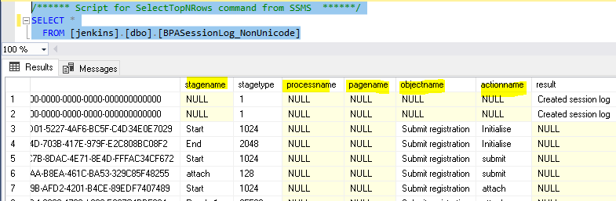

* 1. Input Sheet – populated for ease of forumales. Tester should know the input required for the test.
  2. Expected Output Sheet - populated for ease of forumales. Tester should know the Expected Output required for the test.
  3. Validation Sheet – Formulaes for Validating output. This can be written either as simple excel forumulas, or macros can be written when output validation requires complex logic. Sheet is locked with password admin to avoid formaes getting corrupted when sheets are deleted or overwritten.

# Demo Run

* If everything is set up correctly, run the BP process. It will sequentially execute each process in the specified runtime resource and output will be obtained in Test results folder. Validation sheet of each process will show the status of the Test cases.

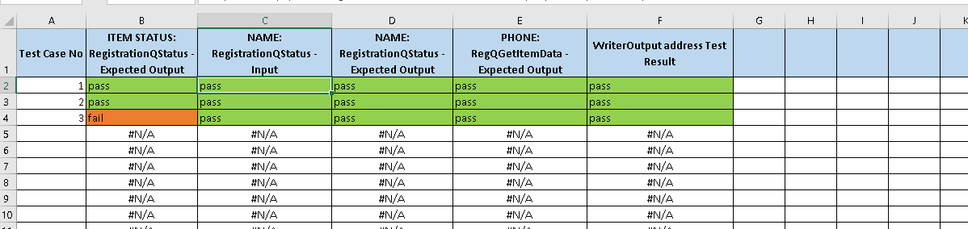

* After every run a new Test results sheet needs to be placed in folder.

# Limitations

* Performance has not been evaluated, this asset is to be used in a lower environment only, if it is to be made scalable, performance , risk and best practice recommendations need to be implemented.
* Asset queries BPASessionLog_NonUnicode tables to get information. Queries present in config.properties should be evaluated from performance viewpoint if this asset needs tobe used at scale.
* Python code is for POC purposes and should be reviewed and changed if required to be used at scale.
* Asset evaluates internal Blue Prism tables to get results, this results in certain exception conditions for eg. If Global Send keys are used, data would be sent to the end application but without correctly clicking on the correct field data will not be input correctly. Assumption is that the main Automation will throw exception in such cases.

Similarly there are other exception conditions to the asset, in cases where Blue Prism correctly completes the automation but data in end application is not correct. In such cases users need to write an output extraction process customised to be automation to populate test results excel sheets which will have the correct output extracted from the end application. Test Suite master needs to be modified to accommodate adding output extraction processes.

# License and Support

The guide and supporting bprelease are available for free under MIT license (license present in GIT repository). The Python libraries used have their own license (most are BSD 3 clause), please do evaluate the commercial aspects of the libraries and scan for any risks.

The asset itself is community supported, any requirement for support can be directed to the Dx community at this [link](https://community.blueprism.com/communities/dx-communities).