|  |
| --- |
| **Calibration Report**  **Issued By: Sigma Sensors (TCL) GmbH**  **Maximilian-Haller Str.20 E-mail*: lab@sigma-sensors.com***  **72488 Sigmaringen** [**www.sigma-sensors.com**](http://www.sigma-sensors.com)  **Germany**  **Date of Calibration: 21**/08/2021 |

|  |  |
| --- | --- |
| **Report No.** | 6003 |
| **ID** | 5060 |
| **Wafer Manufacturer** | SIGMA SENSORS |
| **Model** | CW200_09_01 |
| **Serial Number** | 5060 |
| **Chuck /Chiller Model** | L60 |
| **Serial** | 1107-02459 |
| **Controller Model** | A300TEL |
| **Serial** | 0816-07334 |

|  |  |
| --- | --- |
| **Customer Details** | |
| **PO No.** | **4520021** |
| **Company Name** | **Sigma Sensors (Production)** |
| **Address** | **Maximilian-Haller Str.20**  **72488 Sigmaringen**  **Germany** |

|  |  |  |  |  |  |  |  |  |
| --- | --- | --- | --- | --- | --- | --- | --- | --- |
| **Measurement Standards:**   |  |  |  |  | | --- | --- | --- | --- | | **Type** | **Model** | **Serial No.** | **Cal Due Date** | | RPRT | **RPRT-420-300** | **05794** | **Jan 13,2022** |   **Environment Condition: Procedure:** SSCP 003  Temperature: 21.7 °C  Relative Humidity: 50.9% |

**Method Used:** The wafer and its sensors were calibrated by comparison with two reference standard instruments having known and traceable values of uncertainty, in closely controlled reference environments.

**Result of Physical Examination:** The condition of this device was satisfactory with no visually apparent defects, unless noted below. Minor cosmetic defects are generally not noted unless they are judged to impact the usability of the device.

**Traceability Information:** This Certificate provides traceability of measurement to the SI system of units and/or to units of measurement realised at the National Physical laboratory or other recognised national metrology institutes**.**

**Measurement Uncertainty:** The measurement uncertainty reported is the expanded uncertainty at 2 sigma (k=2), to provide a confidence level of approximately 95%. This uncertainty calculation is consistent with the requirements of the ISO Guide to the Expression of Uncertainty in Measurement (the 'GUM'), NIST Technical Note 1297 and ITS-90.

**Sensor Position (Top View):**

***Figure: 200 mm Wafer***

Calibration Data:

|  |  |  |  |  |  |
| --- | --- | --- | --- | --- | --- |
| *Set*  **Temperature**  **[°C]** | **Sensor Position** | *Found Temperature*  **[°C]** | **Average**  **[°C]** | **Uniformity [°C]** | **Expanded Uncertainty (K=2)**  **[±°C]** |
| {{t1}} **°C**  **(Ambient)** | S1 | {{t1_1}} | {{t1_av}} | {{t1_uni}} | {{t1_unc}} |
| S2 | {{t1_2}} | {{t1_unc}} |
| S3 | {{t1_3}} | {{t1_unc}} |
| S4 | {{t1_4}} | {{t1_unc}} |
| S5 | {{t1_5}} | {{t1_unc}} |
| S6 | {{t1_6}} | {{t1_unc}} |
| S7 | {{t1_7}} | {{t1_unc}} |
| S8 | {{t1_8}} | {{t1_unc}} |
| S9 | {{t1_9}} | {{t1_unc}} |

|  |  |  |  |  |  |  |
| --- | --- | --- | --- | --- | --- | --- |
| *Set*  **Temperature**  **[°C]** | **Sensor Position** | *Found Temperature*  **[°C]** | **Average**  **[°C]** | | **Uniformity [°C]** | **Expanded Uncertainty (K=2)**  **[±°C]** |
| {{t2}}  **°C** | S1 | {{t2_1}} | {{t2_av}} | {{t2_uni}} | | {{t2_unc}} |
| S2 | {{t2_2}} | {{t2_unc}} |
| S3 | {{t2_3}} | {{t2_unc}} |
| S4 | {{t2_4}} | {{t2_unc}} |
| S5 | {{t2_5}} | {{t2_unc}} |
| S6 | {{t2_6}} | {{t2_unc}} |
| S7 | {{t2_7}} | {{t2_unc}} |
| S8 | {{t2_8}} | {{t2_unc}} |
| S9 | {{t2_9}} | {{t2_unc}} |

|  |  |  |  |  |  |  |
| --- | --- | --- | --- | --- | --- | --- |
| *Set*  **Temperature**  **[°C]** | **Sensor Position** | *Found Temperature*  **[°C]** | **Average**  **[°C]** | | **Uniformity [°C]** | **Expanded Uncertainty (K=2)**  **[±°C]** |
| {{t3}}  **°C** | S1 | {{t3_1}} | {{t3_av}} | {{t3_uni}} | | {{t3_unc}} |
| S2 | {{t3_2}} | {{t3_unc}} |
| S3 | {{t3_3}} | {{t3_unc}} |
| S4 | {{t3_4}} | {{t3_unc}} |
| S5 | {{t3_5}} | {{t3_unc}} |
| S6 | {{t3_6}} | {{t3_unc}} |
| S7 | {{t3_7}} | {{t3_unc}} |
| S8 | {{t3_8}} | {{t3_unc}} |
| S9 | {{t3_9}} | {{t3_unc}} |

|  |  |  |  |  |  |  |
| --- | --- | --- | --- | --- | --- | --- |
| *Set*  **Temperature**  **[°C]** | **Sensor Position** | *Found Temperature*  **[°C]** | **Average**  **[°C]** | | **Uniformity [°C]** | **Expanded Uncertainty (K=2)**  **[±°C]** |
| {{t4}}  **°C** | S1 | {{t4_1}} | {{t4_av}} | {{t4_uni}} | | {{t4_unc}} |
| S2 | {{t4_2}} | {{t4_unc}} |
| S3 | {{t4_3}} | {{t4_unc}} |
| S4 | {{t4_4}} | {{t4_unc}} |
| S5 | {{t4_5}} | {{t4_unc}} |
| S6 | {{t4_6}} | {{t4_unc}} |
| S7 | {{t4_7}} | {{t4_unc}} |
| S8 | {{t4_8}} | {{t4_unc}} |
| S9 | {{t4_9}} | {{t4_unc}} |

|  |  |  |  |  |  |  |
| --- | --- | --- | --- | --- | --- | --- |
| *Set*  **Temperature**  **[°C]** | **Sensor Position** | *Found Temperature*  **[°C]** | **Average**  **[°C]** | | **Uniformity [°C]** | **Expanded Uncertainty (K=2)**  **[±°C]** |
| {{t5}}  **°C** | S1 | {{t5_1}} | {{t5_av}} | {{t5_uni}} | | {{t5_unc}} |
| S2 | {{t5_2}} | {{t5_unc}} |
| S3 | {{t5_3}} | {{t5_unc}} |
| S4 | {{t5_4}} | {{t5_unc}} |
| S5 | {{t5_5}} | {{t5_unc}} |
| S6 | {{t5_6}} | {{t5_unc}} |
| S7 | {{t5_7}} | {{t5_unc}} |
| S8 | {{t5_8}} | {{t5_unc}} |
| S9 | {{t5_9}} | {{t5_unc}} |

Captured Data:

Wafer Data

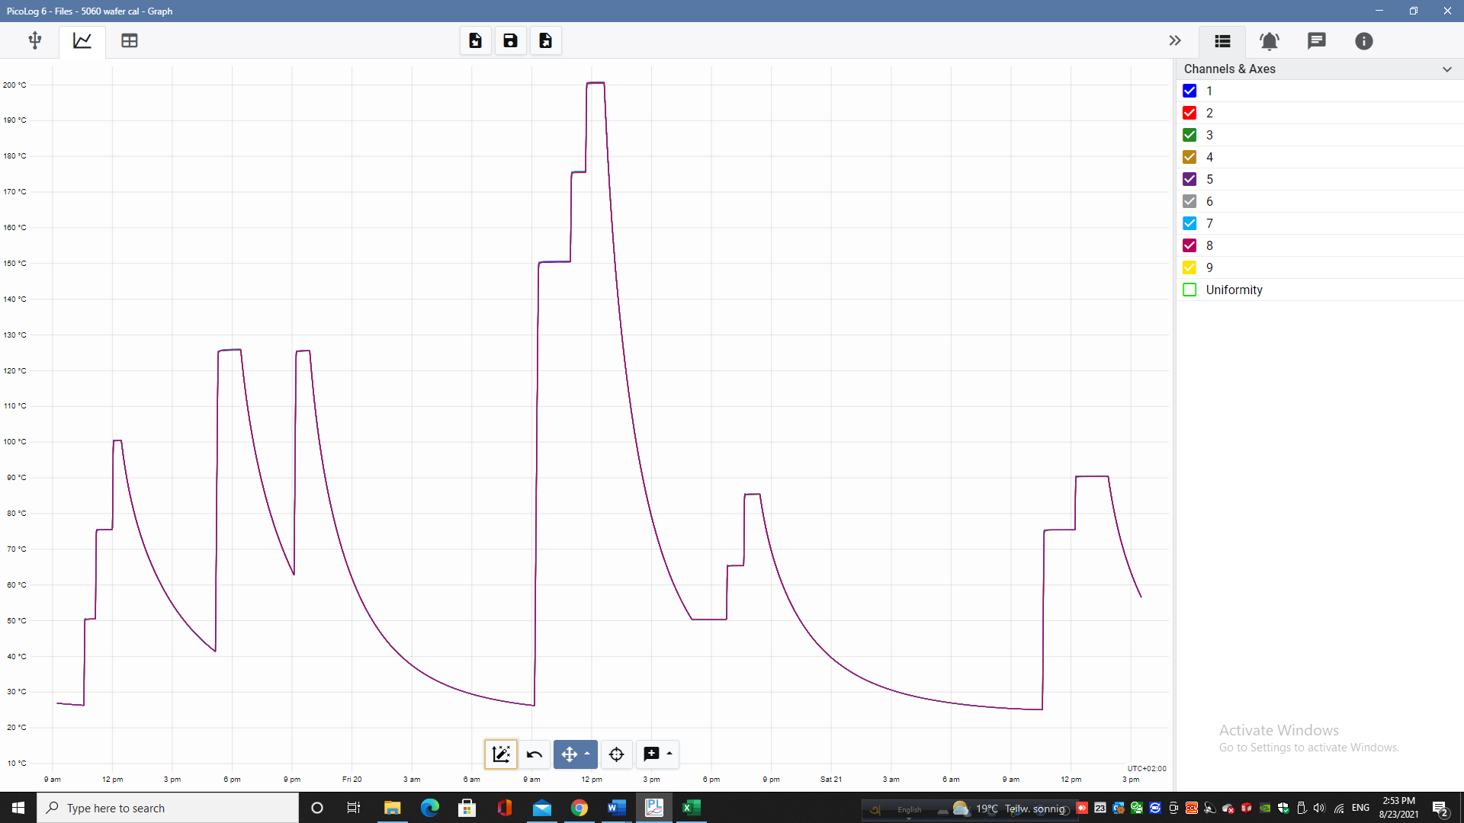

*Raw sensors Data*

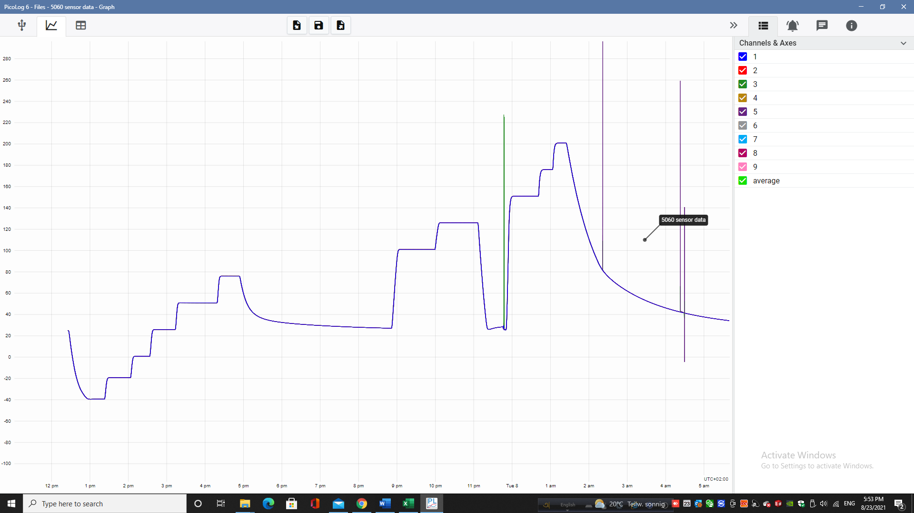

|  |  |
| --- | --- |
| ***Remarks (If any):*** | |
| *Calibration* **Status:** | **Calibrated** |

Calibrated By: Iftakhar Approved By H. Ibele

* The user should be aware that any number of factors may cause this instrument to drift out of calibration before the specified calibration interval has expired.
* This calibration report may not be reproduced except in full without the express written permission of Sigma Sensors (TCL) GmbH.
* This report applies only to the item calibrated. This calibration report shall not be used to claim product endorsement.
* End of Report No.6003