LEAP Review Tools
  - A guide for everyday use
4 August 2026

Welcome
These two tools help you check a LEAP model against the source data it should agree with.
The balance review produces an Excel workbook that shows, cell by cell, where your LEAP energy balance differs from the source data — and by how much. It is the tool to reach for when you want to know what to fix.
The dashboard produces a set of interactive web pages comparing LEAP against ESTO and the 9th Outlook across every sector and fuel. It is the tool to reach for when you want to see the whole picture, or show it to someone else.
There is nothing to install. Everything the tools need is already in the folder you were sent. You give them your LEAP exports, and they give you back a workbook or a dashboard.
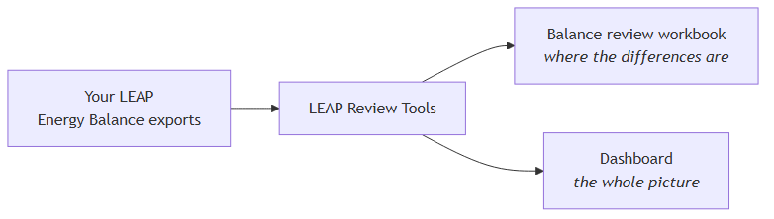

Before you start
Extract the folder somewhere simple. C:\Tools\ is ideal. Avoid extracting it deep inside a OneDrive or Documents folder — long paths cause problems.
Windows will warn you the first time. You will see a blue box saying “Windows protected your PC”. This is expected: the program has not been registered with Microsoft. Click More info, then Run anyway. You only need to do this once.
You do not need Excel to run the tools. You only need it to open the workbook afterwards. When you do open it, Excel will recalculate the sheet — that is normal and takes a moment.
To work with the tools, open the folder in File Explorer, hold Shift, right-click in an empty area, and choose Open PowerShell window here. You will type short commands there. Each one in this guide can be copied exactly as written.

Putting your files in
There is one folder you need to care about: input\leap balances exports.
Inside it, make one folder per economy, named with the economy code. Put that economy’s LEAP Energy Balance exports inside its folder.
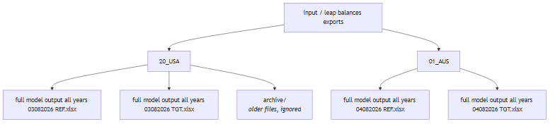
This is the same layout the modelling team uses, so you can copy a folder straight across in either direction.

Naming your files
Name each file like this:
full model output all years 03082026 TGT.xlsx
The number is the date you exported it, written as day, month, year — so 03082026 is the 3rd of August 2026. The last part is the scenario: REF for Reference, TGT for Target. Reference and Target spelled out work too, and so does putting the scenario first, as in REF 03082026.xlsx.
If you have several files for the same economy and scenario, the newest date wins. You do not need to delete the old ones — but if you would rather they were out of the way, put them in a folder called archive inside the economy folder. Anything in there is ignored completely.

One thing that matters
When you export the Energy Balance from LEAP, export it with at least Level 2 detail. A Level 1 export flattens everything into single rows, which leaves nothing to compare. The tools check for this and will tell you plainly if an export is too shallow, rather than producing a misleading result.

Checking it can see your files
Before running anything properly, ask the tools what they can find:
.\leap-review-tools.exe list
You will get something like this:
LEAP balance exports in: C:\Tools\leap-review-tools-0.1.0\input\leap balances exports
01_AUS
Reference full model output all years 04082026 REF.xlsx [2022-2060]
Target full model output all years 04082026 TGT.xlsx [2022-2060]
20_USA
Reference full model output all years 03082026 REF.xlsx [2022-2060]
Target full model output all years 03082026 TGT.xlsx [2022-2060]
Each economy is listed with the file chosen for each scenario and the years that file covers. This is the quickest way to confirm your files are named correctly and in the right place.
If a file is named in a way the tools do not recognise, it says so here rather than quietly ignoring it. That is usually a typo in the date or the scenario.

Building a balance review
This gives you the Excel workbook showing where LEAP and the source data disagree.
Step 1. Decide which economy, scenario and year you want to review. Most reviews are for the base year, 2022.
Step 2. Run the command, changing the economy, scenario and year to suit:
.\leap-review-tools.exe balance-review-from-export --economy 20_USA --scenario Target --year 2022
You do not have to tell it which file to use — it finds the right export for that economy and scenario itself.
Step 3. Wait. It will print its progress as it works. It reads your export, compares every value against the source data, and builds the workbook.
Step 4. Open the result:
output\20_USA\balance_review\balance_review_20_USA_tgt_2022.xlsx
The next section explains what you are looking at.
If you already have a diagnostics folder from the modelling team, you can use it directly instead — that is the balance-review command, and it takes the folder as --diagnostics-directory. Ask whoever sent you the tools if you are not sure which applies to you.

Reading the balance-review workbook
The workbook has five sheets. They are meant to be read in order, and each answers a different question.
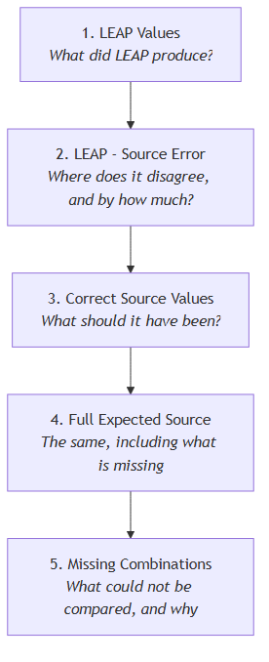
LEAP Values is your energy balance exactly as LEAP produced it, converted to petajoules. Nothing has been changed. Use it to get your bearings — the rows and columns are the ones you already know.
LEAP - Source Error is the heart of it. Each cell shows LEAP minus the source. A red cell means they disagree, and the number is the size of the gap. A grey zero means they agree. This is your worklist: start with the largest red numbers.
Correct Source Values shows what the source data says each cell should be. When you want to know not just that something is wrong but what it ought to be, this is the sheet.
Full Expected Source is the same again, but it also greys out the cells that do not exist in your balance structure at all. It answers “is this missing, or is it just not applicable here?”
Missing Combinations lists everything that could not be compared, one row per case, with the reason and a suggested interpretation. Read this before concluding that a blank cell means zero — it usually does not.

What the colours mean
The colours are consistent across the sheets.
Red is a real mismatch between LEAP and the source. These are the ones to investigate.
Blue is a value that came from the source data.
Purple means there is no direct comparator for this cell. The process was generated from a seed or carried forward, so there is nothing to check it against. Leave these alone unless you have a specific reason.
Yellow means a comparator should exist but was not available. Worth asking about, but not the same as a mismatch.
Green outlines mark production, import and export cells that are affected by the purple ones above. They are not wrong — they are flagged so you know their values depend on something that could not be checked.
Grey means the cell is not part of your balance structure at all.
The important habit: a blank cell never means zero. It means the comparison could not be made, and the Missing Combinations sheet will tell you why.

Building a dashboard
This gives you interactive web pages comparing LEAP against ESTO and the 9th Outlook.
.\leap-review-tools.exe dashboard-from-export --economy 20_USA
This one takes longer — a few minutes — because it reads every export you have for that economy, works out the comparison, and then draws several hundred charts. It prints its progress as it goes.
When it finishes, open:
output\20_USA\dashboard\dashboards\index.html
It opens in your web browser. No internet connection is needed; everything is in the folder.
Down the side you will find a page per sector. Each chart shows up to three series: what LEAP produced, what ESTO recorded, and what the 9th Outlook projects. Historical years compare against ESTO; projection years compare against the 9th. You can click series names in the legend to hide or show them.
Some sector pages may be missing. That is deliberate: if LEAP has no separately modelled detail for a sector in that economy, a page would be misleading, so it is left out. The run tells you which ones and why.

Where your results go
Everything is grouped by economy, so nothing you produce overwrites anything else.
output/
20_USA/
balance_review/ workbooks for the USA
dashboard/ the USA dashboard
01_AUS/
balance_review/
dashboard/
You can review the USA today and Australia tomorrow and both remain in place. Within an economy, workbooks for different scenarios and years sit side by side, because the scenario and year are part of each filename.
Beside your results you will find a run_records folder. Each run leaves a dated record in there showing exactly which files it used and when. You can ignore it day to day — it is there so that months later you can answer “which export did this come from?” with certainty rather than memory.

If something goes wrong
The tools try to explain problems in plain language rather than showing an error you would need a programmer to read. Work through these in order.
Start here. This confirms the folder is complete and working:
.\leap-review-tools.exe selfcheck
You want to see result : OK.
Read the validation report. Every run leaves one in its run_records folder, whether it succeeded or not. If a run stopped, this file says which input was wrong and what was expected. Most problems are answered here.
Check what it can see. Run list again. A surprising number of problems are a file in the wrong folder or a date typed differently from the filename.
If a run failed, no result was produced. The tools do not write a partial workbook or a half-finished dashboard. You will not accidentally use a broken output.
Send a support bundle. Add --support-bundle to any command and you get a ZIP in the output folder containing the run record, the checks that ran, and the logs. It deliberately contains none of your data, so it is safe to email.

Updating settings without a new version
Beside the program there is a folder called config. It holds the settings the tools use: which sectors appear on which dashboard page, the colours, the series labels, and the mapping information behind the comparison.
If your modelling team sends you a replacement for one of these files, drop it in and run again. The change takes effect immediately — you do not need a new version of the program. Each run records which settings it used, so a result can always be traced back to the exact files behind it.
If something behaves unexpectedly after a settings change, that record is the first thing to check.

Quick reference
See what the tools can find:
.\leap-review-tools.exe list
Check the folder is intact:
.\leap-review-tools.exe selfcheck
Build a balance-review workbook:
.\leap-review-tools.exe balance-review-from-export --economy 20_USA --scenario Target --year 2022
Build a dashboard:
.\leap-review-tools.exe dashboard-from-export --economy 20_USA
See what this copy contains and where it writes:
.\leap-review-tools.exe info
Any command also accepts --run-label to name a run, and --support-bundle to package up its record for sending on.
If you prefer not to type commands, double-click the program. It will ask you what you want to do and take you through the inputs one at a time.

